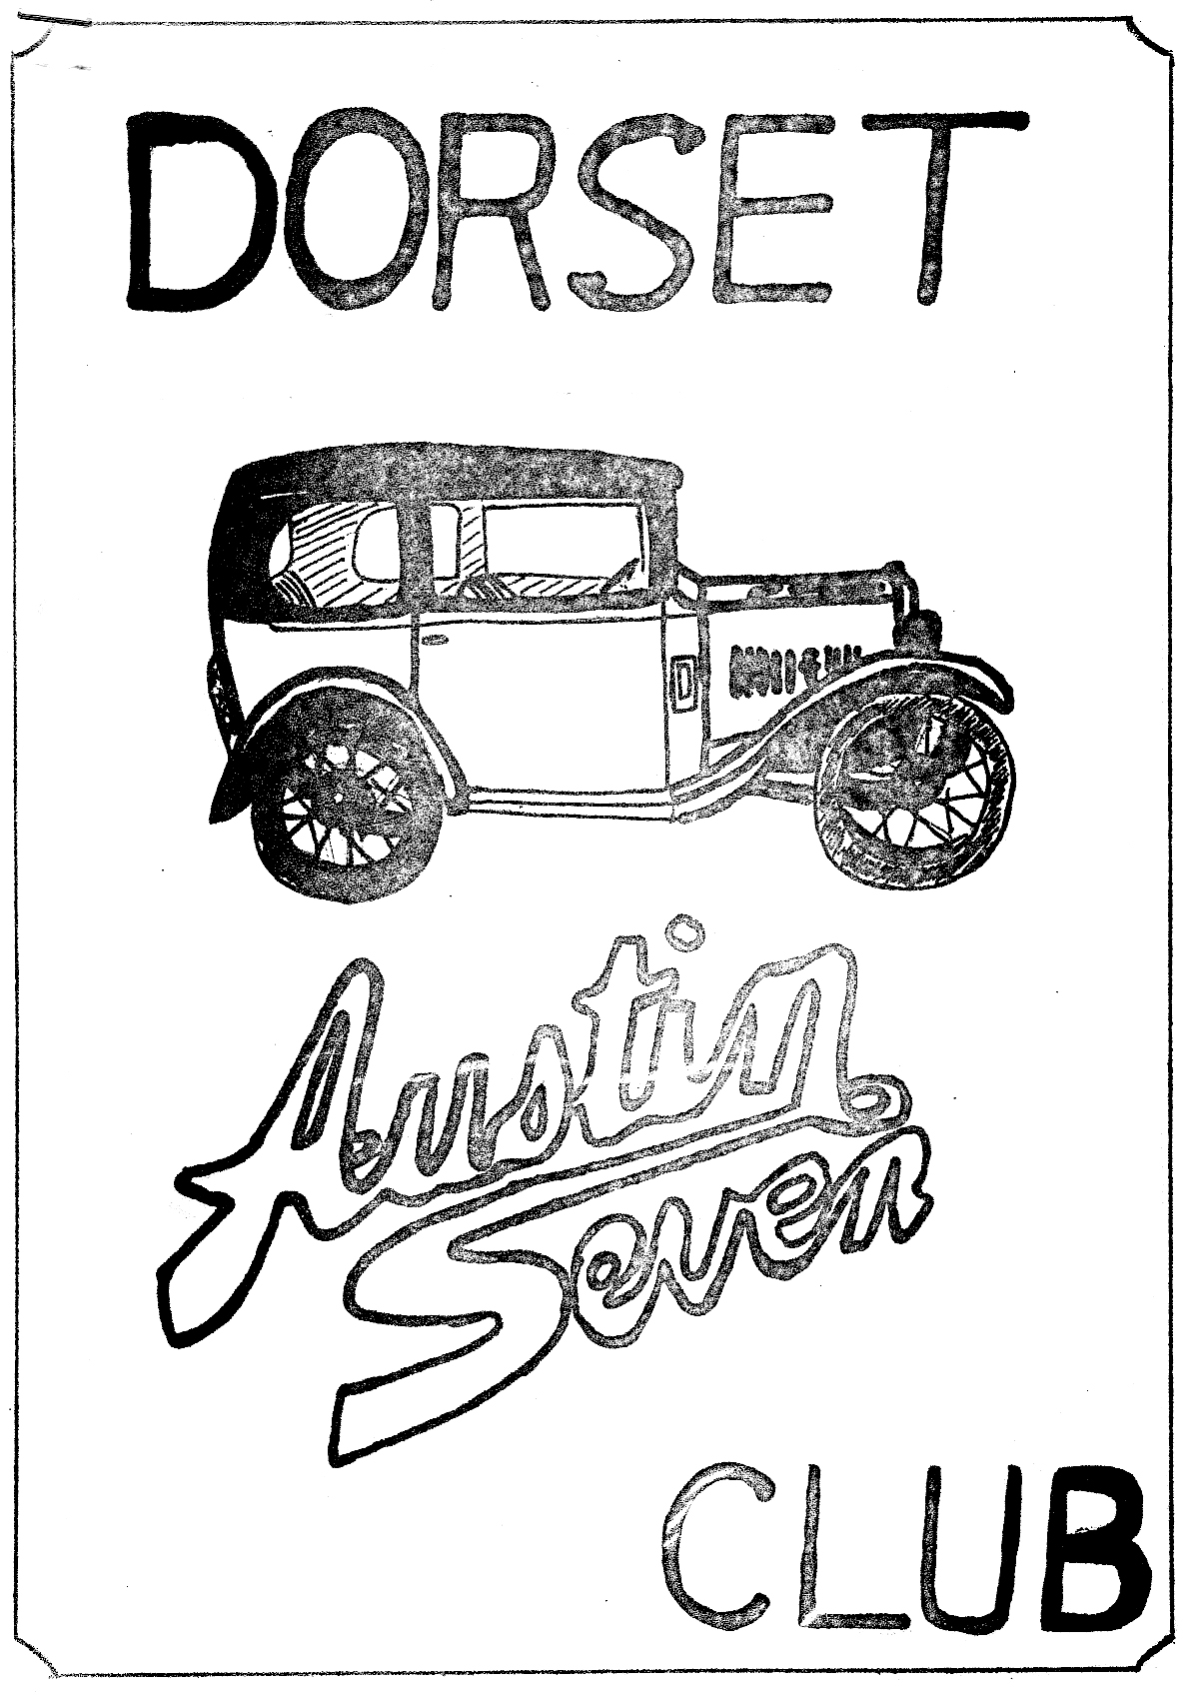
DORSET AUSTIN SEVEN CLUB NEWSLETTER FEBRUARY 1981

FEBRUARY CLUB NIGHT. THURSDAY l9th FEBRUARY - Noggin and natter at the 'Nags Head', Ringwood.

NEXT COMMITTEE MEETING, THURSDAY 26th FEBRUARY - Tyrrells Ford, Avon 8.30 p.m.

EDITORIAL
Hi Gang.
Austin Sevens have been in the news this month, with a red and black 1928 Chummy being the star prize in the television quiz 3-2-1
on 24th January. The lady concerned did not seem to be overjoyed
with her prize.
Last month’s meeting at the Nags Head consisted of a quiz, arranged
and chaired by our Bernie. There were two teams A and B, and the
questions were all to do with motoring, though not all concerned with A7s. No result was given, but I am quite certain that the B team won convincingly. Just before the quiz started, George Mooney gave a report of the A.7.C.A. meeting, which he and Joy attended last month, (see details in this newsletter).
Pat and I had a rather eventful journey to Ringwood last month. On our way to pick up John Bramwell, there was a loud crash and the Ruby veered across the road towards the ditch, as the nearside wheel fell off. On inspection, I found that the king pin had broken. I have never seen John move so quickly as he rushed out with his camera, chuckling and making rude comments. I don't think I’ll come to our next slide evening!!
Finally, you will find an entry form at the end of this newsletter for the GRAND TRANSPORT RALLY run by the Ferndown Rotary Club in
conjunction with the Dorset A.7 Club. Please make an extra effort
to attend this rally, also tell all your friends as this rally is
for charity. The club also stands to make a few bob for funds so
make a note, BANK HOLIDAY MONDAY, MAY 25th.
See you club night.
GLYN

MARCH HARE RUN - SUNDAY 15th MARCH
DON'T FORGET TO MAKE A DATE TO MEET US AT WIMBORNE SQUARE 10.30 A.M. FOR A RUN AROUND THE SWANAGE AREA. MODERNS WELCOME IF YOU HAVE NO SEVEN ON THE ROAD.

SNIPPETS
CONGRATULATIONS to Debbie Munn who passed her driving test recently, first time! Another car on our runs?

NOT PURPLE?
John Page made us chuckle on the New Year’s Day run, when he said he was thinking of painting his Ruby purple! I called round to his
house in Christchurch last night, and guess what, he has, and it is. Go fast stripe next John?
OR PINK
I have heard rumours of a, wait for it, PINK Box saloon in the Southbourne area. Rumour has it that not only is the owner a 'DORSET' member, but that he is on the committee, Gosh.

WELCOME TO NEW MEMBERS
Mr. Kim Henson from Kinson
Mr. W. Bullock from Swanage
Mrs. H. Bullock from Christchurch

EVENTS REMINDER
SATURDAY 14th FEBRUARY Valentines Barn Dance at the Scout Hall,
Redcotts Lane, Wimborne.
THURSDAY 19th FEBRUARY Club Night Noggin and Natter at the Nags
Head, Ringwood.
SATURDAY 28th FEBRUARY Film evening at National Motor Museum,
Beaulieu, showing some rare motoring films 7.45 pm. 'Brabazon' bar. £1 each, members of the Friends of Beaulieu Free.
SUNDAY 15th MARCH Dorset A7 Club March Hare Run to Swanage
area, meet at Wimborne Square 10.30 a.m.
THURSDAY 19th MARCH Club Night

RESTORATION AND RENOVATION EVENING
On the evening of January 31st Pat and I along with several
other Dorset members, drove to the National Motor Museum at Beaulieu for a talk and film show on the restoration and renovation of old cars.
The first speaker, (his name escapes me), a member of the museum staff spoke on the differences between restoration, renovation and
the building of replicas. He said that from the museums stand-
point, renovation, or the repair of the original item, was preferable to restoration, because an original car is frequently used as a reference for someone restoring a similar model. Any original parts that are replaced are kept and a label is attached stating the reason for replacement.
The second speaker was Mr. Dick Crossthwaite a well-known professional restorer, who also showed some slides of some very exclusive cars, such as Bugatti and Mercedes. He explained that very often, he had to make 80% of the car from scratch, and that many were in fact replicas when they eventually left the workshop often costing around £100,000!
There followed a short break for refilling our glasses etc. The next speaker was Barry Clarke, the well-known Austin Seven
restorer and racer. He explained that he felt that it was up to
the individual how or to what extent he restored, renovated or rebuilt a car, and that as long as a replica was not sold as a genuine original vehicle one should be able to do one’s own things.
Following Barry's talk, we were shown an amusing film about a chap restoring a Bull Nose Morris in his garage, a familiar story, I'm sure you'll agree.
Glyn
AROUND EUROPE IN AN AUSTIN 7 CONTINUED
After giving the car a mini service (what, your usual rebore and valve grind? Ed.) We left next morning, after doing the
washing up in a nearby stream. We were, as usual, very short
of money and petrol, and spent our last coppers on 2 litres of
petrol (1/2 gall). We arrived eventually at a small village where we cashed a travellers cheque and bought petrol at the local garage, watched by the whole town. We continued on our way, finally getting a puncture at Genova. After changing the wheel, we continued on along the highly industrialized Italian coast and made camp at a site near San Remo, where we had a swim and met two English lads from Devon. A convivial evening was spent drinking and talking with them. The next day we spent our last Lire on Petrol and air for the repaired tyre and crossed the border into France.
The scenery changed dramatically and we were soon driving through the beautiful town of Monte Carlo.
We tried to find the coast road to admire the scenery etc. (Dirty
Devils! Ed) but we ended up behind the town. We did, at least, see
the famous Casino. Our first priority was to find a bank to obtain
French Francs but being lunch time all the banks were closed, so we stopped in a lay-by to heat up a tin of soup and make a cup of tea. Whilst we were sat in the car admiring the view, we had a miraculous escape. Suddenly there was an almighty bang, and we were showered in bits of Cactus, (ow! painful Ed.) and a Renault 4 careered past us on three wheels, its undercarriage(?) dragging along the road. It stopped 100 yds. down the road and the driver climbed out rather shaken. Suddenly people arrived from everywhere and whisked him away for a drink. We supposed that he had hit the kerb by the lay-by, and ripped off the wheel complete with stub axle. Had he lost control of the car, it may well have been the end of our trip, and of us. We decided that discretion was the better part of valour and drove off, needless to say very carefully!
We stopped at a bank in Nice and were glad to leave the town
which was alarmingly congested. We actually managed to find the
coast road at Cannes but were rather disappointed not to see any film stars, even though we did go round the one-way system twice,
much to the bewilderment of the pedestrians. By this time, we
needed to find a campsite, so we headed on down the coast towards
St. Maxine, where we had been advised to stay. We found a site near
St. Raphael where I re-repaired the puncture. I discovered that
Peter had put the patch about an inch from the hole!
We liked the region west of Cannes as it was a lot less touristy and quiet.
After a meal and a bottle of wine at a beach cafe, we staggered back to the tent "well oiled" as they say in the engineering world. We decided on a peaceful day and stay another night at this campsite, so we spent the morning swimming and sunbathing.
After a snack lunch and a beer, we decided to drive down to
St. Maxine to buy post cards and provisions, but found it too hot for shopping; so we returned to the beach to admire the topless,
Scenery! After supper, we went to our restaurant for a farewell drink and a chat with the owners, and paid for two cocktails!!
So far, we had travelled 1450 miles with no problems, and apart from the back axle getting noisier, and there was no reason to suspect that we wouldn't make the rest of the journey without a single breakdown.
Gary Munn

COPY DATE
Copy date for the March Newsletter is March 12th. The Editorial
drawer is now empty so please find something to send for the
newsletter. Thanks to those who contributed this month.
Glyn.

RESTORER'S LAMENT
- My neighbour next door seems a reasonable man,
But his mind just can't ascertain,
How a rusty old car nearly fifty years old
can appeal to a man that is sane.
- It all started the day I trailered her home
        - And my neighbour came out for a look.
        - Though he tried hard to hide his feelings inside.
        - I could tell he was visibly shook.
- The car was a mess I have to admit.
The grille had a curious twist,
The top bows hung slack with a rip in the back
And the upholstery just didn't exist.
- I tried to explain that this auto was rare
A prize I was lucky to find.
But it was easy to see as he just stared at me,
He thought I was out of my mind.
- Yet, he tried to see it from my point of view
And I thought I had him convinced
But an error was made when he learned what I'd paid
And our friendship's been strained ever since.
- For nearly a year that car sat in my drive.
In view of my neighbour's back lot.
He should have been glad with the rare view he had
But the fence he built proved he was not.
- When I did pull it in and stripped it all down,
        - My neighbour asked time and again,
Why the rusty car sits in out of the wet,
And the good one sits out in the rain.
- My neighbour's wife, too got into the act.
She complained that my children looked pale.
She harped on their need 'til my wife, too, agreed
When she said that I should be in jail.
- Yet, I try not to bother my neighbours at night,
          - As I hammer and solder and lead.
But my grinder is shrill, and so is my drill,
And they go so early to bed.
- They were awful the day I brought home the saloon.
I guess it broke all their hearts
For my neighbour looked hard when he saw my back yard
But, darn it, I had to have part.
- If they just would have waited until I was through,
I know they'd regret all their jokes;
But now I am told that their property's sold
There's just no understanding some folks.

Richard Cowell (with a little help from his friends)

Notes of minutes of Association Meeting 11.1.81
The Lands End to John o' Groats run may be run from Scotland finishing at Lands End.
Mr. Stanley Edge has accepted Presidency for 1981 to 1982 inclusive. Everest Insurance are trying to charge £19.50p to include a £1 brokerage fee, it is recommended that you refuse to pay the £1 extra.
Limited Liability. It is impractical to give umbrella cover to
member clubs by the Association becoming a Limited Company. The
Association may however form a limited company to cover the 1982
Longbridge event.
The following clubs have gone Ltd.
SOLENT, VINTAGE AUSTIN REGISTER.
The following are forming now.
PWA7C, BRISTOL A7 CLUB.
Serious thought is recommended as Insurance is said not to be able
to give adequate cover.
SPARES Neil Bateman declined to take over for the association.
He confirmed J. Barlow is to continue with spares as J. Barlow and
a vote of confidence and thanks was expressed to J. Barlow.
CHAIRMAN’S REPORT
P.Blackbern resigned as chairman, the position was accepted by
Howard Annett.
TREASURERS REPORT
The treasurer resigned and the position was accepted by Geoff
Walker. The general position is satisfactory if not rosy.
Biggest cost increase is in cost of magazine.
EDITORS REPORT
Editor elected to continue at his post ably assisted by Ken Warren.
The Index for the first 10 years will take the form of a magazine
and will be sent out automatically. It may be the 1981 B issue.
ADVERTISING
Clive Wyley will continue. £1,350 is owing to the club for 1980
adverts. Invoices are now going out. Book club associates may
take a 4 page colour advert in 1981 B or C to advertise a new book
called 'ON THE ROAD' Please refer any request for adverts only to the Advertising manager.
ARCHIVIST Phil Baildon told us that 50 different handbooks are now available, photocopies may be purchased. Phil is working on a poster which will show 100 different works and coach built models.
FILMS
There is a super 8 film now available of the 10,000-mile attempt but it requires an 800ft reel, quite an epic, it has soundtrack. COMMITTEE FOR 1981
HOWARD ANNETT - CHAIRMAN
IAN DUNFORD - SECRETARY
PHIL BAILDON - ARCHIVIST
JOE SPALTER - FILMS
DAVE TEDHAM - BREAKDOWN REGISTER
JOHN BATEMAN - EDITOR
KEN WARREN - ASSISTANT EDITOR
GEOFF WALKER - TREASURER
BERNARD GRIFFITHS - EVENTS COORDINATOR
CLIVE WYLES - ADVERTISING
The registrar Mike Wase cannot continue and we no longer have
access to a computer. Registers will now cease. Phil Baildon
will keep what details he can.
Payen are considering production of Copper Asbestos A.7 Gaskets but cost will be between £5.50 and £7.50 for 1000 lot so selling price will be high. There are 10 tons of A7 spares at Clare’s and the Association are trying to organize an auction. They are still sorting stuff out.
Midlands Club are having a test batch of Dynamo/Starter rewind rebuilds. Price will be in the order of £15-£17.50p, each for complete rebuild. If they are good we will hear further.
NOW PLEASE NOTE
1981 D. will have a four page colour inset of club rallies in 1981 so please get your cameras on the go and take a good 35 mm colour transparency of your rally events and submit to John Bateman by end
August, 1981. Transparencies only!
1982 is DIAMOND JUBILEE YEAR and will have the following main events
- Run. John O’Groats to Lands End, EASTER - TSB may sponsor in limited way.
- VSCC have granted permission for parades at SILVERSTONE, OULTON PARK, PRESCOTT, SHELSLEY WALSH. Dates T.B.A.
- LONGBRIDGE RALLY. Probably August Bank Holiday but to be decided.
There were many details not reported here but this covers the main
items I hope you find it interesting. We both got sore bums
sitting on hard chairs with our knees in the way, we were in the Infants class!
George & Joy Mooney

WANTED
TWO OR MORE CONNECTING RODS SHELL TYPE OR SCRAP ENGINE AND OR
CRANKSHAFT 3 BEARING TYPE, FOR 1937 RUBY M. Lawson, 8 The Laurels, Mead Park Gillingham 3496.
WANTED
A RADIATOR AND OR RADIATOR COWL FOR 1937 RUBY N Cowell,
No.2 Cottages, Rivers Corner, Sturminster Newton 72573
WANTED
OIL TRAY GAUZE
OIL FILLER CAP
FAN BEARING WITH TOP PULLY AND SPINDLE
VALVE COVER
All above for pre-1928 Mag. engine.
R. Cowell, 10, The Laurels, Mead Park Gillingham 4102
WANTED
A VOLTAGE CONTROL BOX
A FUSE BOX
A DYNAMO
All for 1934 Ruby Chris Smith Ringwood 78066
WANTED
WINDSCREEN AND OR SURROUND
PAIR HEADLIGHTS
OFFSIDE DOOR
STEERING SIDE TUBE (connects drop arm to wheel)
Terry Jefferies New Milton 616372
FOR SALE
1 BROOMWADE SPRAY GUN (1 pint)
1 WELDING GUN (nearly new)
PAIR OXYGEN AND ACETYLENE REGULATORS
1 SET OF HOSES FOR ABOVE
1 UNDERSEAL SPRAY GUN
OFFERS FOR ABOVE RING CHRIS SMITH RINGWOOD 78066
FOR SALE BARGAIN
DE-COKE GASKET SETS (ex Reliant) 5 USABLE GASKETS INCLUDING HEAD AND MANIFOLD £2.50p. per set. PHONE PHIL WHITTER RINGWOOD 5558
FOR SALE OR EXCHANGE
1 FRONT AXLE LOW TYPE FOR SPECIAL OR SPORTS
2 17" WHEELS '34-'36 TYPE
1 WINDSCREEN FOR '34-'36 RUBY
PAIR TRAFFIC INDICATORS FOR '34 - '36 POOR CONDITION
TWO PAIRS HEADLAMPS LARGE TYPE NOT AUSTIN 7
AUSTIN BIG 7 STEERING WHEEL AND COLUMN
1934 ENGINE WITH STANDARD PISTONS
PAIR RUBY SIDE LIGHTS (Black)
R. Cowell, 10, The Laurels, Mead Park, Gillingham 4102
FOR SALE
936 RUBY (complete except for Body)
IDEAL BASIS FOR RTC SPECIAL
Phil Edwards, 7, Copse Road, Burley
Phone Burley 2441 or Southampton 23855 Ext.442/3

YOUR 1981 COMMITTEE
EDITOR Glyn
Address as below
CHAIRMAN Derek Munn, 36, Avon Ave., Avon Castle,
Ringwood 78795
SECRETARY Bernard Cowley. 232 Rempstone Road, Merley, Wimborne 88766
TREASURER Lawrence Rideal, 68, Strouden Ave.,
Bournemouth 510105
SOCIAL SECRETARY John Stone, 22, Cobham Way, Wimborne 88653 77
EVENTS SUB COMMITTEE John Page, 74, Walcott Ave., Christchurch
75207, Gary Munn, 36 Avon Ave. Avon Castle., Ringwood 78795, Glyn Llewellyn, 10, Woodvale Gardens, New Milton. 613080
COMMITTEE MEMBER G.D.B Mike Wragg, 239, Station Road, West Moors, Ferndown 875087
SPARES SECRETARY Phil Whitter, 134, Northfield Road, Ringwood
MEMBERSHIP SECRETARY George Mooney, 22, Southwood Ave. Southbourne Bournemouth 425989

