February 1978
DORSET AUSTIN SEVEN CLUB
Thanks to you all for your support at the skittle night. We had an attendance of 51 and even if this number reduced the available throws it improved the social side and everyone seemed to enjoy themselves. A word of thanks for raffle contributions, to Jackie and Debbie for selling tickets and Brian and co. for looking after the alley,
Last month Gary and I went to the A7CA meeting at Oxford with Keith Loach and Andy Jackson from the Solent A7C. I was feeling heavy from the night before and welcomed the opportunity of travelling as a passenger with Keith.
At the meeting we soon appreciated the size and organisation of the A7CA and it is certainly in our interest to be represented at each quarterly meeting. The committee for last year was returned en bloc with the exception of Phil Baildon who remained Chairman after a vote. Joe Spalter has taken over the films which the association owns and he reported that many were in a poor state and would benefit from restoration and copying. A lot of concern was expressed over the late publication of the A7CA magazine and the problems that arose with the editor being in America.
On the spares side it was announced that sets of Chummy wings and running boards were available at £120. John Barlow said that his sets of king pins and bushes had a lot of pins out of tolerance - he had to return 40 to the manufacturer. (Full of confidence I ordered a set - see under Spares and Repairs!) Rear spring pins are now available at £1.50 each and pistons are £17.25. A few sets, including +80, are available at £15.50. Liners are available again at £20 a set. He told us that C. Baines & Co. are trying to find their mould for Ruby windscreen rubber (Hooray!)
If anyone wants a binder for twelve issues of the A7CA magazine they are £1.40 each from John Fitch the treasurer. Ian Dunford now handles the distribution of back numbers of the magazine.
It was disappointing to hear that Longleat has been cancelled this year due to expense and organisation difficulties. It seems a pity that our old houses cannot get together with our old cars to their mutual advantage.
Mike Wase the Association registrar distributed his computer register to each club and it seems that when all clubs have made their return there will be in excess of 3000 cars entered. The coding system will certainly keep the unscrupulous dealers from discovering the owners of the more unusual cars.
Well that completes the news of the A7CA meeting - it was an interesting day out in pleasant surroundings (the infants’ classroom of a village school) and it is good to see so much effort going into our common interest.
Back on the car scene I went looking for a cheap Ruby near Fontmell Magna that may have interested somebody. I found the house but they had just sold it to their laundry driver from Wareham - anyone know about it?

2.
Talking of Wareham, the number of Austin Sevens in that area is fantastic, I wonder what is so special about the Purbeck influence.
We are hoping to send a team to the National A7 Quiz at Essex on 22nd April so if any of you fancy a trip and you have a good memory for Wyatt and Nicholson etc. please let Bernard know.
Finally, if any of you have any articles or comments to make please let me have them as I would like to vary the content of the newsletter as much as possible.
Send contributions to Phil Whitter, 89 York Road, Broadstone. Telephone: 094857.
This Month’s Meeting - Nags Head, Ringwood, Thursday l6th February. Keith Roach from the Solent A7C will be bringing some films along of the Solent escapades with Austins.
Next Month’s Committee Meeting - 2nd March, The Angel, Longham. 8.15pm
SPARES AND REPAIRS
KINGPINS I recently received the set of kingpins and bushes that I ordered from John Barlow at the A7CA meeting. They are very disappointing and I have had to return them. They are manufactured by B.H.E. Automotive Ltd. of Brierley Hill - have they ever heard of quality control? I think a first year apprentice could do a better engineering job. The pins are oval, the chamfers are not constant, the bushes are not machine finished around the flange, the cotters are roughly ground on the ends and the cutaway for the pin looks as if it has been stamped instead of ground out. A lot has been said about the correct material for kingpins - what about the correct engineering!
AXLES Dave Delaney tells me he has just had a front axle reconditioned by the West London Repair Co. (see A7CA Mag. 1976D) and he seems pleased with it. He posted the axle to them and they trued it, closed the eyes, reamed them to fit the kingpins which he supplied and strengthened the pin eyes by external welding. Their charge for this service was £10 including return carriage. Their address is: West London Repair Co., 5 Lancaster Road, Wimbledon, S.W.19. Tel: 01-946-6316.
RADIATOR COWL Just had my radiator cowl on the '28 Fabric repaired by Royston & Holbert (Silversmiths) at Wimborne. Not a cheap job but seems to be a good one. I hope Electrostatic make a good job of the nickel plate.
HOOTER BUTTONS I was told that if you are looking for a horn button the Button Shop Antiques at Lychett may be able to help (other than Austin Sevens).
WANTED
Willie McKenzie is still desperate for a headlamp rim for a '34 box.
Phil Whitter wants a pair of front seat squabs for a Ruby. Also needs an early uncoupled handbrake and mounting. Has plenty of spares to exchange for above. Tel: Broadstone 694857.

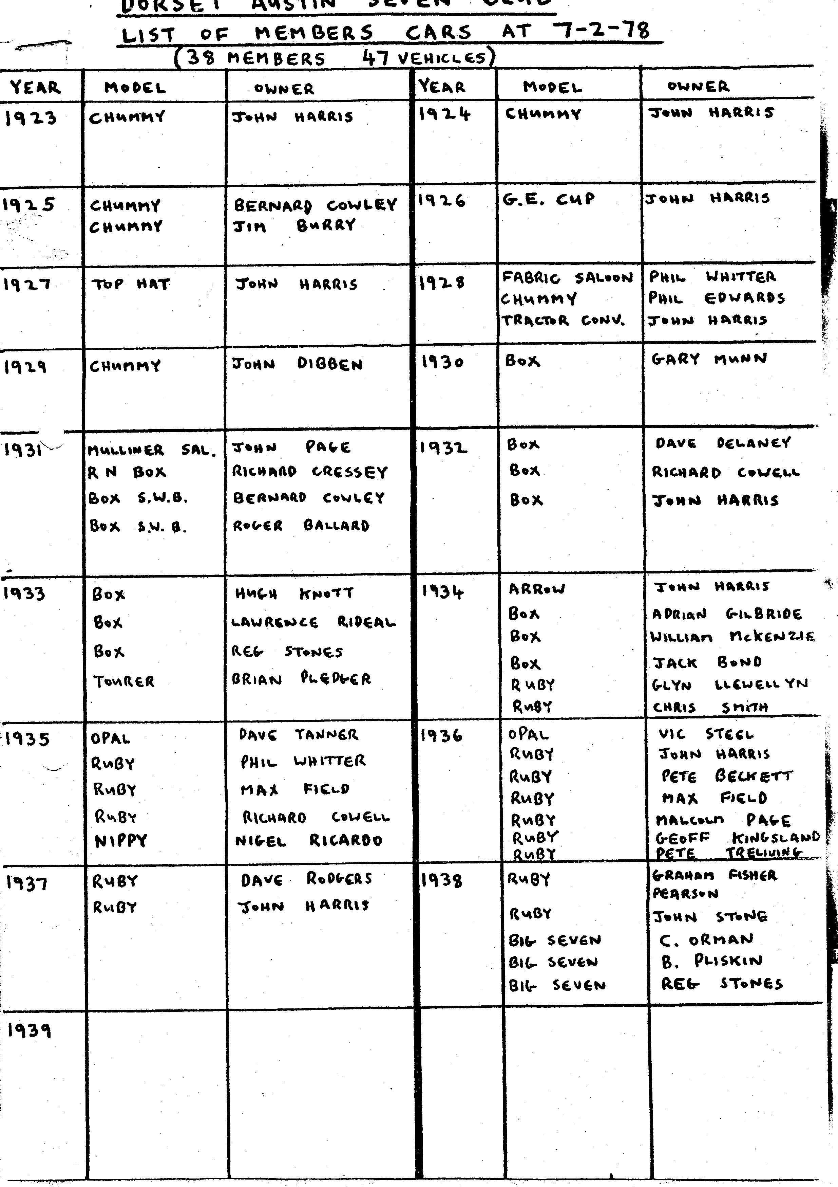

THE first Austin "Sevens" were provided with magneto ignition, a system that prevailed from 1922 to 1928, whereupon it was dropped in favour of coil ignition. Many of these cars are still on the road today and for the benefit of their owners the following information covers this almost obsolete ignition system.
The magneto requires very little attention, the only adjustment necessary being to the gap between the contact breaker points A and B. The correct gap is .010 in. to .012 in. and this should be checked with a feeler gauge.
To do this, first turn the engine by hand until the contacts are seen to be fully opened, i.e., when the fibre heel is at the highest point on the cam then insert the gauge between the contacts. If the gap is correct the gauge should be a sliding fit between them.
Should the gap be incorrect, adjustment can be made by turning the screw B, after releasing the locknut C. Re-tighten the locknut after adjustment has been effected.
Every 6,000 miles remove the contact breaker points and clean them with a petrol moistened cloth. If they are burned or blackened they should be dressed with a fine carborundum stone or emery cloth.
Excessively burned or pitted points, together with a falling off in engine power, usually indicate a faulty condenser; in which case the only remedy is to renew this component. Fortunately, condenser failure is an extremely rare occurrence.
Remove the distributor and clean inside the housing with a cloth soaked in petrol. Similarly wipe the surface of the brush holder, particularly between the safety gap electrodes. Also check that the carbon brush slides freely in its holder.
With an oilcan apply about eight drops of thin oil through the lubricator on the top of the magneto. Finally, a spot of oil should be placed on the pivot bearing of the contact breaker arm. This must be done very carefully, as on no account must any oil be allowed to reach the contact breaker points.
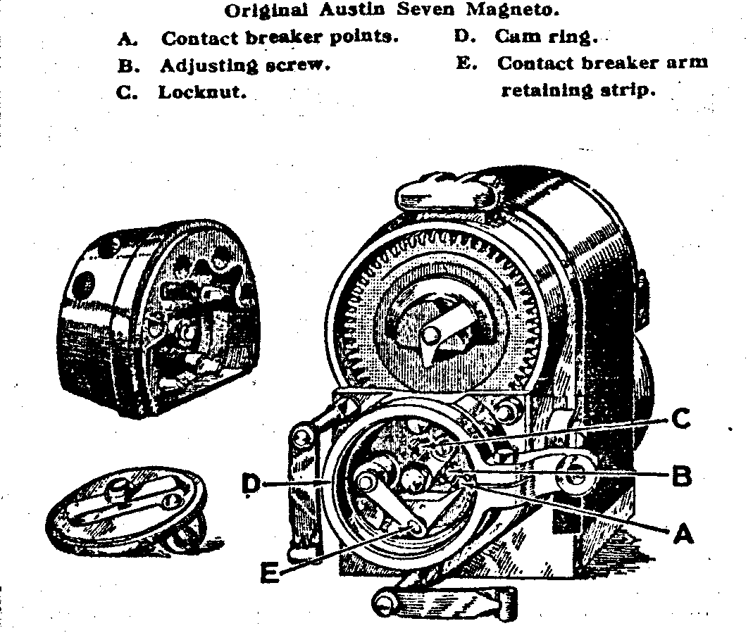
THE

THE pre-war "Nippy" was fitted with a specially tuned engine and made use of a downdraught Zenith Carburettor, model 30 V.E. 1. The usual well-known characteristics of other Zenith instruments in the air bleed and compensating systems were retained. No moving parts were fitted in the carburettor itself, and the maintenance required is simply that of removing the filter and bowl occasionally to clean out any sediment which may have accumulated. Take out the two square-headed bolts which secure the float chamber to the carburettor and remove the float. Do not attempt to pass wire through the jets, which are now exposed in the bottom of the chamber, in order to clean them. This should always be achieved by blowing through them after their removal by means of the float chamber bolt with the squared end.
The standard settings for the instrument are as follows:
Choke Tube .. .. 21
Main jet .. .. 85
Compensating jet .. .. 55
Slow-running jet .. .. 60
Needle seating .. .. 1.5
Capacity tube .. .. 2
Progression jet .. .. 90

The main jet governs maximum power whilst the capacity tube controls acceleration from low speeds and low speed pulling.
Smooth slow running should be obtained with the slow running screw approximately one complete turn open with the engine really hot. Regulate the idling speed by means of the throttle stop screw, which should be turned clockwise to increase the speed.
Bad slow running may be due to air leaks in the induction system, plug points not being set to the correct gap of .015 in. to .018 in., distributor points not in adjustment at .012 in., or valve clearances not at .008 in. inlet and .010 in. exhaust with the engine cold.
These valve settings will give the correct running clearance with the engine hot of .004 in. for both inlet and exhaust.
