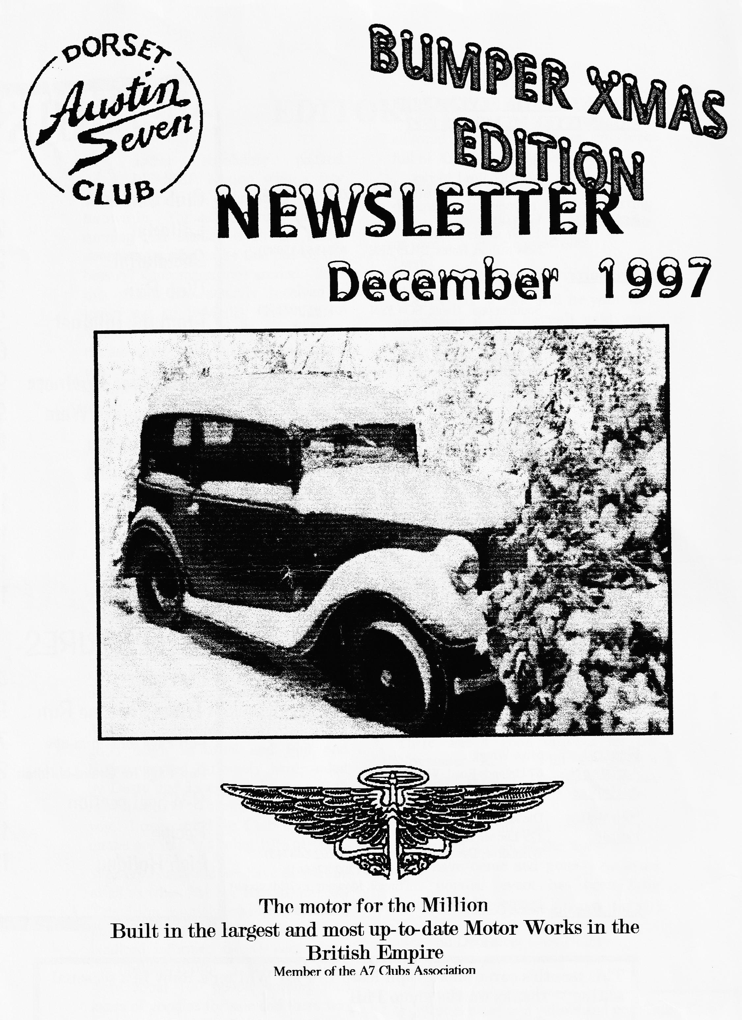

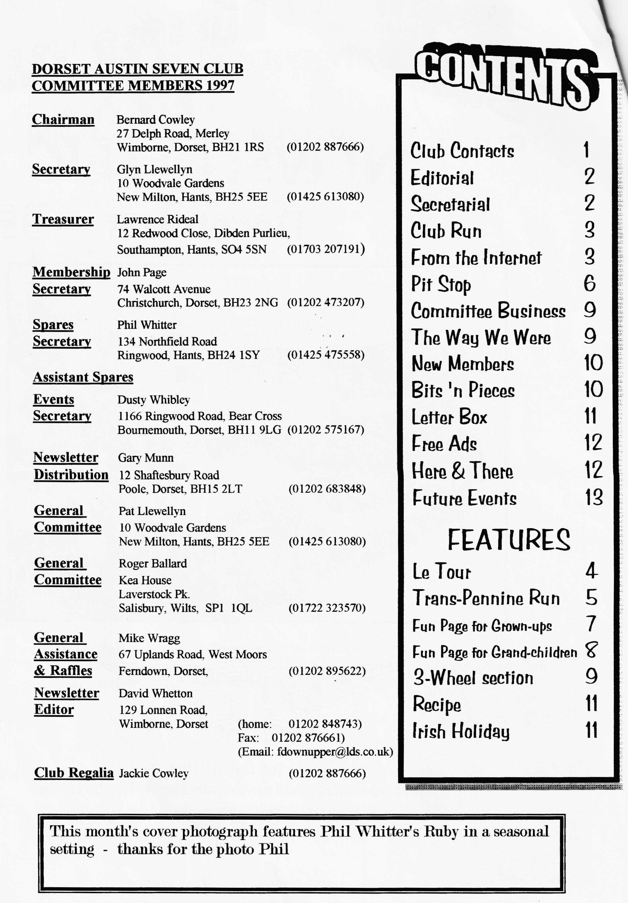

EDITORIAL

A
nother absolutely packed BUMPER edition with a few pages of Christmas cheer thrown in. The summer runs are still running and thanks to all the many contributors who make this one of the best A7 Club magazines around. And this month I've actually received a letter and an E-Mail! Two firsts!! Thanks also to the Burrises who sent me some very good material for future use. Some people know how to make an Editor very happy. Thanks also to Miles who left me, amongst many
editorial goodies, a brown envelope full of Xmas Cracker Jokes.
Incidentally, I've found out the difference between a Pickled Herring and a Soused Herring - Half a bottle of Gin!!! - Have a good one!
David
WARNING - this will be your last newsletter if you haven't paid your subs (£15). Cheques can be posted to John Page or see him at the next Club night. YOU HAVE BEEN WARNED!

Deadline for the next issue is 26/12/97. Please send material to me by post, fax or E-mail or pass it over at Clubnight.
SECRETARIAL

HI, GANG,
November Club Night consisted, as usual, of our annual auction evening. Doesn't it come round quick? It always amazes me the variety of things people bring - from electric trains to Austin 7 wheels, books and even hair dryers - incredible. Everyone had a good laugh as usual and Phil and Hilary worked extremely hard, aided by Dusty and Jane to make sure it all ran smoothly. Thanks to the four of you. I understand the Club made £66 on the evening this being 10% of sales.
We very nearly did not have an auction at all as when Pat & I arrived, the Sky Television people were in the barn bar putting up a large screen and the landlord informed us we could have the upstairs room! I explained there were about 100 people coming plus loads of goodies for sale and there was no way we could all fit in the room
able to get the barn cleaned in time but I said Pat & I would muck in and thankfully he agreed. We got the job done just in time - Phew!
(Thanks are due on all our behalf Ed.)
There was a good turn-out for the November Run - Phil & Hilary's Wiltshire Wander - with 15 Austins attending.
By the time you read this the Club's Christmas dinner at the Tyrrells Ford will have come and gone. As usual this popular event has been fully booked by November.
See you December Club Night
GLYN

A7 members Llewellyns,Tophams & Willbourns have just returned from a 5 day trip to Normandy via Poole-Cherbourg. The Llewellyns in their Fabric A7 & Tophams in their big Alvis, landed onto the Normandy beaches, laying down the necessary smoke screens, allowing the Austin (Healey) & the (don't mention the war) SL a safe landing.
Overnight stops were at the Hotel Du Vieux Chateau at Bricquebec, approximately 25 miles from the ferry. Weather was perfect, excellent motoring down 'car free' country lanes. Both East & West coasts were visited, picnic lunches avec pain et biere/ vin, with evening meals at the hotel. Menus ranged from £8 for 3 courses to £12 for 5 courses. A small amount of wine was also consumed! No breakdowns occurred only minor problems of a loose torque tube plus oil fumes coming up through the floorboards, easily rectified with the aid of plastic bags & bits of rag. Mileage covered approx. 275 miles.
Total cost for the 5-day trip, including ferry, Food etc £180 per person. The Elf company of France have expressed their thanks for the valued custom of the Tophams during their trip. An Internut bvw@msn.com

PHIL'S WILTSHIRE WANDER SUNDAY 23rd NOVEMBER:

T
he meeting place was Ringwood Car Park and Alt and Ivy Edwards, with us, arrived first hoping to find a Car Boot Sale. Last time we had quite a haul of taps and dies and tools, but no luck this time.
At around 10.30am a total of 15 cars had arrived and we headed out of Ringwood, passing the Alice Lisle. Up over the old airfield at Stoney Cross past the Lamb at Nomansland, (no time for a quick one) crossing the A36 Southampton to the Salisbury Road and over a ford making waves like speed boats. At Landford we realised we were entering 'Pickett' territory and sure enough, turning a corner were confronted with a blue Ruby and Reg himself apparently checking Phil's credentials A short chat
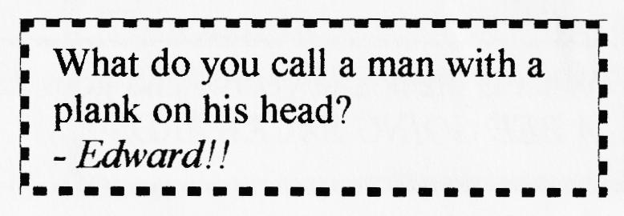
and we went on through Lockersley towards East Dean.
The lunch stop was at the Brewers Arms. They seemed a little overwhelmed by the numbers, but the food was so good it was well worth waiting for. David says it was the best roast beef he has had for a long time. (What does that say for my cooking?) Phil's table was last to be served, so no favouritism there.
After lunch we headed towards Whiteparish and then on to the A36 where, with Lawrence and Alf, we turned for Southampton and the rest towards Salisbury. It was a perfect run, through lovely country with a great lunch stop, and Phil even seemed to arrange for the rain to keep off.
BOBBIE & DAVID BURRIS And thanks to two more new contributors -
well done. - Ed

20th AUGUST – Saintes to Perigieux
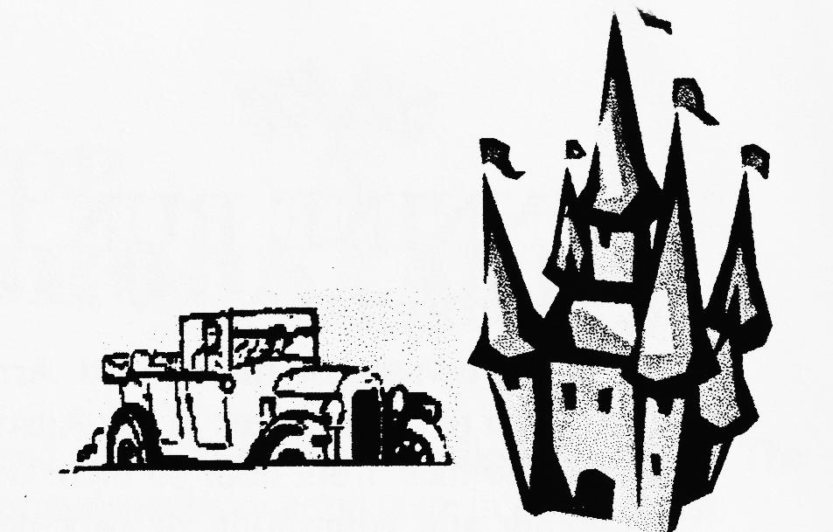
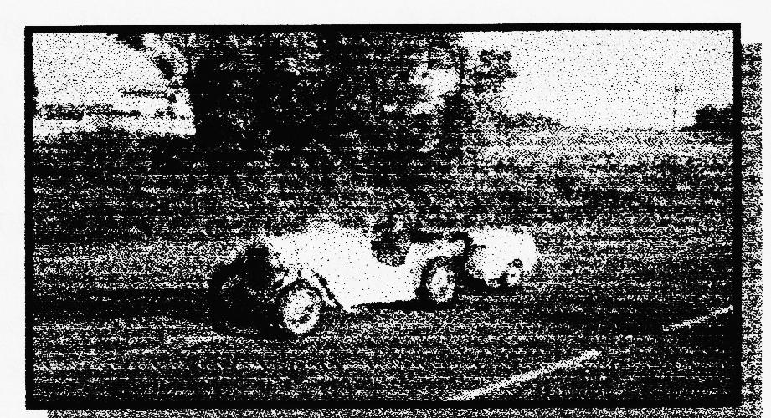
COGNAC by 8.30 am. The trip round the Remy distillery was very well done with the obligatory 'taster' at the end.
The day was hot but the route an attractive wander through villages and farmland but not without incidents - once we ground to a worrying halt, but the problem was soon traced to the electric pump and fixed tout de suit; a young motorcyclist left the road on a bend in front of us performing a graceful triple somersault; and a truck nearly had a collision behind us. Side-shows on the route included an interesting little Auto Museum and a scrapyard. After 132 miles an early night.
kept us down to 25 mph (16 kph) and loosened the remote gear shift again. However, the countryside soon changed to a hilly and twisty challenge between BRASSAC and La SALVETAT where we stopped for lunch in the heart of the old city. The afternoon route cheered up but on arriving at the campsite we immediately decided to look elsewhere. Having found a nice one at MONBLANC, we returned to offer our apologies to the Tacot Club members. It wasn't long before the rest of the Austin campers joined us in our new quarters. This is the southern-most point of the holiday and tomorrow will bring a rest day and a village party!
23rd August Rest Day in Beziers
Rising late we went down to CAP d'AGDE in blistering sunshine but could only survive 45 mins of beach
*r- and sea. A Frenchman explained to his companions that the British drive all this way in old cars just for a few hours on the beach whereas the French just relax and go to the beach. After a good Italian lunch, we went to the GRAND CONQUE and CENTRE POINT to see how the other half lives. Tonight, in the village is the 53rd celebration of the Liberation (is this correct? -Ed) and are we going to party ?!!
To be continued
21st August Perigieux to Montaubau
Today's route included the GRAND ROC cliff houses, lunch at MONTAGNE DE QUERCY with John and Vince, coffee in the medieval village of BELVES with Tony, Iris, Dave, Maggie and Matthew and tea at La FRANCAISE with Ken, Eileen, Graham and Victoria. After a long and very hot 192 miles in which Vince's wobbly wheel returned and the Big Seven got a puncture, we pitched the tent and jumped in the lake ASAP. This is the worst site to date.
22nd August Montauban to Beziers.
A difficult start on roads like corrugated iron which
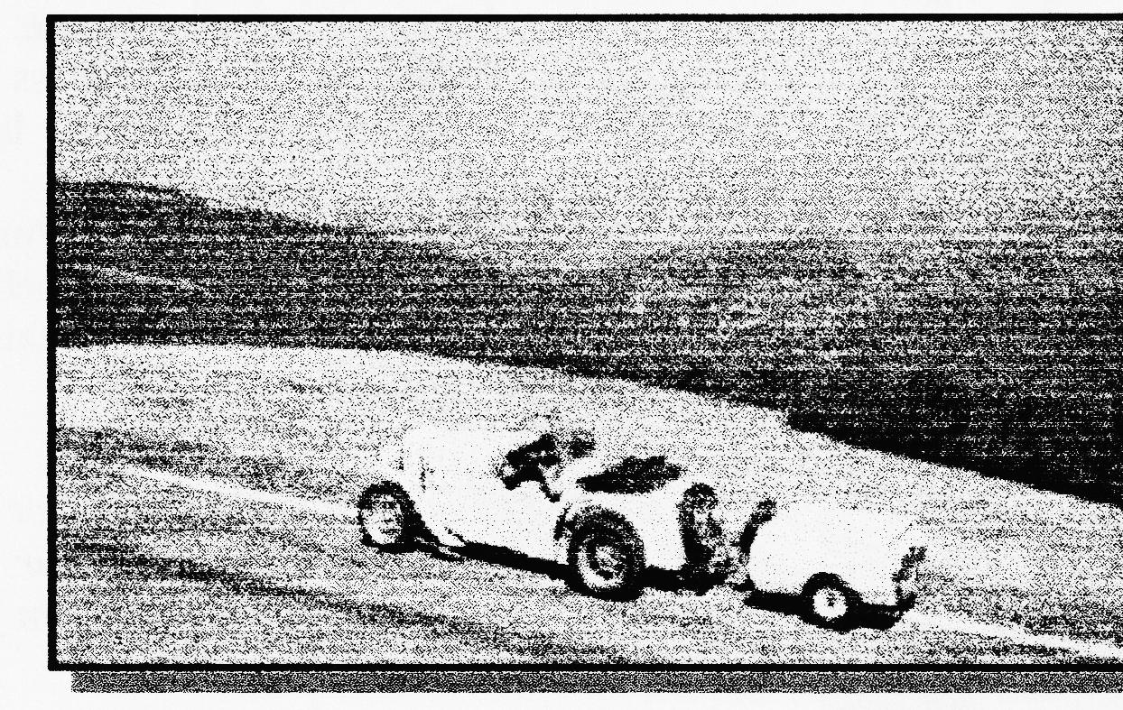

PENNINE RUNN 1997 - Joe & Maggie's Tale DAY 2

S
unday Day 2 The owners of the Moffitt Arms were keen to have photos of the Austins lined up outside their front door so there was much arranging and admiration of cars before we set off for the second part of the run. It was a glorious morning and there was an air of anticipation for more excitement as the cars met up again. We were amazed to see the green Ruby and family as most people thought it would not manage the whole trip. Sunday's run was a mere 139 miles and promised to be less arduous. There were 3 or 4 participants in interesting cars, other than Austins. Sitting comfortably in the back seat of a sleek 1936 Frazer Nash was the owner of the Austin 12 Landau, Mr. Hector Woffinden. He was obviously the navigator, judging by the size of his map. There was a 1936 Riley Lynx, and friends Archie and Brenda Paice, in their BSA Scout Series IV.
It wasn't long before we were on narrow twisty roads again and heading for the North Pennines. The signposts told us we were in an 'Area of Outstanding Natural Beauty' and they didn't exaggerate. We reached the top of a hill and it was 'Gosh', miles of open heather and grass moorlands with a few sheep. Across the wide-open country, we could see our tiny road in the distance, with little ant like Austin 7's climbing an even higher hill before going down a steep incline. We were on our way to Stanhope Ford. We were warned not to attempt the ford if the river was in spate. We felt that a certain member of the Dorset A.7 club would have had a go
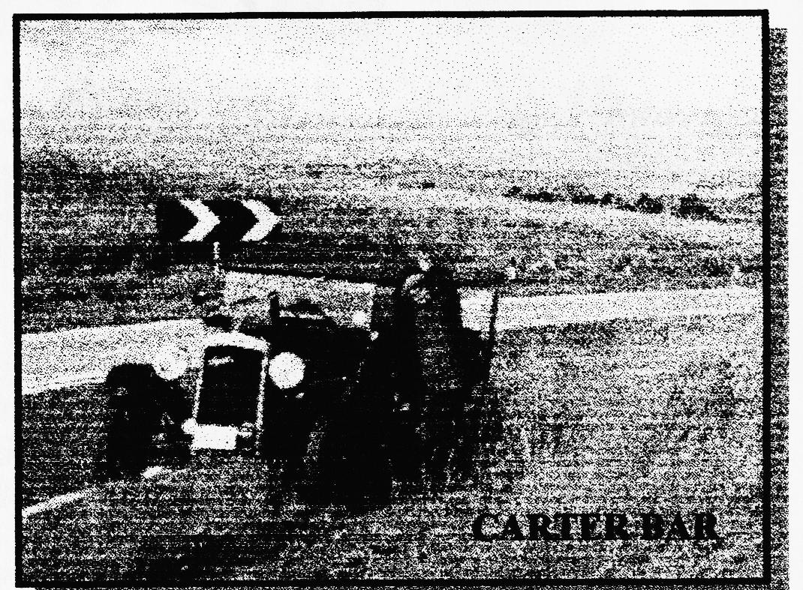
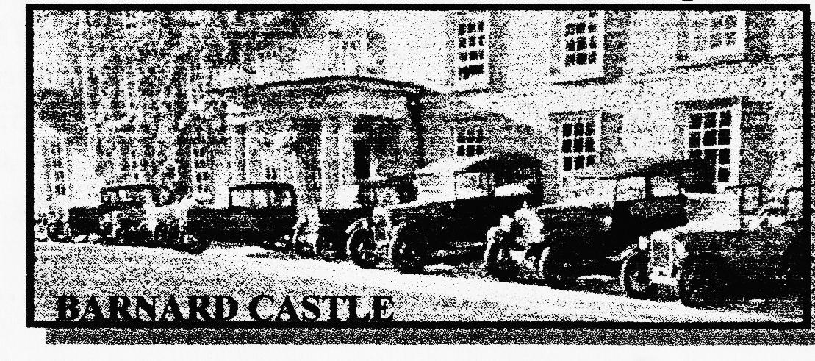
regardless leaving his car not so dusty?
However, when we reached the ford we were all diverted as a bit of road in the middle of the ford seemed to have sunk to unknown depths! We passed the Kilihope Lead Mining Museum and reached Alston, the highest
town in England. Our route then turned North East into Northumberland. The countryside became much more lush and we drove through wooded valleys. A beautiful red squirrel ran across in front of us and shot up a tree. It gave us a real thrill to see it. The village names were fascinating....we were on our way to Wark, via Whygate, (why not?)
We can't enthuse enough about the views and wonderful country which we experienced. It seemed to get better round every bend and over every mountain. Keilder was like summertime in Canada in miniature. After a great drive through Keilder, we arrived back in Scotland. No more dry-stone walls, 'dry stane dykes' here and very plentiful. Our old car had managed well over 550 miles and she really wasn't complaining. She was just slightly louder than she should be, because of the manifold crack. We went through Jedburgh and on to Kelso, with its cobbled streets. Then, over the river Tweed, and, at last, our destination, Mellerstain House, the home of The Earl and Countess of Haddington with about 20 cars already lined up in the grounds.
We are grateful to the Pre-War Austin Seven Club for organising such an excellent Run and showing us how much of Britain is so beautiful and unspoilt.
Maggie & Joe Stalker
(And many thanks to Joe & Maggie for reliving what was obviously a tour to remember. How many Dorsets will join you next year? - Ed)

LEEK WINS AT BROOKLANDS

J
oy & I had the opportunity to go to BROOKLANDS on 9th. November 1997 to the 750 Club Autumn Festival. Neither of us had been to Brooklands before and although the weather was wet and cold it seemed a good opportunity. Setting off at 8 am we arrived around 10.30.
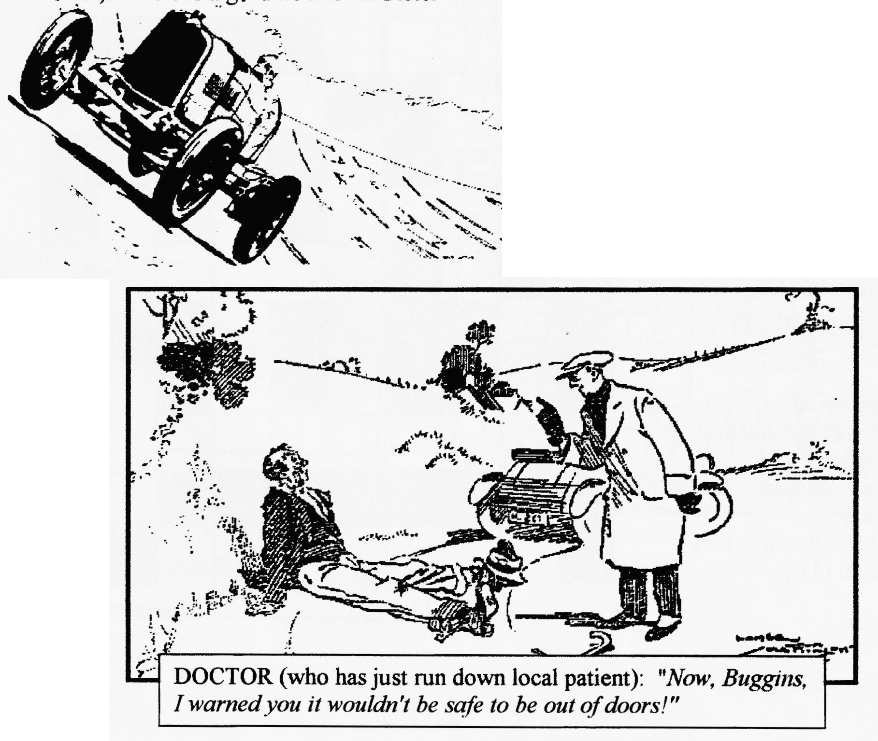
There was a static display Sevens in front of the clubhouse, sprints on part of the old circuit and driving tests near the members bridge on the embankment.
The weather rather spoilt the morning for watching sprint practice so we went in to the various museum exhibits until the weather improved. There really is so much to see! If you have never made the trip I assure you it is well worth while. To my surprise it seems `that, in her...youth, Barbara Cartland was a racing driver, and there is even a room 'dedicated to her' in the clubhouse. (Pink of course) There is a genuine known Ulster
and an A7 Special in an adjoining room. The organisers have good taste in cars at least.
There is also an excellent Aero Museum with the famous R for Roger Lancaster now largely restored. This is the one they fished out of a Scottish Loch. There is a huge Stratosphere Chamber used by Barnes Wallace and various of his bouncing and other bombs.
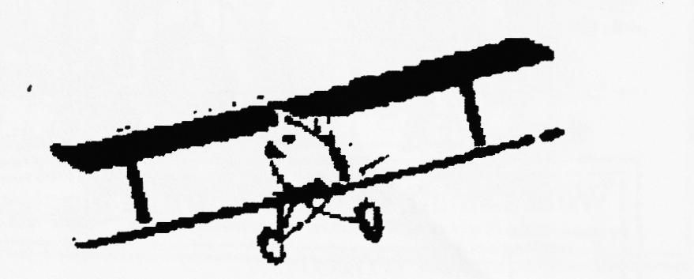
The weather improved about midday, and we were delighted to see VINCE LEEK trounce the competition with his famous "Mouse" Racer taking a well-deserved class win. He was, in fact, much quicker than many larger cars!
We enjoyed an excellent day out - an event not to miss in '98. They even let Joy and I in as Senior Citizens!!
George Mooney Thanks, George, for sharing another good :day out Sevening. I was sorry to have missed _it!! -Ed

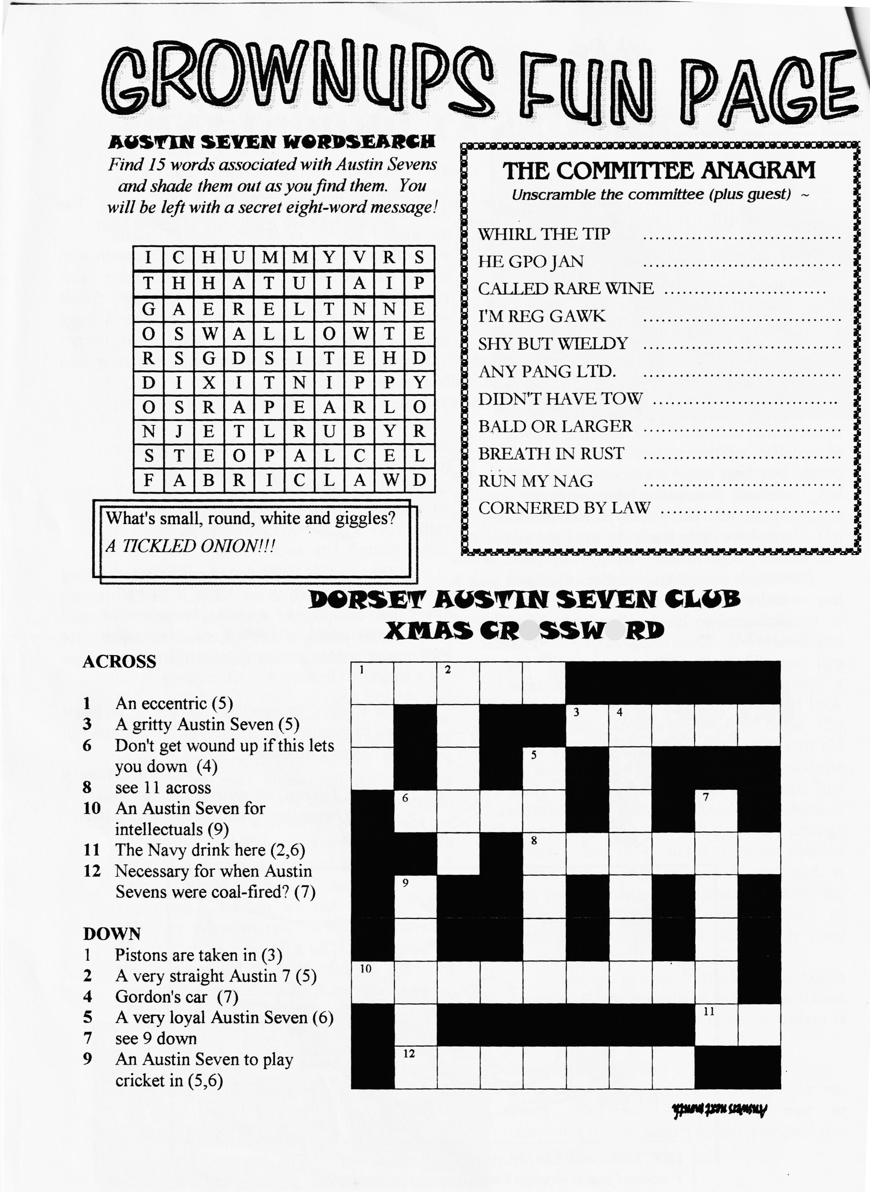

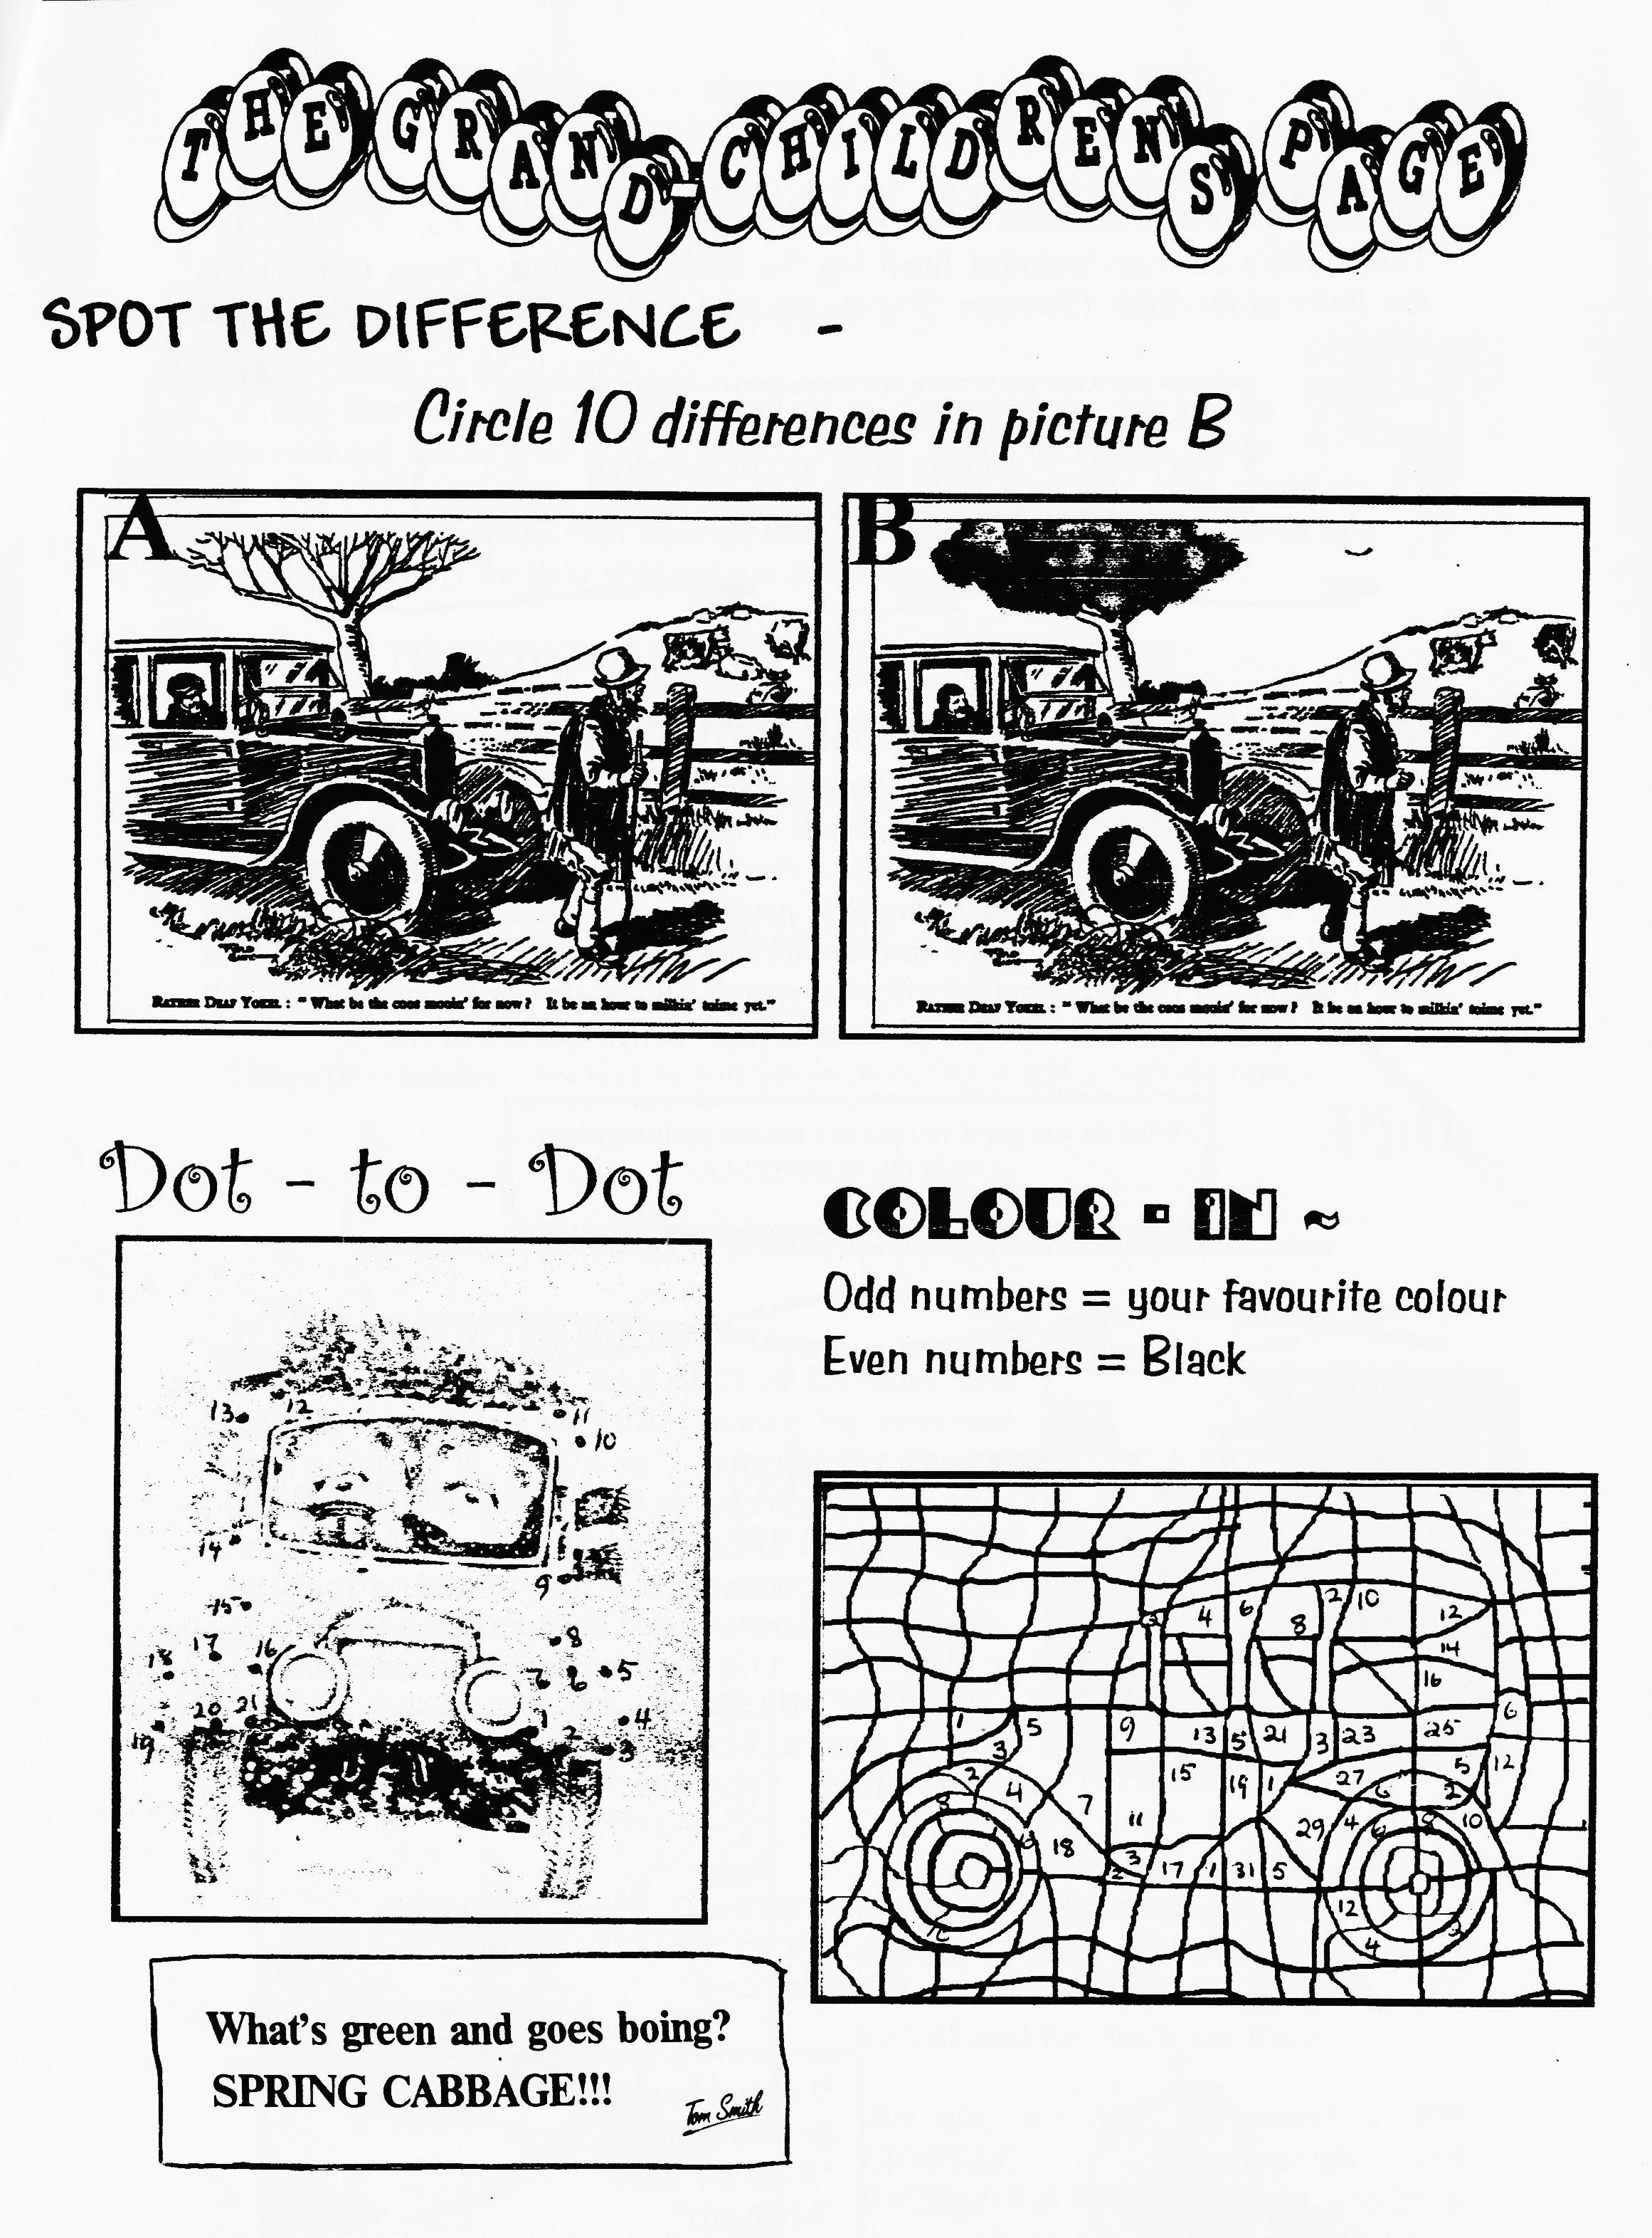

COMITTEE BUSINESS
This month's business included finalising the Bash-of-the-Year (Xmas Dinner) and the Rally-of-the-Year (Swanage '98) as well as the usual review of the spares situation.
What do you call a mushroom who buys you a drink at a party? - A pretty good sort of fun-guy!!
DA7C THREE-WHEELER SECTION
founder members - Gary & Suzie Fatt and Vince & John (en France).
It is quite a coincidence that Ken Medlicott is turning his attention to 3-wheelers as some of you will have heard me express a desire to own a Morgan Three Wheeler. Recently I joined the club and in my first newsletter Ken was welcomed as a new member! My interest is only in a fast and furious JAP-engined special rather than a fully restored car (which I couldn't afford anyway!). So, if anyone has got an ohv JAP V-twin languishing in your shed - give me a ring. PHIL (01425 475558)
What do you get if you put two banana peels together? A PAIR OF SLIPPERS!!!
THE WAY WE WERE - a blast from the past
From the Club magazine for DECEMBER 1976
"First on the agenda was to choose the Club badge.
Type B was chosen after a lot of discussion on the
merits of the other 14. At the December meeting we
will have a TABLE TOP CONCOURSE - any part of any
car presented in an immaculate. condition. This
month's Newsletter includes "How to set up a front axle" and "How to remove a Ruby gearbox".
WANTED:
Very urgent-'30/31 headlights G Munn Ferndown. Pair front seat squabs & rad grille sides for '36 Ruby. - P Whitter Broadstone"
"I would be a great dancer if it wasn't for two things"
"What are they?"
"My feet! !"

BITS 'N PIECES - an occasional focus on SPARES
USED SPARES UP-DATE
NEW USED PURCHASES
Willie, Bernard and myself travelled to Somerset to buy some secondhand spares from Ken Medlicott who is giving up Austin Seven trading. We only picked out items that we thought would be most useful to Club Members. They will be kept separate from other Club Spares and will be on sale to Members only for their personal use at the January Club night.
A GUIDE TO SECONDHAND PRICES AT AUTOJUMBLES
ENGINE PARTS: GEARBOXES:
Heads (18mm) £5 - £15 (14mm) £10 - £20 3-speed (minus lever/gate) £15 - £25
Block £14 - £40 3-speed (complete) £30 - £45
Crankcases (broken lip) £15 - £25 (perfect) £20 - £30 4-speed £10 - £20
Crankshaft £10 - £25 REAR AXLES:
Flywheel + clutch £5 - £20 Early banjos £50 - £150
Conrods £1 - ' D-type £40 - £100
Dynamos (early) £15 - £40 (coil engine) £10 - £30 Hubs £4 - £10
WHEELS: Brake drums £2 - £7
Closed centre £10 - £20 Open centre £5 - £15
I hope this reassures you that Austin Seven motoring is still a realistic hobby.
Phil
NEW MEMBERS
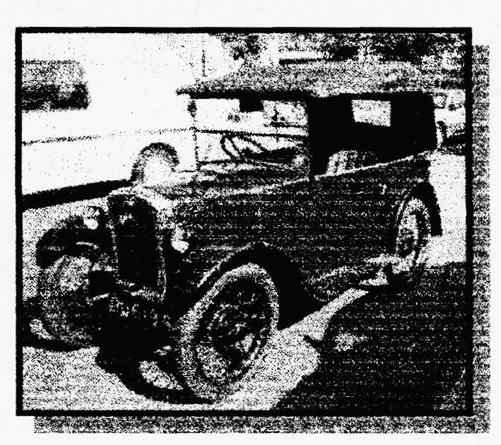
Welcome to Mrs ANN HARRIES of Salisbury who not only has a bright red 1930 Chummy but even sent me a picture of it. Well done - now there's a trend to set for new members!! Ann reports :"it is used regularly, the body could be worse but the all original interior is dreadful.". I understand this car was originally owned by Miss Dinah Parris whose father owned and raced "Slippery Ann".
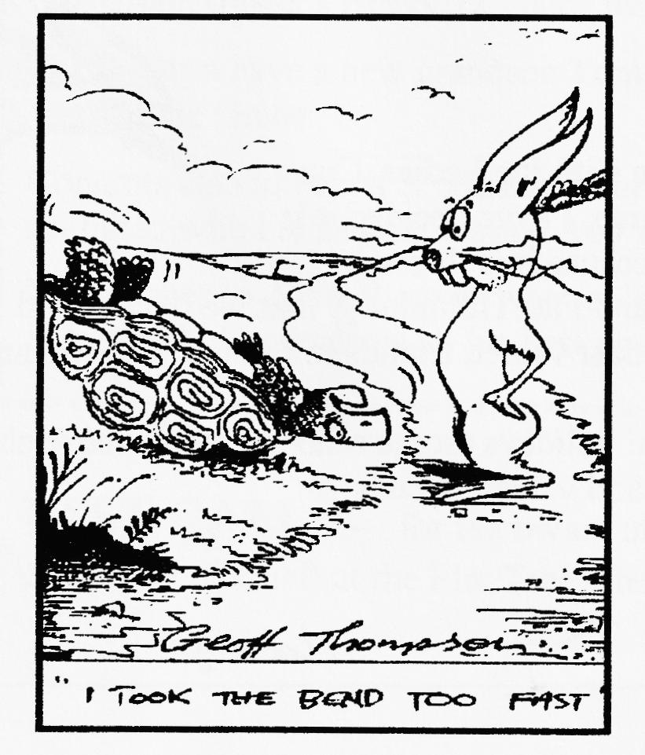
And no less of a warm welcome to PETER TRELIVING of Holt who was a member 15 years ago. Peter has 3 sevens - a 1927 Chummy, a '34 Box and a '35 Special used for classic car trials.
We also welcome this month JOHN LIDDELL of Bournemouth and RICHARD BISHOP of Exeter who has a
'35 Ruby Saloon DeLuxe.

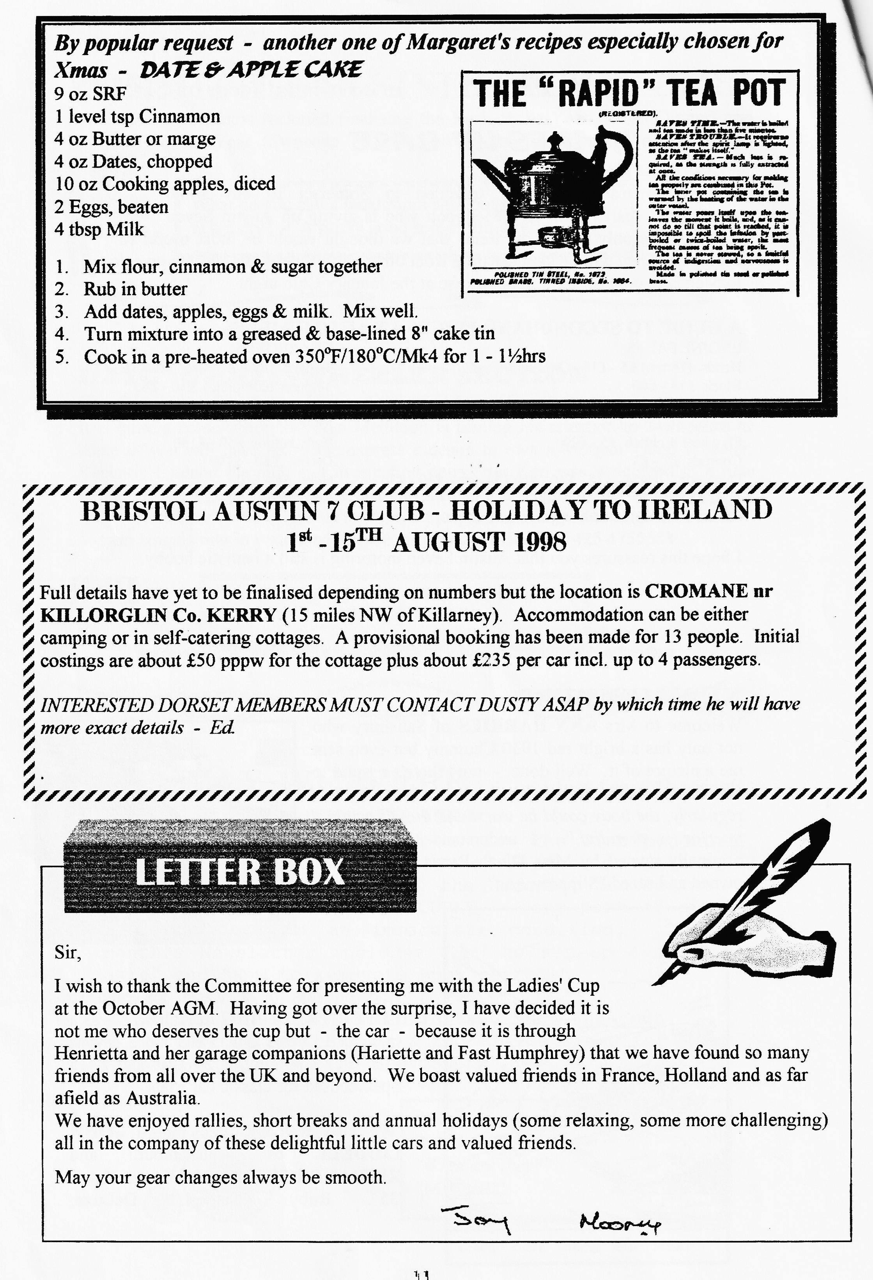

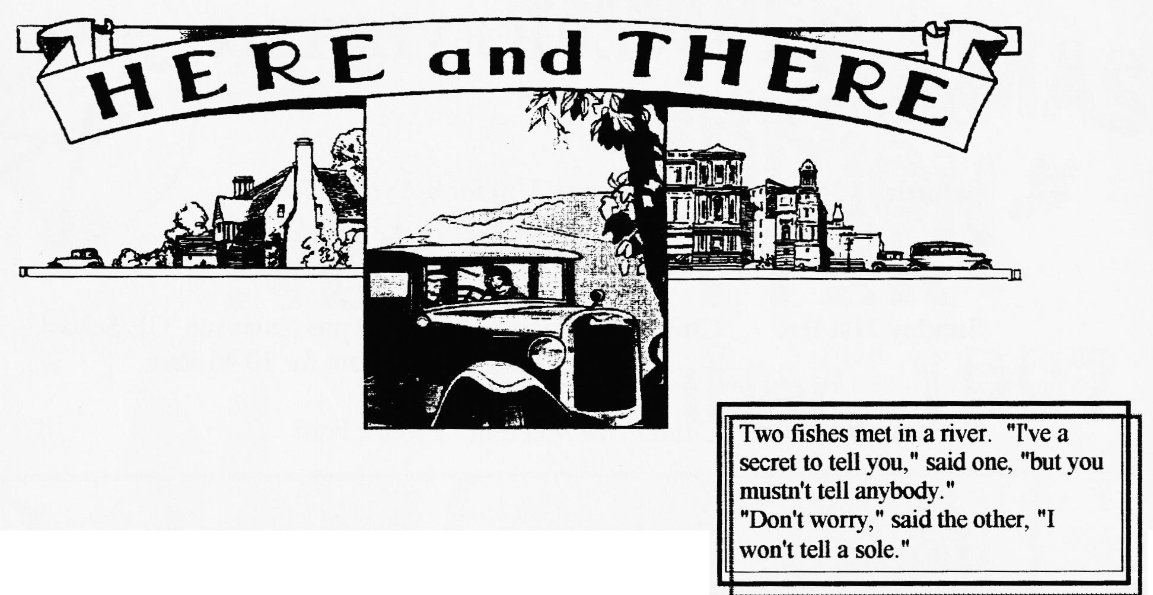
FOR SALE

GENUINE RETIREMENT SALE: All my large collection of 7 spares together with pre-war, '50s/70s automobilia incl. Instruments, chrome headlamps, spot lamps, mascots, badges, car clocks, motor/motorcycle books & mags, mechanics and specialist engineering tools etc. etc. to be sold in lots from £25 upwards. Also ali-bodied "Speedex" road/race special fitted with reliant OHV engine and gearbox, hydraulics, needs finishing but comes with 3 spare engines, 2 spare gearboxes and a spare back axle. All for £950! ! Ken Medlicott (01963) 440604 (T) 9.30am - 7pm; viewing by appointment only.

WANTED
An "ELTOS" alloy remote gear change for a 4-speed A7 gearbox. I am looking for one for my Ulster Special project and will buy or exchange for virtually anything A7. as this man desperate? Ed.) Phil Whitter- (01425) 475558
CLUB FAMILY NEWS
Congrats to Gary & Suzie Fatt who were married at Canford Church - the wedding car was Brian Tolster's Heavy 12. Nice touch!
Pat & Glyn have a new grandson Tom and Bernard & Jackie have a new granddaughter Evangeline Grace.
Congrats also to Mark & Mandy Whibley on their marriage and to Dad Dusty on being re-united with his 28-year owned A60 van - still with original gingham curtains.
Best wishes to John Weaver who is slowly but surely on the mend after an unplanned stay in hospital. He sends us all his best wishes for Christmas and the New Year. See you soon.
LAST CALL - for the owner of a very nice fawn ³/4 length gabardine coat with corduroy collar left at the Elm Tree after the AGM - contact Phil Whitter.

oo CLUB EVENTS oo
December
Saturday 13th Dec. Xmas Dinner 7.30 for 8, Tyrell's Ford
Thursday 18th Dec. Club Night. Pre-Xmas Noggin 'n Natter
Sunday 21st Dec. Club Run. Gary's short local pre-Xmas run. QE School, Wimborne 10.30am for 10.45 start.
Tuesday 30th Dec. Committee Meeting. Tyrell's Ford
January
January 1st 1998 Glyn's New Year's Day Run and Treasure Runt. Cat & Fiddle, Hinton on the A35. 10.30am for 10.45.
Thursday 8th Jan 8 till late - Old Thatch, Uddens/Stapehill near Ferndown
Thursday 15th Jan Club Night - Grand Spares Sale FOR MEMBERS ONLY FOR THEIR PERSONAL USE. (see article in this edition)
Sunday 18th Jan Club Run - details next month.
Thursday 22nd Jan. Committee Meeting. Tyrell's Ford
Oo FUTURE EVENTS oO
Saturday 14th February St Valentine's Dance. Reply-slip with this edition
Thursday 19th February Club Night - Antique Weapons
Saturday 28th March Skittles, Monmouth Ash

