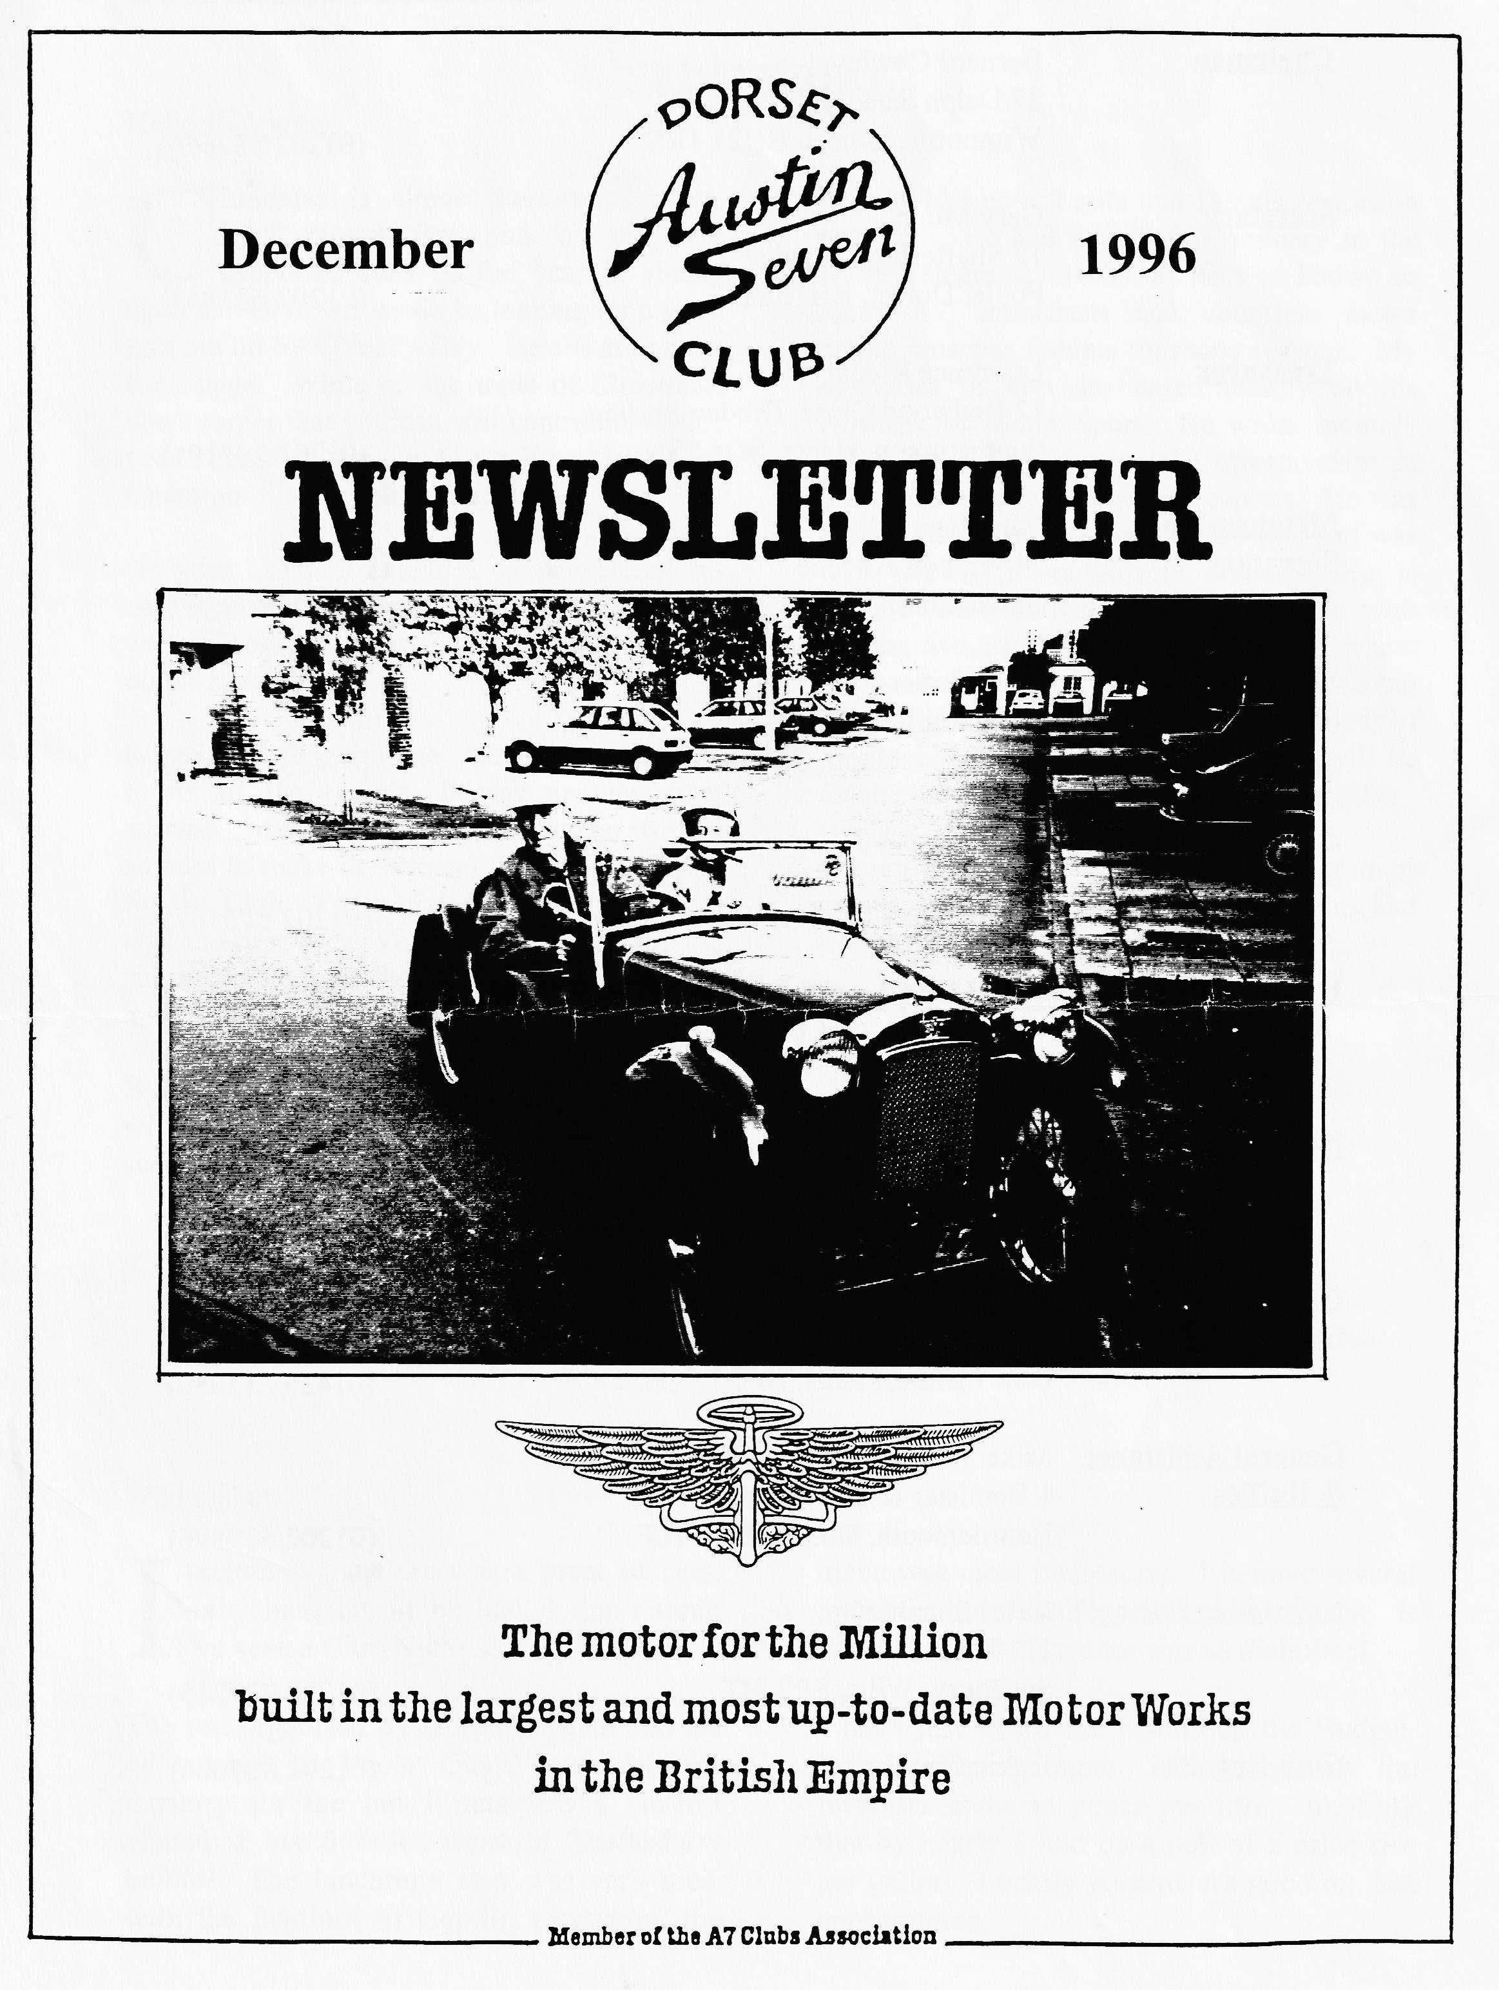

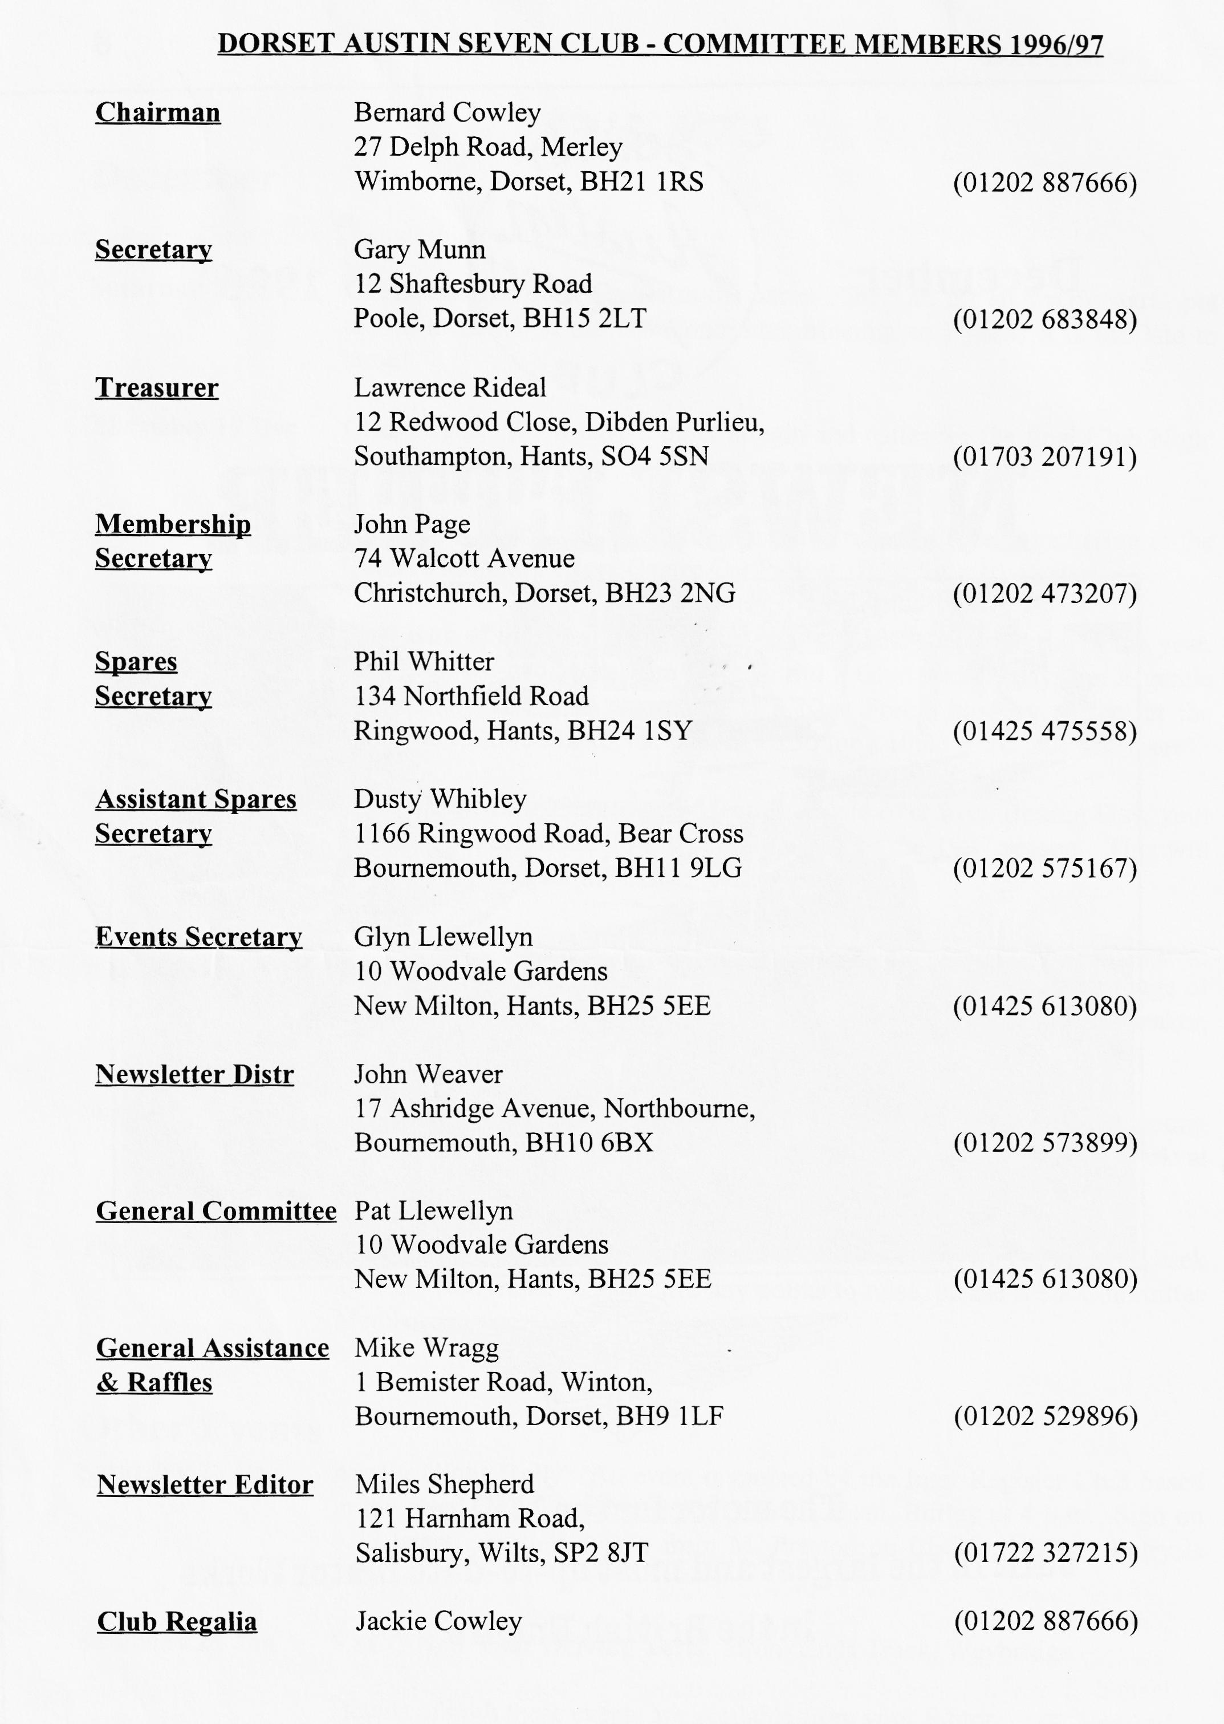

EDITORIAL
Hallo Everyone,
On a sadder note, I note that Dennis Jenkinson has died. He had a very full obituary in the Daily Telegraph. Jenks, as he was known to many A7 enthusiasts and countless motor racing fans was famous for many reasons. My memories of him are based mainly on his writings for Motor Sport. He wrote monthly letters from the Continental Correspondent as well as his regular Grand Prix reports. He was also a founder member of the 750 MC and was well known in motorcycle circles. He is perhaps best known for his exploits with Stirling Moss in the 1954 Mille Miglia where the, pace notes system he developed enabled them to average 97.95 mph, touching speeds of 170 mph! A real motoring hero who will be much missed by a wide variety of enthusiasts.
We are giving away a free Austin Seven this month - a sort of combined loyalty bonus and Christmas present! See page 6.
BFN, Miles
C
hristmas is almost here once more. That means that one of the best supported runs of the year is almost upon us. Glyn will again be looking for a good turn out on New Year's Day. Details are on the back page. While on the topic of Christmas, don't forget that you can still contribute to this year's charity. See any Committee Member at Clubnight if you wish to support the cause.
On your behalf, I extend a warm welcome to new members J Stormont and B Hughes, I hope we will see you all at Club Night and perhaps on the runs too.
I managed to miss the Auction last month. From all the reports, it was another great success. Many thanks to all those who worked so hard to make the evening fun and profitable for the Club. I also understand that the raffle was the best ever, Very Many Thanks for the support both from those who presented prizes and those who bought the tickets.
By the time you read this, the Christmas Dinner will be but pleasant memory. I look forward to seeing you there!
SECRETARIAL

Well Folks!
I
reckon the auction was a great success. Many bargains to be had, I don't think
I've seen a Club Night so busy before.
The run organised by Hon Chairman and his wife went to Poole Quay, very familiar territory for me but I must say I haven't visited it via 6 miles short of Shaftesbury before! The lunchtime stop was very nice, with the landlord of Cypriot extraction, the
menu was most interesting. I believe several members did venture down to the Quay. It was a shame the weather was so diabolical.
I have just heard the results of the Budget. Petrol prices up again, it's funny how the increases come in pence per litre; multiply that by nearly 5 and its a hell of a price rise per gallon. Luckily Austins are good on fuel consumption.

There has been mentioned recently a possibility of two Club Holidays next year. Firstly, an Easter trip to France. Further details and response to John Page. Secondly a trip to Holland in the second week of June. I believe an article on this last will shortly
appear but please register your interest with Glyn Llewellyn.
Well, it comes around seemingly faster every year, Christmas, on behalf of the Committee, have a very merry one and a prosperous New Year.
Cheers- Gary

CLUB RUN TO THE WILTON CARPET FACTORY
T
he day started dry and clear, typical autumn weather, we arrived early for a change, only two other cars, both Solent members in a Pearl and a Ruby. We wondered how many would come!
Shortly, they all started to arrive and we eventually had 13 cars, including a fine and very large Ford, Model A (?) belonging to one of our newer members. I trust he forgives no name mention but the write up was dropped on me at lunch time by Glyn, thanks! As a result, no notes were made. It is all down to poor memory! groan.
Well, we set off at a good pace and off we went across the forest staying well away from any form of 'A' road except perhaps where we crossed them.
Every time I go out on a Club Run, I marvel at the number of new roads we seem to manage to travel along. The run was magnificent, still a great deal of green but strong autumn colours showing through and so many people out enjoying the New Forest in autumn, walking, cycling, out on horses and of course, like us, in our cars. The joy of England in all seasons.
Our run went through village after pretty village and even along the river for 30 or 40 yards, most of us enjoyed that, John Page smiled because everybody thought he had taken a wrong turn.
It is always a risk with a big group that somebody will get lost but we got away with it and even though we went on many attractive though unfamiliar roads to the east of Salisbury, we all managed to get to the excellent lunch stop at the Wheatsheaf at Lower Woodfalls.
The food was excellent, and very good value, I found the service to be fast and friendly, a good place to visit any time you are in the area.
The weather did deteriorate en route to Woodfalls and we left for Wilton in the rain which was quite heavy after lunch.
A short run to Wilton led by John and Cynthia in the Box soon had us in the factory car park.
The Wilton factory is an historic site steeped in tradition with a worldwide reputation that the American group who bought them clearly didn't care about when they cynically took the name and everything they wanted, then closed the whole unit.

The pioneering spirit and sense of tradition was however strong in the management team who purchased the machinery and leased the site, reopening 11 days after shut down. The unit is operating now at a profit, it would appear, because they have now purchased the site and the work force once more exceeds 100.
There is a tour guide to take you round the site, through the museum and to explain the intricacies of the production. Our guide on the day was absolutely superb and she made our visit most enjoyable and rewarding.
many of the Wilton machines are still in full production even though they were built in 1923 and 1926. There are of course modern aids on the machines, but the working parts are from all those years ago.
Until the visit, I had no idea of the difference in manufacture and that Wilton and Axminster are more than just two famous names! Wilton is woven and the pile is cut from the loops. Axminster is made from short cut lengths sort of plugged into the backing.
If you saw the work that goes into making these fine carpets, you would find it harder to complain about the price, I certainly will.
During the visit we discovered that the machine which was developed to shave the wool strands to the same length for that immaculate finish, led on to the development by a textile engineer of a rotary cutter for grass, which led onto the modern cylinder lawn mower. The engineer sold is idea to Ransommes at around the turn of the century.
There is a factory shop and a clothing shop where you can unload your wallet and the whole site is excellent, with great plans for more shops.
After the visit, we enjoyed a cup of tea in the cafe before departing for home.
A point of special note was the rather pleasant surprise of the first run out for Glyn and Pat in the newly completed restoration of his 1930 (I think) fabric bodied Top hat saloon. I saw it before he started. Ouch, what a job.
We all seemed to enjoy the day, Joy and I certainly want to thank John and Cynthia for a really interesting and fun day out.
We look forward to the next one. George and Joy

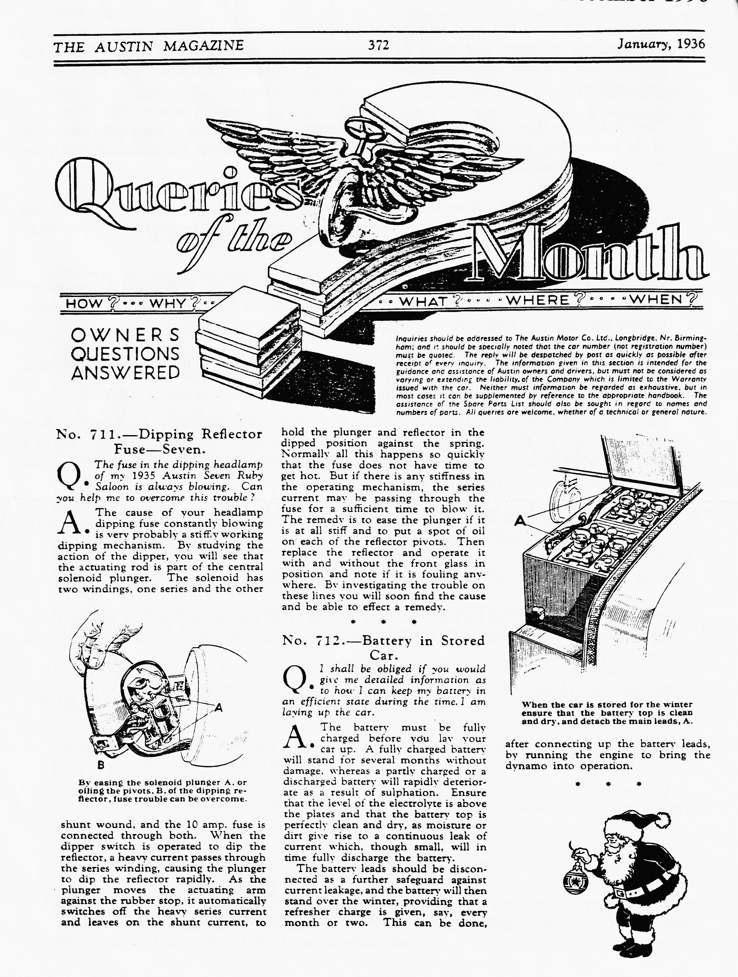

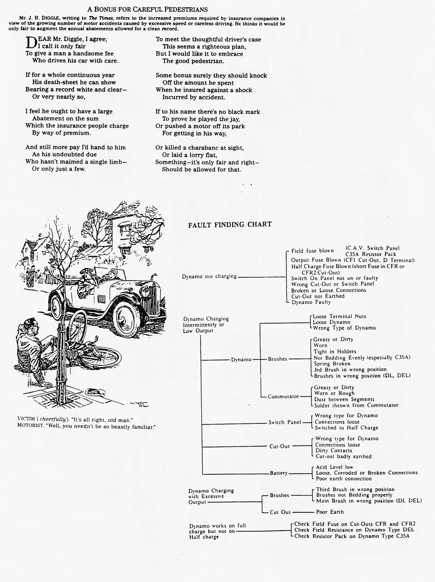

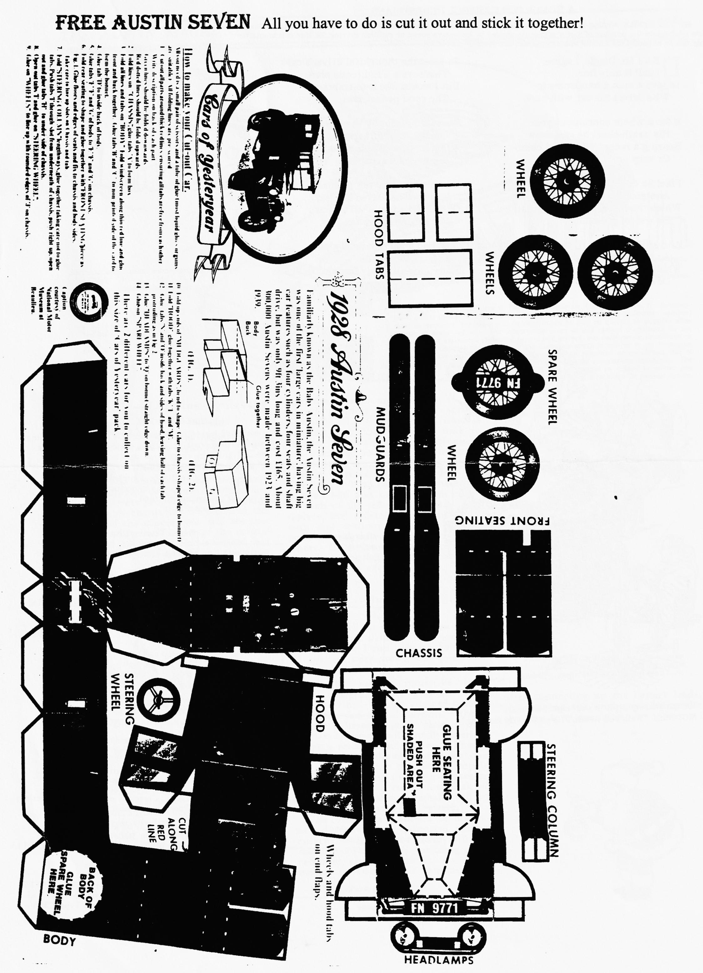

For Sale
1928 Fabric Saloon. Completely renovated and re-trimmed. Brown and Black, MoT and Tax, £6,000.
ALSO
1934 Austin Seven Van. New body, nice condition with MoT and tax. Telephone 01425 613080 (New Milton)
Early Notice
Friday 14th February, DA7C St Valentines 50s and 60s Evening. With Bernies Roadshow Disco (No relation to the Main Man!) Optional fancy dress, Bar with Ringwood Ale, Raffle, American Supper. All this fun for only £3:50 per person. Entry forms later. See Dusty for further details. To be held at Pamphill Village Hall, near Wimborne.
Even Earlier Notice
Thoughts of an Easter trip to France are being considered by a few Club members. If you are interested in such a trip, which would consist of one night on the ferry Poole - Cherbourg and then some 60 ish miles into France to spend four nights B&B, probably with Brittany Ferries, please contact John Page.

EVENTS
December
Saturday 14 Dec Christmas Dinner. Gather in the bar at 7.30 p.m. for an 8 p.m. start. pat
closed the book at the last Committee Meeting so I guess it is too late to book!
Thursday 19 Dec Club Night. We'll have a quiet noggin and natter for the final Club Night
of 1996.
Sunday 22 Dec Club Run. Gary will be leading our final run of the year, gathering at the
Queen Elisabeth Leisure Centre Car Park at 10:30 for a 10:45 start.
Wednesday 1 Jan First Run of the Year! This is just about he best supported run of the year. Last time we had more than 30 cars out. Glyn usually lays on a gentle scatter rally/treasure hunt ending at a New Forest hostelry. Meet at the Ringwood Cattle Market car park at 10.30 for a 10:45 start. See you there!
Thursday 2 Jan Eight-ish till Late/Committee Meeting. Held over from Boxing Day, your
committee meet at the Tyrell's Ford to ponder the 1997 season. This will also be the venue for the early monthly gathering!
Thursday 16 Jan Clubnight. Gather at the Elm tree, as usual. Tonight we have a speaker,
kindly arranged by Bernard. The topic will be of interest to a wide range of members and covers the early days of the Motor Industry. The speaker,
Eric Johnson was head of PR for Mercedes Benz UK.
Sunday 19 Jan Club Run. Details had not been finalised at the last Committee Meeting
but assemble as usual at the Queen Elisabeth Leisure Centre Car Park at 10:30 for a 10:45 start. Details will be forthcoming at Club Night.
Thursday 23 Jan Committee Meeting. At the Tyrell's Ford, assuming we are allowed back
after the festivities! If you have any points to raise, please see a Committee Member.
Other Events
Saturday 28 Dec Austin Night Rally. An event organised by the Inter Register Club based
in the New Forest, starting at the Queen's Head, Burley at 4 p.m. Sign on 3.45 latest. Further details from M. Preston on 01425 618286. Entry is only £4.
Saturday 25 Jan VSCC New Year Driving Tests. Brooklands Track, Weybridge
Details of both these events are available from your Editor.

