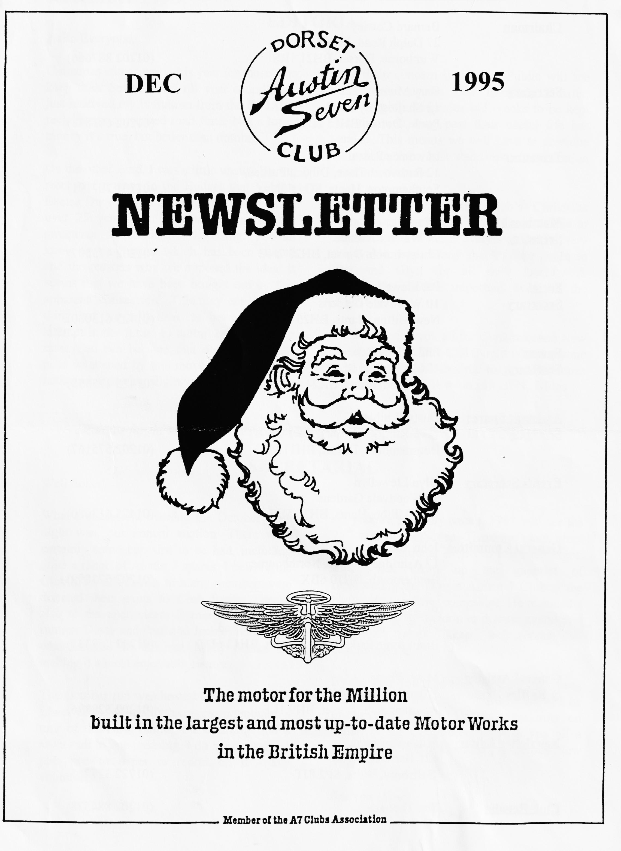

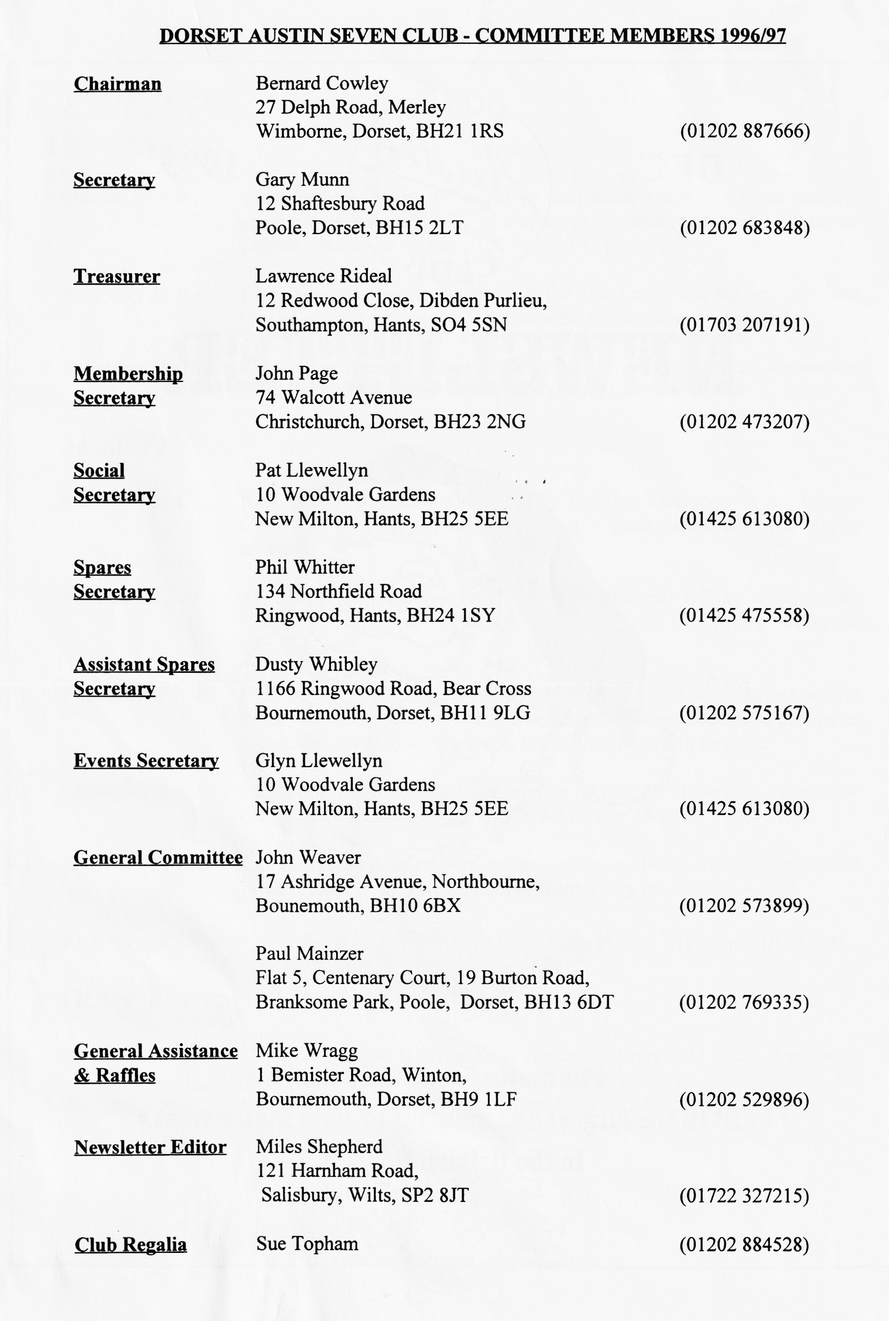

EDITORIAL
Hallo Everyone,
My main concern is that Joe Public will see this move as an Old Banger's Charter, encouraging dangerous old crocks to be kept on the road long past their useful life has ended. This means we will have to continue to maintain the best standards of preparation and maintenance.
On a lighter note, the Club's Christmas Dinner has passed off; sadly I was unable to attend but I'm sure everyone had a very enjoyable time. Many thanks once more to Pat and Glyn for all their hard work organising another important event in the Club Calendar.
Best wishes to you all for Christmas and New Year. See you all at Club Night where anyone who missed contributing to our Christmas Charity will be able to do so! BFN, Miles
Christmas comes early this year for those who keep their Seven taxed all year round! I've just received my invitation from the DVLC to reclaim my unexpired road fund. Not a lot of money it's true, but better than nothing.
On the other hand, I was a little unsure how to react to the news in the Budget that Vehicle Excise Duty was to be abolished for vehicles over 25 years old. This is, of course, the sweetener for continuous licensing. You all know the campaign which has been waged and the reasons why we opposed the idea. It seems that we have been bought out by this apparent 'concession'. This may not be a bad thing but we will have to beware of any attempt in the future to curtail our use of our cars. You can be sure that our position has been weakened by this move, even if it does make our motoring slightly cheaper..
SECRETARIAL

Well Folks!
What a successful evening the October Club night was, our annual auction. There were certainly some bargains to be had, including quite a range of Austin 7 spares. I believe the Club did well, thanks to many members who donated their gains to Club funds. Thanks also to the auctioneers Bernie and Phil, the runners Dusty and Paul and Jackie and Hillary who labelled all the lots. Many thanks for making it a most enjoyable evening.
The October run was hosted by Pat and Glyn Llewellyn. Certainly very cosmopolitan; a tour of the New Forest, the coastline and a town - all in one morning. I do hope someone puts pen to paper to report on it - any volunteers?
As you are probably aware, 1997 will see the 25th year of the Seven. There are plans afoot for several national events to mark the event. Miles has taken up the gauntlet of representing the Dorset Austin 7 Club at the National organising committee. He attended a meeting held at Gaydon to discuss events and will no doubt keep us abreast of developments.
By the time you read this, the Club Christmas dinner will be over and the festivities will be in full swing. May I take this opportunity, on behalf of the Committee, to wish you all a very good Christmas and a prosperous New Year!
See you - Gary

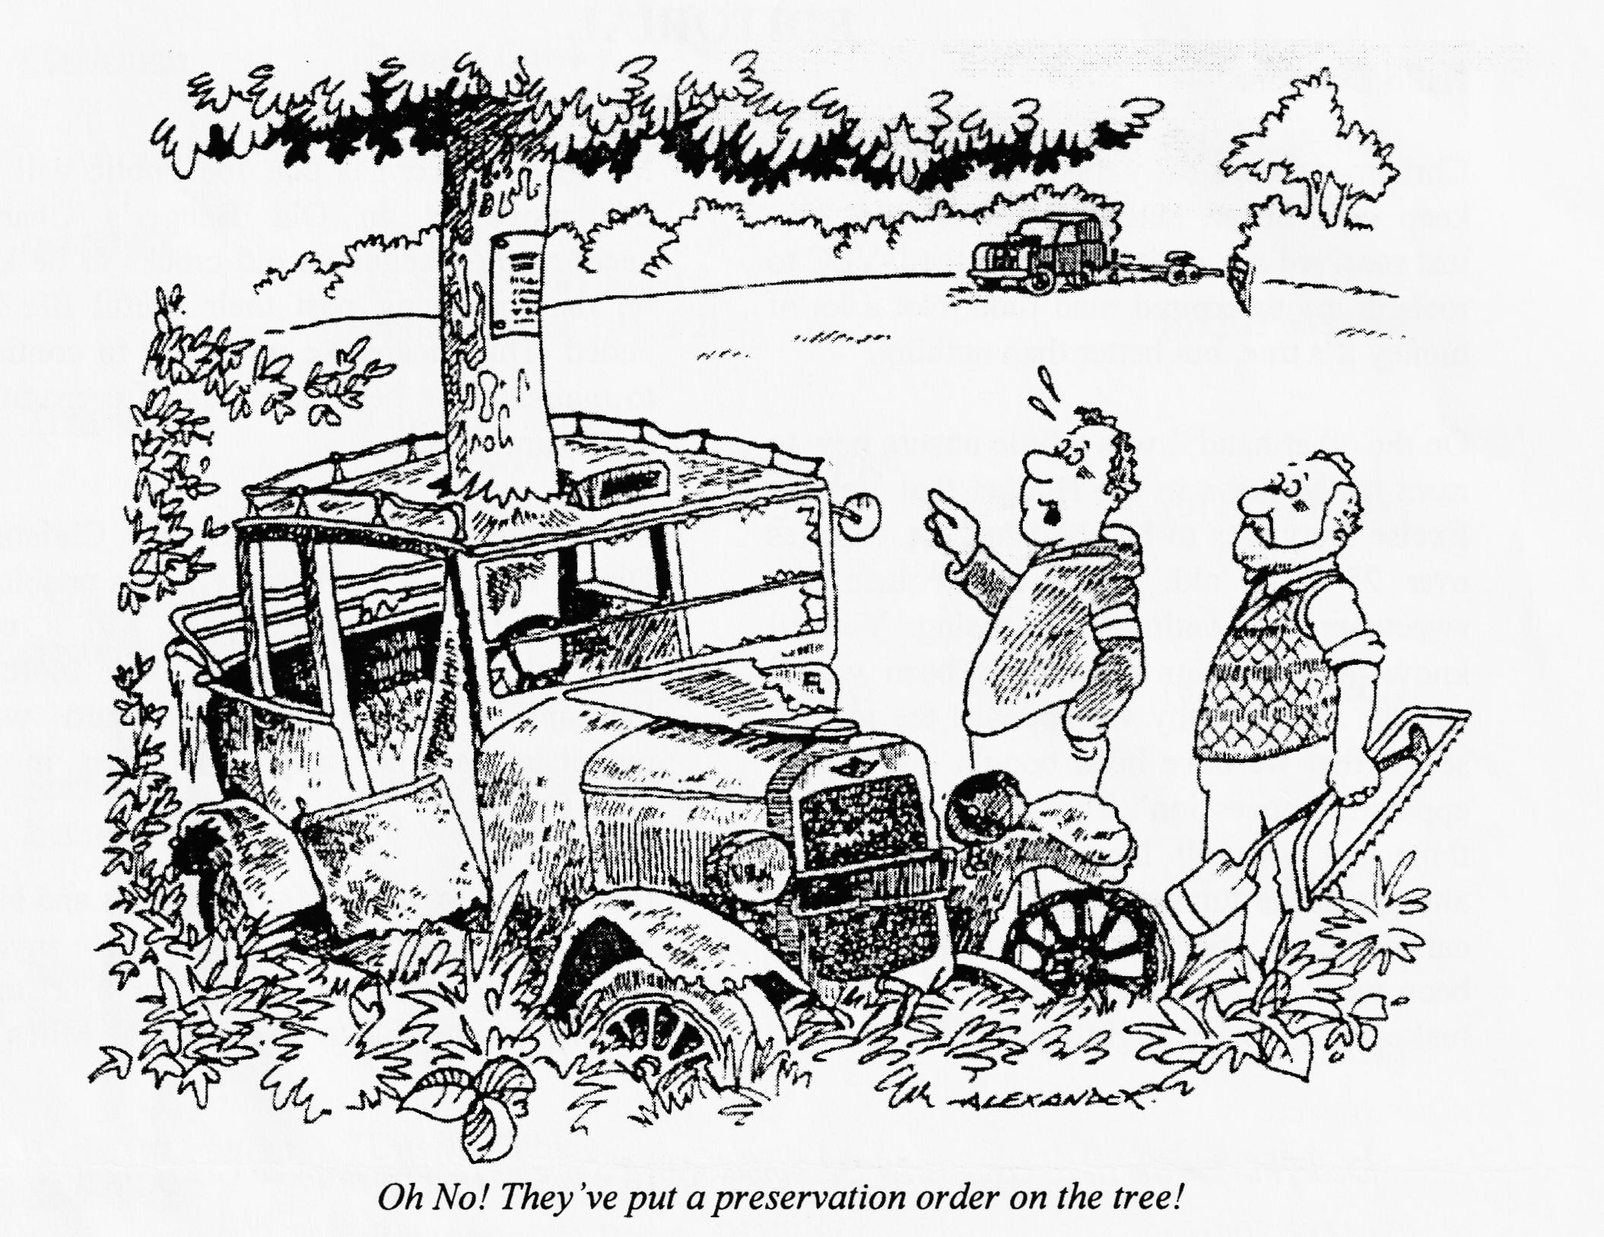
Thanks to Biddy and Gordon for the above cartoon which I think first appeared in the newsletter of the Austin Seven Register of Queensland, who are running a 75th Anniversary Rally on the Sunshine Coast of Queensland over the Easter Weekend (31st March - 4th April) 1997. See me if you would like further details!
75th Anniversary Update
As Gary mentioned in his Secretarial column, I drew the short straw at the October Committee Meeting and ended up as the Club Rep on the Association Committee that is meeting to manage the events for the 75th Anniversary celebrations. This key event in the Austin world, as you all know, celebrates the launch of the Seven in 1922 and so is due to happen in 1997.
As you also know, Lord Austin designed many other successful models and they too have their supporters. Some of them, in the shape of the Vintage Austin Register (VAR), Swallow Register and the Austin 10 Drivers Club are joining with us to make 1997 a truly memorable year for all Austin enthusiasts.

On your behalf, I attended the initial meeting on 19th November at Gaydon, the site of the Heritage Motor Centre. Located just off Junction 12 on the M40, it is easy to reach from most parts of England, but a touch remote for Scottish and Irish supporters and they were not represented by their own committee members. Most of the English Clubs sent one or two representatives to discuss how the Anniversary Year should be marked.
The general idea is that there will be two main events in addition to the usual range of Club runs and rallies and these will be run by the Association. The events are a John O'Groats to Lands End Run (JOGLE) over Easter. Initially, the Pre War A7C offered to run this but 750 MC, who have run the last two such events, offered to undertake the organisation. Concerns were expressed over the high costs involved last time, but Mike Peck estimated a likely entry fee of about £20 per vehicle but said he would need to do some more work on this aspect.
The other event is a major rally to be held at Gaydon. The only available Bank Holiday weekend is the Whit Bank Holiday (24 - 26 May). For those who remember the inaugural rally there a few years ago, I can assure you that conditions have improved considerably. The landscaping has made considerable progress although I have some misgivings about the size of the available areas. Gaydon, in the form of Hazel Gore, put forward a number of persuasive arguments which have swayed opinion and it was finally agreed to use the facilities offered.
The facilities available include the use of the museum buildings for a reception area, cinemas to run a continuous showing of Association and archive film material, facilities for an exhibition and access to the Rover Test Track next door. The precise format has not been decided but you can expect all the major usual highlights of a showpiece static rally. There should be a road run, possibly on the Monday, driving tests and an autojumble.
What part is the Dorset Austin Seven Club to play, you ask? Well, the idea is that each club should be responsible for a specific part of the rally and we (or I, on your behalf!) have offered to organise the overseas visitors and to organise the driving tests if they are to be held. This latter is still subject to discussion as many of the annual rallies are finding it difficult to attract a worthwhile entry for such events.
Other clubs are also playing their part. Alan and Lorna Martin have offered to look after the entries, you will recall what a good job they do at Beaulieu each year while Pre War will look after the reception and A7 Owners Club will co-ordinate a parts display and Phil Baildon will provide an archive display. Static displays of racing cars will be run by Ken Cooke of 750MC and VAR and Al 0 Owners have offered an exhibition of the larger cars. Midland will look after the autojumble and road run, Gaydon will manage the films in conjunction with Joe Spalter. Programme and publicity will be managed by Essex and Bob Olive will look for sponsors.
There will be individual club events as well. One that interests us is the South Coast Run being organised by A7 OC who wish to end their run at our Swanage Rally - sounds fun! Pre War will be running the Coast to Coast from Scarborough to Morecambe in addition to their highly successful Bert Hadley Memorial Trophy events (See next month's Notice Board for details of 1996 events). So there should be something for everyone and I hope you will all take a full part in running our side of the rally as well as enjoying all the events being run up and down the country.

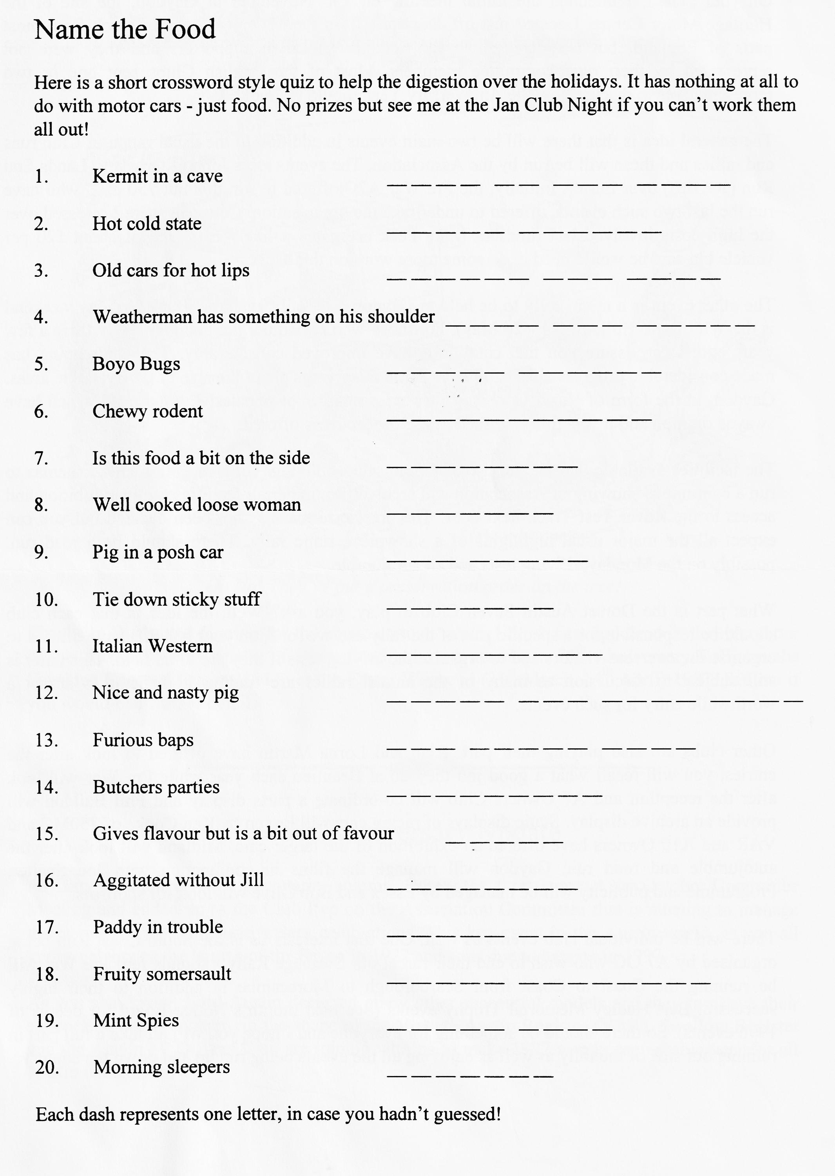

-
Roof Repair and Renovation (Part 1)
In Fig. 1 is shown the construction of a modem saloon roof which is covered with leather cloth, or other material to prevent drumming. The cant rails are joined to the side-roof rails by short curved ribs. This part of the roof is metal panelled. The two side rails are connected by a series of hoopsticks which in turn support lengthwise battens. These form the foundation of the flexible covering.
An enlargement of a portion of the roof framework is illustrated in Fig. 2. It will he noted that the side rails is recessed so that there is a flush surface when the roof cover is placed in position. The side rails and battens are lapped into the front rail above the screen and the edge of the roof material is well hidden by a metal moulding as shown in Fig. 3. There is a similar rail and method of fixing across the back of the roof.
Defects Like to Arise
Any part of the roof framework may be cracked or broken. A screw or nail may work loose, which although it may not allow water to come through, yet squeaking and chafing are set up which wear the surrounding parts. The fabric covering may become dull and may often he renovated by the use of a suitable paint or dressing which saves the expense of renewal.
Repairing a Broken Front Rail
Fig. 4 illustrates the various parts which have to be detached when the wooden rail above the screen is broken. 'Me screen is removed by unscrewing the side irons from the front pillars. The broken front rail consists of a header rail, grooved for the top tube of the screen, and a rail above it shaped to the roof curve. This is rebated on its back edge for the roof cover in a similar manner to the side rails already described.
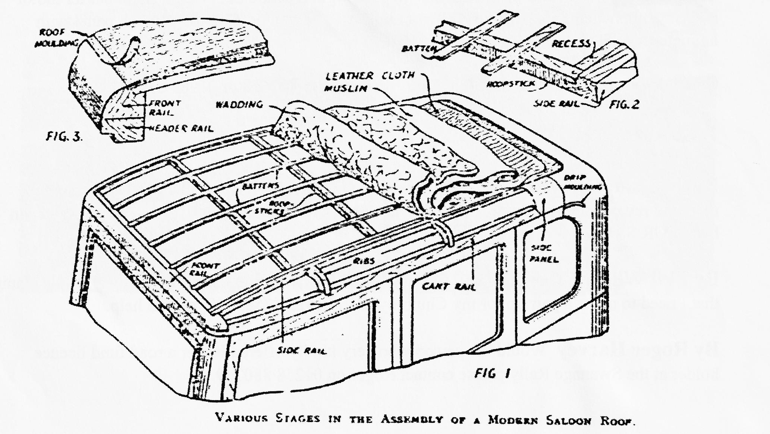
To release the front rail the drip moulding is unfastened. The roof cover is released by lifting the moulding which secures its edges. This moulding is also shown in Fig. 3. The roof cover usually consists of a pad of cotton wadding overlaid with muslin which is immediately under the leather cloth. Often the wadding lies on a foundation of wire netting which is fixed with staples at the edges. Netting and woodwork do not come in contact, because there is a layer of felt between them.

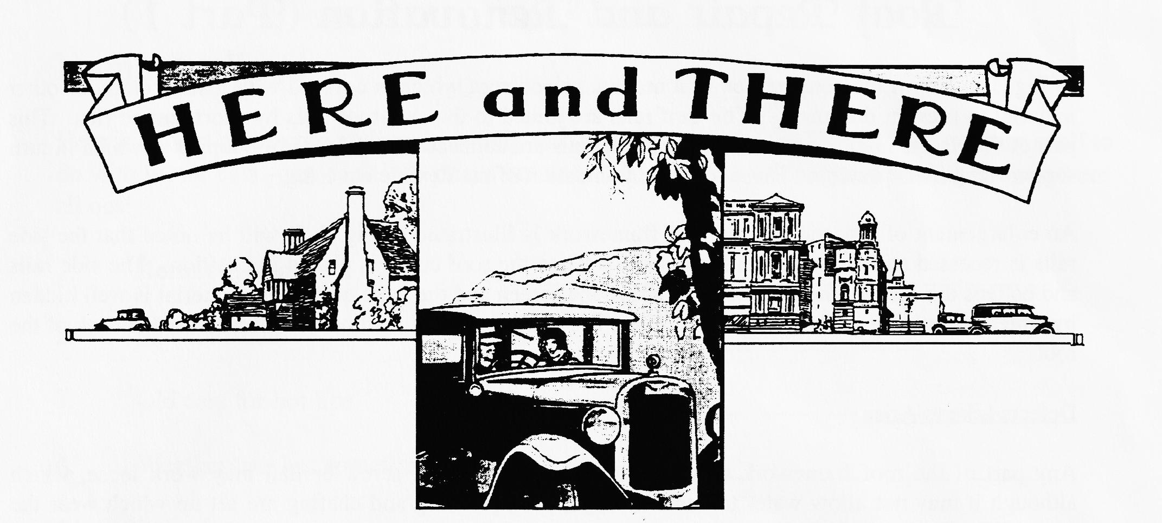
For Sale
1937 Opal - JK 6691 - Car No APE 269825, Engine No 290919. In excellent mechanical condition, MOT, older restoration. Maroon and Black. Best offer over £5,500 Contact Arthur Christian on 01635 298334 (Basingstoke). Non member, via Association Secretary.
Spares and Goodies!
CASTROL OILS now available XL, XXL and EP 140. Also special correct greases; LM, CL etc. Supalloy head £25, Big & complete front axle C/W stub axles £60, French High lift cams from £20 each, Selection of 2 and 3 bearing cranks all sound from £20 each, pair front hydraulic backplates £20, selection of flywheels from £5 each Various crankcases - phone for details. Pair Ruby headlights (1 rim missing) but no dents £60, various other Ruby lights, variable condition, variable prices! Box (or Chummy) steering wheel excellent £65, 2 Box saloon propshafts - good UJs £20 eachl solid centre wheel, sound with very good centre £25, bacon slicer starter motor working, no switch £55, pair pre Girling radius arms very good £30, mag switch panel with ammeter, vgc £40. Could deliver to Club Nights. Tel. Vince Leek 01985 847658 or 01985 216632.
Wanted
By the Editor! Any instruments suitable for my Ulster. If by any chance you have flange mounted rev counter or speedo, please let me know. Let me know on 01722 327215 if you can help. FOR SALE.
By Phil Whitter One 'Knobby' spring adjuster (or two!). It's the spiral spring and axle clamp that I need to make a pair up for my Chummy. Call 01425 475558 if you can help.
By Roger Harvey Would the person who very kindly offered Roger a road fund licence holder at the Swanage Rally please contact Roger on 01258 880269.

All members who have rejoined by December's Clubnight will have their names entered in our special draw. The Draw will take place at Clubnight and the winner will have free membership starting on October 1996.
Come on Folks, rejoin now. We give better odds than the National
Lottery does for its £10 prizes
If you don't rejoin, this will be the last newsletter you receive!
Apart from the old hands rejoining, we have four new members so on your behalf I extend a warm Dorset welcome to David Burris, Charles Lyford, A Edwards and Mr Tennant. I hope we will see you at one of the runs this holiday season or at Club Night. In case anyone is thinking of putting together a Special over the winter, the photograph below may give a little inspiration. It shows Ral Appleby working on one of the Twin Cams - some Special!
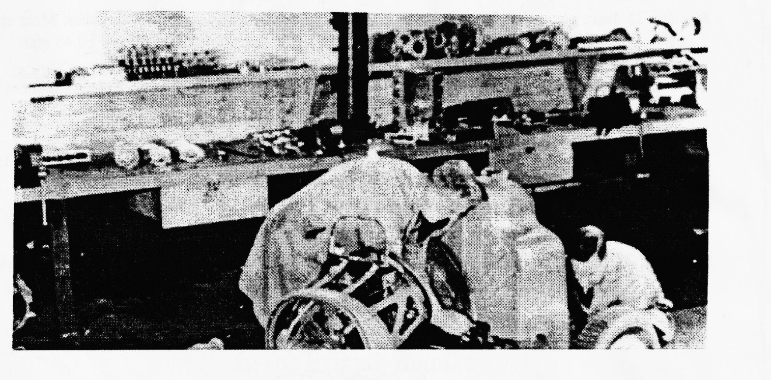

EVENTS
December
Sunday 17 Dec Club Run. Note that this is earlier than usual, something about holidays getting in the way of Austin 7s! Anyway, a short run, meet at the Wimborne Leisure Centre Car Park at 10.30 for a 10.45 start.
Thursday 21 Dec Club Night. A Noggin and Natter at the Elm Tree before the festivities and the last of 1995, plus spares for those who suffer withdrawal pangs!
Thursday 28 Dec Committee Meeting. Your committee will be gathering to discuss the events for the New Year at the Tyrell's Ford. Last time for 95!
January
Monday 1 Jan New Year's Day Run. Organised by Paul Mainzer, meet at the Leisure Centre Car Park at 10.45 for a 11.00 start. A great chance to blow away the cobwebs!
Thursday 4 Jan Eight till Late. The first early meeting of the year will be at the Angel, Longham. The crowd assembles at around 9 p.m. Don't miss out on the latest gossip....
Thursday 18 Jan Club Night. The New Year starts at the Elm Tree with an illustrated talk on Poole. We have booked a well known and entertaining speaker to give us an insight on the old town. No spares but all the crowd will be there.
Sunday 21 Jan Club Run. Lawrence is leading our first regular run of the year. Meet at the Cat and Fiddle on the A35 at Hinton Admiral at 10.30 for a 10.45 start.
Thursday 25 Jan Committee Meeting. You committee gather to discuss weighty matters and so will gather at the Tyrell's Ford at about 8.30 p.m.
For Your Diary
Skittles Night on 24th Feb at the Monmouth Arms.
Other Events
Saturday 27 Jan VSCC New Year Driving Tests. These are being held at the Brooklands Museum site in Weybridge. The first car away is 10.45. Tickets are available on the day only at £5 per adult and £3 for children under 16. Family tickets for 2 adults and up to 3 children cost £14.

