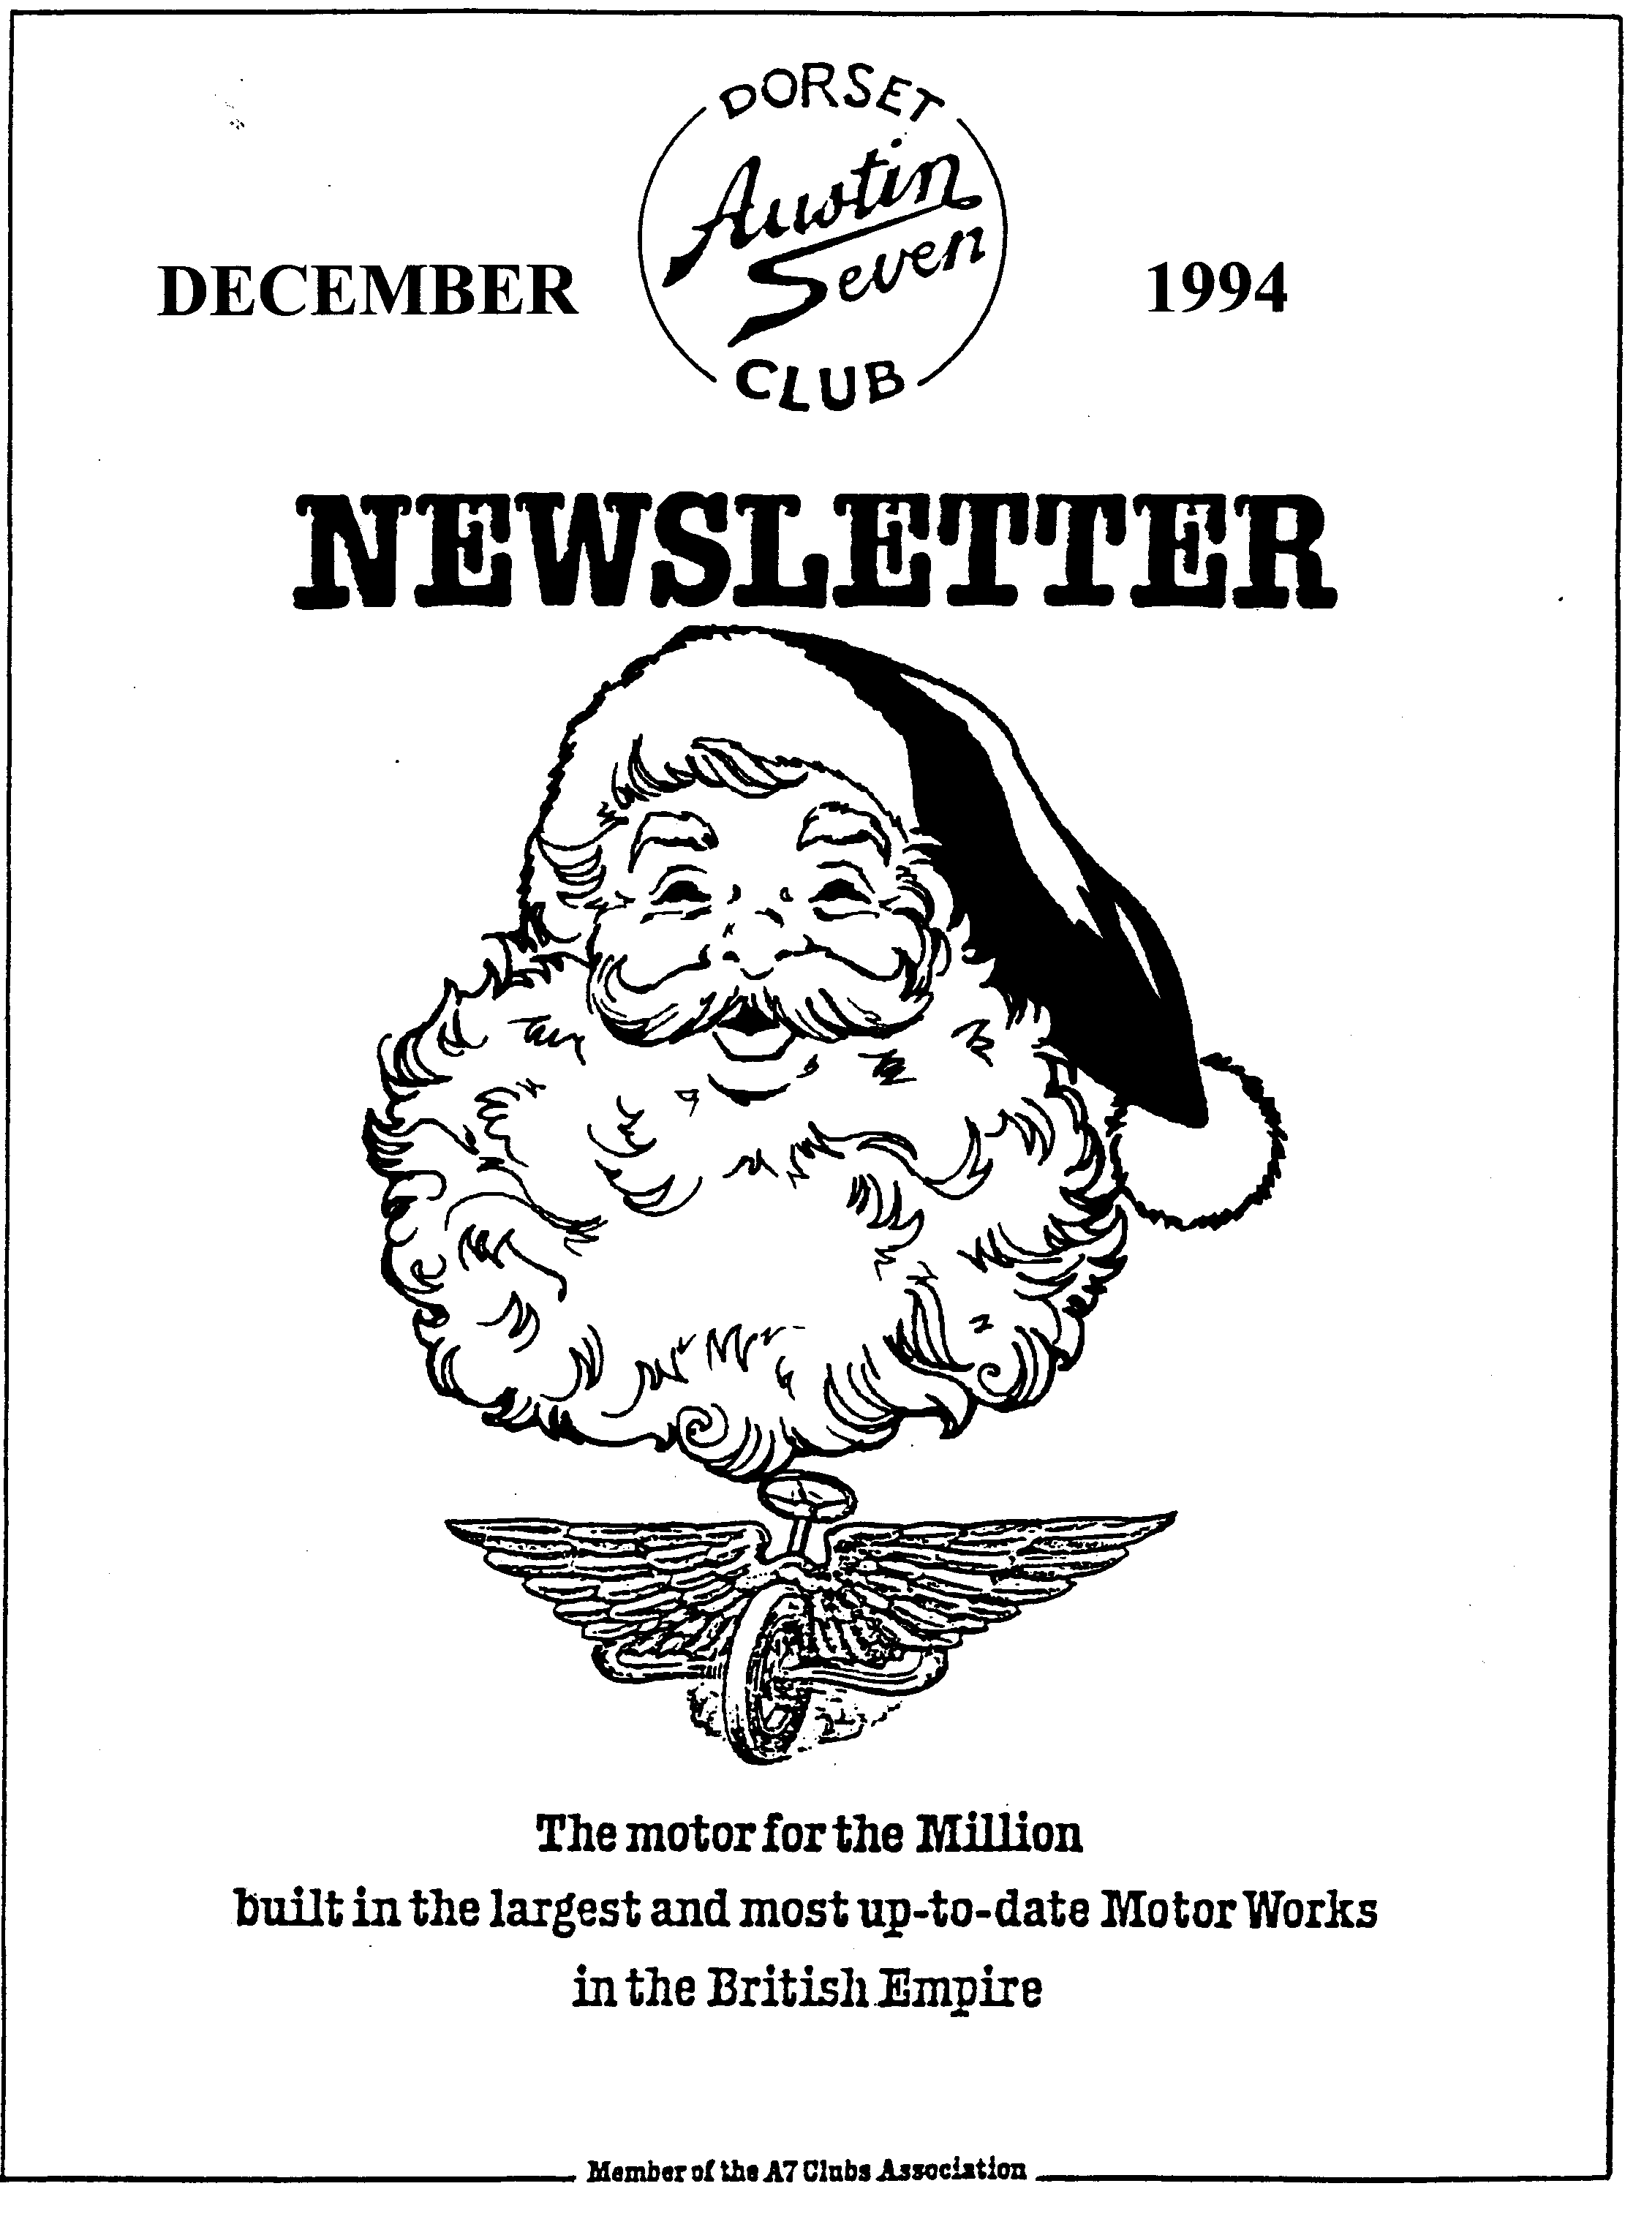

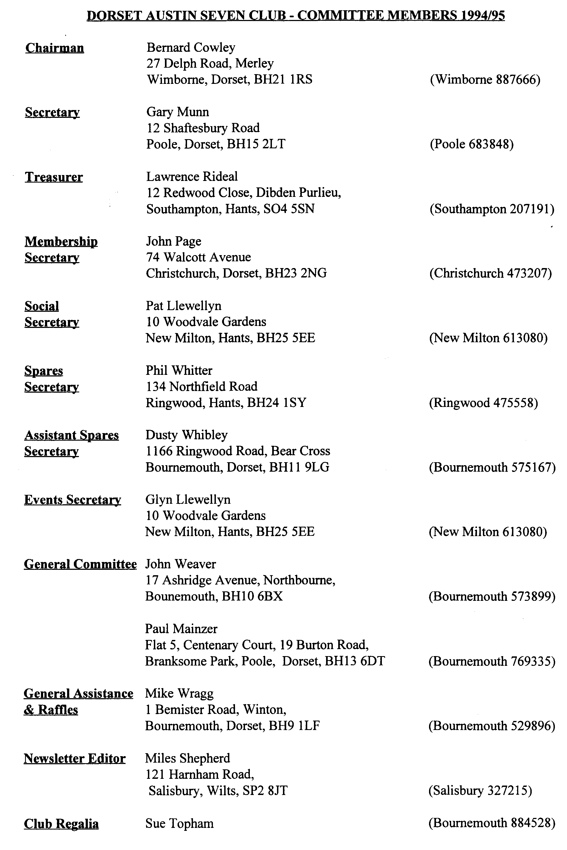

**EDITORIAL**

Hallo Everyone,

Well, another year has gone, and the Festive Season is upon us once more. It's hard to know where the year has gone. From a personal point of view, this has been a year of major change which has left little time for motoring. My Austin activities have been somewhat more restricted than I would have liked but I did get to Blandford for the Driving Tests and had a few other runs out in the Chummy. So most of my enjoyment this season has come from meeting other enthusiasts at the various rallies, club night and other events. Many thanks to one and all for making the year so enjoyable.

As Kate and I won't be able to get to the Christmas Dinner, we would like to wish you all a very happy Christmas and a prosperous New Year. We have sent our donation to Lawrence for the Children's Society, so don't expect a card! Kate was especially touched by the Get Well card the Club sent after her operation and says she will soon be back on her feet. In time to help with my New Project, I hope! More of this next time, suffice it to say that fun though the Chummy has been, it is time for a change. To what, you will have to wait and see....See you at Club Night

BFN

Miles

**SECRETARIAL**

Well Folks!

By the time you read this, Christmas will almost be upon us! May I take this opportunity to wish you all, from the Committee, a "Merry" Christmas and a prosperous New Year!

I will probably see most of you at the Club Christmas Dinner, it is always a great evening, hopefully to be made even better this year by a highly recommended duo who will be playing after the meal. I won't harp on much longer about the Festive Season but will just re mind you that your Committee has decided this year to donate to the Children's Society instead of issuing Christmas Cards, Anyone who wishes to join us, there will be a collection at the Dinner.

Last Clubnight saw our annual Auction. A great success it was, too, with 10% of takings going to the Club. I believe we took in excess of £40. Well done, and thanks especially to those who made donations.

This month's run was organised by Richard Cressey, out into the wilds of Dorset, to avery nice Pub and onto the Haynes Motor Museum at Sparkford near Yeovil, very interesting! Thanks, Richard.

I understand our new Social Secretary, Pat, has arranged a Skittles evening to the Monmouth Ash near Verwood in February. I'll keep you posted

Several of us have expressed interest in taking our 7's on an organised run next year to Czechoslovakia (Ed. - it is either the Czech Republic or Slovakia now!) about 800 miles each way. If anyone else is interested, see a Committee Member, but I believe places are limited.

Paul Mainzer has taken up the gauntlet of organising the new Club Library Scheme, I believe books will be available for hire shortly, from one Club night to the next. Further details to follow. See you all at Clubnite for the Christmas Noggin and Natter? Gary

**December 1994**

**2**



**HAYNES MUSEUM RUN**

Sunday the 20th November began in a very damp and overcast way, but undaunted we set off to call for Terry and Barbara Jeffries on route for Wimbome for the start of the run. We arrived safely and in time to see Austin Sevens decanting from Safeway's Car Park to the car park in front, where the Dorset Austin 7 Club now meet for runs leaving from Wimbome.

Pat and I led off for the first few miles to Sturminster Newton Mill where we were to meet our leaders, Richard and Margaret Cressey, with Rosie and Emily. Timed to perfection, we and the Cressey family arrived at the Mill at the same time and managed to cause a fair bit of disruption to the modern tinware in the vicinity as the ten Austin Sevens all turned round at the same time in the entrance!

All was soon sorted out and off we set once more. Richard now leading as we meandered our way via some lovely little lanes through the pretty villages, the names I made a note of and then promptly lost, until on coming to a large lay-by Richard stopped and announced that we were about 15 minutes early (Pub not yet open until 12 o'clock) so we all got out and had a natter, watered the geraniums, picked flies out of everyone's cars, and then we were off for lunch at the Elms at Alweston. A super pub with the walls lined with display cases full of model cars, and American number plates. The food and beverages were excellent but after a pleasant couple of hours we set off once again for Sparkford and the Haynes Motor Museum.

The Museum has been extended since our last visit, with another hall added, there is a very comprehensive display of all sorts of cars, including a Box Saloon and a 31 Special, though my favourite was the damson coloured Aston Martin DB6. We dreamed and browsed through all the exhibits until most people decided on a cup of tea and cake in the Museum Cafe before setting off for home.

Thank you Richard and Margaret for a lovely day out Glyn

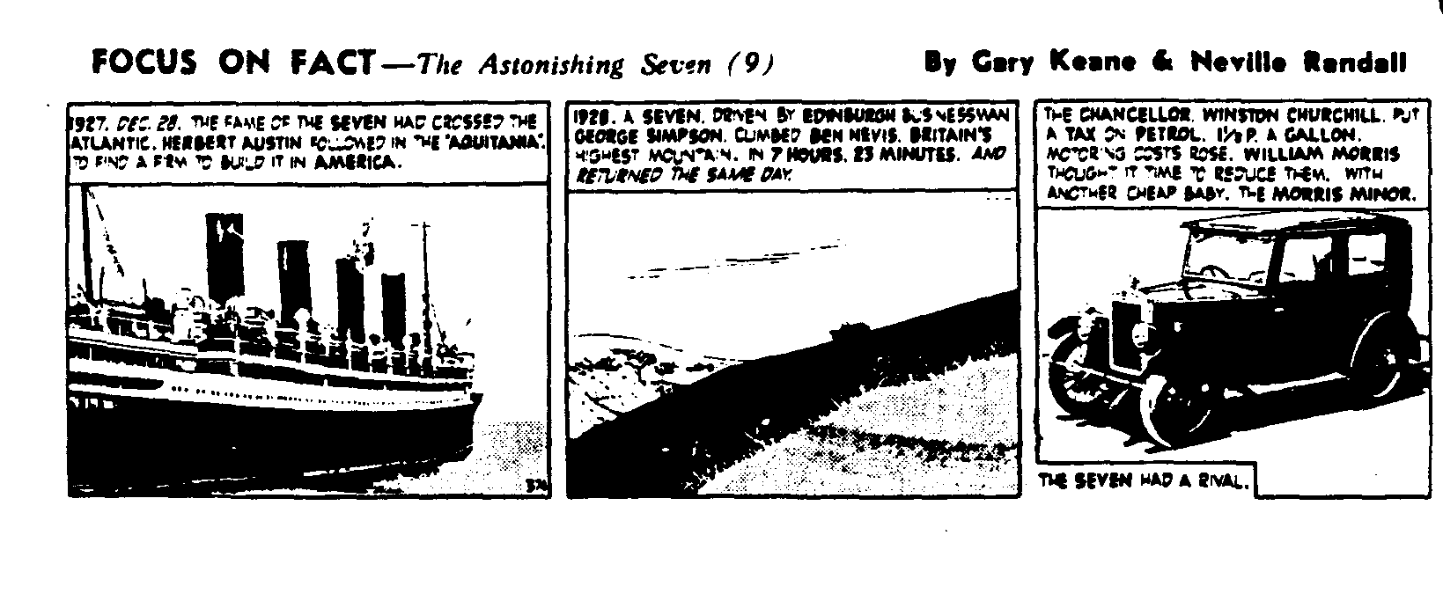

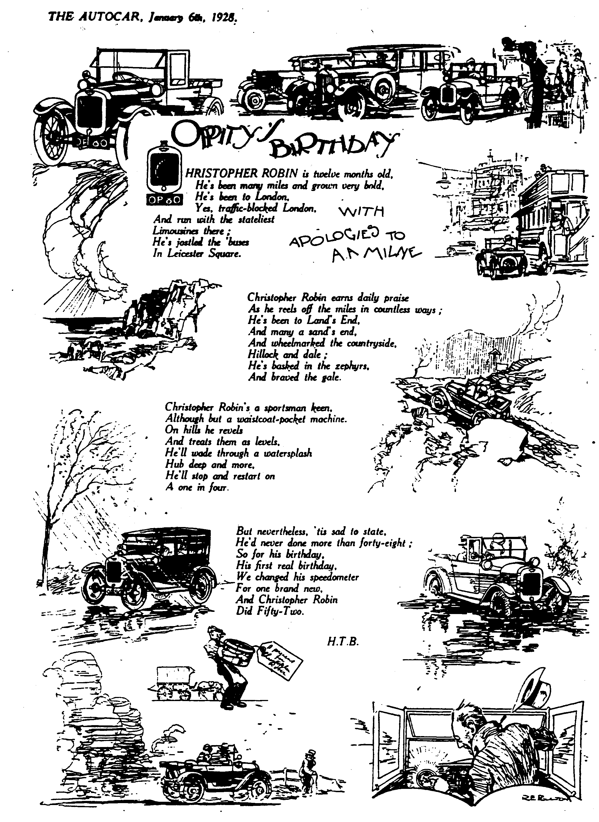



George Mooney has sent me a note asking that his and Joy's best wishes for a very happy Christmas and prosperous New Year for all Club Members. Many Thanks George and Joy, looking forward o seeing you both at club night.

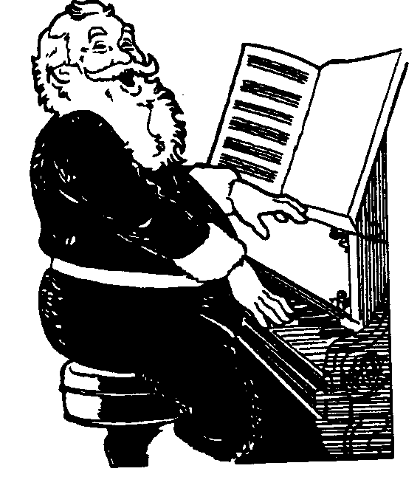

**FOR SALE**

**Club Regalia -** This is absolutely your last chance buy that last minute goody before Christmas! Those who placed their Christmas orders at November Club Night can collect them at the December Club Night.. Sue Topham

**1928 Saloon.** See photo (left) VGC contact T. Lane at 2 School Lane, Toiler Porcary, Dorchester, Dorset or phone 0300 320219.

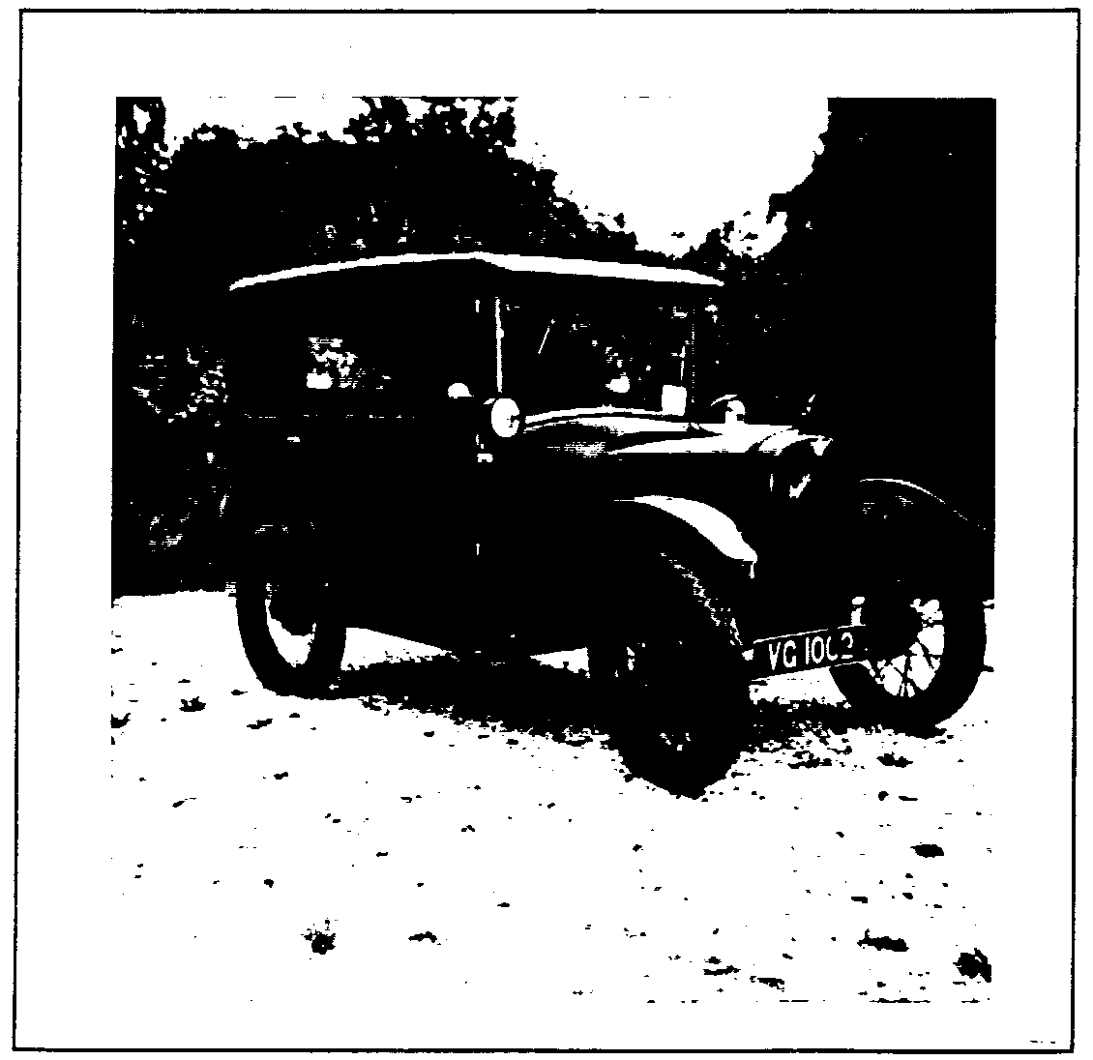

**1928 Chummy.** The editorial chariot needs a new home as there is no room for it and my new project! A sound, working car with new weather gear and a recently rebuilt (by Munwellyn!) coil engine. This is the transitional model with the front mounted headlamps and nichol plated radiator, none of your nasty magneto engines here! Long MOT **ALSO....**

**1960 Morris Traveller.** A sound car in everyday use, restored in 1988, it needs little work to return it to concours condition. All original except for replacement carpets, excellent woodwork. Call 0722 327215, Taxed and 12 months MOT. Call Miles on 0722 327215 before they appear in Exchange and Mart!

**Racing A7 Ulster.** Roach body, 15" wheels and V5. Available with choice of engine and box. Fully rebuilt regardless of expense in 1992. Contact G. Wilson on 0243 512735 (West Sussex) for details.

**1932 A7 Special.** Tuned engine, Aero Screens etc. Prescott timed at 57.60 sec (Ed. And that's fast!) £3,750 ono. Contact Roger Du Croq-Slip Tel: 0222 569785 or 0222 342382 (Cardiff)

(Both these two are from VSCC newsletter for December)

**Close Ratio Gearbox.** With remote (unused), rear facing starter engine, long and short chassis, Nippy front axle, 15" wheels. Ken Medlicott Tel: 0963 440604

**Vintage A7 Bits.** 25 - 28 axle casing £100, pair short half-shafts, good ends £60, Pair narrow rear axle halves 1925 - 28 £50, Pair dropped radius rod ends in steel £40. Crown Wheel and Pinion 5.25 £75. Ulster seatframe kit (12 pieces) £35 Gil Corliss Tel 0509 672778 (Leics)

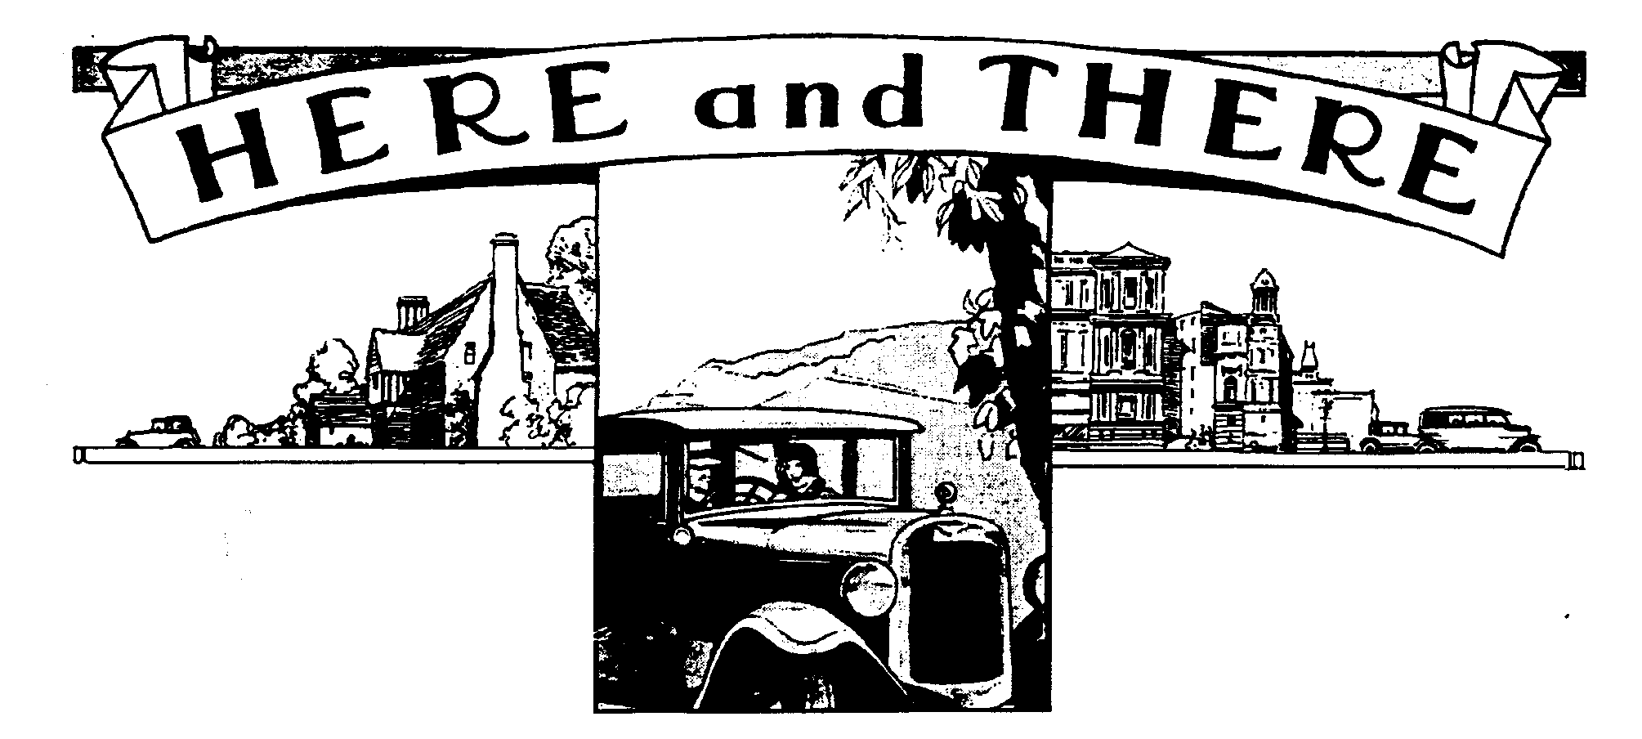

Welcome to new member Ian Rendle, from Marlborough. Some of you may have met him already as he made it to the Club Auction last month. Welcome, too, to Nicky, James and Tim Gilbride. We all look forward to meeting you at the many club events in the New Year, if not at Club Night this month.

Raffles continue to be a great feature of club nights, thanks to the efforts of Mike Wragg. I had to sneak out before the calling last month but I gather that a record prize pool was distributed. Mike asks me to thank Club Members for taking part so willingly, and a special thanks to the many members who contribute prizes. All are much appreciated, please keep up the good work in 1995!

This time of year sees many club AGMs, and I note from the many newsletter that we receive that there has been a change in committee membership at Midlands, Scottish and Bristol to name but a few. The committees no doubt have a great impact on the activities of the clubs but I mainly notice the changes in newsletter style and content. I have mentioned before that I find the MA7C journal excellent, with good quality printing, splendid photographic reproduction and good content. The new editor will have his work cut out to maintain the content of his predecessor. Meshing Point, newsletter of the Scottish Club, is photocopied like ours but I note that their new editor has brought in a more graphic style - the march of technology continues. The committee of the Dorset Club wishes all these new committees much success for 1995.

Auction Night was an unqualified success once more. I'm always impressed how smoothly it all goes and this must be due to the experience of the Team. For those who haven't seen it, the process is that items arrive and are logged in by Jackie, who gives each lot a number, records its owner and any reserve. The lot is tagged with the number and once bidding gets under way, she records the top price and sends one of the "runners" (usually Paul and Dusty) of with the item once sold to extract the money from the buyer. The auctioneering is done by Bernard and Phil in a brisk, realistic and friendly fashion so that we get through the list in the evening. At the end of the evening, 10% of the takings are deducted for Club funds and the remainder distributed to the sellers and we all depart satisfied! Many thanks are due to all who make the event go so smoothly



The law concerning the wearing of seat belts changed last year but there was little publicity. The Vintage Sports Car Club report a letter from FBHVC legal adviser Arthur Jeddere Fisher. He states that the old law on the use of restraints depended on whether a seat belt is required to be fitted to the car concerned. The new regime depends on whether a restraint is available. Whether a seat belt is required still depends on the Construction and Use Regulations but the use of a car without a seat belt where one is required to be fitted is a separate offence. After representation by the FBHVC, the DOT requirement to belt up children travelling in the front seat of a vehicle, except a motor cycle, irrespective of whether a seat belt was required to have them fitted has been dropped for cars which were first taken into use before 1965 and seat belts are not fitted. The full rules are complex but remember that even if your vehicle is not obliged to have seat belts, a child under 12, and under 150 cm tall, can never be carried in the front of a vehicle with rear seats unless properly restrained. Also, if do you have a suitable restraint provided in the front (whether legally obliged to do so or not) a small child passenger must use it rather than be unrestrained in the rear, when no such restraint is available there.

New BS4040 fuel should be available for the summer. Peter Henley, the VSCC and FBHVC fuel expert reports that this fuel will be on sale between 1st June and 31st August 1995 with "summer" volatility levels equal to those for unleaded and super unleaded, and for the same period in each summer thereafter. This is excellent news for all historic cars as it should substantially reduce the instances of misfiring and poor running caused by vapour locks in warm weather.

VSCC events have not yet been published but most of them are traditionally at the same venues from year to year. The next event is the New Year Driving Tests which take place at Brooklands Museum, Weybridge, Surrey on Saturday 28th January. There is a small charge for spectators but this includes admission to the entire museum. I have not been before but hope to correct that omission in 1995. I'll be travelling up by Modern as the traffic on a Saturday is too much to cope with on the motorway. Further details from me at Club Night.

Radiators can be repaired by M.B.Vardy Services, Station Road, Over Wallop, Hants, S020 8HU according to a report in the December edition of the VSCC newsletter. There are also details of various overseas events such as the Beaujolais Rally in April, the Giro di Sicilia, also in April, which covers 600 miles on really rough coastal roads in Sicily and the celebrations to mark the 90th anniversary of the 1905 Gordon Bennett Cup. There is a strong Austin connection with this last event since Herbert Austin took part when he was with Wolseley. The event will invite one car from 1905 to 1995 will be invited to take part at Clermont Ferrand in France. If you are interested in taking part, let me know by Christmas.

The Swanage Railway is getting a lot of publicity just now. Did you see the piece on Meridian TV last week? It looks like the new section to Corfe Castle will be open for our summer rally. This will give added steam travel to the rally and may attract even more people to our event. Speaking of which, the Rally Committee have had their first meeting with the railway people to put arrangements in hand for next year. The past two years have been excellent events so be sure to keep the weekend clear. Details will emerge in due course but I expect the format to be broadly similar to last year.

**EVENTS**

**December**

**Thursday 15 Dec Club Night.** Another chance to catch up on the gossip as this will be a Noggin 'n Natter but this time, Phil will have the spares on sale, positively your last chance to get that special part before the Holidays. Don't forget, this is also your last chance to buy Club Regalia from Sue Topham AND Roger and Rosemary will be bringing a choice selection from the stock of Merely Motoring.

**Sat 17 Dec Christmas Dinner.** Places were again strictly limited so if you didn't get your booking in to Pat, it's probably too late! Don't forget that this year, rather than exchanging Christmas Cards, the Committee are making donations to the Children's Society. A collection will be taken on the night and if members wish to do the same, they will be very welcome.

**Sun 18 Dec Club Run.** Short run organised by Bernard to blow away any cobwebs! Meet at 10.30 for a 10.45 start at the small car park, Safeways, Wimborne.

**Thursday 22 Dec Committee Night.** The last meeting of the Year at the Tyrell's Ford.

**January 1995**

**Sunday 1 Jan Glyn's New Year's Day Run.** Meet at 10.30 for a 10.45 start at the

Ringwood Furlong Car Park. This is one of the most popular runs of the year, attendance is usually between 25 and 35 cars. What better way to start the year than in the company of our kind of people and our kind of cars!

**Thursday 5 Jan 8 till Late.** The watering hole this time is the New Inn on the A45 at

Oakdale. See you there?

**Thursday 19 Jan Club Night.** Gather at the Elm Tree for a Technical Night! If you have a re­build or restoration question, this is your chance to have it answered. A panel of respected and knowledgeable experts will be on hand to help, so don't be shy! All the other attractions will also be present, another fine way to start the year.

**Sunday 22 Jan Club Run.** John Weaver is organising this outing, so meet him at 10.30 for a

10.45 start in the outer car park by Safeway's in Wimborne. Further details next month

**Dates for Your Diary**

**Saturday 11 Feb Skittles Night.** Our popular Skittles Evening to be held at the Monmouth Ash,

Manor Road Verwood. First ball away 8 pm. Entry form next month.

**Sunday 19 Feb Dusty's Mud Run.** Always an exciting run, keep the date free!