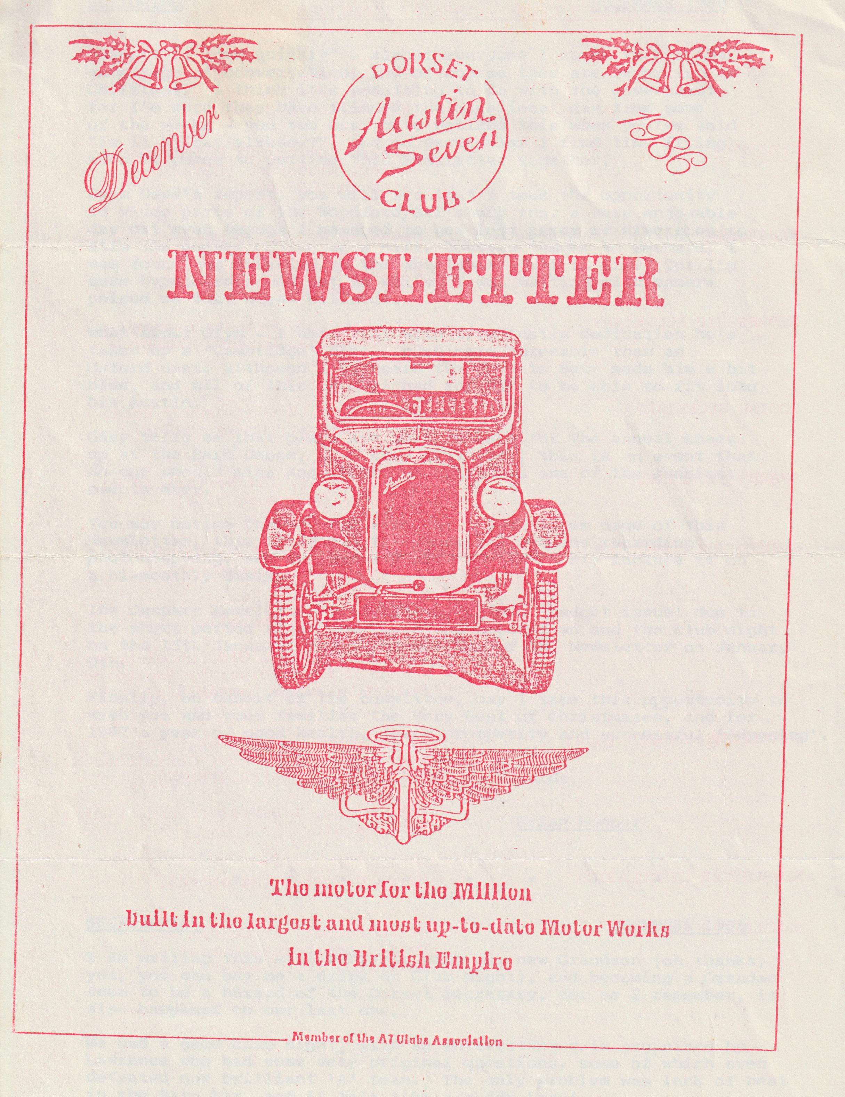

EDITORIAL DECEMBER 1986
"Hasn't it come quickly" - almost everyone I speak to has the same type of conversation, and of course they are referring to Christmas. I think it's something to do with the government for I'm sure they have trimmed the occasional day from some of the weeks - you too must have noticed this when you've said "is it Friday already?", and in particular I find time flying when it comes to putting this Newsletter together.
From Dave's report, you will see that I took the opportunity to video parts of the Woodford/Salisbury run, a very enjoyable day out even though I managed to get lost after my diversion to film the convoy coming up a hill, however thanks to Bernard, I was found and directed to the Wheatsheaf just in time, for I'm sure hypothermia had set in whilst I was waiting with camera poised on that bleak hillside.
What about Glyn? - I hear that with true Austin dedication he's taken up a 'Cambridge' diet - much more agreeable than an Oxford diet, although I've heard the results have made him a bit blue, and all of this is designed for him to be able to fit into his Austin.
Gary tells me that plans are well in hand for the annual knees-up at the Barn Dance, as I said last year, this is an event that no-one should miss and should be billed as one of the funniest events ever.
You may notice that I have left out the services page of this Newsletter, this being due to economic reasons regarding photo-copying, and in future I will probably only include it on a bi-monthly basis.
The January Newsletter will also be only a 'budget issue' due to the short period after the Christmas close-down and the club night on the 15th January, requiring mailing of the Newsletter on January 9th.
Finally, on behalf of the committee, may I take this opportunity to wish you and your families the Very Best of Christmases, and for 1987 a year of good health, peace prosperity and successful 'Sevening'.
Regards,
Brian Hooper
SECRETARIAL DECEMBER 1986
I am writing this as I baby-sit with our new Grandson (oh thanks, yes, you can buy me a drink on Club Night), and becoming a Grandad seem to be a hazard of the Dorset Secretary for, as I remember, it also happened to our last one.
We had a good club night, with an interesting quiz organised by Lawrence who had some very original questions, some of which even defeated our brilliant 'A' team. The only problem was lack of heat in the Barn bar, and it felt like a ruddy barn!
I was sorry to miss our last run to. Woodford as I know the pub is super and serves very good food and I remember particularly the delicious sweets, However, as I am at present on a diet, it is perhaps just as well we couldn't go. I will of course be finished the diet in time for the Club dinner.
While looking through a photograph album recently I came across some photos of a run we were invited to a few years ago, it was a cross-country run, and rough country at that. We drove across boulders, tree roots and through quarries, woods, over fields etc. in our Austins, and I hasten to add we all enjoyed it although most of us suffered some damage. Three or four Dorsets were there, but I doubt if I would do it again, for the old cars have come through such a lot in their lifetime, including a war and countless student owners during the last 50 years or so. Whilst I don't mind the occasional gravel track and a few water fords, I think a little respect in their old age is advisable - or am I just getting old?
Finally, Beaulieu has been chosen as one of the starting points for next year,s Norwich Union RAC Classic Car Run. More than 600 classic vehicles built between 1905 and 1967 are expected to head for Silverstone on May 24th starting from Beaulieu, Bath, Buxton, Brands Hatch and Norwich. Entry for this event opens on January 2nd and details are available from The Secretary, 3 Belgrave Square, London.
See you soon,
Glyn
- 0 - 0 - 0 - 0 - 0 - 0 -
SERVICES
About a year ago we asked if members had knowledge of, and could offer advice/assistance on, any subjects to other members if they would let us know via the Newsletter.
It is not expected that Professionals should take on a job or impart the secrets of their trade free of charge, but the fact that their knowledge/service is known might be of mutual benefit. Further, a member might find a D.I.Y. job or hobby made a little easier by someone who has 'done it before'.
Please let's hear from you if you have something to offer or if you would like some help.
CLUB NIGHT
The committee received a number of complaints regarding the lack of heating in the room at the November club night. Efforts were made during the evening to get this corrected but without success, and the matter has now been taken up with the publican, which should resolve this for future meetings. Apologies to our members for this occurrence.
THE WILTON VIDEO RUN
We arrived unsuspectingly at 10.15 am on a bleak Sunday morning in Ringwood cattle market car park and this geezer with one eye pressed to a thousand pounds of Japanese trade balance shouts "smile !" Calls for the make-up girl offer no relief against the hard, uncompromising lens. The only saving grace is that the Austin, at least, had had a quick polish whilst waiting for the family to get its Sunday morning act together. Eight Sevens turned up - 3 Rubies, 3 Boxes, Chummy and Opal plus son Tim learning in the F**d and Lawrence in his Saab (Yes, this reporter reveals all. There was some lame excuse about a temporary building site, but the camera will show the accompanying shifty look.) Phil had obviously been tipped-off about the video since he put in a short appearance and it was nice of Mervylle, our newest member, to be there to wave us off.
It wasn't long before the drizzle fizzled out and we were sailing along through some beautiful Wiltshire valleys. The route took us up through Alderholt and Rockbourne. On arrival at Wilton we sped straight past the pub. Some consternation had been caused a little earlier by a pale green Ruby belonging to Videoman peeling off from the orderly formation and going its own way, but now all was revealed, although too late unfortunately for Gabrielle. Videoman was there ready to capture the graceful progression of our little cars up a very picturesque valley when John decided to behave completely out of character in a very irresponsible way. Some people just can't cope with being on film. Eight three-point turns and one seven-point turn later and, no, the latter wasn't Learner Tim, we descended to the warm and very welcome Wheatsheaf for lunch. To add to the pleasure of the occasion we were joined by an old friend and former member John Stone, complete with wife and Ruby, now transposed to the Bristol Club.
An hour and a half later we emerged from the fug and tried to make small-talk in the freezing car park whilst Videoman continued to practice his zoom and pan. John Stone soon had had enough and led the procession down into Salisbury. After a short tour of the town's car parks, John having finally settled on a free one, we set off on foot for the Cathedral. This correspondent found alternative delights on the way in the shape of Mompesson House being unusually open. They are trying an experiment of opening on the five Sundays Before Christmas.( NT members please note ). Eventually) we all joined up but only to go our separate ways after a very pleasant day which will be re-lived again and again and again
David Whetton
CLUB NIGHT QUIZ
That was the quiz that was. Lawrence Rideal as seen on T.V. (with acknowledgement to Victoria Woods who could not have written a better script).
A good deal of time and effort must have been put into collating the questions (not so sure about the answers!!) and the picture pages. However cold as the club room was there was no justification for the B team being frozen out of the marks. We too had burnt the mid-night oil re reading Lady Chatterley reference books many times for information about three "bearing" jobs and Watership Down for mass production techniques. In the event we might as well have a studied First Among Equals, Paradise Postponed or, better still, Goon Show scripts.
There is no doubt that there was left wing bias in favour of the A Team - no even handedness here, and in common with my friend Norman Tebbit feel something should be done. I was amazed how readily the A Team were given points even when no answers were forthcoming. I concluded that they were a team of ventriloquists as they never moved their lips. It was not until near the end when Mr. Mastermind acknowledged that our star Jackie was in the B Team and that we should have had all her points. No member of the "Listening Bank" this Mastermind (thank heaven) but must be inhaling all the Dorchester brewery ozone too liberally. This made me adjust my chair to peruse the scene and all became clear. The A Team not only had the Chairman but the Committee as well (Mr. Mastermind knows from which side his glass is filled). We were surrounded and the analogy of Custer’s Last Stand immediately occurred to me that history was about to repeat itself and the Indians were going to raise their score to 2 nil.
I think we deserve an independent enquiry under the Chairmanship of 'Allo 'Allo Paul (alias Tractor Sid) or preferably a new quiz evening organised by Mr. Mastermind.
It was an excellent show, Lawrence, and we do appreciate all your hard work you put in to improve our technical knowledge and humour. Thank you also for the prizes... thanks to my Blankety Blank NatWest pen I can now write my Christmas cards. Happy Christmas and New Year to all. Do drive very carefully. BILL QUAYLE
REMINDER
Have you renewed your club subscription - if not please send it now (renewal form in last month’s Newsletter), to John Page. This will be the last communication/Newsletter sent to anyone whose renewal has not been received by December 31st.
A CHRISTMAS QUIZ FOR VETERAN MECHANICS
(OR WHEN I WAS A LAD, CARS WERE CARS)
This quiz reaches down into parts that other quizzes cannot reach - the world of the obscure and the ridiculous in motor engineering history. It must only be attempted after immoderate amounts of Whitbread or Christmas cheer. The answers are as uninteresting as the questions and can only be bought from me at a ridiculous price (viz: 1 pint of Best).
SECTION A: WHAT WERE THE FOLLOWING AND HOW DID THEY WORK?
- Ford oil disc
- Zephyr piston
- Clupet piston ring
- Poppet valves
- Packard oil purifier
- Daimler automatic hinged oil troughs
- Jones automatic compensating system
- Lanchester torsion damper
- Lanchester harmonic balancer
- Knight double sleeved valve (Daimler)
- Burt McCollum single sleeved valve (Argyll)
- Italia rotary valve
- Lanchester wick carburettor
- Autovac fuel feed system
- A.F.S. suspension system
- Houdaille shock absorber
SECTION B: ODD ENGINES - WHAT WERE THE PRINCIPLES BEHIND THEIR CONSTRUCTION AND HOW WERE THEY DIFFERENT FROM OUR FRIENDLY 747?
- Lancia staggered-V engine
- Brown valveless engine
- Solid injection engine
- Mitchell swash plate engine
- Still engine
SECTION C: MATHEMATICIAN'S DELIGHT, OR THANK GOODNESS I'VE ONLY GOT FOUR. WHAT ARE THE FIRING ORDERS OF THE FOLLOWING ENGINES?
- 6 cylinder (eg.Lanchester. 2 possible solutions)
- V8 (2 possible solutions)
- V12 (eg. Packhard Twin 6. 3 possible solutions)
- 5-cylinder radial engine
David Whetton
EVENTS
SUNDAY DECEMBER 14TH Club Run to the Red Shoot Inn at Linwood, and then to the Moors Country Park near Ashley Heath. Meet at the Cat & Fiddle (Christchurch - Lyndhurst Rd) at 10.45 for 11.00 a.m. start.
THURSDAY DECEMBER 18TH Club Night, 8.00 p.m. at the Elm Tree, Hightown, Ringwood. Noggin and Natter plus there will be informal viewing throughout the evening of the Club Videos Barbecue and Salisbury Run.
SATURDAY DECEMBER 20TH Club Christmas Dinner at the Manor Arms, Burton.
THURSDAY JANUARY 1ST New Years Day Run - Meet at Viewpoint, Constitution Hill, Nr Poole at 10.45 a.m. for an 11.00 a.m. start. Mystery run to include a Pub Luncheon stop.
THURSDAY JANUARY 8TH Committee Meeting, 8.30 p.m. at the Tyrrells Ford, Avon, Near Ringwood.
THURSDAY JANUARY 15TH Club Night, 8.00 p.m. at the Elm Tree, Hightwon, Ringwood. "Bright Sparks for your Austin" everyone's Guide to Austin Ignition, talk to be given by Phil Whitter.
SUNDAY JANUARY 18TH Club Run (further details next month), but meet in Wimborne Square at 10.45 a.m. for 11.00 a.m. start.
VIDEO
If you were at the Barbeque in the Summer, or on the Woodford/Salisbury run last month, do come to the December Club Night and see yourself on T.V.

