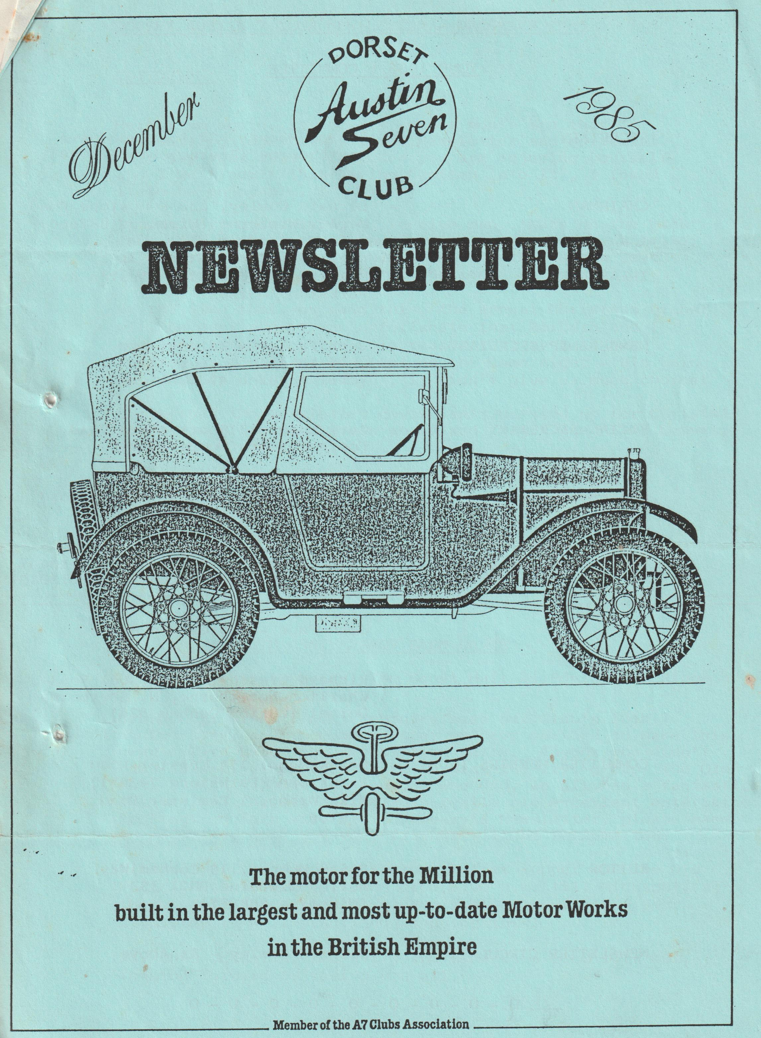

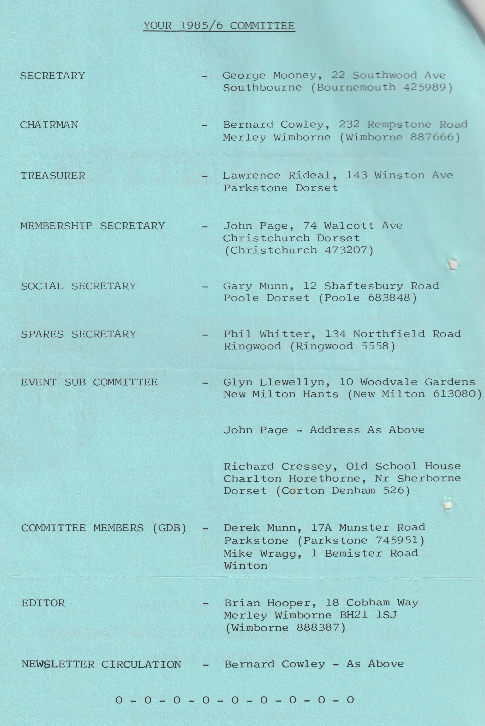

DORSET AUSTIN 7 CLUB NEWSLETTER - DECEMBER 1985
EDITORIAL
Here I am again, it doesn't seem a month ago that I was putting together my first Newsletter and editorial. They say that time flies when you are enjoying yourself and I must admit that having "gotten into it", I found it to be enjoyable.
It was very encouraging to receive many 'pats on the back' from club members and I appreciated particularly, a letter of congratulation from Robin Newman of The Austin Seven Club Association, re my first edition.
By the time that you read this, the annual Christmas Dinner will be over, and it was unfortunate that Barbara and I couldn't attend for the sole reason that my boss had invited us to attend his 'do' on the same night - his being somewhat of a Royal Command, it didn't give us much choice!
Sorry that the Newsletter cover isn't dressed up for Christmas I was compiling it a month ahead and forgot the Holly Leaves, anyway hope you like it.
Any contributions for the January Newsletter would be appreciated, if possible, to me by Monday 6th January.
Best regards, BRIAN HOOPER
10th ANNIVERSARY BARN DANCE
(Saturday 15th February; The Scout Hall at Poulner nr Ringwood)
Believe it or not, next February sees our Club's 10th anniversary, and to commemorate, we have decided to make this year's Barn Dance our celebration party. Anyone who didn't come to last year’s barn dance to hear the live group 'The Old Pull & Push' should ask someone who did, we all had a fantastic evening and The Old Pull & Push really are excellent entertainers! Application form will be in January's Newsletter, please make an effort to come and your friends will be welcome too.
Tickets will be £3.50 to include buffet supper and the Old Pull & Push will be playing from 8.00 p.m. till midnight, so there's plenty of time to make a fool of yourself - your committee is well practiced at doing this!
For this occasion, let's try and make it a 100% turn out, looking forward to seeing you all.
GARY
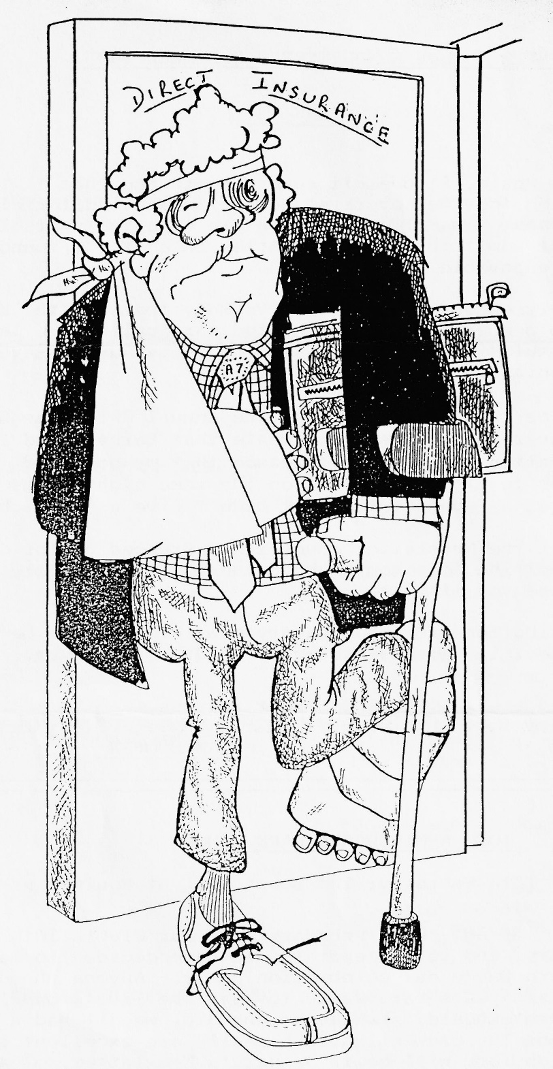
Went on a run wit:' the Dorset Austin 7 Club, followed their convoy rule, kept the person behind in sight and hit the brick wall in front!, but the good news - I'm still within your annual mileage limit - just 2499 miles and I know it’s true - my speedo has said so all year!

I'm afraid that this month we have had to 'go' without a Secretarial. George did tell me at the onset that he needed a lot of pushing, but this month despite calls to his office and home, I'm afraid that due to pressures of work, George was unable to get his copy to me.
I suspect that George would have made comment on the new meeting place - The Elm Tree at Ringwood and I'm sure that we all agree that it is a super venue, that is once we had found our way in, and having found 'our room' being used for a study group. Still the barn bar was a very acceptable alternative albeit that the thermostat must have been stuck at maximum temperature and unfortunately, there were no staff to man the bar.
I believe that George was also going to give us the run report on the Melbury Abbas Mill trip. As I wasn't able to go (being a new grandfather has given me some additional family responsibility), I can only comment briefly on the 'hear say' That is, it was an excellent day out despite being bitterly cold, and that the return trip became a bit of a race home, to get back to the warm.
EDITOR
Some of you may remember the "Little Motoring Quiz" that I put in the October Newsletter. It obviously wasn't as interesting as I thought it would be, for I only received two entries - Glyn & Pat Llewellyn and Bernard Cowley. By coincidence, both achieved the same number of points – 10¹/₂ , and therefore the prize of a bottle of Vino was split so that each received a half bottle.
Answers to some of the trickier questions are as below:-
Question 10 - In which year was the Armstrong Siddeley 18 Limousine introduced? Answer 1950
Question 11 - In which year was the Armstrong Siddeley 18 Limousine discontinued? Answer 1951
Question 6 - What was the Winning car in the last full race at Brooklands? Answer 52 Litre Graham Paige
Question 16 - In 1946, a new English 'Peoples' Car was developed, to be produced in the Lake District - what was its name? Answer Kendal Car
Question 18 - What was the first year that the G.P.O. introduced the scheme for fitting telephones in Private cars? Answer 1960
BRIAN HOOPER

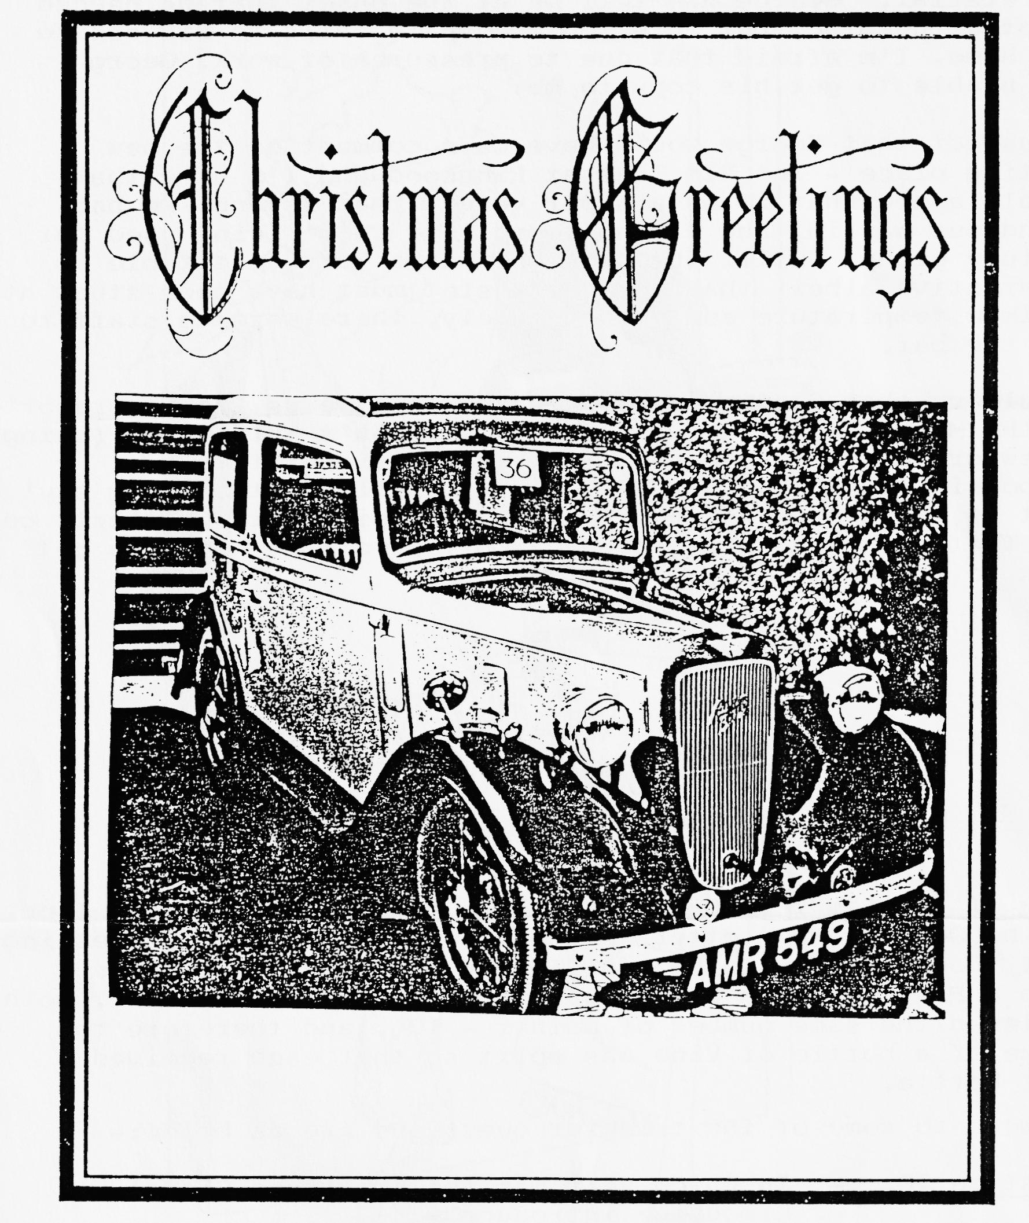
As Editor of this Newsletter it has given me the opportunity to use this medium to extend our best wishes for a Very Happy Christmas and our hopes that 1986 will be a year of Health, Peace and Prosperity to all of our Austin Seven friends.
Brian & Barbara Hooper (and Esmerelda pictured above, starring in her first Christmas Card).
AUTUMN LEAVES BICYCLE RIDE IN THE NEW FOREST
Not so many club members joined the S.V.C.C. on their annual Autumn Leaves run this year. Apart from Keith Mitchell, who organised the ride, there were Cynthia & John Page & Family, my Father-In-Law Don, Cyril Taylor & friend Brian Cooper (more of those two later!) and Richard, Rosie & myself. This year Richard lent his penny farthing to John and his son Christopher, so Rosie was able to join us on the crossbar of Richard's Raleigh. (Emily was left at home since she is an inveterate bottom pincher and leaner when seated on the back of a bicycle).
Once again there was a fine assortment of bicycles - Penny Farthings, Bantams, Dursley Pedersen and my favourite, the ladies Sunbeam.
We took the same route as last year, stopping for lunch at Bucklers Hard and once again enjoyed a warm sunny October day. John very ably rode the Penny Farthing (even if we did nearly lose him in the hedge) but Christopher certainly had the knack and rode very well.
On returning to the Car Park, we waited for about 45 minutes and Cyril & Brian had still not returned. Since they had left the map provided in the van (a clever move!), we realised they probably didn't know where they were or where they were heading. We set out to look for them, John going in one direction and ourselves in the other but had no luck. Eventually we returned to the Car. Park to find two rather sheepish chaps sitting in their van. We were right, they didn't know where they were and ended up in Lymington. From there they continued to Brockenhurst before finding the Car Park at Norleywood. They obviously felt the original run wasn't long enough!
Keith has said that he hopes the next Autumn run will be in the Ringwood area, so perhaps we will get a few more of our four-wheeled club members on to two wheels - it's great fun and any bike will do.
Margaret Cressey.
* * * * * * * * * * * * * * * * * * * * * * * * * * * * * * * * * * * * * * * *
CORRECTION
In last month’s Newsletter report on the last association meeting, reference was made to an insurance company - "Bloxey & Baltic" - this should have read "Black Sea & Baltic". Thanks to Robin Newman for pointing this out.
Robin also advises that this company have been found to be very helpful and prompt in settling claims. If anyone has contact with the Black Sea & Baltic insurance company, perhaps we could have some proposal/quote forms for circulation in a future Newsletter?
The following letter has been forwarded to us, and for anyone wanting a challenging holiday this might be ideal:-
PROPOSED TOUR TO THE U.S.A. IN 1987
My Ruby celebrates its 50th anniversary year in 1987 and by way of something unusual I am thinking of a drive across the U.S.A. to mark the occasion. This involves a journey from Baltimore to Austin, Texas, about 2,500 miles over a 4-week period, trucking the vehicle back to Baltimore, during September/October.
I discussed the idea with my brother, who is a highly placed official in the U.S. Department of Commerce in Washington D.C., to see if he thought any sponsors might be attracted by the idea particularly in the provision of accommodation, fuel and shipping. He is fairly confident of lining something up but said it would generate more support and attention if several vehicles were involved, so does anyone fancy the trip of a lifetime to America with your Austin or any other suitable vehicle?
Obviously, a great deal of planning has to be done far in advance and I would like to have preliminary matters in hand by early 1986 so if anyone is interested, it need not be definite, please let me know as soon as possible. I hope that some American owners may join in en route which is being worked out for me in America at the moment.
N. H. Barr
President PWA7C Ltd

Mr. N. H. Barr can be contacted at 41, Leopold Street, Derby, DEl 2HF, his telephone number being Derby (0332) 368459.
COMPETITION
A little competition for you to -play with over Christmas. Let the kids have a go as well - no limit to the number of entries.
From the 11 letters in "Austin Seven", how many words (in English Dictionary) can you compile using each letter only once in a word (unless they are repeated in "Austin Seven" i.e. only letters S, E & N can be used twice). To get you going here are some examples - TIN, VASE, SEEN, NEAT etc.
Send or give your list of words to the Editor by January 16th (Club Night), showing entry name and address. The Winner will receive a prize and will be announced at the February Club night.
52 Julyan Ave
Parkstone.
Dear Editor,
Just a line or two from a new member to the club, and an even younger member to the 'A7' love affair.
What I would like to see in the club newsletter is an advice page, where members can ask for advice on a problem, or future project, which could be answered by other club members which from their experience, might give the solution to the problem, or even various alternative methods of doing it.
I have a future job and an immediate problem for which advice is sought:-
Future Job
To rewire 'Bluebell' our A7, which is a ‘31 Box. The Seven Workshop catalogue for my year shows six types of cable in three different amp ratings. If I run the lot in armoured cable, they will not fit in the cable clamps, so any ideas on "what sort of cable goes where and in what?".
Problem
Bluebell has just passed her M.O.T. (what a great feeling). They kept the car for two days, as I had said that I wanted an independent body to look at her, however Bluebell ‘flew through'.
The brakes, however, are not good and my problem is, does the arm on the rear brakes back plate go up from the shaft or down? I have seen three or four cars and some are up (like mine) and some are down. The latter seems to me to give a better pull-on effect as the brakes take hold, but the brake cables do not give a straight pull. Any advice please.
Jeff Bridge
Editor's Comment
Re your request for a problem page in the Newsletter it is always 'invisibly there' i.e. any request for information will always be published. However, I cannot guarantee a reply, for this is dependent on a member, who has the 'know how', responding. Further, any reply via the Newsletter would be at least one month after the enquiry.
Personally, I've found with my problems (and I've had more than my fair share) that I've been able to find someone at club night to put me right, and a recently purchased copy of the Austin Seven Companion has proved invaluable.
Ed
Jeff Bridge has forwarded details of the original 1911 prince Henry Cup Tour, held to commemorate the Coronation of His Majesty King George V, as follows:—
THE PRINCE HENRY CUP TOUR
To Commemorate the Coronation of His Majesty King George V
July 5th - July 20th, 1911
The Tour was suggested by HRH Prince Heinrich of Prussia, to start in Germany and finish in England. The event was a competition between a team of cars from the R.A.C. and a team representing the K.A.C. (Imperial Automobile Club of Germany). Detailed regulations were published, many of which were subsequently ignored, and the entire event turned into a high society carnival. Each car carried an Observer, being an Officer of the Army or Navy of the opposing country. The competition depended on the reliability of the cars.
The Tour started in Homburg on July 5th, proceeding in three days to Bremerhaven. The German public flocked to the event, the British press remarked about this and the unattractive route over north Germany. It became a thinly disguised race over not to. good roads.
The ship arrived at Southampton where the U.K. start was made on July 10th. The Route went via Winchester, Newbury, Oxford, Woodstock, Stratford to Leamington for the first night. Rugby, Leicester, Nottingham, Worksop, Doncaster, Wetherby and to Harrogate for the second night. Ripon. Helmsley, Thirsk. Northallerton. Darlington to Newcastle for the third night. Morpeth, Alnwick, Berwick, Dunbar, Edinburgh for the fourth night and a day of rest and the fifth night. Via .Moffatt, Gretna Green, Carlisle. Bothcl Keswick to Windermere for the sixth night. Kendal, Lancaster. Prescot, Warrington, Whitchurch, to Shrewsbury for the seventh night. Church Stretton, Ludlow, Leominster, Monmouth. Gloucester, to Cheltenham for the eighth night. Gloucester. Nailsworth, Badminton, Marlborough. Staines to London and the Final Banquet.
As can be seen, the route gave ample opportunity for visiting various stately homes, including Beaulieu, Welbeck Abbey, Alnwick Castle, Knowsley Hall. Badminton. It also took in a few of the more notorious: main road hills and concluded with a visit to Brooklands.
At the Final Banquet. which took place in the newly opened R.A.C. Headquarters in Pall Mall the Prince- Henry Cup was awarded to the British team.
The Veteran Car Club of Great Britain are organising a re-enactment of the 1911 Tour, in 1986, a summary being:—Friday July 11th — a token start from Southampton at 4.00 p.m. and assembly of all competitors at Newbury for a start on Saturday July 12th and drive 132 miles to Nottingham; July 13th — drive 136 miles to Newcastle; July 14th — drive 144 miles to Peebles via Edinburgh; July 15th — drive 120 miles to Windermere; July 16th — rest day; July 17th — drive 128 miles to Shrewsbury; July 18th — drive 96 miles to Tewkesbury; July 19th — drive 136 miles to London.
If you are in any of the above areas at the time of this run (particularly the start at Newbury) could be an interesting spectacle.
EVENTS CALENDAR
THURSDAY 19TH DECEMBER - Club Night at the Elm Tree, Hightown Ringwood. Noggin and Natter)
SUNDAY 22ND DECEMBER - A short run to the Red Shoot Inn at Lynwood for lunch. Meet at the Ringwood Cattle Market Car Park at 10.45 for an 11.00 a.m. start.
WEDNESDAY 1ST JANUARY - New Years Day Run. Meet at the Cat & Fiddle Inn at Hinton (on the A35 between Christchurch & Lyndhurst) at 10.45 for an 11.00 a.m. start.
THURSDAY 2ND JANUARY - Committee Meeting (Tyrrells Ford)
THURSDAY 16TH JANUARY - Club Night at the Elm Tree, Hightown Ringwood ("Film Nite").
SUNDAY 19TH JANUARY - Club Run to Braemore House, Countryside Museum. Meet in the Lorry Park in Kings Park, Bournemouth at 10.45 for an 11.00 a.m. start.
THURSDAY 23RD JANUARY - Committee Meeting.
SATURDAY 15TH FEBRUARY - The Barn Dance - booking form in January Newsletter.
THURSDAY 20TH FEBRUARY - Club Night
SUNDAY 23RD FEBRUARY - Club Run to the Dorchester area. Meet in Wimborne Square at 10.45 for an 11.00 a.m. start.
EASTER SUNDAY (MARCH 30TH) - The March Hare Run. Meet at Co-Op Car Park, Christchurch (end of By-Pass) at 10.45 for an 11.00 a.m. start, for a visit to the Ealing Tide Mill.
- 0 - 0 - 0 - 0 - 0 - 0 -
Please don’t forget - — THE Barn Dance. It’s the day after Valentines, romance may still be in the air and a lot more if last year is anything to go on! (You don’t need to know how to dance and the laughing comes naturally )

