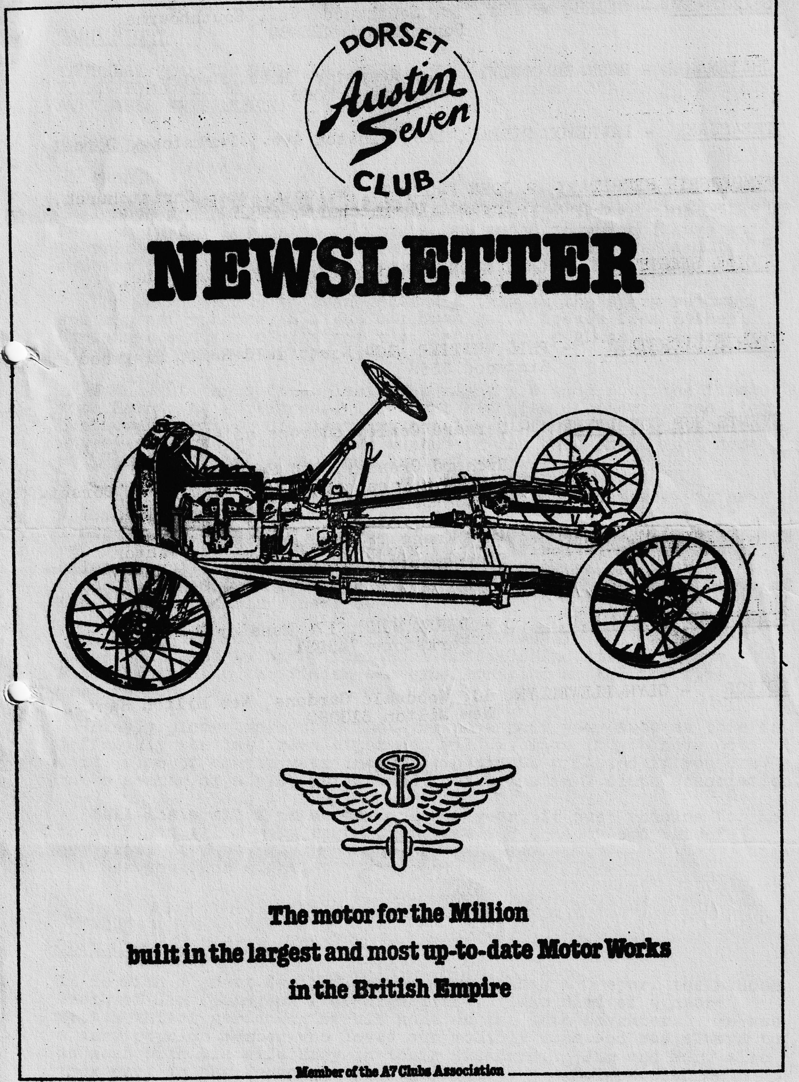

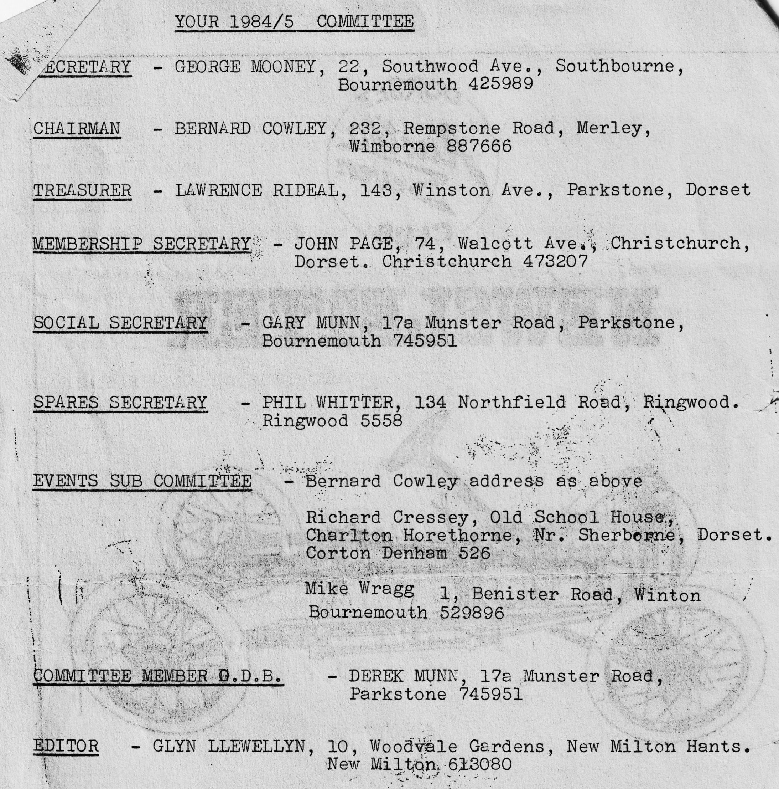

DORSET AUSTIN 7 CLUB NEWSLETTER DECEMBER 1984
MERRY CHRISTMAS TO ALL OUR MEMBERS AND THEIR FAMILIES
CLUB NIGHT
THURSDAY 20th DECEMBER AT THE DORMERS, WIMBORNE. A COUPLE OF FILMS FOLLOWED BY A NOGGIN AND NATTER. (THERE WILL BE NO SPARES AVAILABLE THIS MONTH)
EDITORIAL
Hi gang,
I hope you get your copy of this newsletter before club night as I am rather late with it this month added to which I have got to print it and put it together as our wealthy printer and membership sec. has gone to the Alps skiing for Christmas.
The December run to Swanage, and a trip on the steam railway, was a great success. All the children got a prezzy from Father Christmas and the adults got a mince pie and a glass of Sherry, all except Hilary who had six glasses !!
I thought the auction last club night was good fun: the first with Bernie as auctioneer, I thought his idea of showing one item, but accepting bids on something totally different was quite novel!. Anyway, everyone got what they wanted in the end, and I went home with as much rubbish as I had arrived with.
I popped round to Terry Jefferies house the other week to have a look at his newly finished special. It really is super, it looks like a production sports car, and is beautifully finished in red with black trim, he has wired it for 12 volts, and it has a balanced and tuned engine with large inlet valves and sports camshaft, should go like the proverbial clappers, definitely one of the nicest specials I have seen.
I have just had a set of five Austin 7 wheels shot blast and stove enamelled by Spray Finishers Nuffield Industrial Estate Poole. I thought the finish was excellent and at £35 for five (cash) very reasonable.
Finally, please make sure that you have paid your subs as this is definitely the last newsletter you will receive if you have not paid, also of course your insurance could be affected if you are not a member of a club affiliated to the Austin 7 Clubs Association.
Well, that’s all from me for another year, it just remains for me to wish you all a very merry Christmas and a happy and peaceful new year.
See you Club night.
Glyn
Obituary
It is with a great deal of sorrow that I have to report the sudden death of Jim Clenaghan from Highcliffe. Jim died of a heart attack whilst gardening at his home on the 16th November. He was a very popular member who loved our monthly runs and was always to be seen with his wife Mary in their Tickford. Jim and Mary also took part in the French trips organised by the Solent Club and later by ourselves. I am sure all of us in the Dorsets whould like to express our sympathy to Mary, and their 3 children..
EVENTS CALENDAR
THURSDAY 27th December Committee Meeting 8.30 p.m. Tyrrells Ford, Avon.
TUESDAY JANUARY 1st New Years Day run. Meet at The Cat & Fiddle Inn on the A35 at Hinton 11 a.m. SHARP
SUNDAY 13th JANUARY .... . Austin Seven Clubs Association meeting.•
THURSDAY 17th JANUARY Club Night.
SUNDAY 20th JANUARY Club run more details next month
SATURDAY 16th FEBRUARY SUPER VALENTINES BARN DANCE WITH A LIVE BAND, SUPPER PROVIDED, BRING YOUR OWN DRINK AND GLASSES.
Glyn's Run to the New Forest
We met at the Cat and Fiddle Inn at Hinton. When we arrived, Vic Steele was already there, fresh from his holiday in West Germany in ARY, his Opal tourer. He travelled some 1800 miles altogether and as far as. the East German border. On last year’s holiday he went into East Germany and as far as Russia. He certainly shows some of us younger members up. Anyway, it was lovely to see you on one of our runs, Vic, although it must have seemed a bit tame in comparison.
After the others had turned up we set off in rain and cold as is the tradition at this time of year. There were five cars in all - Us, Vic, Gary, Glyn & Pat and Bernard and Jackie, with 'Claire and Daniel. We had a very pleasant drive through the lanes of Ossemesley Manor and the fords of Brockenhurst. On the way, Glyn’s quiet running car scared the wits out of a horse, which unseated its rider in front of him and then galloped off into the trees. Glyn moved off at almost the same speed. We then drove through the Ornamental Drive on to Burley where the Toffs live, then back to the Cat & Fiddle for dinner. Dusty and Jane arrived - late as ever.
In the afternoon we went on to the Red House Museum at Christchurch to see a part of local history. Everybody enjoyed the museum and seemed reluctant to leave - perhaps because it was so warm inside.
We then went home - I watched a film with Morecambe & Wise in it and Cynthia went to her mums to pick up the kids. I was asleep by the time the Dukes of Hazzard came on. All in all a pretty good day despite the weather.
John Page
SECRETARIAL In recent days and weeks your secretary seems to have been out of the main stream of A7 happenings so this report is necessarily brief but I hope of some interest.
DA7C were represented at the last A7CA meeting by Gary and Glyn who heard about many things some of which will be of interest to you dear reader.
You will probably all now know that DA7C has an officer-in-the A7CA in the form of Geoff Canning as assistant editor, well done Geoff and thanks to John Bateman for the last 4 years.,
The Association are desperate to recruit a new advertising manager. If we do not secure somebody to sell and get-paid-for advertising the magazine cost will double. Any volunteers out there? please let me know.
A new magazine is now in circulation called 'Yesterdays Motorist' apparently a little thin at £1 per copy'. Anyone seen it yet?
There is a new book on the A7 advertised in Automobile at £14.95 each by Chris Harvey. It must be hard to find something new and useful on A7's however this could be a nice Christmas present if you can get hold of a copy.
Some of you may know that Phil Baildon has been working upon a new "All Bodies" poster. It is possible that this excellent poster will be available Xmas ‘84 with a follow on poster for overseas models, coach built and specials for Xmas ‘85. Look out for these, my guess is that you will all want.one 1 Ideal for framing.
For those interested the association registrar is about 18% on his way through producing a new printout with details of known cars. That I believe brings you up to date with national matters.
Closer to home it was with great sadness that I heard of the death of Jim Clenaghan and I feel sure everybody who knew him and Mary will want to offer their condolences and sympathy. --We will miss seeing Jim & Mary in the Tickford on the club runs.
The year is about all in and I believe it has been a good year all round and when you look around the world we in the DA7C have few problems.
I would like to take this opportunity of wishing you all a very happy Christmas and a healthy and prosperous New Year from Joy and myself.
Off to the puffer train tomorrow, see you there or at the dinner or the next club meeting.
Yours truly,
George.
SERVICES
Munwellyn's for all Austin 7 mechanical and electrical repairs and restorations. Phone Gary on Parkstone 745951 or Glyn on New Milton 613080
Brake and Clutch Linings Phone Bernard Cowley Wimborne 887666 for 24 hour service. 8 shoes £15.25 Clutch £8.50
Regars Engineering Columbia Road, Bournemouth. for Crankshaft regrinding and Con rod remetaling. Blocks rebored and general machining.
Shot Blast and Stove Enamelling Spray Finishers, Nuffield Industrial Estate, Poole £35 for 5 A7 wheels (Cash) I can recommend them. Mention the club.
Upholstery and Trimming Colin Morris, Bournemouth 524671
Radiators Repairs or your radiator re-cored. Hants and Dorset Radiators 77, Stanley Road Bournemouth 301277
Resprays George Mooney. Bournemouth 425989
FOR SALE -/ 4 - 450 x 17 Tyres very good condition (nearly new) £40 Phone Gordon Brown New Milton 613996
