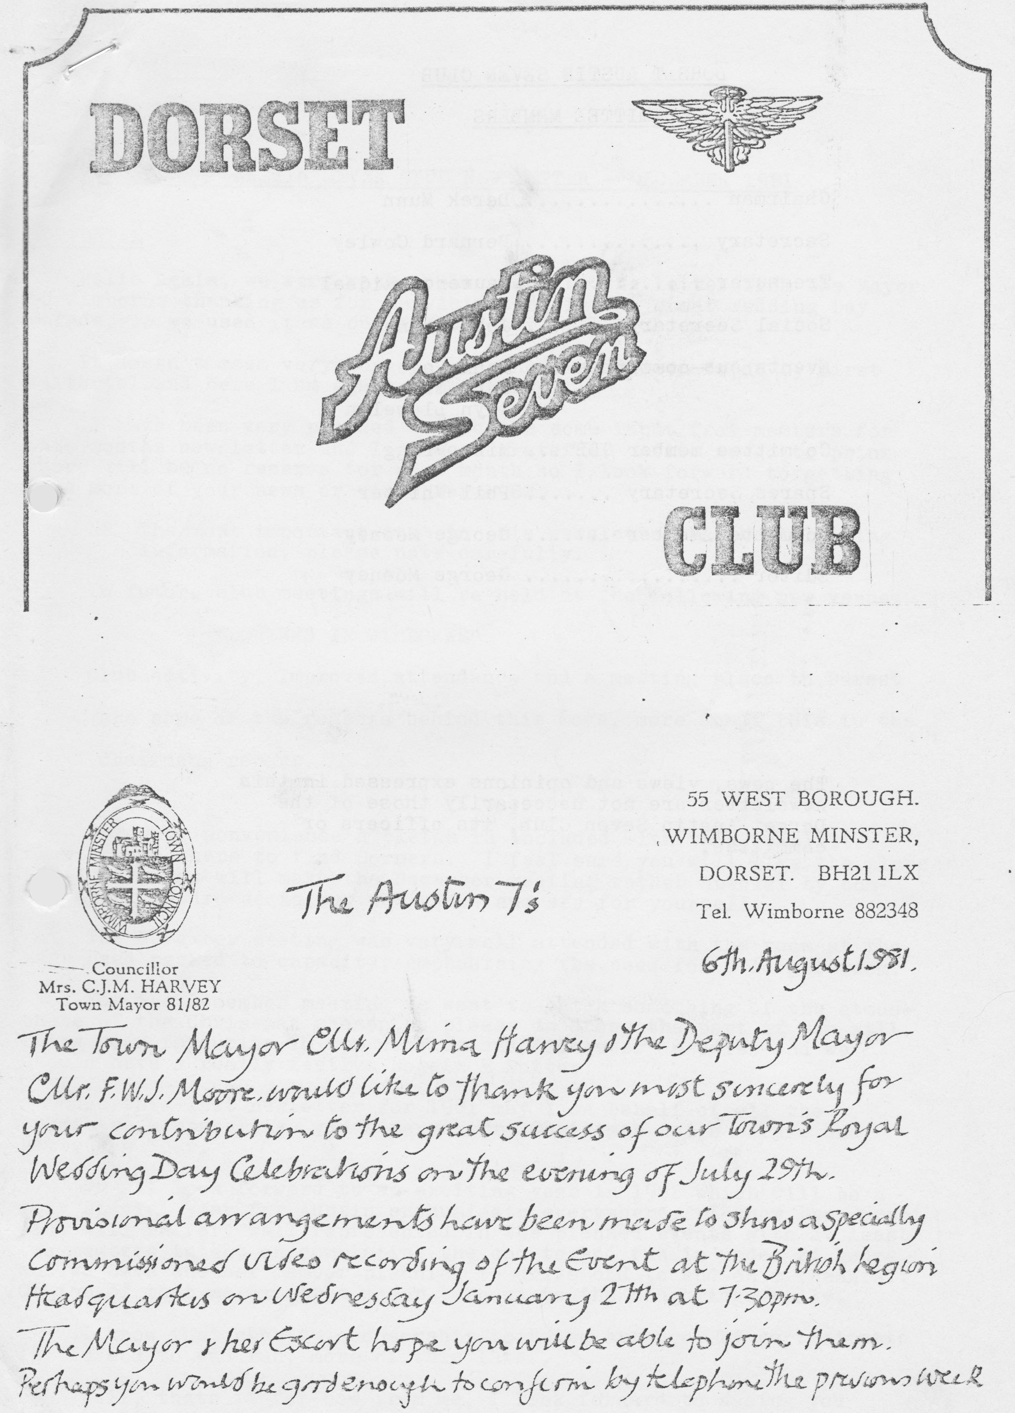

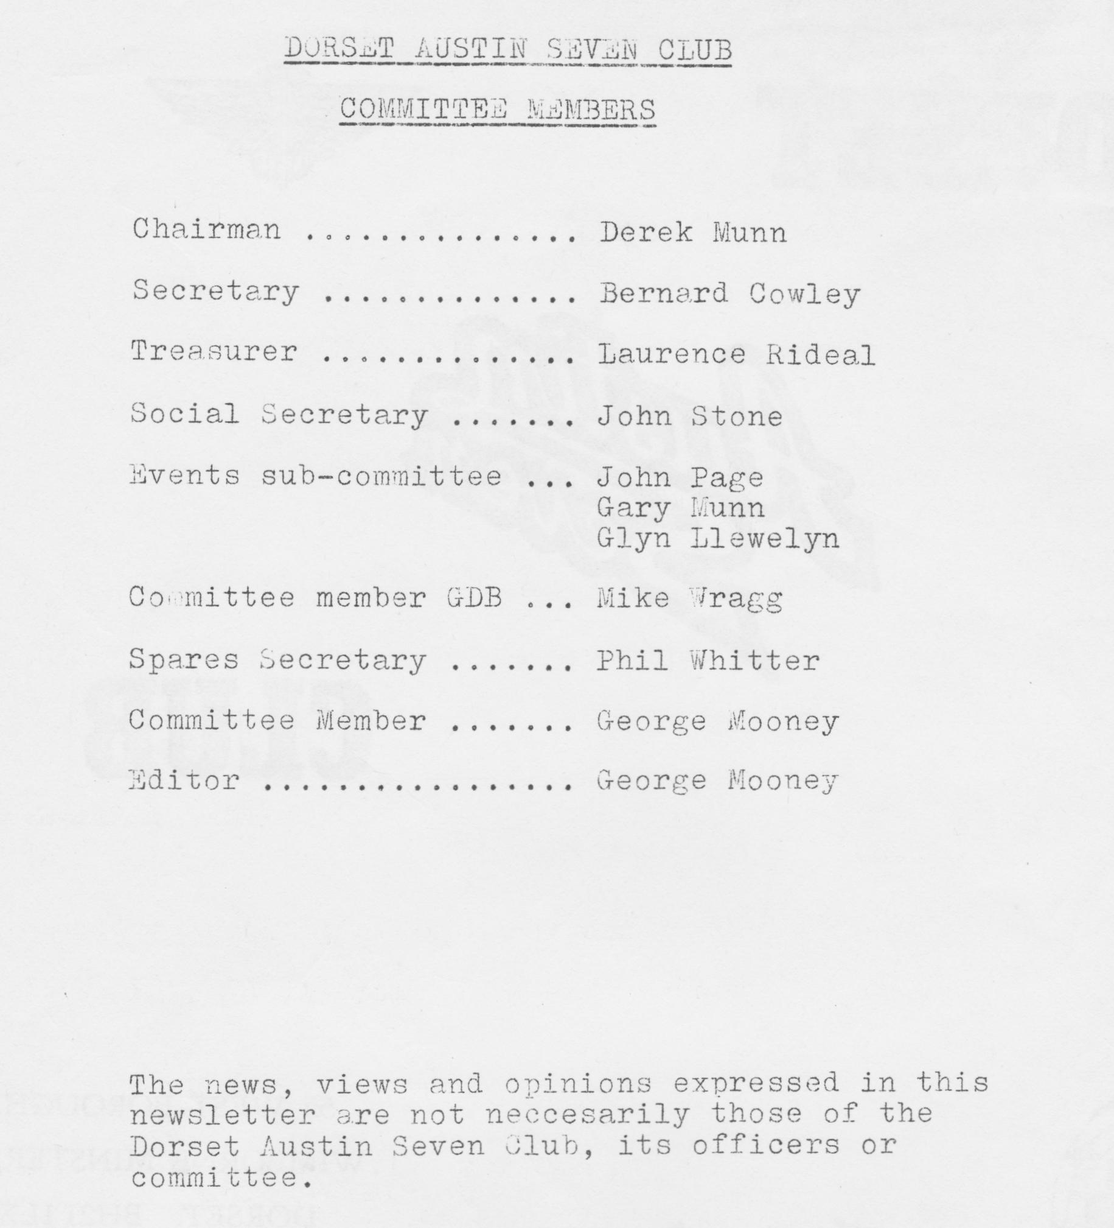

DORSET AUSTIN SEVEN NEWSLETTER DECEMBER 1981

EDITORIAL
Hello again, we were rather pleased with the letter from the Mayor of Wimborne thanking us for participating in the great Wedding Day Parade, so we used it as our front cover.
It doesn't seem very long to me since I sat down to do my first editorial and here I am again. Tempus Fugit!!
I have been very pleased to receive some input from members for this month’s newsletter and I am most grateful. After we go to print there will be no reserve for next month so I look forward to getting some more of your news or views for 1982.
NB The most important item in this newsletter is the following information, please note carefully.
In future club meetings will be held at the following new venue: “DORMERS IN WIMBORNE".
Club activity, improved attendance and a meeting place in Dorset are some of the reasons behind this move, more about this in the Chairman’s report.
For your convenience, a sketch is included with this newsletter showing you where to find Dormers. I feel sure you will like the place and I hope you will make the December meeting rather special by coming along in droves to our new venue and see for yourself.
The November meeting was very well attended with the room at the Nags Head packed to capacity, emphasizing the need for a larger room.
For the December meeting we want to catch something of the atmosphere of the Christmas season so please do dress the part if you will, bring your favourite 78 rpm records and 'Songster' needles and we should have a really festive Noggin & Natter.
In this last newsletter for 1981 may I on behalf of all the committee members wish you a very Merry Christmas and a secure and happy New Year.
We all look forward to an exciting year in 1982 which will be a very special year for Austin enthusiasts everywhere. I know the Dorset club will be very well represented in the planned events with at least two members intent on completing the end to end run in under 24 hours and we have another member planning to drive end to end on a chassis! On top of that we expect a major turnout to the Longbridge rally.
I know that charity sponsorship is being arranged by participants in the end to end run, more of this later.
That’s it for now from me, I look forward to seeing you next meeting.
George

THREE MONTH CALENDAR
17th December. Clubnight Christmas Noggin & Natter, funny hats and crackers optional!
20th December. Sunday Club Run to the High Corner Inn. Depart from Ringwood cattle market car park at 11am sharp. Just a short run to the very popular Inn at Linwood.
21st December. Monday Committee meeting at the Tyrells Ford, Avon. 8.30pm.
1st January. Friday Club run to Calshot. Leave "Cat & Fiddle" at Hinton Admiral 11am sharp (on A35 near Christchurch).
16th January. Saturday Skittles Evening at The Langton Arms, Tarrant Monkton, nr. Blandford.
21st January. Thursday Club Night at the Dormers, Wimborne. Brush up on your Austin facts and general knowledge for a bit of fun.
23rd January. Saturday Solent 10th Anniversary Party, Beaulieu.
24th January. Sunday Club Run to Shaftesbury. Leave Wimborne Square llam sharp.
28th January. Thursday Committee meeting at the Tyrrells Ford 8.30pm.
13th February. Saturday Barn Dance at the Scout Hut, Wimborne. Highly recommended. More details in January newsletter.
18th February. Thursday Club meeting. Further details January newsletter.
21st February. Sunday Club Run to Hamble. Depart 10.30am from Ringwood cattle market car park.
25th February. Thursday Committee Meeting.

Will other club secretaries please note. Visitors to Dorset A7 Club runs are always welcome so come along if you can. Tell your members.

SALES/WANTS
STILL WANTED: Steering wheel in good condition to fit Ruby/Pearl. Please contact, with price/wants: Margaret Cressey, Old School House, Charlton Horethorne, nr. Sherborne, Dorset.

WANTED: Some Ruby parts 1937
N/S rear wing
Pair headlights or singles
Pair sidelights or singles
Ring with price and details. M Lawson, Tel. Gillingham 3496

MEMBERSHIP MATTERS
We welcome a new member this month, Mrs. Angela. McL. Power of 'Wychwood’ Harbridge, Ringwood who has just bought a Ruby, sensible girl.

Change of address: L. Rideal, 3 Woodland Court, 398 Charminster Road, Bournemouth.

Erratum: John Page’s phone number should read 473207. Please note your records.

Brian Pledger dropped us a note to offer his apologies for vanishing from the club scene recently, I'm sure it isn't really necessary! He has been snowed under with work (good for business!) and has moved house to the new address shown in the membership list.

FRENCH TRIP
Many of you will know that in conjunction with Solent, the. club have made a trip to France for the last two years.
A 1982 trip is planned for period 8th April to 16th April. Will all interested members please let the Editor know. Further details later!

NOVEMBER MEETING
The Nags Head room was full to overflowing for the film/slide show at which we showed no films! Instead much fun was had with the semi-automatic slide projectile! It must have been a projectile, the way it shot horrid films of Elvis Presley Munn on to the wide screen.
We saw some great shots of the last French trip and a very special showing of cars in various states of decay. Special thanks to Keith Mitchell for his slides of historic bicycles with the really well-informed commentary. It is always a pleasure listening to somebody who knows their subject, isn't it?
Apart from the slides many a photo collection was perused and the Spares Sec. did a good trade in new spares, a really great night. Thanks for taking part.

REPORT ON THE WEYMOUTH RUN
It was on a cool but dry morning that members of the 'Dorsets' gathered in Wimborne Square for the start of the Weymouth run . This year our organisers for the day were John and Cynthia Page. The rest of the gathering consisted of George and Joy Mooney and family in their Ruby, Bernard and Jacky Cowley and family in a Chummy, Gary Munn also in a Chummy, Richard and Margaret Cressey and Rosie in their R.N. Saloon, Phil and Hilary Whitter and family in a Ruby, Peter and Daphne Holmes and family in a Morris flat-nose, Jim and Mary Clenaghan in a Citroen and Pat and I in the Ruby. Seven Austin 7's, one Morris flat-nose and one modern.
We left Wimborne Square at 10.30am and followed the Page’s Ruby through narrow lanes bordered by trees covered in the brown and bold leaves of their Autumn livery. After about half an hour Gary waved us down at a junction, saying that one of our group had gone straight on, instead of following the others round a left turn. He rushed off in pursuit, and returned after about fifteen minutes to say that he had found them and that they were returning. So, after a natter we all plodded on again to reach our lunch stop, 'The Sun Ray Inn' just outside Weymouth at about 1 o'clock. We were made very welcome by the Landlord who opened a room especially for the children as the Children’s Room was being given a face lift.
After a fine meal and one or two pints, we trooped back out to the cars and wended our way through Weymouth town and on to Portland Bill, where we stopped in the car park near the lighthouse. On our last visit, the fog horn had been sounding and I can assure you it is not very pleasant when you are stood right underneath it. This year, however, apart from the sound of the surf on the rocks, all was quiet and several of us went for a walk around the 'Bill'.
By the time we had retraced our path back to the cars, we all felt a bit cold and decided to have a cup of tea in the small Cafe. There was not much room and we just about took the place over, but the staff didn't seem to mind. All too soon it was time to leave and after a session of driving one another’s cars around the car park we set off for an uneventful trip home, thanks John and Cyn for a very pleasant run.
Glyn.

*(This is really a great pub: At the time we were there a group of about 60 horses and riders stopped here for lunch. A7's and horses all over the place and in the middle of all this activity the Landlord’s wife was going frantic! The micro-wave oven broke down!) Ed.

OLD GROANERS
“Now Miss, what gear were you in at the time of the accident?"
"Let me see Officer - blue skirt, blue Dorset sweat shirt and kinky boots!"

*******
Abe: Solly, sorry to hear about the fire!
Solly: Schhh, it's tomorrow.

*******
"I'm very sorry lady, I've just run over your cat. I'd like to replace it!"
"How are you at catching mice?"

********
Son: Dad, there's a man at the door with a bill.
Dad: Don't be daft, it must be a duck.

********
How did you find the steak, Sir? Easy, I'm a detective.
*******
Jock: Doctor, I'm not feeling myself.
Doctor. Glad to hear it Jock, it’s a filthy habit.

*****
Where do policemen live? 999 Letsbe Avenue.

TECHNICAL TIPS
This month a few from other newsletters, please send yours next month.
Bristol club remind us that Winter is on its way and suggest that you might take your fan belt off right now. The car will warm quicker and is unlikely to overheat in the cold weather. But keep an ear cocked for gurgles just the same. Incidentally, it does make sense to hand crank the engine two or three revolutions before starting the engine to get some oil around before you start it. It will cut down the wear and tear.
For those of us restoring cars Bristol club report that Renault 4 van (and presumably saloon) felt window channel is identical to that which suits Rubys and Boxes, so pop down to your local Renault agent. and get some.

THIS AND THAT
'Meshing Point’, the Scottish A7 Club bulletin, carried an article about a new film due for release by United Artists. The film is a wartime spy thriller starring Donald Sutherland, Kate Nelligan,
Ian Bannen, Christopher Casenove, the Scottish A7 Club and sundry others!
The film features the following vehicles provided by the SA7C and others Singer Le Mans, Morris 8, Riley Falcon, Riley Monaco, A7 Van, Ruby, Ford Y, Velocette 350, Triumph 350.
It has been a reported success in the USA taking three million dollars in its first week! It sounds like compulsory viewing. With thanks to Scottish A7 Club.

Glyn Llewelyn and George Mooney have just announced a race to the finish with an Easter target for two more Boxes on the road in the Dorset club. No money changed hands but the winner gets to buy the second round! Both of them have been lacking in refreshment and are now drinking the meths that refreshes the parts that other drinks can’t reach!! Does anyone believe they will do it? Wait for the next exciting episode.

CLUB SPARES
The following club spares (unless previously sold) available from Phil Whitter on club night or on Ringwood 5558 by arrangement

All felt oil seals King pin sets early & late
All gaskets Lock washers
All studs and stepped studs Manifold nuts and studs
Brake cables Oil Pump springs
Brake cams Prop shaft universal joints.
Brake cam bushes Radiator hoses
Brake drum screws - Rim tapes 17"
Clutch linings Rear spring pins & bushes
Clutch mousetrap springs Bad. caps (Ruby)
Clutch comp. springs Spring shackle bushes
Core plugs large & small Spark plugs
Distributor caps. (late) Shock absorber rubbers & washers
Engine mounting rubbers Shaft keys
Exhaust flange nuts & bolts Track rod kits
Distributor points (Ruby type) Valves
Dynamo brushes Valve guides
Fly wheel keys & nuts Valve springs
Fan belts early & late (original & nylon)

Special Offers This Month
Nylon everlasting fan belts coil/mag £l each
Split collet valves (believed, but not guaranteed to be exhaust quality, £1.50 each (normally £2.20)
LI 1¼ bearings for wheel hubs diff. ball races 23-28 1st motion shaft 3-speed box normally £6.30 each, £3 each/£5 pair.
SWEATSHIRTS available in Navy Blue, Red and Grey with large and small motifs. Ideal Christmas presents!!! Available at next Club meeting get 'em while stocks last.
Please note orders to Phil Whitter for your sweatshirts, cash or cheque with order, if stocked items not your size. Most popular sizes available. See Phil on clubnight or ring Ringwood 5558.

Ode to an A7
The Seven is my auto, I shall not want ... another,
It maketh me to lie down in wet places,
It anointeth my face with oil,
For its sump runneth over,
Its rods and its engine discomfort me,
It leadeth me into the paths of ridicule for its name’s sake,
Yea, though I run down the valleys,
I am towed up the hills,
Surely to goodness the darn thing,
Wont follow me all the days of my life,
Or I shall dwell in the house of the insane for ever.

************
The Seven Bug
When I first met Richard, it was several weeks before he mentioned that he owned an Austin Seven, which at the time meant little to me. About a month later he took me to see the R.N. Saloon which was stored in a friend's barn for the winter (it's used all year round nowadays). I can remember feeling slightly disappointed when he opened the door of the large and lofty barn to reveal a little blue and black box tucked away in one corner. I didn't know a thing about cars, ancient or modern, and wondered why Richard was so enthusiastic about the fact that the Austin started first time - with stale petrol!
However during that summer some of Richard’s enthusiasm rubbed off onto me and I enjoyed going to various rallies, although I couldn't tell one Seven from another, except that some were open and others closed.
By the following summer I was sufficiently fond and confident of the car to agree to go on honeymoon to York in it and after unravelling the several rolls of loo paper in which the car had been wrapped, we headed north, smelling strongly of kippers! The car did not go very well on the journey - the engine was missing by the time we got to Frome, about 12 miles away. It was such a hot day that the petrol was evaporating in the carburettor. We eventually reached York and for the rest of our stay, when travelling, simply took the bonnet off to cool the engine.

By the end of our honeymoon, my enthusiasm was building up. I started to read Richard's A7 books and newsletters and didn't automatically switch off when Richard started talking A7.
A couple of years later Richard decided to have the Box resprayed. He was to prepare the car for spraying himself and as he removed the wings, et cetera, they had to be stored somewhere. The obvious place was the dining room. I was rather dismayed since it had taken the three years that we had been married to clear it of two bicycles, one B.S.A. motorbike and several piles of junk. To reach the sideboard was rather like attempting an assault course. I was always tripping over something but gritted my teeth - it was all in a good cause after all.
Gradually I found that when someone asked me about the Box, I was able to tell them quite a lot. I was rather surprised when I walked round the Berkeley Rally giving a friend a short run-down on the different models. Where did I acquire all this information? I suppose when you live with someone who lives and breathes A7 90% of the time, you're bound to absorb something.
I realised I was becoming equally fanatical when I insisted that our new-born daughter should travel home from hospital in the Box, despite the fact that it had been snowing the day before and it was an extremely cold and foggy afternoon.
We have recently acquired a very original Pearl Cabriolet and are working towards having it on the road next year. I decided I would like to be actively involved in the restoration this time (I'm not sure if Richard is pleased by this decision!) and I'm doing the fun jobs, like cleaning and treating the upholstery, polishing the chrome and shortly, rubbing down the chassis.
What prompted me to write this? Well, this morning, whilst picking my way across the dining room floor, I tripped over the Pearl's back seat. I was about to curse Richard when I remembered this time I'm the culprit!
Margaret Cressey

*********
Well, that’s it for this month folks. Let me have your 'Old Groaners', Technical Tips, Sales and Wants, Services information, letters of praise or moans or anything for the newsletter, I get lonely!! See you Clubnight.

Copy date for January newsletter 5th January. SALES & WANTS EXTRA
WANTED a set of 5 x 19" chrome centre wheels for a Club member. Please contact P. Whitter with details, price, what you require, on Ringwood 5558.

SKITTLES EVENING
Saturday 16th January

A Skittles evening has been arranged at the Langton Arms, Tarrant Monkton, to be held in the skittle alley at the rear of the pub. The alley has its own bar and the cost of the evening includes a buffet supper.
Please complete the attached form and return it to John Stone, 22 Cobham Way, Merley, Wimborne, Dorset by the 4th January 1982 with your cheque.
The village of Tarrant Monkton is signposted from the main Blandford/Wimborne road at The True Lovers Knot pub and also signposted on the Blandford/Salisbury road.

Name

No. of persons @ £2.00 each.

Amount enclosed

Austin 7 Brake Lining Service. Exchange Brake Shoes

Special Price to DA7C members.

Set of 8 shoes any year relined with original wire braced linings or softer better braking material £12.25 inc.VAT (postage £2 extra if I cannot deliver)

Also available
Clutch linings incl. rivets 23/36 ..„....£7.50 inc. VAT

Also your flywheel and centre plate relined for an extra £2 - personal service only.
Exchange Borg and Beck 36/39 clutch plate … £9.50
Austin 8 - 10 - 12 exchange brake shoes …£18 set
Bernard Cowley, 232 Remptstone Road Wimborne. Tel. 887666

