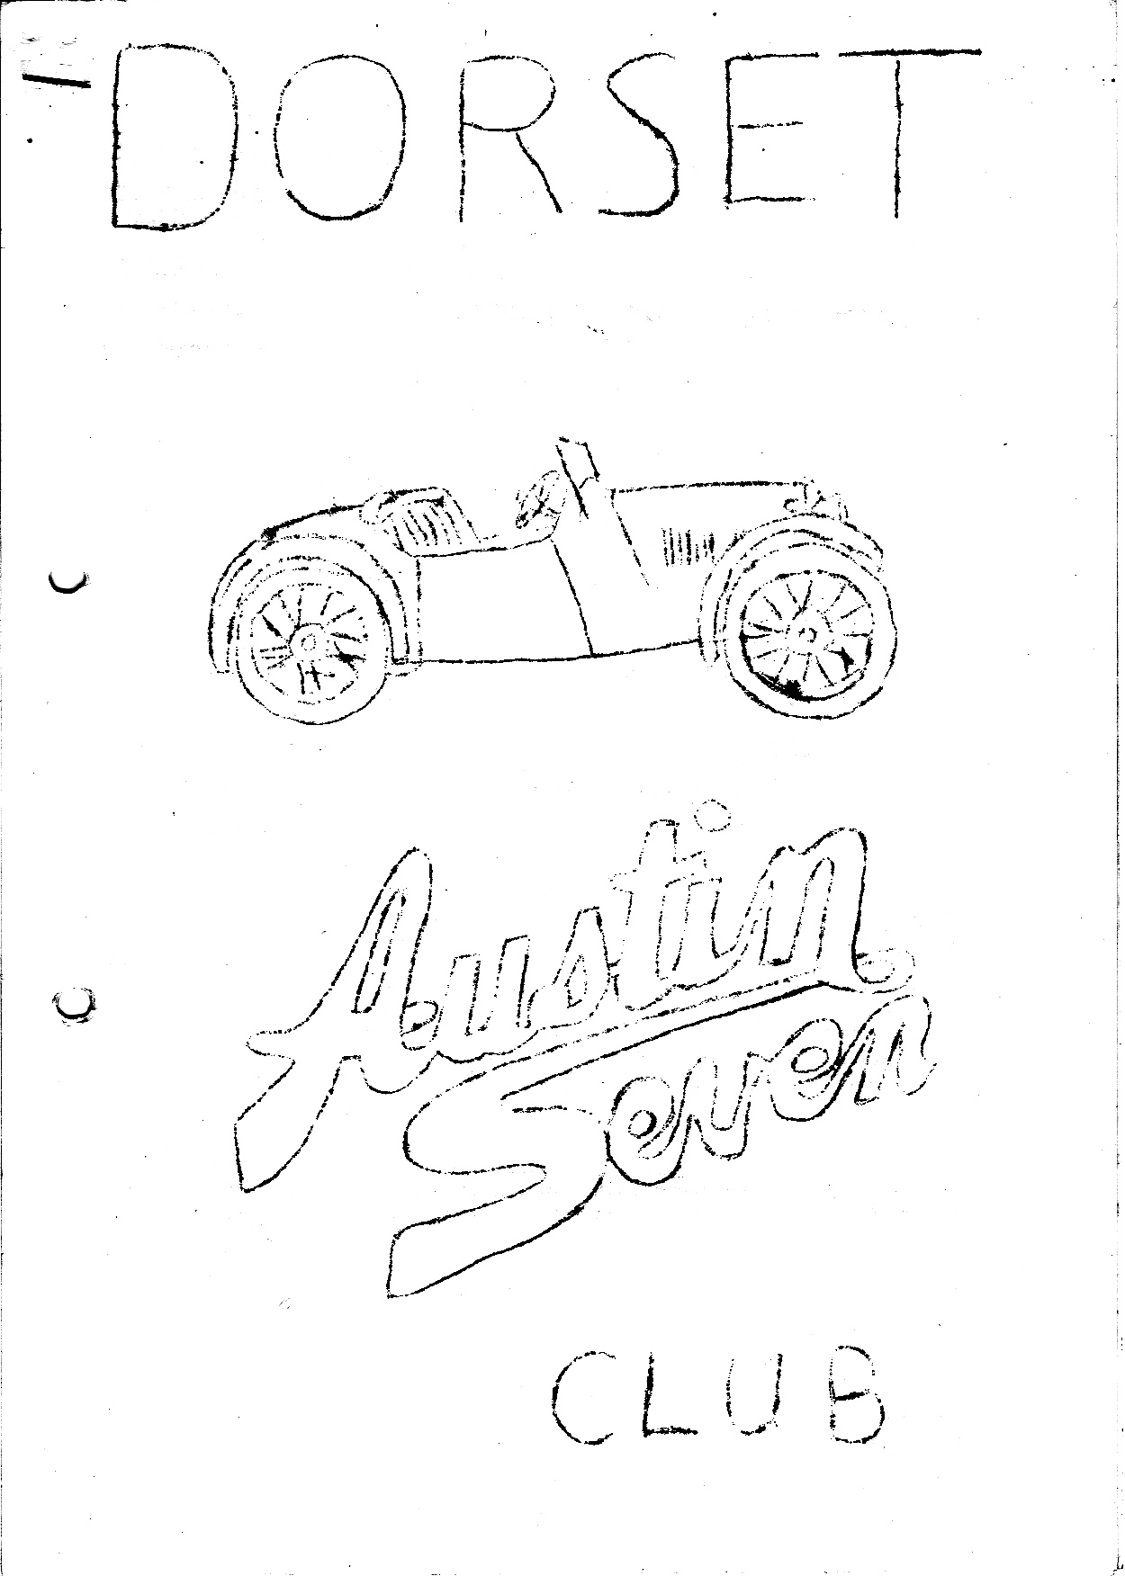
DORSET AUSTIN 7 CLUB NEWSLETTER DECEMBER 1980

DECEMBER CLUB NIGHT Thursday 18th
A TALK ON OVERHAULING A7 DYNAMOS BY PHIL WHITTER AT THE NAGS HEAD, RINGWOOD.
JANUARY CLUB NIGHT Thursday 15th At the Nags Head, Ringwood.
OUR INTREPID SECRETARY IS ORGANISING A QUIZ, SO GET SWATTING.

NEXT COMMITTEE MEETING Tyrrells Ford, Avon on TUESDAY 23rd December

EDITORIAL
With only a week to go to Christmas, and the end of another year. I think it has been a good year for our club with quite a varied events calendar most of which were reasonably well attended, with one or two exceptions. The programme for 1981, promises even more variety and will, hopefully, be even more successful as new members join in on the runs, and newly restored cars are put on the road for the first time.
On behalf of the committee, a very merry Christmas and happy 'Sevening’ in the new year to all of you.
Glyn

NOVEMBER CLUBNIGHT
Tom Newsome of the Pre-War Austin Club came down to the Nags Head on club night and showed us some of his many films. I think that it was one of the best evenings that we have had at the Nags Head. All those who came agreed that it was the best laugh they had had in ages.
The evening started with a film of a rally run by the Pre-War Club, the rally took place near Ashby de la Zouch, Leics. There was on show a very diverse cross section of motor cars, including many 'Sevens' and the event included a game of Auto Polo, where the passenger had a big mallet with which to hit a football around a marked course.
Tom went to some length to explain that his photography was not very good though some shots of female posteriors looked very well practiced. The next film was concerned with a holiday Tom had had in France, riding a 1935 push bike, which he had just restored. All his gear, consisting of a small suit case, a sleeping bag, and a polythene bag to sleep in, was strapped onto a carrier on the back of the bike and, in this manner, he made his way through France, his main aim to visit the twin town of Ashby De La Zouch, the name of which escapes me.
After this film there was a break to re-charge our glasses, after which Tom told us that he lived in a semi-detached house in Ashby De La Zouch, with no rear access. He went on to explain that he
wanted to get his Ruby round the back, build a brick garage around it, and restore the car. The following film was to be how he managed it. First, considered taking down his neighbours fence, between the two houses and simply driving the car in that way. But although he got on quite well with them, they would not allow him to do this. He next considered driving the car down the public footpath at the rear of the house, removing the fence, building a bridge across what he called the brook, which was a stream in a very deep ditch, and getting in that way. His neighbour, however, thought that the people down the way, would certainly complain to the council, who owned the footpath and the fence. The third alternative was the one they decided to adopt, and consisted of building, by means of scaffolding, two platforms over the neighbours dividing fence, driving the Ruby up, via ramps, on to the first platform then across to the second, and then dismantling the first to put it up again on the other side of the second one, and carrying on infinitum until they reached their goal.
Things did not go smoothly however, and the film opened with a shot of Tom driving up a pair of very steep ramps, being pushed by many willing hands, and then, 'Calamity' just as his front wheels rolled on to the first platform, the ramps collapsed and the rear of the car crashed down to the ground, and hung at a very precarious angle. Tom could be seen shouting and gesticulating to be freed from the car so that he might dash to the lavatory. On his return, there was a conference as to what to do next, and it was decided to try the second alternative, namely, to drive up the public footpath, remove the fence, cross the "Grand Canyon" and home.
The first part of the operation went smoothly, and they built the bridge out of the roofing timber for the garage. Tom then edged the Austin slowly across the great divide, first the front wheels eased on to the far bank and then the rear ones inched slowly off the bridge and, calamity, the bridge collapsed. Fortunately, the car did not plummet into the bottomless abyss but with much pushing and digging was slowly eased up the bank and into the garden, where it can now be lovingly restored.
Please Tom come back and show us how you get it out again. I think I would have sooner moved.
GLYN

REPORT ON OCTOBER MEETING OF A7CA
Lawrence and I travelled to Great Haseley to represent Dorset at the October meeting. On the spares side, it was reported by John Barlow that for the seventeen months ending 31.5.80 sales amounted to £15,400 showing a profit of £766 of which approx. £300 was due to the Association. There was also some discussion on the production of brake levers (which we all need !). Obviously, such items needed to be 100% from the safety point of view and samples were being tested to 800 lbs before bending. These examples were forged and there was mention of high quality cast examples which Keith Roach was experimenting with. John Bateman had taken over as editor from Roger Shea and new printers were being sought in the Reading area. Dorset was mentioned as one club that did not send its newsletter to the editor (we send it to the secretary). We also heard that the index to the first ten years of A7CA mags. was due soon.
New telephone numbers to note were A7 Services now Thirsk 587201 and Everest Insurance now Worthing 204341.
At dinner time Joe Spalter showed us the first reprint of an Austin Motor Co. film "Men Who Work". This is available in Super 8 sound (copied from original 16 mm.) at £28 a copy. It was really interesting to see work conditions and methods of production in 1935 and I understand it was possible to estimate from the film that the average weekly wage at Longbridge was about £3.50. There were some interesting shots of Austin transport used by the workers - Sevens in particular
After dinner there was some lengthy discussion on club liabilities for damage claims and it was suggested that the A7CA pursue investigation of a blanket cover policy for all member clubs. After one or two minor items in AOB. the meeting closed and Lawrence and I rushed off to a place just north of Oxford for me to pick up a Ruby chassis and some bits from a contact I made in the Summer.
We then had a good trip back weighed down by a Ruby chassis on the roof rack!
Phil Whitter

The following letter was received by Lawrence Rideal

Kokerlaan 5
0vrijse 1900 Belgium
4.11.80
Dear Lawrence,
I have received and read with interest the Dorset A7 Club Newsletter. Regrettably I cannot of course take part in many events. However, my 1932 A7 is now completed, less the upholstery, which Owen Legg is going to do early next year.
So my interest now turns to the Chummy (replica) project. I have a good quote from John Heath for a 1926 Body Shell and hope to start preparing a chassis. As I mentioned last summer, my only
spare chassis is on a 1932 special and is of course a long wheelbase frame. I wondered, therefore, if, through the club, there was any possibility to locate and buy/swap a short wheelbase fame. Alternatively, do any member have direct detailed experience of how to shorten the longer frame, as done by many special builders and racers.
Any assistance would be more than welcome, so that work this end can commence.
Regards,
Dr. I.D.R Mason-Smith

Can anyone help?

LONDON TO BRIGHTON VETERAN CAR RUN
Although I have been to the finish of the London to Brighton many times, I have never before been to the start of the run from Hyde Park, mainly due to the early start needed. However, this year we were in London for a few days, so decided to make the effort to see the cars set off for Brighton. On the approach to Hyde Park along Kensington High Street we caught up with a veteran car driving to the start, as we found out a little later several of the London-based cars drove to the start. Most, however, are brought on trailers and unloaded around the perimeter of the Park, then started and driven to the centre of the park for the off. Most owners have friends and helpers in another modern car in attendance. When the correct number of people have gone off in the veteran car the following car and trailer is loaded with the spare modern and towed down to Brighton - to save money I suppose. The veterans are lined up on either side of the road in a kind of Le Mans start and are called for the off in small groups, oldest first, by a town cryer with a staff and bell and dressed in the criers garb. We wore able to wander amongst the lines of cars, and see the owners and drivers getting the engines started and chatting amongst themselves, and to spectators - no sticky fingers here - totally different from Brighton where the cars are all fenced in a paddock for safe keeping.
There were 321 cars entered for this year’s event and just over 300 started. No. 1 was a 1893 Benz driven by ex-racing driver Phil Hill. Although there are many differences of opinion on the subject of who invented the motor car, it is generally accepted that Gottlich Daimler and .his fellow countryman Karl Benz were the true fathers of the motor industry. Not surprisingly, Benz was well represented in the run with 13 cars taking part. One, an English Benz, entered by an American is believed to be the first car assembled in Jersey and first took part in the Brighton run in 1928. A similar model Benz had been in the same family from new, being handed down from father to son and has entered every run since 1927, The Americans had many cars entered with no less than 7 Cadillacs, 4 being flown over just for the run. Also entered from America was a 1901 Columbia electric driven car once owned by Thomas Edison and then given to Henry Ford in 1907 where it
remained in the museum until 1977. This car has a range of 72 miles before a recharge is necessary.
Many cars came from Europe, one Dorracq made in France in 1900 is believed to be the only one of its kind, and has been brought from Switzerland just for the run. Later Dorracq became famous for their racing successes. The most popular French car seems to be the De Dion Bouton with 57 due to start the run. Of the British cars entered was a 1902 Dennis (of fire engine fame) driven by a member of the Dennis family. A remarkable English car is the "English Mechanic", this being a do it yourself car made from a kit in 1900 and two survive today. Mercedes had 6 cars entered, one still
capable of breaking the 1903 land speed record of 84 mph. The oldest known Rolls Royce in existence was also there. Charles Rolls introduced Peugot to this country in 1895 and several were entered for the run, one baby Peugeot from Japan sent here in packlng cases. Several Steam cars were entered, notably Stanley who at one time held the land speed record. A regular for the run is a 1898 Stephens, and was driven by R.J. Stephens who helped his father build it. Finally a 1900 Daimler owned by the Queen and driven by Prince Michael of Kent, which is thought to be the car bought by King Edward V11 in 1900.
This is certainly the best show of veteran cars in the world

ROUND EUROPE IN AN AUSTIN 7 PART 3
We drove on a pretty flat road to Berne - which we passed on an excellent dual carriageway, and travelled on towards Interlaken. By now we were becoming increasingly aware of Switzerland’s beauty as we drove by a lakeside with mountains towering all around. We had to cross these - a daunting challenge.
Arriving at Interlaken at lunchtime, we parked the car and set off to explore this lovely town, but all the shops were closed so we contented ourselves with spending an hour supping pints of Bass on
draught in an "English Pub"!
After lunch, we cashed a couple of travellers cheques, and set off for an afternoon’s excursion to visit Mount Titlis. When we arrived at the cable car start, some 2 ½ hours later, a coach load of English people rushed up and patted us on our backs, quite astonished that we had made the climb in such an old car. They obviously didn't know Austin 7's. As it was 4.30 p.m., too late to go right to the top of the mountain, which was in cloud anyway, we contented ourselves with a ride up to the snow line costing £3 each, instead of the rip-off price of £20 to travel to the summit - well at least I can say I have been on a cable car (very similar to your own Ed.) When we returned to the car,
it was surrounded by local National Service soldiers, all looking on admiringly except one who assured his mates that it was obviously extensively modernized (coil ignition and electric lights Ed.)
By the time we got back to Interlaken after some shopping, it was dark, so we pitched the tent at a campsite by the lake, and went down the road for a drink after supper and retired. We awoke next morning to a magnificent view of the lake surrounded by mountains and engulfed in a veil of mist. Setting off early, we found ourselves at "The Gorge of the Aart" by 9.00 a.m. and spent an enjoyable hour walking by the river with the Gorge walls towering above us on both sides. We decided to press on to lake Orta just inside Italy some 100 odd miles distant. On the map this didn’t seem far, with just a couple of squiggles showing mountain passes – some squiggles!! The first was the Grimsel Pass which took 3 hours to climb, mostly around hairpin bends, on the edge of the mountain, and to make matters worse the "road" was being extensively repaired and re-routed, and on several occasions we only just managed to re-start after stopping at make-shift traffic control, indeed at one or two places we just had to crawl on disregarding the signs, otherwise we wouldn’t have got going again, but naturally we made it to the top some 12,000 feet up, triumphant, oblivious to the looks of astonishment around us, and celebrated with a couple of beers and lunch in the summit cafe.
The trouble with Swiss mountain passes is that no sooner have you struggled to the top on one side, than you corkscrew down again on the other side, which is great fun on the edge of a mountain with Austin 7 brakes!! By now it was getting rather warm and after an hour of flat driving we reached the second and last mountain pass - the Simplon which looked easier than the previous one as it was less steeply graded and had an excellent surface. But we forgot one thing, the afternoon heat, and thus after only about five minutes in 2nd gear the car started to cough and splutter badly. Fearing a partly seized engine, I stopped rather smartly to have a look. In fact, the engine itself was quite free, but the carburettor was rather hot, in fact so hot that the petrol was boiling in the float chamber, so starving the engine. The only solution was to soak a duster in water, wrap it
around the carb. and prop the bonnet open with my car mascot teddy bear (Your What? Ed.) Anyway this worked and we continued up to about half way when smoke started rising from under the bonnet. (The Teddy was on fire? Ed.) Hastily stopping I found the duster smoldering and duly re-soaked it with water.
As we neared the summit the engine began to knock rather, which somewhat worried me to say the least. 8,000 feet up in Switzerland seemed rather a lunatic spot to strip down an engine! But mercifully after a short stop to cool down, and a top up with water we continued on with the engine quiet again and me rather relieved. By the time we reached the top we had no spare water left, so after a top up and a tank of petrol, we were all set to start our decent to meet the suicidal drivers of Italy.

TECHNICAL TIPS
When I took the Ruby engine out for an overhaul in June my replacement unit was a bit of an unknown quantity. It was "unknown" in that I took it out of a scrap Ruby about ten years ago and it had been lying in the shed ever since and the only attention I had given it was oil in the bores. It appeared to be seized but this proved to be only a nut which had dropped into the timing gears.
My first job was to take off the sump and assess the wear on the big ends and main bearings. Beware main bearing rollers which have stood still for many years - they can be corroded. Luckily mine were ok and I decided to leave the slack in the big ends until it was running so I could assess any noise (motto - do them at the time) Next I checked all the gudgeon pin clamp bolts were really tight, (I once had one come adrift and take half a piston with it) locking tabs are b…y useless - use lock washers, Loctite and make sure the H.T. bolts are in good condition and really tight.
I then turned my attention to the oilways taking the plugs out of the main gallery and made sure everything was clean.by blowing paraffin through and also ensuring a good 'line of fire' from the oil jets to the crankshaft troughs. It was at this point that the need to check "unknown" areas paid off. You can't clear the front camshaft oilway without taking the cam out and there, nestling nicely in the end of the oilway, was a great lump of steel from a previous mechanical disaster. Ever tried putting a camshaft and rollers back in without dropping rollers everywhere? The answer seems to be put the rollers on the shaft with grease, wire them in position with a piece of wire rather like a piston clamp and then gently push the shaft into position and the bearing housing will push the wire off. Don't forget to cut the wire ring off. After this I overhauled the top end with new valves and springs and a general decoke noting the block was + 60, worth knowing to carry the right size spare piston with you. I was just about to put the sump on when I decided to check the oil pump. I took the hose off and both vanes were heavily corroded through standing so long. I managed to find another set from another engine - pity someone does not make them. Now, changing the subject completely, with all this cold weather I decided to take my fan belt off. Simple job I thought, but once it was off the noise from the unloaded timing gears was such that I put it on again. The result was then a high-pitched scream every time I revved the engine. I took the fan off, still the same, then by luck I noticed as I leant on the carb the scream got worse - it was a leaking manifold gasket due to loose stub nuts.
Incidentally talking about fan belts, if yours keeps creeping off the pulley take it off and turn it round and it should creep back on due to the direction of weave.
Well folks, that’s all the useless info, for this month.
Phil Whitter

YOUR 1981 COMMITTEE
CHAIRMAN Derek Munn 36, Avon Ave., Avon Castle, Ringwood 78795
SECRETARY Bernard Cowley, 232 Rempstone Road, Merley, Wimborne 887666
TREASURER Lawrence Rideal, 68, Strouden Ave., Bournemouth 510105
SOCIAL SECRETARY John Stone, 22, Cobham Way, Wimborne, 886537
EVENTS SUB COMMITTEE John Page, 74, Walcott Ave. Christchurch 75207.
Gary Munn, 36, Avon Ave. Avon Castle, Ringwood 78795. Glyn Llewellyn 10 Woodvale Gardens, New Milton, 613080.
COMMITTEE MEMBER G.D B Mike Wragg, 239, Station Road, West Moors, Ferndown 875087
NEWSLETTER EDITOR Glyn Llewellyn, 10, Woodvale Gardens, New Milton 613080
MEMBERSHIP SECRETARY George Mooney, 22, Southwood Ave., Southbolunc, Bournemouth 425989

