DORSET AUSTIN SEVEN CLUB December 1976
SECRETARIAL December always seems a very quiet month on the A7 scene - everyone getting on with their restoration, or dare I call it resurrections. Peter Treliving has just torn apart his Ruby and Phil Whitter is busy building a garage to store and rebuild his Ruby. Chris Smith's Ruby seems well on the way to being ready for the road and likewise Gary Munn's 30/31 Box. Nice to see that Geoff Kingsland’s Ruby has now overcome its oil leaks. He was telling me that the rear main bearing carrier did not have a drain hole and subsequently the oil was running straight out into the clutch housing instead of back to the sump!
I was very surprised at the turn out at the last meeting and also how many Sevens there were in the car park - considering that there was Miss World on the box. First on the agenda was to choose the club badge. Type B in last month’s newsletter was chosen by a majority decision after a lot of discussion about the merits of the other 14 badges on show - a very good effort by everyone concerned. A copy was then shown around of the Austin Seven Journal, which I can supply to members on club nights for the princely sum of 10p when available.
Next came the highlight of the evening, a showing of slides of Beaulieu,North Devon runs, Longbridge rally, a few buses and some of Singer rallies from John (1924; Singer) Bramwell.
NEXT CLUB NIGHT December 16th We have devised what is called a Tabletop Concours - that is any part belonging to, or associated with, a car in immaculate order, or even a model of a car which you have made, will be judged. There will be two teams, each judging the others items. A prize will be given for the best item of the evening - only one entry each please.
This month’s newsletter consists of "How to set up a front axle", courtesy of the 750 Bulletin 1955 and further episodes from the Austin Seven Service Bulletin. This month - how to remove a Ruby gearbox.
SALES AND WANTS
Wanted Rear side window frames and catches for '35 Ruby and shock-absorber star spring. Chris Smith Ferndown 874205
Wanted Very Urgent - 30/31 Headlights - a pair. Gary Munn Ferndown
891473
Wanted 31/32 Gearlever for 3-speed box. Richard Cowell Sturminster
Newton 72573
Wanted Nearside front wing and door for '35 Ruby. M.A.Field, 62 Weldon Avenue, Bear Cross.
Wanted Clutch thrust bearing for Ruby. Dave Rogers, c/o Herbert Hospital, Alumhurst Road, Westbourne.
Wanted Pair front seat squabs and radiator grill side-plates for 1936 Ruby. Phil Whitter.
A Ruby might possibly be for sale for a reasonable price, near Ringwood. See Phil for details.
Please inform Phil Whitter on clubnight or at 89 York Road, Broadstone Tel. Broadstone 04857, re. your sales and wants.

FRONT END ATTENTION by K. A. Bowden
Good steering depends firstly on a sound axle beam correctly aligned. In the case of the A7 beam, check that the king pin retaining ends are not twisted (See Fig. 1).
The system should be made self-centering, back-lash in the steering box or joints is not really important though rather undesirable. With ordinary standard shock absorbers and a level road you should be able to release the wheel and still keep straight ahead. Ninety percent of lack of stability is due to having insufficient castor rake on the axle beam.
Have a look at the front forks of a motor cycle or bicycle sideways on. Fig. 2 shows the A7 beam viewed side-on from the offside with the stub axle removed. The rake should be nine degrees positive. (It never is as standard). If the chassis is level in normal road trim this is easily obtained by loosening off the radius arm nuts, twisting each arm in turn, and whilst so twisted lock the nut up tight (Fig. 3) If the chassis is high at the rear, i.e. cambered springs, lower the radius arm fixing ball joint on a piece of 1/4 “ plate below the level of the first cross member. A simple means of checking is shown in Fig. 2 taken on a level floor. Toe-in and toe-out only wear the tyres. Generally speaking the radius arms should be horizontal. Unless the rear springs are heavily cambered, this-treatment gets -rid of oversteer as well.
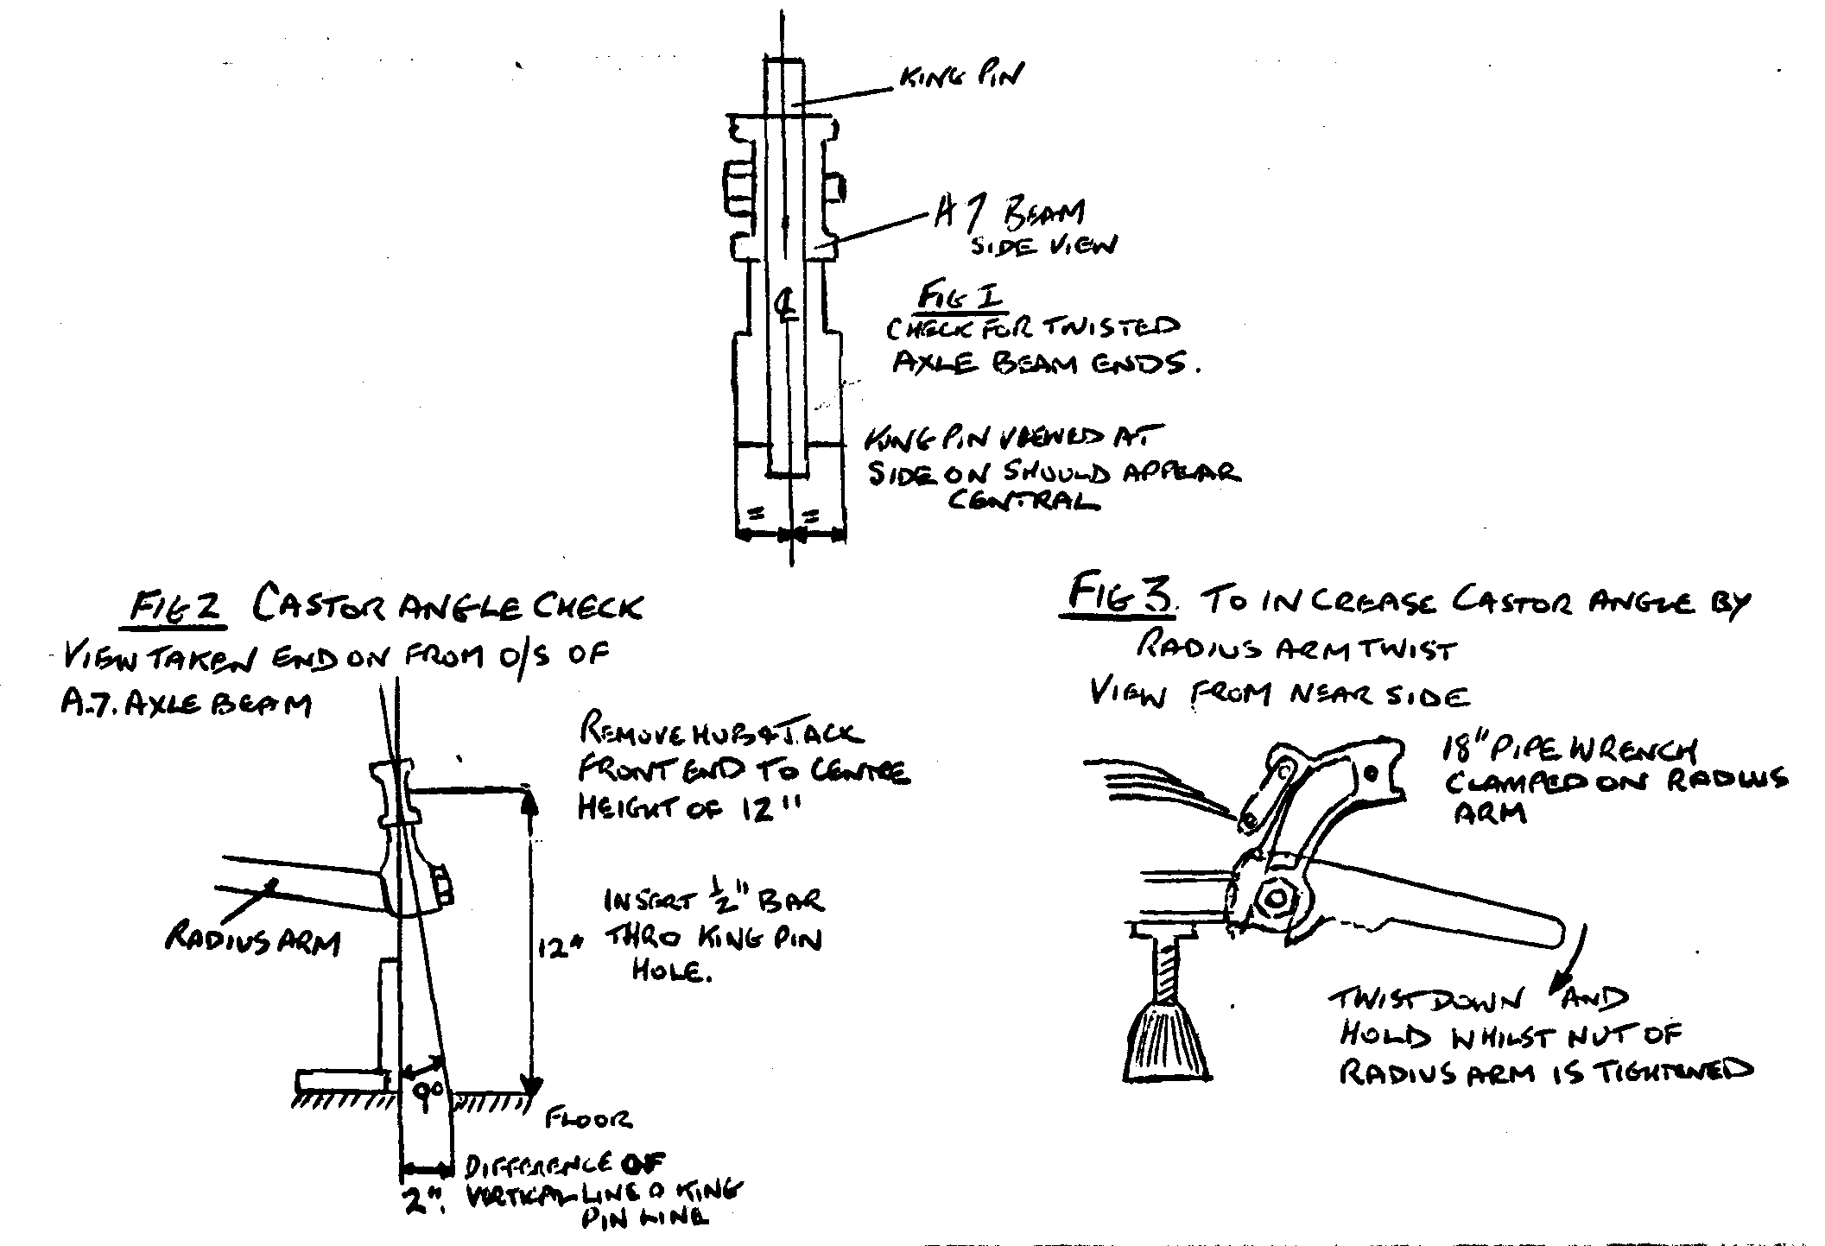

MARCH, 1935 56
AUSTIN SEVEN GEARBOX REMOVAL
AS all our Dealers may not be aware that the gearbox of the latest type Austin Seven can readily be withdrawn from inside the car, thereby effecting a considerable saving in time and cost, we herewith describe the job fully, giving the correct sequence of operations for which the average time taken is 5 hours, which includes for replacing.
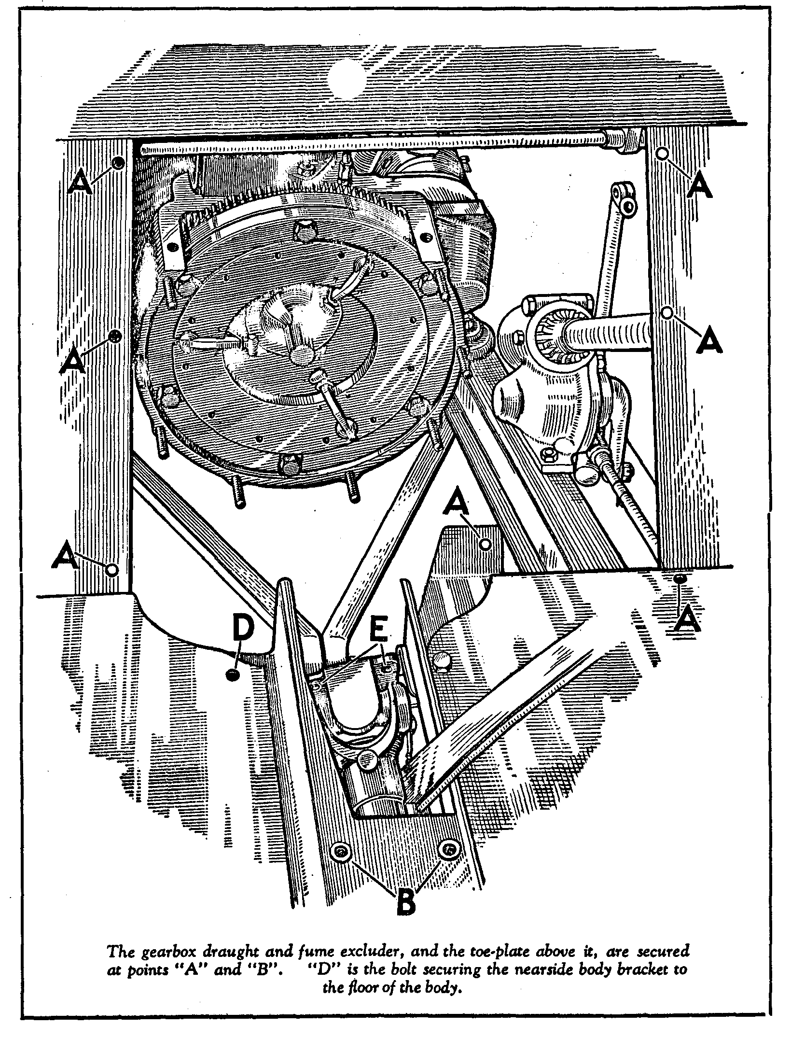

MARCH, 1935 57
Austin Seven — Gearbox Removal —(contd.)
First take out both the front seat cushions and the front rubber floor coverings. Then remove the eight nuts and bolts at "A" in the accompanying illustrations and the two setscrews at "B" with their lock-washers that together secure the gearbox fume excluder, and the toe-plate above it, to the metal floor.
Working from underneath the car, fully slacken off the hand-brake lever adjustment and disconnect the speedometer coupling from the gearbox. Returning to the interior of the car, release the metal gearbox shield from the rubber seal round the base of the gear lever and remove the shield by pulling it up and off the gear and hand-brake levers after pulling the latter right back. The rubber seal can be left on the base of the gear lever.
Lift the offside of the bonnet and slacken the nuts and bolts securing the brake- and clutch- pedal stalks in the split ends of the levers. Returning to the front compartment, withdraw the pedal stalks through the toe plate, and remove this plate.

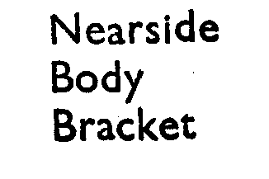
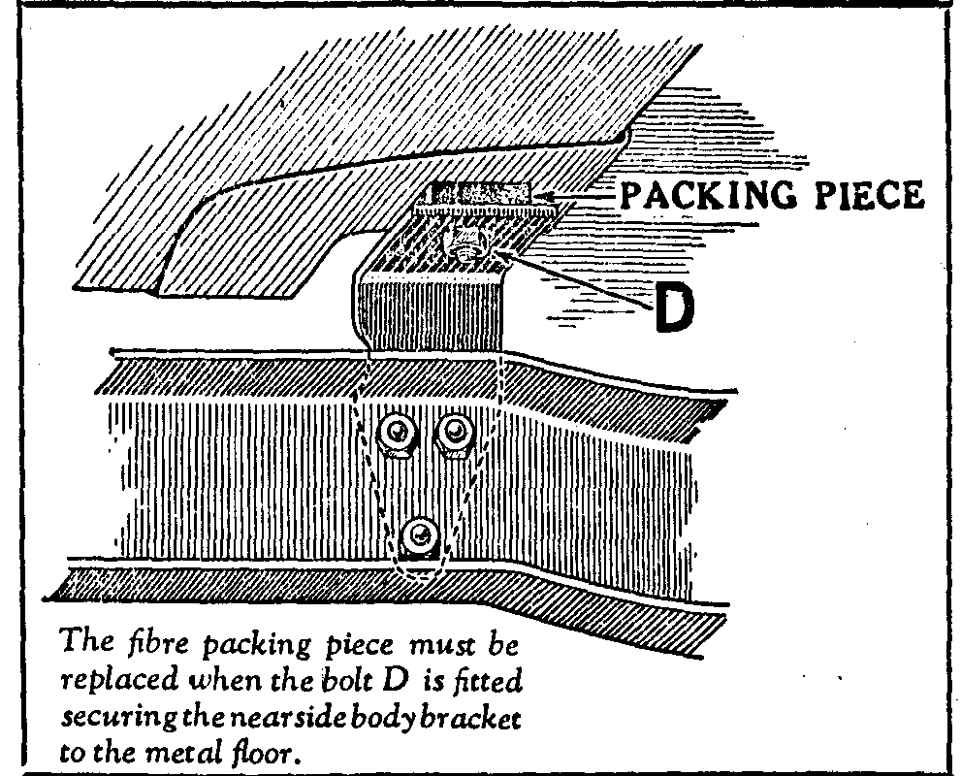
Unlike the offside transmission tunnel body-bracket (which is riveted) the body-bracket on the nearside is bolted to the frame to allow it to be easily removed, which should now be done by undoing its three securing bolts to the frame and a further bolt passing through the floor (see the illustration herewith). The fibre packing piece shown in the illustration must be carefully retained and replaced when refitting the body bracket.
Bend back the lock-washer tags of the four nuts and bolts "E" (see main illustration) securing the front propeller shaft joint to the third motion shaft, unscrew the nuts, remove the four bolts, draw the joint back on its splines and allow the propeller shaft to rest on the hand-brake cross shaft.
Remove the eight nuts and washers from the studs securing the gearbox to the flywheel housing, and the two setscrews retaining the flywheel pit cover. It will then be possible to draw the gearbox off the studs and the splined clutch plate centre and lift it out of the car from the nearside.
Replacing the gearbox is simply a reversal of the operations described above.
In our next issue we hope to deal with relining the latest Seven clutch for which several special tools are available.

