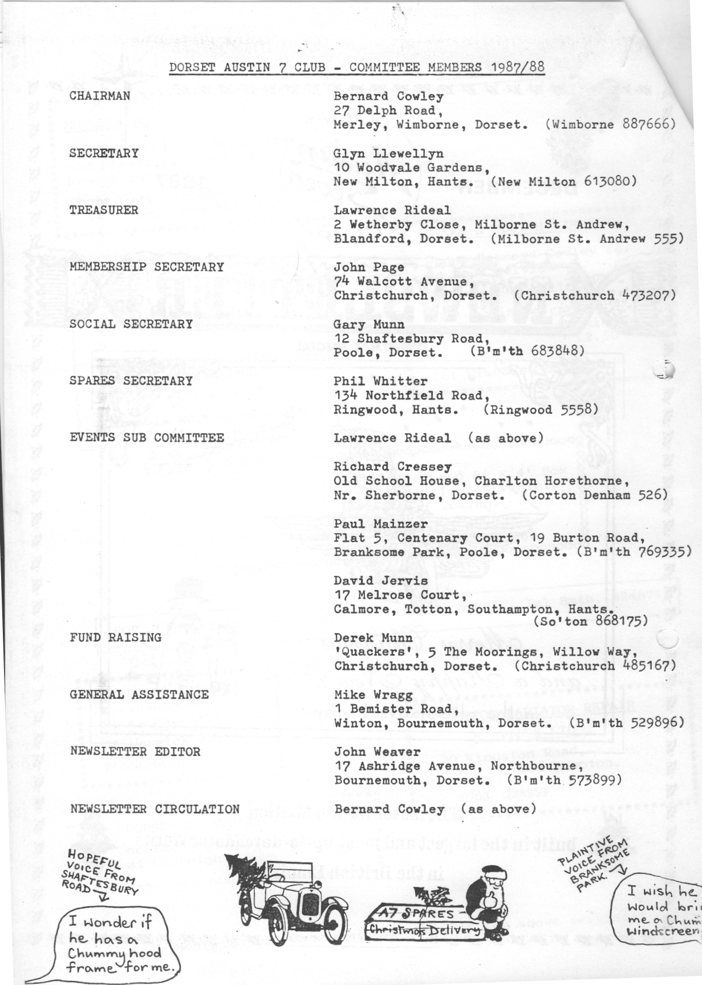
EDITORIAL

I suppose most people now know that your Editor is off the road for at least six weeks having broken his ankle on Guy Fawkes' Day afternoon. Various imaginative suggestions have been made as to how I might have done it but the sad fact is that all I did was step into a pot hole in a car park. Such is life.
The Bonfire Night party at Pete Treliving's went extremely well according to reports. Gay and I were sorry to miss this and I'm sure that Club Members who did go are grateful to Pete and his wife for their invitation and their efforts.
We did manage the Skittles Evening, however, and the usual fun prevailed. Thanks
to Gary for fixing the event. Also apologies to Gary for misprinting his telephone number in the new list of Committee Members last month. It is now correct.
As there was a fair bit of interest in last month's feature on Austin Marine Engines I have included some illustrations showing more detail this month. Also, as promised, the Wiring Diagram for 1930/31 A7s together with some Test Data for the Lucas Set. Thanks to Phil for this.
We have more from David W. as he continues to share his adventures at the 'block face'
and items from 3 new contributors. Things are looking up For those wanting to know where it was, here it is. Christmas is in the air; may your preparations go well
and I am sure that I can speak for the whole Committee in , wishing every Club Member a Very Happy Christmas. Keep your revs. up:

John.
SECRETARIAL

The Auction went well last Club Night I thought, though there was not much 'Seven' stuff to be seen. I still left about £15 poorer, but with a couple of rather nice pictures and a copy of "Building and Racing My 750", 1 was well pleased. I hope you were too. The Club gained a 16mm sound movie projector, which I think Bernie has got to go to classes to learn how to operate, so we should have some good film nights this Winter.
As promised the delayed Wiltshire Wander took place on Sunday 22nd November and it was well worth waiting for, as Phil and Hilary had found more lanes that most of us didn't know existed. A report, hopefully, appears in this Newsletter.
The Club Badges have arrived and you can get them from me at the reduced, yes reduced, price of £5 or more if posted, so see me quickly before they have all gone.
It was good to see George and Joy Mooney on the Wiltshire Wander. As you may know George has not been too well, but he assures me that he is now on the mend and that he will be returning to work in the U.K. in the New Year, so we should see them more regularly again. But we didn't see our Editor, who, whilst in a dream I expect, managed to fall over and break his ankle; was it outside a Whitbread pub John? Anyway it has left him with plenty of time to put together a bumper 'Newsletter!! Well done Pegleg!
Don't forget the Christmas Dinner; Gary tells me it is booking up much faster than usual so if you haven't booked yet, better give him a ring now.
Does anyone want a short wheel base box about 1930/31. Gary and I have the job of repairing and preparing for M.O.T. a red and black one for a customer who wishes to sell it for about £2000. Let us know if you are seriously interested. It is fairly tidy and could be used as it is, though it would look better with a respray, it also has no rear seat.
I have still not managed to finish the Opal. I really must try and get on with it as I intend taking it on our French Trip at Easter next year. I know I said that last year, but it was cold in the garage and there always seems to be such a lot to do in the warm house. Oh well!
See you Club Night.

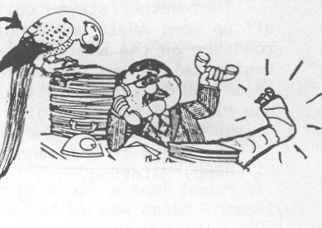
THE WILTSHIRE WANDER - SUNDAY 22nd NOVEMBER

Eight Austins and one 'motorised plank' met at Ringwood on a cool Sunday morning in November for the great Wiltshire Wander. On arrival, each of us was accosted by Glyn with the new cast aluminium Club Badges (and very nice they are too!)
We left Ringwood at around 10.30, only to be stopped about half a mile up the road when a certain couple in a maroon Box spilt their coffee! We went along some very pretty country lanes, through villages such as Alderholt, Damerham, Broadchalke and Bowerchalke, to name but a few. We even went round one area twice, the chap washing his MG by the roadside looked somewhat bemused when we passed him on our second lap!
We stopped for lunch at 'The Penruddocke Arms' (I hope I spelt that right) at Dinton, the food was excellent and very good value for money. The suggestion of a walk in the afternoon, to wear off our lunch, was met by groans from certain members of the Club, who suddenly remembered various important things that they had already planned for the afternoon!
The weather stayed quite reasonable for us and the somewhat reduced group of cars set off up some small and winding lanes, passing a very pretty Gypsy caravan parked by the roadside on the way. Our walk took us up onto the Fovant Downs to see one of the Regimental Badges carved into the hillside. It was a rather long and steep climb and Brian and Jill certainly proved their walking capabilities by charging off ahead of e^{ve}ryone else. (I was very glad it was downhill on the way back to the cars!)
We drove most of the way home together, which was a nice end to the day. -- •
My thanks to Phil and Hilary for such an enjoyable run.
Happy Motoring. ' _

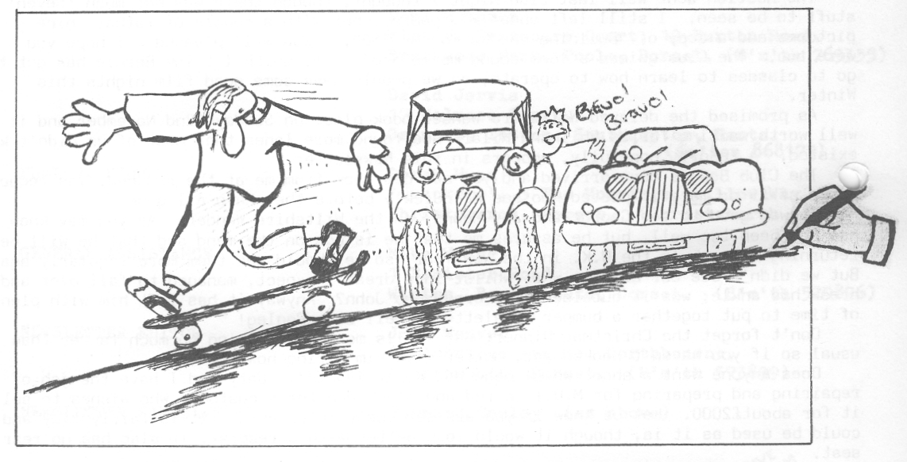
Not mentioned in Jo's report are our Chairman's exploits
on a skateboard in the pub. car park. Fortunately Daniel was there to record his father's ability to drive (and fall off) anything with four wheels. Thanks for the cartoon, Daniel; it's good to have a contribution from a younger Club member.
A CHRISTMAS STORY - A TALE FOR 'RUBY-FOLK'
We all know how scared the average young kids are of meeting up with Father Christmas in his Grotto, don't we? Well in the good old days when A7 1934 Ruby's could be bought for £20, you could take the kids to THAT store with green and gold bags, (yes Harrods not Marks and Sparks!) to visit Santa roaming around the toy department; kids could approach him in their own good time - usually after they had spied on him secretly from behind the mountains of bikes, cars, teddies and the like.
At such a time this story truly took place.
Imagine the scene: five fairly scruffy kids straight out of school; ages 5-7yrs. old, all jammed into the back of BUMPY (Ruby circa. '32) Ma of two (me) proudly at the wheel bumping along round the back of Harrods searching for a Ruby sized spot in which to park. Right there at the bottom of the back door steps between a long row of Rolls', a gap.
Luck was with me. Arm out, having no refinement of a flick-up indicator, and across the road.
Excitement in the back changed to groans as it became obvious that the gap wasn't quite big enough. Ah! well we'll find another place.
"One moment", called the green suited doorman, "I'll get these cars to move up a little".
He went along the chauffeurs either side of the gap. Silently each gleaming Rolls
shunted, until my new 'friend' declared there to be enough room for BUMPY.
What power these doormen have I marvelled, as I held my head up high, bellowed at the over-excited kids to pipe down and proceeded to reverse in.
Slowly total embarrassment descended as it became patently obvious that the wheel lock was having the last say in where I could park. I swear these cars are almost human at times. Red faced I thanked the doorman and the chauffeurs who had by now eased themselves out of their feather bedded seats to view the entertainment. I explained the idiosyncrasies of the Austin and said I'd have to find a larger gap.
No self respecting RUBY is going to let its owner get away with that and to prove superiority the engine stalled (on purpose, d*** it!)
I breathed, SLOWLY and deeply, got out, unleashed the starting handle, and holding the slice of inner tube which had held it to one side, proceeded to yank restored life into IT! I returned the smiles of my audience (the only saving grace thing to do in the circumstances), replaced the retaining inner tube, and slid into the driving seat.
"Let me out of here quick", my spinning brain cried.
"Excuse me Modom."
It was my Harrods, green suited doorman again.
I sickly smiled a quizzical look at him.
"Was Modom coming into the store?"
I nodded weakly, quite expecting him to tell me where the nearest Woollies was,
"If Modom would like to unload the children and herself, I'll get these gentlemen, indicating the chauffeurs, to help to lift the front wheels round into the space."
I nearly died, LIFT, did he say LIFT? Suddenly I saw the funny side of it. Of course he must have thought me to be an eccentric millionairess or some such.
"Come on kids, out you come, up to the top of the steps, we're going to see Father Christmas" Out they bounded, looking that much more scruffy, as all things do when seen through other people's eyes. Bursting with laughter but not yet daring to show it I followed in full flight.
"Modom" called my friend, "th^{e} door; you haven't locked the door or put the window
up.
"Oh don't worry, it won't lock and er... well the window just won't fully wind up either. But thank you all so much for your help, you're very kind."
I'm often tempted to try a repeat performance, not for self glory, merely to see if the present Ruby would behave in the same way.
Gordon says, "I'm glad I didn't know her at the time!"
Biddy Brown.
`

\

..₀ a BODGERS' CORNER THE OPAL SAGA III or "The Bottom End Revealed"
Having delivered the solid bits of the engine to Regar Engineering for reboring etc., (new readers please see parts I and II) attention was turned to what was left on the bench, viz all the moving parts and mysterious bolt-heads apparently holding nothing together. The Green Bible explains exactly how to get off the flywheel and even provides a working drawing for the fly-wheel puller. Two little first year pupils knocked mine up in a double period, although I had to go to Barlow's Fastenings for the 2" long bolts. (Schools are all metric these days!). For their pains I treated them to a mini lecture on the principles of tapered joints and pullers. One day they'll tell their grandchildren of this nutter at school. However, their handiwork was excellent and with only two thumps with the Very Big Hammer - off it came. The replacement bottom-end had lost its main bearings along the way, so once the big ends and centre main are released - and what a surprise to find the main's bolts go right up through the block with their shaped heads hidden underneath the old gasket - the crank becomes alive. The process of getting the crank out still remains a mystery. I wiggled it, I waggled it, and swore at it to no avail, but the minute I turned my back on it - out it came. All that remains inside the case is the oil pump and cam shaft. I thought at first that the cam shaft was on a spring but it is only the suction of the oil left inside the end bearing, and the shaft just pulls straight out. But I had been told that the previous owner had had oil-pressure problems so I decided to investigate the inside of the pump. An initial test, trying turn the pump with a finger on the worm, indicated that there was something catching and further investigation revealed a sticking "bit". (Technical jargon that). All the pump consists of is two bars of metal, separated by a spring which go in and out as they turn eccentrically. One of those kept getting stuck so I swopped over pumps from my poorly departed and all works smoothly now. On the bench that is. Now to tackle the mysterious bolts. A tentative and wary extraction of one of them explained what Phil had said when I first told him of my plans (after he had stopped laughing) i.e. make sure you clean out all your oil-ways. At the time I thought it politic, that is less embarrassing. not to ask, but now I see it all. Lord Austin cleverly put a large hole at the end of each gallery for pouring petrol down, and I only got caught once on where it came out. But one of them isn't - it's the hollow spring retainer for the oil-pressure relief valve, and the head breaks off very easily. A real tip here on how to extract the left-overs without drilling is to use a half inch hexagonal Allen key lightly tapped down the hole and used as a handle to screw out the headless shank.
Now the engine is completely in bits, all in neat little rows and labelled tins, it
is difficult to get out in this weather away from the fire-place to do any reconstructing. Perhaps enthusiasm will return with the rebored top end. Look out for Part IV, this could run and run I'm afraid. Which might be more than can be said for the engine.
David
Restoration Corner All tips are welcome - including the following from Fran Frampton:

Any neighbours walking past our garage last night could have been forgiven for wondering what was going on, at the sight of me lying on the floor of Merv's Morris Minor with my legs astride and feet pressed against the window, accompanied by grunts from hubby of "It's coming, it's coming, nearly there!"

As, of course, any dedicated Club Member's wife would know, we were replacing the rear window, me on the inside pressing the glass with my feet and Merv on the outside with a piece of string lifting the flange of the rubber seal into place.

I should have thought it was quite obvious!!!

Fran.
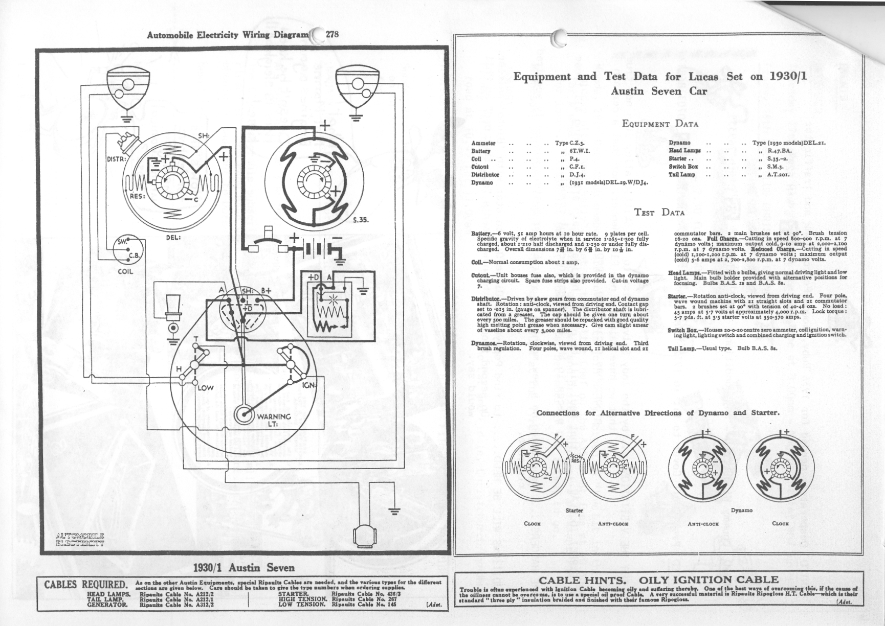
WANTED Desperately needed for 1936 Ruby, sound Petrol Tank and Trafficator.
FRANK JOBLIN ⁰& B'mth 522316
WANTED Chummy Windscreen - any condition. PAUL MAINZER _{OR} B'mth 769335
WANTED Prop Shaft Cover to fit in 1932 Tourer/Box. DAVID JERVIS ~(0703)868175
AFTER THE VISITATION by the lady Salvationist to the Skittle alley it is not true that we have gained a new Club Member, nor that a certain Sevener has decided to repent.

WE EXPECT TG HEAR that Paul will be off on holiday again after winning all those 10p pieces in the skittles knock-out competition.

APE HANGERS have taken on a new meaning as your Editor masters his newly acquired crutches.

AUDITIONS WILL BE HELD to find Popeye and Olive Oil to star with 'Bluto' Whitter. On second thoughts the new beard's "not that bad" as Phil would say.
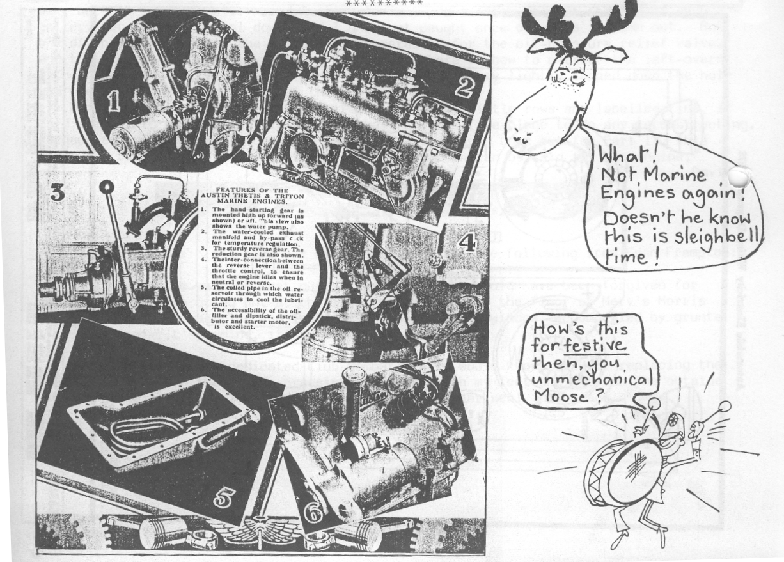
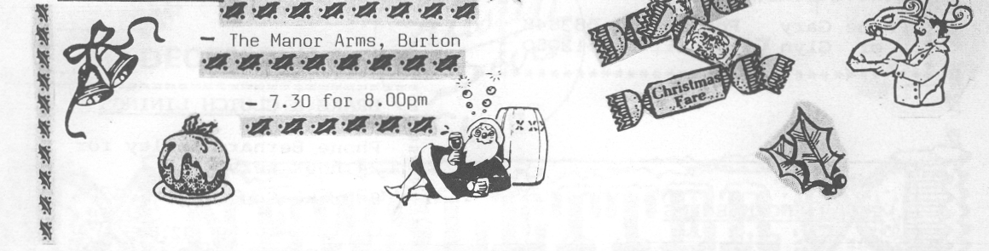
EVENTS
:
DECEMBER
Thursday 17th Dec. Club Night at the Elm Tree at 8.00 pm - Noggin, Natter and Spares Friday 18th Dec. CLUB CHRISTMAS DINNER * -,-A
Monday 28th Dec. Club members are invited to join Henry Morgan on "The bit in the middle after Xmas Rally", meet at the Little Chef on the A31 at St. Ives at 10.30 am for a short run with a few simple questions and prizes ending at a pleasant Inn
„ for lunch. Please let Bernard know by 21st December if you intend to go.

Wednesday 30th Dec. Committee Meeting - 8.30 pm at the Tyrrells Ford. JANUARY

Friday 1st Jan. NEW YEAR'S DAY RUN Meet at the Cat and Fiddle, Christchurch/Lyndhurst road at 10.45 for 11.00 am
Thursday 21st Jan. Club Night at the Elm Tree at 8.00 pm Film Night with the Club vintage projector.

Sunday 24th Jan. The 'Dorset Cream Tea Run'. Following a short run and pub lunch on to John and Gay's for a Trivial Quiz and tea. Meet Wimborne Square 10.45 for 11.00 am. „
.

1
JANUARY NEWSLETTER. Your contributions welcome - by 5th January.

ALL SUBSCRIPTIONS FOR 1987-88 ARE NOW DUE
The Club Membership subscription remains at £7.50 which covers all the family.
Please let John Page have your subscription as soon as convenient. Cheques
should be made out to Dorset Austin 7 Club.
Newsletters cease after December if subscriptions are not renewed.
-------------------------------------------------------------------------------------
NAME
ADDRESS
..................................
I enclose cheque for £7.50 to renew my subscription.


