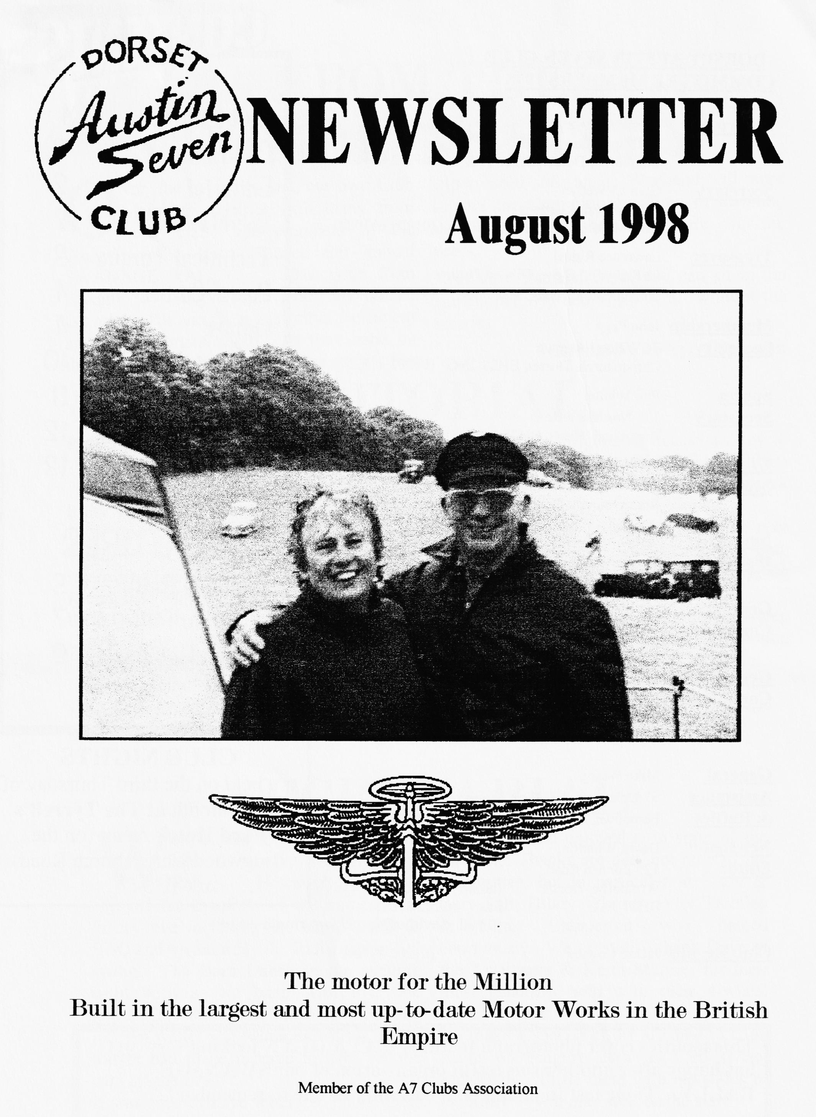

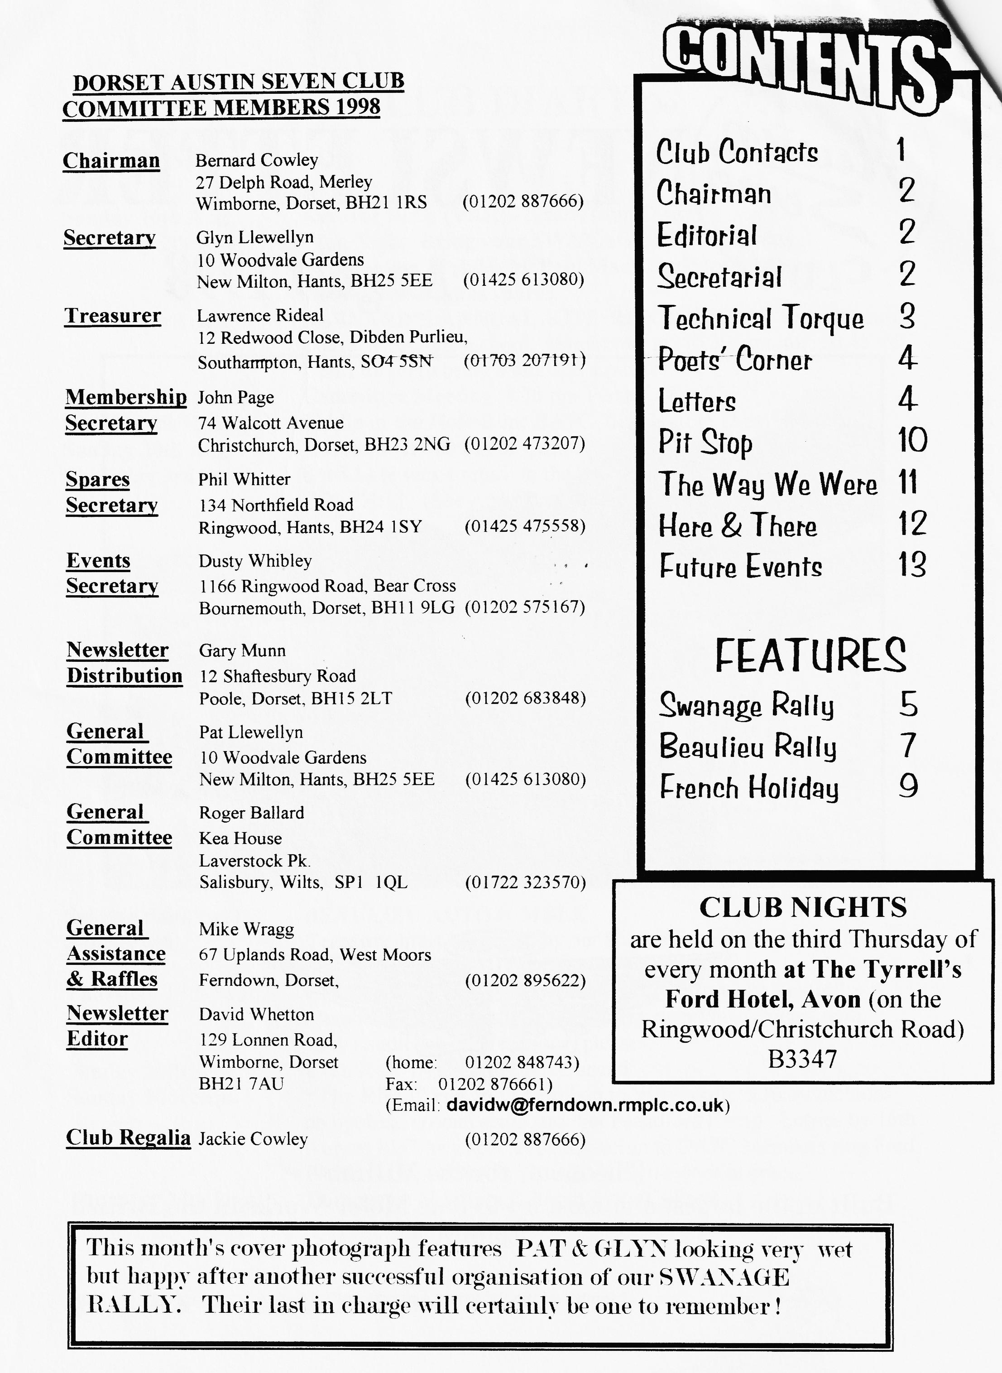

FROM THE CHAIRMAN'S STUDY

O
ver the past six years, our own Club Members together with many from other clubs and members of the general public, have enjoyed our annual SWANAGE RALLY. It has gone from strength to strength since 1992 due almost entirely to Pat and Glyn Llewellyn's efficient and tireless organisation. As they hand on the organisers hat. everyone who has experienced a Swanage Weekend will want to join the Committee and me in thanking them both for all their hard work over the years.
Next year, Pat and Glyn, you can sit in the sun
Bernard Cowley, Chairman

EDITORIAL

Two great rallies in one month and all the PICS and NEWS you can want in one newsletter. Whilst mentioning The Rally, can I thank the MERRY CHERRIES Paul Perry, Brian Clapperton and Peter Trebilco for sterling marshalling under interesting conditions. Thanks also to Richard & Marlies Bishop for a report on their FRENCH HOLIDAY en Austin Sept. Under a new, occasional section best called "How to EMBARRASS Club Members" there is a picture someone may want to forget recording an unforgettable occasion. Joy & George have sent us a POSTCARD from Cornwall and the POET FATT has struck again.
Brian Hughes has provided a welcome note of sense for those of us who are less than enthusiastic about the prospect of stripping down a REAR AXLE before breakfast.
Back to normal format next month - keep the articles recording a Summer of Sevening rolling in.
David

SECRETARIAL

HI, GANG
much they had en_{j}oyed it in spite of the weather. Thanks are due, not only to the Committee, but in particular to Suzie & Gary Fatt, Hilary Whitter, Peter Trebilco & Brian Clapperton who helped enormously. We must also thank Dave of the Austineers & Keith Mariner for their most generous help with their 4-wheel drive vehicles.
Do make a special effort to come to Club Night on August 20th as Paul (Mac) McKenzie will be there with his slides of the Rally - you may well be the star'
See you all there –
GLYN
Well, it had to happen sooner or later — a very wet Swanage Rally. However, everyone enjoyed the comforts of the marquee on Friday eve including the beer, music & BBQ and by Saturday the Rally was in full swing. The Barn Dance in the evening went with a real bang with everyone getting into the "spirit" of things. Sunday just got wetter and wetter and straw and a tractor had to be ordered to help get the cars off the field. It was nice to have letters & phone calls after the Rally from people saying how
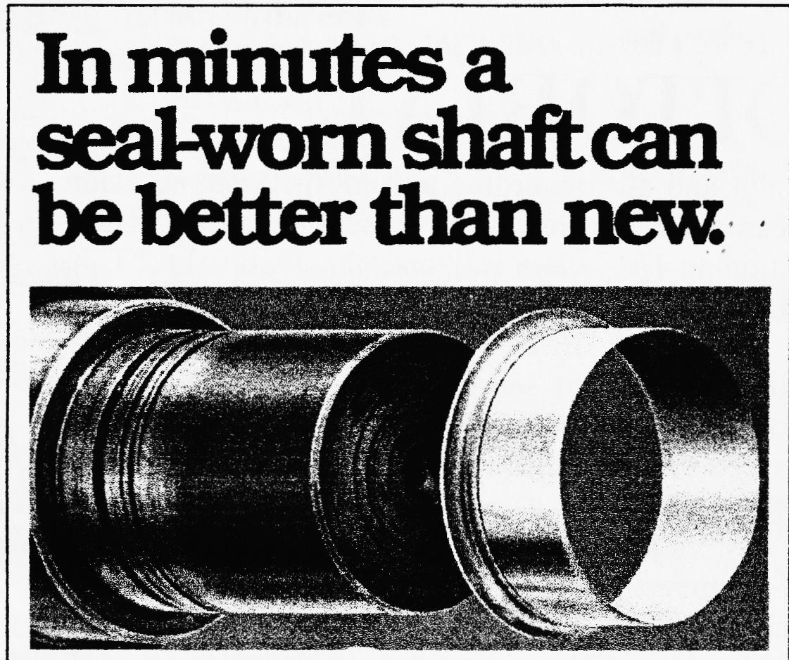
KEEP THE OIL OFF YOUR REAR BRAKE LININGS - AFTERTHOUGHTS
Following last month's article, Club Member BRIAN HUGHES approached me with yet another solution to the problem of oil leaking past the rear hubs onto brakes, wheels and the road which he has successfully used himself SUPER-SLEEVES or SPEEDI-SLEEVES. The correct size for the standard hub is 1.500" inside diameter x 0.500" long. and costs about £24 each from either Ashley Bearings, Poole or Industrial Links, Upton Industrial Estate. A new oil seal (Ashley Bearings part number S 250150025) then slips over the sleeve forming an oil-tight fit. They do need an applicator to hammer them down the hub and Brian has found a 38mm plastic pipe 8" long from his local plumbing centre just right. One warning from Brian, though, to work properly the hub itself needs to be machined CONCENTRIC and Brian has offered his services to anyone embarking on this project.

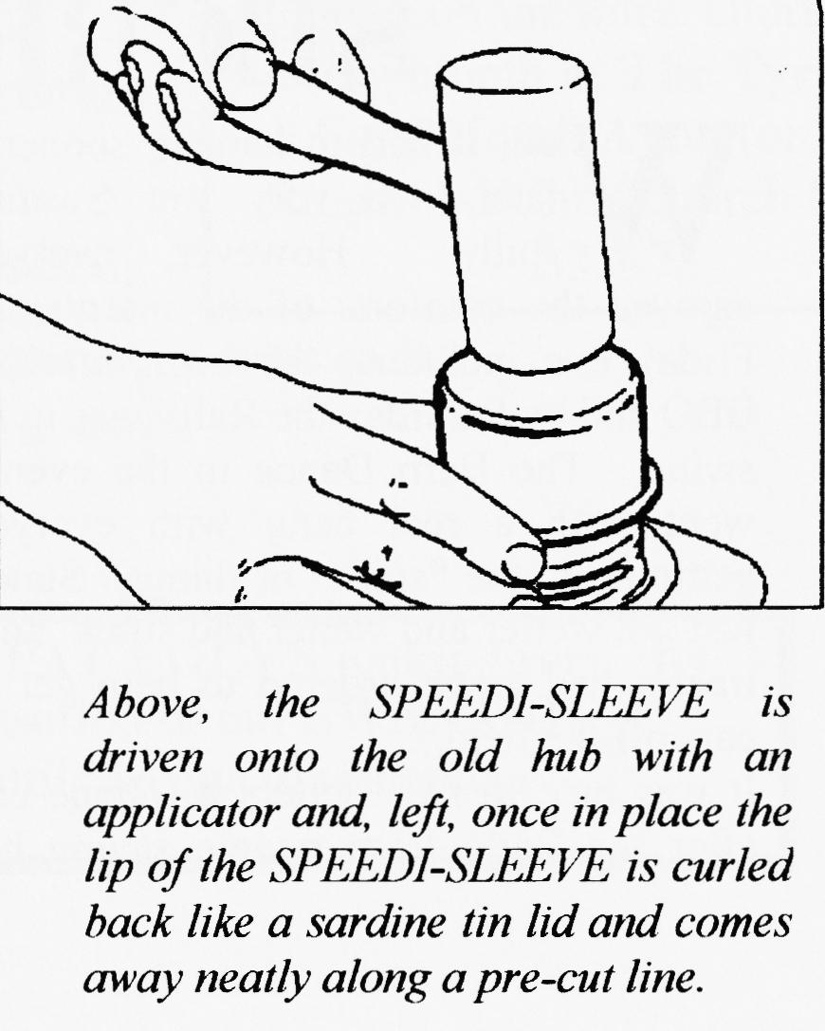
Thank you, Brian for a more user-friendly and modern approach to a perennial problem - Ed
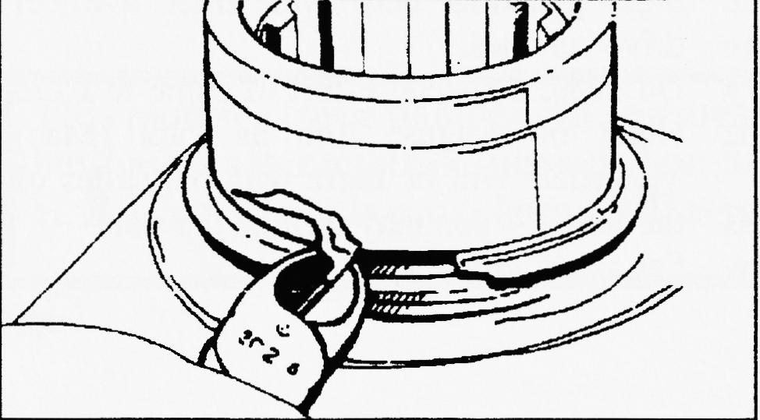

Didn't it rain, Lord, Didn't it rain

RAIN? — Good gracious did it pour. Never seen rain like that before.
The wind it came up with such a force
It nearly blew the tents off course.

That evening some to Corfe they went
To find a good hot meal — Hell bent Banging on Pub door to open -
Poor landlord's peace was surely broken.

Wet but happy, tummies full
To the Barn Dance with Push & Pull. Sorry Hilary came a cropper
But when she "goes" no-one can stop her.

Through that night the rain still falling Made conditions quite appalling.
So, next day, few people came.
A good event — Oh what a shame
The mud it was now ankle beep
And that hill was fairly steep.
But little Austin had no trouble
Through the lot — at the double!

Now to talk of Pat & Glyn.
(Not to mention — what a sin!)
Their wares they tried so hard to peddle.
It is agreed — they deserve a medal.

The event was their last to organise.
A lot to do with one that size.
Through thick and thin they always stayed.
So -
MANY MANY THANKS CONVEYED.
Suzie Fatt

and many many thanks to you, Suzie (with a little help from Gary no doubt) for capturing the soggy but happy event. - Ed
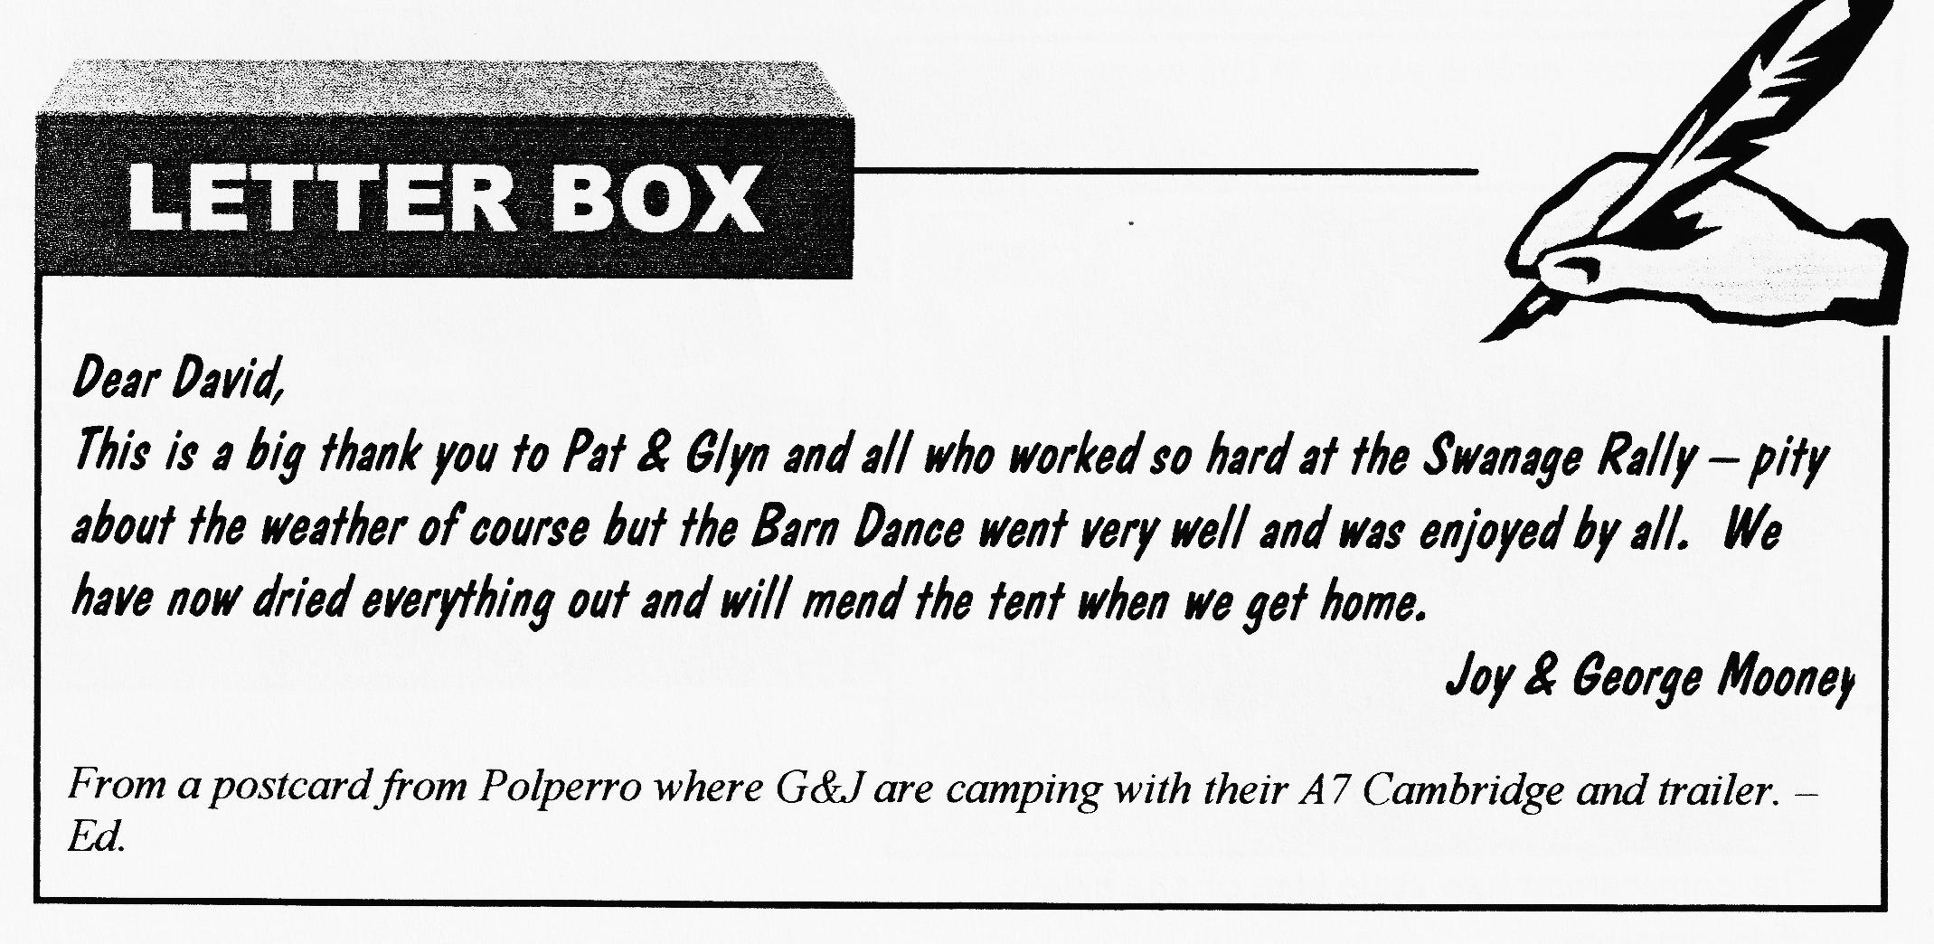

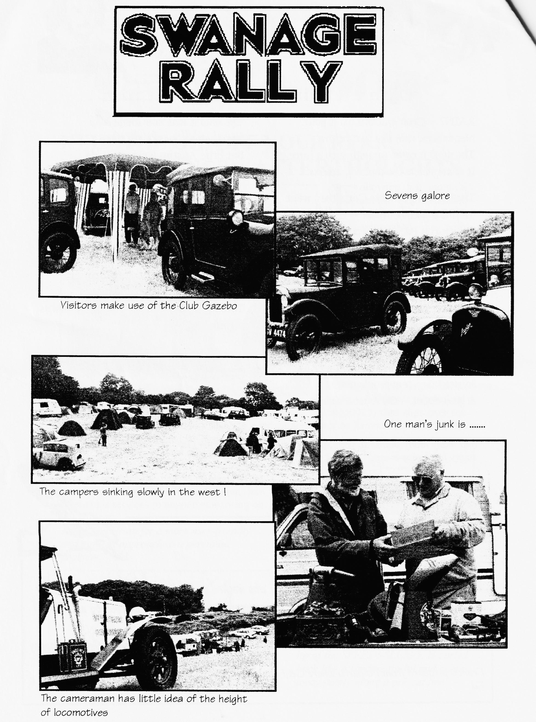

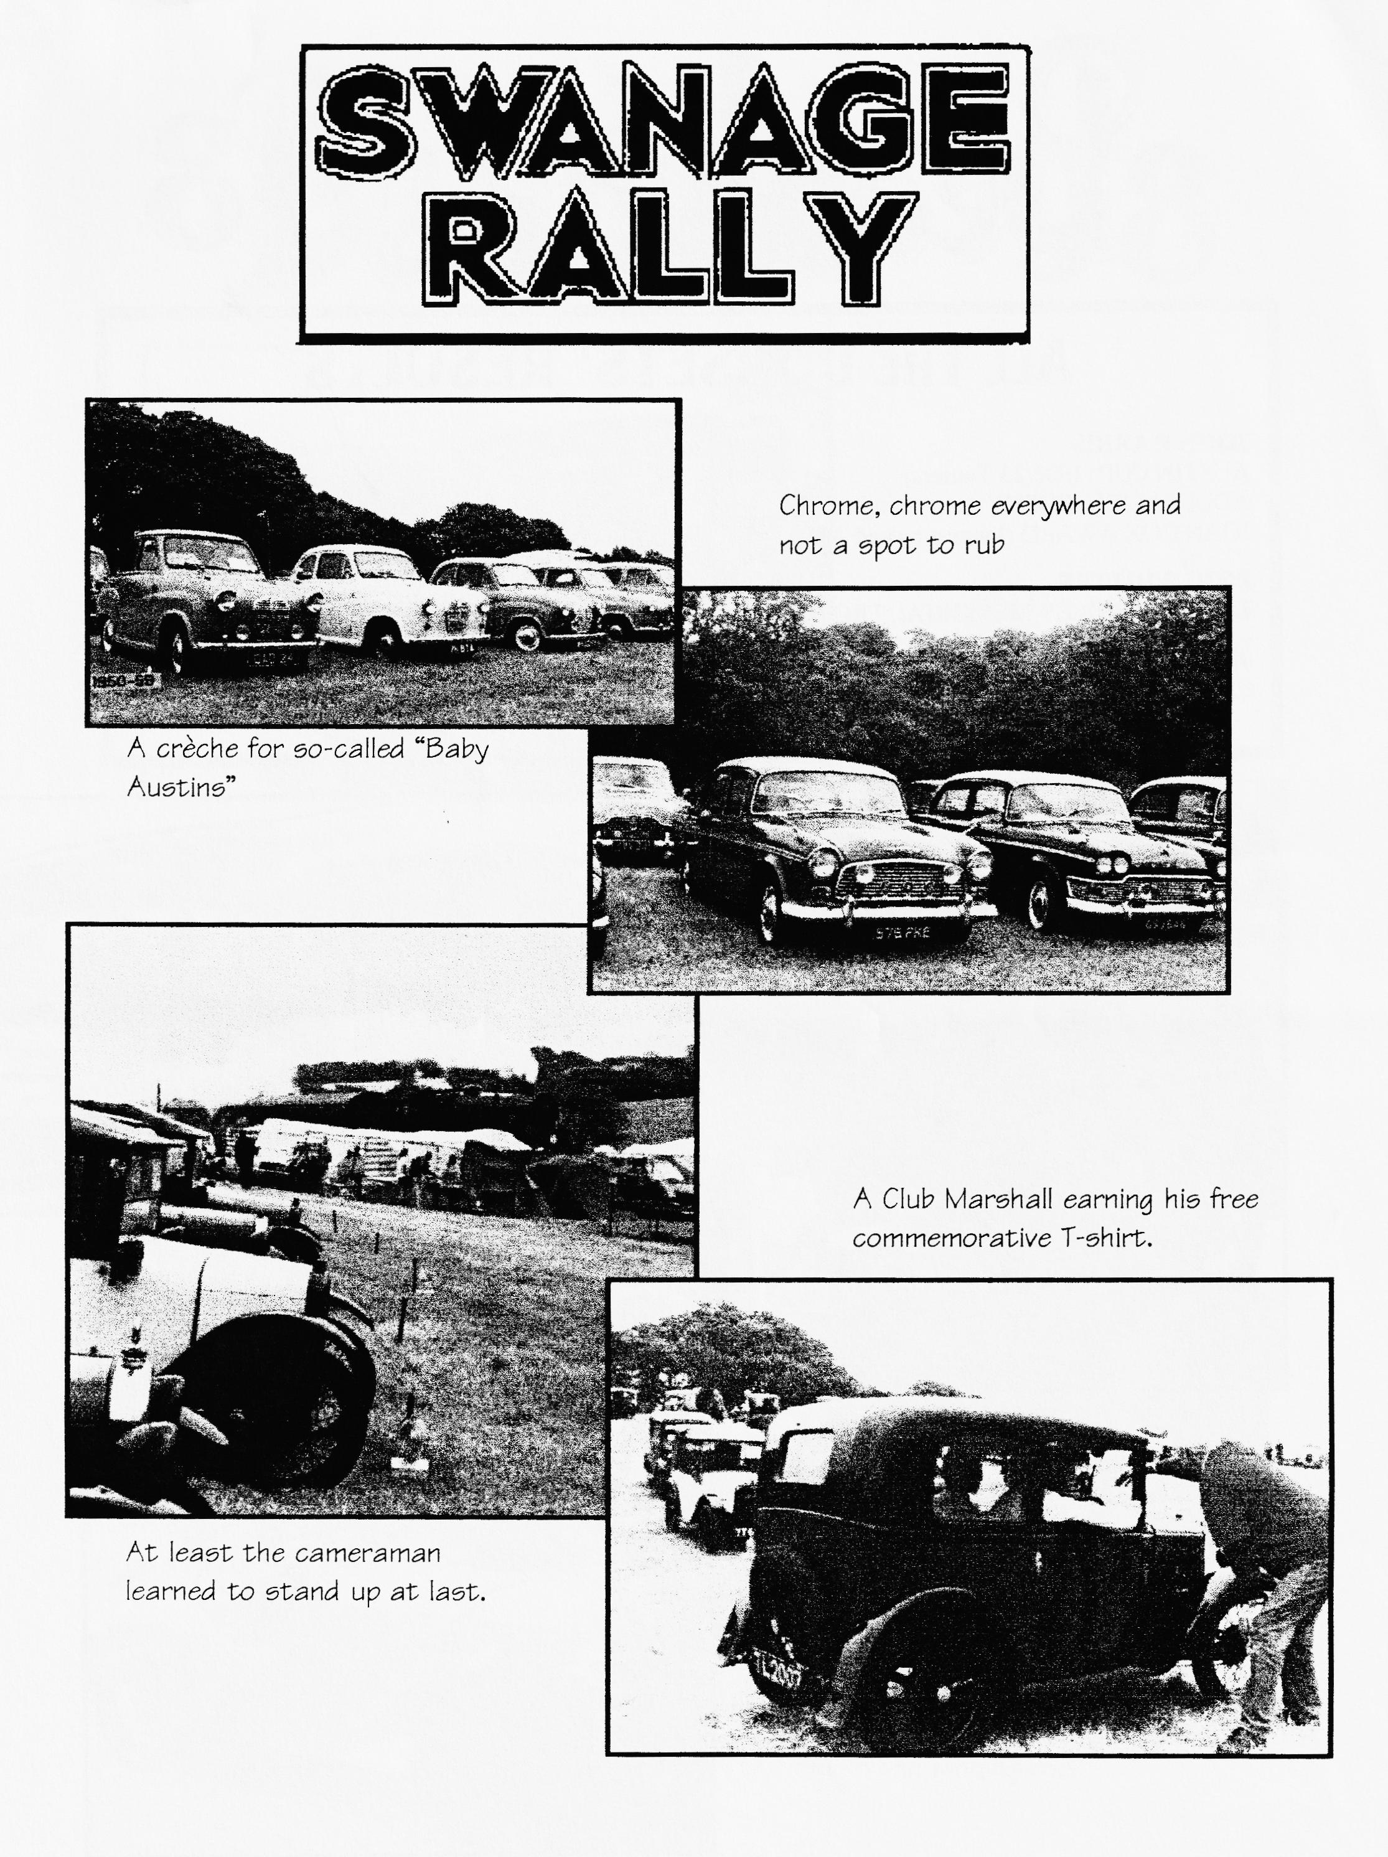

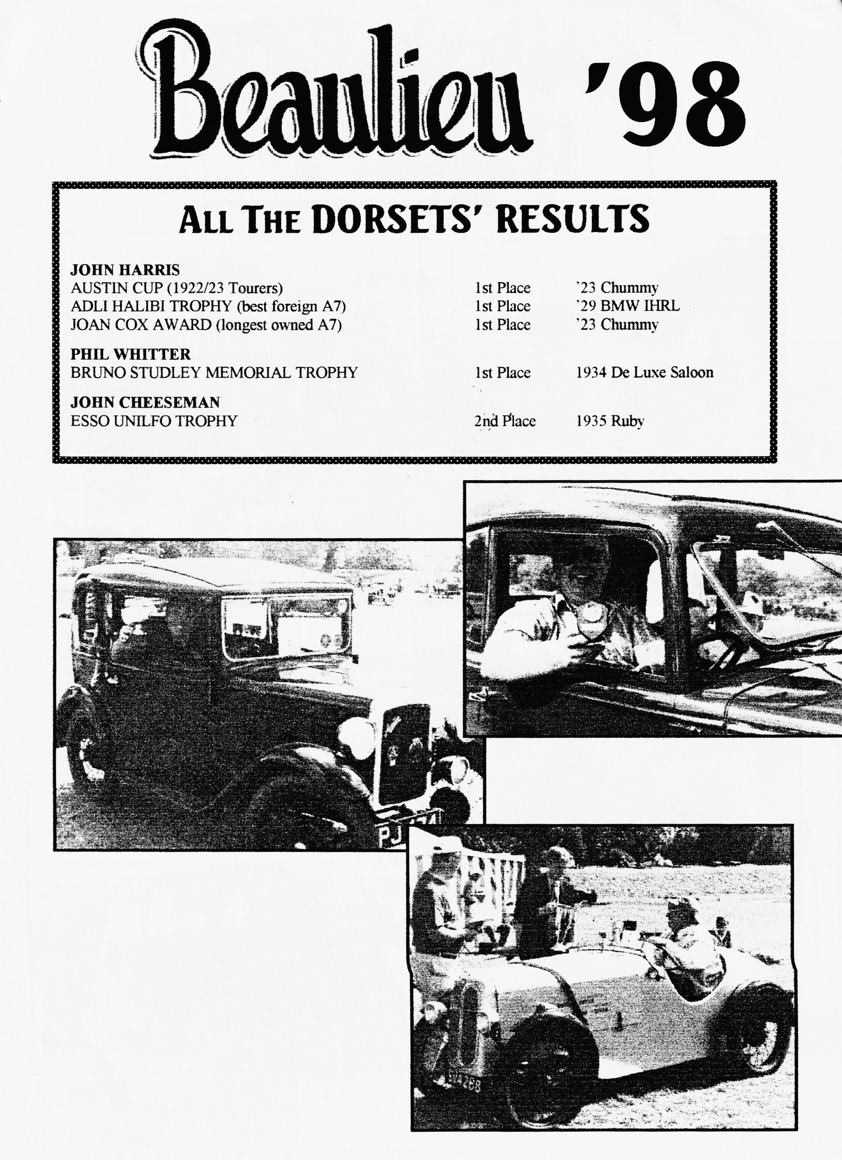

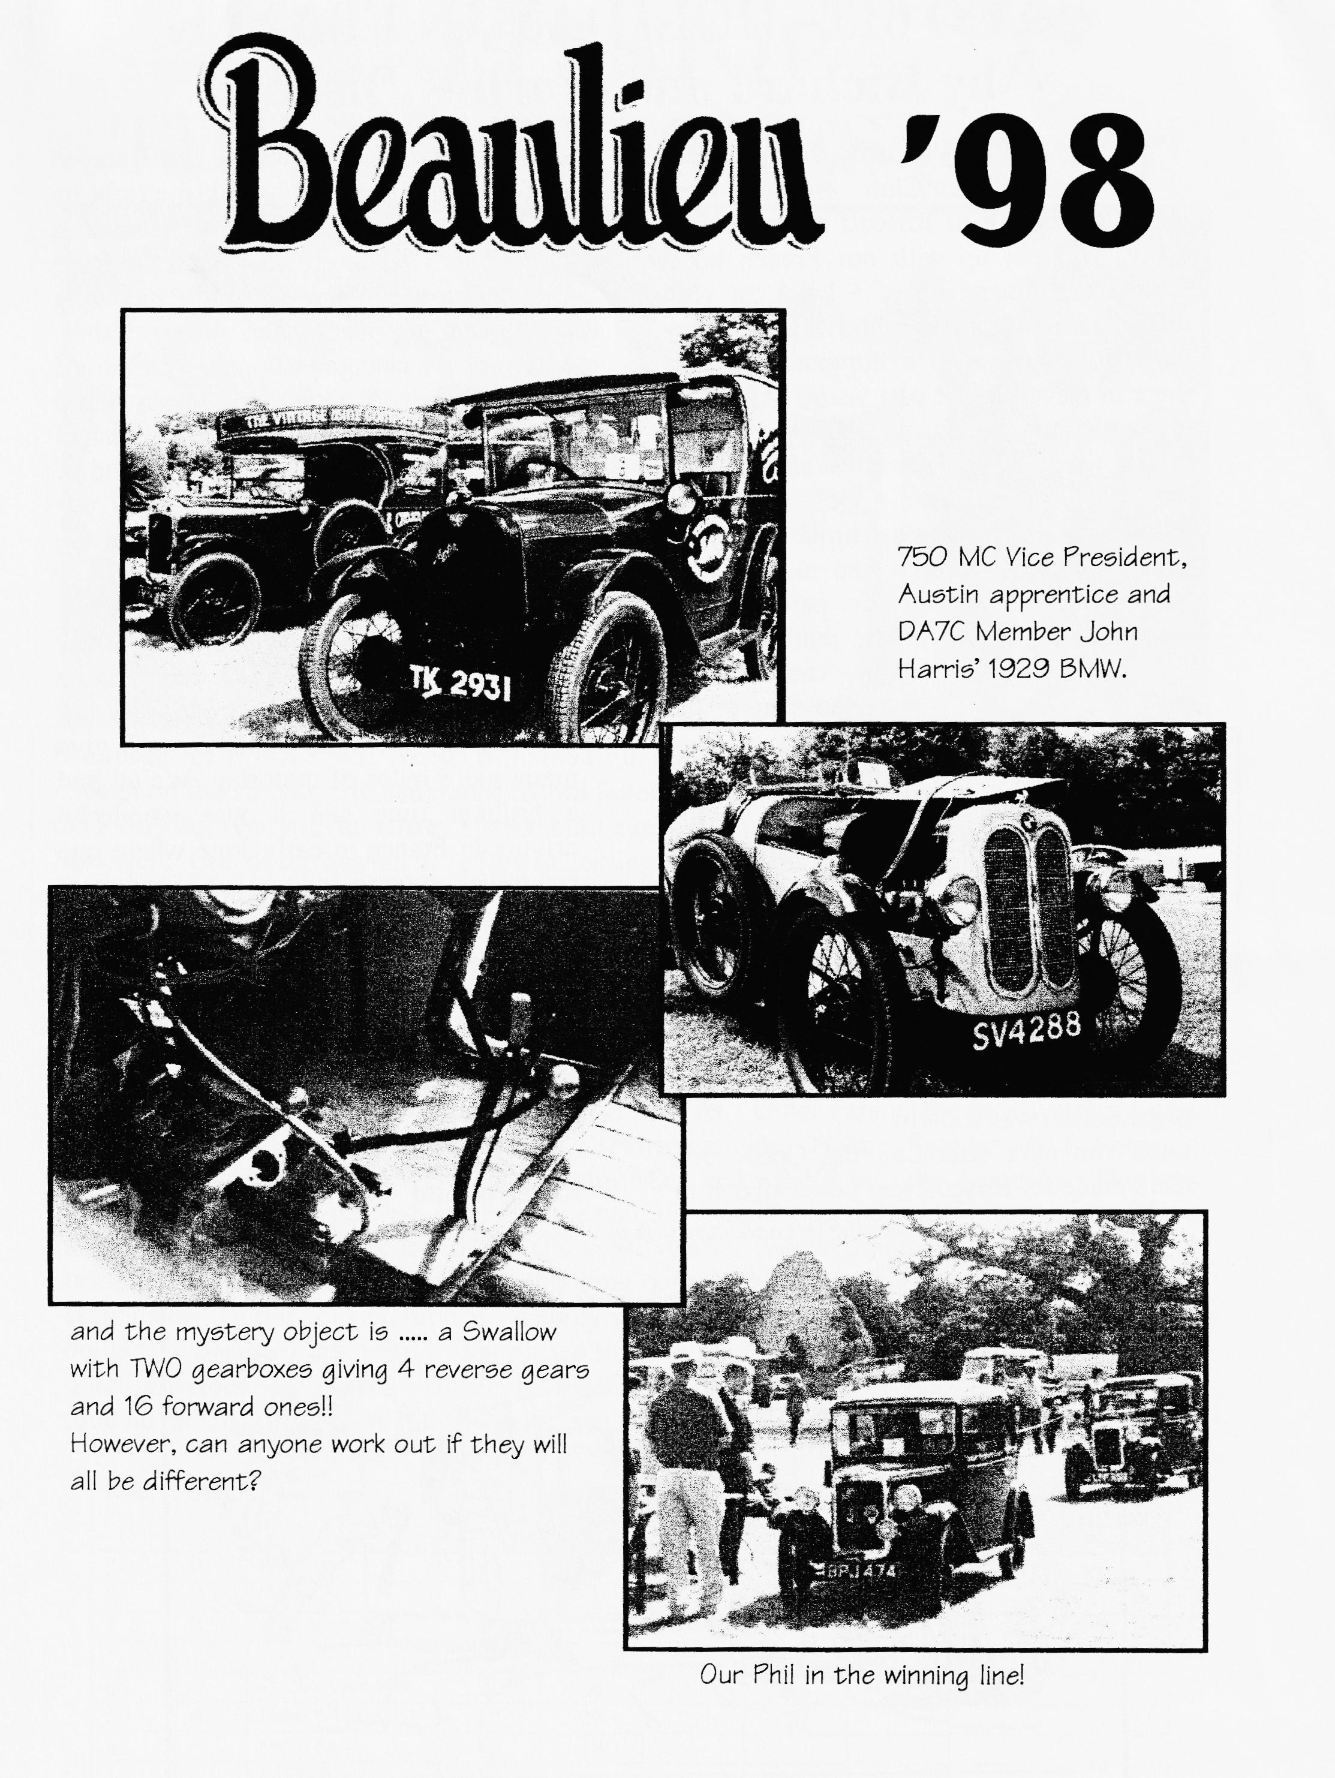

AUO 613's HOLIDAY IN FRANCE
by Richard and Marlies Bishop

T
wenty Pre-War cars from Exeter's Crash Box Club crossed from Plymouth to Roscoff at the end of May. We met up with our French hosts who are all members of a local car club based around Lannion in Brittany. They have joined in with a number of events here in Devon in the past years. After two days of tours, eating, drinking and Breton music we all headed for Brest and the start of the 18th "Tour De Bretagne." Unfortunately, the weather broke and Brest was a sea of umbrellas and macs. There were some 500 vintage cars parked in the centre of the town for the public to see. This, as one can imagine, caused some serious traffic problems - the start of the Tour was a real nightmare!
In spite of the wet beginning, we had a super run along some beautiful coastal roads. The route was lined with spectators even though it poured with rain until late evening. The French certainly support their rallies in a big way. That first night we all sat down for a meal in a massive sports hall. There were a thousand people to wine, dine and entertain, everything went like clockwork, in fact the whole organisation was superb!
Later the next afternoon the Crash Box Club made for Roscoff and home after four
memorable days but Marlies and I stayed on for several nights at a campsite right by the beach at Locquirec with superb views of the bay. From there we toured the Rose Granite coast and saw the sights including a day trip to one of the many islands. Midweek we changed campsite and moved south nearer to Quimper. Again, more spectacular cliff walks, sightseeing and of course good food and wine! At the end of the week, we finally had to say our goodbyes and head up to Roscoff and the night ferry.
We were away for eleven days, covered a total of 750 miles and the car had used a litre of oil! The new engine with the Phoenix crank and con rods has settled down well and hopefully will give many more miles of motoring. We all had a brilliant time and it was wonderful driving in France in early June where one can travel on good country roads and meet hardly any traffic, a holiday well worth repeating!
By the way, 1 am writing this at the Spye Park Rally early on the Sunday morning after a very late night of country dancing, local ale and good company!
Richard and Marlies Bishop (Exeter)

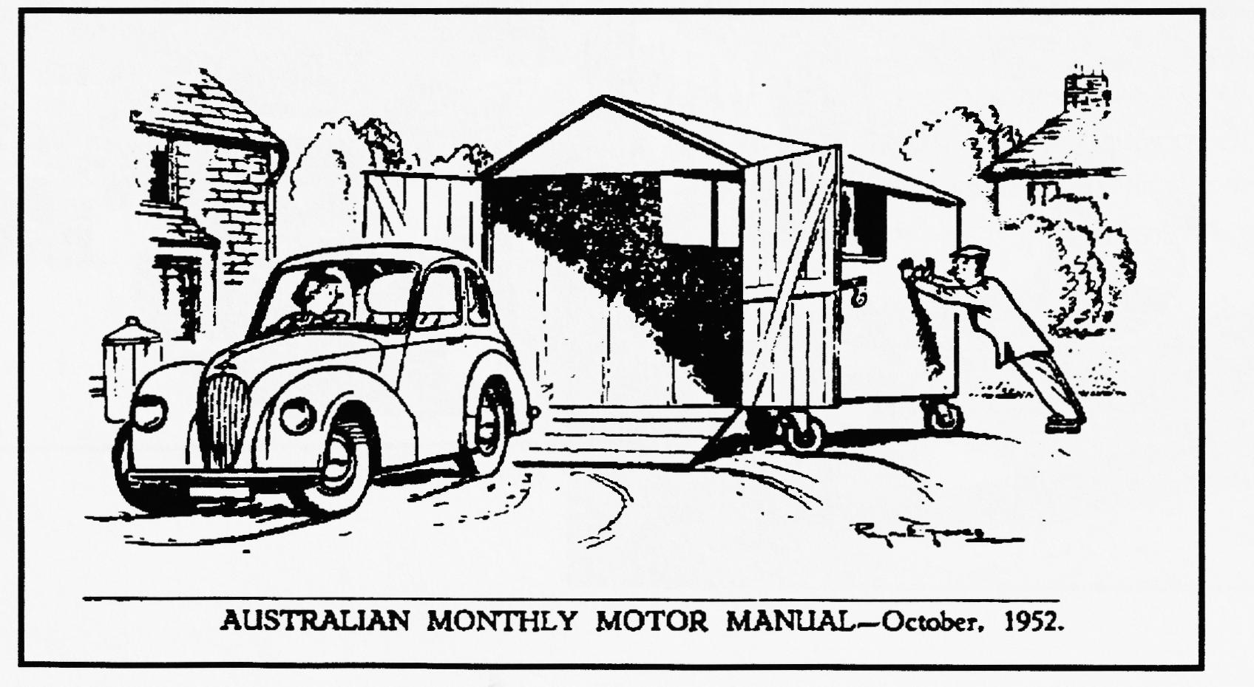
and thanks very much for sharing this adventure with us - perhaps a snap for the front cover anon ? - Ed

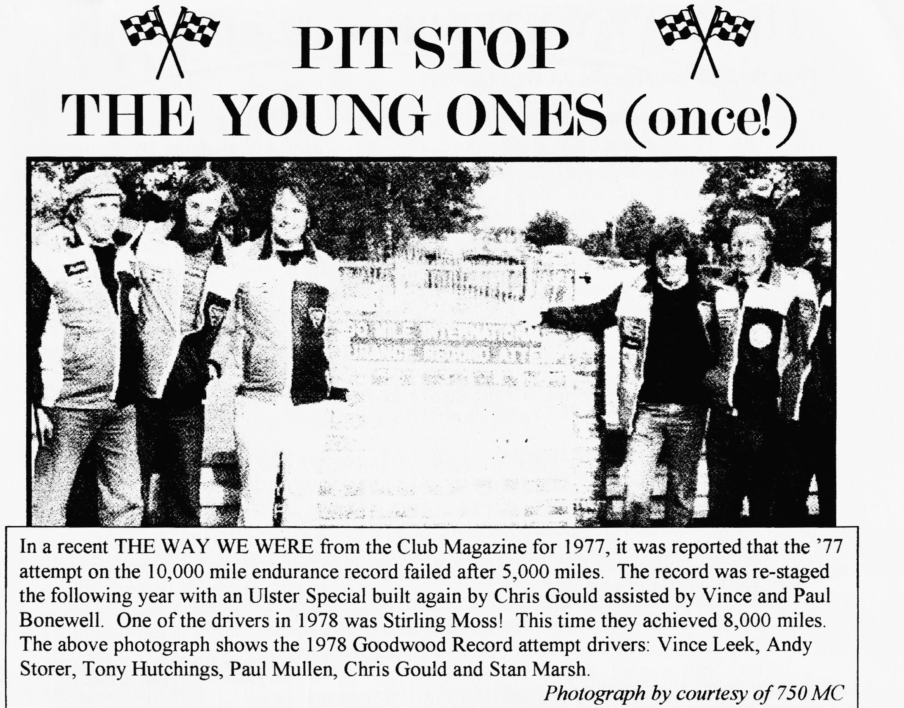
DAVE BEATS DAMON AT PEMBREY
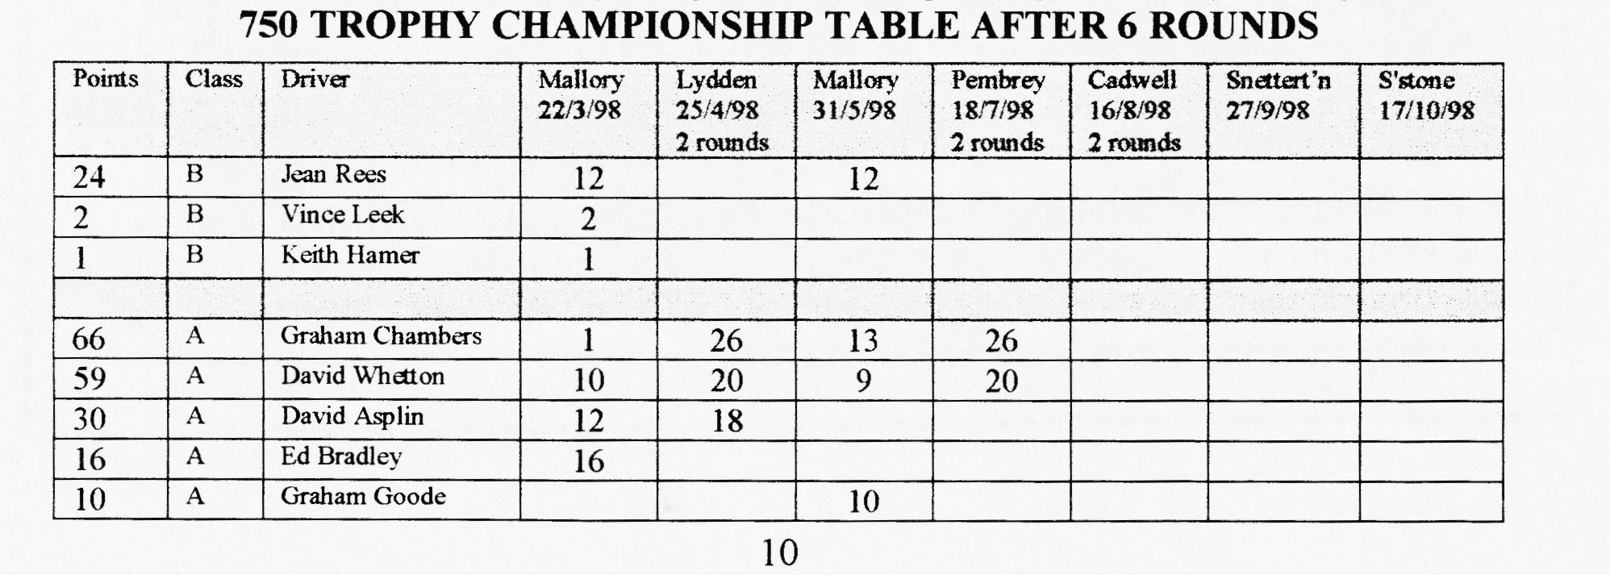
Only in the sense that our man from Dorset gained his highest placing yet - 6th place overall in a keenly fought race, also finishing second in class. Other cars in the race were: a Lotus Mk.6; Genie (supercharged); Cooper Mk.7 (Norton engine); Hague; Scholar Mk.1; Phoenix; Cooper Mk.5 (JAP engine);WEV 750; a Lotus Mk.6 and a RWR plus the Austin 7s. This was the fastest speed yet achieved — 6250 revs equal to 90 mph! - on the start/finish straight where a con-rod decided to come out of the crankcase exactly twelve months ago to put an end to last year's season. The modification this time out which may have contributed to taking 11 seconds off the previous laptime at Pembrey was the fitting of a SPEEDEX competition head bought at Beaulieu last year. This places the plugs directly over the exhaust valves. One other milestone was passed — all the wheels stayed on the trailer. Next race will be the first time out at CADWELL on 16th August — just time to slip in a quick family holiday!!

THE WAY WE WERE - a blast from the past
From the Club magazine for AUGUST 1977:
"REPORT ON THE CLUB RUN TO HARDY'S COTTAGE
At 11 o'clock on the last day of July four Austin Sevens and an Eight met in Wimborne Square. There was Bernard and part of his family in his Box, Gary Munn and Dad in his Box, Vic Steel in his Opel, John Page in his Mulliner and Mike Wragg in the Austin Eight. Following behind in the Mini Traveller was Jackie and the rest of the Cowley crew. We eventually all descended on the Silent Woman and ate our picnics accompanied by a few pints before setting off being joined by Nigel Ricardo in his Tourer. After walking round the outside of Hardy's Cottage we all had a cream tea in Bockhampton. I think everyone enjoyed their day out very much covering about 65 miles on the journey.
REPORT ON THE WIMBORNE AIR DAY „
Our meeting at the Rotary Air Day turned out to be pretty successful - about 19 entries altogether! I hope Lawrence wasn't mugged on the way to the bank!! Mike Wragg was there at the crack of dawn as was Nigel Ricardo with Basil, Ferndown Insurance Brokers, and my Dad (who learned to drive in the Tank Corp – ‘huff said!!) The whole car display created nearly as much interest as the flying - aerobatics, sky divers, helicopters, hot air balloons and a plane powered by a VW engine. The star attraction was Bernard doing a commentary as we all paraded round the arena --he really ought to be reading the news on the telly! Gary Munn.
FOR SALE - Two 19" wheels, chrome centres, one good tyre, £5 the lot - Bernard"
CLUB FAMILY NEWS
July saw our first INTERNATIONAL CLUB NIGHT with visitor ERICH WINTER from BOZEN, SWITZERLAND. He has one of only THREE SEVENS (1932 Box) in the country and, understandably, has great difficulty getting spares. His face was a picture when he saw our huge range of spares all laid out — like a little boy in a sweet shop!!!
July Club Night also presented a few people with the sight of a life-time — JOHN HARRIS & VINCE, suitably attired, roaring-up in John's 1926 GORDON ENGLAND CUP.
And the bouquet of the rally season must go to JEFF & MARILYN BRIDGE who, as reported last month, had their son's wedding on the same day as Swanage. But, not to let us down, brought their Box over on the Friday night and even remembered to collect it again on Sunday. Now that's what I call DEDICATION!!

NEW MEMBER Welcome to DEN LARKING from Shaftesbury who brings an early 1931 SWB Box into our fold. Say hello at Club Night.
FOR SALE Brand new 1928 REAR AXLE CROWN WHEEL & PINION CONTACT Bernard for details (and cost!) 01202-887666.
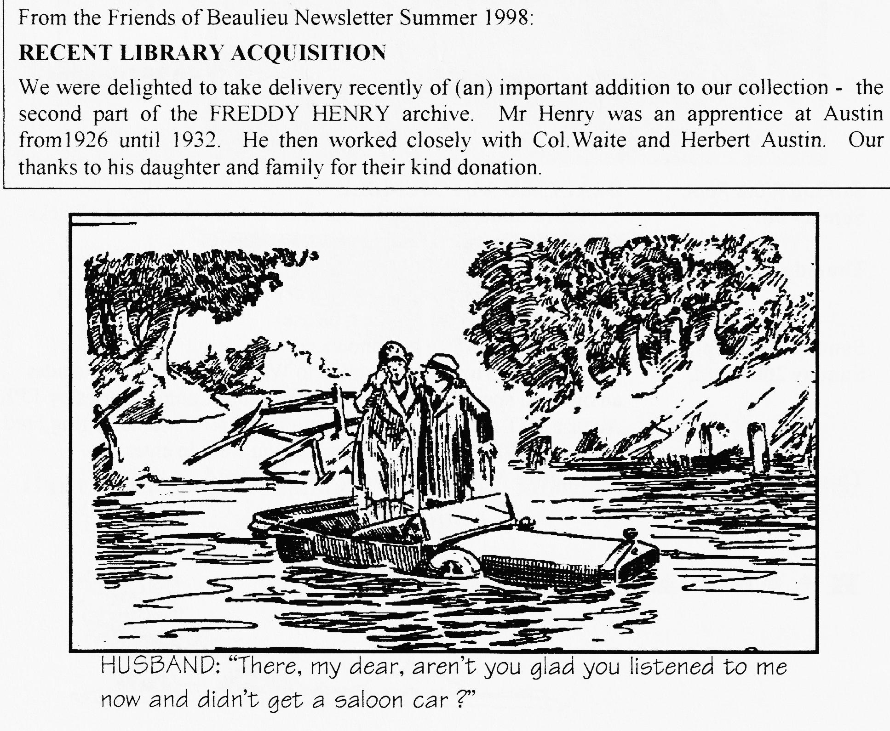
WANTED (From the Internet): David, I'm beginning to think that the Big 7 and late 7 axles are not the same because they have different track apart from anything else, but they may share some common parts possibly the hubs. I've managed to acquire a late axle, minus hubs. My hubs are a bit knackered as the back portion is loose on the bearing, so the wheel moves about a bit. So what I need are a couple of very late hubs if you could run this ad. for me I'd be very grateful. Hugh Barnes (Cambridge A7C)

oo CLUB DIARY oo
August
Sunday 16th Aug Ashover Rally (VAR) - details from Dusty
Thursday 20th Aug. Club Night: Bring your SWANAGE PHOTOS plus presentation of slides by Paul MacKenzie (official event photographer) plus spares.
Sunday 23rd Aug BERNARD'S ANNUAL KITE RUN & PICNIC to Cranbourne Chase Meet QE School. Wimborne at 10.30 am for 10.45 off. Don't forget to bring a kite and a picnic!
Thursday 27th Aug Committee Meeting 8.30 pm Tyrrell's Ford
Sat/Mon 29/31 Aug Piddle in the Hole Run: BA7C- details from Dusty
Sunday 30th Aug A Grand Gathering of Cars: West Bay - details from Dusty
Thursday 3rd Sept 8 'til Late sees a return to the popular BARLEY MOW, COLEHILL. (See April Newsletter for map)
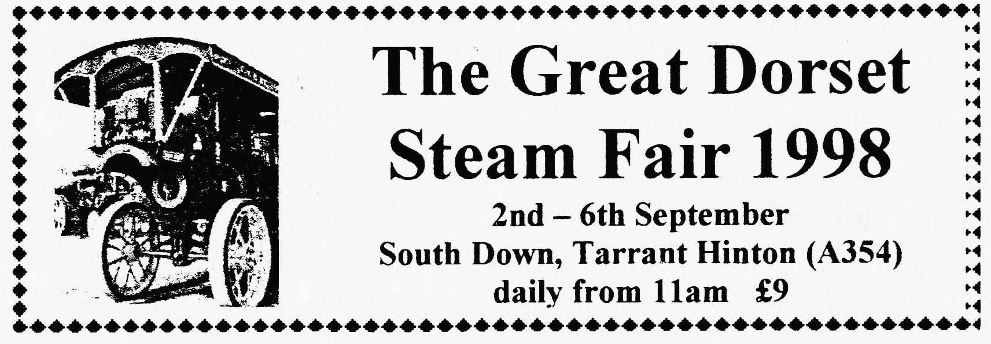
oo FUTURE EVENTS oo
Sat/Sun 5/6th Sept. BEAULIEU AUTOJUMBLE
Sunday 6th Treasure hunt organised by our friends from the Wessex Ducks. Meet at the Tyrrell's Ford Hotel at lunchtime.
Thursday 17th Sept. Club Night "Building Reliability into your Austin" a Members' Forum hosted by your very own Phil Whitter with active audience contributions (please).
Sunday 20th Sept. Club Run Details to be announced.
Sunday 20th Sept. "The RNLI" run from Beaulieu to Weymouth. 16.50 includes an optional special stage sprint at Blandford Camp. Entries by 15th August BUT as a special dispensation to DA7C Members ring Fred Paddock on 01258-454236 ASAP if you want to enter.
Thursday 24th Sept. Committee Meeting: 8.30 pm Tyrrell's Ford.
