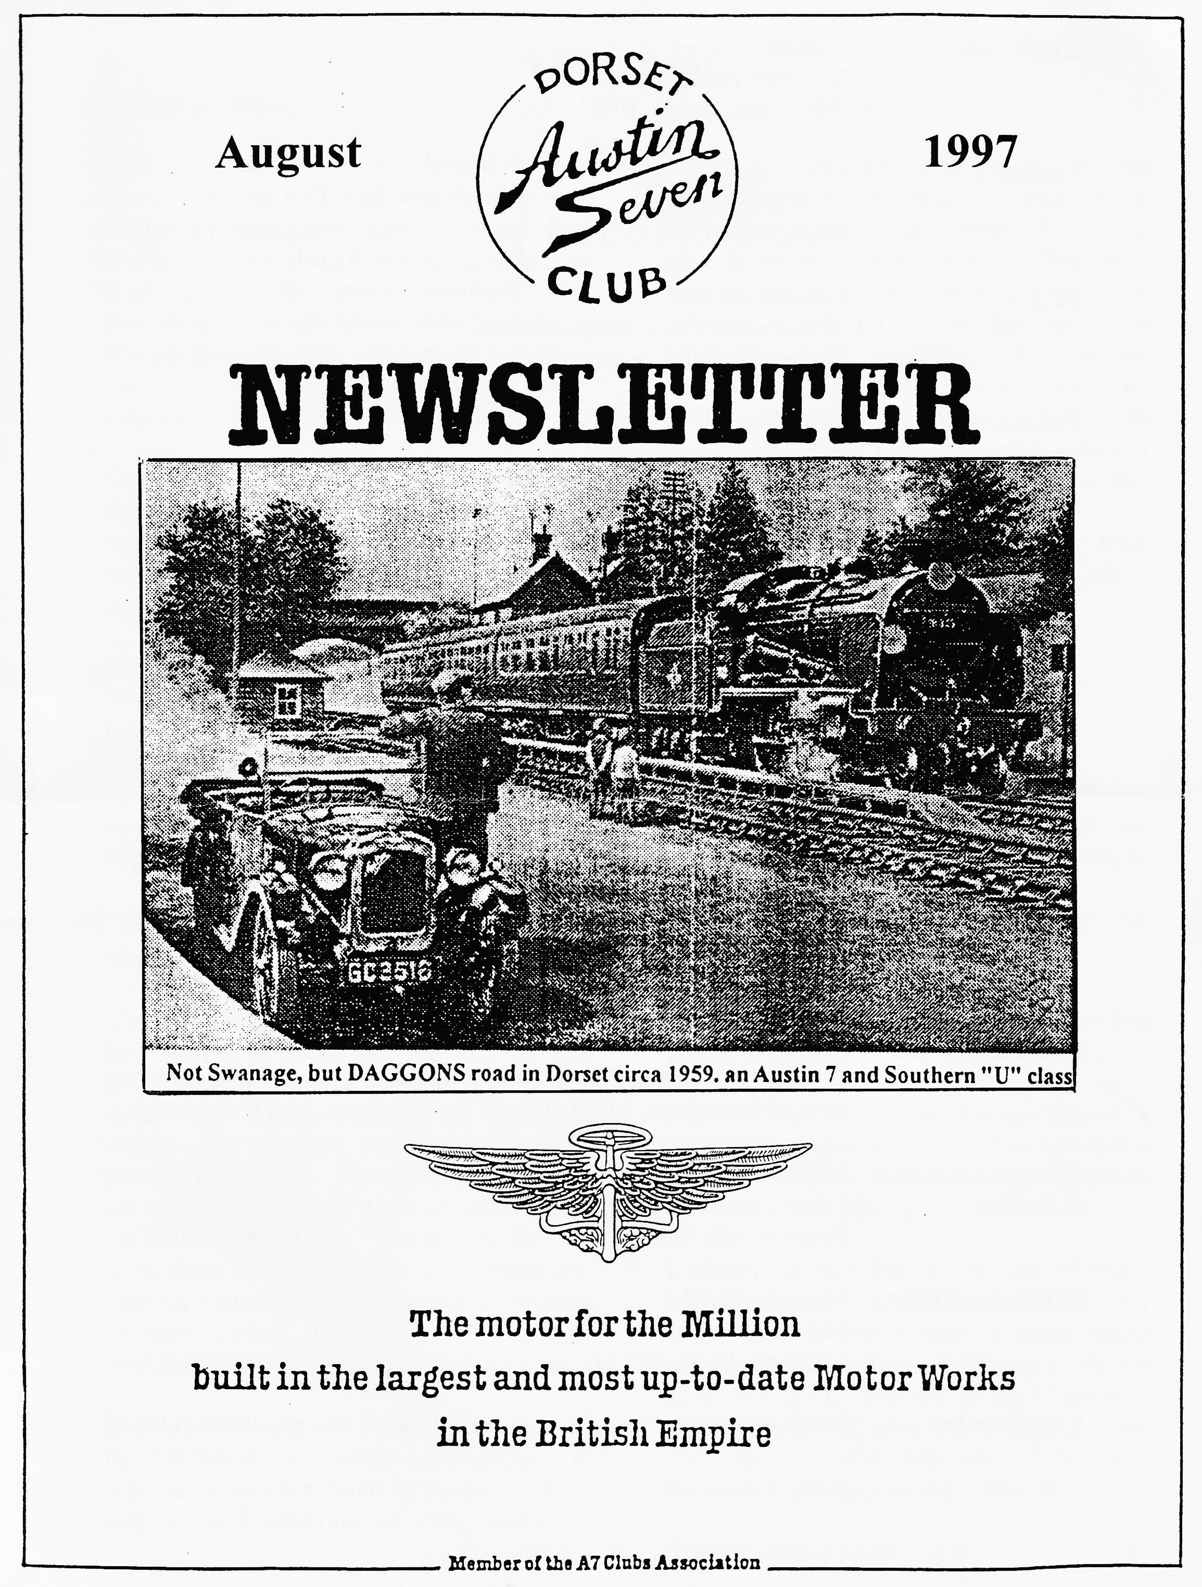

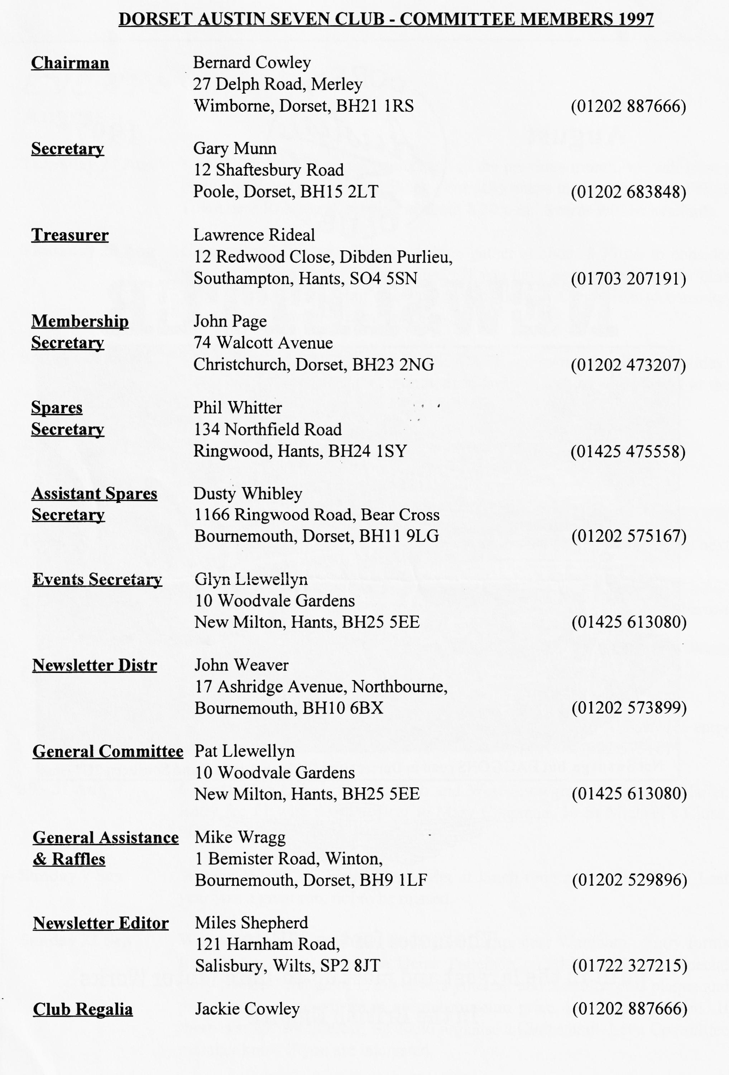

EDITORIAL
busier at work (the curse of the writing classes!) which has made it increasingly difficult to edit your newsletter. I am very glad to announce that from the September edition, you will have a new Editor. Dave Whetton has been a stalwart member of the Club for many years who has written regularly in these pages, most recently on racing matters. He thus requires no introduction from me. On your behalf, I welcome David, long may his postbag be full!
Welcome, too, to Malcolm Connolly from Fordingbridge who has just joined the Club.
See you at Club Night
BFN - Miles
Cover picture courtesy "The
Wessex Ducks" 2CV club.
Hallo Everyone,
Well, the Club Rally is well behind us once more. As you will read elsewhere in this edition, it was once again a resounding success so our thanks and congratulations must go to the many members who contributed their efforts and time to make it one of the highlights not just of our Club year, but of many other Austineers and a very large selection of the travelling public too.
The Editorial Chariot was not present on the day, for reasons you can read about later. Suffice it to say here that I suffered from a surfeit of brakes, a most unusual situation to find one’s self in!
The few of you who actually read this part of the Newsletter will have noticed that I am frequently unable to get to club night or to Committee Meetings. I have become much
After the early deadline last month, we revert to a more normal timetable for the next issue. Please
send lots of material to Dave Whetton, address below, by 29 August. The cover picture shows those brave souls who ventured into deepest Somerset for the Witches and Windmill Run
SECRETARIAL

Well Folks!
The Rally is over for another year, everyone I have spoken to from both the Railway and DA7C seems to have thought it all went really well. I understand that the Railway's takings were excellent, it all helps them with funding their work. Pat and Glyn to whom we owe most thanks to, have agreed to run it for one more year. Thanks from the Committee to those of you who helped out over the 3 days. Our prayers certainly seemed to have worked, it was one of the best weekends for weather we have had this year.
The July Clubnight saw a very interesting talk by Phil Whitter on vintage gramophones. It must have taken him hours of research. There was a good selection of club member's players on display, luckily they were not played in unison!
I did not manage to attend Richard Cressey's Run but from past experience I'm sure that a good time was had by all. No doubt an article will appear [See p3 Ed].
I understand that due to pressure of work, Miles is shortly to stand down as Editor and I believe that a new protégé is being honed already for the position; details are explained in the Editorial. The rest of the Committee trust that you will give Dave all the support you can, it is I'm sure one of the most demanding positions on the Committee.
See you at Club Night- Gary

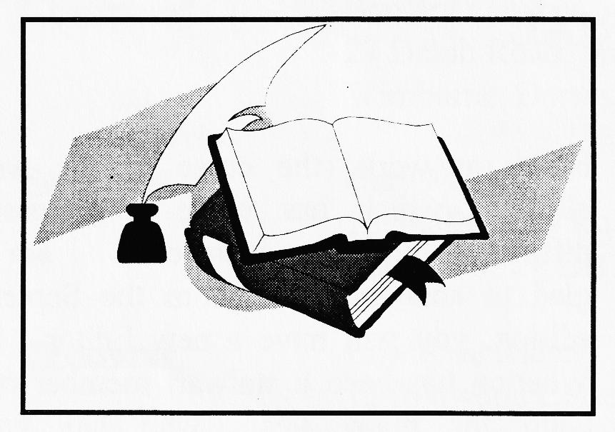
Book Review

Unique Motoring Portfolios of Essex recently sent the Club a copy of its latest compilation "The scarcest servicing information, road tests and adverts ever produced on your car" which focuses on the Austin Seven. Colin Pitt has put together an 86-page A4 sized book which for the most part reproduces period articles from "the Light Car", running from 1930 to 1938, interspersed with some adverts and articles from "Motorsport", "The Austin Magazine" and "The Sphere".
One of two you will already be familiar with from the two Brooklands Books publications on Austins [these are Austin Sevens in the Thirties and Austin Seven Cars 1930 - 35 to which must be added the Austin Seven publication from the same house published in 1982 to coincide with the 60th Jubilee - Ed] but for the most part the compilation is new to the enthusiast if somewhat limited in its coverage. I say limited because most of the articles cover the Ruby and Big Seven instead of the acknowledging all the models in the period 1922 - 1939. Most of the servicing information contained in the publication has had some previous exposure and most Austin fanatics will find nothing new. However, I did particularly like "Servicing the Austin Seven" from the Motor Trader of 1936 and "Tuning the Austin Seven" from Motorsport in 1938.
Producing a new and interesting book on Austin Sevens is quite a challenge and requires a lot of thought on format and content if it is to succeed where so many others have previously ventured. My impression of the Portfolio is that it has been put together rather quickly from a somewhat limited database, i.e. The Light Car 1930 - 1938. In spite of this, many Austin enthusiasts will find it interesting and worth reading.
As someone who has a complete library of Austin Seven publications, my thoughts for success would be along the lines of producing a portfolio of articles and adverts assembled in chronological order from 1922 to 1929 and taken from all available publications in that era. These would be distilled into a useable size by consulting a few 'experts' from potential customers in the Austin movement who would soon be able to identify the new interest articles and adverts which would appeal to fellow enthusiasts. Finally, double the price for all the effort and quality that has gone into the publication. Finally, having said all that, I will certainly be buying a copy for my own library - its not too dear at £9.25 (possibly cheaper. for a club order??) so please take a look at the sample available at the next club night. If there is sufficient interest, we can investigate a bulk order.
Regards, Phil Whitter

One View of the Rally
There always has to be one...this time I was the culprit. When MoT-ing the Nippy, Peter Stacey said the brakes were marginal even for an Austin Seven. As it was the Thursday afternoon before our Rally, I asked him to do the necessary. When he stripped them down, he found excessive wear and the only course of action was new bits. I got the news at 5.30 p.m. and phoned Phil Whitter to see if he could help. He was packing the caravan to go off to Harman's Cross but said he would sort out all the spares he had for the job and leave them for me to collect, which he did that evening. How very fortunate we are to have such an efficient and dedicated spares expert. There's no-one quicker than quick fix Phil Whitter!
Thanks to Phil and Peter Stacey's efforts on Friday, we were able to go to our Rally and have a very happy time. What a wonderful show it was once again with a rare mix of cars etc. So much hard work must have been put in over the year and on the weekend to ensure such a great success. The whole show was so efficiently organised beforehand that everything just fell in place. On our rounds we chatted to many visitors who said it was their favourite Rally because of the efficient organisation but relaxed family atmosphere that prevails and looked forward to next year...don't we all!
Grateful thanks to all concerned and especially to Pat and Glyn; they really are great. Bill Quayle

Beaulieu Spring Jumble This year the event spanned two days and after previous complaints from traders, they were allowed to set up during Friday without a 'bottleneck'.
The event is smaller than the September International gathering with some 500 stalls compared with the 1500 plus of the bigger event. It does not attract the foreign visitors that you get in September but given good weather it is still an interesting jumble. Unfortunately, this year the weather was very unpredictable and it rained quite a lot which discouraged many from making the pilgrimage. Saturday was the busiest day for people buying with Sunday mainly being 'people out for a look'.
It was good to see so many local Austin enthusiasts and particularly interesting to hear about Mike Topham's latest acquisition - a 1931 Cross and Ellis sports bodied 12/50 with Silver Eagle engine. Please bring it along for us all to see, Mike - we certainly won't think it too grand so don't worry!
For many, the downside of Beaulieu is the cost. A stall costs nearly £100, entrance to the public is kept at normal museum entrance prices although the majority will only attend the Jumble, and it is not the easiest place to get to. Montague Ventures need to seriously look at meeting customer needs, where the customer is not only the visiting enthusiast but also the stall holder who helps make the event a success. Motorcyclists have already pulled the plug on Beaulieu with their own separate event at nearby Netley Marsh - at the same time as the September Jumble!
Happy jumbling, Phil Whitter

AND WINDMILLS RUN
Of course, living the nearest to Q.E. School, it was inevitable that Bernard and I would be the last to arrive. However, at 9.50 a.m. on a beautiful, bright and clear Sunday morning in July seven Austins, all different, set off at a brisk pace and made Sturminster Newton Mill in just over half an hour. Here we met Richard and Margaret our leaders for the day, in their racing green Ulster type special. (I really like those doors, Richard) At this point our 'out-rider' Bob Stanley, a member of the motorcycle section of the DA7C, left us and one Fabric Saloon, a Chummy, a two-seater Tourer, one Ruby, an Opal, a '31 Box Saloon and the red special of the sole member of the Racing Section of the Club sallied forth into the Dorset countryside en route for Sherborne. From here our route took us roughly north through pretty villages with strange sounding names and cottage gardens lush with summer flowers, and across into the interesting scenery of the Somerset Levels. At one point along the way, I thought we had arrived at Glastonbury Tor but it turned out to be the mini version at a place called Burrow Bridge - almost an exact replica but a third of the size.
By now I was beginning to wonder why Witches and Windmills and kept an eye out for any strange low flying women but all I spotted was a Buzzard lazily circling over a corn field and a `Swordfish' flying low and very, very slowly over Yeovilton Airfield. How do they keep in the air going so slowly?
All was revealed regarding the Witch when we arrived at the pub. The Black Smock at Oath (or Stathe) is an isolated building with a strange legend attached to it about a woman who disappeared up a chimney when they tried to arrest her for being a Witch. However, the present Landlady is certainly not a witch, we were made most welcome and fed very well indeed. At the Pub, Jane and Dusty in their Ulster joined us. Having missed us at the Mill they had done some great detective work and eventually tracked us down - not easy without a map!!
Well-fed and watered we drove a short distance to Stembridge Tower Mill, a most attractive building built in 1822 and now owned by the National Trust. We climbed the terrifying steps to all the floors and then sat in the late afternoon sunshine admiring the cottage garden and orchard surrounding the Mill. It was a peaceful end to a lovely day out. Thank you, Richard and Margaret, for a most enjoyable run.
PS I think the ladies really appreciated the 'comfort stop' on the way to the Pub.
Jackie Cowley

Another View of the Rally
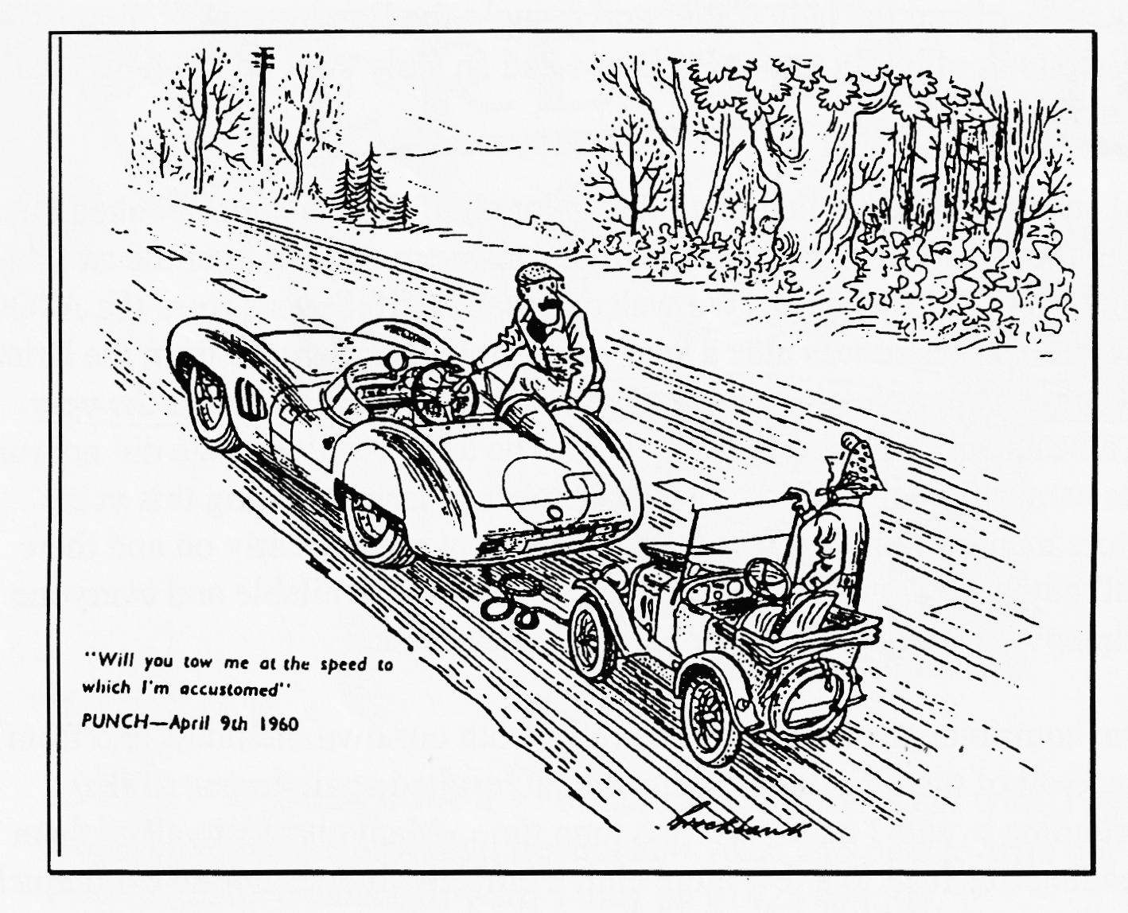
The signs were not good when I arrived on the Friday afternoon. This buzzard was circling over the .rally field and the train was in full steam. It looked like the Indians were about to attack for the last time and wipe out the settlers!
Fortunately, all was calm and well under control, John Page and Glyn had marked out the field so I was left to admire the changes from previous years. These were that the Austins would use the whole front of the hill, so they would be the centrepiece of the show. Bernard had noted the point made at Gaydon, where some thought that it would be good to segregate cars. He grouped the Austins into four types, Chummies, Boxes, Rubies and Sports. It seemed to work very well and still allowed the informality that is the hallmark of Swanage. Other changes were less easy to spot. The Railway were looking after all the catering, not just the Beer Tent. There were more toilets, and we had a new Band and Caller for the Barn Dance.
On the Saturday, my trouble began. I set out early to be able to marshal the cars onto the Rally field. All went well until I stopped for a cuppa. After breaking to a halt and consuming a welcome cup of tea, I set out once more only to find forward progress severely slowed! The brakes had locked on and I could not drive the car, so Kate had to come out an collect us both. Hence the cartoon above! I had noted an increase in rolling resistance when I took the car along for its MoT. Roger Ballard kindly came to my rescue when I found the brakes then had locked up. We bled the brakes and generally worked the master cylinder over and got everything back to normal, we thought. The problem is a sticking piston in the master cylinder so I have invested in a new master cylinder and should have fitted it by the time you read these words.
And so to Harman's Cross, a couple of hours late. Pat and Glyn have a sure touch on the entrance and directed a steady stream of entrants to the marshals on duty. Many thanks to Gary. Kevin Wissett and Dave Whetton for holding the fort until I turned up. While this was going on, Phil and Lawrence were doing sterling work keeping the toilets clean and fresh, a task they carried out all weekend. I'm told the flowers in the Ladies were much appreciated! Bernard had got a good number of jumblers in and I was able to spend some time admiring Dave Phillips display from the Seven Workshop on the Saturday and Ken Medlicott's wares on the Sunday. There were plenty of others there catering for most tastes. I found a handbook for the Zenith 30 VEI carb I had been looking for years!

The Barn Dance went very well, I liked the lady Caller and thought the Band were excellent. The hats were pretty good, too! I slunk off early to our B&B as I had an early start on the field, that was my excuse, and I am sticking to it!
Sunday dawned bright and sunny; the cars rolled in all day. Not all of them had pre-booked but Pat and Glyn took all that in their strides. Some 97 Austin Sevens were entered over the two days, with about 70 attending on each of the two days. We welcomed about 18 Sevens from the A7OC at the end of their South Coast Run; there was also a very good turnout once more from the Bristol Club. I did not count the Classics but a rough estimate was about 300 which included the very handsome Topham Alvis, a beautiful Talbot and what I took to be a GP Amilcar. We did not run out of space for the various cars, although with double the number of trains running this year, there were even more visitors than ever and as a result, the Beer Tent ran dry early on and there was a distinct lack of the all-day breakfasts. However, alternatives were available, and everyone seems to have gone away happy which is the main object of this exercise.
There are many people who contribute the success of the rally, both our own members and from the Railway. Many thanks to all of them for their efforts which resulted again in one of the friendliest and smoothest running events I have seen in a long time. Many thanks to all of them. Next year, how about spreading this load to a few more club members. It does not take too much to give an hour or two to relieve one of the stalwarts so they can see some other parts of the rally.
I'll be back again next year hopefully with the Ulster! S see you there? Miles
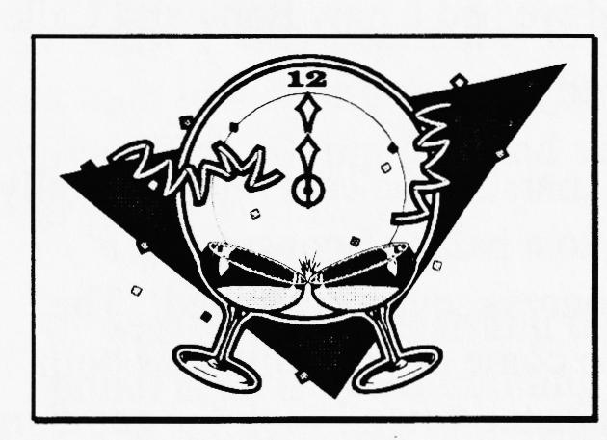
Great News!

After two years of often painfully slow progress, the consolidating legislation on the Roadworthiness Testing Directive has passed through its final stages and has been approved by the Council of Ministers and now forms the Roadworthiness Directive 96/96EC. Thus may not sound very impressive but what it means is that vehicles which individual states consider to be 'of historic' interest' shall be subject to testing must not lead to the 'application of stricter standards than those which the vehicles concerned were originally designed to meet.' Within the United Kingdom, this means that all existing exemptions and provisos which have been taken care Of within our own MoT Test will be able to continue in the same way.
We owe a considerable debt to the many people who have been concerned with achieving this breakthrough, particularly the FIVA consultant Reg Dawson, the sympathetic officials at the European Commission and FBHVC.

FOR SALE
1931 SWB Box Saloon - Former club member's car with 3 speed box, in red and black paint work, Given the Munwellyn treatment 4 years ago plus re-wire but not used since. Needs tidying. Price U4,250. Contact Howard Tilley on 01425 474504.
WANTED
URGENT REQUIREMENT! I badly need a cam shaft from an un-supercharged Ulster for my rebuild project! These are the ones with the extension to run the rev counter from the front of the shaft. If you can put me on the track of one of these, I will be suitably grateful! Contact your Editor on 01722 327215.
Austin 7 - Must have sound bodywork/chassis. Mechanics not important. Any age or type, 4 speed preferred. Ring Bob Stanley on 01425 619212

NEW EDITOR

From 25 August 1997:
DAVID WHETTON
129 Lonnen Road
Wimborne Dorset
BH21 7AU
Tel: 01202 848743

Please keep the articles, letters and photos flowing, remember that the job of the editor is to prepare other people's material for publication! I was fortunate having contributors such as Biddy Brown, Phil Whiner and Gary who could always be relied on to get his Secretary's notes in on time. You too can help!

EVENTS
August
Thursday 21 Aug Club Night. After all the excitement of the previous month, we will have a plain old Noggin n' Natter. Bring your rally snaps to the Elm Tree at High Town near Ringwood, starting at about 8.30 p.m. Spares will be available.
Thursday 28 Aug Committee Meeting. The Committee gather at about 8.30 ish to consider weighty matters at the Tyre11's Ford. If you have any suggestions for club runs, outings or anything else you would like the Committee to consider, please let a committee member know.
Sunday 31 Aug Club Run. NOTE CHANGE OF DATE to avoid the Bank Holiday! Lawrence is organising this month's run and would like you to meet at the Cat and Fiddle at 10.15 a.m. for a 10.30 start.
September
Thursday 4 Sep Eight-ish till Late-ish. Meet for a Natter at the Fish at Ringwood.
Thursday 18 Sep Clubnight. Throw a Pot for Charity. Sounds fascinating - full details next month.
Sunday 21 Sep Club Run. The 'volunteer' for this run had not identified him or herself when I last heard so details will emerge next month
Other Events
Sunday 10 Aug Luccombe Country Fayre, in aid of RNLI, near Milton Abbas. No entry fee turn up on the day but please phone Dusty first on 01202 575167
30 - 31 Aug Countryside Cavalcade the Bath and West Showground, Shepton Mallet. Entry fee £1 with details of car to Mary Chapman, 10 St Michael's Close, Stoke St Michael, Bath, BA3 5LF
Sunday 7 Sep Wessex Ducks Treasure Hunt. Met at lunch time at the Elm Tree. Last year was a great run, not to be missed.
Sunday 21 Sep Wessex Classic Car Show, Bovington Camp, near Wareham. Entry forms from Pat or Glyn, or phone Derek Patterson on 01202 691792. Special early booking charge of £2.50 covers your car and 2 adults, plus plaque and programme. Late entries at normal museum price, i.e. £5 per person! If there is sufficient interest, we could organise a Club stand. Let a Committee member know if you are interested.
THIS IS AN EVENT THE 2CV CLUB INVITE US TO IN APPRECIATION FOR OUR EFFORTS AT SWANAGE, PLEASE SUPPORT IT!

