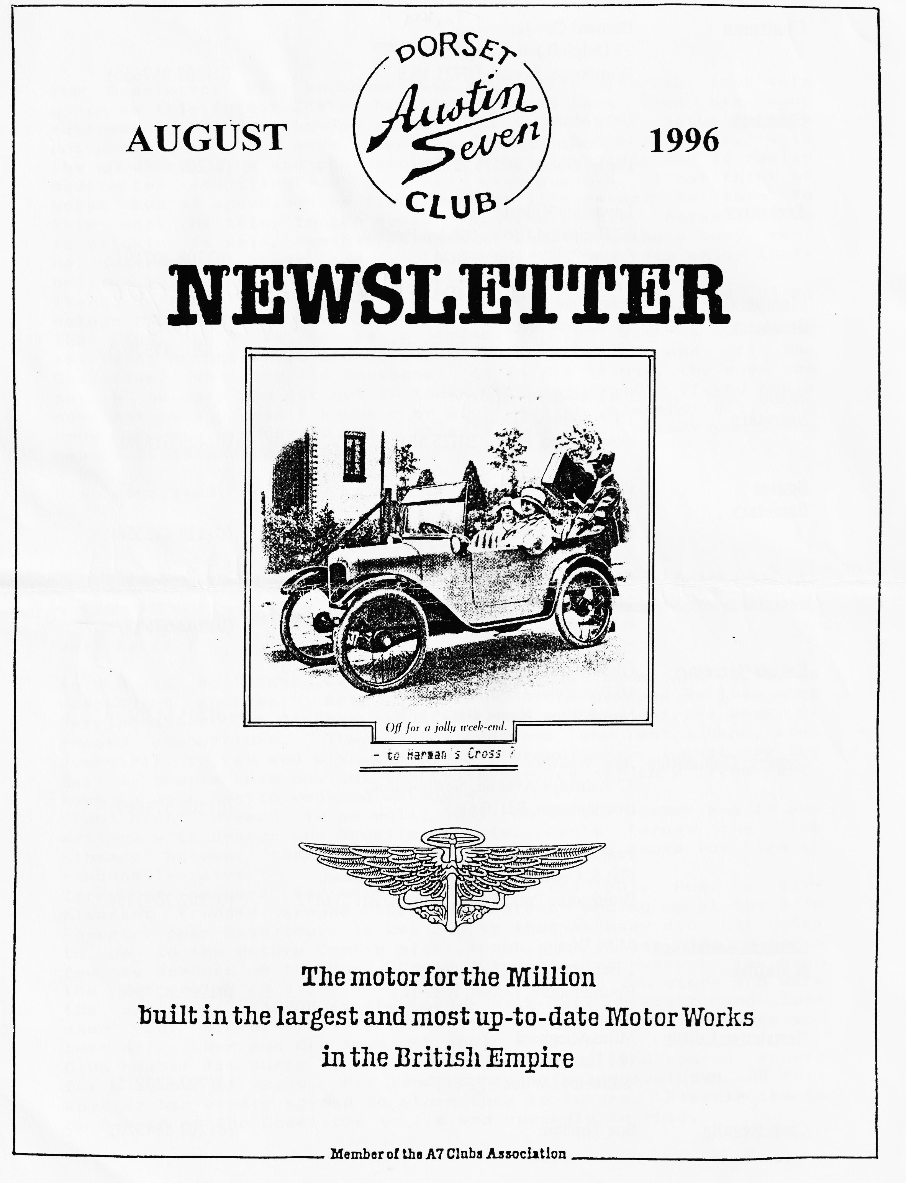

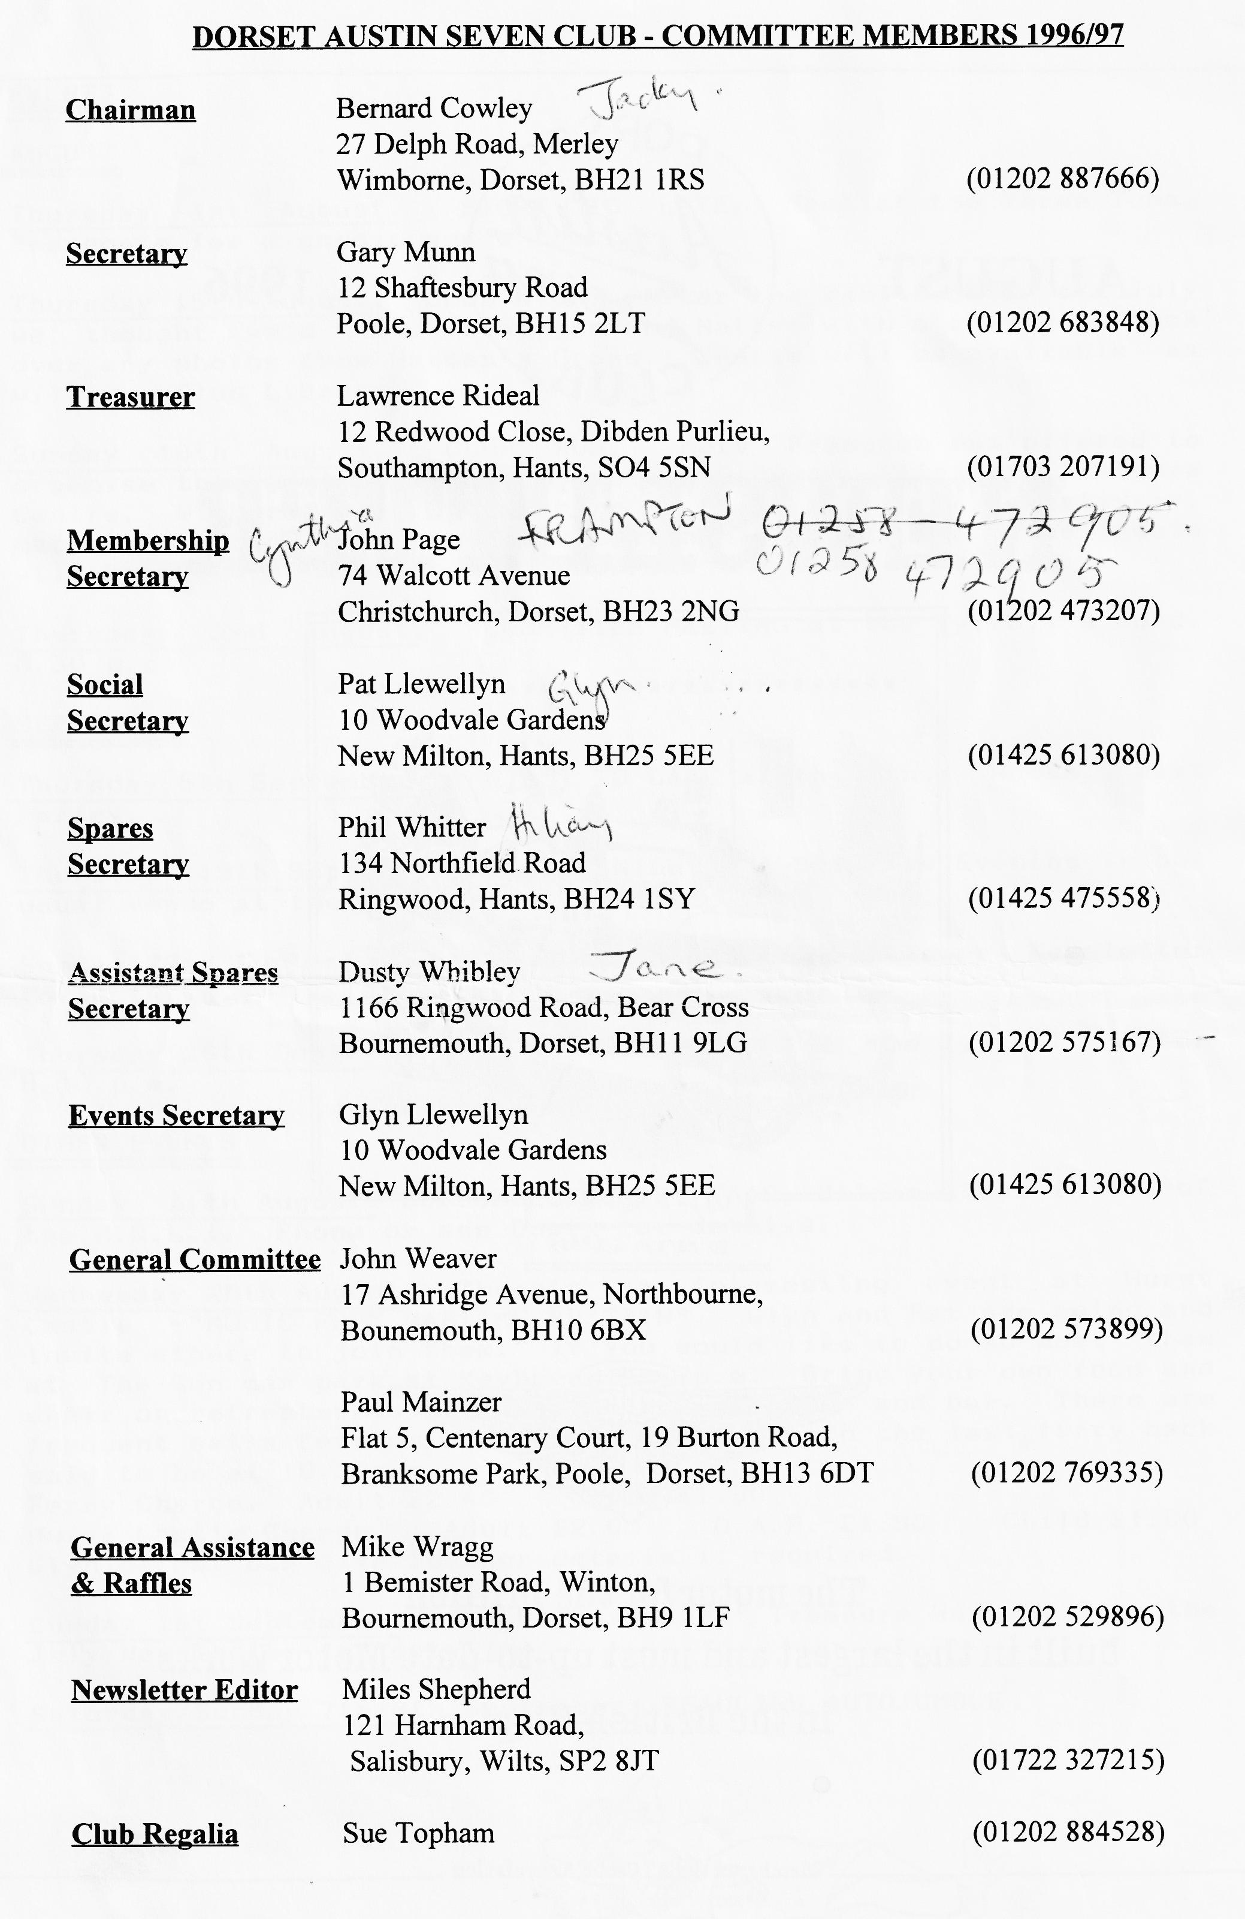

EDITORIAL
The Newsletter will no doubt have a slightly different look this month as this former Editor has been dragged back from his smug retirement to do the job again - for this month. Actually, it's not unpleasant to be back in action, on a temporary basis, with the scissors, glue and photocopies. Newsletter editing is really Newsletter compiling as you may have guessed. I can think of worse ways of spending the time although it's harder to turn to this sort of thing in the summer than the winter. Anyway, Miles is sticking it well, month after month, despite being a busy man. He deserves a break, and we hope that he and Kate enjoy their holiday in an "antique land" - Crete in fact.
Thanks to those who have sent in contributions - including Miles before his departure.
The Club continues to be a friendly Club with a number of selfless, enthusiastic and good-natured folk both on and off the Committee, who are its backbone. As in all things, the more you put in the more you get out in the way of enjoyment. it you are a newcomer make yourself known - or other newish members will not know if you are new or not. This is your Club whether you are a new or longstanding member.
Keep your revs. up !!
John.
SECRETARIAL
Well Folks !
As you are no doubt aware our Rally has been and gone, a
resounding success. Both our Club and the Swanage Railway were very pleased. The weather was kind to us and the entries were of record proportions. Thanks to everyone who lent a hand, most especially to Pat and Glyn the overall organisers. I must say the Railway people have now got the train service off to a fine art, keeping up a hectic weekend schedule.
Club Night seemed to go well; just one of our summer Noggin and Natters with Spares and Regalia on sale. Don't forget the Club Library Scheme, there are some interesting books for hire at reasonable rates.
Terry and Barbara Jefferies organised the July Run, a very pleasant trundle around the New Forest ending up at the Bold
Forester near Beaulieu. It was a pity that so many did not stay
to go to the Nature Centre after lunch, but it was nice to see a few new Members on the Run. Could I just remind everyone to keep the car behind in sight-Stop if the car behind you stops and mark the corners (i.e. STOP at the corner of a left or right hand turn when your mirror tells you that the car behind will not see you turn off. When you are in sight again move on).
Club Member Jim Burry has kept our Club secondhand spares secure for a number of years. His land is now being redeveloped and Phil Whitter has kindly agreed to store them in future. Firstly, thanks on behalf of the Committee to Jim and secondly to Phil.

THE SWANAGE RAILWAY RALLY
T
he weather forecast for our rally was dismal to put it mildly. Overcast on the Friday with rain and thunderstorms over the weekend. However, Saturday 13th July dawned fair and bright so at an early hour I popped out to the Motor House, rolled the Ulster out and started up, but not before completing all the usual checks; oil, water, petrol, security of the wheels and a quick look over the various steering connections. All was well so off we set for Swanage.
All went well until coming up the hill out of Tarrant Kingston when I heard a sharp crack. Stopping at the side of the road and a rapid inspection, while dodging the trucks, revealed nothing amiss so I pressed on while maintaining a careful hear open. Then cruising along the Blandford by-pass, the offside bonnet panel came loose. This was no real problem so long as I put the flapping panel into the clip from time to time.
Arriving at the rally field at about 9.00 a.m. revealed Pat and Glyn manning the entry post with the Page's with the kettle already on the boil. Terry Jefferies and Kevin Wissett were seeing to the early arrivals so I had time for a cuppa before donning the marshals fluorescent waistcoat. Fortunately, Phil Whitter had a spare bolt and fixed the loose panel for me, many thanks Phil.
For many people, the rally began rather earlier. The rally committee consisting of the Llewellyns, Cowleys, Pages, Whibleys, Whitters and several other club members all arrived Oil the Friday to set up the site. This ♦entailed putting up the toilets, marking out the areas for the different classes of cars, marshalling the camping area and a hundred and one other small but important tasks. All was accomplished in good time and we were ready for action by about 5 p.m. Time to sample the beer tent, one of the more agreeable duties; testing that the brew was potable. Health and Safety regs, you know! We were all ready to accept early arrivals - but they had been arriving since lunch time so the camp site was already quite crowded by the time I arrived at around lunchtime.
In fact, rally planning began many months ago. Negotiations with the Railway began only weeks after the previous year’s rally. Pat and Glyn decided to alter the way the rally was organised this year and a committee member was allocated a particular task and was responsible for planning and executing the job. Pat and Glyn ran the arrivals desk (Rally Control to the organisationally minded), the Pages looked after the refreshments. I was responsible for the marshalling, Dusty was in charge of the camping and Phil was responsible for the toilets while Gary was looking after the Barn Dance. This plan seemed to work quite well and spread the load rather more evenly than in previous years. Many thanks to all who helped out, especially to Terry Jefferies, Kevin Wissett, Scott Whibley, Russell Topham, Paul Henwood and Gary Munn all marshalled on the Saturday while John Weaver, Jeff Bridge, Lawrence Rideal, Terry and Kevin all helped on the Sunday. An essential element on these occasions is the sale of club regalia and we are grateful to Marion Trimby who stood in for Sue Topham who was taking a break with the Morris (and Mike) at another rally. I gather sales were respectable.

Those who attended will know that our rally is somewhat less formal in layout than some others you can attend. We have one area for Austin 7s, of which more than 60 were on show; the other cars are lined up between the Austins and the Camp site. Entrants are not put into any order apart from being group into decades such as the Thirties. There were a large number of 'post was collectibles' or Classics as well as a few Vintage and Post-Vintage cars, more than 200 cars in all plus half a dozen stationary engines and 15 various motor cycles. In other words, something for everyone!
On booking in, entrants receive their pack of goodies. This year the 'give-away' was an embossed leather coaster. There were also tickets for unlimited use of the railway for the weekend. This alone was worth more than the entry fee! I made early use of mine to pop into Swanage, a town I had never visited before, partly as I had never been able to get away from the Rally in previous years.
As usual, meeting people was the best part of the weekend. Marshalling gives a good opportunity to meet arrivals and see who is there. Many Club Members took part and we drew a goodly number of our friends from the Bristol and Solent Clubs, not to mention the Wessex Ducks. It was good to see Bill and Norma Quayle out with the Nippy as well as the many other club members who turned out in such numbers both with and without their Austins.
The Barn Dance started earlier than last year and seemed to go particularly well. I fell out early, pleading the effects of too much sun on the first day so I missed the high jinx of later in the evening. There certainly were a few slow starters the following morning!
Bernard looks after the Autojumble which is slowly building up a solid reputation. Each year there are a few more jumblers and this year we were fortunate to have Dave Williams who brought a selection of goodies from the Seven Workshop down on the Sunday. Many thanks to Dave and the other jumblers, we hope you had a pleasant time and did a brisk trade.
While we were all busy enjoying ourselves, the Llewellyns were busy getting people in and out of the rally; John and Cynthia Page were providing tea, coffee and snacks and the ever-busy Phil was on patrol ensuring that we had the cleanest and best maintained toilets I have ever seen at a public event. We owe them all a big debt of gratitude for all their hard work throughout a long hot weekend There were many other people who helped make the weekend a success, from our friends on the railway to the many who helped clear up field after the rally was over. Many thanks to all the many helpers, the rally would not be the success it undoubtedly was without you.
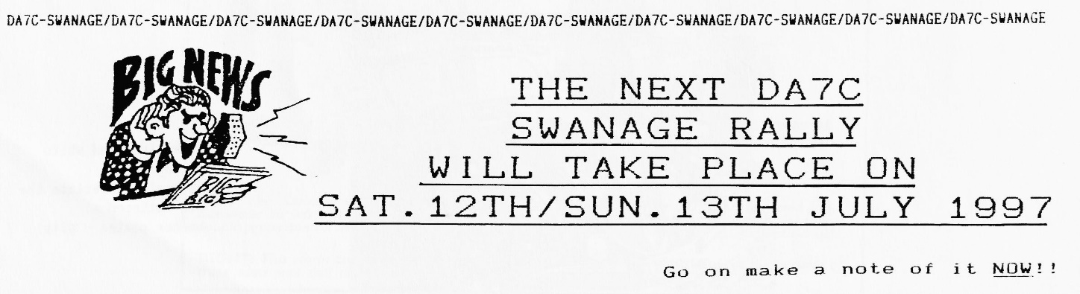
See you next year? Miles

DORSET INTERNATIONAL AUSTIN SEVEN CLUB ?
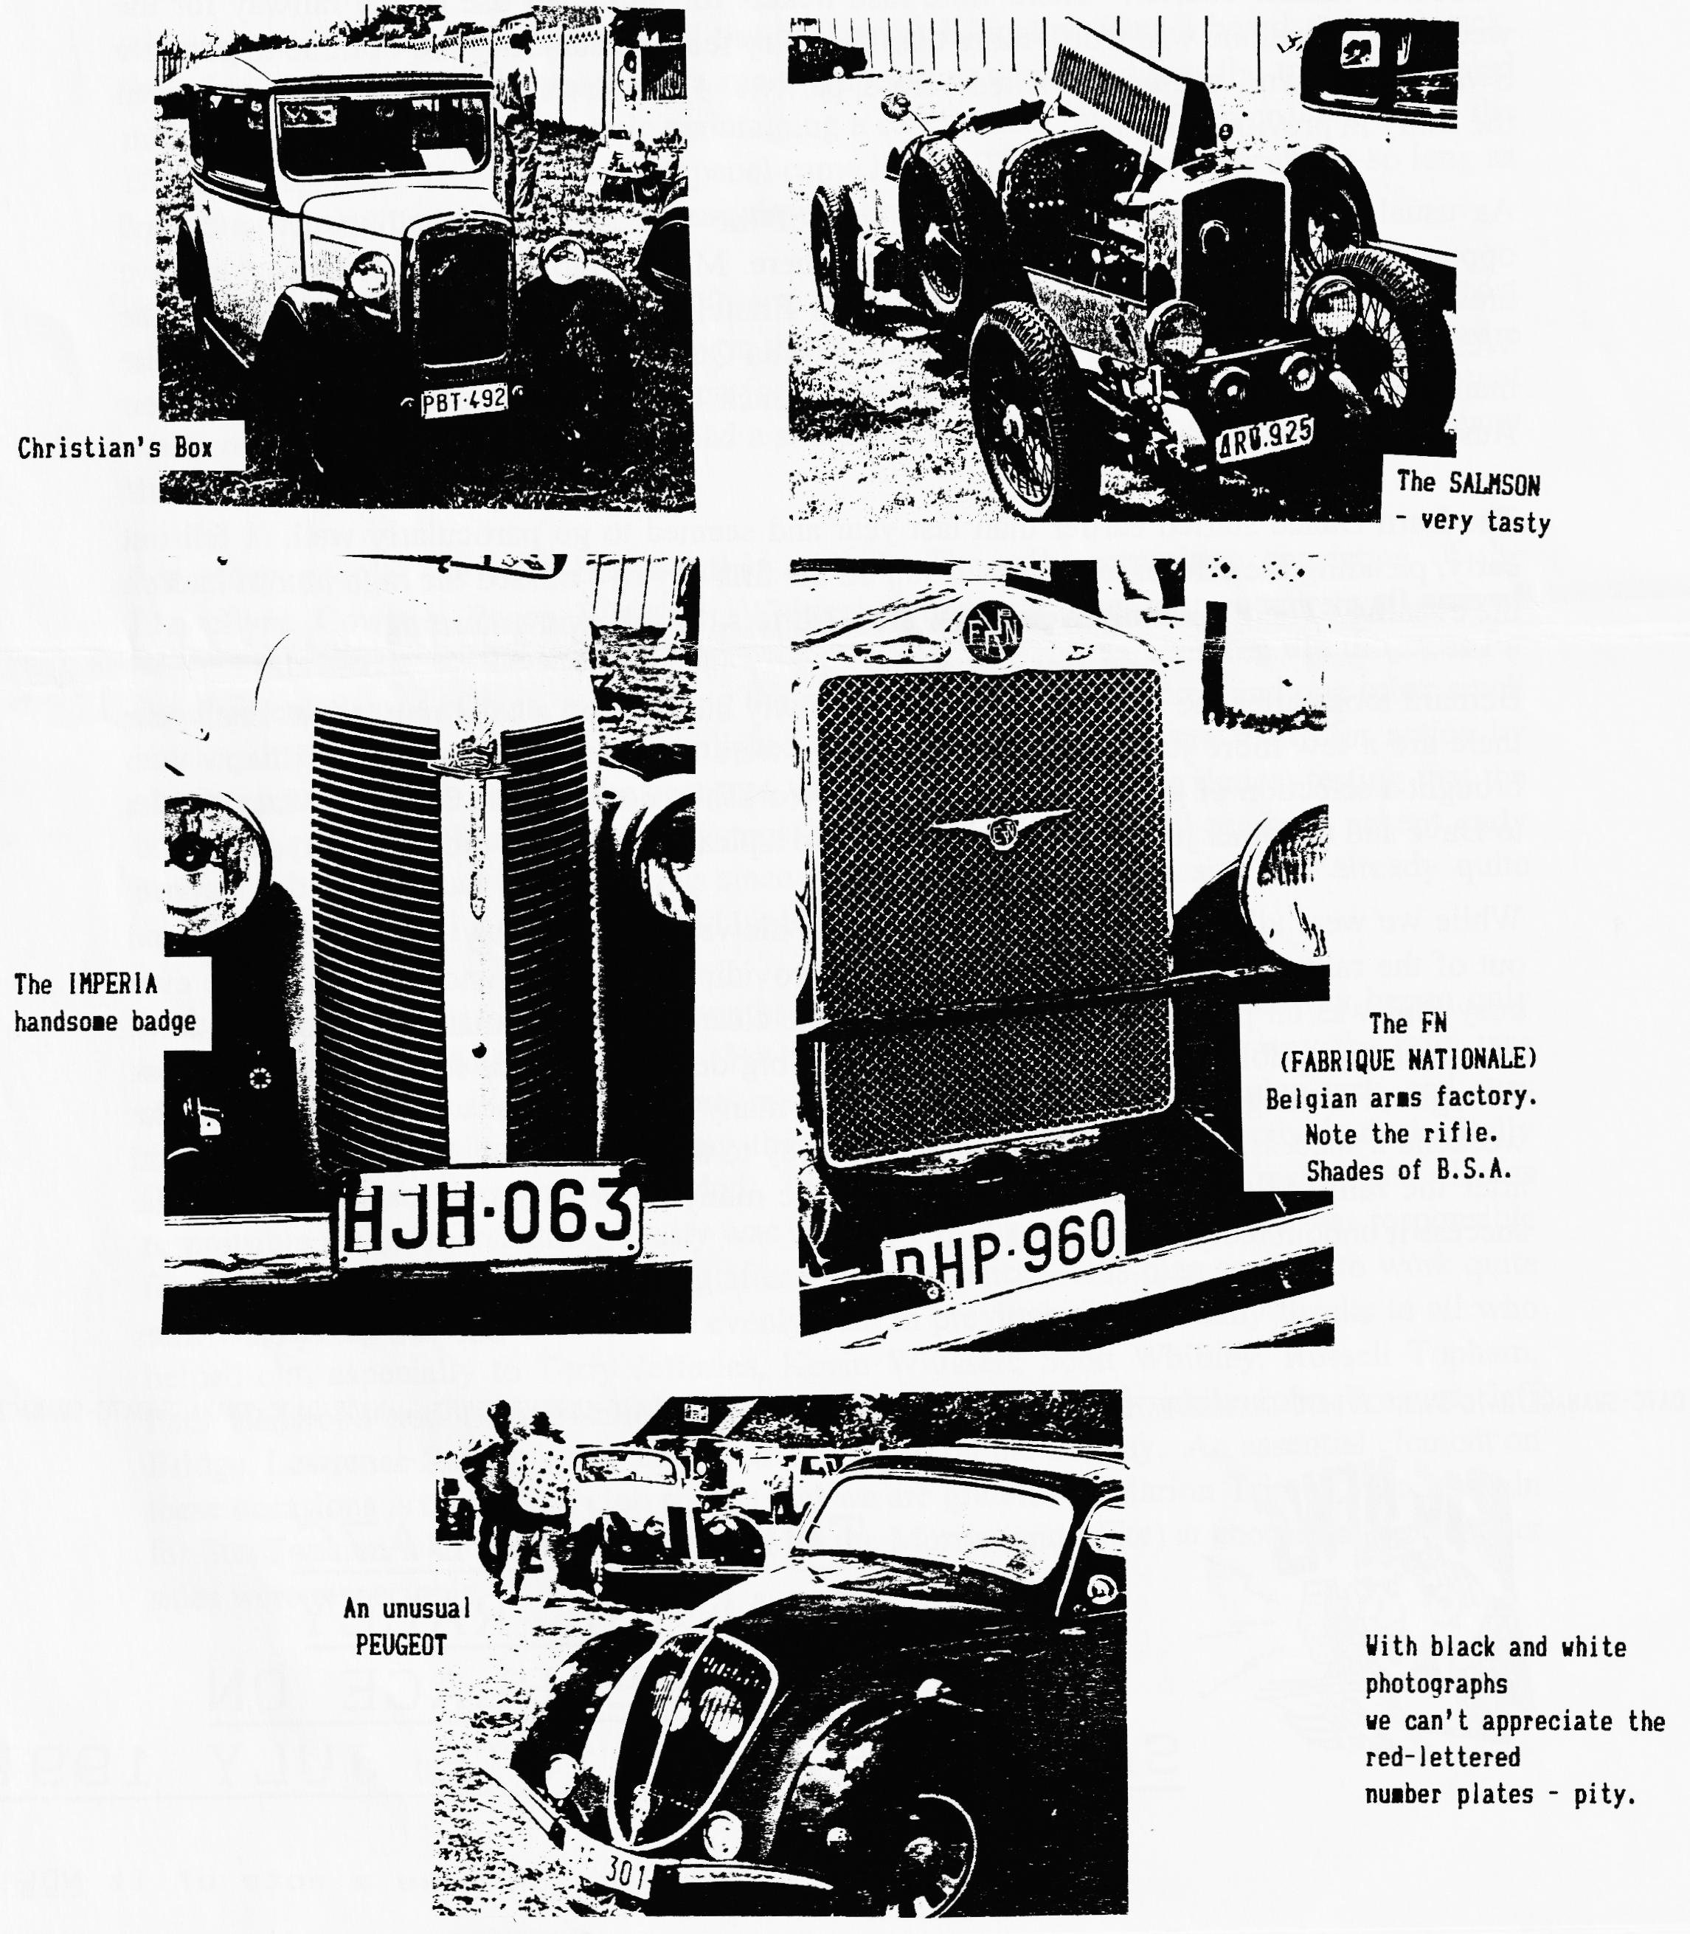
Did you know that we have a Belgian Club Member ? Christian Lauffs lives in Malonne, Belgium and is a keen Sevenner, so much so that he led some of his vintage motoring compatriots to our Swanage Rally on the Saturday. Bernard met Christian at Beaulieu and was able to find him the Box Saloon of which he is very proud and which is now registered in Belgium. If you missed seeing these unusual cars here are a few photos - and when you read this, Christian, we were delighted to see you and your friends. Well done.

OBITUARY We are very sorry to report that Club Member Mr.John Graham Baldwin died in June and offer our sincere condolences to Mrs. Bridget Baldwin. John had a Special that is now for sale. Details elsewhere.

NEW MEMBERS
A warm welcome to the following new members :-
Tim Northmore, Dorchester. Has a 1932 RN.
Rodney Lloyd-Denman, Poole.
Roger and Mandy Stringer, Broadstone. Have a 33 Box.
P.Simmons, Wimborne. Looking for a car.

THAT RALLY AGAIN !
Among the expressions of appreciation received was a letter to Glyn and Pat from Lesley and Keith Marriner of the Midland A7 Club. Writing from Hinckley in Leicestershire they say:-
"Just a note for your Newsletter to say a big thank you to you all for a smashing weekend and rally. We enjoyed every minute. Thanks toyourselves for the cooker, but most of all to Jeff and Marilyn. We certainly do owe them a lot. It was a great venue, lovely weather and good to see lots of old friends again. We shall spread the word "up North" that the Dorsets did us proud.
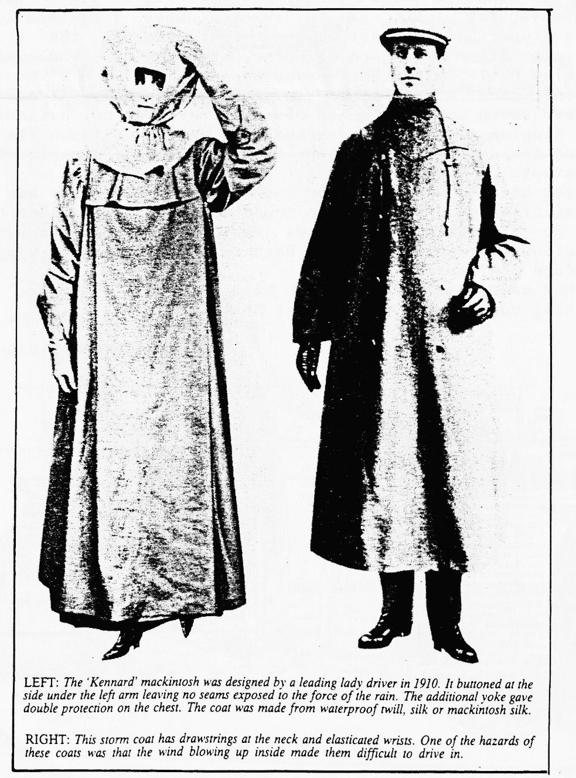

THE HELL AND HIGH WATER RUN or CHRIS BIGGIN'S TREASURE HUNT - ONE DARK NIGHT ON 7TH JUNE 1996
The start of which was at Carey's Manor hotel where Chris had laid on a welcome glass of sherry, or whatever, for participants in his rain and thunder endurance test. He had misled various people by telling them it was to be a treasure hunt; I assume this was done to boost numbers !
According to the clock in the bar we arrived around 8.30p.m. G.M.T. (having failed to get the watch fixed yet) and after being briefed we set off. Last but one being Gary and Paul, sorry two in one. Dusk was near as we hurried from clue to clue, driving fast to lose the last man and catch the first. In doing so we lost everybody, although we did see Gary and Paul going in another direction ! think we got that one wrong. After finding the Fireplace (can't remember much else about it) we managed to get back on course, but it was getting rather dark as we saw the man walking his Collie for the fourth time. Suddenly the rain started, pea sized lumps of it shortly followed by great forks of lightning hammering down to earth and long rumbling cracks of thunder. However, the lightning came as a blessing in disguise as our discharged battery was having trouble keeping up with the demand, so we were able to drive on sidelights through the deserted forest lanes, making Chris's light show even more spectacular. But as we reached what I assumed to be the furthermost part of our test a barn owl flew across the windscreen in a vain attempt to keep airborne, at which time the navigator's candle blew out. By now her nerves were so shot we had to drive on auto-pilot and sixth sense to get back to base. I could have sworn we were on the M4. We travelled on, switching from head to sidelamps as the need arose, not daring to touch the brakes as having three 18 Watt stop lamps the high voltage department became non-existent.
We did get back to Carey's Manor where my poor navigator was revived with a stiff drink and awarded a compensation prize for her efforts. Please do it again Chris, but next time I'll charge my battery first; also first were Terry and Barbara, who cheated by doing the test before the storm !
P.S. Other members of the DA7C are said to have been there.
We'll still come next time. Thanks Chris.
Dusty, Jane and Bluebottle
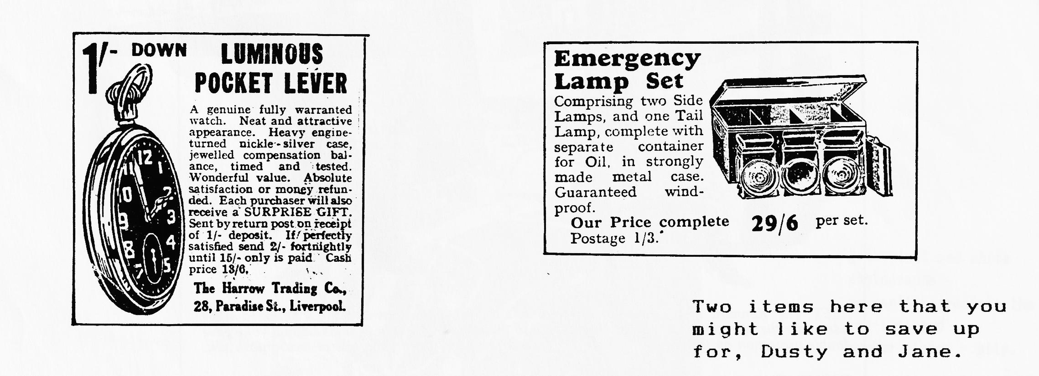

FOR SALE
AUSTIN SEVEN SPECIAL 1936 on a Ruby chassis. R.T.C. body. Very attractive car in maroon and cream. Tonneau, roof cover and picnic hamper on rack included. New MoT. £6,500 Phone Baldwin on (01202) 426868

MORRIS MINOR Smoke grey 2 door saloon in very good condition. Recent new wings etc. MoT October. Tax Free ! £995 Phone Gary on (01202) 683848

NOTE Miles has successfully sold Kate's Traveller through the
Newsletter. This is clearly the place to advertise - and there is no charge !
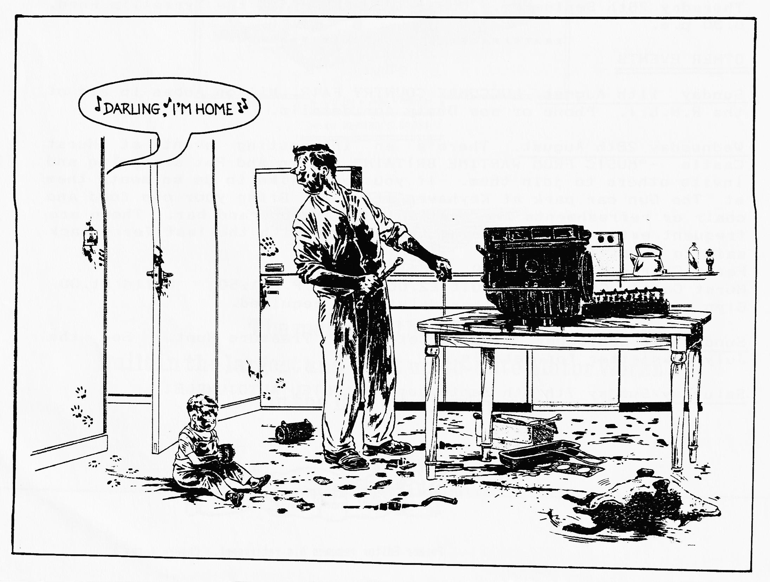

EVENTS. AUGUST
Thursday 1st August. EIGHT TO LATE. Meet at the Three Tuns,Bransgore for a gossip and a chuckle.
Thursday 15th August. CLUB NIGHT. After the excitements of July e thought we'd have a Noggin and Natter with a chance to look over any photos from Harman's Cross. Spares will be available as will the Club Library.
Sunday 18th August. CLUB RUN. Mery Frampton has offered to organise this month's Run so meet at Queen Elizabeth Leisure Centre, Wimborne, at 10.00 for a 10.15 start. Alternatively, catch the convoy at Sturminster Newton Mill at 11.00. The route will be about 40 miles so be prepared.
Thursday 22nd August. COMMITTEE MEETING at the Tyrrell's Ford. 8.30 p.m.

SEPTEMBER
Thursday 5th September. EIGHT TO LATE at the Manor House, West Parley.
Thursday 19th September. CLUB NIGHT. A Skittles Evening in our usual venue at the Elm Tree.
Sunday 22nd September. CLUB RUN. See the September Newsletter for details.
Thursday 26th September. COMMITTEE MEETING at the Tyrrell's Ford. 8.30 p.m.

OTHER EVENTS
Sunday 11th August. LUCCOMBE COUNTRY FAIR, Milton Abbas in aid of the R.N.L.I. Phone or see Dusty for details.
Wednesday 28th August. There's an interesting event at Hurst Castle -"MUSIC FROM WARTIME BRITAIN". Glyn and Pat are going and invite others to join them. If you would like to do so meet them at The Gun car park at Keyhaven at 7p.m. Bring your own food and chair or refreshments are available. Barbecue and bar. There are frequent extra ferries during the evening with the last ferry back said to be at 10.30p.m. Ferry Charge. Adult £2.40; Child £1.50. Hurst Castle Charge Adult £2.00 O.A.P. £1.50 Child £1.00 Glyn or Pat can give further details if required.
Sunday 1st September. The Wessex Ducks' Treasure Hunt. See the July Newsletter for details.
Saturday/Sunday 7th/8th September. BEAULIEU AUTOJUMBLE.

