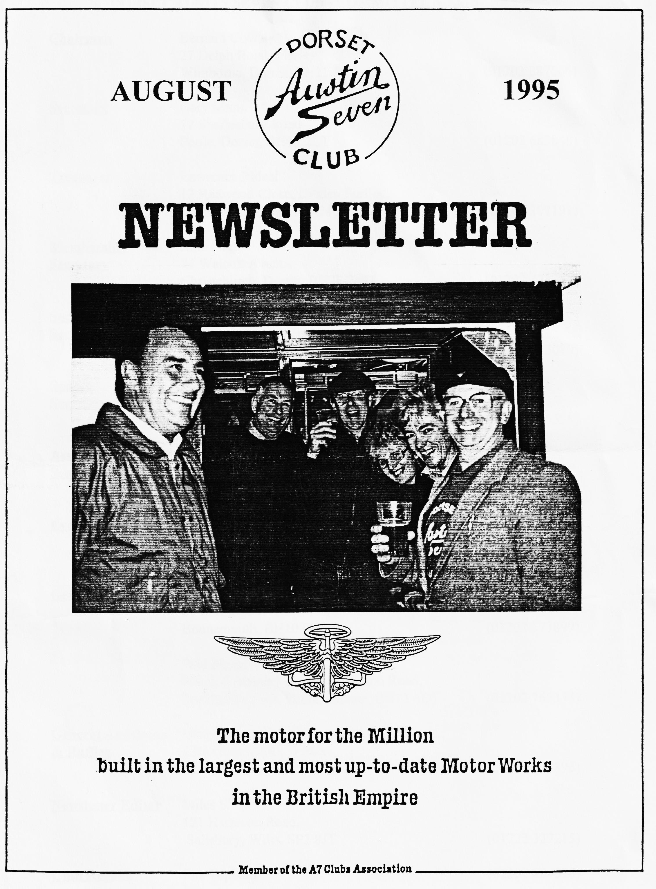

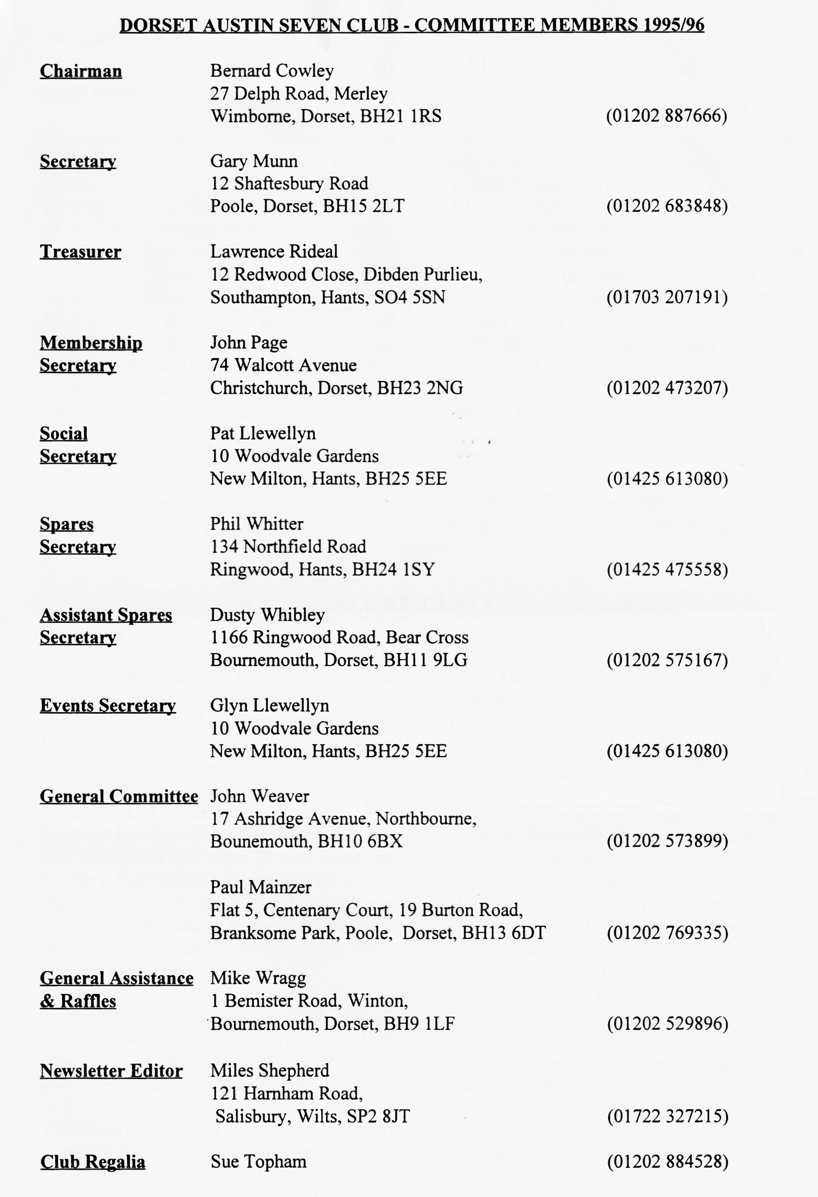

EDITORIAL

It sometimes seems that the rally season ends in August when so many people are away on holiday. However, there are many events still to come, as a glance at the back page will show. What is missing though, are the reports on some of these events. If you have taken part in an event, you can show your appreciation for the work the organisers put in by letting your fellow club members know all about it. This serves several purposes - you can thank the organisers, encourage others to enjoy events they might otherwise not join and let others enjoy an event they missed.
As I mentioned briefly last month, our rally was a resounding success. A small number of people worked extremely hard, among them Glyn and Pat, John and Cynthia, Mike and Sue, the Whibley family and others I didn't see. Very many thanks to them all, without your efforts, the weekend would not have been anywhere near as much fun. All our visitors had a great time too, as you may judge by the two extracts printed elsewhere. Many thanks to all concerned.
See you all at Club Night! BFN, Miles

SECRETARIAL

Well Folks!
What a busy month! On Club night Paul Henwood and I organised a light-hearted Walking Treasure Hunt, just down the road from the Pub and back. This seemed to go down well and there were about 9 teams taking part. Congratulations to the winners, Brian and Jill Toalster with full marks!
The Sunday run saw about 10 cars, organised by Terry and Barbara to North Dorset, a very pleasant drive down many lanes I didn't know existed. It was a shame that we lost the last 3 cars on route.... what do we always say about marking the corners?
Turning to our rally at Harman's Cross, virtually all the comments received were good. It really seemed to take off this year and we even had some Autojumble stalls.
The camping area was almost full and well over 150 entries were received on the rally
field. The club made a small profit and the Swanage Railway were very pleased with the results.
Thanks must go to Pat and Glyn for their sterling efforts, all far too much work for them to handle and still be able to enjoy the weekend. Next year, duties will be shared out to even out the workload so the DA7C will be relying on everyone to do their bit. Help from all quarters will be most welcome. Non-committee help this year was very much appreciated, many thanks to all for their help. I will give you a fuller run-down after the Committee Meeting.
By the way, my Box is still for sale, see the advert on page 7. Any takers? - it is vintage, making it rather rare. I need the space for the next restoration!
See you - Gary

Swanage Railway Rally
Once again our joint rally with the Swanage Railway Trust at Harman's Cross was blessed with excellent weather. The turnout of Austin Sevens, Classic Cars, stationery engines and spectators was even better than in previous years. There were 88 cars booked for the Saturday which included more than 40 Austin Sevens of various types. Some 129 cars were booked for the Sunday which brought the total up to 51 A7s . With the numerous late entries there were about 170 vehicles on the site.
The site is a few hundred yards from the Wareham to Swanage road, alongside the railway, on a slope which is cleverly used so that the new arrival is greeted by a show of Austins with the Classics grouped in areas representing a decade each spreading away to face the railway itself. Thus the Club occupies centre stage but everyone gets a good site. This year there were special areas set aside for clubs such as the Wessex Preservation Club and the Wessex Ducks, a branch of the 2CV Club of Great Britain.
Other interesting exhibit included a London Greenline bus and a Bedford Camper van which, apart from its own interesting history was accompanied by a number well restored 'period' everyday items such as bicycles, lawnmowers and garage equipment. While not everyone's cup of tea, it provided an unusual insight into the recent past.
The Rally is not just about machinery, interesting or otherwise, it is more a chance to renew acquaintances and make new friends. The well thought out arrangement of cars and the informality of parking ensures that the entrant has maximum flexibility to get along side old friends, similar cars or just a more convenient spot to picnic! This meant that my 'well-worn' Ulster was not forced to park next to Dusty's beautifully built car or any of the others which show how much work I need to put into mine over the winter.
The social side went well. The Beer tent with its craft stalls was well supported and much tea was provided Chez Page. I don't know how many Restoration 10 Commandments were passed out but I got mine when I purchased a hat with a wider brim from the Club Regalia stall ably run by Sue and Mike Topham. This stall was a gathering point for many visitors, perhaps because the Topham daughters were there to help Mum! Saturday night sees the traditional Barn Dance and although it was a little slow getting going, I put this down to a too generous dinner at the Scott Arms, Kingston, where a goodly number of Austins both large and small were in evidence. Anyway, It was my first experience of such an event and I much enjoyed it.
Another enjoyable part of the weekend was meeting many old friends. On the Seven front, we were well supported by the Bristol and Solent Clubs as well as having a strong showing of our own club members. A useful way of meeting people is to help marshal the field. The small band were not overly taxed as entrants arrived in small numbers so there was time to talk as each new arrival was shown to a suitable site. Many thanks to those who undertook this work. I shall be looking for a small, select, team to help with this work next year. Names of volunteers will be very welcome! Thanks too are due to all those who worked so hard before - and after the event to make it the success it undoubtedly was. Many people said how much they had enjoyed it and I can endorse that comment. The opportunity to enjoy a weekend in the idyllic surroundings of Harman's Cross, in the company of many like-minded enthusiasts, with a ready supply of the essentials of life (beer tent!) and the opportunity of exploring Swanage and the railway ensure that everyone has something to enjoy. Many thanks to the organisers

UPDATE ON FUEL MATTERS
From the Federation of British Historic Vehicles Clubs
Background
There have been two serious concerns about petrol which have vexed the 'old vehicle' movement in recent years, namely, leaded fuel (its merits and its availability for the future) and the volatility of today's leaded 4 Star (leading to vapour locks in the fuel systems of some period vehicles). The VSCC formed a subcommittee in 1990 to investigate the leaded petrol situation and to evaluate lead substitute additives as a prelude to determining the best way to ensure supplies of suitable fuel for the future, if and when 4 Star leaded ceased to be available. The sub-committee has so far produced two booklets, "The Use of Unleaded Fuel in Older Engines" and "Fuel Problems; Use of Modem Petrol in Older E-,Engines". Both booklets presented all the known available evidence to allow their readers to understand - respectively - the issues in the leaded/ unleaded controversy and the use of today's 4 Star fuel in older vehicles (including the misfiring problems usually caused by fuel vapour-locks). Generally, both booklets have been very well received throughout the movement, except for a small but vociferous minority who have difficulty in accepting either or both theses. (This dissention, incidentally, whilst surprising, does not matter; the whole point of the booklets was to set out the facts and allow readers to form their own conclusions, thus hopefully - avoiding the "if only I'd known" syndrome regarding such potential disasters as the probable consequences of prolonged use of unleaded fuel in engines with unsuitable exhaust valves and seats, and the likely causes of poor running and misfiring plus the possible adverse consequences of adding paraffin to petrol as an amelioration.)
I [ Peter Henley, of the VSCC] have chaired the sub-committee since its inception and am willing to do so for the foreseeable future. A recent development has been my appointment to the BSI Technical Committee PTC/11 - "Petrol and Automotive Diesel Fuels" through the sponsorship of the FBHVC. Its responsibilities are to produce standards for the fuels within its orbit including such matters as labelling of pumps on garage forecourts and (far more importantly for all of us) the composition of fuels including lead content and volatility characteristics. It is important that the deliberations and decisions of the BSI committee are made known to all the interested parties.
The Status Quo
VOLATILITY
The BSI Committee PTC/11 are considering a revision to BS4040 'Leaded Petrol (Gasoline) for Motor Vehicles' introducing a reduction in the seasonal volatility characteristics. (The volatility characteristics, as a point of interest, arc changed in order to "provide protection against vehicle malfunction as a result of seasonal changes in temperature" which should result - rather arbitrarily - in summer specification fuel at retail outlets from 1 June to 31 August and winter specification for the rest of the year.) Such a proportional reduction in seasonal volatility would bring BS4040 fuel in line (in this particular respect) with Unleaded fuel (BS EN228) and would be beneficial to those currently suffering from chronic vapour lock misfiring symptoms.
Points of interest which arose during the PTC/1 1 's discussions on BS4040, as part of a routine five yearly review, undertaken on 15 June 1993 were; the UKPIA (the UK petroleum industry's representative) had no record of complaints about the volatility of leaded petrol (a classic example for the need of a voice from the FBHVC) and that, to align BS4040 with EN228 in terms of volatility characteristics would cost the industry £28 million per annum, a cost which the industry did not think justified. A consequent additional cost to the motorist was calculated (by the DTI) at 8p/litre; (an addition which some of us might believe worthwhile if it cured vapour locking).

Although not fundamental to the volatility issue, the UKPIA said that they expected sales of leaded petrol to reduce to less than 10% of their current levels by 1998/2000. This statement is, of course, crucial to the leaded petrol conundrum; firstly it confirms to some extent the previously understood situation that leaded petrol would be available in the UK until the turn of the century but, secondly, it begs the question as to what level of leaded sales would remain commercially viable to the companies; 10% of current sales sounds alarmingly small -'and behoves us all to buying as much as possible meanwhile.
The Future
VOLATILITY
The outcome of the BSI Committee's deliberations on volatility should be known soon and I will notify the decision when it is made.
LEADED FUEL
Much evidence of disaster attributed to the use of unleaded fuel in inappropriate engines is emerging from the USA. Presumably this may well provoke urgent investigation for suitable lead substitutes there: also parts of the UK petroleum industry appear to be seeking an answer because of the commercial potential (the Federation represents about 250,000 old vehicle users, which reflects a large number of vehicles continuing to thirst for leaded/lead substitute fuel into the 21st century). The VSCC Sub-Committee intends to investigate the lead substitute arena next; meanwhile those currently being marketed are known to be of limited help or no help at all.
Peter Henley December, 1993
Over the last six months, much development testing has been undertaken with a commercially available anti-valve seat recession (VSR) additive which has been used extensively in the USA. The testing was carried out in a European car, whose engine is known to be very susceptible to VSR with unleaded petrol. A drive cycle representative of European driving conditions was employed, using engine speeds up to 4500 rpm, corresponding to a vehicle speed of 120kph, thus providing a realistic test of the additive.
At higher treat rates than would normally be employed, it was demonstrated that VSR could be reduced to very low levels, comparable with that measured after use with leaded petrol. It looks very probable, therefore, that it will be technically feasible to offer an additive for use in older cars, which will effectively overcome the problem of VSR. An additive of this type would be added by the owner directly to the fuel in the vehicle's tank.
More testing is required to ensure the absence of ad verse side effects. However, the current situation is encouraging, particularly when it is borne in mind that leaded petrol offers a complete solution and is widely available in UK. It seems very likely that an effective anti-VSR additive will be available at a reasonable cost before leaded petrol has become scarce or difficult to obtain.
Peter Henley March, 1994
Addendum: - Fuel
The following extract from The Motor of 25 March 1913 highlights the dangers of adding paraffin to petrol, despite the possible gains from doing so. The Motor editorial is saying exactly what the VSCC sub-committee on fuels has been publishing as a warning in recent years. Perhaps, because it is from the era when the cars which are perceived as benefiting most from paraffin were new and in daily use, the warning will add credibility to the views of modem academics.

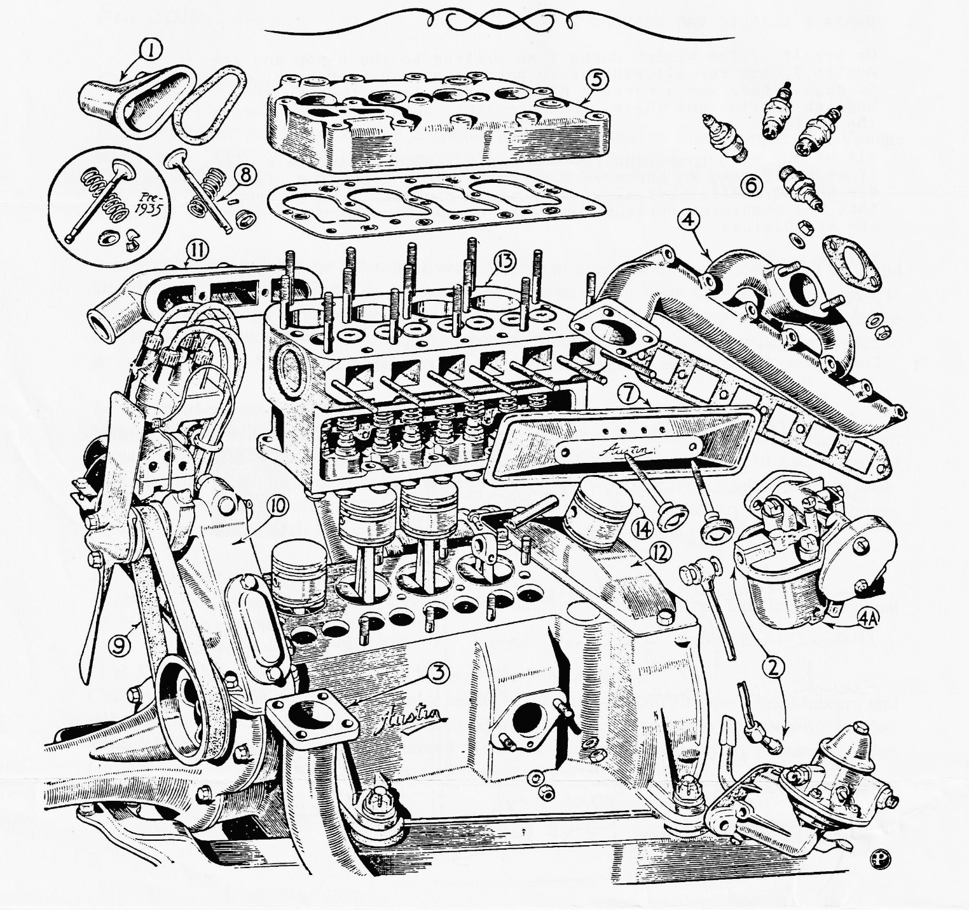
"It has already been explained why a large admixture of paraffin has certain disadvantages, amongst which are those of difficulty in starting up and the usual faults of incomplete combustion, such as fouled-up plugs and a smoky exhaust. There is a still more serious disadvantage of paraffin which has not been, so far, touched upon, and that is its adverse effect on the lubrication of the engine. It is safe to assume that any paraffin that fails to be consumed during the explosion stroke will condense back into its liquid state, and in so doing will more or less dissolve off the film of lubricant from the surface of the cylinder walls and piston. This is bound to cause increased fric6on, as anyone who has given a cylinder an over-injection of paraffin at starting will appreciate if they have had to continue fuming the starting handle. The fact is that paraffin has no lubricating properties, but is, on the contrary, anti-lubricating in its effect. Owing to its great mobility, any condensed paraffin is certain to leak past the piston rings and run into the crank chamber base, and it is here that the greatest risk occurs. The gradual accumulation of paraffin will thin down the lubricating oil and greatly diminish its lubricating properties. The risk of a "seize up" of connecting rod or crankshaft bearings must, as a result, be an ever-present one; in fact, instances of this have already occurred, hence the need for a timely warming on the subject."

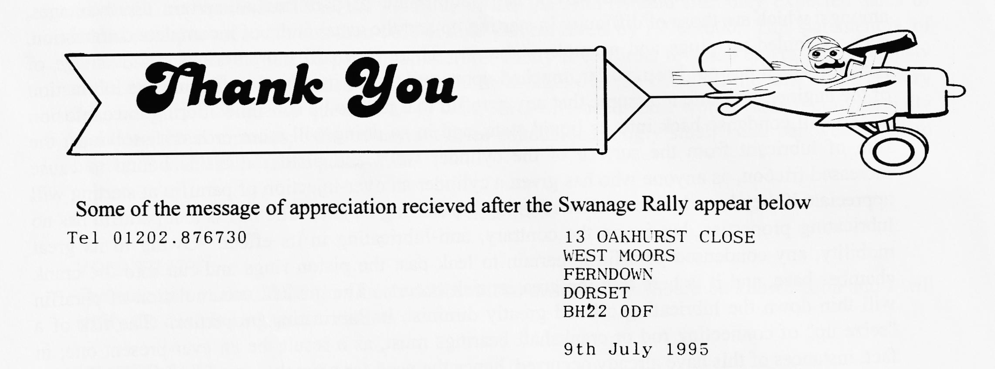
Dear Mrs Llewellyn
SWANAGE CLASSIC CAR WEEKEND
On behalf of The Wessex Ducks I am writing to thank you and the Austin 7 Club for allowing us to participate in your event at Swanage. There was a certain historic symbolism, the way the English Austins and their French cousins faced each other across the _valley!
All of our members thought it was a great success and have asked if we could make an appearance at next year's gathering, (if you are having one!). Several of them would probably like to camp if that was possible. Perhaps you could remember us when you start the organising?
Thanks again.
Chris Tucker
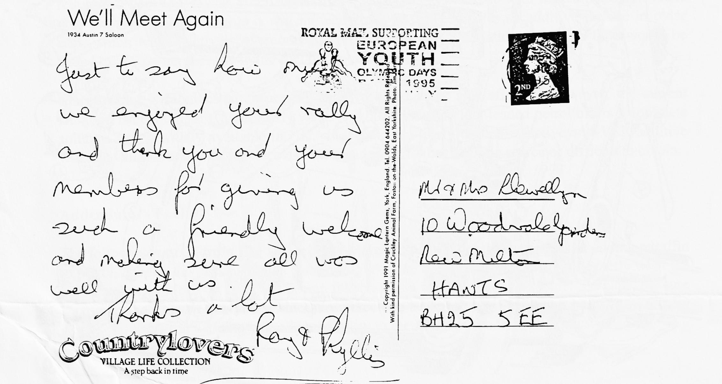
Committee Member. The Wessex Ducks (Part of 2CVGB)

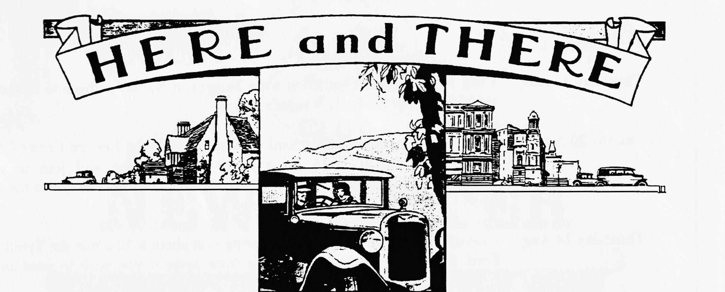
For Sale

Gary's Box Saloon
This well known car is in excellent condition and in daily use. A fine example of a Vintage saloon, only £3995. Contact Gary Munn on 01202 683848 for further details.

Events
You may have seen, on Page 8 that there are a number of events in the local area which we could attend during September but they all come at the same time! Your Committee are happy to arrange Club outings to these events but we need to know what you want us to do. So please decide which events you wish to take part In then let either Bernard or me know what you want to do by no later than August Club Night.
10^{m} September- Wings & Wheels at Popham Airfield.
Many members will be going to the Beaulieu Autojumble but for those who want a change, I am prepared to organise a run which would leave Ringwood Furlong Car Park at 10 a.m. sharp and spend the day at Popham, near Andover. Entry is free and we can have a Club area if we wish. Last year there were over 150 vehicles of all descriptions, from stationary engines to buses, modern to veteran. Sounds like an informal, enjoyable day out at minimal cost.
17 ^{th} September - RNLI Run.
Another good day out but costs £14 per car plus lunch at £3:50 per head. This is an individual effort, no Club component.
17 th September - Wessex Classic Car Show at The Tank Museum
Club Stand available, costs are Car and 2 adults which includes entry to the Tank Museum and rally plaque or £10 for family entry (2 adults, car plus up to 3 children up to the age of 16). A club stand will be arranged if sufficient interest is shown. Names, and money to Bernard by Club Night.

EVENTS
August
Thursday 17 Aug Club Night. A quiet gathering for a Noggin 'n Natter, perhaps to discuss the successes of the Rally season!
Sunday 20 Aug Club Run. Organised by Richard Cressey, meet at the Leisure Centre Car
Park, Wimborne at 10.15 for a 10.30 start. Richard will join us at Sturminster Marshall Mill at 11 ish.. The destination is a mystery - to me at least! I'd be glad for a report.
Thursday 24 Aug Committee Meeting. The next gathering is at about 8.30 pm at the Tyrell's Ford. See one those listed inside the front cover if you wish to raise any points.
September
Thursday 3 Sep 8 till Late which actually gets under way at about 9 p.m.! The watering hole
this month is the Portsmouth Hoy, on Poole Quay. Parking may be a bit of a problem but lets see a good turnout while the weather holds.
Thursday 21 Sep Club Night. We hope to have a speaker for this evening but details had not
been fixed as we went to press so you'll just have to turn up to see who it is!
Sunday 24 Sep Club Run. John Page is arranging a special outing for which you will need
to have some warm clothing as well as your Austin! Gather at the Wimbome Leisure Centre Car Park at 9.45 for a 10.00 start, prompt.
Other Events
Weekend 9/10 Sep Beaulieu Autojumble. Standard format, many club members will be there, with and without stands. Last year visitors were well down, matched only by an equally poor quality of stand (with a few well known exceptions).
Sunday 10 Sep Wings and Wheels. Popham Airfield. A very popular event with flying,
balloons and a wide variety of cars. For further details, ring 01703 642147 but see also Here & There (Page 7).
Sunday 17 Sep RNLI Beaulieu to Weymouth Run. Ever popular event with a good lunch
stop at Kingston Lacy House and a 'Sprint' around the airfield at Blandford
Camp., details from Fred Paddock on 01258 454236.
Sunday 17 Sep Wessex Classic Car Show. The Tank Museum, now in its 5th year with
static displays and moving cavalcades. More details available on 01374 410823 but see also Here & There on Page 7.

