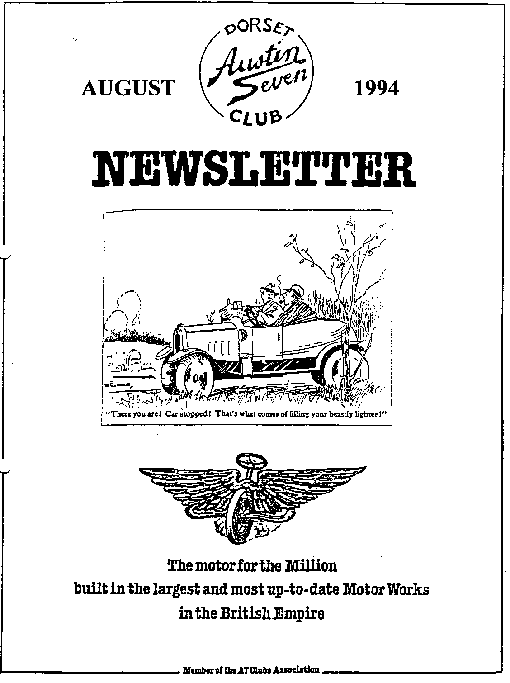

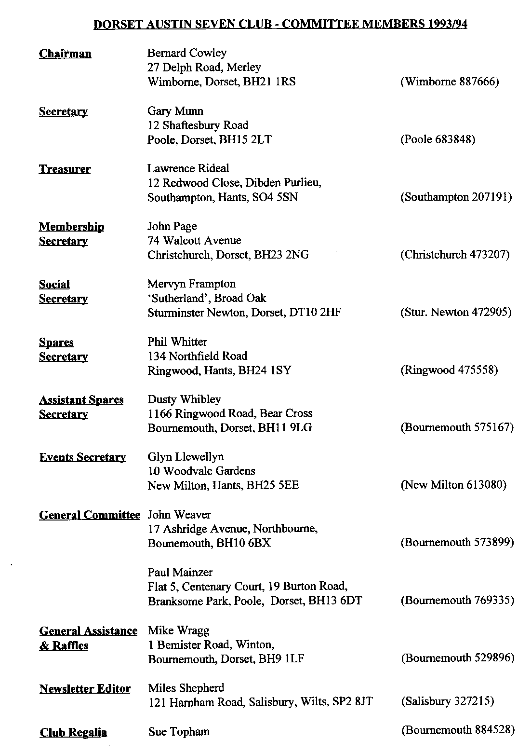

August 1994 1
EDITORIAL

Hallo Everyone,
This year will go down in the record books, rather like 1987, for fine weather. The task of event organisers has been made easier and the result has been some fine events. As mentioned last month, work commitments prevented me from getting to our own Rally but all the reports indicate that it was a resounding success. The Committee thank the many members who put in so much effort to make the rally such fun. Particular thanks must go to Pat and Glyn Llewellyn for their months of organisation and work which were rewarded by an excellent turnout for what must be one the most enjoyable events of the Austin Seven year. Thanks, too, to those members who donated raffle prizes. Well done to all concerned.
Thanks are also due to Mervyn for yet another superb barbecue. Reports on that are not yet available, but I expect it was well up to its usual standard.
There are a couple of points to bring to your attention: first, the debate over whether the A7 Clubs Association needs a President and, if so, who should be invited to take on the role. The arguments are set out in a short article on page 2. Please let the Committee know your views next month so that we can put them forward at the next Association Meeting in October.
The Rally Season is not yet over and no doubt plans are being made for various outings over the Bank Holiday Weekend. Please do let me have any reports of events you have taken part in during the year. All contributions are welcome. No need to be as formal as an article, a simple letter would be fine.
That's it for now, see you at Clubnight Miles

SECRETARIAL
Well Folks!
As you may know, we belong to the Federation of British Historic Vehicle Clubs who fight on behalf of the old vehicle movement to keep our cars on the road with no restrictions on their use. They sent some disturbing news which you may have seen reported in the Press. Basically, the Government wants to change the way in which the Vehicle Excise Duty is levied. This could be really bad news for anyone with several cars! See page 2 for more details.
The suitcase sale last month was a great success and the Club Run was also much liked, a nice laid back day in the sun. Just what the doctor ordered!
See you all at Clubnite? Gary
What fantastic weather we've had lately. Ideal for '7' driving! The sun shone down upon our rally, what a great weekend. We had over one hundred entrants in the end and from the feedback I have received, most people thoroughly enjoyed themselves.
We nearly had one last-minute disaster, however, as the Railway people could only get a license for two days - Friday and Saturday! However, thanks to the efforts of the Landlord of the 'Purbeck Hotel' in Swanage, a bar was fixed on site for the Sunday. After our pre-arranged donation to the Railway, we came away with a small profit, which we shall keep for a rainy day. Plans are afoot for another bash next year.

CAR TAX CHANGES
Plans to change the way the Vehicle Excise Duty is levied were announced in Parliament at the end of last month. In essence, the Government intends to move from taxing cars in use to a tax on possession of vehicles. When this issue last came up, some 10 years ago, pressure from the Public and a massive petition organised by the fore-runners of the Federation of British Historic Vehicles Clubs (FBHVC) was successful in persuading the Government to change its mind.
This time, public opinion may not be on our side and the FBHVC is preparing to take action to preserve the current position, where you only pay tax on cars which are 'on the road'. Once full details are known, the FBHVC will take action. However, when it comes to action, the FBHVC will need maximum support and backing. When talking to Governments, numbers count. The Club will be playing its part as a fully paid up member. You can do your part by becoming an individual supporter - Gary has details for those who wish to take this action.
Is the News all Bad? The proposals are expected to include a shakeup of registration procedures, including a new registration document which would include log books containing a number of improvements such as a list of previous owners and a record of mileage which could reduce `clocking'. The main purpose of the proposed changes is to prevent evasion of Tax which costs the Exchequer some £145 million a year. This can only work if all cars are recorded on the computer at Swansea.
Why should you worry? Well, the proposal will result in a "system of continuous licensing based on possession, rather than use, for all cars”. This means that the collection of parts you have been building up to make into a Special will be taxed. It also means that vehicles not registered at Swansea may not be recognised as cars. How do you register that original Seven you discovered in a barn in deepest Dorset?
What can you do? Apart from becoming an individual member of the FBHVC, you can write to your Member of Parliament stating your objections. You can also write to Mr. Brian Mawhinney, the Secretary of State for Transport.
The Government has stated "naturally there are many details to be settled and the needs and wishes of those that will be affected must be taken into account. I [the Minister of Transport] will be issuing a consultation document shortly." Don't wait till it’s too late, write to your MP.
AUSTIN 7 CLUBS ASSOCIATION PRESIDENT
The debate about the role of Association President was raised at the April Association meeting. The post has been vacant since Bert Hadley died. Some discussion over a replacement took place. I suggested that first we should determine what the role of the President is to be. Should it be just a figure head, in which case we should invite some worthy individual who was associated with the
Seven to take on the post. On the other hand, we might want someone who could be more active to represent us, for instance at the RAC or FBHVC. In that case, some well-known current Club member elected for a fixed period might be more appropriate. Clubs are required to vote on the role at the October meeting and then, if it is agreed that we want a president, one be selected/elected at the the AGM in January. The Committee need to know your views on:
- Do we want a President?
- If so do we want a figurehead or an active one?
- Who should we approach?

FUEL ADDITIVES – A CAUTIONARY NOTE
The following extract from The Motor of 25 March 1913 highlights the dangers of adding paraffin to petrol, despite the possible gains from doing so. The Motor editorial is saying exactly what the VSCC sub-committee on fuels has been publishing as a warning in recent years. Perhaps, because it is from the era when the cars which are perceived as benefiting most from paraffin were new and in daily use, the warning will add credibility to the views of modem academics.
"It has already been explained why a large admixture of paraffin has certain disadvantages, amongst which are those of difficulty in starting up and the usual faults of incomplete combustion, such as fouled-up plugs and a smoky exhaust. There is a still more serious disadvantage of paraffin which has not been, so far, touched upon, and that is its adverse effect on the lubrication of the engine. It is safe to assume that any paraffin that fails to be consumed during the explosion stroke will condense back into its liquid state, and in so doing will more or less dissolve off the film of lubricant from the surface of the cylinder walls and piston. This is bound to cause increased friction, as anyone who has given a cylinder an over-injection of paraffin at starting will appreciate if they have had to continue fuming the starting handle. The fact is that paraffin has no lubricating properties, but is, on the contrary, anti-lubricating in its effect. Owing to its great mobility, any condensed paraffin is certain to leak past the piston rings and run into the crank chamber base, and it is here that the greatest risk occurs. The gradual accumulation of paraffin will thin down the lubricating oil and greatly diminish its lubricating properties. The risk of a "seize up" of connecting rod or crankshaft bearings must, as a result, be an ever-present one; in fact, instances of this have already occurred, hence the need for a timely warming on the subject."
From the Federation of British Historic Vehicles Clubs Newsletter.
SWANAGE RALLY 9th & 10th July 1994
To all the members who came to the Swanage Rally, a big thank you, the turnout was very good. And to all the members who didn't make it, you missed a great week end. The Tombola Stall did very well thanks to members generous donations, and I would like to all the willing ladies who helped on the Stall and made it a great success. Thanks also to Sue Topham and helpers who did a brisk trade on the Club Regalia stand, and to all the willing gentlemen who did the marshalling etc. It all went very smoothly thanks to all their help.
The weather, of course, could not have been better and we hope to have even more than the 100 plus next year.
Thanks again,
Pat Llewellyn

AUSTIN 7 BEGINNINGS - 46 - A STORY OF AUSTIN FOLK ARTHUR COX
Arthur's story may not, you may think, fit neatly into our title 'Austin SEVEN Beginnings, his great love is for owning BIG Austins. One must travel in hope. In the way that 'from little acorns do great oak trees grow', so might it be that 'from Big Austin interests, do tiny Austin Seven interests grow'!
Apprenticed at Westbourne Audi Garage, Arthur bought his first 'do-up' car, a 1938 Rover 14, in 1965 for £30. One year's restoration time before using it for his successful driving test.
1968 saw his true love, car-wise that is: a Heavy Twelve PL 3551 towed into the Westbourne forecourt. A very dilapidated 1930 Heavy Austin Burnham Twelve with revolting, moth-eaten headlining, rat and mouse evidence in many areas and with a price tag of £100. Reflect - £100, more than a month's take home pay for this young, newly married, mortgage-paying man. A wreck of a car which had lain in a garage, unused since 1960; the time of MOT introduction. And how to find the £100? No probs: sale of one restored Rover, exactly £100. Long held ambitions were beginning to become reality. Mind you, his mates in the workshop wrote him off as a complete NUTTER! Know the feeling?
The original, and only, owner of the Burnham Twelve, Mr. Slade, had been and Admiralty Surveyor, with a petrol allowance during the War. Unlike most other private car owners, he managed to run the car; so many others were forced to lay up their cars. Hard to imagine: having a car but no fuel. Actually, any car which he, Mr. Slade, owned was laid up, i.e. not sold until he died. He had an A40, 1948 A8, Singer, Daimler Conquest and others, all tucked away! I should remind you here that all the Heavy Twelves were called after towns: Clifton, Ascot, Windsor, Burnham etc.
A garage in Hamworthy was found for the car to be yet again laid up, awaiting the re-vamp; body strung up in the roof and rolling chassis underneath. Nothing done until Arthur stirred himself into action with a New Year's Resolution `to get going', and he did. His daughter's wedding date of April 14th 1992 speeded on the final touches; perfection on a wedding day car and all that.
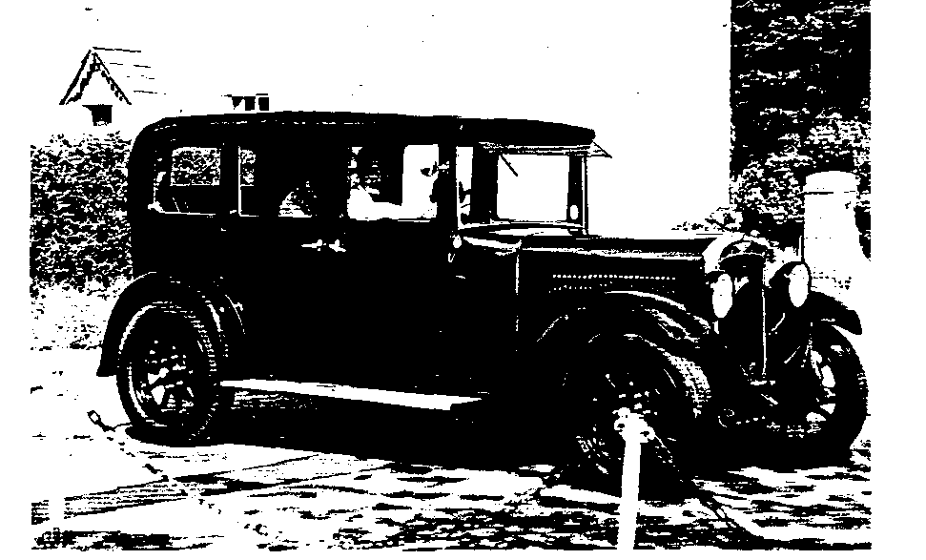

New Year's Day 1981 through to 14th April 1992, was the taken for the restoration. As much as possible of the original car Arthur held onto. An ash tree bought, planked and dried in a privately owned kiln provided frame replacement parts where needed; school woodwork lessons proving useful at last! Upholstery and trimming professionally done by Kevin Baggs. Glass: some needed replacing, though that of the doors is original. The giant tyres, Goodyear 6 ply Taxi Cord.
Hearing that the car has been used for quite a few weddings after the original one already mentioned, I ventured (after careful wiping of shoes) into the back to 'get the feel'. WOW! It really is super. Oceans of room, very comfortable, supporting real leather seats, high up from the ground, seaman-knotted silk hand-grabs; sorry hand-holds (grabs definitely not a fitting word for such luxury) and finally, a dinky, wee side-mounted switch for the interior light. HAA! Happy sigh. No wonder brides want to ride in this and have their dresses shown off against the subtle, Son of a Gun, Turtle-waxed, gleaming blue paintwork.
Not content with driving brides to weddings, Arthur now has a 1928 Tourer, PLC 5361 with a self-rebuilt engine and clutch. Also in 1992 at his workshop garage at Charminster, arrived UO 6017, a 1928 Heavy Twelve Shropshire Flat Bed.
Why the Austin Seven Club?
"I asked if I could join; they said `Yes' and they're such a friendly bunch" replied Arthur. Say no more....well, except that an Austin 7 would look fun alongside the Heavy Twelve! BB June, 1994
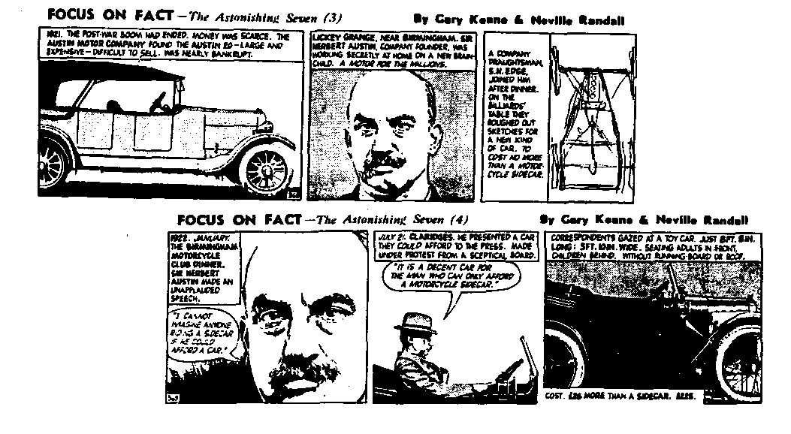

BIRTH OF THE GRASSHOPPER
The original announcement of the Trials Specials in the Light Car, 19 April 1935

Curing Wing Flap.
FOR THE "LAND'S END "
Three "Austin Specials" To Take Part
NEW RADIATOR COWL AND OTHER NOVEL FEATURES
With regard to our article published recently of the method used on MG Magnas to cure wing flap, a reader writes that he has successfully cured this trouble on his Ulster Austin Seven in the following way:—
A bracket was made from 1/8-in. mild steel plate which fitted on to the front shock absorber anchorage. Two stays of mild steel were bolted between this bracket and the wing tie bar as shown in the accompanying sketch. The whole assembly was finished in cellulose to match the coachwork of the car. The method is, of course, applicable to cars other than Austin Sevens, but the design of the bracket and the position in which it is fixed will have to be altered as is required
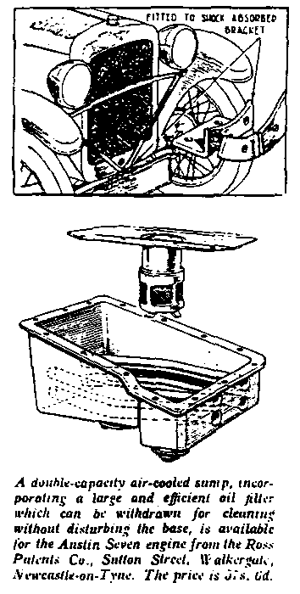
THREE Austin Seven " Speedy " Sports with entirely new bodies will be seen in the London-Land's End run. They are to be driven by Orford, Milton and Richardson. The chassis, it is
understood, follow the usual specification tor this model which includes a full-pressure lubrication system for the engine:
Instead of the usual radiator cowl there is a new design which follows the lines of that employed on the 10 h.p. and 12 h.p. Austin Sports cars: it is raked and has a centre rib. The bonnet is longer than usual and has holding-down strips.
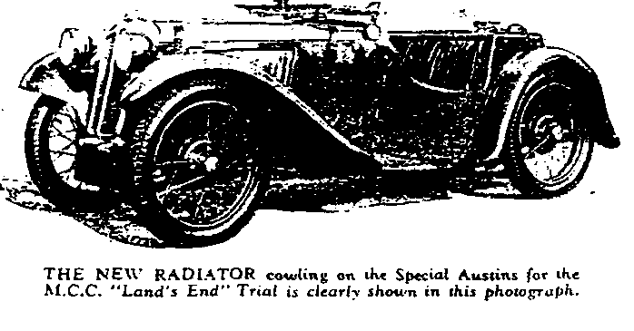
There are two spare wheels, so that either standard or competition tyres are available. Just in front of them is an external tank with a quick-action filler cap and a capacity of six gallons. The body, of course, is a two-seater and behind the seats is space which accommodates the hood as well as luggage. This hood is cleverly arranged with only a single hood stick which slides down into the body when the hood is lowered. A green cover to match the body finish fits over that compartment. At the front the hood is attached to the screen by "Lifta dot" fasteners and the screen itself can be folded flat.
Another noteworthy item is a remote control gear change of rather unusual design. At present this model is not standardized and the three cars in question have been built especially for the drivers named. We hope at a
later date to be able to road test one of these cars.

Underneath the bonnet alongside the battery is a tray on which all the tools are accessibly arranged, each in its own clip. In the facia-board there is a large cubby hole in front of the passenger, together with a handrail for his use. The off-side of the facia-board carries the instruments which include a rev. counter as well as a speedometer: both have 5-in. dials.

Welcome! to new members Arthur James from Gillingham, Joanne Tompkins and Peter hales from Southampton, Ken Medlicott from Yeovil and S. McKendrick from Paignton. Please make yourselves known at Club Night, or indeed at any of the Club events.
Spares Phil is taking orders for a new batch of Taiwanese tyres. He is intending to collect them at the October Association Meeting. If you need new rubber, call Phil, number on inside front page or see him at the next Club Night.
Articles for newsletters are always hard to come by so Editors frequently use material from other clubs' publications. I often rely on the Midlands Club as they seem to be able to get their hands on some good Pre-War material. Several Clubs have used our material, too. Phil Whitter's article on brakes appeared in several and I note that in the June issue of the Austin Seven Owners Club newsletter, no less than 6 pages consist of material first seen in this journal! Pity the source is not acknowledged.
Sports models are frequently in newsletters, research seems to be easier despite the relatively small numbers produced. Articles in the pre-War motoring press regularly form the basis of articles, I know that's what I used when I wrote the Sports Jottings. I note that the 750 Bulletin has had an interesting two part article on Hubert Austin as a racing motorist which builds on my article Origins of the Sporting Seven in Association Magazine 1984C and fills in some of the gaps. The first of a two-part article on Grasshoppers also appeared in the June issue - I am awaiting the next instalment with baited breath!
Another link with the Longbridge sporting scene has been broken with the death recently of George Coldicutt, aged 96. He was a tester at Longbridge and was best known as the driver of "Slippery Ann", the ex-works supercharged record-breaker sold minus its engine to Jonny Pares. Coldicutt built a non-supercharged engine for the car. Pares was described by Freddie Henry as a "senior progress officer of special projects" but 1 think he went on to become a dealer in the Worthing area just before the War. His sister was a member of the Solent Club. Coldicutt had numerous racing successes but was best known for his exploits at Shelsley Walsh hill climb course in Worcestershire but he also took part in the 1929 Ards TT where he finished 19th at an average of 55.77 mph. His racing career ended in 1932 and he transferred to the factory Service Division where he remained until he retired in 1962.

August
Thursday 18 Aug Club Night. Meet at the Elm Tree, Hightown for the monthly gathering. Noggin and Natter plus Automobilia Night. Bring along an item for display. Phil will be bringing the Spares as well.
Sunday 21 Aug Club Run. Meet at the Ringwood Furlong car park 10.30 for "Glyn's
Gander"!
Thursday 25 Aug Committee Meeting. Once more at the Tyrell's Ford, statrt about 8:30pm.
September
Thursday 1 Sep Eight til Late. Meet at the Coach and Horses, Poole Road, Wimborne for a chance to talk over last month’s events
Thursday 15 Sep Club Night. The Elm Tree sees the Club gathering. Full details next month.
Sunday 18 Sep Club Run. Details next month.
Other Events
Monday 29 Aug VSCC Race Meeting, Donington. Last UK race meeting for vintage
racers. Tickets available at the circuit.
Sunday 4 Sep Vintage and Classic Car Display in aid of the Lewis-Manning Hospice Day
Venue is the Walled Garden, Upton House, Upton Country park, Poole Contact the Hospice at 1 Crichel Mount Road, Poole Dorset BH14 8LT for details.
Weekend 10/11 Sep Beaulieu Autojumble. Miles of stalls, biggest event of its kind outside the USA Your chance to buy junk at vastly inflated prices. Not to be mired, more a social occasion than a sale. Tickets from Beaulieu.
Sunday 18 Sep 10th Brockenhurst Park Rally. A free event! Strongly recommended by
Biddy and Gordon, call Jeff Carpenter on 0590 23175 for further details.

