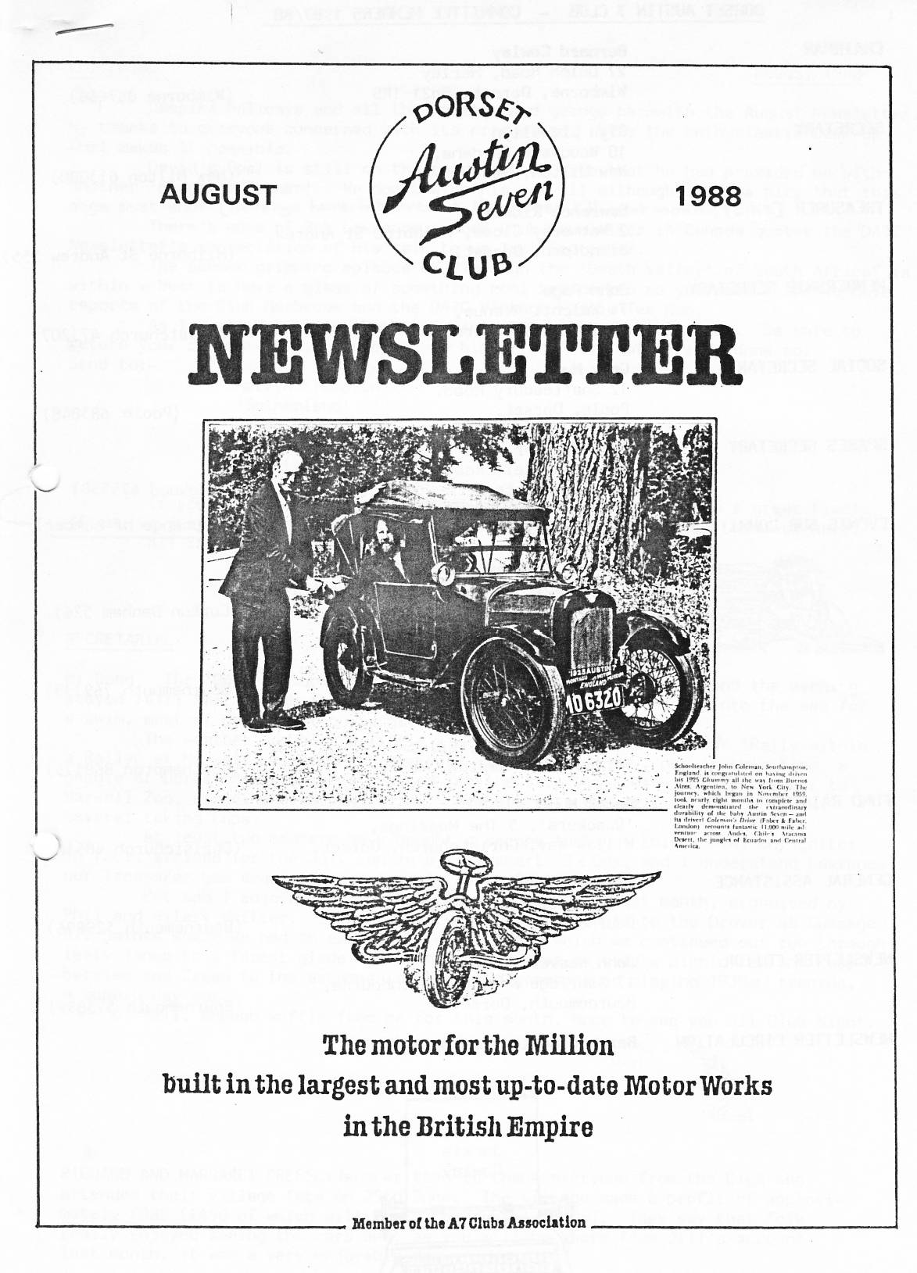



EDITORIAL AUGUST 1988

Despite holidays and all the comings and goings herewith the August Newsletter. My thanks to everyone concerned with its production. It's the enthusiastic back-up that makes it possible.

David's Opal is still on the road, but despite that he has provided us with another 'Bodger's Corner' We don't wish his car ill although it is a pity that this saga must end!

There's news of Bob Lawrence, whose Club Newsletter in Canada quotes the DA7C Newsletter's appreciation of his talk to us last September.

The second gripping episode of "Through the 'Death Valley' of South Africa" is within - best to have a glass of something cool beside you as you read - and we have reports of the Club Barbecue and the DA7C Vintage Picnic Tea Run.

Send to:- •

Mervyn Frampton

'Sutherland'

Broad Oak

Nr Sturminster Newton

, Dorset.

If you are now off on your holidays journey safely and have a great time! If you've just returned you will be glad to know that it ain't 'arf been wet here. All the best.

John

SECRETARIAL

Hi Gang. The 'Dorset' luck held out for our Barbecue at Studland and the evening stayed fair; fair enough in fact for a few of us to again venture into the sea for a swim, most of us, if not quite all, suitably attired!

The weather was also a little kinder for the Solent A7 Club's 'Rally within a Rally' at Marwell. I remember last year it poured all day, not so this time, a gaggle of Dorset Members met at Cadnam for the trip via Romsey and Winchester to Marwell Zoo, arriving at around 11.30. Members cars did well in the Concours, several taking Cups.

At least two members have bought a second Austin 7 this month, our Editor

in fact, arrived for the July run in a very smart '32 Box, and I understand Lawrence our Treasurer has acquired an extremely nifty Special.

Pat and I enjoyed the Raspberries and Cream Run last month, organised by Phil and Hilary Whitter. It took a very picturesque route to the Drover at Gussage All Saints where we had an excellent lunch, after which we continued our run through leafy lanes to a forest glade near Linwood where we enjoyed a picnic tea and Rasp­berries and Cream to the accompaniment of two gramophones playing 1930s ' records, a superb day out.

Well, enough waffle from me for this month, hope to see you all Club Night.

Gly

RICHARD AND MARGARET CRESSEY have written to thank everyone from the Club who attended their village fete on 25th June. The village made a profit of approxi­mately £980 (£450 of which will go to the school funds). They say that folk really enjoyed seeing the cars and, as you will be aware from Jill's account last month, it was a very enjoyable day.

2

PUB LUNCH AT THE DROVERS, FOLLOWED BY RASPBERRIES & CREAM - Sunday 24th July

A bright, blustery morning saw nine A7's turn out at The Furlong car park Ringwood. After the obligatory examination of any previously unexplored engines, including John's new "Frilly Knickers", we set off for our pub lunch at the Drovers, Gussage All Saints. By the way I'll take this opportunity to introduce Alan and myself with "Maisie".

The route chosen was delightful, as we found ourselves winding our way along country lanes that were-certainly new to Alan and me - hopefully we plan to find them again, but I'm not known for my sense of direction! What joy to be passing picturesque little cottages and pretty little churches, instead of the usual maze of roadworks, traffic lights that always change to red just as you reach them, the constant jostling for positions on roundabouts, not to mention avoiding those foreign students who always step out after having just looked the 'wrong' way.

All nine arrived safely at the Drovers, where a generous portioned lunch was enjoyed- Alan can definitely vouch for the sherry trifle! Suitably refuelled we continued on our way in search of our picnic site. (The original one chosen had to be abandoned, as apparently it was now more suitable for mallards!) This turned out to be a quaint little spot at Linwood, complete with stream - what more could we want? The wind break was skilfully erected by Phil - yes, you've guessed the weather conditions. But in true British stalwart style we anchored everything and ourselves to the ground. This idyllic scene was completed to the strains of "Run Rabbit Run",%.*' provided by Bernard and Jackie's authentic wind-up gramophone.

We were eventually joined by Brian and Jill, who timed their arrival just right for the superb helpings of raspberries and cream kindly provided by Hilary - they were delicious. We then spent a pleasant hour chatting in the warm early evening sunshine - when we were furnished with more hairy details of what goes on under plaster-casts. (Sorry Jill, couldn't resist it). All in all we had a smashing day.

Margaret Seymour

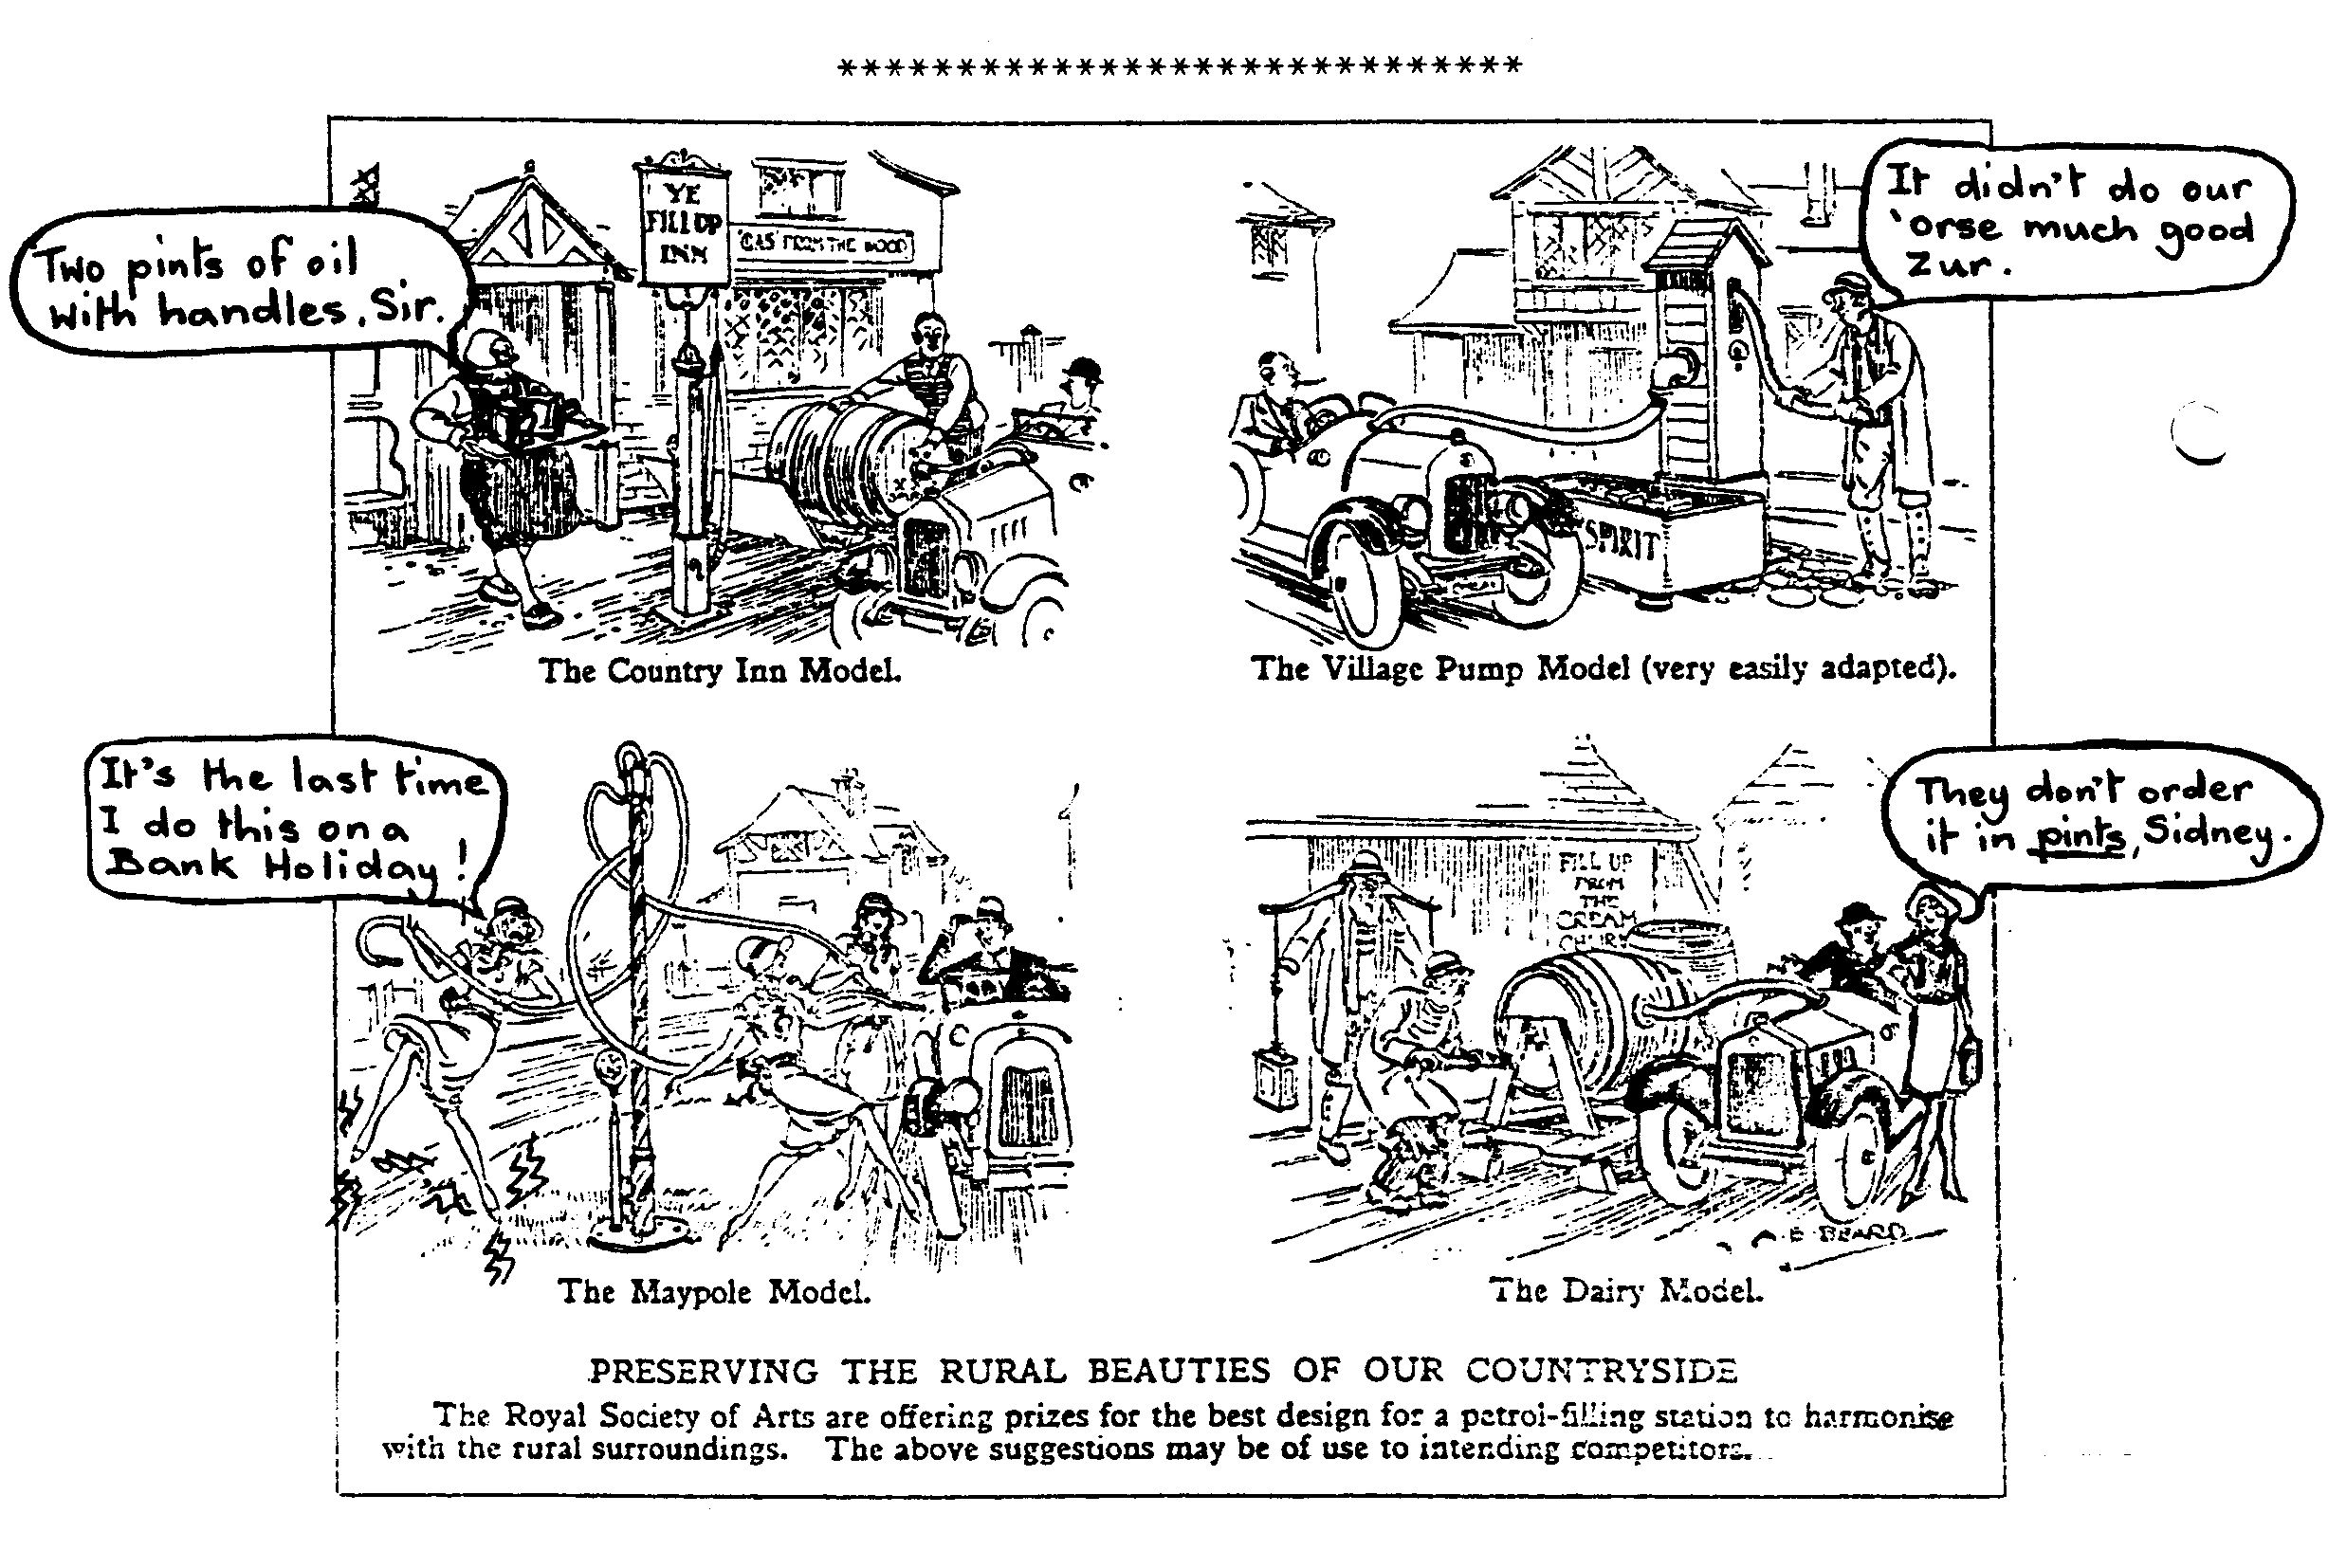

CUE AT STUDLAND - 16th JULY 1988

Although it was wet and miserable all day - fate was once again kind to the DA7C and the evening was, if not sunny, calm and mild for our annual beach barbecue.

I was most impressed with this year's set up. Pat and Glyn did a grand job with a canvas shelter for the food and barbecue which proved most welcome when a few spots of rain did fall. Even our half oil drum barbecue was resplendent in a fresh coat of silver paint - thanks to John P.

Thirty-six Club Members were present and a splendid time was had by all with the usual excellent food, wine and plenty of chatter. We had lovely background music provided for us by Gay on her Piano Accordion - Mike provided the cabaret!!!! - and Jill's antique wheelchair gave a period ambience to the proceedings, appropriate to an Austin Seven Club event. As is traditional, several hardy types had a swim and were then very glad of the glowing barbecue to warm themselves.

The end came when we had to pack up in time to catch the last ferry across to Poole at 11 o'clock.

I'm sure everyone who was there will join me in thanking Pat, Glyn and Gary for organising a really great evening.

Jackie



**A** CANADIAN VIEW

Club Members who were there will surely remember last year's outstanding talk by Canadian Bob Lawrence on the Canadian EXPO '86 exhibition of veteran, vintage and collectors' cars, backed up by his unique collection of slides. Many of the cars were new to us and with prices few could ever afford.

Gordon and Biddy are still in touch with Bob and have kindly sent his account of the Beaulieu Autojumble, as it appeared in a Canadian motor club newsletter. It

. makes interesting reading and is a reminder that the annual plod-around is almost with us again.

Herewith a photocopy of Bob's account. (2 Canadian dollars =£1):­

**AN AUTOMOTIVELY JUMBLED REPORT FROM ENGLAND**

**In** the autumn of 1986 I was able for the first time to be in the south of England in mid-September; therefore, with the legitimate cover of doing serious theatre research five miles from Beaulieu (interviewing a retired actor), my wife and I joined many other people at the Autojumble organized each year (on a Saturday and Sunday mid September) by the National Motor Museum, which began about thirty years ago as Lord Montagu of Beaulieu's private collection.

What is an Autojumble you may well ask? A large heap of wrecked cars? No. It is what we in North America call a swap meet. This one, reputed to be almost as large as Hershey, consisted of 1,600 stalls and was attended by 39,000 people (two day admission about $12.00). Lord Montagu profitably opened up four pastures and chased out the cows. It rained! His Lordship thoughtfully put down corrugated tracks along the main avenues so that vendors could get their vans on site, but in between, along the many rows of stalls, mud was knee high, churned up by approximately 78,000 marching feet. This figure makes no mathematical allowance for those feet that covered the same lane two or three times as their owners searched for an elusive spare part.

I found it impossible in less than two days 'even to glance at all 1,600 stalls stretching, it seemed, to infinity, as my feet got more and more tired, each foot carrying pounds of mud. Food stalls offering beer, hot-dogs, tea, fish and chips, were in evidence, but they had no seats. The secret was to take time to look over the indexed catalogue. Thus, if you were looking say only for Jaguar spares, you could mark on your map the location of the twenty-two vendors of Jaguar material.

Then you chart a weaving course to bump into each Jaguar unit, taking care not

.

to be distracted by the stalls offering non-Jaguar items. There were headlamps, badges, auto toys and pedal cars, books and brochures, spark plugs, valves, wheels, old and new tires, bumpers, doors, radiators, mascots, bicycles (a genuine 1860 boneshaker for $3,000), and thousands of other tempting goodies (prices negotiable). Think sympathetically of a visiting Canadian with only two suitcases for accumulated treasures.

I noted very few spares for pre-war North American cars, principally because only a small number were sold in G.B., and present owners of old Fords, Buicks, Pontiacs, Cords, etc.. are catered for by their own clubs or sub-divisions of American clubs. I spotted a rusty hubcap for a Ford A -- asking price $16.00. I didn't buy it.

Two or three vendors had glass Lalique radiator ornaments on offer. I thought that a Lalique eagle would look good on the front of my Model A Ford. The dealer wanted $600. for it. I didn't buy that either.

I did, however, have fun chasing Bentley spares - not many about. I wanted an exhaust manifold for a 1930's Bentley and learned that one stallholder somewhere in the four fields had two. Then came the pleasure of pursuing that lead from stall to stall through the mud. I heard repeatedly, "I don't have such a thing, but you might try the man in K 22 (a quarter of a mile away)." At last I caught up with the owner of the manifolds. One had already been sold, but I acquired the last Bentley manifold at the Autojumble, at a little less than the asking price,,,,,

.

My wife insisted that it should come back to Canada in my suitcase. I still lean slightly to the left. That is not a political statement.

Sunday the skies cleared, and the people selling books, maps, and sales brochures took away the plastic covers and did a good business. I wondered how many vendors made a substantial profit from the Autojumble. Each space, on which one could park a van and sell from the rear or could set up card tables, cost $120 for two days. Several people had rented two or more spaces. A few stalls, perhaps one hundred, were inside tents, but the rental fee was obviously higher than out of doors. I suspect that many of the vendor-participants regard the event primarily as a social occasion.

If you couldn't be bothered with the small stuff, there were a few big ticket items; a field of old cars for sale. I should very much like to have brought home a r.h.d. 1938 Hudson drop head coupe carrying a British body, with suicide doors, by Salmons. Probably unique, with a likely justifiable price tag of $32,000. If only my garage were bigger, I could have acquired a 1939 Buick Limited (r.h.d.) in fine original

' condition for only $17,000. Then I came down to earth and looked closely at a shabby, badly painted 1929 Ford A Tudor (r.h.d.) I thought it overpriced at $10,000, however, A's with the North American engine are fairly rare in G.B.

The Beaulieu Autojumble provided me with two exciting and exhausting days. Would I go again? Take up a collection for my airfare and try me.

Robert G. Lawrence Victoria Chapter

P. MacCarty

My Chummy seems to be used more and more of late and if they are used they wear out quicker!! On arrival at Spye Park this year a dreadful noise

was heard from my engine. After a consultation with the experts and the use of an umbrella as a stethoscope, it was discovered to be coming from the dynamo. On removal the end bearing was found to be broken up - due to my lack of lubrication! This is where Paul MacCarty came in. I took the dynamo there on Friday and, lo and behold, it was overhauled by Tuesday - what super service. He has since overhauled my DEL dynamo in equally quick time, all for a very satisfactory cost. It is so nice in this day and age to get a super service from an expert who even knows all the different types of dynamo/starter that where fitted on 7's and no complaints or lack of enthusiasm when asked to repair our 'old' parts. Long may it continue.

Bernard





Through the "Death *Valley"* of South Africa -cont..

You have heard, I do not doubt, of America's "Death Valley," an inferno of heat among the Californian Hills. Cold seekers have left their bones in it before finding wealth ; one God. forsaken ranch huddles somewhere in it next the solitary spring ; the two motor cyclists who first crossed it wrote half a book about it.

Though you may not know it, South Africa also has its "Death Valley." On ordinary maps you will find no trace of it, just as Bushmanland will probably be little more than a blank, bare of names or markings. But on a large scale surveyor's map you may be able to trace a depression shown as "Koa Valley."

This was the former bed of the Orange River, which has now found a course a dozen miles or so to the northward.

It is a sea of sand, rather like the bed of the Bromo craters in East Java. Unwary, I drove down a hill-side into the valley, and before I could shake o9' the drowsy heat and summon up alertness, we were in the sand and we had to go on.

Your city motorist knows nothing of sand. He never has to drive in it. He meets a ten-yard strip near the seashore, and sticks. In Thirst, land you learn to negotiate sand while you learn to drive. Otherwise you never learn to drive at all.

One pause would have been fatal for us ; slow­ing wheels would have sunk rim-deep in the soft, clinging stuff, and we should have found it difficult to free them. So, with the engine racing in second gear and the "Tar Baby" bucketing about like a destroyer in a heavy sea-way, we roared onwards under the relentless sky. The temperature in the sun was 151 degrees Fahrenheit;

the water in our radiator boiled furiously, the stench of superheated oil hung heavily in the saloon.

1 mourned for the engine, bursting her little heart to pull us through ; for a quarter of an hour we raced through ; for a quarter of an hour we raced onwards with the radiator boiling all the time. On the best of roads, in the heat of this desert land, my passenger had to climb out every ten minutes to refill the radiator ; now we could not risk stopping.

My eyes glued to the track-a double line of wheel marks which a heavier car would have found useful. The big car with standard track finds little difficulty in taking sand if driven with

skill. But my car's track was narrow, and only one set of wheels could take the "spoor" ; while the off-side wheels ploughed deep, the near wheels churned over the hump between the scores. We lurched along at an incline of 30 degrees, swaying, jolting, skidding.

And then at last we found a hard patch, 30 yards across, on which we could stop. We filled up a bone-dry radiator and deflated the tyres to half-pressure, a device we should have adopted before if "Death Valley" had not taken us unawares. Only tough tyres will stand up to much work deflated, particularly in abrasive *and, which wears the very soles of the Afrikaner's veldskoens in a few score miles.

Then I looked ahead and saw the barrier which the tough gentlemen of Springbok had described in awe and solemn warning. Imagine it, if you can ; Muizenberg or Waikiki beach, two miles wide, coloured a blazing red : ruffled . and scrabbled by a thousand school children ; and then up-ended sharply to the steepness Of Pike's Peak or some other famous test hill. And then imagine coaxing a baby car up it.

This was Kooisabees Hill. We debated waiting for the relief lorry, but pride forbade the admis­sion of defeat. We would go on, even if we left the bones of the car on the hill. At least we should be found and rescued.

We let the engine cool, and shading it with blankets from the fierce rays of the sun which kept the radiator almost at the boil. We dumped overboard every superfluous article of gear ; I "revved" the engine up as carefully as though I were in an aeroplane starting a flight.

The car rushed at the hill, swore, raved up it in low gear, stammered and faded, picked up again, almost gave up. I sensed the door swing­ing open ; a hundred yards on I missed my passenger ; noble fellow, he had jettisoned himself I

Somehow the Baby climbed the hill. I think the laughter of the tough gentlemen of Springbok spurred her on. I swear she could never do it again. I would not ask her. Two miles up that ferocious hill - oh, the agony for her tiny brave engine.

My passenger walked two miles up, up that ferocious hill. The temperature in the sun was 151 degrees Fahrenheit. Fortunately he wore shorts, shirt and wide-brimmed hat. I was driving clad only in a towel for loin-cloth, and veldskoens to insulate my feet from the searing heat of clutch and accelerator pedals. Even so. I streamed with sweat.

Through the "Death Valley" *of* South Africa -cont..

*"If* I could only be in my office writing an article about ice hockey," said my passenger, collapsing into the car.

At the top of the hill a heavy six-cylinder car had smashed a big end and piston and torn a hole in the side of her crankcase. Two dis­consolate Germans in khaki bush-shorts, and bound for Windhoek by way of Goodhouse Drift, were struggling to extract the smashed piston.

A week or two before another heavy car broke down on the hill. The passengers, a man and a woman, both over 60 years of age, walked 12 miles to Goodhouse for shelter, food and . assistance.

The Baby Austin skimmed onwards in the twilight over a road no better than the first 55 miles, but no longer execrable to us. The sunset had tipped all the fantastic sea of peaks bounding the Orange River with scarlet tints ; behind us was the red hell of Kooiaabees Hill and the red desolation of "Death Valley."

Before, on the river bank, was Goodhouse­

the hottest place in South Africa, but a paradise to us at the moment.

[Goodhouse is, as the official temperatures show, the hottest spot in South Africa. Day after day it heads the temperature tables issued by the Government Meteorological Department in Pretoria. It stands supreme as a hot spot, and because it has had such constant publicity for its temperature records, Goodhouse is generally accepted to be a town.

Actually it is no more than a fruit-growing estate inhabited by one white man (Carl Weidner) and three-score coloured folk. It lies athwart a drift on the Orange River, just scrap­ing into the Union of South Africa. Across 750 feet of muddy water lies South-West Africa, which was German territory until, with the ending of the War, the Union accepted it as a mandate from the League of Nations.

Today the Goodhouse Drift b one of the accepted ways into South-West Africa. Bold motorists strike up from Cape Town occasion­ally through Namaqualand to the drift, and then head northwards through more desert to Windhoek.)





**7**

**AUGUST Thursday 18th August -** Club Night. A short evening run to The Red Shoot, Linwood. Meet at the Elm Tree, Hightown, at 8.00 pm.

**Sunday 21st August -** Club Run to Singleton and the Weald and Downland Museum. No pub lunch. Bring your own picnic and lubrication. Meet Ringwood Cattle Market (the Furlong) at 9.45 for 10.00 am **or** The Fighting Cocks, Totton at approximately 10.30 am.

**SEPTEMBER Thursday 1st September** -'8 to Late' (for those who want to meet for a natter) at The Horns Inn, Dudsbury (near Parley Cross).

**Thursday 15th September.** Club Night. Indoor meeting at the Elm Tree, Hightown, Ringwood at 8.00 pm. 'Noggin, Natter and Spares'.

**Sunday 18th September.** Club Run. A Scenic Dorset Run. Meet at Wimborne Square at 10.15 for 10.30 am.



FOR SALE Front and rear wings and boot lid for late Ruby. £25

' **Richard Cressey 096322526**



