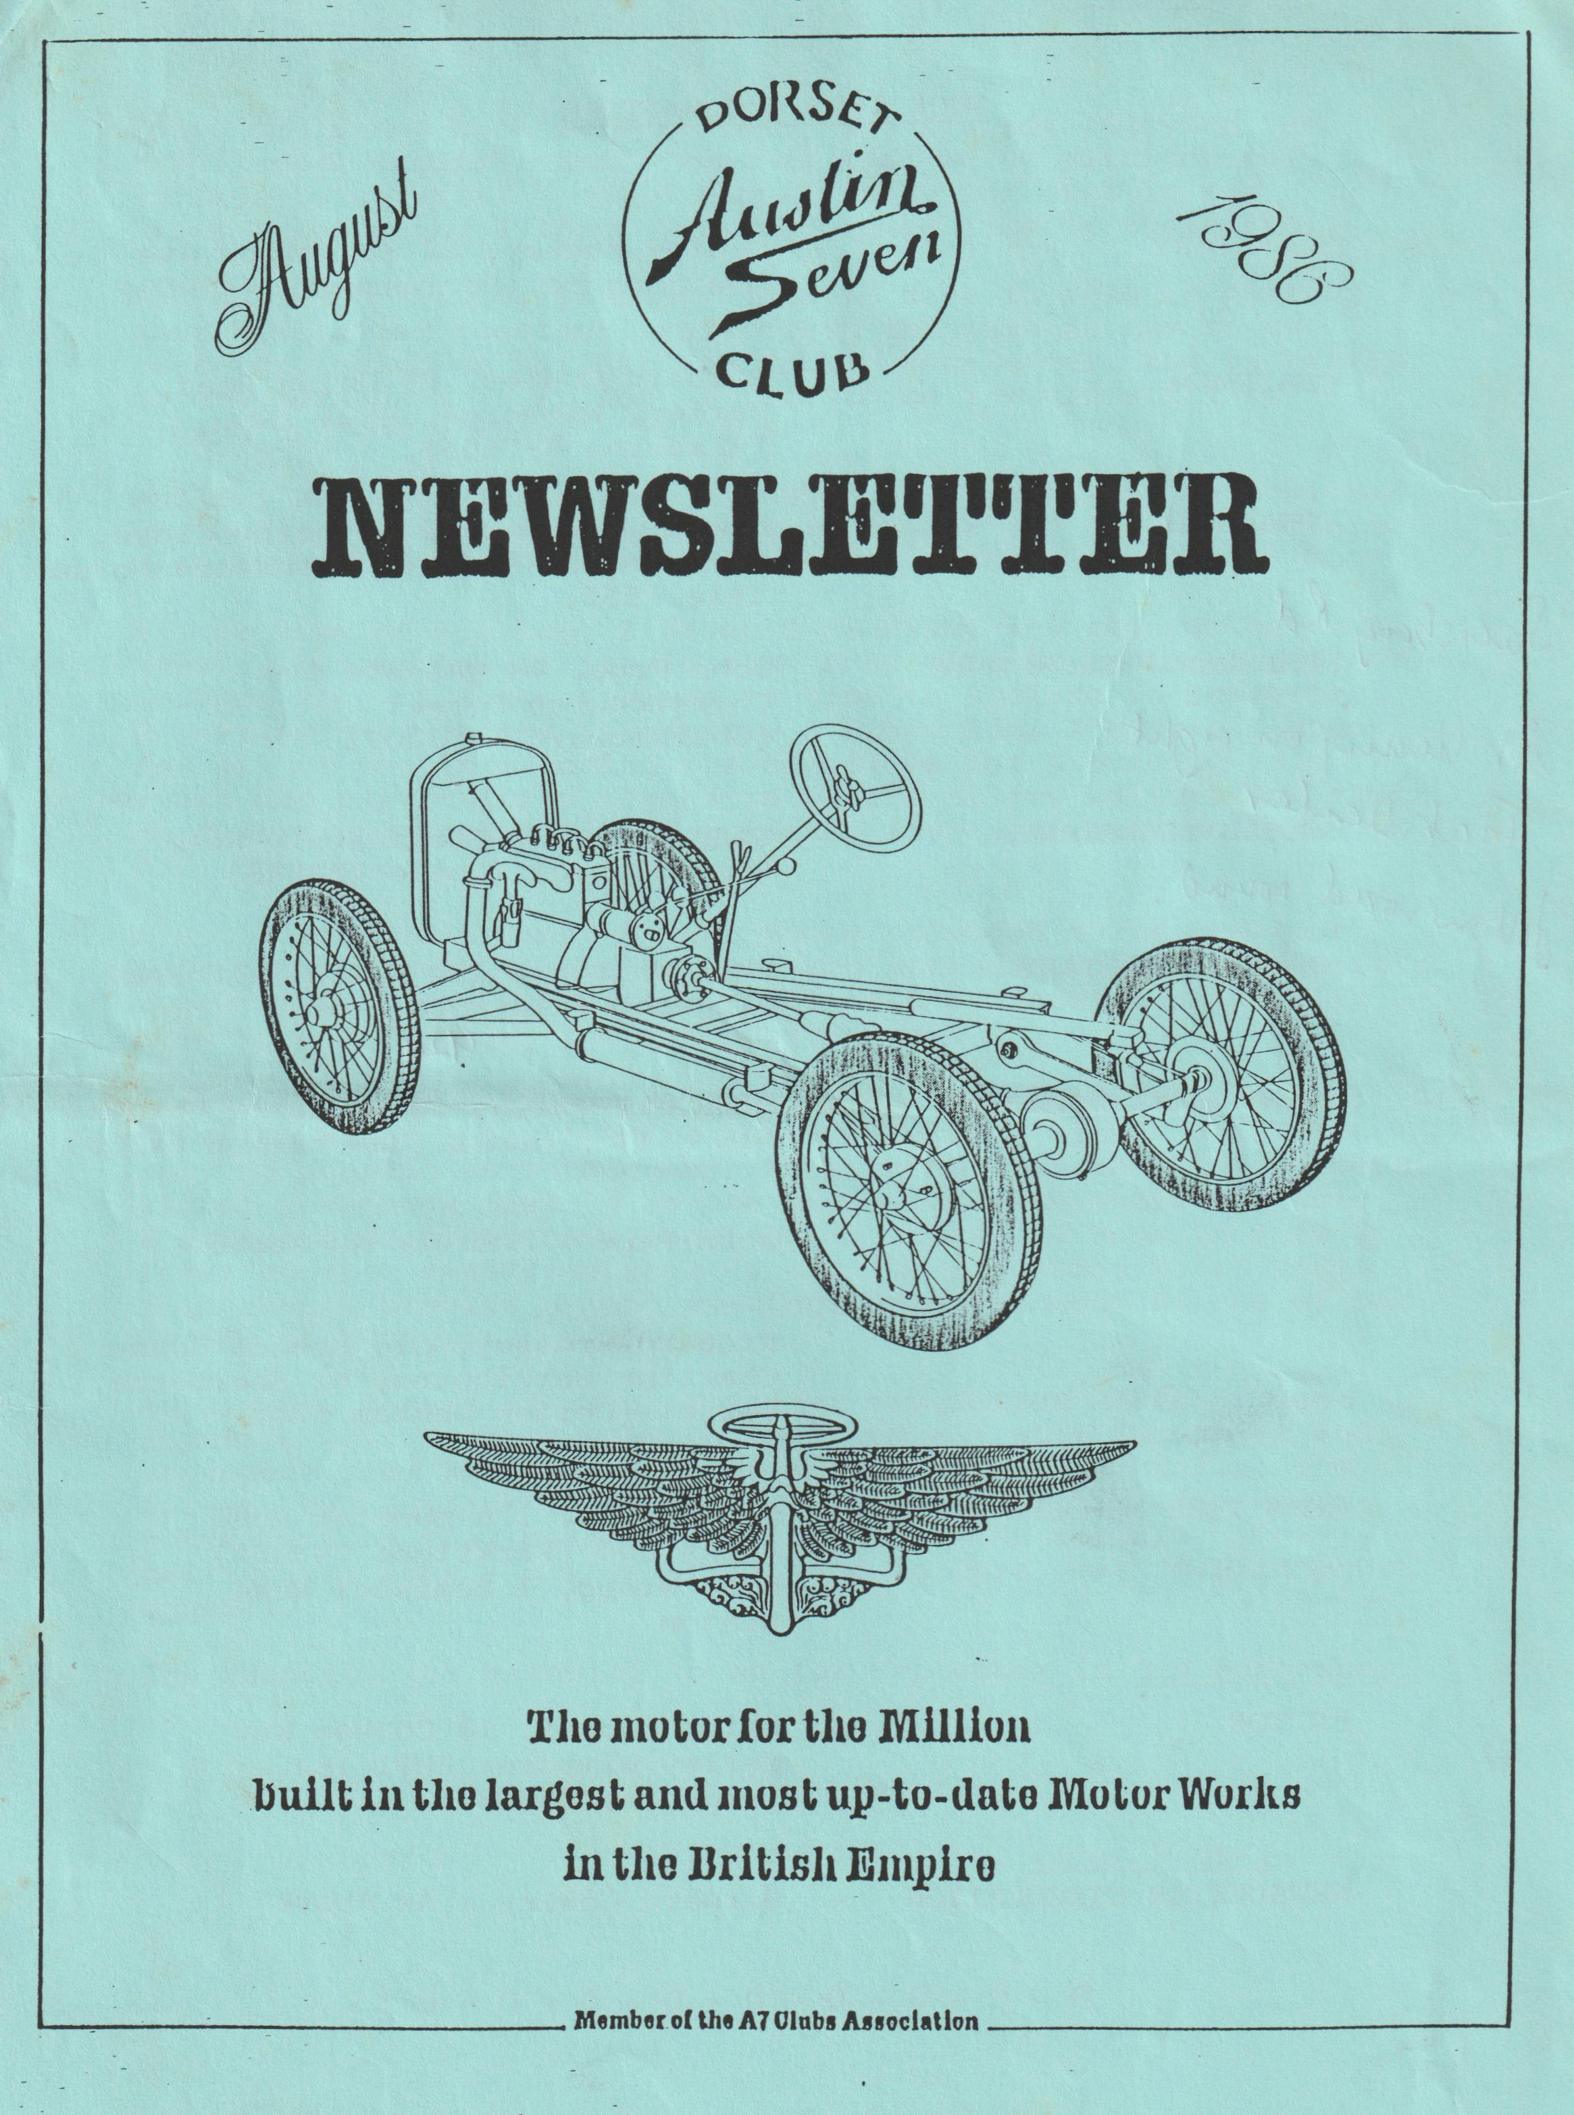

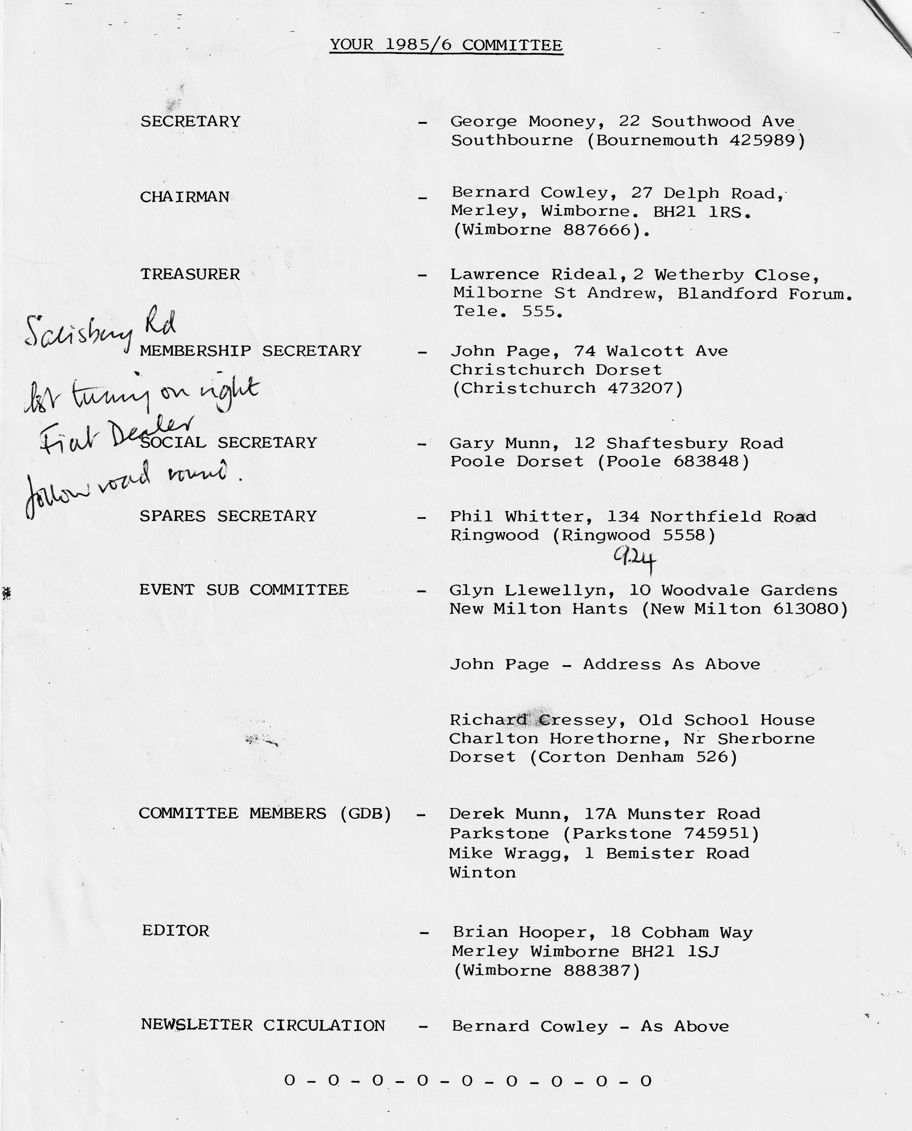

EDITORIAL AUGUST 1986
Yours truly now back from holiday, and I'm not enjoying the traditional English summer weather that we've returned to, suffice to say that I could happily stay for ever in the Greek Islands and I think our Ruby would like it there too.
For whatever reason, I always seem to have to rush in putting this Newsletter together, this month the rush is due to my secretary going on holiday and to our Newsletter, she is really more important than I, for if left to me I would still be typing up last January's edition!
While I was away there were a number of events that were missed including Spye (they always seem to change the date to coincide with my holiday), Beaulieu, Strawberry & Cream run etc.
At the time of writing, I haven't received any reports on these events, but if any arrive in time they will be included, if not, perhaps they will be received in time to include in September. Referring back to the Strawberry & Cream run, I'm sure I speak for all of you in thanking the committee for providing this event and particularly thanks to Phil & Hilary Whitter for their hard work and hospitality provided - I've seen some photos - it did look good.
Also, I know that Janet & John Stone provided their generous hospitality again to our members who attended Spye Park and it's rumoured that our members now call it the 'Janet & John rally', with Spye Park being the secondary event!
Before going on holiday, we went to the Barbecue at Studland, this too was a super evening and hopefully I didn't upset too many by popping up throughout the evening with the Video camera. All of you there feature in the Video and even those who were a little camera shy have come out as stars! I hope to film at least another event/run shortly and the resulting total video film should provide a good evening’s entertainment at one of our winter club nights.
As always, I need material for your Newsletter - please send anything - it doesn't have to be typed - I will interpret and reproduce from whatever you can let me have. Naturally, I'm biased, but I think we have a good Newsletter and it is your contributions, that make it - so come on - an article, story, criticism, idea - you've still time in this year to give your support.
The deadline for material to me for September is 3rd September.
Regards,
Brian Hooper
Highdown Cottage,
Compton Down
Nr Winchester
Members may be interested to hear of three rallies that we have been to this year, which weren't too far away from Dorset:-
Eastleigh Vintage 13th Annual Rally - Botley
The sun shone all day and the pitch was crowded, unfortunately the Seven refused to start, so we had to take the Rover.
There was a vast selection of vehicles, and stationary engines were well represented as music poured forth from the loudspeakers.
There were some very good stalls and a Fish & Chip Wagon, models were displayed in a large building on the site, and the display of Fire engines gleamed and shone, one of which was painted green. A rally which was well worth going to.
Lover Vehicle Rally
Geoff was working on the Saturday and it was raining, but Sunday dawned bright and clear. The Ruby buzzed along the narrow lanes on the way to Downton and the roads were quiet. Next to Lover Garage is a large field, which quickly filled with vintage cars. There were several Austin Sevens, a magnificent Lagonda and a rebuilt 1931 Singer, plus stationary engines well represented.
Bert Hopkins of the Lover Garage had a magnificent Austin 10 Lichfield for sale, the body was rough, but the engine was running and it was very quiet. Dave Hopkins was showing Military vehicles and Netley Marsh had an assorted display of tractors. In addition there was a good selection of horse-drawn carriages. We enjoyed the wide assortment of stalls and the refreshment tent and bar - altogether another rally well worth going to.
Lymington Rally
It was the first time that we had been to this Show. We were the only Seven, but there was a Forlite and a Lichfield. We saw more tractors and motorbikes- than at any other rally, and there were stationary engines down two sides of the field. John, from Eastleigh Vintage Society was grinding flour and making bread, and you could pick your own Strawberries and buy cream at the farm. Stalls occupied three long rows including autojumble, and Aircraft were parked in the field with model aircraft whizzing overhead. The plaque was most impressive - altogether a good day out
- 0 - 0 - 0 - 0 -
We had an accident in our Ruby in February, but I'm glad to say she is on the road and was in time- for the summer rallies.
See you soon.
Daphne Canning

1 expect that most members know Linda and Chris Smith, two or our very popular members from Ringwood.
Linda and Chris always provide a lot of support to the Club, and now we have the opportunity of supporting them in their fund raising for their chosen charity - The Leukaemia Research Fund.
There is a special reason that Linda and Chris are raising funds for this Charity, for their little daughter Rachel who is two years old (I believe her birthday is in September, so I expect Rachel would like to be known as nearly three years old) has unfortunately suffered with Leukaemia since she was about 22 months. Naturally, Linda and Chris know firsthand the problems and needs of Leukaemia Research to which they have pledged their support.
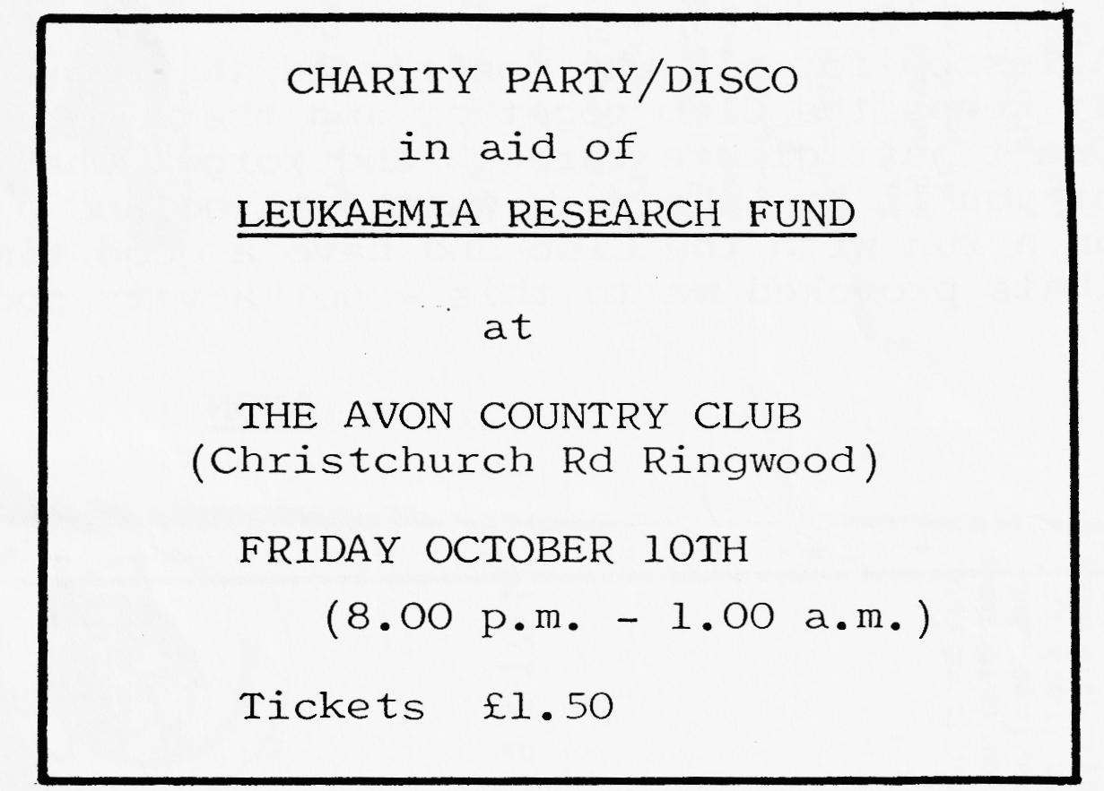
To raise funds, Linda and Chris have organised a charity party/disco:-

Tickets/reservations for this party can be obtained by telephoning Chris or Linda at Ringwood 478066, or by writing to:-
Mr & Mrs L. C. Smith,
'BROOKFIELD,
Hightown, Ringwood.
(Cheques etc payable to L.C. Smith)
- 0 - 0 - 0 - 0 - 0 -
It would be nice to think that all of our members will buy tickets and by involving their friends, colleagues etc. Chris and Linda's target of selling 300 tickets will be achieved. Hopefully, everyone buying tickets will be able to turn up at the party, but for those that can't, their ticket purchase will of course help the fund. To do my little bit to help, I pledge to Linda and Chris that for every ticket sold up to the 300, I will add a further 5p, and of course I hope to see you all at the party.

-A SUMMER EVENING LAMENT-
August the first, and sat down indoors
watching the rain that pours and pours
Thinks - what can I do to keep me awake
The Austin Seven - wish a run I could take
Thoughts of my friends who belong to the Club.
Would be nice to meet them tonight in a Pub

Come 10.30 and bored to tears
Find something to read, so go upstairs
There is my Newsletter, top of the pile
Another read through - it may make me smile
Look at events coming, to see what will be on
What’s this? - tonight they met at Hinton!

Too late now, how I wish I had read
it through last night before going to bed
For I'd have been there, at the Cat & Fiddle
drinking my share and having a
In future, the events I'll stick on the wall
so I don't forget - by the door in the hall

A lesson for all who don't read the Newsletter
It keeps the Club together and there's nothing better
Don't just glance through and forget what's in it
or you'll be like me - wanted to go and didn't
on a run with the Club and have a good time
that’s provoked me to this - not a very good rhyme.
ANON
KEA HOUSE
Laverstock Park
Salisbury
Could you find space to mention that there are a couple of local Fetes, who would welcome a display of 'old' cars:-
Shrewton Fete August 25th starting at 2.00 p.m. in aid of the local brass band.
Whiteparish Fete September 13th starting at 2.00 p.m. in aid of the local youth club.
Yours sincerely, Roger Ballard
EDITORS COMMENT
Nice to hear from you Roger - I guess that any members requiring further details of these fetes can contact you on 0722 23570.

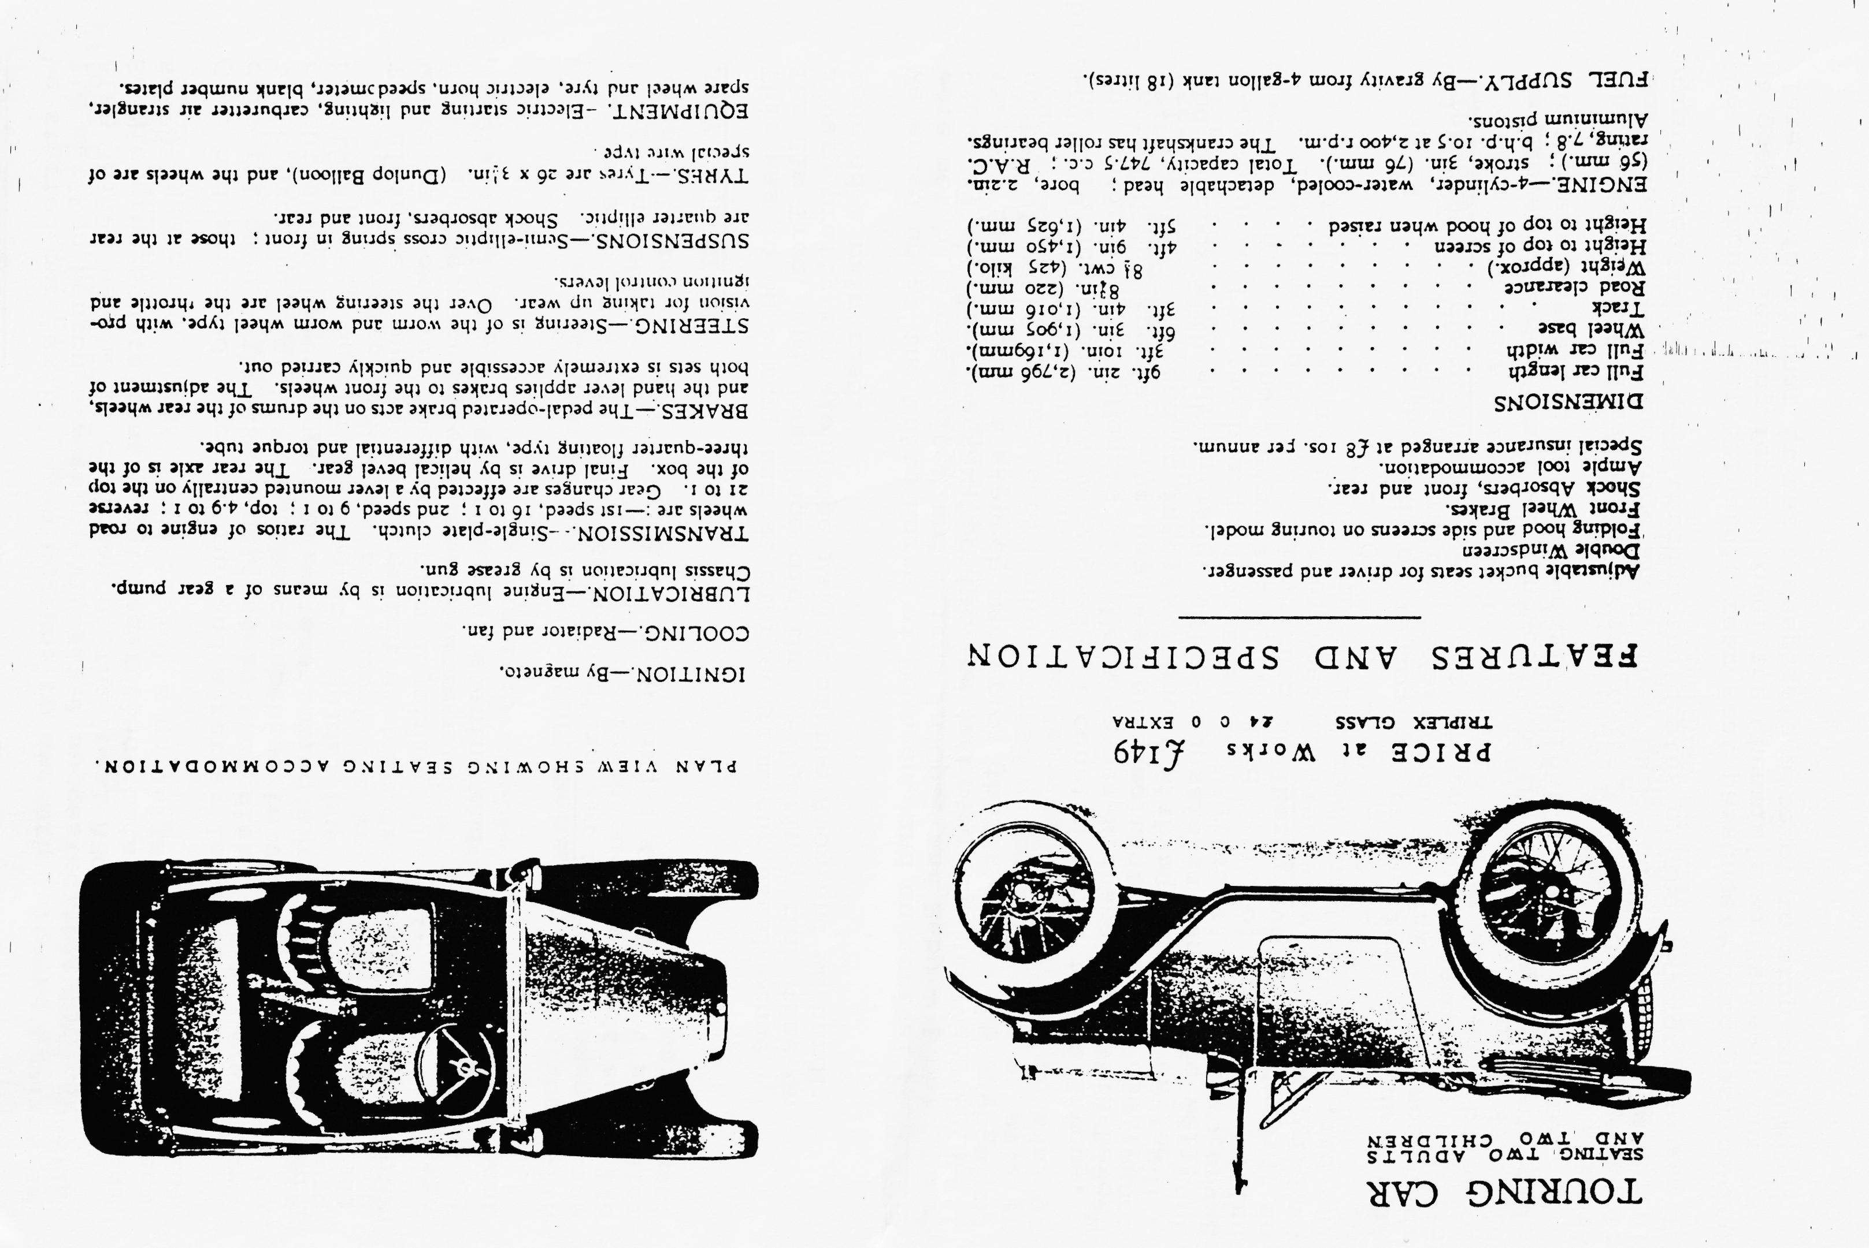

EVENING RUN REPORT -
We started our 'extra' evening runs on the 4th July and as I'd met Ken Henson a week previously, I suggested that his car club joined us (he is chairman of the local A30/35 club). So Wimborne Square that night was full of both A7s and 'later Sevens'.
Gary had arranged a scenic run and a rather large crocodile of cars followed - the A30s getting lost at first, not knowing the convoy rule of keeping the car behind in view. They soon caught us up however when my external wing mirror dropped off and I had to stop.
The ultimate venue for the evening was the Cross Keys at Mannington where we took over the back room adjoining the bar. I must say we were made very welcome and we were even there after closing time!, all in all a very pleasant evening and a good turnout.
Bernard
- 0 - 0 - 0 - 0 -
JULY CLUB NIGHT
This was to be a run, and we started from our usual venue The Elm Tree, and John Page did the navigating, this time on a very pretty run along the valley of the Avon and we hardly touched a main road.
We ended up at the White Horse at Downton, and on arrival we were met by Steve Joiner and friend in Opal and Ruby - I met Steve at the last Wessex meeting and had mentioned we were going there. He has been a staunch member of the Bristol Club for a number of years.
The turn out again was very good - I counted about twelve Sevens, an Austin 10 and a Morris 10. We also met a chap from North Devon in his Nippy Special - he had been chasing us around the country all evening - he had an interesting car with a tuned A35 engine and gearbox with a Big 7 rear axle - he said it went quite well!
Bernard
- 0 - 0 - 0 - 0 -
STRAWBERRY & CREAM RUN
An eleven o'clock start at Ringwood saw the usual band of intrepid Austineers preparing for our yearly weight-watchers nightmare!
Phil and Hil had arranged a pretty route through the Forest and north to the Fordingbridge area, then back south via a two-mile gravel road which went through the depths of the undergrowth.
We all thought that Bernard's rear seat passengers were just having a good time leaning forward over the Chummy's windscreen, but later we found that it was a desperate attempt to stop bottoming!

We arrived promptly at twelve at the Red Shoot Inn to find Glyn already there (surprise, surprise after all it is a Whitbread pub!). They hastily put on a very good value Sunday roast, consumed by most of us and necessitating a forest amble later on to make room for the strawberries.
Two groups left following the same signposted walk, but seemed to go in totally opposite directions, however after an ice cream it was back to Phil and Hil's for the feast. Hilary had done us proud again - chairs and tables arranged around the garden and there were Strawberries and Cream, tea and cakes galore - even we DA7 lot of vultures couldn't finish it all.
After tea, a working party sneaked away and broke into Phil's garage to investigate the shelves of rare spares and goodies, and it wasn't long before Phil had made several sales!
After our annual peruse of Phil's 'Fabric Saloon' and many words of encouragement for its restoration we bade the Whitters farewell - all of us about a stone heavier! Phil and Hilary - I definitely think you've made this a permanent fixture in our calendar! - many thanks from us all.
Gary
- 0 - 0 - 0 - 0 - 0 -
SPYE PARK
I travelled up on the Saturday morning with Jackie following in the modern with the camping gear. We arrived just after 10 giving us time to put the tent up before John Stone and family came along to take us and other 'Dorsets' on a run around the Wiltshire countryside.
We first headed to Devizes where a coffee stop had been arranged in a converted barn near the town centre, with lots of home-made goodies - the scones were especially good. After being suitably refreshed, John said there was an antiques market just up the road and as all Seven owners are 'totters', we were soon spread out all around the hall! I managed to buy a book and a Yesteryear model. Then we went on through some lovely rolling countryside to a Pub just outside Avebury, where we were very pleased to take over a room just off the bar, - the food and beer being very good.
After lunch we went around the corner to the nearby Avebury Rings where some of us watched the cricket whilst others walked around the circles of stones wondering why they were erected. From Avebury we followed John back to his house for a cream tea - this year held in his back garden as the weather was so good. I must say that it was a super spread - many thanks to Janet.
After a gentle ride back to Spye with stops for petrol and chips, it was time for a spruce up for the Barn Dance, which was to be held in the marquee on site. This year we had a 'proper' band - last year it was a jazz band with no dancing.
After taking over a corner of the marquee, we were soon all swinging around to the music. At about midnight the music stopped and we all crept back to our tents - very tired after a long enjoyable day.
Sunday dawned - all dampness and drizzle, yet another wet Spye - but no, at about mid-day the sun came out and after that it was super. The Dorsets again did well with the pots - myself winning a rose bowl, Dusty winning a cup and Bill Quayle, Nick Moffat and Glyn all getting awards (I hope I haven't forgotten anyone).
We also won the interclub award again, this year being the 5th time. The contest was fitting two valves in a block in the fastest time, and due to the nimble? fingers of John and Gary, we won in about 2 ½ minutes.
So ended yet another super Spye Park Rally, with especial thanks to John and Janet Stone, and the Bristol A7 Club for the organisation.
Bernard
SECRETARIAL
Sorry to have to advise again, but Marco Pollo (George I mean) is still doing his thing around the world. I telephoned Joy last night who told me that George was last seen getting on a plane to Tel Aviv (has to go and see his bank manager occasionally!) and next week-end George is off to Norway.
I asked Joy if there were any little stories from George, but she had nothing to report and when questioned, Joy said that George hadn't even had the time to be a naughty boy!
I'm sure we all hope to hear from-George soon, meanwhile on behalf of the club, I take this opportunity to wish George good health, success and safe landings, in his travels.
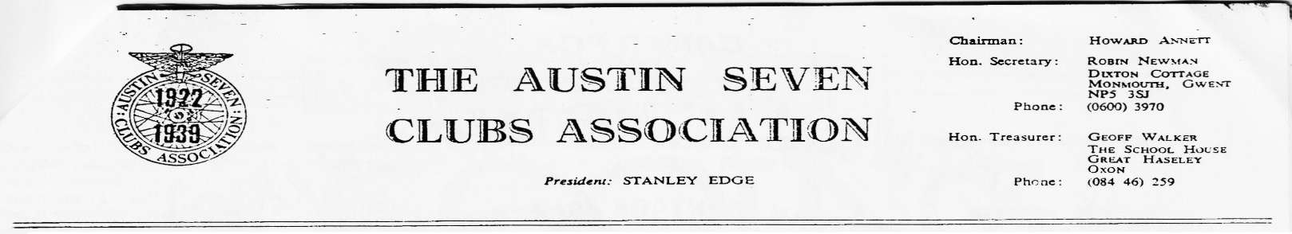
Ed
17 Jun 86
All Club Secretaries
Dear George,
It hardly seems like three years since I took over as editor of the Association Magazine but time flies when you are having fun! As I explained at the last Meeting, I cannot carry on after the October issue is produced and so I seek your help in finding a successor.
Most will know that the job entails preparing other people’s work for production. This is not as difficult as it might seem and is not too time consuming although there is a fair amount of letter-writing to be done but for someone living in UK, much of this could be done over the telephone or at various rallies throughout the year. Full handover notes are available along with the files and photographs. There can be little doubt, however, that access to a typewriter is a distinct advantage. Apart from that, few special skills are required.
Many of you will also know that I have been running the association advertising, on and off, for the past year and a half. Sadly, this too must pass into new hands. It is not an onerous job but does take a certain amount of time and letter writing. Again, full handover notes are available and instruction will be available.
Could I therefore ask you to give full publicity to both these jobs? Both are very satisfying and give a great deal of fun. No special skills are required although access to either a typewriter or a secretary are useful. All those interested are asked to contact me, in the first instance. All help will be gratefully received!
With very best wishes,
Miles Shepherd
1.

PLEASE NOTE WE HAVE JUST PURCHASED A COLLECTION OF SIX A7s PLUS WHAT LOOKS LIKE AN ORIGINAL SPORTS CHASSIS OF. SOME SORT WITH STRAIGHT REAR SPRINGS AND DROPPED FRONT AXLE. THE CARS RANGE FROM A 1929 FABRIC. SALOON, A VERY EARLY RN SALOON, A 1937 RUBY, AN, ALL-ALLOY TWO-SEATER ,CALLED A W.E.V. (AS FEATURED IN EARLY .ISSUES,OF THE 750 MAGAZINE),A FALCON AND AN ASHLEY, BOTH WITH THEIR HARD TOPS.
PRICES RANGE FROM £2,000 TO £500. IF ANY OF YOUR MEMBERS ARE INTERESTED CONTACT US ON 0621 772096
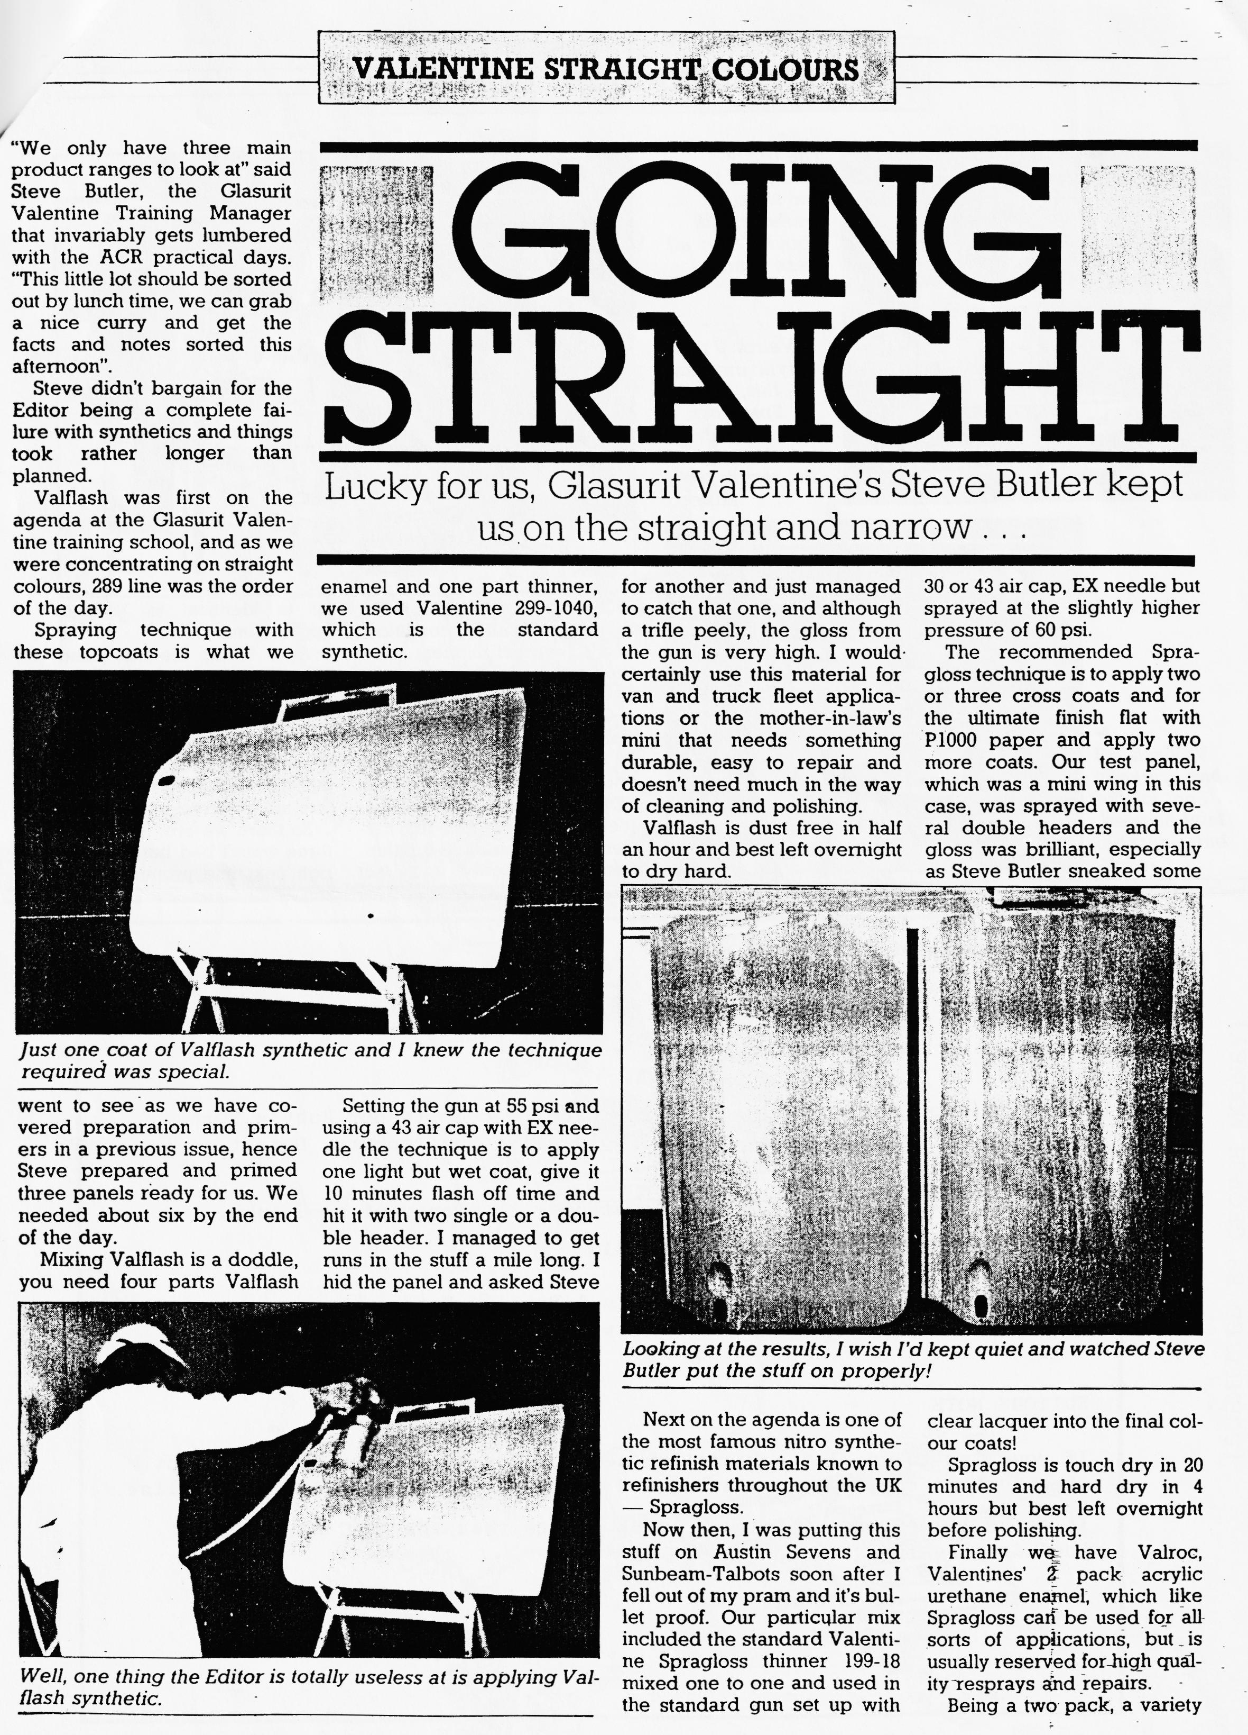

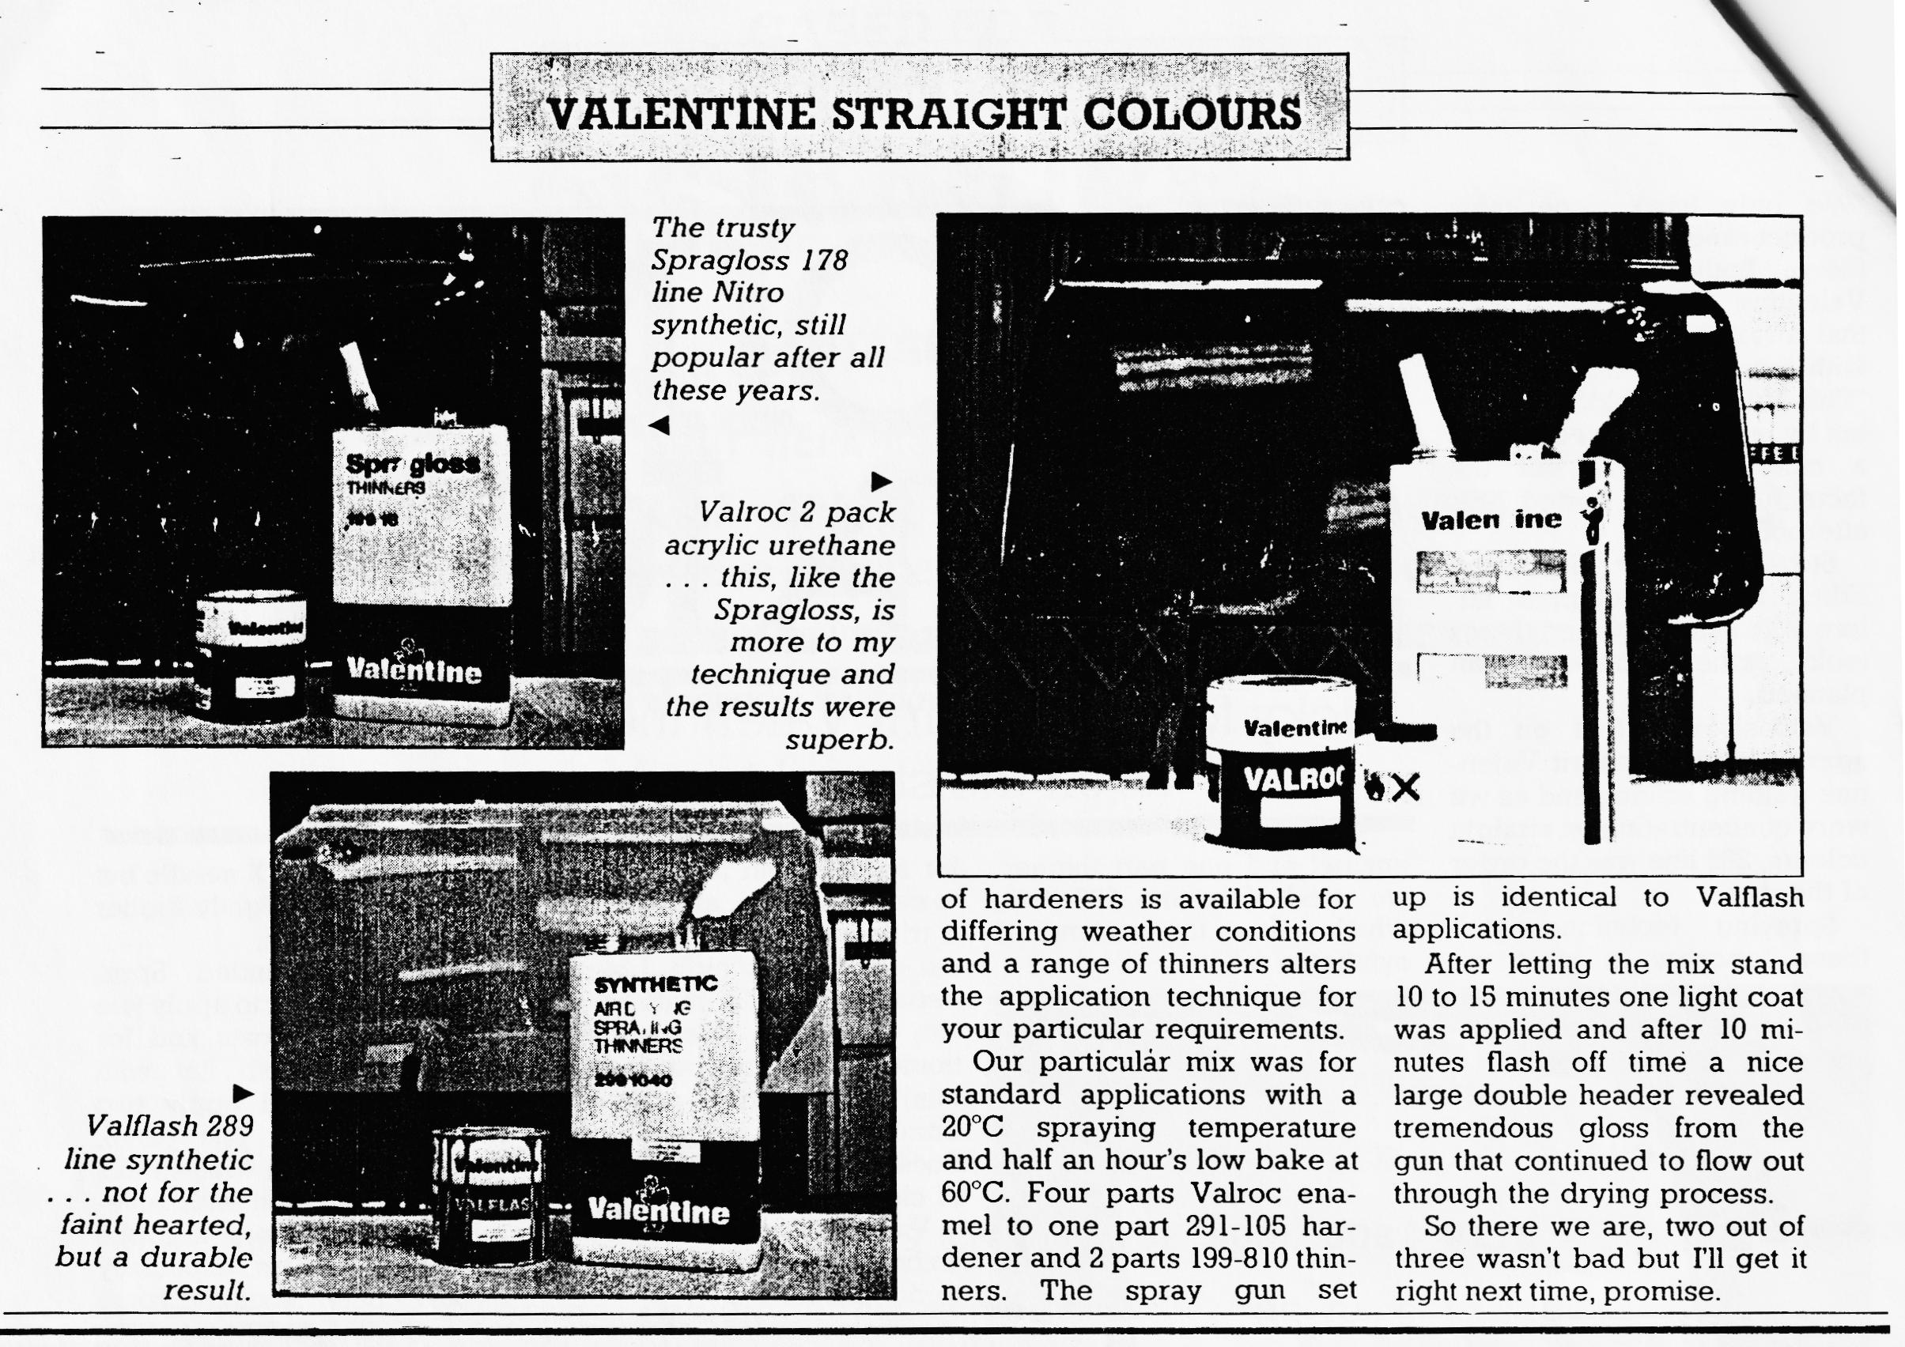
We have received the following invitation;-
10 Magdalene Lane, Shaftesbury, Dorset.
An invitation to Dorset Austin Seven Club to come to our Ruby's 50th Birthday Rally on Parkwalk (top of Gold Hill) Shaftesbury, Dorset on Sunday October 5th at Mid-day.
Beer and Cake provided - superb location with plenty of good pubs. Please RSVP to Shaftesbury (0747) 3412.
Kevin & Pauline Barnes (New Members)
EDITORS NOTE
If you wish to go, let a committee member know at the August Club night, when numbers can be coordinated and advised 'en bloc' to Kevin & Pauline.
It looks like being a big event, for I note that the WVPC have also included the invitation in their Newsletter.
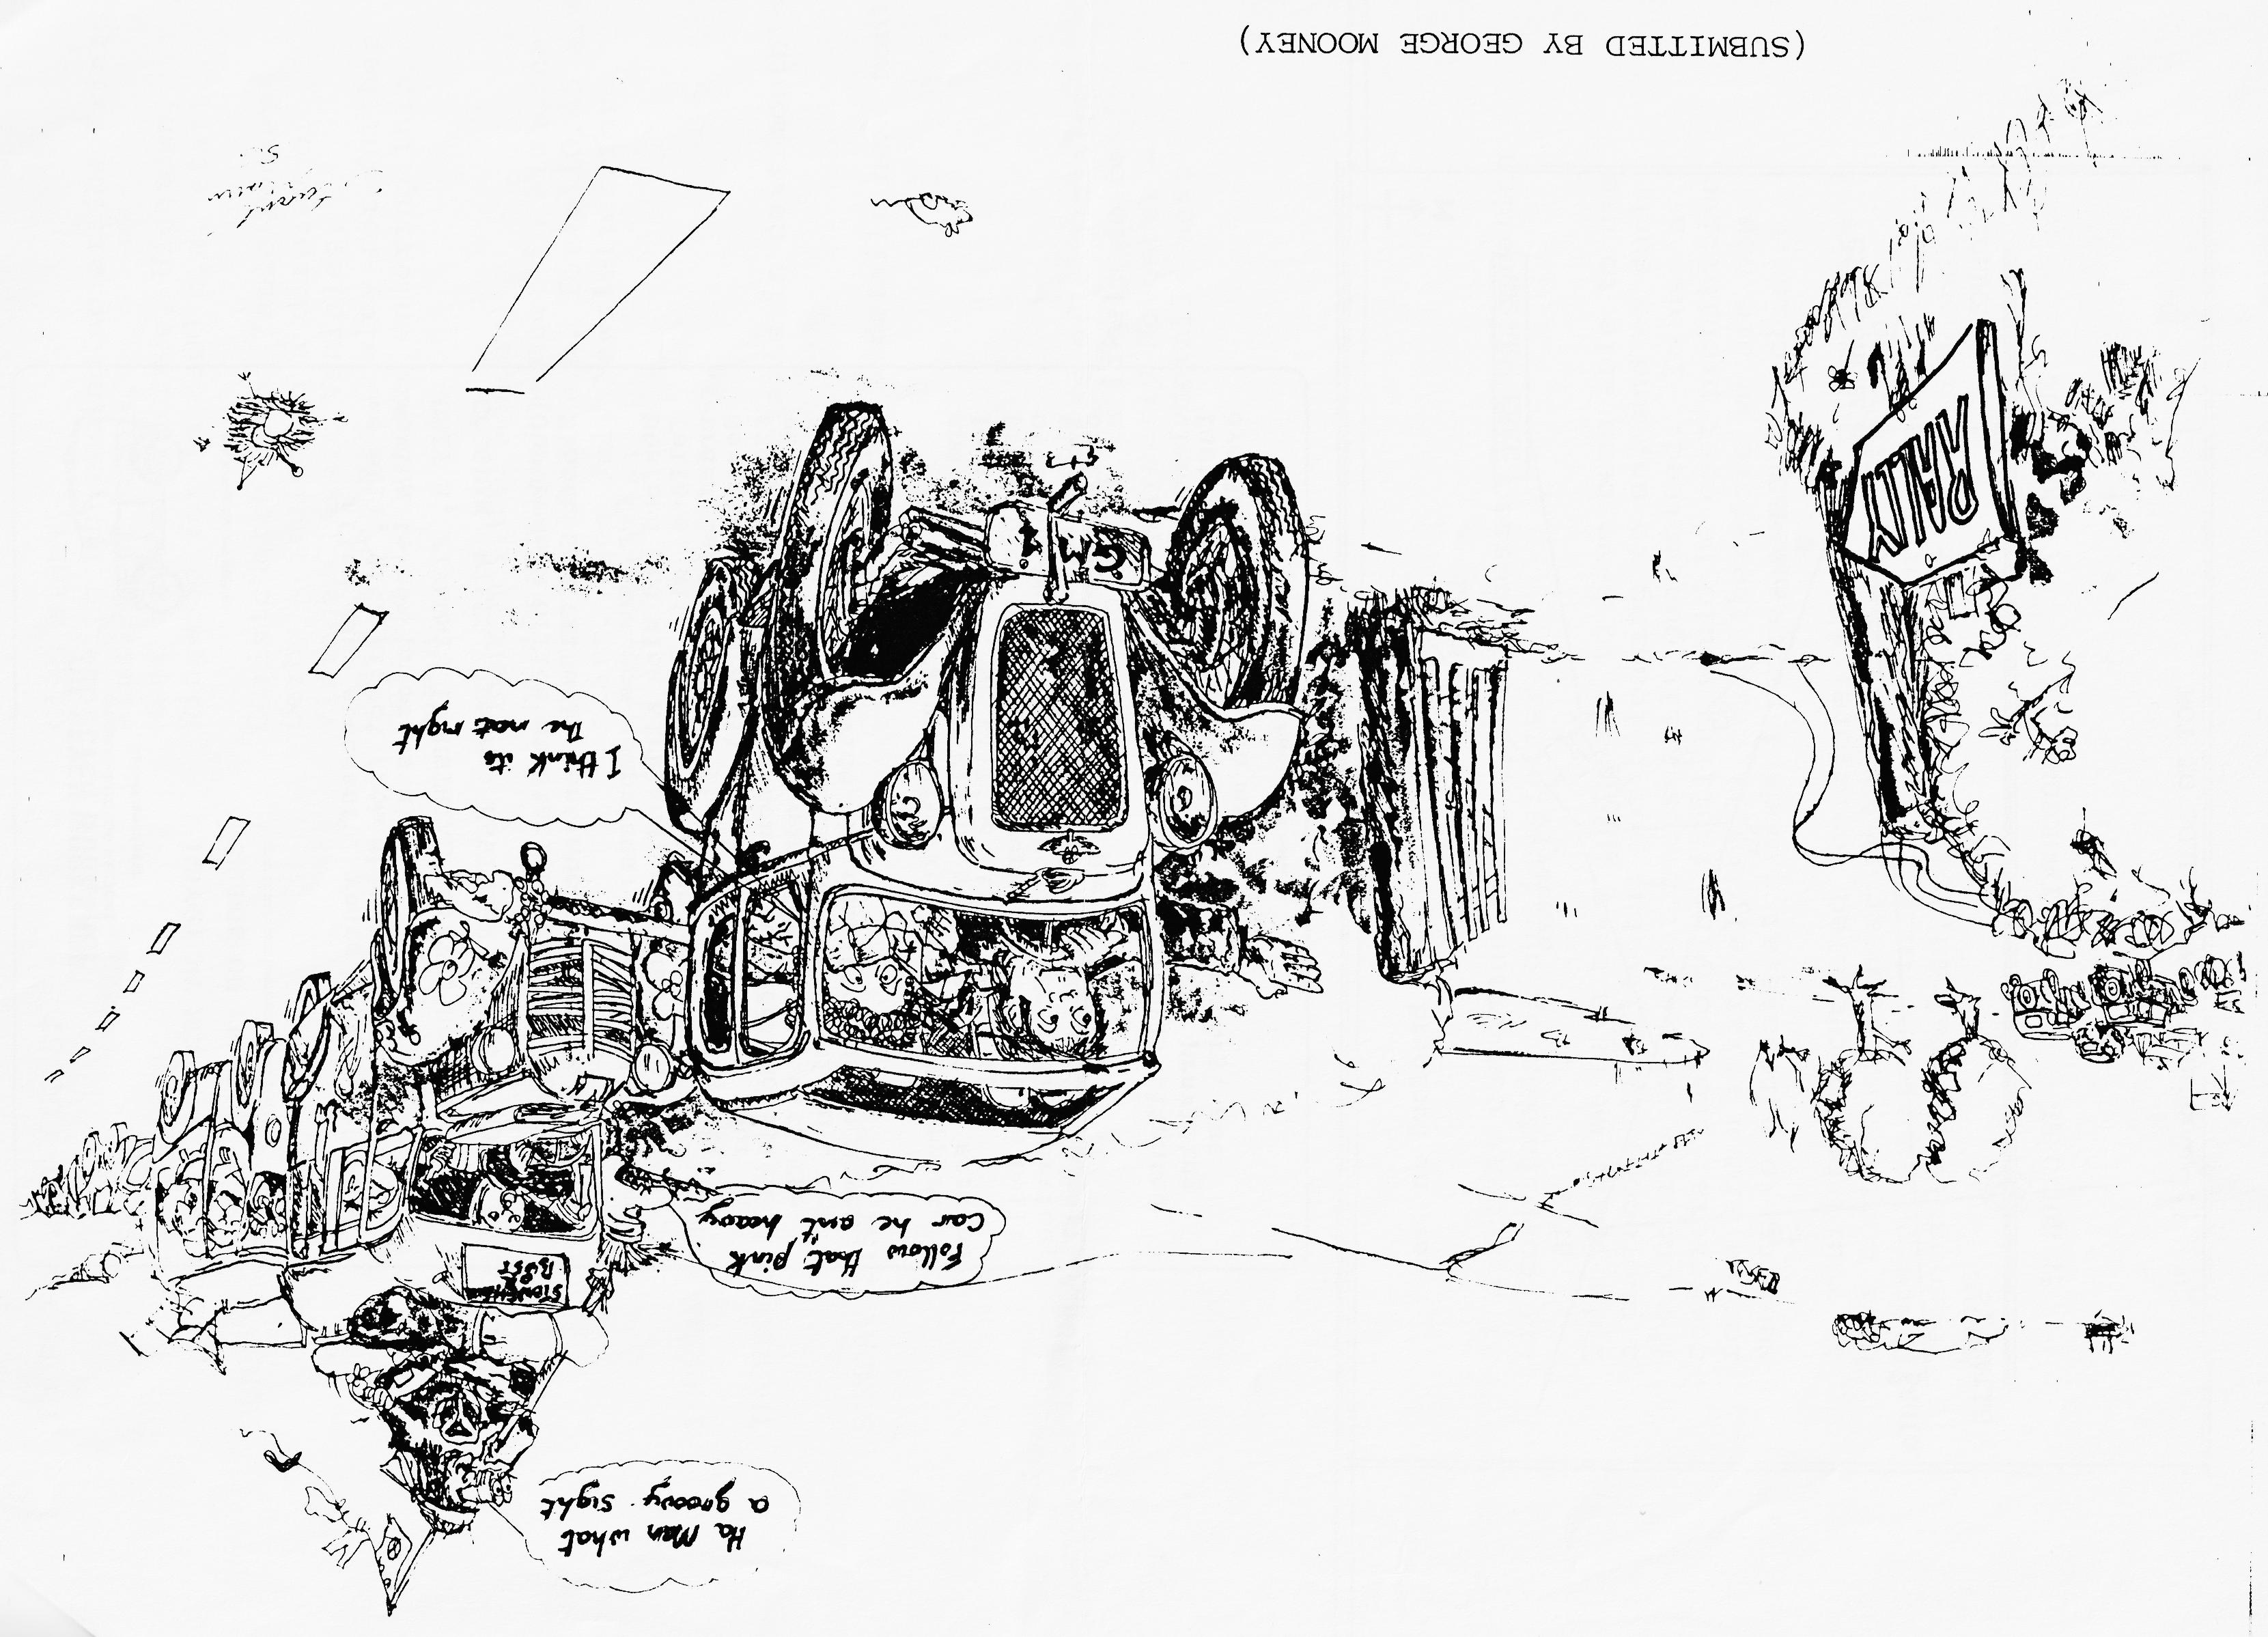

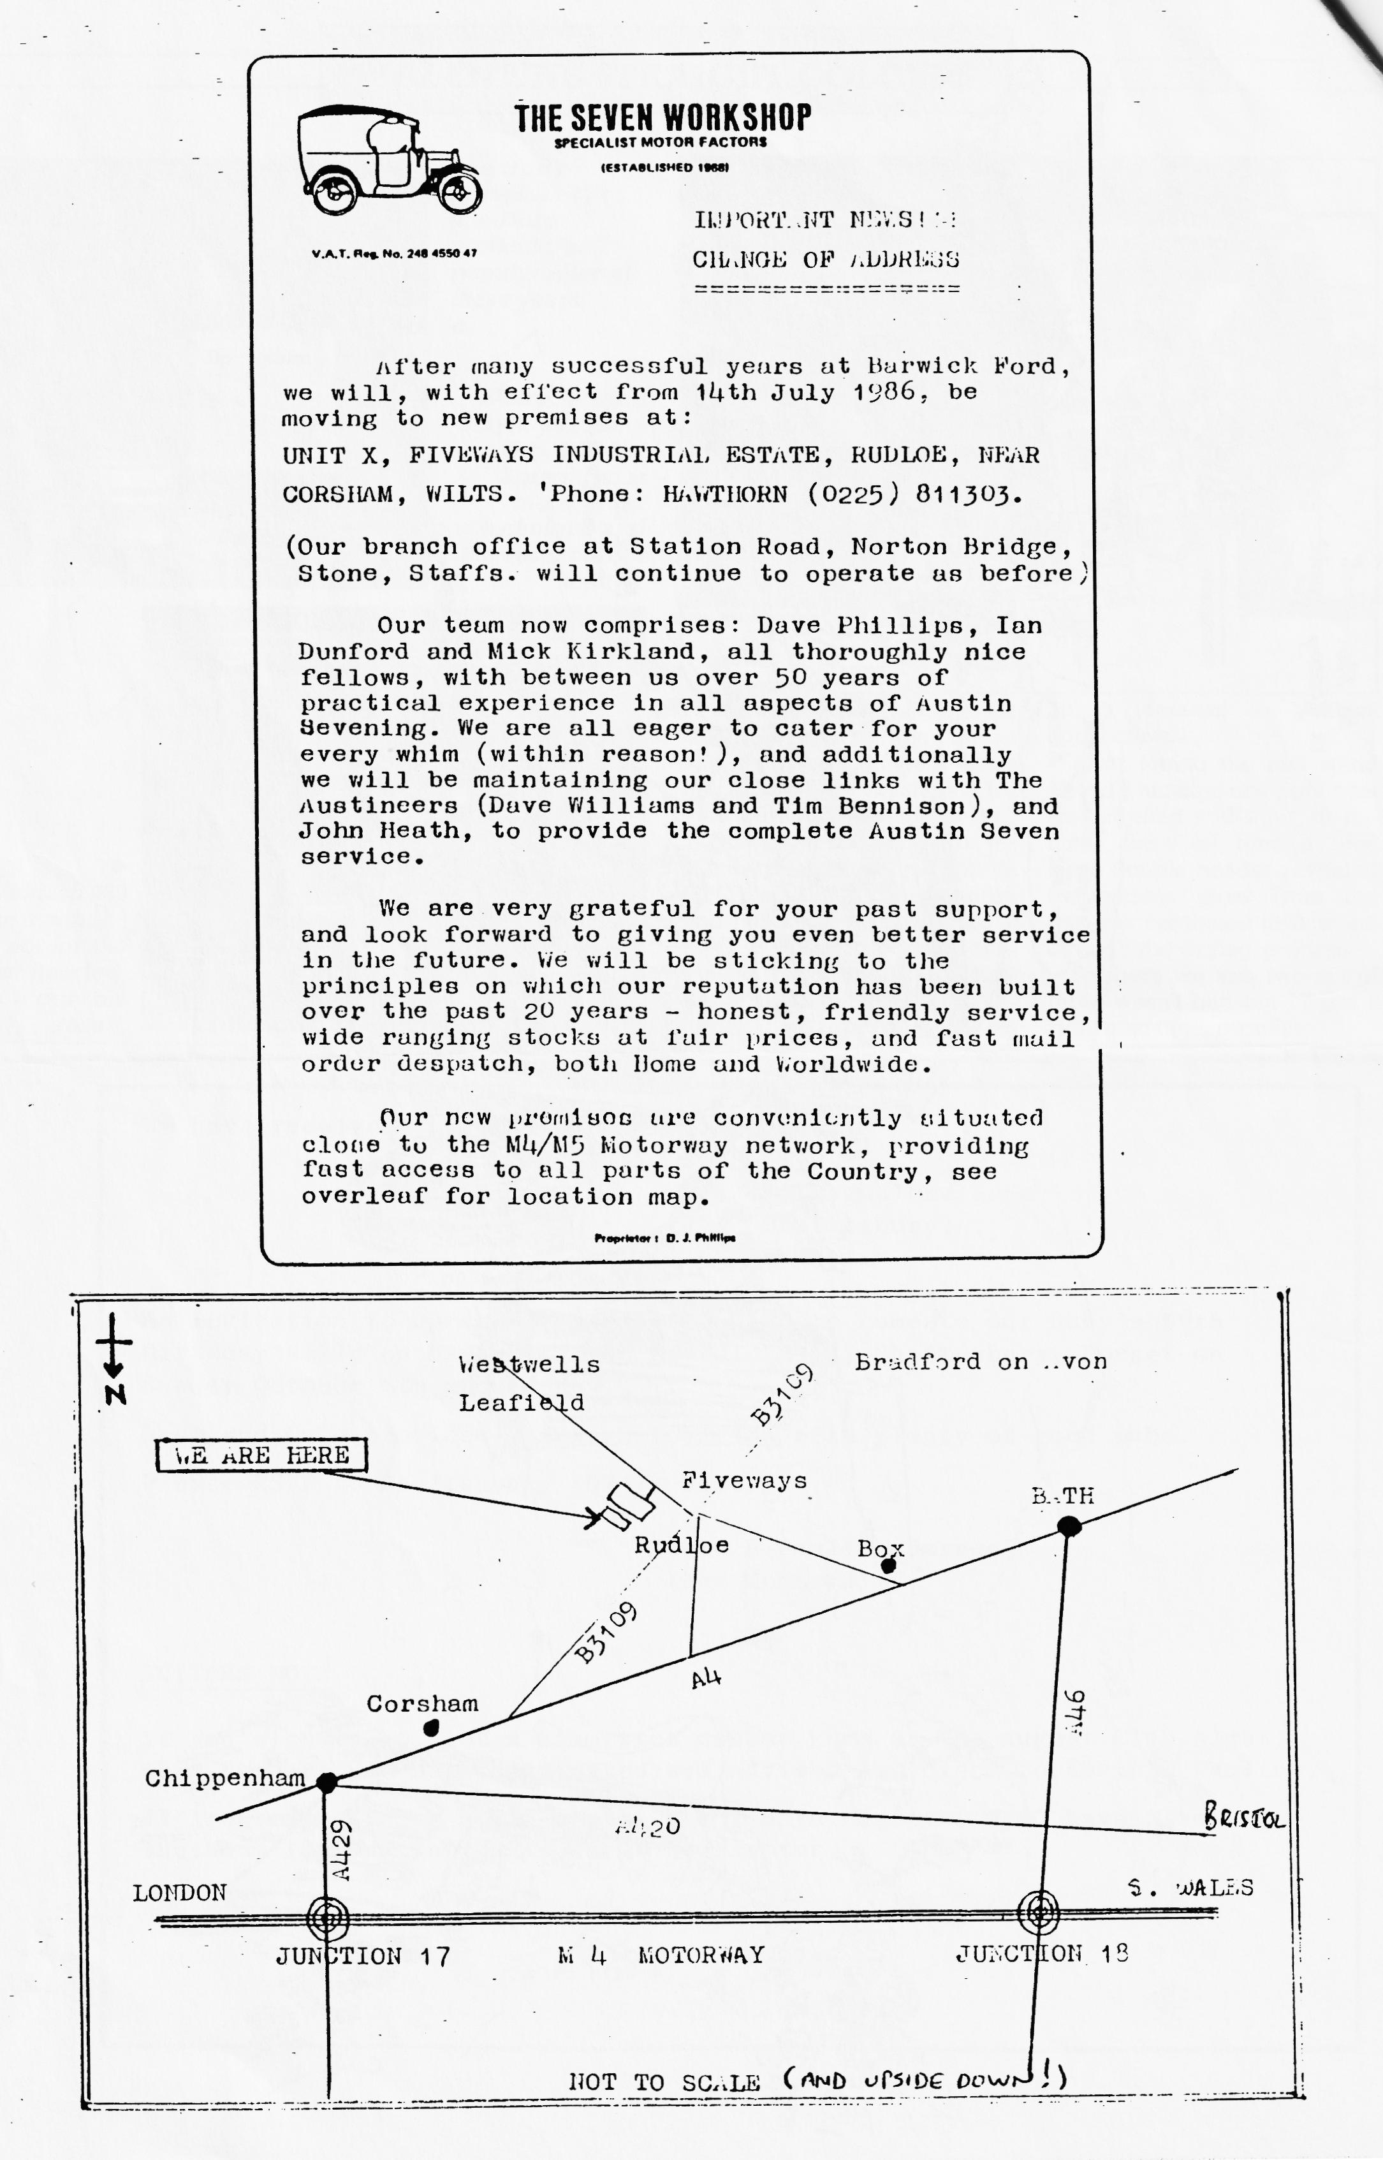

EVENTS
THURSDAY 21ST _AUGUST Club Night. Evening Run ending up at the Friars Arms, West Moors. Meet at the Elm Tree, Hightown, Ringwood for an 8.00 p.m. start.
SUNDAY 24TH AUGUST Christchurch Round Table Donkey Derby - including a display of Vintage/Classic Vehicles. Contact Bernard Cowley for further details if you are entering this event.
MONDAY 25TH AUGUST (Bank Holiday Monday) The 'Beach Run - meet in Wimborne Square at 10.30 a.m. for a 10.45 a.m. start. (see July Newsletter for other details).
THURSDAY 28TH AUGUST Committee Meeting.
THURSDAY 18TH SEPTEMBER Club Night - details in next month's Newsletter.
SUNDAY 21ST SEPTEMBER Club Run to Bere - details next month-
- 0 - 0 - 0 - 0 -
ANNUAL SKITTLES NIGHT
Gary is in process of organising this now - it is likely to be late October/early November - we hope to have details next month.
At a recent committee meeting, we discussed the origination and compilation of our Newsletter. This year, we have been fortunate to have been able to use a photocopy facility but not belonging to us, and as such the ongoing use is not necessarily guaranteed. To use a commercial photocopying facility would be cost prohibitive, for we are a relatively small club, therefore we are now seeking to purchase at a modest price, our own machine.
It would be appreciated therefore, if any of our members have contact with, hear or know of anyone with such a piece of equipment that is in working order and has been reasonably maintained, to let our Editor - Brian Hooper know.

