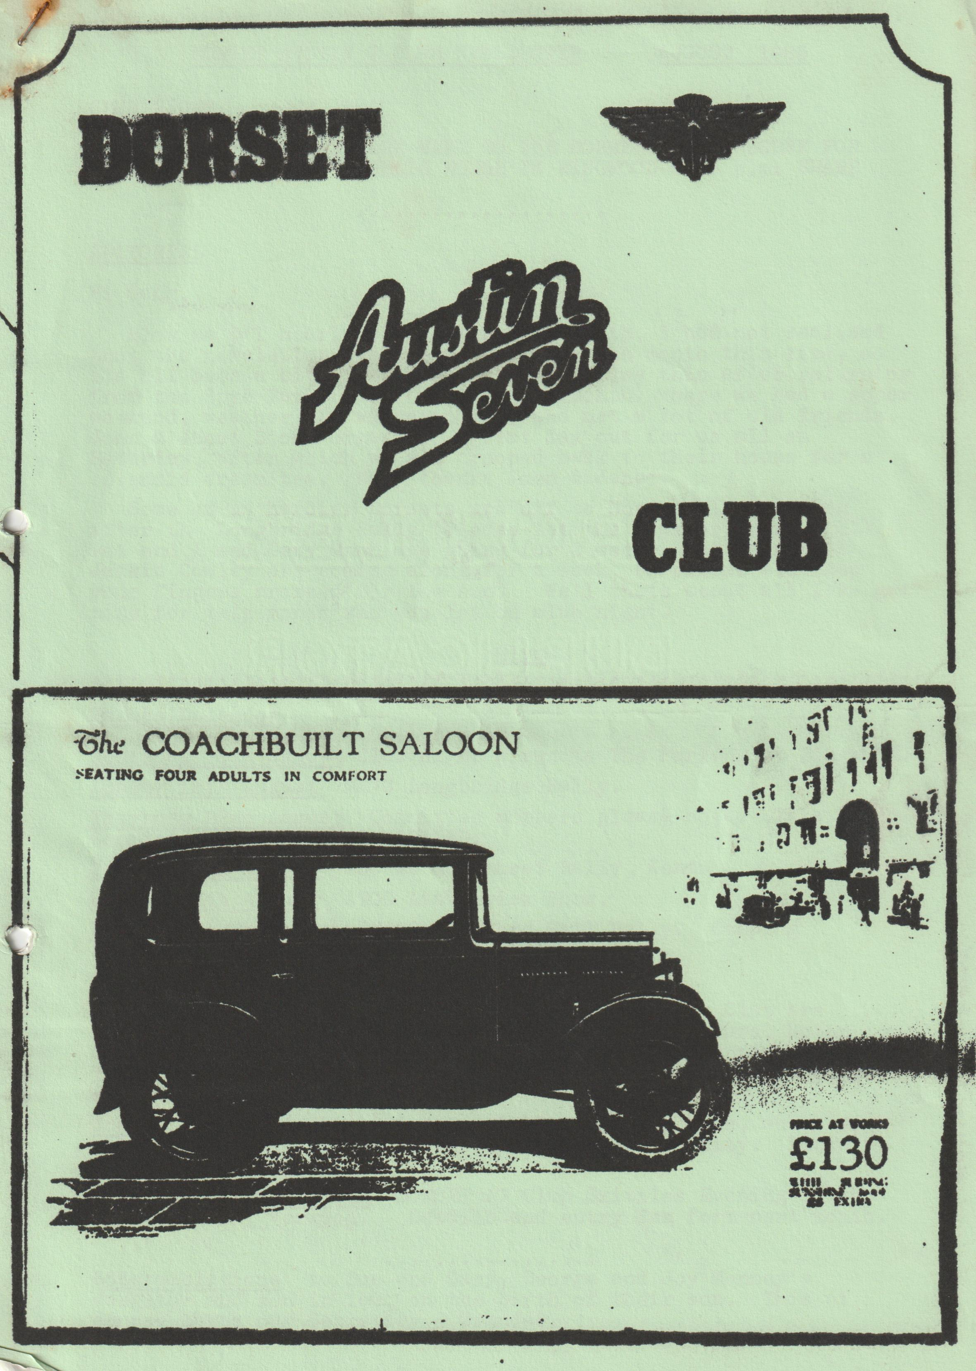

DORSET AUSTIN 7 CLUB NEWSLETTER AUGUST 1985
CLUB NIGHT
MEET IN SAFEWAYS CAR PARK NEXT TO THE DORMERS IN WIMBORNE FOR A RUN TO THE FURLONG PUBLIC HOUSE IN RINGWOOD at 8 p.m. SHARP
EDITORIAL Hi Gang,
Blow me! I nearly slipped up this month. I had not realised that the newsletter was due so early in the month this time, so its all been a bit of a rush. I am writing this after returning from the Spye Park Rally (report next month) where we had a super weekend, weather notwithstanding, and met a lot of old friends. John & Janet Stone organised a great day out for us all on Saturday, after which we all trooped back to their house for a splendid cream tea. Many thanks, John & Janet.
Some of us hardier Dorsets are off to North Wales camping after the Longbridge Rally (Please let the weather improve!!) Pat and I and Gary Munn are going for 2 weeks, and Bernard & Jackie Cowley are coming along for a week, so please all keep your fingers crossed for the sun. Well that’s about all I've got time for this month see you lot on club night.
Glyn
EVENTS CALENDAR
Thursday 15th August Club night - a run to The Furlong at Ringwood.
Sunday 18th August MA7C Longbridge Rally.
Thursday 22nd August Committee members please note. This Committee meeting is CANCELLED.
Sunday 25th August 750 MC Hawkhurst Rally, Kent.
Monday 26th August A7OC Littlewick Show.
Sunday 1st September MA7C Stanford Hall Rally. Camping Saturday night if required.
Saturday 7th Sunday 8th Beaulieu Auto Jumble
Sunday 15th September Christchurch Model Railway Club are holding an exhibition of Model Railways, Vintage Cars, Motorcycles, stationary engines etc. and we are invited to enter. 10.30 a.m. till 4.30 p.m. at Mill Road, Christchurch. George Mooney has the gen. B’mth. 425989
Sunday 29th September Club Run to Southampton area, where we will have a guided tour of the Old parts of the City. Lunch at the Bugle at Hamble.
Saturday October 12th DORSET A7 Club. Skittles Evening at the Monmouth Ash, Verwood. Details and entry form next month.
Congratulations to Sue and Gary, George and Joy Mooney’s daughter and son in law on the birth of their son. This of course makes our Secretary a Grandad.
The Sunshine Rally
The sun shone on Attingham Park, for the Severn Sevens third rally; also, third year for perfect weather. Well done again Chris Chambers.
Henrietta was rather reluctant to make her annual trip to Shropshire, she had to be nursed up the hills and coaxed along the flat, but a new second-hand coil seemed to put new life into her, so we were confident of an easier journey home (wrong again).
The rally was well attended with a large selection of makes, from Bentley to a very nice Triumph 21. There was a large contingent of Post War Morris Minors, even saw one of them being trailered to and from rally!!! The event included a fun run, two laps of Attingham Park, about 5 miles (no not in the' car, on foot). George and I said, “Pass” and were happy to spectate. We were entertained by Telford Sea Scouts marching-band-and Wem Jubilee Band. There were the usual stalls of bric-a-brac and swag. We didn't take part in the driving test thinking-of the many miles the pink peril had to face later in the day.
We enjoyed meeting so many old friends and being able to meet and chat to Stanley Edge again.
We planned to leave for home at 4 p.m. but .didn't get away until 10 minutes to six. Henrietta seemed quite frisky and eager to respond to. the slightest touch on the throttle, but that happy state of affairs didn't last for very long. I thought we wouldn't make it to the .top of Birdlip but the gallant old girl slowly trundled up-in 1st. gear for a lot of the way. Once at the top we stopped for coffee and sandwiches and let the engine cool though she never did boil. We made slow progress with the car seemingly getting very tired. 30 mph on the flat was all she could muster but she got us home at 12.35. We were rather tired and stiff (another puncture in driving seat) but happy. We enjoyed the weekend. Mileage 456 and plan to go next year. Who is going to join us?
Henrietta is to undergo major surgery this weekend, re-bore and new valves. She will: be as good as new. Next year we may go in the special if it is ready, but nobody is to mention it to the Pink Lady.
Joy Mooney_
SECRETARIAL AUGUST 1985
Sorry to have missed out altogether on the last issue. I was away a great deal during the last month solving the usual commercial problems and I had the good fortune to go on a paint refinishing course at ICI. All very enlightening. In the last week I became a grandad. My son and daughter aged by becoming an uncle and aunt respectively and they-are only 17 and 16! Joy seems to have taken to being a grandma with no problems at all! Great when you can hand them back.
It is to be hoped some of you made the Winterslow Show, with events here and my daughter coming home on Saturday we couldn’t make it. I have written to make my apologies.
I have had to engage in some correspondence this month, to two prospective new members, one gentleman near Bridport, recently made deaf by a virus infection caught in South Africa and the Winterslow organizers.
All seems to be well with the club or at least no complaints are on record.
Anybody near Bridport who would be prepared-to spend some time with Des Jenkins, the man from South Africa? He knows A7's and the loneliness of deafness is driving him to distraction. I have his address, please let me know if you can help. He fancies helping with a rebuild and he is working on lip reading.
The weather is so spectacularly awful that it rates e mention. The worst in Bournemouth for 16 years and an outing to Alderholt was washed out. We didn’t go and how disheartening it must have been for the organizers. After a busy couple of months, we seem to have hit a quiet spot.
The Solent rally was most enjoyable and the Pink got a third. I think that is the first award Henrietta has received, maybe people are getting used to the colour. At Solent I saw synthetic oil at £30 + per 5 litre. I know it is good but at the rate most 7's get through oil it looks like a lost course.
Beaulieu enjoyed a lovely day and as ever we enjoyed ourselves. A very good selection of autojumble with some magnificent blown A7 engines; (not blown up) Prices are still all over the place for parts, but they are climbing upwards so be careful about what you throw or give away, but spares there are a plenty.
Chris Gould had his new fibreglass bodied special body on show, a fine effort and I feel sure it will be nice finished but I thought it looked a trifle over-bodied. I don’t know how heavy it was. A nice growth in the number of specials, how on earth do they judge the specials?
So much has taken place since I last wrote that it is, hard to remember, I always intend to make notes, I never do.
Beaulieu opened their new “Wheels" journey through motoring ages. Several of the local 'Friends' in the DORSET club were seen there, very pleasant evening and an event to remember. Certainly, it is worth a visit.
Some of the committee members went to join Bristol Club for their 20th Anniversary weekend I believe it was an excellent gathering, but the runs chosen had rather too much of the A to B motorway approach.
I should stop now, enough’s enough and we are late with the newsletter this month, but I must comment on two minor events. The evening gathering at Gordon and Biddies school was very well attended on a lovely bright, if breezy evening. It was amusing to notice that Vic Steel had a Police Cop on a BMW very interested in his proper motor bike.
Several of us turned up. to the Bashley Fete, which would have been excellent; the organization was great, but, yes, you guessed it, rain washed the whole event out. That's about it for now but just a final reminder: Christchurch Model Railway club exhibition of model railways and old cars/stationary engines takes place 10.30 - 4.30 p.m. at West Hampshire Water Company Social Club, Mill Road, Christchurch on 15th September. See you there? Happy SUMMER Sevening
Grandad
Strawberries & Cream Run
Well, and as David Bellamy would say, an en..or..mmm..ous gathering of Austin Sevens assembled in the early morning light at Ringwood Cattle market car park - Actually there were probably about ten of us and the time around 10.30, but I thought I'd start off with a bit of poetic licence.
We departed in convoy at 10.30 a.m. prompt (which in Dorset language is about an hour before midday) following Phil & Hil in the Ruby and managed to find our way out of Ringwood without stopping at any pubs, although we'd doubtless been looking for Glyn and Gary (otherwise known as Munwellyn's - Free Plug I) had it been opening time. We then followed a number of picturesque byways through both wooded & heathland parts of the forest before taking over half the lounge bar at the Red Shoot Inn near Linwood for lunch where we received a friendly welcome, enjoyed beer at the right temperature and good food. What I had I liked but I can’t now remember what I had!! (MMM!! Ed.)
In accordance with true Dorset A7 Club tradition a number of ladies drove in the afternoon whilst the weaker sex coped with the lunchtime beer intake and, again following the lead set by Hil & Phil, we set off west, crossed the A338 and the River Avon, wound our way round some more country lanes and eventually found ourselves motoring elegantly along the long private drive leading to Lord Normanton's country residence at Somerley Park, where garden open day was in full swing and, in fact, the garden was so open we all slipped in through the back gate - nevertheless honesty prevailed and we all made our contribution in the offertory box by the main entrance on the way out - French Francs, brass farthings, A7 washers, buttons, pocket fluff etc. - Seriously though folks, the place was well worth a visit. A nice detached property in its own grounds with a fantastic view over the Avon valley. The sun was kind and shone on us during the afternoon, and then we commenced the third leg of the journey to the Whitter abode at Poulner where there was an absolutely scrumptious tea laid on by Hilary (who then got up.& wiped herself down) and Phil.
There were strawberries and cream and raspberries and cream & ice cream and delicious homemade cake and I'm really ashamed to say that in the absence of Mike Wragg I must have eaten more than anyone else. (that’s true Ed.)
Thanks a lot, Phil & Hil for organising a splendid day out for us all.
Lawrence
TECHNICAL. TIP
When overhauling the 'Seven' back axle, instead of fitting new felt seals, which invariably let oil past, fit modern rubber seals in their place. These are readily available from bearing stockists such as Edmunds Walker, Wallisdown and measure as follows: 7/8" inner x 1¹/₂" diameter x ³/₄" deep. These will be a press fit into the existing tin housings, (I pressed them in with a vice successfully) When replacing the housings, set them in 'instant gasket' to prevent leakage and should there be a gap between the housing and circlip, pack this out accordingly. Hopefully the above modification should prevent the dreaded oil on the brakes and is a far less scorned upon ‘mod' than drilling holes in the axle side tubes:
Gary Munn

DORSET ANNUAL BARBEQUE
This year it was decided to hold the barbeque in the New Forest. It was quite a nice setting on the old perimeter of Beulieu Airfield - a bit of a problem for we couldn’t find any grass to stick the brollies in. The main drawback being the weather. -It-started raining mid-afternoon but as the area was already booked, the Dorsets had to go ahead with the event. We arrived just before Glyn, Gary, Derek and Jane struggling to get the fire lit resorting to petrol when everything else failed. Soon a few other hardy ones arrived including Geoff complete with a big tarpaulin which we eventually fixed between his van and Richard's trailer but unfortunately the wind was a bit high and the cover a bit low. Soon after we erected it, the rain stopped! So for the rest of the evening until we were packing up it was dry. We had music from Gary's tape player and strains of music from Bernard’s wind-up gramophone. Also included in the price this year was a glass of wine, so the evening was fun-filled and wine-filled!!
Midway through the evening Bernard read out a letter from the Bong Tree Austin Seven Club nominating Phil to be an honorary member for his outstanding achievements on finding bits for the Dorsets, and they also included a Rolls Royce plastic bag to collect-them in when travelling around Autojumbles - One comment made by Phil was that he would have to hide the bag so people wouldn’t ask too much for the spares he was trying to buy As I said, luckily the rain held out until we had eaten so ended an enjoyable evening. Many thanks to all the organisers with special thanks to the cooks Jackie, Rusty & Pat. Here’s to next year, where next Gary?
Bernard
LETTERS
Dear Editor,
Just a note to thank the committee for providing the Strawberries for the "Strawberry and Cream run". How about a similar run in the winter to be known as the "Whiskey Run", with the same provision?
Regards,
Brian Hooper
Dear Secretary,
Please accept my deepest apologies for not writing to you sooner to thank you for supporting Wentworth Summer Time Special, it is really very poor of me.
The cars were very well received and certainly added to the day. My own father-in-law brightened visibly at seeing these vintage autos.
We raised £1,700 on the day, and I feel all of our efforts were well rewarded. Once again, my sincere apologies and thanks.
Yours faithfully,

WANTED
AUSTIN 7 1933/34 OPEN TWO-SEATER. PREFERABLY "ON THE ROAD", ALTHOUGH ONE REQUIRING MINIMUM RENOVATION CONSIDERED. TEL. (0202) 888387
SERVICES •
Munwellyn's for all Austin 7 mechanical and electrical repairs and restorations. Phone Gary on Poole 683848 or Glyn on New Milton 613080
Brake and Clutch Linings phone Bernard Cowley. Wimborne 887666 . for 24 hour service 8 shoes £16 Clutch linings £10.
Regars Engineering Columbia Road, Bournemouth for Crankshaft regrinding and con rod remetaling. Blocks rebored and general machining.
Shot Blast and Stove Enameling Spray finishers, Nuffield Industrial Estate, Poole. £35 for 5 A7 wheels. (Cash) mention the club.
Upholstery and Trimming Colin Morris, Bournemouth 524671
Radiators Repairs or your radiator re-cored. Hants and Dorset radiators 77, Stanley Road, Bournemouth 301277
Resprays George Mooney, Bournemouth 425989
Starters and Dynamos Overhauled. P.A. Maccarty, 35, Warwick Road, Boscombe. Mention Bernard Cowley or club.
CLUB SWEATSHIRTS AVAILABLE £7 each. Adults. Please ring Pat Llewellyn on New Milton 613080 or see me Club Night.

