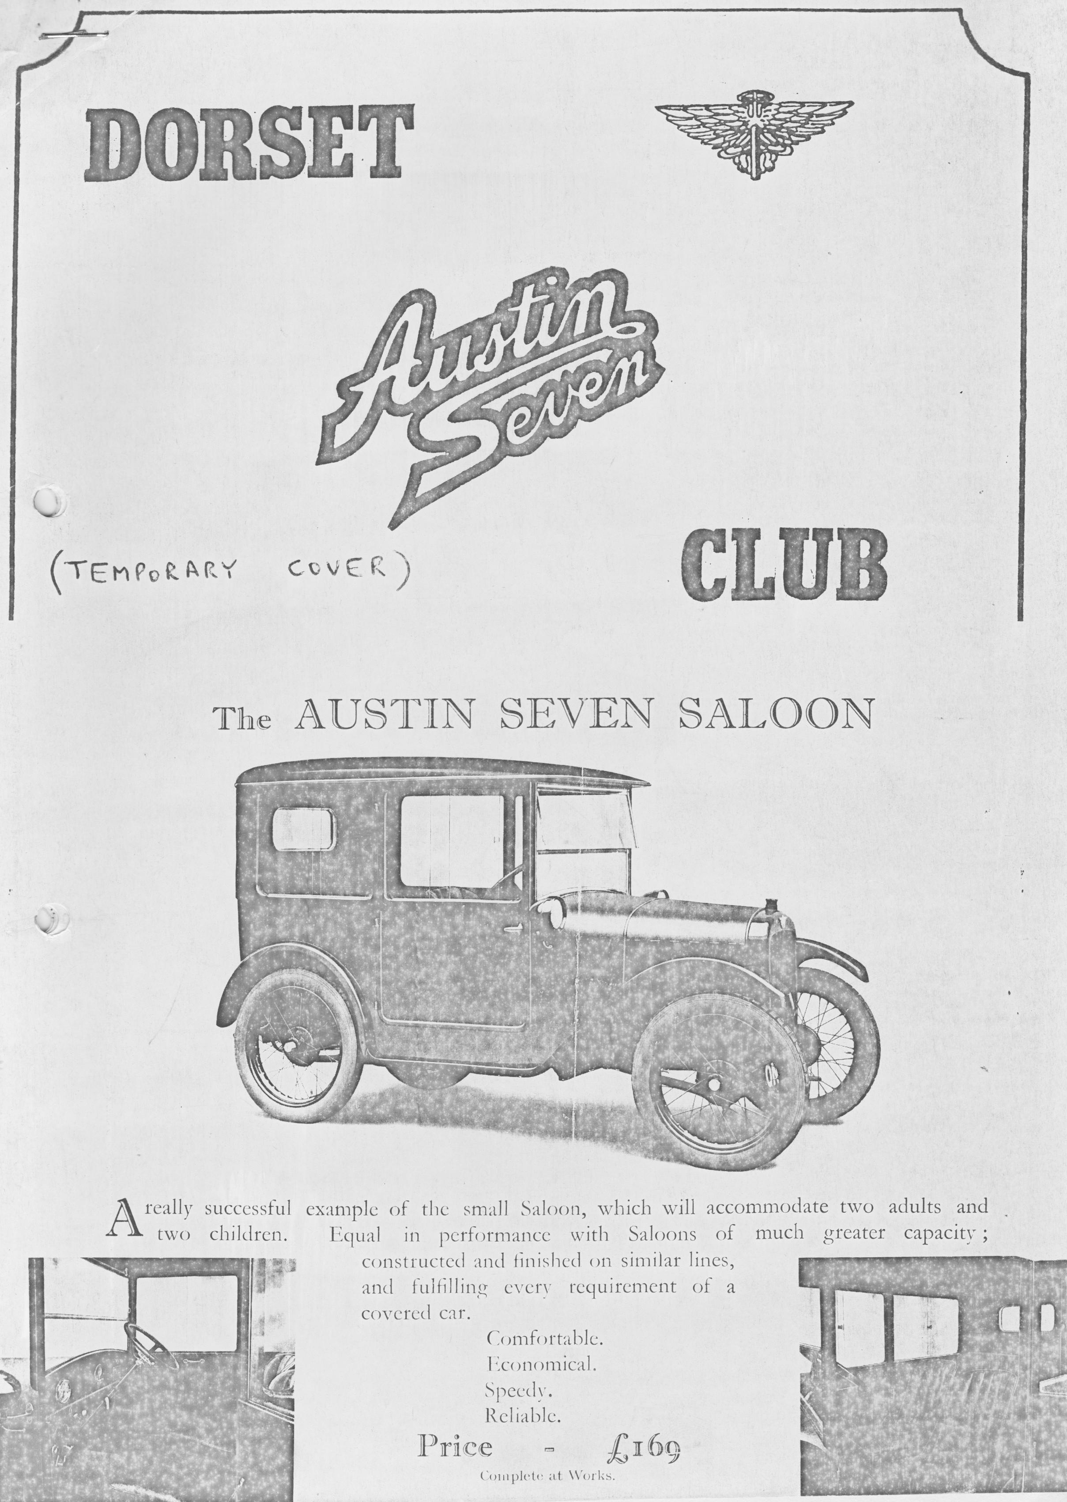

DORSET AUSTIN SEVEN CLUB NEWSLETTER - AUGUST 1982

EDITORIAL
Hi there, aren't we having a marvellous summer, long hot days, plenty of sunshine. Ideal rally and Sevening weather.
The Diamond Jubilee year is fast coming to its climax with the great Longbridge rally only days away. I hope you got your booking made because, if not, I think you will now be too late.
We have been enjoying our newly re-organized garden, but it seems to me that instead of sitting in it, I should be finding some job or another to do.
Can I remind you all that I need details of your car which you should fill in on the form supplied with the June newsletter, this is needed for the A7CA registrar. Will you please dig it out and send it to me as soon as possible?
Come on, out there, let’s have your input.
Yours in the garden,
George

Copy date for September Newsletter August 31st.

MEMBERSHIP REPORT
We are currently 69 strong and we are very pleased to welcome two new members!
Mr. & Mrs. Ted Coates, 33 Verona avenue, Southbourne. Telephone! B'mth 432059
Ted has a 1931 Tourer in the course of rebuild.

Dusty & Jane Whibley, 1166 Ringwood Road, Bear Cross, Bournemouth BH11 9LG Telephone; N'Bourne 5167
Dusty and Jane have just bought Bernard Cowley’s early SWB box. We hope they both enjoy the club.

AUSTIN SEVEN GOLDEN JUBILEE 1972
Preparing for the Diamond Jubilee celebrations set my mind thinking back to the Golden Jubilee Rally in August 1972. I had completed. restoration on my 1931 R.N. Saloon that summer and apart from a couple of local steam rallies, this was to be my first major A.7 rally.
Bernie Cowley and I were at the time both members of the W.V.P.C. (no DA7C then) and decided to travel up to the rally together. We met at Willoughby Hedge. I travelled with my girlfriend of the time and Bernie took as a passenger a friend. of mine, Simon, who was a student in Birmingham and wanted a lift up.
Bernie was a seasoned A.7 driver and I was very much the novice. I had a job to keep up with him as I didn't realise a Seven could go so fast. Bernie hasn't changed much, and I've improved! Bernie's Box saloon must have been a bit noisy, as travelling behind him, I had the perfect view of the back of Simon's head with a tuft of cotton wood sticking out of each ear.
The only mishap on the journey up that I can recall occurred when Bernie shot off at speed to the left. I wound the window down quickly to make a hand signal and the winding gear jumped from the guide and the glass fell to the bottom of the door. A quick repair job on the side of the road soon had the window fixed and we were off again. . .
We arrived at the campsite at Cofton Park, opposite the Longbridge works on the Saturday evening. We had decided not to attend the dinner that evening and instead went off to a local pub.
The static rally was held on the Sunday in the works, outside the Mini line. The cars were lined up in chassis order, the earliest being a 1923 Chummy owned by the Birmingham Transport Museum and the latest a 1939 Ruby. The programme contained 567 cars.
There was an excellent exhibition in one of the halls containing various A7 parts, an extensive display of A7 wheels and sketches and drawings by Stanley Edge and Sir Herbert Austin. We were also able to visit Sir Herbert's office which is still preserved in the works.
On Monday, we headed for home. Unfortunately, this meant that we missed the drive around Birmingham. There were no troubles on the return journey until we reached Frome (by then we were three up) when the main leaf in the rear spring snapped with a loud bang. However, careful driving ensured that we reached home with no further problems.
Richard Cressey

JOHN COLEMANS EVENING .
The evening at the Nook and Cranny with John Coleman was absolutely great. It was a pleasure to meet and talk to a man with such an achievement to talk about and remember.
The catering was excellent, and after the meal John enthralled his audience with an abbreviated account of his journey.
When you consider what was achieved and when you see the car, (the car was on show) it is barely believable that it was possible. Such a small car for such a mighty task. No wonder Austin Sevens were often referred to as the Mighty Atom.
If you haven't read the book get hold of it, such excellent reading.
I was enjoying myself so much I kept interrupting, sorry if I didn't let you get a word in edgeways. A terrific evening!
We had magnificent support from both Solent and Bristol club members who came along to make up the numbers. Our thanks to them and to Gary for arranging this marvellous event!
George & Joy

JULY MEETING
At the July meeting we had an informal concours and the results are listed overleaf. The names are left out to protect the innocent, but I am sure you will guess who owns most of the cars!
-
Best Boat - GX 4631
Best Angled Headlight - OW 3654
Shiniest Morris - EYF 210
Best Crackle Paint - FDH 275
Morris 8 Award - JD 5627
Best Clothes Peg - ARY 803
Best Unoriginal Saloon (back to front doors) –OW 221
Most Under-Polished Brass Handle and Unoriginal No. Plate Award - WL 1133
Custom Car of the Year Award - HA 9643
Best Mazda. - FK 2666
Most Original Spare Tyre Award - OP 4345
Best Biggest A7 Award - LJ 5892
Flattest Tyre Award - JT 3433
Most Underused Car Award - CMK 201 .
2nd Best Used Spare Award - DR 9605

The results are listed in the order as judged and are not in order of importance, Oh! and please note the number of cars! How many clubs get that amount of support?
.
EVENTS CALENDAR
19th AUGUST Club Night, Dormers. Guest Speaker.
22nd AUGUST Cricket Match and Sporting afternoon with Solent Club. Meet at the Alice Lisle pub at 1 pm for lunch to be followed by a 'very limited over' match.
Volunteers required for the team please ring Gary and we need some cricket gear, somebody out there must have some! Bat, Ball, Wickets, Shin Pads. Please ring Gary and tell him what you have got to lend for the afternoon. Thanks.
26th AUGUST Committee Meeting, Tyrells Ford, Avon.
27th AUGUST Longbridge Rally Notes:
11 am first group depart from Ringwood Market for Longbridge. 6.30 pm second group depart from Ringwood market for Longbridge.
*28th AUGUST 10 am Third group depart from Ringwood market for Longbridge.
We believe there will be people wanting to travel in groups and there should be somebody going on the journey on each of these three suggested times. If you want, to travel in company then please be at Ringwood cattle market at the times shown. There is no activity on the Saturday 28th August in the Longbridge programme but those members who are there from Saturday morning will be having a run during the day which will make a pleasant run up to the rally which starts on Sunday.
29th/30th AUGUST Longbridge Rally
16th SEPTEMBER Club Night, Dormers. Activity to be finalized but possible film night.
19th SEPTEMBER Club run to Bath. Depart Wimborne Square 10.30am,
23rd SEPTEMBER Committee meeting Tyrells Ford, Avon.

*Longbridge Rally
Will you all please note: The club have got a stall in the autojumble so if you have something you want to sell will you bring it with you and get it along to Bernard Cowley at the stall on the opening morning. Please label it clearly with your name and the price you want. Deduction of 10% will be made as a contribution to the cost of the stall, any profit to club funds.

AN EVENING WITH JOHN COLEMAN
One day, on his way home from work, Gary Munn happened to stop at a garage for petrol that he did not usually patronize. While talking to the attendant about the car, the man remarked that he knew someone who had crossed the Andes in an Austin 7.
Having just read 'Colemans Drive' Gary immediately pricked up his little pointed ears, and discovered that the attendant did indeed know John Coleman. Gary managed to obtain an approximate address from him and wrote a letter to John Coleman straight away.
After a. short while Gary received a reply from John, stating that he would be delighted to give the club an illustrated talk about his trip from Buenos Aires to New York, and suggested that we might like to book the restaurant that he owns, though does not run himself, for dinner and he would show us his slides of the trip afterwards.
After some discussion with the committee, the evening of Friday 16th July was suggested and John readily agreed. It was decided to invite our friends from the Solent and Bristol clubs so that we could really fill the restaurant.
Finally, the evening arrived and we trundled over to Warsash, on the other side of Southampton in the Sevens to the Nook & Cranny Restaurant. Parked outside was the 1925 Chummy which had carried John on his marathon. John has kept the car just as it returned from New York even down to the trunk on the back seat, and the machete for hacking through the jungle.
John Coleman joined us outside where we discussed the cars and signed copies of his book, Coleman's Drive. The bar was open, and we sipped pints and chatted until everyone had arrived, whereupon we sat down to a splendid roast dinner copiously washed down with wine.
After the meal, we all topped up our glasses and adjourned to another room where our host showed us his slides and recounted stories of the places he had visited and the people he had met, only occasionally interrupted by our projectionist, Chucklebum Mooney, with a joke or a question.
We were all astonished to learn that the car was still sitting on the same tyres that had covered the whole journey and there was tread on them. Equally surprising was that the car had not had any major engine work over the whole trip (amazing when you think that Gary has to do a rebuild every 5,000 miles). The only real problem with the car was the magneto, which was temperamental over the whole trip.
John said that his main worries in South America were snakes, wild animals and bandits.
But for all these obstacles John arrived safely in New York to a terrific welcome. A marathon trip indeed. Thanks to John Coleman and to the restauranteurs for a super evening and a big thank you to Gary for organising a memorable occasion.
Glyn.

IT PAYS TO USE YOUR AUSTIN SEVEN
Having parked the Box in one of our local car parks, I took our dog Tufty for a walk and when I returned to the car, the inevitable gentleman approached and said the usual thing, that “I had one of
these, bought it for £5 in 19... whatever, I wish I still had it now, that must be worth a bomb". He went on to say that he still had an original rear light in his garage and that I was welcome to have it. So back we went to his house whereupon he produced this little gem. So, you see, it pays to use your Austin. You never know, someone might give me a Chummy one day.
Pat Llewellyn

CHAIRMAN’S CHAT
Well, it’s happened at last, Debbie and Martin have become engaged. So that's what he was doing at the Berkeley Castle Rally, swotting up on Austin Sevens to impress the future father-in-law, eh?
They are going to get married about next April to give me time to save up. I must get a bit of advice from George about this.
It was a good night out at the Nook & Cranny restaurant to hear John Coleman talk and to see his slides. It was also very pleasant to see old friends from the Solent and the Bristol clubs, thanks a lot for coming along, chaps. Also, a big thank you to Gary for organising the evening and making it so enjoyable.
Don’t forget Longbridge over the August Bank Hol. It should be a marvellous do this year.
Also, don't forget to support the joint meeting with the Solent club on Sunday 22nd of this month. Meet 1 pm at the Alice Lisle for an inter-club Cricket match. Bring your rattles, trumpets, bells, etc. but please only throw rotten fruit at the opposing-side!
Derek

SALES/WANTS/SERVICES
FOR SALE - 1937 Rover 16 Tatty but easily restorable. Stored at Newton Abbott £300. Tel Mark Rosenthal Ringwood 3101
********
MUNWELLYNS AUSTIN 7 MECHANICAL RESTORATION AND REPAIRS
TEL: NEW MILTON 613080 OR RINGWOOD 78795
*********
CLUB TEE SHIRTS & SWEAT-SHIRTS
An order will be made for a new batch of T-shirts and sweat shirts. Details of these appear below. -PLEASE ENSURE THAT YOUR ORDER IS PLACED BEFORE 31st AUGUST.
Cash or cheque made payable to 'Dorset Austin Seven Club' please - with order. Either give to Phil Witter on club night or post to him a 134 Northfield Road, Poulner, Ringwood, Hants BH24 IMPORTANT last order of these items for at least six months. Please ensure you specify whether you want large or small club motif and don't forget the colour! (No items can be changed unless faulty).
PRICES
T-Shirt Child £1.75p
T-Shirt Adult £2.25p
Sweat Shirt Child £3.75p
Sweat Shirt Adult £4..75p Ex.Large £5.00
T-SHIRT COLOURS White, Red, Light Blue, Yellow, Black; Navy, Green
SIZES: ADULTS Small Medium Large Ex.Large
34 36 38-40 42-44
CHILDREN'S: 24" 26" 28" 30" 32"
When sizing Sweatshirts please remember that they are often worn over other garments.
SWEATSHIRT COLOURS: Sky, Navy, Royal Blue, Grey, Green, Wine, Red, Wheat, White, Yellow, Black, Denim Blue.
LARGE OR SMALL CLUB MOTIF

TECHNIC-L TIPS
Ruby Petrol Filler Rubber
Is your petrol pipe into the tank blocked by a tatty, leaking original filler rubber? These unobtainable items cause lots of problems and can be extremely difficult to replace. The filler rubber from an early Datsun 1200 or 1300 saloon will fit perfectly - just cut off the angled piece to the right length and you have a replacement which I found I was able to fit in half an hour providing you can fiddle it in place from underneath and through the boot lid.

Gudgeon Pin Clamp Bolts
Probably the worst disaster that can happen on your engine is to have a gudgeon pin clamp bolt work loose and come out. On its way out, it will probably bend the con rod, score the bore and break the piston. It will drop on the gauze filter, be picked up by the crankshaft and smash a star like crack in the side of the crankcase. The answer to this is not to use locking tabs but to ensure that you have new high tensile bolts fitted with spring washers and do them up really tight using 'Loctite' etc. on perfectly clean threads. (P.S. we have them in the club spares!)

Engine Cutting Out At High Revs.
I noticed that for some weeks my car had been cutting out and losing power at high revs. Closer inspection revealed small amounts of brass dust in the distributor caused by the rotor arm being loose on its peg. Changed the rotor arm and no more problems.

Fire Risk
I have twice had starter switches (ruby type) catch fire because dirt trapped inside them combined with oil (starter is just below the filler cap) has caused an internal short circuit. Check yours by flicking the switch lever backwards and forwards and sideways to see if it sparks. To rectify any problems dismantle and clean.
Phil Whitter

NEWS SNIPPETS
Hilary saw a Punk Rocker in Mainstop car park taking a photo of George and Joy's pink Box. (Shows the sort of people attracted by Pink Boxes!!)
Brent Dillard and Richard Cressey are working non-stop to have Richards Pearl ready for Longbridge, but have been dogged by distorted head and block.
Well folks, that’s it for another month. Hope you all have a great summer holiday and that you really enjoy Longbridge.
See you at Longbridge or club night.
George

