August 1977
DORSET AUSTIN 7 CLUB

SECRETARIAL Longleat Rally is with us again but by the time you have read this it will be over. This year I am taking both my cars - one on a trailer (thanks to Peter Treliving). We seem to have a few entries for Wimborne Air Show on the 21st. If you have not entered please try to make it - you can enter on the day if you wish. Remember your entry will help Club funds. Last month’s meeting included a run to Fordingbridge. It was nice to see a few 'Sevens' on the road - unfortunately the "Albany" did not stay open after hours! There were a couple of good local events last month for 7 owners. Firstly, the Netley Marsh Rally which was only spoilt by a few showers and secondly, a Summer run organised by the DA7C to Hardy's Cottage at Bockhampton. The turnout for this run was low - where are all the stalwart '7' owners? I won't think the date clashed with any other rallies. Report below.
Next Clubnight 13tn August. Road run to the Alice Lyle, Linford. There will be a short meeting in the room to the left of the bar before we leave.

Forthcoming events
August 21st Wimborne Air Show (see above)
August 27/28/29th Corfe Castle Old Tyme Fair. We have been invited
to attend. Please contact Mrs. P Sherwood, Corfe Castle 594 if you wish to enter.
August 28th Hawkhurst A7 Rally. 750 MC. Closing date 20/8/77. Entries
to I. Thomas, West Point House, Cross in Hand, Heathfield,Sussex.
August 28th - Vintage Car Display, Sherborne School Quadrangle at 2 pm
Entries accepted on the day.
August 29th - Littlewick Show A7 Rally, Peens Farm, Littlewick (on A4)
Entries accepted on the day.

For Sale
Two 19" wheels chrome centres, one good tyre £5 the pair - B. Cowley
(if not sold at Longleat)

Report on run to Hardy's Cottage_by Elizabeth Wragg.

At 11 o' clock on the last day in July four Austin sevens and one Eight
met in Wimborne Square for a road run. There was Bernard and part of his family in their Box, Gary Munn and Dad in his box, Vic Steel in his Opel, John Page in his Mulliner and Mike Wragg and his family in the Austin Eight. Then following on behind was Jackie with the rest of the Cowley family in a Mini Traveller.
We all set off and travelled via all the back roads & country lanes to Blandford then on down to Wareham where we all descended on the Silent Woman. We had our picnic lunches and a few pints in the pub garden before setting of again. This time we had lost John who had to go back home but had gained Nigel Ricardo in his Tourer. We then drove on to Thomas Hardy's Cottage where we had a walk round though no-one went in to look round as they were all saving their pennies for their cream teas which we had a few miles down the road in a tea rooms at Bockhampton. I think every one enjoyed their day out in the sunshine very much, covering approx. 65 miles on the journey.

MARCH—APRIL
67
AUSTIN SEVEN—Continued.

With the first type of bolted on torque tube, and the screwed-in type which superseded it, to remove the bevel pinion from the torque tube, first knock back the lock-washer and remove the nut holding the bevel pinion flange on to the taper on the end of the pinion shaft. Pull off the flange with the special extractor and then drive out the key from the keyway. The pinion may now be driven out of the tube by tapping the taper end of the shaft with a hide hammer.
In the case of the latest type of tube, there are two dual purpose bearings at the bottom end, which are held in position by a ring nut, which also acts as a distance piece. Before the bevel pinion can be removed, this nut must be unscrewed from the end of the tube, and then the pinion may be driven out, as with the other types.
When fitting a new bevel pinion to any but the latest type of torque tube, first remove the bearings from the old pinion and examine them for wear. If they are found to be in good condition, refit them into the tube; if not, new ones must be fitted. In either case, make sure that the bearings are bedding down properly on to their seatings when fitted into the tube.
Now fit the pinion, carefully driving it into position with a hide hammer — nothing else.
Insert the key into the keyway at the end of the shaft and fit the pinion flange on to the taper, making sure that both the taper on the shaft and that in the flange are perfectly clean before assembly.
Fit the flange nut, tighten it down and lock over the lock-washer.
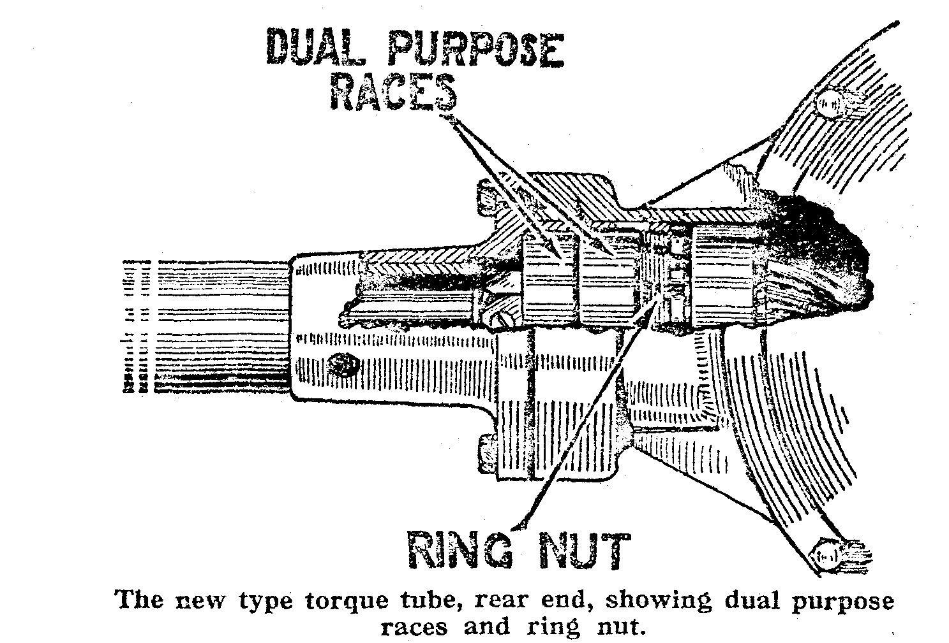
It will now be found necessary to adjust the pinion for end play in the tube. To do this, tighten down the adjusting nut as far as it will go towards the rear end of the tube, and then bring it back half a turn. This will give the correct amount of end play. Tighten down the locknut and bend over the tangs of the lockwasher.
In the case of the latest type of torque tube, i.e. that with the dual purpose bearings at the rear end, the process is somewhat different.
Transfer the races on to the new pinion, or fit new ones if necessary, and tighten down the nut which fits on to the thread on the pinion shaft. Lock the nut in position with the lock-washer, or in the case of a few of the earliest of this type, with the setscrew let into one of the faces of the nut.

