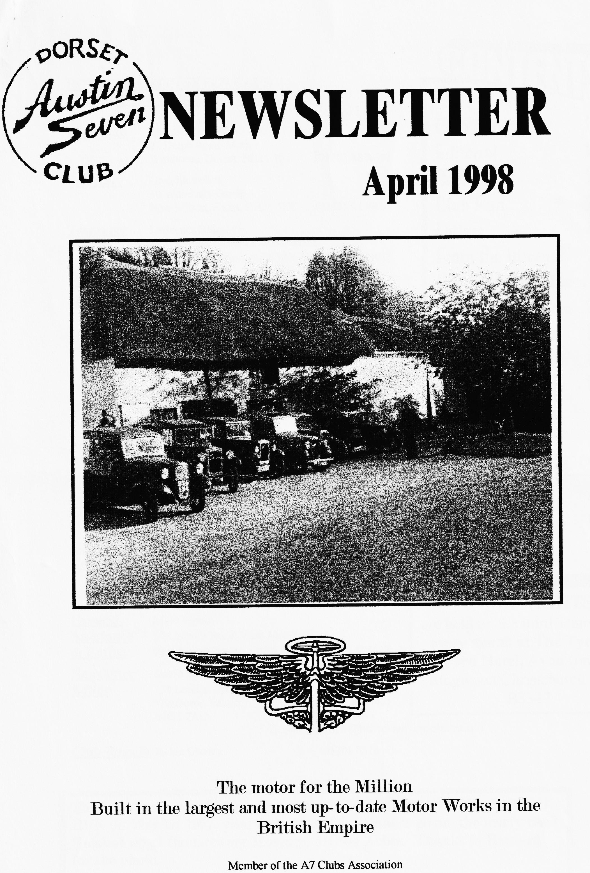

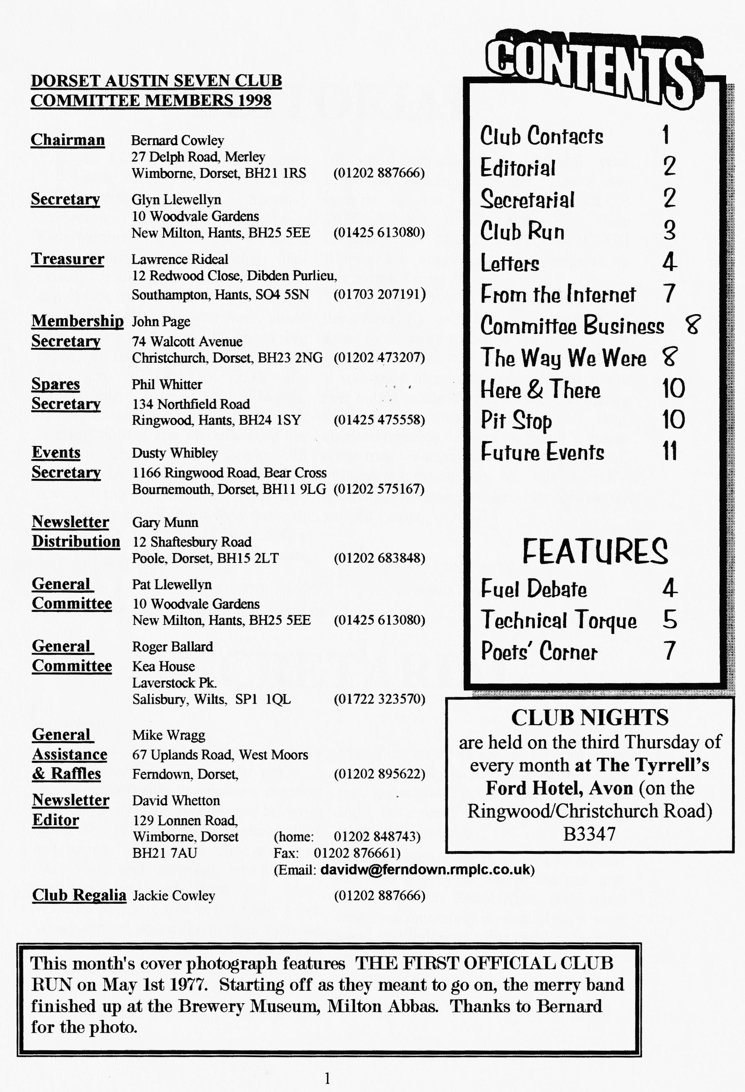

EDITORIAL

The FUEL DEBATE continues with an article Peter Trebilco spotted in the Saturday
Telegraph. I rang the columnist Peter Lorimer — at home and we had a long, interesting chat (rather one-one-sided!) concluding that, with the experience from USA, NZ etc., that for our cars there's nothing to worry about and, certainly, nothing to spend big money on replacing valve seats. And I've got a LETTER (Oh joy unbounded), from Alf Edwards, coming to the same conclusion. . The opening night at The Tyrrell's Ford has been recorded for posterity in POETRY by the Fatt family — Suzie's now got the rhyming bug! Now that the Summer Run Reports have come to an end, it's the time of year for a TECHNICAL ARTICLE and we start
off with instructions to overhaul your Pneumatic Windscreen Wiper. Looks easy enough to me but read the CLUB DISCLAIMER. The Way We Were describes the FIRST OFFICIAL CLUB RUN and a picture to prove it appears on this month's front cover.
The EVENTS PAGE has some interesting departures (!) including two changes of dates for Sunday runs and the return of an EVENING RUN.
It was good to see old man Weaver at the first outing at the Tyrrell's Ford and thanks to everyone who let me pinch their cherished photos. It was an Editor's dream come true — a room full of nostalgia. And, of course, thanks to all this month's contributors without whom our Newsletter wouldn't exist.
David.

Deadline for the next issue is 24/4/98. Please send material to me by post, fax or mail or pass it over at Clubnight.
SECRETARIAL

HI GANG
Our first club meeting at the Tyrrell's Ford was, I am pleased to report, a great success thanks to members entering into the spirit of the evening and bringing along their photographs of bygone rallies and events. There were photographs of Gary Munn with curly hair Jane Whibley with red hair and Scott and Mark Whibley in short trousers! Even Mike Wragg looked young (he is older than me you know) but, seriously, many thanks to everyone who helped make our first club night at the new venue a great success.
March also found us on Dusty's annual
Mud Run, an event looked forward to by most, feared by some, but enjoyed by all and, guess what, not a dollop of mud in sight, but a really super day ending up at a very different pub.
On April club night there will be a short talk and display of Motor Badges, and emblems, old Petrol tins and other motoring memorabilia, should be a very good, and lighter evenings will be with us too.
That's all from me, see you club night

GLYN
DUSTY'S NOT THE MUD RUN
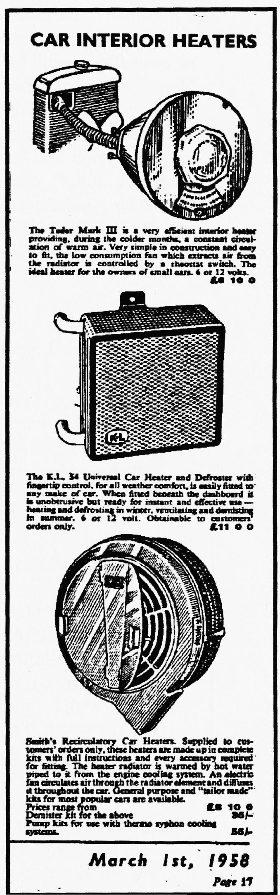
22nd. March 1998

Ten sevens, one heavy twelve and Marc and Mandy in their modern arrived at The Viewpoint Parkstone for NOT THE MUD RUN with an optional treasure hunt thrown in for good measure. Ben and Marion turned up in their modern to wave us off. The idea for this month's run was to follow a map with arrowed route, leaving in one's own time winding in and around the Purbecks lanes and hills. Unfortunately, there had been a landslip on the ridge road which caused panic in the planning department so a last minute rerouting was drawn on each of the 16 photocopies, using much midnight oil.
Jane and I were the last to leave but caught Phil and Hilary on the ferry to Studland. When they stopped to gather treasure, we ambled on catching Chris Biggins going into Swanage doing both driving and navigating plus gathering treasure.
We carried on alone winding back and forth over the Swanage railway meeting George and Joy and Cambridge coming the opposite direction. I politely pointed out that their bonnet was pointing in the wrong direction but after another mile realised it was me that was going wrong. So much for my own map! On arrival at the pre-arranged Corfe coffee stop we met Glyn, Pat, John and
Cynthia who were just leaving for the next leg. We decided we would go ahead by way of Steeple and Kimmeridge, back through Corfe and Kingston to the Square and Compass at Worth Matravers to arrange parking in front of the pub with wonderful views of the hills rolling down to the sea.
After much thought and checking of bounty which included various nickers, underpants and a bra (all empty!), the prize was awarded to CHRIS BIGGINS for his loan effort.
Some of the braver ventured into the quarries cut 100 ft. deep into the base of the cliff supported by but a few remaining stone props - brave men indeed! Back up the cliff and across the hills to our afternoon tea and cake stop where we nattered until the sun sunk over the roof tops and made known it was the end of another Dorset Austin Seven Club Run that hadn't turned out at all bad after all. (Plus, we bought a dozen fresh duck eggs on the way home for tea.)
See ya soon, Dusty
Wot no Mud ? but thanks to Dusty not only for writing up his own account but for all the extra preparation that a route map entails.
Well done that man! - Ed

FUEL DEBATE UPDATE

PETER TREBILCO sent me a copy of the Daily Telegraph Motoring Section for 24/1/98:
"The lead content of four-star has already been reduced, and where cars are used primarily for short journeys, where the engine speed rarely exceeds 3,000 rpm and where they rarely even heat up enough for the thermostats to open, the valve seats simply will not reach high enough temperatures for recession to occur. In any case, valve-seat recession is a slow process. It took a Dutch reader 100,000 kilometres to burn out the valves of his cast-iron-headed V6 Granada running on LPG with no cylinder head modifications. What if you don't want to restrict your driving to low revs, and either your engine can't he converted or
you don't want to stump up the money? You need a fuel additive that prevents valve seat recession as used by millions of old-car buffs in the US, Japan, Australia and New Zealand. There was a question mark over whether sulphur-based VSRP fuel additives, effective in these low sulphur petrol countries, would work with Europe's higher-sulphur petrol. But STP has done an enormous amount of research on this and has come up with what it describes as a "much superior" VSRP additive formulation, which is neither sulphur- nor heavy metal-based and is likely to become the standard throughout Europe."
Thanks for that, Peter - it confirms the "don't panic" advice - Ed.

Dear David,
With the debate about leaded petrol in mind I thought that I would try to find out some facts.
Hardened valve seats are not needed for ORIGINAL blocks, but should the seats have been replaced then hardened inserts will have to be used together with STAINLESS STEEL VALVES as there could be an electrolytic effect between the two dissimilar metals. As to ADDITIVES, the lead is replaced by a carbon compound which coats the valve seats. Unfortunately, it also coats the spark plug insulators leading to shorting. There is another additive employing a CATALYST - I am told from a reliable source that you would be better off buying a string of worry-beads as there is no scientific basis to it at all. In New Zealand, where there has been no leaded petrol for years, the additions have been shown to be useless.
To sum up, using un-leaded fuel in original blocks is perfectly safe — the only drawback being more frequent de-cokes. One very good tip, if you are still not happy about the possible effects of un-leaded fuel is to set up the tappets and re-check carefully for any wear after 500 and 1000 miles. I know of two people-who have been using un-leaded-in their Sevens for over ten years. However, I'll still be doing the tappets check in the Pearl and I'll let everyone know how I get on.

The Pneumatic Windscreen Wiper

This article was first published in the Magazine of The Vintage Austin Register written by Jim Stringer

The automatic windscreen wiper was first introduced onto Austin Motor vehicles in the October of 1924. The device was manufactured by Joseph Lucas of Birmingham and was operated by the vacuum created via the inlet stoke of the engine carried through a length of small-bore tube connected to the inlet manifold.
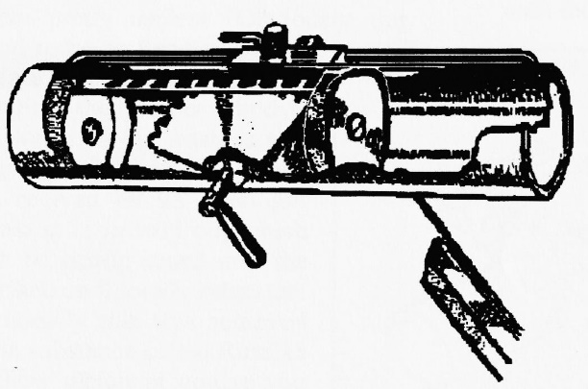
The device is operated by first unscrewing the suction control screw this allows the air which is in one of the cylinders to be withdrawn, the resultant suction moves the rack which operates the wiper arm via the sector wheel or pinion. When the rack reaches the end of its travel a slide valve is tipped, and the air is sucked from the opposite cylinder and the rack returns. The space between the two leather washers is always maintained at atmospheric pressure (otherwise the thing wouldn't move!)
A small lever is provided to allow the device to be operated by hand whenever there is insufficient vacuum to operate it mechanically. Although the device worked quite well, it did have a couple of drawbacks. One, the dropping of the wiper arm directly in front of the drivers line of vision when it was switched off. This was subsequently rectified in 1930 when a special valve mechanism operated by a small slide situated behind the adjusting screw was introduced. The other draw back concerned the inability of the motor to operate at full efficiency when the engine was being accelerated and the amount of vacuum was significantly reduced perhaps this may have been viewed as a good deterrent against driving too fast in the rain!
It is of course a requirement for the MOT that, if fitted, the wiper motor must work. If it doesn't -take it off if you have a car with a split screen which will give you adequate forward vision, for later cars such as the Box or Ruby models, this won't apply.
Generally speaking, there is very little to go wrong with a vacuum wiper and they seldom give trouble. A small hole is provided (in the most inaccessible position) on the top of the unit for the

occasional few drops of oil. How often, I wonder, does this hole ever get used?
If your wiper does ever fail, it is a simple matter to remove it and strip it down to its component parts to effect a repair.
To remove the unit, first take off the wiper blade which is secured by a collet type hexagonal screw. Once removed, two smaller screws will be revealed which actually hold the unit onto the screen. Finally, remove the rubber tube which is connected to a pipe at the top of the unit.
Once stripped, clean all the bits carefully in clean paraffin using a cheap artist’s paint brush. If your unit has not received any attention for several years, the chances are that the washers will be dry and hard, making them pretty useless (Obviously they need to be soft and supple to create the best seal possible within the wiper body). However, if the washers still appear to be 'sound' they can be revived by an overnight soaking in linseed oil, which can be gently eased into the surface until totally saturated. Originally this was achieved by a substance called Russian Tallow which of course you could still use If you could find any
If the 1³/₈ inch washers are beyond redemption you may be able to obtain replacements from a hardware shop. If you have to fit new washers carefully remove the rivets holding them and then carefully rivet the new ones in their place. If riveting causes a problem, you could use small nuts and bolts, but remember that any small
protrusions will interfere with the smooth operation of the unit. Thoroughly inspect all components for wear and tear. Other than the washers, the only bar to the unit behaving satisfactorily will probably be accumulated dirt and congealed grease, or more likely, a perished rubber hose to the inlet manifold (which can be supplied by John Barlow and The Seven Workshop amongst others)
Check that the slide valve operates smoothly and that the pipe connections are free from any blockages. Check that the teeth on the 'pinion' mesh smoothly with the slots on the 'rack' and that the shaft onto which the arm is located is not bent.
When you are satisfied that all are in good working order, grease the two halves of the barrel with a thin smear of Vaseline and check that the 'rack' with the washers attached runs through them smoothly but with a slight resistance.
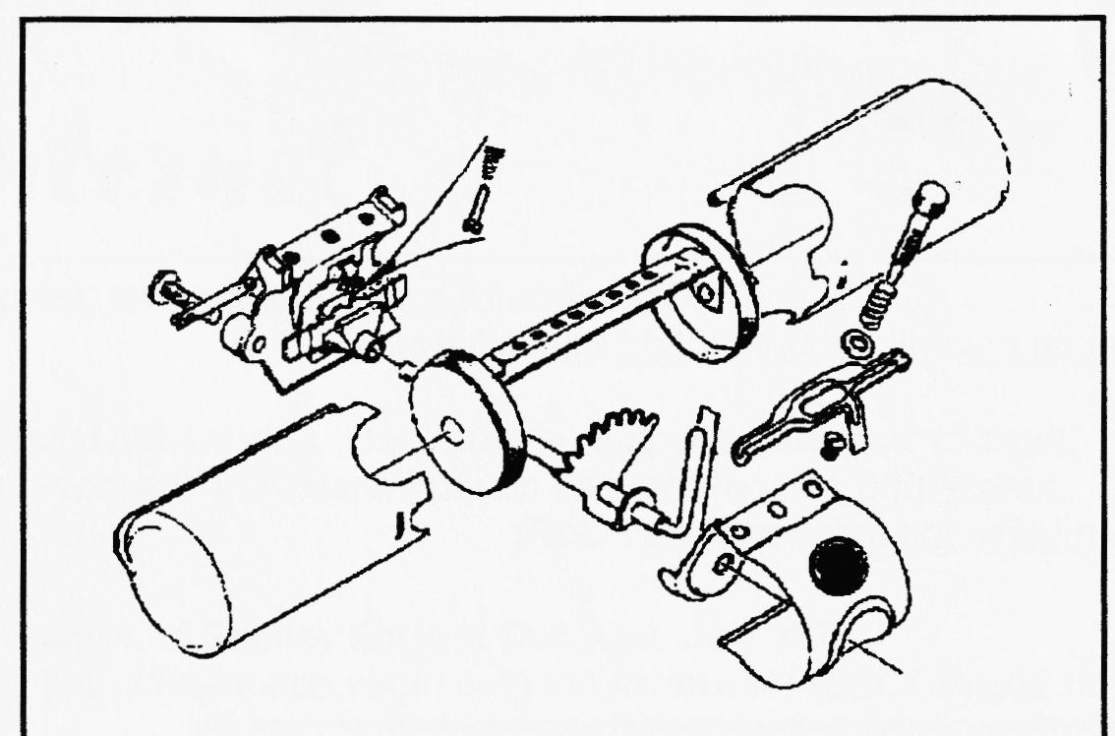
Reassembly is the reverse of the stripping down procedure - so it will pay you to make a note of how you took it apart! Refit the motor to the screen and reconnect to the tubing from the manifold, and - Hey Presto!

The Ballad of Tyrrell’s Ford
Our meeting at a venue new Photos all seen and dismissed to the full;
Brought excitement all around. Everyone anxious and hoping –
A "Quiet. Please" call came about.
Will this be The Chairman’s lime to speak
The brand new stomping ground? We all knew
Wont he didn't ward to shout.
All expectations seemed fulfilled
with more chatter than ever before. Bernard asked if we liked the room
But, perhaps that is due “Yes” we harmoniously roared
To the theme of the eve - With a few light changes_ -
Photos by the score. a chair here or there -
To one side a table set It's hooray, for the Tyrrell's Ford
For the pictures old and new. Suzie Fatt
They. bought some nostalgia
That's fair to say Wow! and thanks Suzie for celebrating our move in verse
With everyone eager to view.

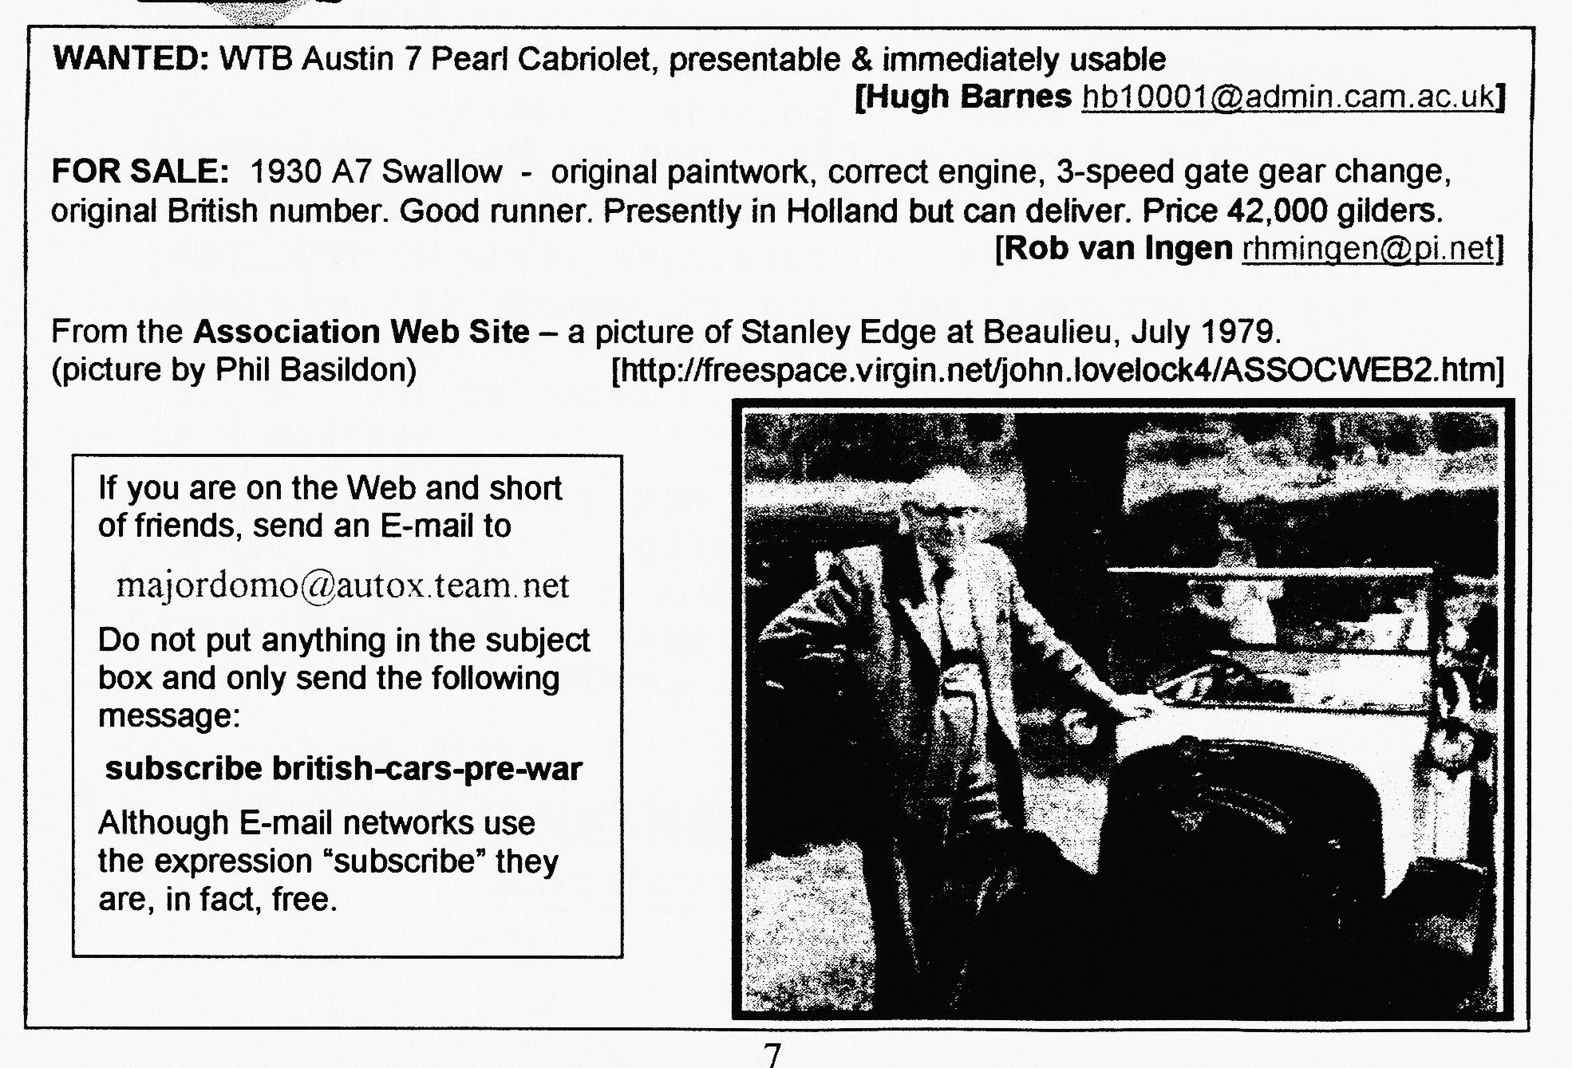
COMMITTEE BUSINESS
The Swanage Rally is filling up nicely and our own entry forms are with this Newsletter. Instead of coasters we will be receiving a free book about the Swanage Rally. MEMBERS ARE REMINDED THAT THIS WILL BE GLYN & PAT'S LAST YEAR AS ORGANISERS and it will be a golden opportunity for volunteers to shadow them before taking over in 1999. It was agreed to increase the raffle prizes from £20 to £30. Phil will be re-ordering some new 17" tyres for the spares stock.
THE WAY WE WERE - a blast from the past
From the Club magazine for April 1977
"There has been a lot of discussion in recent months about the running of the DA7C. To avoid certain difficulties with other clubs, we have decided not to over publicise ours. We believe that too many members may endanger the informality that exists. We have 33 members and welcome J Harris of Salisbury - one of his cars, a 1923 A7 has been on show at Beaulieu.
I have received details of the 10,000 mile record attempt by Chris Gould and the PWA7C. Eight drivers working in three-hour shifts had completed 4,147 miles at an average speed of 50 mph before the crankcase bolts sheared. However, they have broken the 1,000 km and 5,000 km records for Class 4, category 4, group 1 cars.
SPOTLIGHT ON PETER TRELIVING - Originally, Peter bought a '30 Chummy in bits for restoration but soon realised he wouldn't have an A7 to run around in. At last, he found a '30 Ruby which he renovated in 4 months!
FIRST OFFICIAL CLUB RUN - May 1st 10.45am Wimborne Square. Pub lunch followed by visit to Blue Pool. Details subject to revision on the day.
APRIL CLUB NIGHT - Nags Head, Ringwood followed by a run to the Red Shoot, Linwood."

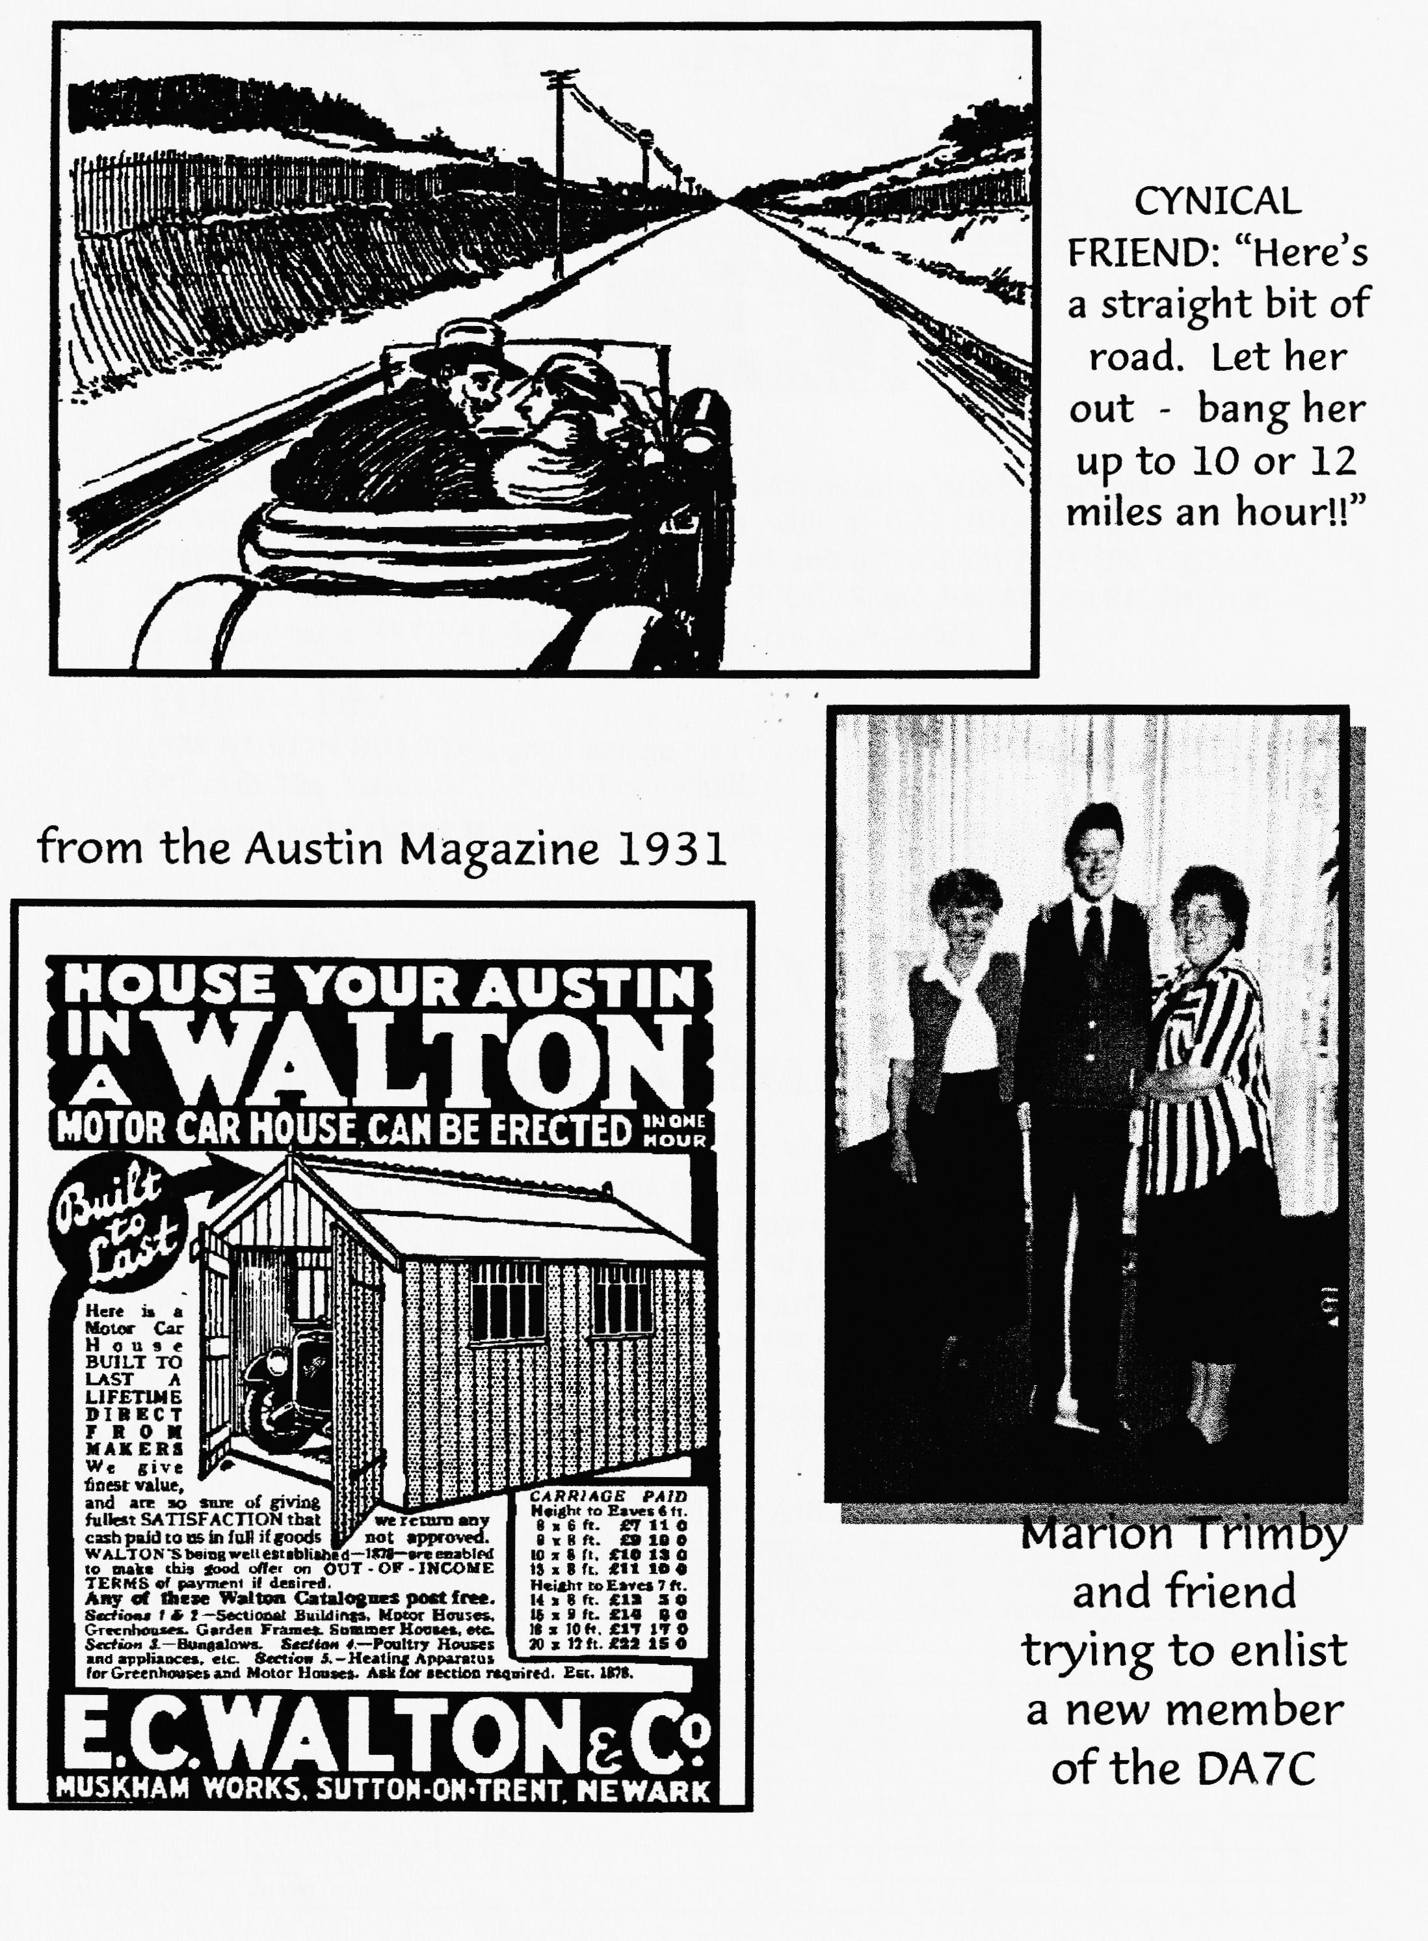

NEW MEMBERS
A big welcome to four (!) new members with an interesting bunch of Sevens: JEAN JAMES from Bournemouth comes with a 1937 BIG SEVEN, TONY THOMAS from Hythe has a '34 SPORTS 65 and a '36 RUBY, JOHN GLYDE from outer Bridport has a 1931 2-SEATER SPORTS and BRIAN PARKER from Bransgore has a '33 OPAL (must see these at Club Night — Ed)
FOR SALE
1938 AUSTIN BIG 7 Dry, good storage for 10 years, previously concours winner. Offers to Alan Mason 0121-7073649 (Solihull)
Self-standing FLOODLIGHT with 300W bulb - £18 See Phil at Club Night

DORSET BOYS AT MALLORY PARK
Vince Leek and David Whetton turned the first wheel of the season at Mallory Park on March 22". A bitterly cold morning practice left the Pits full of broken cars - our own Vince having to take off his head and replace the gasket over lunch in a vain attempt to cure a carburettor backfire. Vince had to retire in the afternoon race after having put up the fastest lap in Class B at an average speed of 72 mph but David improved on his last year's efforts under the power of a new engine coming third only 9 seconds behind number 2. Mallory is a very fast, sweeping circuit which doesn't really suit our cars and the boys are looking forward to the next round at Lydden Hill on April 25th.

00 CLUB DIARY 00
April
Thursday 16th April Club Night (TYRRELL'S FORD) Noggin 'n Natter with display of badges, emblems & mascots by Mike Sargent and Mike Topham. SPARES BY ARRANGEMENT ONLY
Saturday 18th April VSCC Italia Race Meeting Silverstone
Thursday 23rd April Committee Meeting Tyrrell's Ford 8.30 pm.
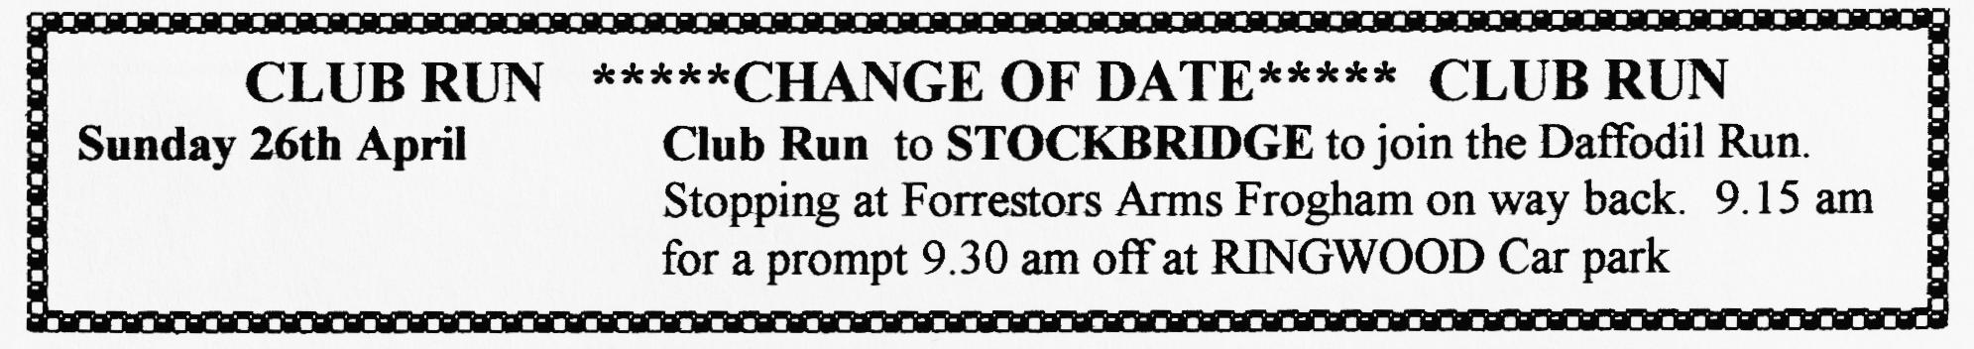
oo FUTURE EVENTS oo
Thursday 7th May 8 til Late BARLEY MOW, COLEHILL (Sketch map below)
Saturday 10th May VSCC Wiscombe Park Hill Climb, Devon
Sat/Sun 10/11th May Beaulieu Spring AutoJumble
Sunday 17th May Club Run (ANOTHER CHANGE OF DATE): Rally to Bath with picnic by the canal by John Page.
Thursday 21st May Club Night Talk on "4-speed thrust in a 3-speed 'box" by Phil Whitter (replacing quiz.)
Friday 29th May EVENING CLUB RUN to Corfe. Meet VIEWPOINT 6.45 pm for 7 pm off.
Sat/Sun 6/7th. June Coast to Coast '98 (details in March Newsletter)
Sunday 7th June South Hants Vintage Show & AutoJumble Petersfield -`phone 01705-613490
Sunday 7th June Motorcade 98 Baiter Park - forms from Glyn/Dusty
Saturday 13th June VSCC Hawthorn Trophy Race Silverstone
Fri/Sun 19/21th June Spye Park rally - booking forms later
Saturday 4th July VSCC Shelsley Walsh Hill Climb
Sun 5th July 750 Club Beaulieu Rally- booking forms later
Sat/Sun 11/12th July CLUB RALLY at Swanage _
VOLUNTEER ORGANISERS NEEDED FOR '99
Sat/Sun 5/6th. September Pennine Run (details in March Newsletter)
