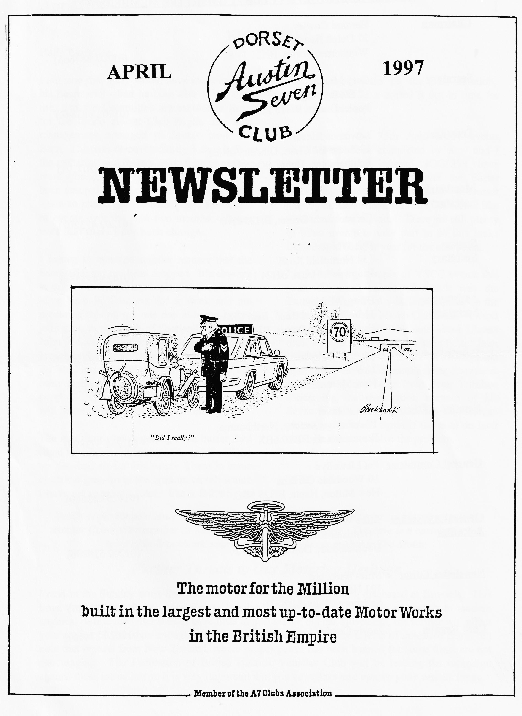

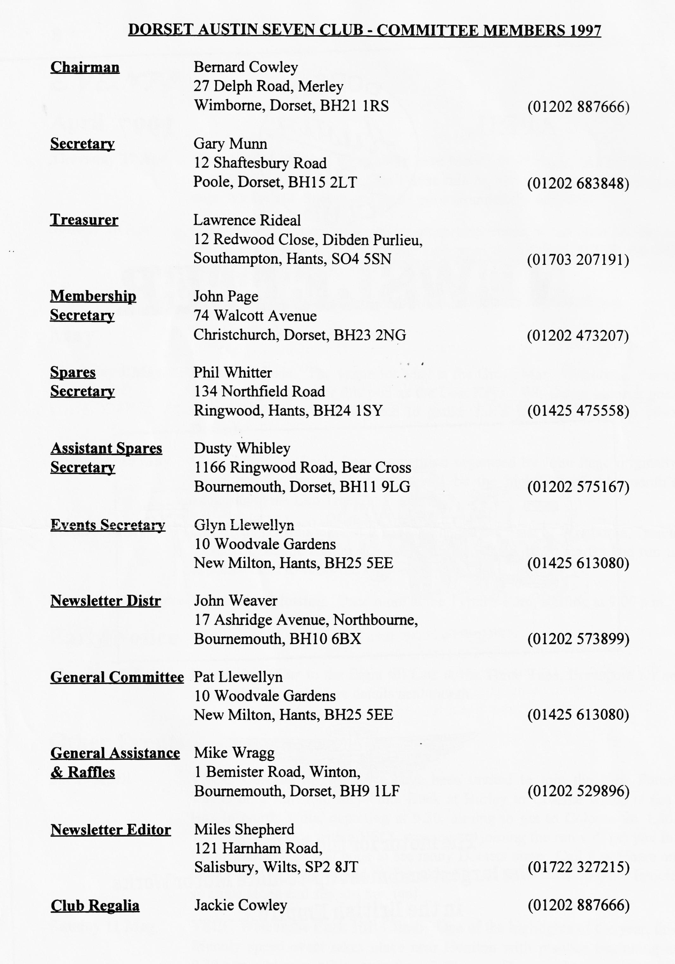

EDITORIAL
Hallo Everyone,
the electrics would be the best solution.. Hopefully, I'll have sorted it out in time for the events in May.
The first of the 75th Anniversary events should have been completed by now and I expect that the intrepid JOGLErs have recovered from their run over the Easter weekend. I am not aware of a Dorset contingent but if there was one, we would like to hear of your exploits! There are still plenty of other events to take part in so this looks like being a bumper year for the enthusiast.
I have been to a couple of VSCC events this year, the most recent of which was the Exmoor Fringe Trial which took place on the Saturday before the March Club Run. A short report appears later. The note about Ulsters drew a response from Association Editor John Hinchliffe, one of the more knowledgeable Sporting Sevenists: extracts appear elsewhere. Another response came from Peter Tribilico concerning the registration number of his Seven, but I have mislaid the details, Peter, so please get in touch again if the note on later numbers does not solve the problem.
BFN, Miles
I am sure that Gary would have mentioned in his Secretarial - had he been able to get it to me, that the Committee are extremely sorry for the fiasco at last Club Night. The new management managed to double book the Barn. This was discovered only 3 days before the gathering and there was no time to get the word around. After some discussion, we have been assured that the problem will not occur again so please see the back pages for details of events over the next two months. Please note that there have been changes
I hasten to reassure regular readers that the Secretarial has not been dropped. It's absence is due to a temporary logistical problem. I have been in Cumbria for a week and am preparing this on my one day at home before jetting up to the north of Scotland. Although John Weaver has once again stepped into the breach and collected the material I normally get at Committee Night, the Post Office has been unable to get it to me in time to get the copy to Gary for printing! Normal service will be resumed next month - I hope!
The motoring year is getting even busier than usual but I have not managed to get the Ulster on the road so far this year. There is some electrical gremlin in the ignition circuit which I have yet to trace. Looks like a full strip of
Further Threats to Our Motoring Heritage
I read in the Sunday press that more anti vehicle legislation is being discussed at Brussels. This time, the bureaucrats are attempting to ban leaded petrol and to fit engine governors to modern engines. While the latter should have little impact on the old car movement, the former will affect your engine. More than enough has already been published on the effects of unleaded petrol but note that reports from New Zealand, where proper petrol has been banned for some time, are not encouraging. The Federation of British Historic Vehicles Club will be leading the campaign against these intrusions so it is very important that you complete and return your census form.

MORE NUMBERS
As I mentioned last month, the registration number of your car can indicate where and when it was first registered. Unfortunately, when the 'system' was streamlined, back in the Seventies, the seeds of many problems were sown. The streamlining consisted of transferring registrations to the Swansea computer. Not unnaturally, DVLA (as it became) concentrated on vehicles which were in use, in other words - those with valid Road Fund Licenses. A period was set for those with untaxed vehicles to register them with Swansea. Some people took advantage of the opportunity but many did not. This left a lot of known cars, often under restoration, off the official record. You can take the view that these people made their own problems but what about the person who makes a genuine 'find' in the proverbial barn?
All would have been well had officialdom not thrown out the old licensing records! With these original records available locally, via your Local Vehicle, Licensing Office or through the County Records Office, the interested car owner could trace the history of their vehicle. This soon ceased. Swansea had no long-term data available and had no time to search anyway. Many concerned vehicle enthusiasts protested long and loud at this state of affairs and I know that at least one motoring civil servant was able to find the old registration ledgers for his county and rescued them from the skip into which they had been thrown. Sadly, not every county was so lucky.
The problems soon began to emerge. First of all, unscrupulous people began hoarding numbers and old logbooks so that they could sell them to unfortunate owners of 'unregistered' cars. The Swansea response was to offer unused period numbers to enthusiasts. That is why you see so many `SV' numbers on vintage cars. `SV' was the Kinross-shire set of numbers withdrawn in December 1963. Many of these numbers were never used so Swansea was able to issue them to those who needed age related numbers for their cars. Of course, these unoriginal numbers reduced the resale value of the cars in many enthusiast’s eyes.
More recently, Swansea has operated a system whereby they will reinstate an 'original number' if a reputable club can verify that it was genuinely issued to the car in question. The Dorset Austin 7 Club participates in this scheme and Gary Munn spends much effort helping genuine enthusiasts to regain their numbers. There are extensive safeguards built into the system and these take much effort to implement so if you have had to seek Gary's assistance, you can be sure that he has had to spend a lot of time and effort on your behalf.
There are plenty of opportunities for the unscrupulous to make a fast buck at your expense. One of the more recent scams has been to reregister a car seen at a show and then steal the car. The car and number can then be separated and sold on to some unsuspecting sucker. There are lots of other examples so if you find that the re-registration process takes longer than you expected, you can the need for it.
Returning for a moment to the Numbers game: when a Licensing Authority 'ran out' of numbers, they added a letter to the front of their original 2 letter combination. Thus AO (Cumbria) became AAO, and TK (Dorset) became ATK, and latter still it became PTK. When all the legal combinations ran out, or were close, the Government began to change the system completely by first of all adding the suffix so that PTK 123 became PTK 123 A and later still became A 123 PTK. The intervals between the major changes reduced dramatically since sales of new cars became very much faster in the Seventies and Eighties. What is the next change, I hear you ask?

One possibility is issuing drivers with a number which they retain for the whole of their driving career, rather as they do in Switzerland where they also publish directories of numbers so that you can easily find out who the gorgeous driver in the Rot Box who passed you on the Motorway was and how to contact them!
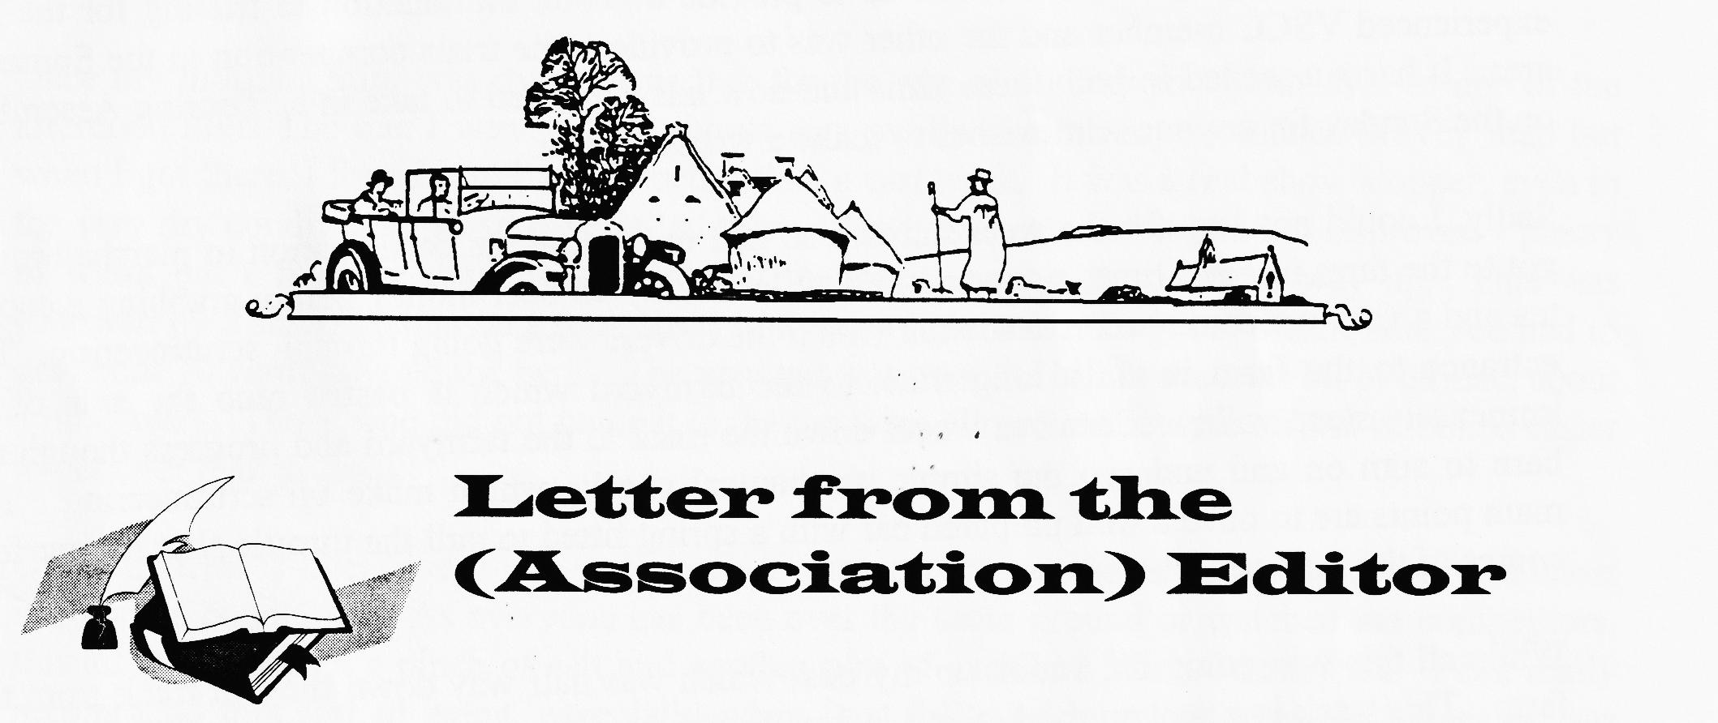
Miles

Dear Miles,
With all respect to Mike Costigan, he makes some very contentious statements without offering any evidence to support them. My 1931 sports engine has an 1½ " crank which I believe (on the grounds of knowing the original owner) to be original. A slightly earlier engine which, I bought as a spare in 1960, also has a 1½ " crank. All the chaps I knew racing sports engined 7s in the late 50's and early 60's used 1½ " cranks. Are we to believe that so many sports owners bought Speedy cranks and rods in the late 30's and threw away the 1 ⁵/₁₆" ones?
"5.25:1 rear axle permitted max revs in top" If we take "max" to mean 5000 rpm , as suggested, this equates to slightly over 75 mph which is well above the capabilities of a standard sports model. If the car would really pull 5000 in top on a 5.25 axle, it would certainly do so on a 5.67, in which case, with 3.50 x 19 tyres, it would be doing marginally below 70 mph. So how did max speed drop to 60?
Best wishes, John.
Editor's Comment - Deary me! The notes I copied were passed onto me when I took over as Sports Registrar back in the 70's and I am not even certain they were written by Mike Costigan. Just goes to show, always check be printing! John is well known as a Sports Expert and has a far greater technical knowledge then me, so I print his letter in full to keep matters straight. Many Thanks for the comments. Miles

The Exmoor Fringe
It was just getting light and the weather was distinctly foggy as I set out for South Holding Farm near South Molton in Somerset for the start of the Exmoor Fringe Trial. This is an annual event which has run for about 5 years and I have been marshalling for the past 3 years. It was intended to fulfil two main purposes; the first was to provide a gentle introduction to trialing for the less experienced VSCC member and the other was to provide some trials competition in the Somerset area. It has succeeded in both these aims and now has expanded to take in a 'Touring Assembly' on the Sunday for anyone who wishes to make a weekend of it.
Sadly, I could not stay for the weekend and so had to confine me participation to marshalling. I got to the farm in good time, signed on and collected my £3 beer money before grabbing a cup of tea and a very welcome bacon sandwich which the drivers were going through scrutineering. The entrance to the farm is via a long track to the farmyard which is pasted onto the side of an immensely steep valley. Cars free wheel down the track to the farmyard and progress though the barn to sign on and undergo the simple mechanical checks which make up scrutineering. The main points are to have a well-prepared car with a spring fitted to pull the throttle shut if your foot comes of the loud pedal!
While all this was going on, I took up my post which was halfway down the exit track from the farm. This track is a sunken road, about 7 ft wide and usually very greasy. The idea is to start at the bottom of the hill and drive to the top. There are no serious tricks, like a stop and re-start, on this hill which is the last before lunch. This year, it was fairly dry and I think only one car failed to get to the top!. I was at the 16 to 18 marks and my task was to see mark the point at which the front wheels stopped forward motion. In official terms this is called front wheel marking and marks are awarded for the 'that part of the course reached by the centre of the front wheels. A car is deemed to have stopped when the front undriven wheels cease to revolve...'
To achieve this taking work, I adopted a position on the grassy bank and listened for the throaty roar of Vintage machinery blasting up from the start which was about half a mile below , just after a small stream which was the start and finish line for the previous test. As we were the last hill, we had about an hour when no cars appeared, but this is not unusually since competitors are allowed tackle hills in any order they like so long as they get round in the time permitted; in this case by 1.00 p.m. Hills close fairly promptly for a quick dash to the pub before the afternoon.
There were close on 60 starters this year, many of which I had seen on the past 2 or 3 trials. Austin Sevens were much in evidence. Barry Clark, lately President of the VSCC and a well-known trialist had the famous "Grotty Chummy" out while Jim Musty in a very tidy GE Cup shot up the hill in slight haze of Castrol 'R'. There was a Taylor bodied coach-built model, which I thought would be too heavy for this sort of competition but was proved wrong when it hurtled past. There were also Ulsters, Chummies and a couple of Cambridge Specials, some 23 from 58 entrants. It almost goes without saying that none of the Austins had any problems on this hill. Amongst the other sporting machinery was one of the original Cream Cracker MG PBs so the scene was very reminiscent of the 30's.
One of the good parts about trialing is that you have a chance to meet so many people and chat over interesting cars. I managed to see one or two useful mods to the Ulsters which took part. Despite all having correct dropped front axles, they all had a lot more ground clearance as they were using 3.50 x 19 wheels. Anyone got a spare set I could borrow?

One interesting development is that many of the bigger cars, and a few of the smaller ones toc had compressed air cylinders on board. At least I assume that was what it was as I did not see an barrels of beer on board! Before you think that the gas was oxygen for the crew, I should point out that each trial has a minimum tyre pressure but the hills are usually separated by several mile of proper road so once you have completed a section, you need to pump up the tyres. Hence the compressed air - not for the crew after their exertions!
Once my morning stint was over, I was free for the rest of the day so I went over to one of the afternoon hills. The one I went to was shown as a public road on my Ordnance Survey map but when I got there, I found it to be little better than a cart track. It was a real showstopper, even in the very dry conditions. I had marshalled there a few years ago and it had not improved - plenty of width but a massive diagonal rut crossed the track about a third of the way up. This was followed by a sharp incline up a rock sheet to a sharp right turn. To get a 'clean' here you had t get about 30 yards beyond the bend. The way out was over the hill to the next bit of tarmac, about a mile away. Those who did not make it to the top were allowed to reverse off but it looked easier to get over than go back!
Once the trial is over, everyone goes back to the pub to swap tales of heroic drives in alma: impossible conditions. As everyone has been over the same ground or watched the competitor: this all is taken with a pinch of salt and another pint of excellent West Country ale. I can really recommend this sort of event, especially when it is followed by a run over the moors as was planned for the following day. I could not stay for that, but the idea is to follow a route of about 8 miles from a central start point. The more elderly Edwardians have a slightly shorter route, and no-one minds if you drop out at lunch time so long as you let the organisers know. Eligibility is simple: cars must be taxed and road legal and must carry a fire extinguisher. As cars set out a minute intervals, you need a map and a little practice in following the 'tulip' symbols is helpful but not essential. You need not be a VSCC member to take part. I'll be trying it next year and will let you know how I get on.
Other Events:
11 May Haynes Motor Museum Run. 80 mile run in aid of Dr Barnardo's. Starts in Bath, ends at Longleat. Details from Pauline Penn on 01963 440804.
24 - 26 May 75th Anniversary Rally at Gaydon. Forms are available from me or from Gary. Full details of the 3 days, including autojumble, programme are in the Association Magazine.
29 June Michael Sedgewick Run. Organised by the National Motor Museum, Beaulieu, this year's event is on the Isle of Wight. Details from Emma Crossley at Beaulieu, S042 7ZN or phone 01590 612345.

The snippet below came from the Light Car magazine dated April 6, 1934. The extract was amongst some paper Glyn Llewellyn found under a carpet he was replacing last year. Quite a coincidence, don't you think? I hope it prints clearly
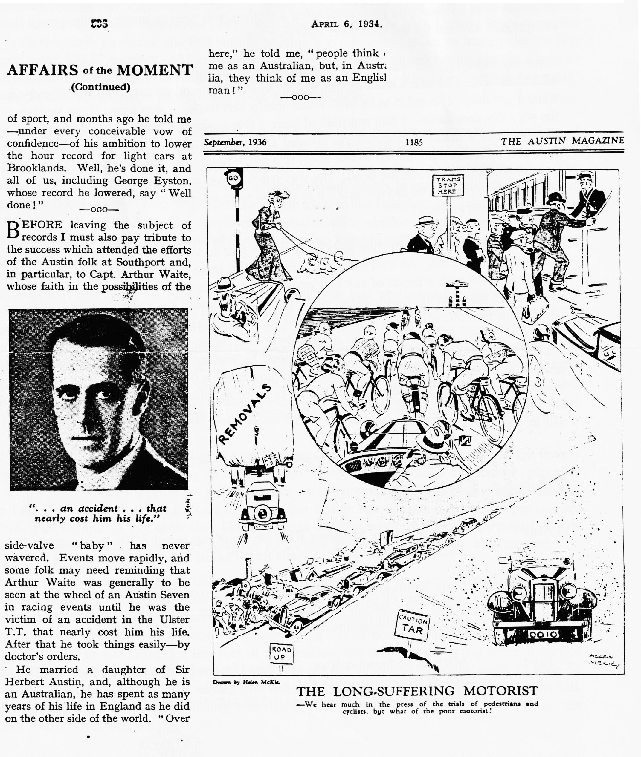

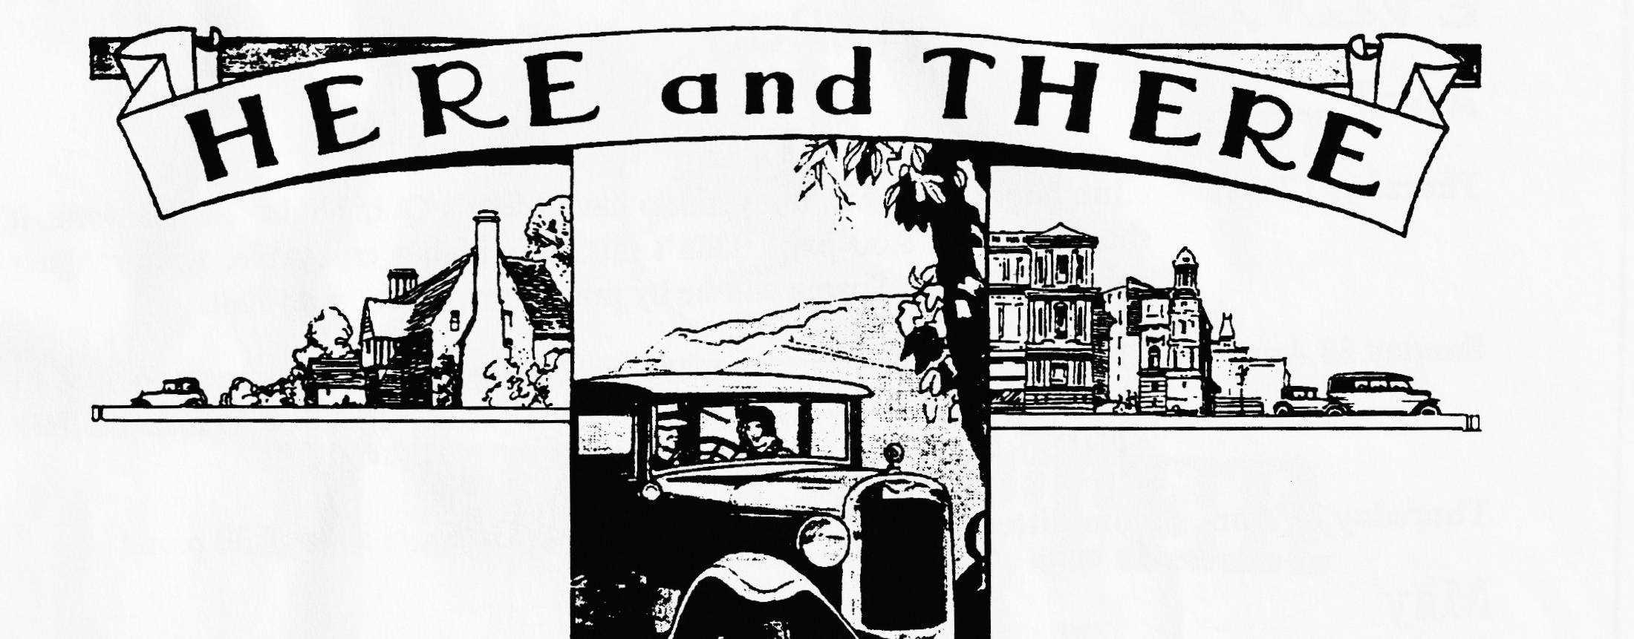
FOR SALE
1933 Box Saloon AKK 644: In course of restoration. Chassis, back axle and engine all rebuilt including engine rebore, new pistons, and rings. New tyres and tubes, brakes and cables, dynamo rebuilt by Lucas. New radiator and battery available, electrics still to do. Body partially rebuilt; still to fit. £2,500 o.n.o. Contact Tony Day on 01590 673651
1937 Morris 8 Sliding Head 4 Door Saloon. Original condition, 3 owners only. Much history. New battery, Sirrom oil can, new MoT, maroon and black. Price £3,850 o.n.o.
ALSO
1947 Series E Sliding Head 4 Door Saloon. Much work done, sound vehicle, needs finishing. Price £2,160 o.n.o. Contact Kevin Wissett on 01202 576792
Daimler Sovereign 1979 Series III. 4.2 Litre Two owners, local car with history, MoT and Tax. Good sound condition, plus spares. Four doors, bonnet, cylinder head with injection, dashboard, all electronic packs, relays and much more. Price £2,500 (The lot) o.n.o. Call 01202 594394 (day) or 01202 576792 (eve).
Spares Chummy half shafts, engines, Gearboxes, starter/dynamo housings, wheels, Box Saloon engine, gearbox, OS front mudguard, scuttle tank, running boards, wheels. Ruby bonnet, luggage carrier, gearbox, front/rear axles, steering Box/column, running boards. Hundreds more items! Ken Medlicott tel 01963 440604
WANTED
Shock Absorbers Arms, front and rear, or complete assemblies for 1936 Ruby needed by new member Brian Hughes. Call on 01425 274035

EVENTS
April
Thursday 17 Apr Club Night. We will try again to have Merv's Quiz Night. As last time, it should start at 8.00 p.m. Don't miss this highly enjoyable, wide-ranging quiz, fun for all! Spares will be by prior arrangement with Phil.
Sunday 20 Apr Club Run. As there are so many competing events, it has been decided to reduce the number of Club Runs. Consequently THERE WILL BE NO APRIL RUN.
Thursday 24 Apr Committee Meeting at the Tyrell's Ford. Gather at about 8.30 p.m.
May
Thursday 1 May Eight Till Late. The venue for May is the Green Man, Wimborne. Some of you may remember this pub as the Lost Keys. Whichever name it goes under, it will be a good place to gather for a friendly chat with other Dorsets.
Thursday 15 May Clubnight. The Feely Bag competition organised by John Page originally scheduled for the April meeting will be the highlight of this month's gathering at the Elm Tree.
Sunday 18 May Club Run. Details were still being arranged but meet at Wimborne, Queen Elizabeth Leisure Centre Car Park, at 10.15 for a 10.30 start. The run is expected head towards the Purbecks
Thursday 22 May Committee Meeting. Once more at the Tyrell's Ford, starting at 9.00 p.m.
EARLY NOTICE
Thursday 5 June Bring Your Car to the Eight till Late at the Three Tuns, Bransgore for an informal Concours. More details next month.
OTHER EVENTS
Sat 19 April VSCC Colerne Sprint. We have been invited to join the New Forest VSCC on a run from the White Buck at Burley to Colerne which is near Box in North Wilts, departing at 9.30, aiming to get to Colerne for 1.30. The only way in is with a VSCC member so joining the run will get you in. I'll be marshalling and hope to see many Dorsets there. Call Ray Hoare on 01425 471174 if you would like to take part. Jo Moss is running her Invicta so come along and support her, too!
Sunday 11 May VSCC Wiscombe Park Hill Climb. One of the highlights of the year, this friendly speed event takes place near Honiton with practice beginning at 9.30 a.m. and competitive runs from 2.00 p.m. There is also an autojumble and some spaces are still available. Call John Green on 01984 623468 for details. Admission costs £5 per person, no dogs!

