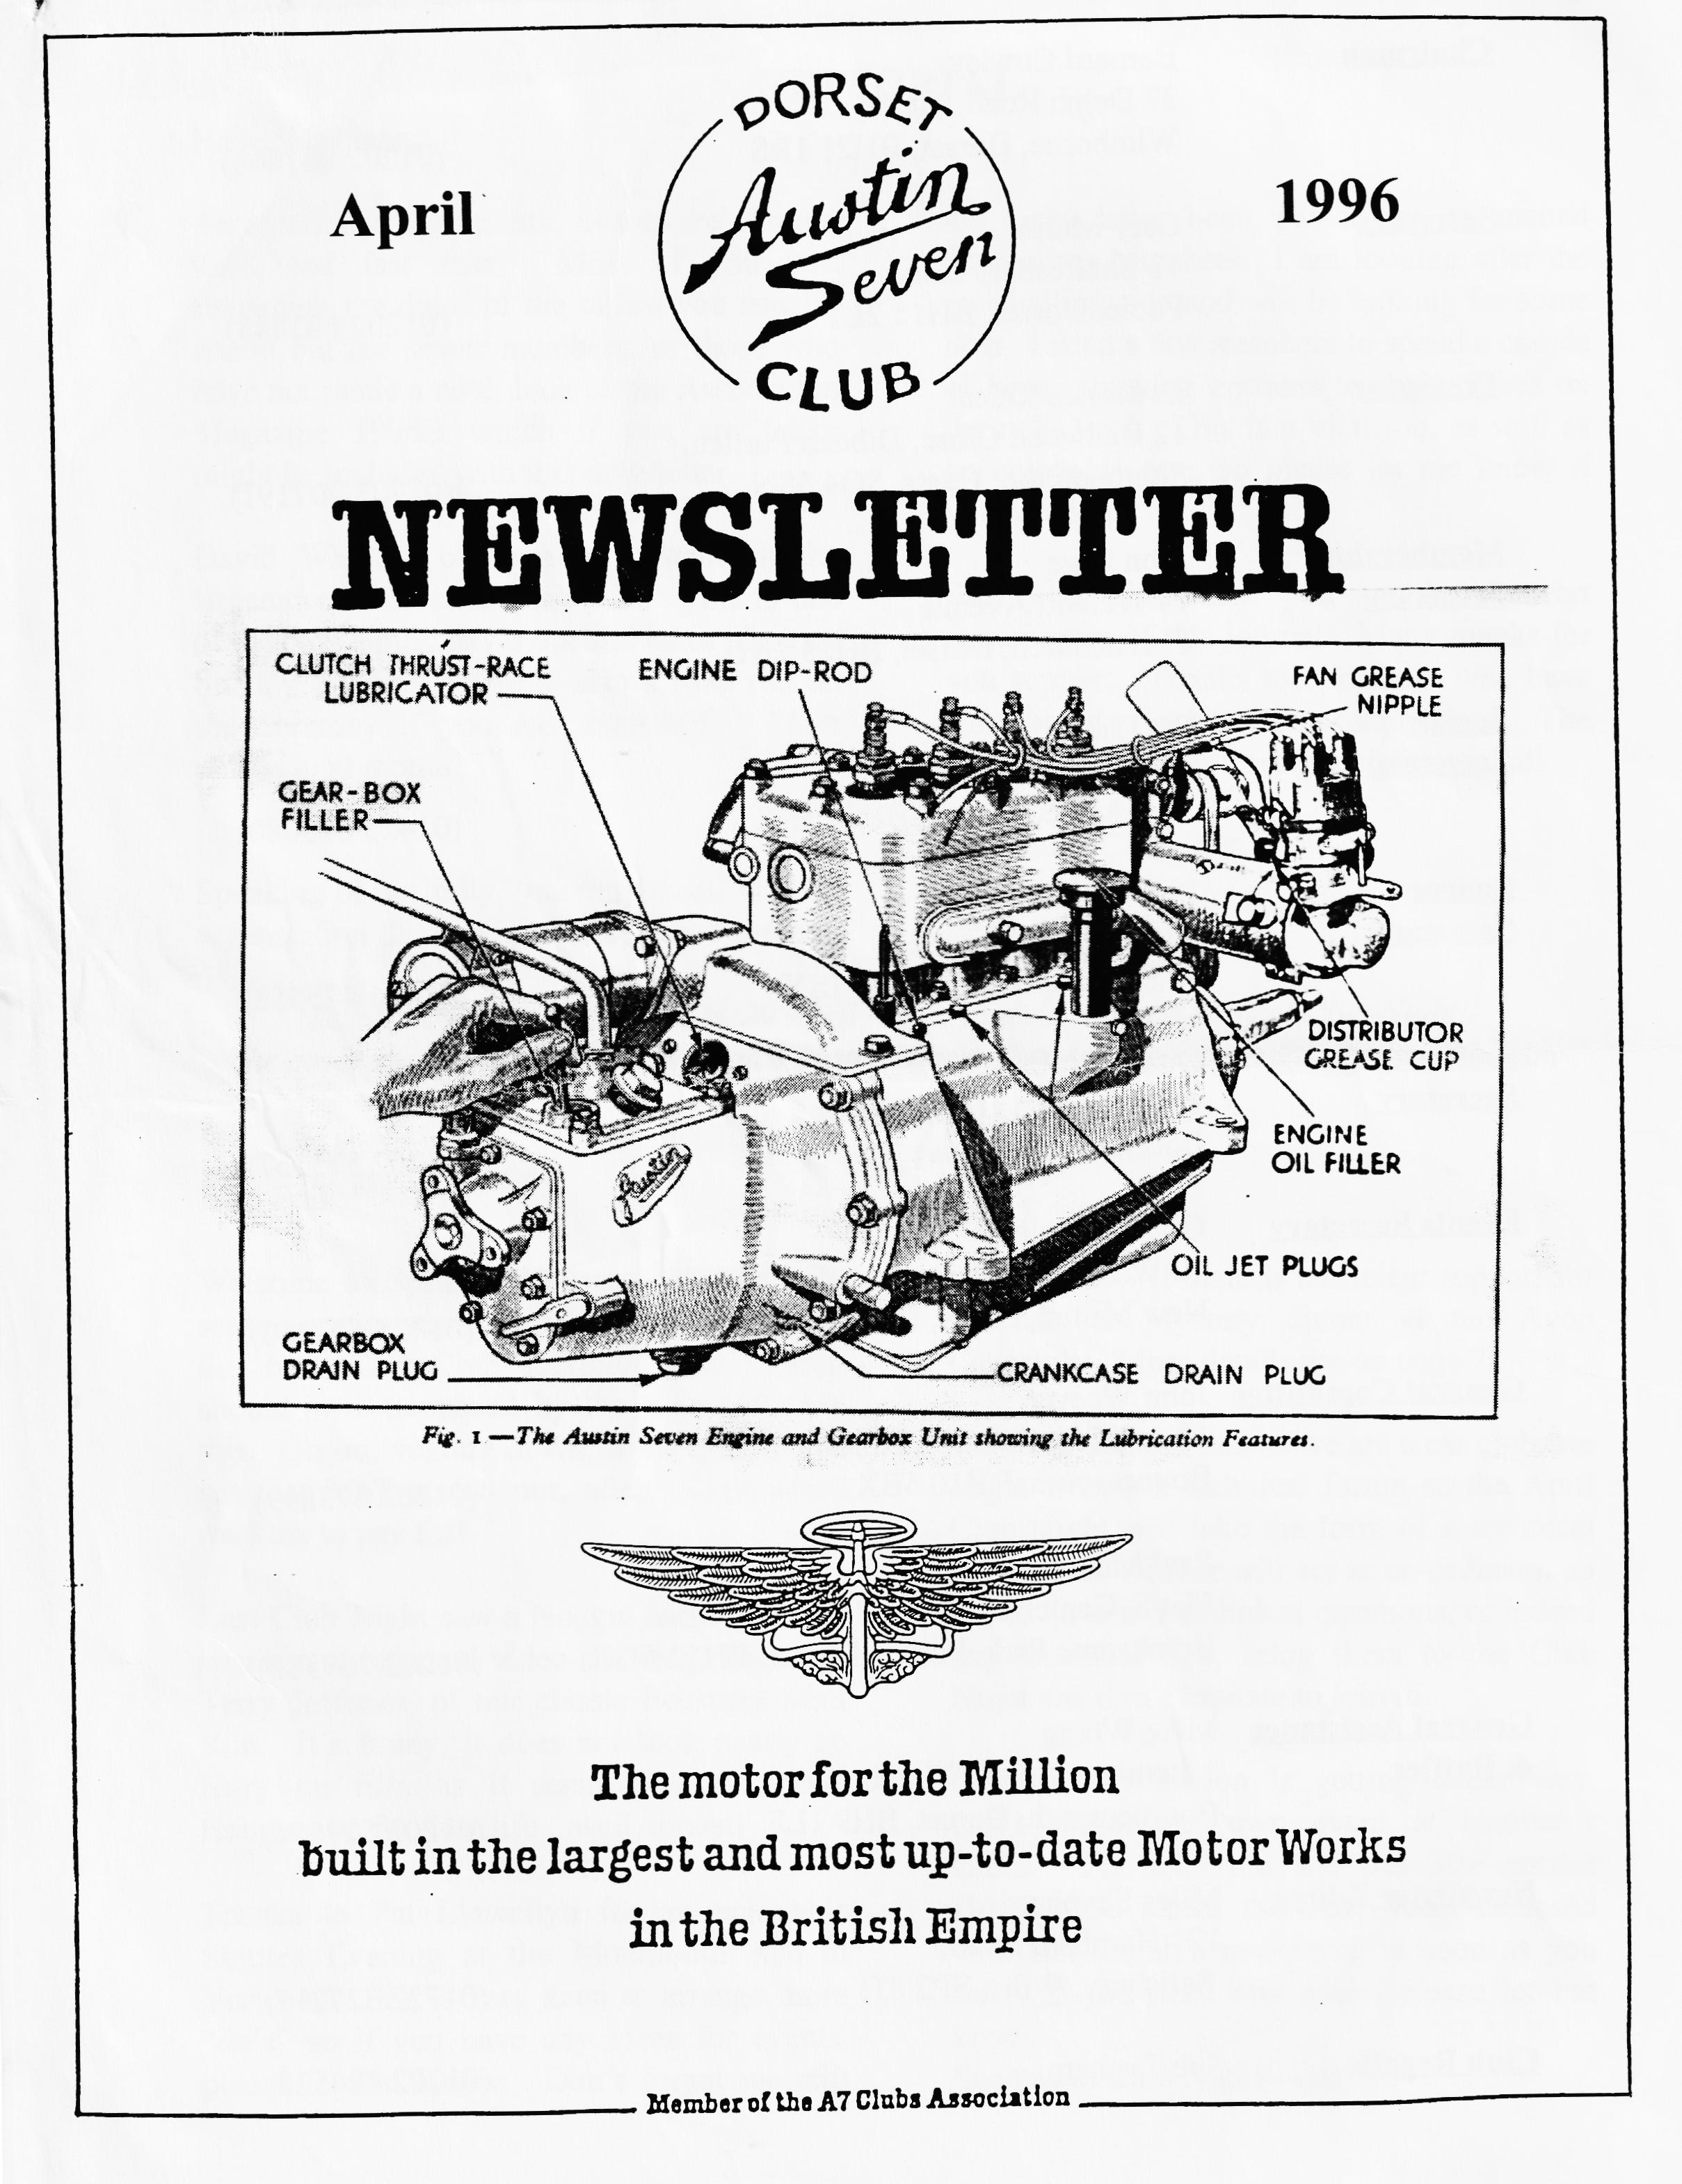

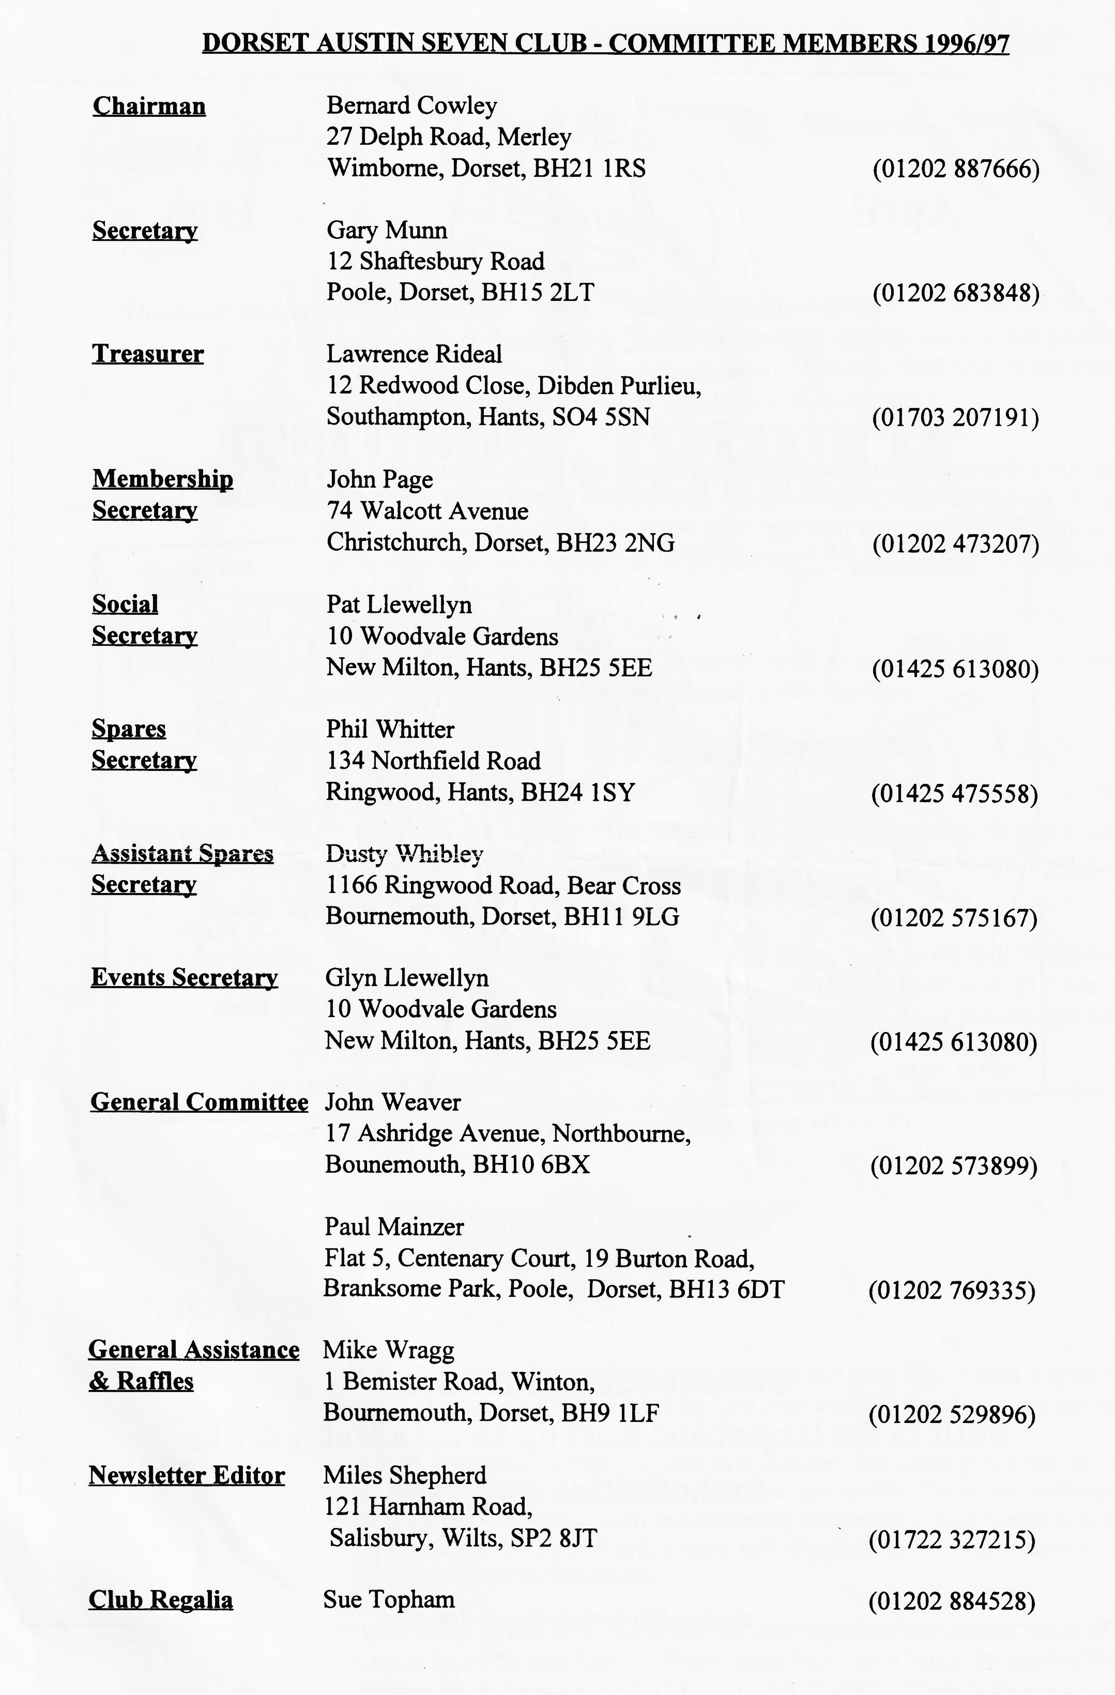

EDITORIAL
Hallo Everyone,
the tasks have been passed on to named Committee Members. I am looking after the marshalling side and will be looking for some help. I need a few members to spend a couple of hours showing entrants to their places on the rally field. This is a vital job, as well as an enjoyable one, so please let me know if you can help.
Finally, a big thank you to the stalwart contributors of this journal! Many thanks for you support. Thanks too, to those who have contributed prizes to our monthly draw. The Club and Committee are grateful to you all.
See you at Clubnight. BFN, Miles
As mentioned last month, events are coming thick and fast now. Most of you will remember the dates of the rallies you usually attend but for newer members, or those who have not made a note, look in the Association Magazine 1996B which if you are lucky might be included with this newsletter.
David Whetton organises our stand at the Breamore Motorcade each year. This is one of the best family day's out and takes place on Sunday 2 June. There is also a road run on the Saturday if you are interested. More details next month.
Speaking of our rally, you may recall that the organisation this year is different and some of
SECRETARIAL
Well Folks!
want to know if there is sufficient support for the Murder Mystery dinner at the Avon
Causeway. More details are on page 7.
We have decided that as we are a car club, we ought to host a technical forum so the April Club Night will take the form of a technical night. Phil Whiner will act as co-ordinator so if you have any technical questions, or indeed any technical tips, bring them to the Club Night and don't hesitate to join in.
As the rally season is getting under way, don't forget our own event at Harman's Cross. Pat tells me she has 30+ entries already. Do return the entry form enclosed with last month's newsletter as soon as you can. If you need any more, please let Pat know.
See you at Club Night - Gary
Welcome to Spring! I always feel the rally season proper starts after Easter, usually with the bean Car Club Daffodil Run, which should have happened by the time you read this. Go on, venture down to the garage and get that MoT sorted out, after all, no more road tax to pay for!
Last Club Night saw a Noggin 'n Natter with spares and informal video showing, thanks to Terry Jefferies, of our classic February Mud Run. It's funny, it does not look nearly so hairy on film as it seemed at the time. Hanging on for dear life....well almost!
Thanks to Pat Llewellyn for an enjoyable Skittles Evening at the Monmouth Ash at Verwood. She is very keen to arrange more "do's" so if you have any ideas for events, please let Pat Know. Don't forget we still

AN EARLY SPRING DORSET DAWDLE
Eleven cars assembled at the Leisure Centre Car Park by the Queen Elizabeth School in Wimborne from 10.30 a.m. onwards but a prompt start to the Club Run was not possible as the attending members had to be allowed a little time to view the bargains (or otherwise) available at the Car Boot Sale in front of the school.
Eventually the convoy departed, to by-pass Wimborne and Corfe Mullen onto the Dorset lanes and by-ways through Lychett Matravers, Morden and Bloxworth. Shortly before Lane End, a short rest was taken. Whether the rest was taken for the benefit of the cars or their occupants, I am not quite sure.
Our winding route took us through strange sounding places such as Cloud's Hill, Pallington, Tincleton and Lower Brockhampton. Brian turned off the main road to travel through what I took to be a private estate. Leaving the estate??, the main Dorchester to Weymouth road was closed so we proceeded to skirt the earthwork fortifications at Maiden Castle, through the pretty village of Martinstown, then steadily climb up to Hardy's Monument at the top of Black Down.
Here we made a short stop to admire the views but even though the sun was shining at the time, visibility was not too good and the wind at this exposed site must have been up to or near gale force. I think the main objective here was for the run organiser "Captain" Brian Willbourn to pay homage to his senior rank, Admiral Hardy.
It was only a short descent down Portesham Hill to the village of Portesham itself where refreshments were taken. After their fill of both solids and liquids, most members made their various ways home. Brian, Susi, Marion and I went on to Abbotsbury for a short walk and to take the air before returning home via the quiet lanes of south Dorset.
The whole trip was most enjoyable with the early spring flowers beginning to bloom, the fields full of new-born lambs and to cap it all, the weather was fine and sunny all day. Our heartfelt thanks to Brian and Susi for organising such a pretty run.
Marion and Ben
75Th ANNIVERSARY UPDATE
The main details were explained in the December issue so I will only briefly mention that the main activities sponsored by the Association are the John O' Groats to Lands End Run at Easter next year and the Rally to be held at Gaydon over the late Spring Bank Holiday. The committee met at the end of March to discuss progress. Basically, we were there to hear the proposals from British Motor Industry Heritage Trust, Gaydon to you and me.
A considerable amount of discussion took place where Gaydon tried to suggest what they thought we would want while we tried to get some firm figures out of them. This was not a fruitful exercise and details have yet to be fixed and we did not establish costs. Proposals follow, I'm told!

75Th ANNIVERSARY UPDATE (CONTINUED)
The one positive note was the publicity side which is being handled by Brian Eckersley and his team from the Essex Club. They made some sensible suggestions and came up with some attractive Tee Shirts and Sweatshirts.
More generally, I raised the issue of whether driving tests are really worth attempting. My recent experience is that there is very little call for them. If you recall, Bristol have dropped them from their Spye Park programme and there has been a very poor turnout at Beaulieu for the last few years. This is the area which we have been asked to run. I'll report further when details are clearer
Miles
Other Events In Our Area
5 May Popham Car Rally
12 May Spring Autojumble, Beaulieu
21 23 June Festival of Speed, Goodwood
6 - 7 July Downs Steam Show, Froxfield, near Petersfield
13 - 15 September Rosengart Rally, Near Cologne, Germany. Let me [Ed] know if you want details of this one, it sounds good value.
Spares Notes
Geoff Roe has sent me his latest list of rubber mouldings suitable for Austins. They are all very accurate and reasonably priced. Let me know if you would like a copy.
We have received a parts list for those thinking of converting to halogen lights! Prices are not cheap and the power requirements are rather higher than is healthy for an A7 dynamo, but is you use a VW unit or have a 12 volt conversion....
Miles

A CAUTIONARY TALE
My time in common with most of us is limited and I also tend to grossly underestimate the amount of time required to complete any given task. This often results in an untidy garage, irregular purges are undertaken when the whole place is cleaned and tidied up. On the day in question the garage had started out in a fairly tidy condition. I was working on the steering on my Tatra 12, the front of which was on axle stands, wheels removed etc. The Austin Seven Tourer was standing alongside (restoration had just been completed).
The rectification of the steering required several bushes and swivel pins to be turned on the lathe and the heat treatment of one part. I was concentrating on the job in hand and started to heat the component with a gas/air torch. As the critical heat approached a small tin (125m1) of primer at the back of the bench exploded, throwing burning paint in all directions, this burning paint set light to all inflammable items it came into contact with. Panic!!!!
I had only one chance, I turned off the gas and ran from the garage turning off the power as I went through the side door, ran the 30 yards to the other garage and picked up the fire extinguisher and ran back to the fire and hit the button on the extinguisher (This was a water-based unit and totally inadequate) but this was the only thing I had. On arriving back approx. 2 mins had elapsed and the flames were reaching the roof. I worked my way between the two cars spraying water onto the flames. At this point I could see the folly of my ways, on the bench were aerosols, thinners, paint, all burning and ready to explode, a large Calor bottle was located at the side of the bench on the floor. "These were all life threatening" !!!
Fortunately, the major flames were extinguished and I was able to concentrate on the smaller flames (e.g. 15 burning screwdriver handles). During this time, I had the mental picture of me outside the house directing the Fire Brigade as to where the inflammable and explosive items were stored (it was horrendous, hazards were everywhere).
When the fire was out it only left the cleaning up, paint, water, thinners and burnt items were everywhere. But I got off very lightly. The total damage was just about £200 plus the cost of a new fire extinguisher. In fact, I have now purchased several for both garages, house and all cars. Inflammables are now stored in a metal cabinet.
If the fire had not been controlled, I would have lost the Tatra, The Austin, lathe, drill, all electric tools, a lifetimes collection of tools, spare parts plus the garage. Insurance would have covered the basics but in 10 years’ time I would have been still looking for "that tool". In retrospect my advice is;
- Purchase an adequate fire extinguisher.
- Make sure work areas are clear.
- Double check before using heat or flames.
- Store hazardous materials in a safe area.
I was lucky - you can make your own luck by being careful.
Bob Hughes
This article first appeared in the Austin 7 Owners Club Newsletter for February 1996, there have been at least three other garage fires over the winter....

THE DYNAMO. .
CARE OF THE DYNAMO
Lucas dynamos will give thousands of miles of uninterrupted service with hardly any attention beyond very occasional inspection of the commutator and brush-gear and lubrication of the bearings.
Very little lubrication needed
All dynamos are sent out from the works with the bearings packed with grease which lasts for a considerable time. About every 10,000 miles or when the car is taken down for a general overhaul, it is advisable to have the machine dismantled, preferably by a Lucas Service Depot, for cleaning and adjustment, and repacking the bearings with grease.
Dynamos of the type illustrated are provided with a lubrication wick at the commutator end of the machine. About once every year unscrew the cap of the lubricator and if the wick is dry, refill, cap with Vaseline.
Some dynamos have oilers or greasers to enable you to give them a little additional lubrication. Oilers should be given a drop of oil every 1,000 miles. Greasers may be given one turn every 500 miles, and should be recharged when empty with a good quality high melting point grease.
With some machines you will find a flap marked "Grease" at the Commutator end of the machine. Periodically, say when the engine is being decarbonised, move aside the flap and add a very small quantity of high melting point grease.
Inspection of Commutator and Brush gear.
About once a year, remove the metal cover from the dynamo for inspection of the commutator and the carbon contacts or brushes as they are called. Take care not to lose the dished nut when removing the cover fixing screw, as the cover is liable to spring open when the screw is released-in some cases, the cover can be slid off the end of the machine after slackening the screw.
The brushes must make good firm contact with the commutator. With some machines, the brushes are held in boxes by spring levers. Hold back the spring lever as shown, and at the same time move the brush to see that it is free to slide in its holder. If there are any signs of sticking, remove it from its box and clean it with a cloth moistened with Petrol. With other types, the brushes are secured to spring arms. Lift the levers carrying the brushes and see that they move freely on their pivots.
After removing brushes for cleaning or any other purpose, care must be taken to replace them in their original positions, otherwise they will not "bed" properly on. the commutator.
If, after long service, the brushes have become worn to such an extent that they will not bear properly on the commutator, they must be replaced. Always fit genuine Lucas brushes. as these are made specifically for use on Luces machines and will give far the best results and the longest life. We advise you to have the brushes fitted at a Lucas Service Depot so that they can be properly "bedded" to the commutator.

Next examine the commutator. It should be clean and free from any trace of oil or dirt and should have a highly polished appearance. The best way to clean a dirty or blackened commutator is by pressing against it a fine dry duster and getting someone to turn the engine over slowly by hand. If the commutator is very dirty, the duster may be moistened with petrol.
Belt-driven dynamos.
With belt-driven dynamos, the dynamo driving belt should be kept fairly taut and should be adjusted from time to time to take up the slack. Care should be taken. however, not to over-tighten the belt, and also to see that the machine is properly aligned, otherwise undue strain will be thrown on the dynamo bearings.
Dynamo Output.
The dynamo output is accurately set before leaving the Works, to suit the requirements of the equipment fitted on car, and in normal service, the battery will be kept in good condition. If, due to very special running conditions, however, you should find that the battery is not kept in a charged condition, or is being excessively overcharged, we advise you to consult your nearest Lucas Service Depot, where any necessary adjustments can be made. We do. not recommend owners to attempt the adjustment themselves.
Ammeter Readings.
The ammeter, which usually forms one of the instruments on the dash, indicates the amount of current passing into or out of the battery. For instance, suppose the dynamo is generating 7 amperes at a particular speed and that some of the lamps are in use, taking, together with the ignition coil, say 5 amperes, then 2 amperes are left for charging the battery - this is the reading given on the ammeter.
The Cut-out-an Automatic Dynamo Switch.
It will be noticed from the ammeter readings that the dynamo does not charge at very low engine speeds. This is because it is not moving fast enough to generate sufficient energy to charge the battery.
Connected between the dynamo and the battery is the cut-out-an automatic switch which acts as a "valve," allowing the flow of current from the dynamo to the battery only. It closes when the dynamo is running fast enough to charge the battery, - and opens when the speed is low or the engine is stationary, thus preventing current from flowing from the battery through the dynamo windings.

Wanted
Ulster type radiator (17", central filler).
For Sale or Exchange (see above)
An early Chummy radiator (15") in excellent condition. Contact David Whetton Tel: 01202 848743.
Another Request!
We are still looking for that piece of land with a bit of a hill on it! Do you have a bit of land with a hill which the Club could 'play' on one Sunday afternoon? Your Events Secretary would like to hear from you if you can help, either with an offer of a hill or perhaps the name of someone else who might be able to help. Please contact Glyn on 01425 613080.
MURDER MYSTERY EVENING
Several members have already enjoyed one of the Avon Causeway's Murder Mystery Evenings and have provided more information. The begins with your arrival at 7.30 p.m. prompt and by 8 p.m. all the suspects have arrived. Guests are then taken across to the train and shown to their seats before Inspector Plod visits each table to explain the plot so far. He will also be looking for 6 prime suspects. There are usually six prime suspects, he may feel you are one of his suspects, if so he will give you a profile of the character you will be for the evening. The candlelight dinner in the Orient Express carriage is a 3-course affair with a choice of menus. After dinner, Inspector Plod gets all his suspects to stand up and guests will ask questions regarding the murder. If they ask anything on the profile, the character must tell the truth but if asked something which is not on the profile, the character may lie and try to lead them astray. The plot then unfolds, the prime suspects grilled, and Inspector Plod will uncover the clues - but beware the Red Herrings!
We can arrange a private party for the Club but we will need at least 30 takers. If you would like to take part, please let Pat Llewellyn know by Thursday 25 April at the latest. Her phone number is inside the front page.

EVENTS
April
Thursday 18 Apr Clubnight. An Austin 7 Technical Night. Regulars will recall the excellent evening last year where a variety of common and not-so-common problems were discussed in a lively and informative fashion. Phil will be the Master of Ceremonies (and technical details as well, I expect!).
Sunday 21 Apr Club Run. Richard Cressey has offered to organise this month's outing so
meet at the Leisure Centre Car Park by the Queen Elizabeth School, Wimborne at 10 a.m. for a 10.15 start. Richard will meet the convoy at the Sturminster Newton Mill at 11.00 and will be taking us out in the direction of Wincanton.
Thursday 25 Apr Committee Meeting. Your committee meet as usual at the Tyrell's Ford at about 9 pm to discuss matters connected with the club.
May
Thursday 2 May Eight-ish till Latish! The Nag's Herad on the Christchurch Road out of
Pingwoori ^{just} been refurbished cr, we thought it would a suitable
place to start the month. See you all there?
Thursday 16 May Clubnight. By way of a change from things Austin, we will be having a suitcase sale. This does not mean you should look out all your old suitcases, just one to bring all the booty! Bring anything you can get into a suitacase - not necessarily Austin related.
Sunday 19 May Club Run. Details had not been finalised by the deadline so watch this
space next month for the latest information.
Other Events
20 April VSCC Colerne Sprint. Dreadful weather last year didn't spoil a great day
out. Let me know if you want to go, you need a VSCC member to get you in!
12 May VSCC Wiscombe Sprint. Situated near Honiton, this meeting is a fine day out,
as many m,embers who attended last year can testify. There are rudimentary catering facilities plus a small but discerning autojumble - Tony Leslie is usually there, to name but one. Practice starts at 9.15 and the sprint proper starts at 1.30 p.m. See me for further details.
23 June Spye Park. Bristol A7C run one of the most enjoyable and relaxed rallies of the year at Spye Park near Lacock. Entry forms from David Parks, 30 Sherford Road, Haydon Wick, Swindon, SN2 3PR (tel 01793 724592). There is always a stromg turnout from our members, so there will be a number of old friends there!

