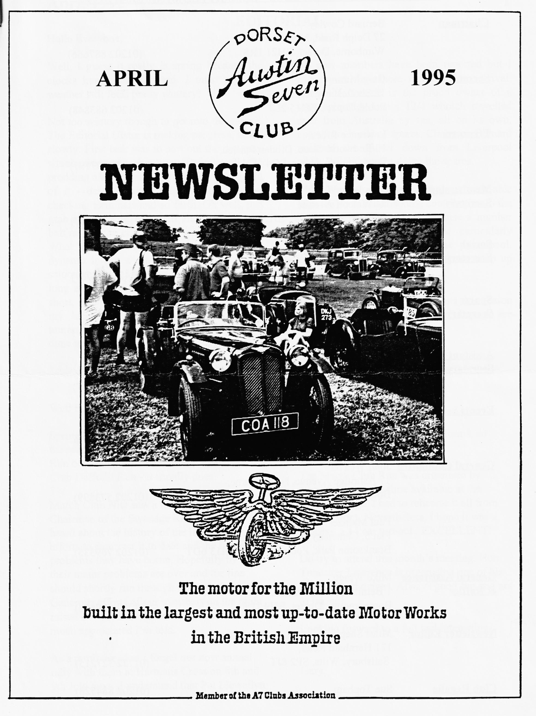

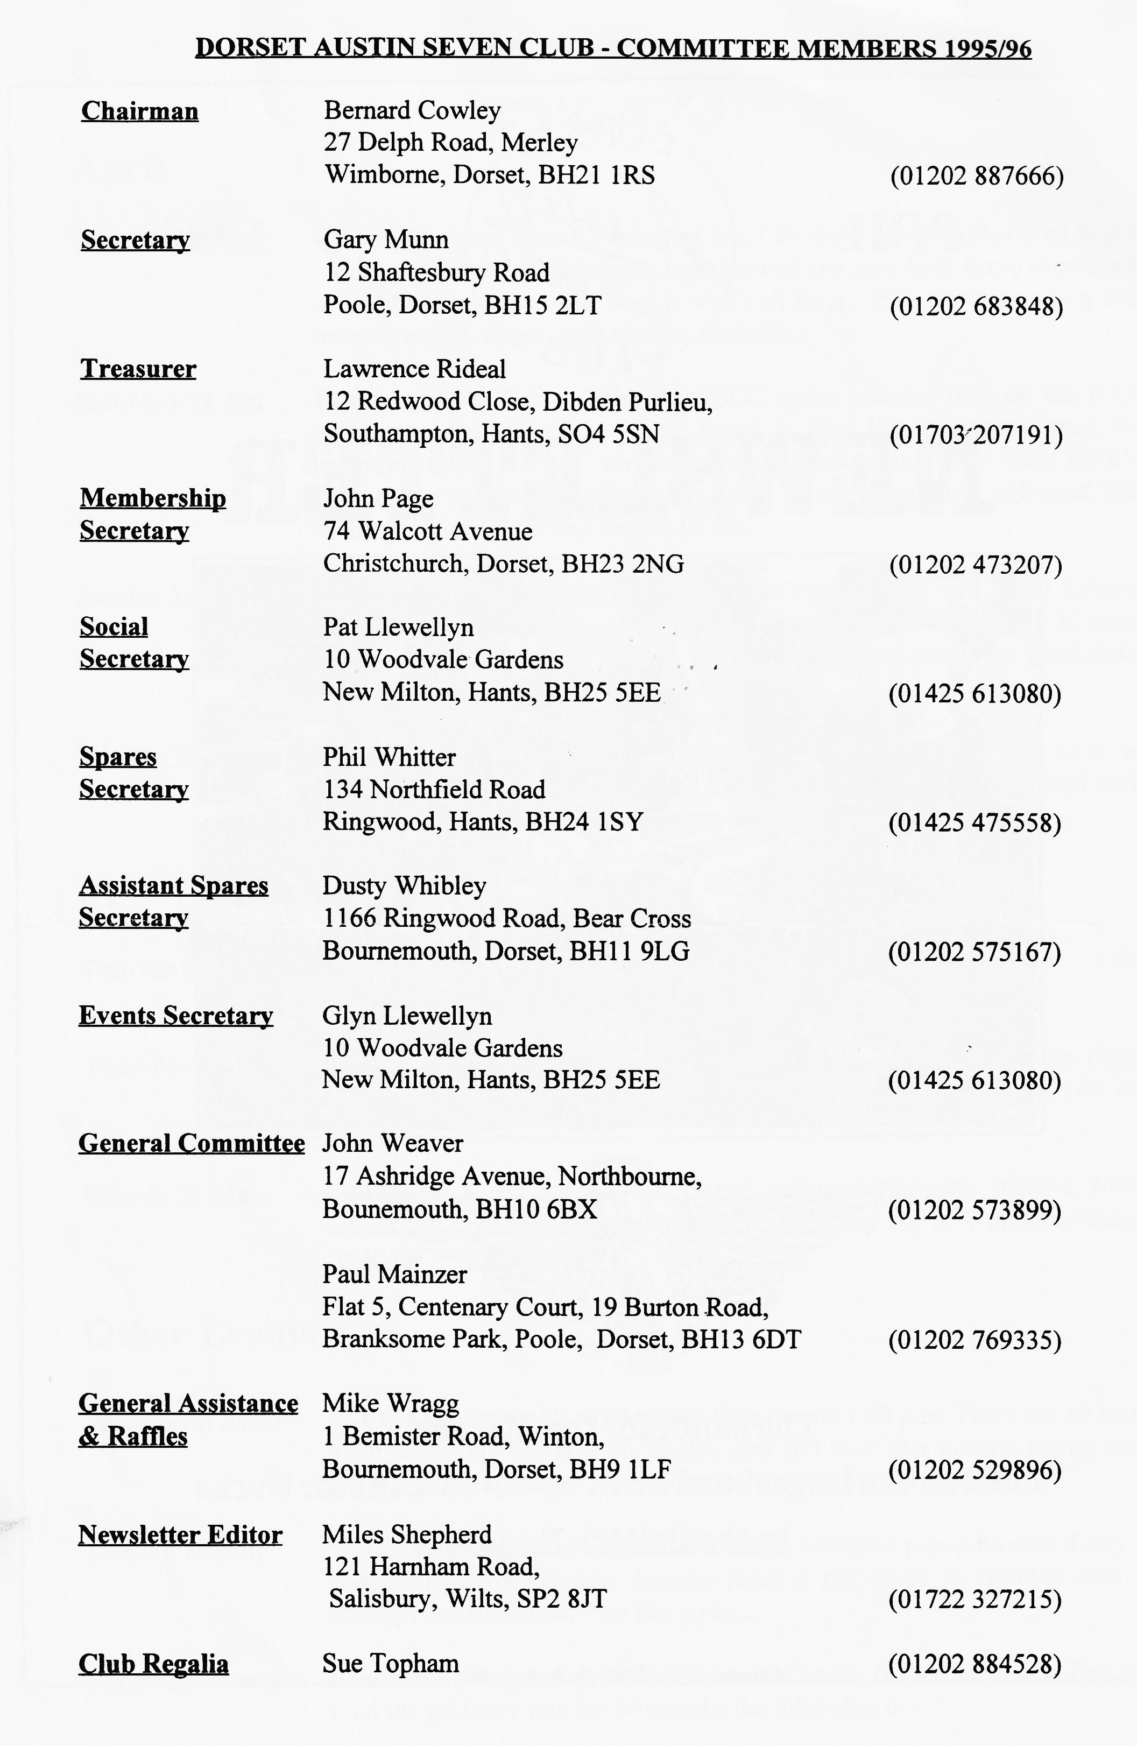

April 1995
EDITORIAL

Hallo Everyone,
Well, I guess it really is spring because the clocks have gone forward. I must say, the weather still feels pretty wintery!
Not too wintery though to get into the garage. The Editorial Ulster is making progress, albeit slowly. First task was to sort out the dynamo, which was not charging. Despite all the prodding and cleaning, I could get nothing out of it - despite much waggling of brushes, checking terminals and so forth. Oh well, just grab a spare from the shelf and it won't take half an hour to change over - or so I thought! What I had not reckoned on was that the dynamo is not a standard unit so the Box saloon dynamo I had was about an inch too long and would not fit. To cut a long story short, the offending item is being repaired at my local electrical specialist. I collect it tomorrow and will report how they have done next month.

No new members have been reported but I can report that there has been an arrival. Willie Mackenzie is the proud owner of a very splendid Austin 12/4 which travelled over from Australia by sea, all on its own, apart from a pile of spares. Chairman Bernard trailered the motor down from Liverpool while Willie brought down the spares.
Mike Wragg reminds me that we were able to make such a handsome contribution to the Swanage Railway mainly because a number of members were once more particularly generous with donations to the prize pool. Many thanks to one and all, please keep up the good work!
There are many really god events this season so keep an eye on the back page, hope to see you on several of them.
BFN, Miles

SECRETARIAL
Well Folks!

Spring has sprung; all roadworthy Austin on the road? I'm pleased that our April Club Run does not coincide with the Bean Car Club Daffodil Run - it usually does!
March Club Nite saw a talk from Bill Trite, Chairman of the Swanage Railway Trust. We heard about the history of the line, their efforts to resurrect it to date and the financial problems they have borne. Hopefully by now their major problems are over and the line should shortly run through to Corfe Castle. Generous efforts of our members on the night raised £47 profit for them from our raffle, much appreciated I'm told.
As a reminder, don't forget our now annual rally with them at Harmans Cross on 8th and 9th July next. I understand that Pat Llewellyn has already produced the entry forms, so please tell all your friends.
The March Club Run was organised by myself. Due to the time available at the planning stage, I had to rehearse it all from back to front. Nevertheless, I hope it was a success, a 14-car turnout , EXCELLENT!
Do try to attend this month's meeting. Hon Treasurer Lawrence is organising one of his lighthearted quizzes. Always good fun and not too taxing!
Looking forward to a full and interesting season.
Gary

The Old Car Scene Down Under

Strangers in Paradise -
continuing Gordon and Biddie's adventures in Aussieland - Part 3
Melbourne is a fabulous city with its trains, cathedral-like public library and, to the north east, a magnificent animal sanctuary at Healesville. It was here that we saw our first duck-billed platypus (one of only two egg-laying mammals in the world, echidna the other), and Koala bears looking as cuddly as they do in pictures. Wildlife in Australia is unique, and worth a visit on its own account.
A few days later we attended our first monthly car club meeting: the Melbourne branch of the CHACA (Classic and Historic Automobile Club of Australia). The ethos of this club is to 'bring together persons with a common interest to encourage the use, maintenance and preservation of automobiles built from 1st January 1931 to the 31st December 1942 or any later date as determined, without prejudice to make, model, method of manufacture or country of origin.' We saw several cars at the club that were later than 1942 but apparently none is eligible if it was built before 1931. All club meetings in Australia seem to have a formal element so we learned what had been going on recently, and various reports were presented. After this, Bob Lawrence presented a well-received slide show entitle 'Classic Cars of America' and both he and I were presented with a current road atlas of Australia. The club's hospitality continued with tea and homemade refreshments, again we were impressed by the friendliness of everyone we met. One fund raising feature of this club meet was the on-going Secondhand Book Sale. The same club continued their hospitality on the following Sunday, 9th October, when we were guests on a run to a kind of Nature Reserve, with a picnic lunch thrown in. They didn't hold it against us too much that we were Austin Seven owners. Their magazine said; 'It was nice to have with us our motoring friends from Canada, Bob and Joan Lawrence and their friends Biddy and Gordon Brown from England. They enjoyed their day extremely and whilst Biddy and Gordon have their own 'His and Hers' Austin 7s, they were ecstatic about the ride and comfort of '38 Buick and '39 Pontiac.' In fact, the writer owns a 1937 Austin 10 but he obviously prefers his Buick! During lunch on this day, which was again most generously provided, we learned some Australian slang and heard some jokes which are not really repeatable in a family magazine!
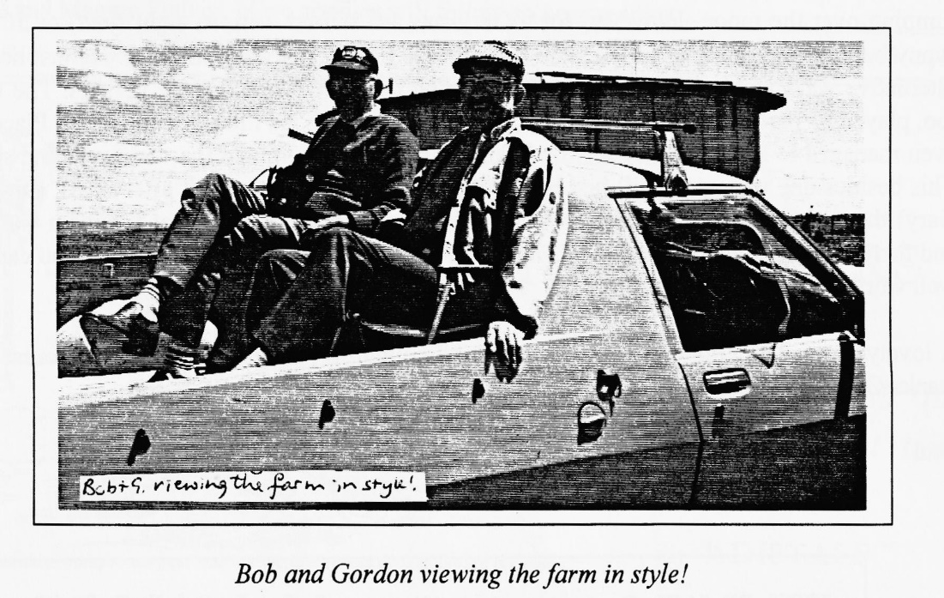
At the Bay to Birdwood Run we had met June and Alan Hale who own a very nippy 1937 Austin Chummy Tourer, restored and maintained in his impressive garden workshop - a recurring feature of all the car buffs we visited, and they invited us to tea at their home outside Melbourne. In fact, we had afternoon tea with the usual tea and scones and then about an hour later a cordon bleu three course meal. Expandable waistbands are a necessity when visiting Down Under! Then Alan took us to the meeting of the Melbourne Austin Seven Club who, as their Adelaide counterparts, have their own club premises. These were most impressive: roomy, carpeted, fitted kitchen, in-house printing set-up, workshop, shower room etc. In short, most luxurious. After the formal part of the meeting there was a fascinating talk by an ex-racing driver, and finally we were served tea by several male members of the club and driven back to our Youth Hostel by the Club President, Doug Veel, 1930 Austin Ulster Sports roadster owner.
Leaving Melbourne, we met up and stayed on a sheep farm with Bob and Joan Riches who reminisced about the wonderful joint birthday party of Phil and Dusty. As well as owning an Austin 7, Bob is also an old motorcycle buff and took us to a weekend Velocette rally near Tumbarrumba, near the Snowy Mountains. everyone stayed in the same Motel, and all those with their bikes went out on a daily run before returning at night to a lavish banquet Avery novel way to raise money for charity was adopted by the rally organiser: everyone was fined for something having the wrong-coloured socks, having a nice mother-in-law etc. Even being English and Austin 7 owners! Well, you can't win 'em all and apart from raising a whole lot of cash, the verbal `accusations' had us all rolling around the floor with hilarity.
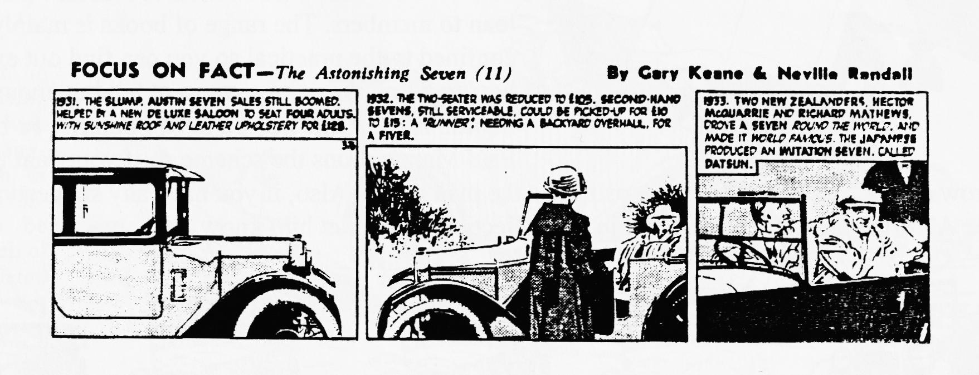
(To be concluded) Next Month! We meet Grandma and chase a crocodile. GORDON BROWN

THE GARY MARCH RUN
Hi diddle diddle, the Cat and the Fiddle and although I looked hard, I failed to see any cows jumping over the moon. However, for a Gary-run, we started well, in sight (just) of 10.45 It's funny but although none of us lives too far from the Forest, it always surprises me just how many alternative ways and bye-ways there still are to be found. We found some corkers. The weather, too, played its part in making for a really enjoyable run. With his influence in Higher Places, Gary even managed to lay on some snow and hail in between the rain and the very welcome sunshine. This besides one very steep hill just before lunch - just as well it wasn't afterwards. I'm told (by Gary) that we were 14 cars. I believe it for the car park at the Foresters at Frogham was packed and there were no other cars there when we arrived. The Pub did us proud an d if you can find it, well worth a visit.
A lovely run and a happy day. I even got a drink bought for me (not from Gary of course). Many thanks Gary,
Paul
'Club Library scheme
The Club now have a selection of Austin 7 books for loan to members. The range of books is mainly confined to the practical so you can find out exactly how to do all those jobs we were talking about last month. Also, it allows you to 'try before you buy'. Paul Mainzer runs the scheme so if you want to borrow a book, against a small deposit, he's the man to see. Also, if you have any suggestions for other A7 title you would like to see in the collection, please let him know.

Continuing the Antipodean theme, the following is the first installment of four. First published in the Austin Magazine, this comes from the pages of the Australian VAR magazine, kindly supplied by Joe and Maggie Stalker. More goodies will follow so keep reading…
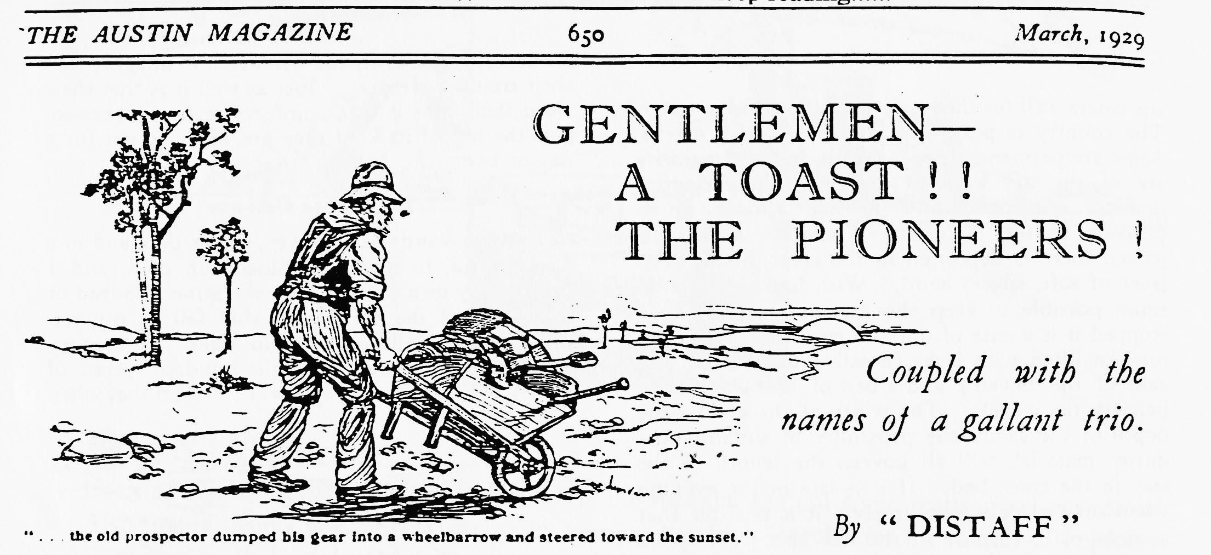

" They say this land outback is grand,
Mebbe to them that said it ;
I find it not a straight out scrub,
Nor yet an honest desert."

It is long since it was my privilege to pay tribute to a more gallant trio than that which has recently completed a remarkable journey to the top of Cape York Peninsula in Northern Queensland. Terse and to the point comes the information that the journey has been completed. How much is left to the imagination ! What must have been the adventures of MacQuarrie, Matthews, and the Austin Seven ? How comes it that this combination can achieve something that has puzzled the rest of the world for such a long time ? What lies behind the achievement ? Assuredly the journey was not all plain sailing.
As I sat before a comfortable fireside preparing this tribute to the gallant three, I found it not very difficult to visualise the adventures that were theirs whilst journey-ing to the far North. There are no roads connecting one town with another anywhere north of Mackay. Motorists are to be found in each of the many isolated townships but their machines are used for journeys be
tween homesteads and settlements, from farm to farm, or place to place within, say, a thirty-mile radius..
In the Sugar Country.
It is not very long after leaving Mackay before the first difficulties arise. Great stalks of sugar cane from six to sixteen feet in height testify to the richness of the soil, but the nature of the " going " testifies to the further fact that good soil does not mean good surface.
Soon the cane fields and their assurance of civilisation are left behind for a no-man's-land remarkable only for its many creeks. Indeed, it is not "a straight out scrub, nor yet an honest desert" ; either would be preferable from the motorist's standpoint. Men may write books about deserts and the difficulties which they present, but the pioneer motorist will plump for the desert every time if given choice between it and the ordinary Queensland outback. This is a land of terrific rainfall and, as is the way with old Mother Nature.

she caters well for the removal of the surplus water. The country is positively intersected with creeks. Some are permanently wet creeks, but the majority are of the dry variety (designed for periodical drainage purposes) and neither affords much pleasure to the motorist. When the water has passed there is deposited in the creek bed a deep layer of soft, silvery sand. With luck it is sometimes possible to keep the car moving, but once stopped it is a case of dig and corduroy. The car may be lifted with jacks (possibly by hand in the case of the Seven ) and a bed of branches made beneath the wheels. The width of the creek—the depth of the sand—the proximity of suitable corduroy material, will all govern the length of the stay in the creek bed. If it is late in the evening when such place is encountered, it is possible that a night will he spent in the one spot ; a tropical creek is not the best place for a comfortable rest, more particularly if the travellers have forgotten their 'skeeter nets.
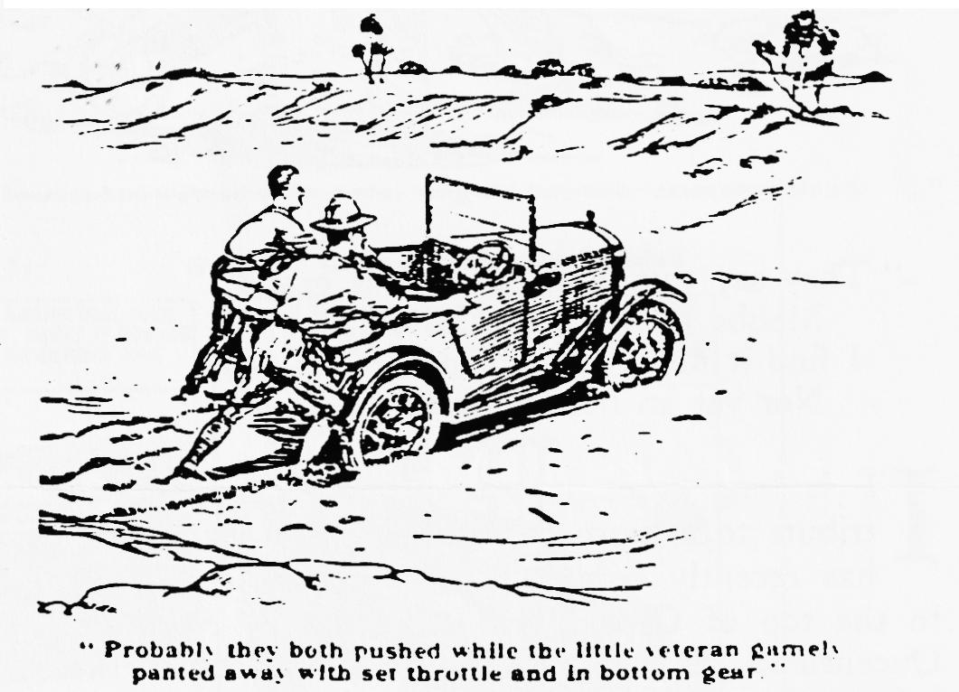
I am wondering just how glad were MacQuarrie and Matthews when they found temporary comfort at Proserpine. Here is a very nice little town with a 'couple of excellent hotels, a sugar mill, and no doubt a cheerful welcome for the visitors. We can imagine them tempted to linger, hut with memories of the past. and the knowledge of worse to come, it is doubtful whether they tarried long. The roads around Proserpine are few indeed and the mileage brief. Not half-an-hour will have passed before their troubles again begin. Creeks—scores of them. Washed-out tracks and devil-devil country will keep them amused all the way to Townsville. By this time their hands are blistered, and they have ceased to stow the axe and shovel under the baggage, hut are keeping these weapons handy near the top. The " Banjo " is in perpetual demand and the travellers have found that cursing is of no avail—are beginning to regard the difficulties as an essential part of the journey, as indeed they are! Methinks they had a rousing welcome in Townsville. The Austin is already popular in this fine northern city, and no doubt a crowd of enthusiasts would turn out to see the Seven that had tackled the trackless areas which they themselves prefer to give a miss—shipping their cars when going south.
Once more renouncing the fleshpots, our heroes push on for Ingham. This part of the journey by comparison with their previous adventures will pass like a song. The rutted tracks, washouts and miniature creeks will present no difficulties to the hardened trio, and we can 'imagine that they will rat themselves on the hack as they drive into the muddy old cane-town and will begin to imagine that their troubles are over. Just as well it is that their sleep this night is in a comfortable hotel, because it is the last of its kind, they are likely to get for a day or two.
Ingham to Cairns.
The very words have power, at this date and in a distant land, to make my blood run cold, and I think of my own journey over the same hundred or so miles and the adventures that fell to my lot. One hundred miles—one solid week. .A century of miles, but more than one hundred years of misery. I recall the Tully River ; the fact that when 1 crossed over in 1924 they were building the railway to the north. The line was laid upon sleepers across water that boasted some real old-man crocodiles. I remember with what enjoyment tilt railway workers informed us that one man and half-a-dozen dogs had fallen to the maw of the saurian since camp was pitched on the hank I lo". comfortable I felt when essaying to cross the river on the sleepers. This was the only way without a tremendous and difficult detour, as the water at this spot is anything up to sixty or seventy feet deep. Bump, bump, bump, sleeper to sleeper--wonderful means of progression ; a crocodile possibly waiting some fifty feet below—a tyre blow-out and precipitation into the sunlit hut wicked-looking water. We are in the very middle when along comes a ballast train and there are some tense moments until it is clear that the driver has his juggernaut under control. The crossing took about an hour. One hour of humps from sleeper to sleeper - I take my hat off to the men who must have piloted an Austin Seven over the same "road" I should have been afraid that the tiny vehicle would fall between the first two jarrah slabs.

FOR SALE
I've had a note from Sue Topham reminding me that she has got some really good new stock. Also, many thanks to Marion Trimby for running the Club Regalia for the month of February. With April and Spring weather (!) approaching, Tee Shirts and Ladies scarves will be available at the Club Meeting so do come along and take a look at our new stock.
Also....
Phil Whitter still has a few of the new tyres and tubes. 350/375 X 19" (6 ply) at £22:50 each, tubes are £5 each. There should still be a set of 400 X 17" including tube at only £37:50 each. Rim tapes for both 17" and 19" are £1 a set. Contact Phil on 01425 475558, but be quick!
And....
Pat Llewellyn announced at the last Club Night that she was arranging tickets for the Jazz Cruise on the paddle steamer Waverley which leaves Bournemouth Pier at 7 p.m. on Friday 19th May and returns for about 10 p.m. Although the offer has closed, Pat may be able to get a few more tickets. She has negotiated a group discount so tickets will be £10 each. Cheques payable to Dorset Austin 7 Club but ring Pat first for full details.

STOP PRESS
Continuous Licensing Consultation Paper Issued
The long-awaited Consultation paper was issued on Thursday 30 march 1995. We now have 3 months to examine this contentious proposal and make our views know. Your Committee have a copy and will discuss the paper at a Club Night. Once we have assembled all the club points, we will be submitting them in writing to Mr. Robert Oliver at the DVLA with our Club views. We also hope to attend one of several workshops set up by DVLA to explain the proposals, how they could affect Clubs such as ours and hopefully listen to what we have to say. Further details will appear as we get the details.
EVENTS
April
Thursday 20 Apr Clubnight. Apart from all the usual fun, Lawrence has kindly offered to put on one of his hugely enjoyable light-hearted quizzes. Last time, even I got some of the answers right! And it won't all be A7 trivia so come along and have some fun. Spares will also be available.
Saturday 22 Apr Colerne Speed Trials. This is a VSCC sprint meeting held on the RAF runway at Colerne, near Bath. Entry is free but spectators must be accompanied by a VSCC member. I hope to have my Ulster ready for it's first outing. If anyone else wants to come, let me know and I will meet you at the Warminster service area at 10 a.m.
Sunday 23 Apr Club Run. Glyn is arranging this month's run which will be to Exbury Gardens. Meet at the Ringwood. Furlong Car Park at 10.15 for a 10.30 start. Entry to the Gardens is £2.50 per person at the group rate (very good deals Pat is fixing!)
Sunday 30 Apr Daffodil Run. It's too late to enter but there may be a run over to Stockbridge to watch the rally pass through. If you wish to be involved with this very enjoyable run contact Gary.
May
Thursday 4 May Eight till Late. The In Crowd gather at the White Hart at Longham for the traditional Noggin. Come along for a chat.
Thursday 18 May Club Night at the Elm Tree. By way of a change, it will be a Skittles Night in the Barn. No spares this time but you can always ask Phil if you are desperate!
Sunday 21 May Club Run. A run out in West Dorset and no doubt more besides. More details next month but the start will be at the Lay By in Wimborne Road. 10.30 for a 10.45 move.

Other Events
Saturday 8 April VSCC Silverstone Race Meeting. First race is 1.00 p.m. There are 10 races in all, including Pre War big engine cars and Post War historic racing cars. It'd too late for reduced rate tickets but it's still a good day out.
Sunday 14 May VSCC Wiscombe Park Sprint Meeting. Always a popular event. Entry is about a fiver on the day. Anyone fancy a run down to Honiton area in convoy? Let me know.
Saturday 13 May Beaulieu Spring Autojumble. Claimed to be the second biggest in Europe! Find the go-faster bits for Wiscombe the following day!

