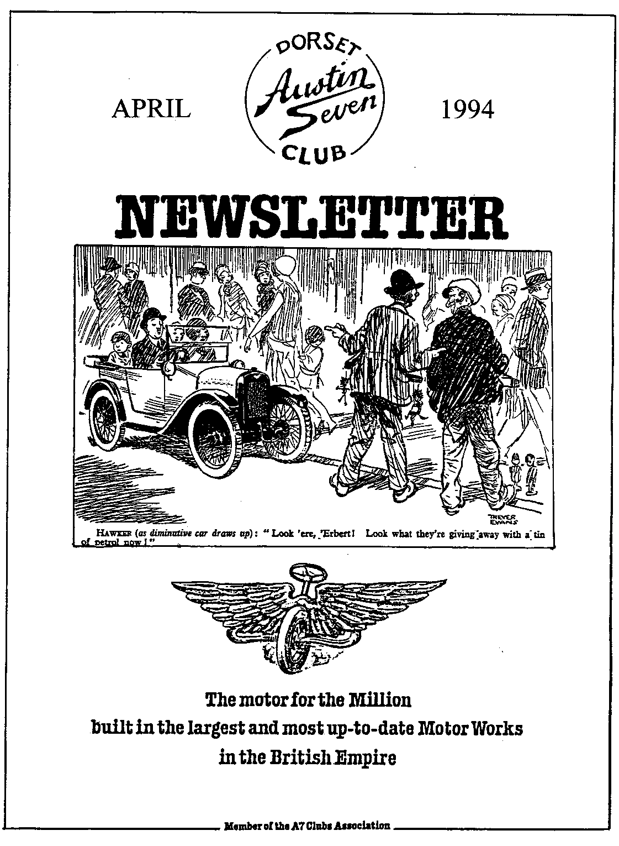

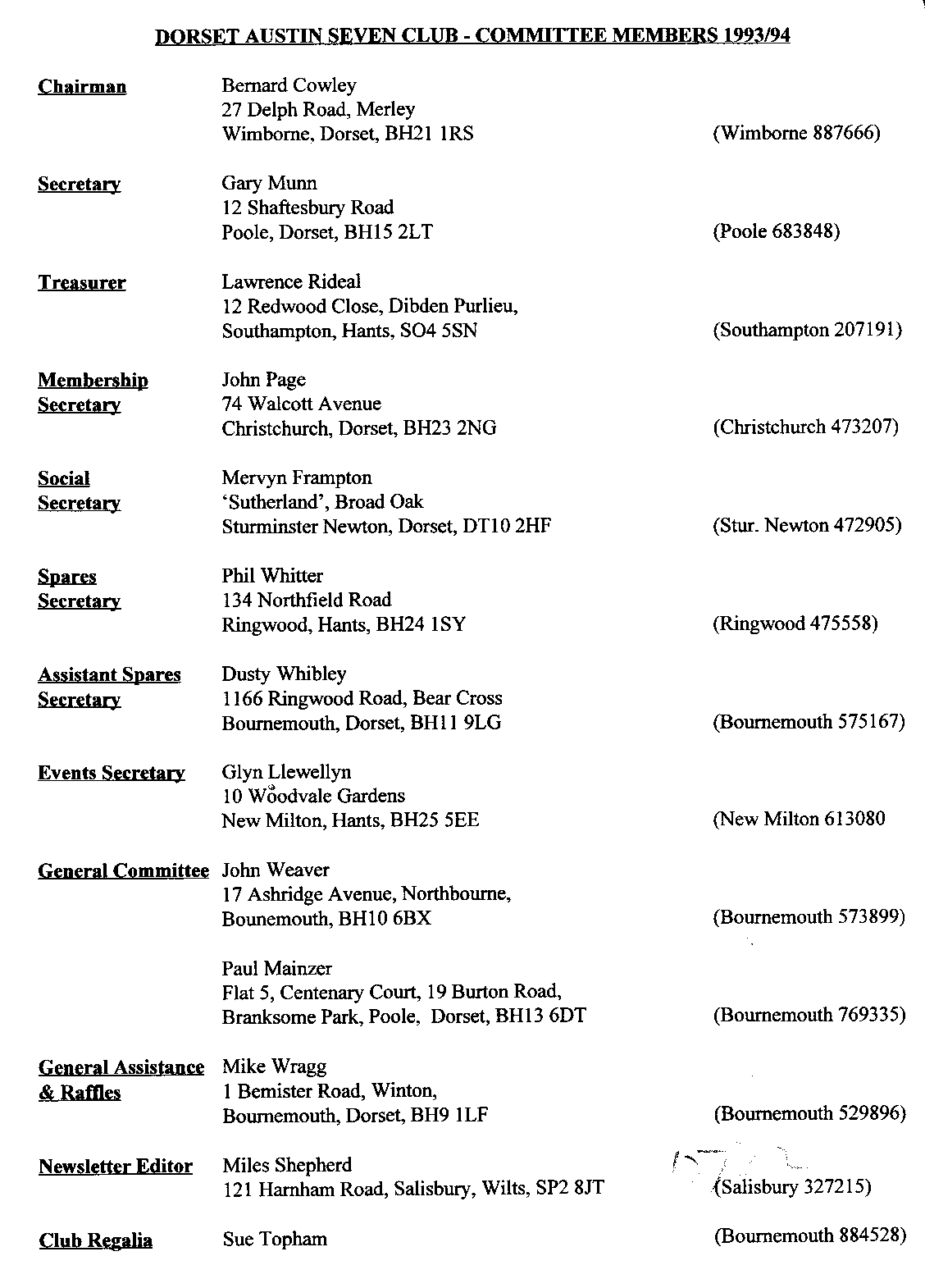

EDITORIAL

Hallo Everyone,
The 'Oh Dear' Department is open early this year! First of all, I got the date of this month's Clubnight wrong. Please note that it is 21 April, full details are shown on page 8, as usual. Second, if there was an error in the label on your last newsletter, it is due to my poor typing. I hope I have corrected all the mistakes but if there are still some problems, please let me know.
Having observed last month that there has been a great deal of activity over the last few months, I am delighted to say that the sporting season is well under way. Vintage Silverstone will have passed by the time you read this, and both the Pre War A7 Club and 750 MC are well into their programmes. Most of their events are some way away but if you are interested in attending or taking part, I will have details at Clubnight.
While on the topic of events, there are an amazing number of rallies, shows and sporting events so there should be something for everyone. I usually only publish details of local, or at least not too distant, events which are not published in Austin 7 Club publications. So if you wish to know about A7 events run by other Clubs, refer to the Association Magazine. Details of VSCC events are listed on the back page. If you can't find something to suit, give me a ring or see me at Club Night and I'll try to help.
You may notice a slightly different look to this month's Newsletter. I am using a new word processor and a new printer in an effort to speed up the production process. Apart from the opportunity this gives to experiment with fancy print effects and importing graphics, this is necessary because my firm has re-located to Swindon and I am expecting to have a little less time than normal to get the material to Gary to be printed. So should anyone wish to send in material on disk, I am using Word for Windows but can import most other word processor formats, any less typing speeds up the production!
See you at Clubnight. Miles

SECRETARIAL

Well Folks!
The Rally season is almost upon us once again. Traditionally, many people put their 7's back on the road for the 1st April, although looking at Club Run attendances during the winter, I think a large proportion of the membership keep their car on the road all year round. With the cheaper tax, good value insurance and good fuel economy, why not. After all Sir Herbert designed our cars to be used, not just kept in moth balls.
Paul Mainzer supplied the entertainment last Clubnight with his Feely Bags. It was a close run competition in the end, but well done Terry and Barbara, you obviously have the right touch!
Another good turnout for the March Run, although I didn't manage to get to the Farm myself. I'm sure an article will appear (Ed. see page 2).
There have been a few developments on our Swanage Classic Car Weekend and Autojumble, which takes place on 9 - 10 July. David Green at the Railway has confirmed that arrangements for the site, bar and marquee, etc. are all well in hand while we have received confirmation that "Diggery Venn" will be leading us in the Barn Dance. We have decided to have commemorative key fobs made for entrants, instead of the usual rally plaques. We thought it would make a change. Entry forms are available from Glyn and Pat. KEEP THE WEEKEND FREE, YOU'LL ENJOY IT! Gary.

Sue's Spring Saunter
\
Fourteen assorted A7s and one modern, with their eager drivers and passengers met at Safeways Car Park on a typical English Spring morning – dry and sunny but with a certain nip in the air. All set off roughly on time to first climb slowly up to Colehill and then at a leisurely pace through Broomhill, Whitesheet, Higher and Lower Row, the lovely village of Hinton Morten and on to meet the main Wimborne to Cranborne road. This is certainly a horse conscious part of Dorset for we met many young riders exercising their mounts.
Our route continued through Witchampton and on to the outskirts of the Crichel estate and house. The daffodils in the estate were just beginning to come into bloom, whereas it was noticed that the daffs in the roadside verges were in full flower.
After passing Crichel House, the convoy of 7s (plus of course the Modern) turned into a country lane, which during the very wet weather earlier in the year, had become very muddy. However, during the recent comparatively dry spell caused the cars to produce quite a dust cloud. My three young passengers in the rear seat of my Box all exclaimed in unison that this track must be named "Dusty's Lane" after our own Assistant Spares Secretary.
We continued through the many beautiful lanes of Dorset, passing Long Crichel, Gussage St Michael, Gussage St Andrew, Dean and on to Sixpenny Handley where to our surprise another Austin 7 joined the convoy. The owner is not a member of the Club as I understand he comes from Warminster but he was most welcome to join our happy band. Our journey now took us on to a climb into the hilly lanes of Wiltshire to Alvediston and Ansty.
It was during this stretch of the trip that our intrepid leader came to a full stop on a 1 in 5 hill with 6 or 7 other cars close behind. They, too, were forced to stop on this steep hill. Susi had to disembark and walk up the remainder of the steepest part of the hill before Brian could coax his car to the top. I am glad to relate that none of his followers had to face the ignominy of Susi's fate!
There were no further mishaps before the arrival at Farmer Giles Farmstead, although a few cars did go astray. All eventually arrived in their own lime. Even though the Farmstead were expecting the visit of our Club, I do not think that their restaurant were ready for the sudden influx of custom. However, we all eventually had our fill at very reasonable prices.
The afternoon was spent viewing the various animals, from the smallest bunny rabbits to the large Shire horse, including some Pot Bellied Pigs which amused our grand-children. A good view was to be had in the cow-shed looking down on cattle at milking time with one dairyman milking 12 - 14 cows at any one time. About mid-afternoon we all assembled in the car park to make our return journey home with a short stop at Ansty to feed the ducks by the pond-cum-lake.
Thank you, Susi and Ben, for your time and effort in organizing this wonderful trip and day out, for I am sure that all who took part in 'Sue's Spring Saunter' had an enjoyable day.
Marion and Ben

The cost of running a motor vehicle is an elusive quantity. A big car costs more to run than a small one; a fast car costs more to run than one of moderate speed, and given any car of any type or power, in the hands of one driver it will cost more than in the hands of another.
Economy in motoring need not mean inefficiency or insufficiency. It is just a matter of care.
The first economy is to buy well.
Depreciation - always going on whether the car is used or not -suggests that the first cost is compatible with the accommodation and the speed required, and of these two considerations accommodation should come first. For four passengers (including driver) an eight or ten horse-power car gives ample room. There is no room for an additional passenger, but the fuel and tyre economy of the smaller power, the lessened taxation and depreciation, are important assets to the man or woman of moderate means.
But given any type of car, of any horse-power or any width, length, or accommodation there are some basic rules of economy which, if carefully
and faithfully carried out, will reduce the mileage cost of motoring without impairing the service or the pleasure to be derived from the use of the car.
These rules refer mostly to the actual driving of the vehicle.
High bursts of speed send up the fuel bill. One may travel from London to Manchester in the same running time and under the same load and with the same stopping periods, and in one case consume 10 per cent more fuel than in the other.
Keeping a fair average speed and avoiding crawling for part of the way and speeding for the other will make a definite saving in the fuel consumed. Speed always increases fuel costs, which can be said to go up at twice the rate at which the speed is increased. It is well worth bearing in mind that for economy a steady average should be aimed at. Not only does it save on fuel, but it is less wearing for engine, transmission and tyres. But tyre economy is not merely a matter of restraint in respect of speed.

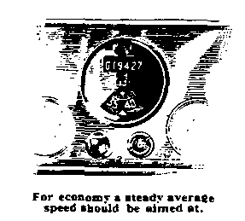
The biggest strain and greatest wear comes on tyres by starting, accelerating and slowing. The rapid spectacular start - beloved of the speed man - is a tyre eater. Rapid acceleration at any time is just as wearing to the substance of the tyre and to the cotton cords which form its structure, as sudden and violent brake application. The former is accompanied by excessive and useless expenditure of fuel. The latter also wastes fuel, for to drive under full power to the last moment and then take it out of the tyres to achieve a sudden stop, is waste at both ends. Most motorists use their brakes much more than is really necessary and so wear out tyres and brake fabric and add very materially to the mileage cost of running and repairs.
Sudden accelerations and decelerations also entail wear of the engine. Cylinder wear is increased by quick opening of the throttle which causes a rush of liquid petrol into the cylinder, sweeping away the lubricant and inducing excessive friction and wear between piston rings and cylinder walls. The expense comes in before re-boring is required as the wear increases the consumption of oil, the most expensive accessory to motoring.
Failure to keep the mechanism of the car adequately lubricated with the right lubricants involves expense which can be avoided. Gears and back axle drives starved of clean new oil wear unduly and require earlier replacement.
Engine big ends and main bearings wear badly if the lubricant is not changed at the proper intervals.
It is false economy to denude the engine by allowing it to run for long periods with worn-out and unchanged oil.
Economy in oil means buying the best, generally the most expensive, which lasts longer and so costs less for a given mileage and defers indefinitely expensive engine reconditioning which would eat up the cost of a year's supply of lubricant. Cheeseparing on the cost of engine lubricant is not economizing. Some oils are more expensive than others, and low priced oils often prove to be the most expensive of all.
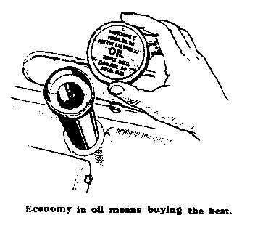
True economy means making adjustments for wear as soon as they become at all necessary. Delaying small matters means the certain arrival of big and expensive troubles. The little attentions cost no more than a little of the owners time, but as they save pounds of cash, they should be given right from the commencement of the use of the car.
When the car is new, high speeds, especially high engine speeds, are expensive and should be avoided. A rigorous restriction of speed during the first thousand miles will give the car a chance of many months of longer wear and use than it would otherwise have. It is useless to adopt any economy after a few thousand miles of all-out, full-power, full-braking, and full-acceleration driving. The mischief has been done and only money spent on expensive overhaul and reconditioning can put the matter right.
From the Austin Magazine of January 1936

AUSTIN SEVEN BEGINNINGS - 42 - A STORY OF AUSTIN FOLK ANDY WALLS
"Ooh!, Ahh!, Look, it's an Austin Seven. Ay! Just look at it, and to think I did my courting in one of them! How did we manage?"
One of, no - perhaps the most romantic observations of the IUTOOT (I used to own one of those) type of comment we all get from time to time.
Andy can go one better for he used to do his courting in his Father's Seven, sitting out in the drive before he could drive.
After he had passed the Driving Test, the 1931 Box was given to him by Dad who usually had about three hanging around as rollover spares. 'Sort of the Lada of the day, weren't they?' says Andy. Modem junk or not, Andy used his for work and even for intrepid journeys from Boscombe to Epsom and back. Then the 10 year MOT came in, writing off as it did many of the pre-war cars as scrap - which one often had to pay to have taken away.
Despite having other cars, Austin Seven ownership yearnings led Andy a merry dance through a couple of years and areas as far afield as Broadstairs in Kent, Gloucestershire and Whitchurch near Newbury. Here it was that he joyfully loaded his Chrome Rad Two Seater Tourer, brought it home and unloaded it only to find that the crown wheel and pinion had 'GONE'. Putting it mildly, he was just a tiny bit miffed: all this trouble to no avail. The previous owner did offer to take it back or return £120 towards the cost of repairs. And took this latter option. Fortunately for him, Bob Stanley happened on the scene, bringing his knowledge and experience to bear, guiding the overhaul of.... engine bearings, front axle, radius arms... well, in fact everything apart from the paint and upholstery.
No matter, WSU 200 (a very appropriate `year related number' from Cardiff) is not only alive and on the road but is also Andy's only car so is in daily use. "After all, that's what the car was designed for in the first place" reflects Andy as he prepares for a trip to look around the Normandy beaches.
•
BB Mar 94
PS - Anyone wanting B&B or a Gite, with spacious safe parking in that area would do well to try Michael and Rosemary Chilcott at Manoir au Pont Rouge, St Loup Hors, 14400 Bayeux, Calvados, Normandie. (Tel, from UK 010 33 3122 39 09. Michael is also extremely knowledgeable on the history of the Normandy Beaches and I believe he will do conducted tours for small groups.
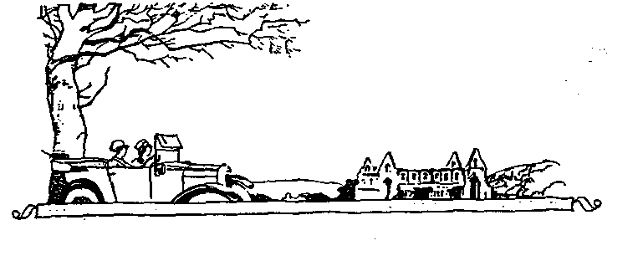

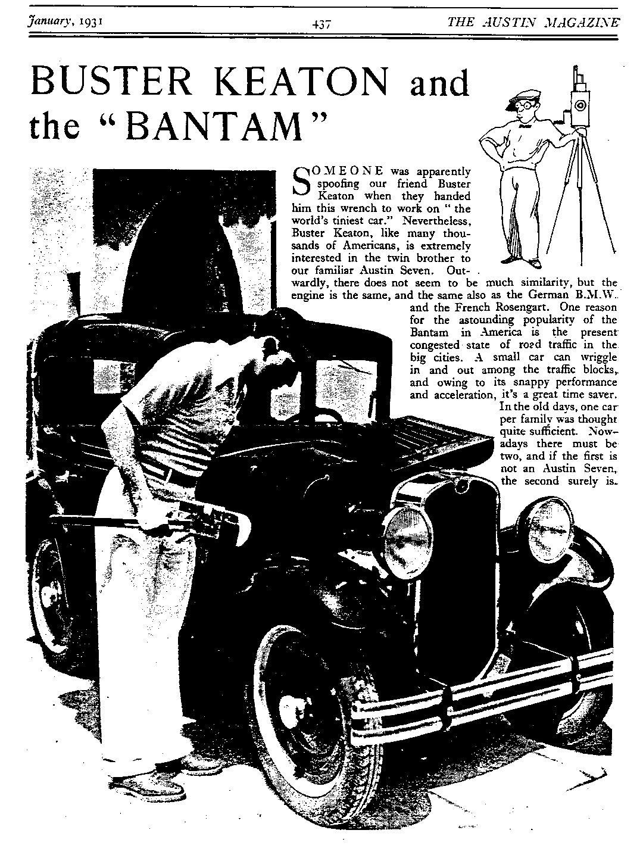

CLUB NOTICE BOARD
FOR SALE
- Five New (old-stock) 400 x 17" Dunlop tyres. These are the only original tyres suitable for Rubies etc. and are totally unobtainable. £120 the set.
- Five New (old stock) 400 x 17" Homerton Remoulds. Bargain at £60. Phil Whiter Tel: 0425 475558
WANTED
Help! - Austin 7 Owners! Please phone Louise on 0425 272295. Morning of May 28th Two little bridesmaids hitching to Lymington Registry Office - Can anyone assist?
CLUB NOTES
I have a few notes passed to me by our Chairman, some of them are a little old but bear telling none the less! Tony Day asked me to thank all those who entered his Christmas Cross word competition. The result was a tie between John Weaver and Joe Stalker. Congratulations to both.
Has anyone seen the Chairman's "new" Ruby? I heard, in February, that it was due to be on the road within the “next month” - no prize for a sighting but I would be grateful for a photo! Other "new" cars seen so far this year include the Stalker 2 seater which had its first Club airing at New Year, as did the Tophams' latest 1933 Open Road Tourer.
There is a rumour that some members of the Club have taken up cycling and caravanning. Seems unlikely, I know but that's what the word on the street is! Any more news would be welcome.
There are two books which may interest readers: the first is not new but is the long awaited 2nd edition of Bill Williams' classic Austin Seven Specials. If you haven't got, this is a must. As it is a revised edition, many enthusiasts will be buying one anyway. The other is The Enthusiasts' Guide to Vintage Specials by John Bateman, my predecessor as Editor of the Association magazine. I have not seen a copy yet but his research was always meticulous so I have no doubt it will be in great demand. Both are available from Haynes at Sparkford Museum call 0963 440614 for further details.
OTHER CLUBS NEWSLETTERS
We receive newsletters from several other A7 Clubs, such as A7 Owners from London, Bristol, Midlands, Solent, South Wales, Scottish and 750MC. Filch is different, both in size, layout and content. All are interesting, giving an insight into how the rest of the A7 world go about enjoying themselves. Technical articles seem to be few and far between. Perhaps it has all been said before, or perhaps the availability of well written manuals has reduced the need for such items. I did read in the Pre War newsletter that they were recording on video how certain major overhaul activities are carried out. Seems a good idea to me, the theory is fine but there is nothing like seeing an expert do it in the comfort of your lounge - especially as you do even have to clear up the mess! The only problem is how do you get the tele and video down to the Motor House without causing angst indoors! There was a very good article in Meshing Point, the Scottish journal, on A7 synchro gearboxes which I hope to 'borrow' later! See you all at Club Night, Miles

CLUB EVENTS
April
Thursday 21 Apr Club Night. Photocall at the Elm Tree - Bring a photograph of yourself as a young child. Others to judge. Guess the Identity, Prize for the winner! No spares available!
Sunday 24 Apr Club Run. Wadworth’s Brewery Visit. Meet at the Safeways Car Park, Wimborne at
9am for a 9.15 sharp departure. For full details see Feb newsletter.
Thursday 28 Apr Committee Meeting. At the Tyrell's Ford, start time 8pm.
May
Thursday 5 May 8 ish till Late. The gathering is at Kings Arms, Longham. Meet us there for a noggin and natter.
Thursday 19 May Club Night. Once again at the Elm Tree, details not to hand as we go to press but you can bet that the crowd will all be there, so why not join us. Phil will no doubt have the spares should you need that hard to find item.
Sunday 22 May Driving Tests. Meet at the Safeways Car Park at 10 am for a 10.15 start. After a short run, the Annual Driving Tests will be held at Blandford Camp. Barbecue available, bring your own picnic.
Thursday 26 May Committee Meeting. As usual at the Tyrell's Ford, 8 pm start
OTHER EVENTS
Sunday 23 Apr Colerne Sprint Held on the disused runway off the A4 near Bath. Entry is free but access is only available to those accompanied by a VSCC member. Let me know if you wish to go - I am a member and will go if there is sufficient interest.
Sunday 8 May Wiscombe Park Hill Climb. This popular event is run near Honiton in Devon and attracts many spectators from the Club. Practice starts at 9.30 and the competition proper is at 2 pm. Admission at the gate only, price £3 each, children 15 and under free - but no dogs!
Weekend 13/14 May Fordingbridge Rally. 1940's D Day theme (optional). Details from Phillip Hadfield on 0425 654736.
Sunday 5 June 750 MC Austin Allsorts Rally. Norfolk. Details from Paul Mitchell Tel 0953 604304
Saturday 11 Jun Hawthorn Memorial Race Meeting. Silverstone. First race 1 pm but practice starts at 9.15 am. Tickets, including paddock transfer, are £9 each, ordered through me by 1 Jun 94 or £ 10 on the day.

