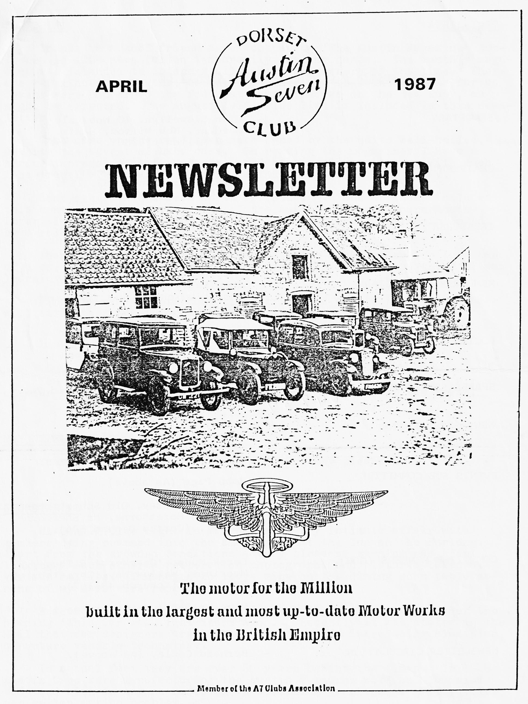

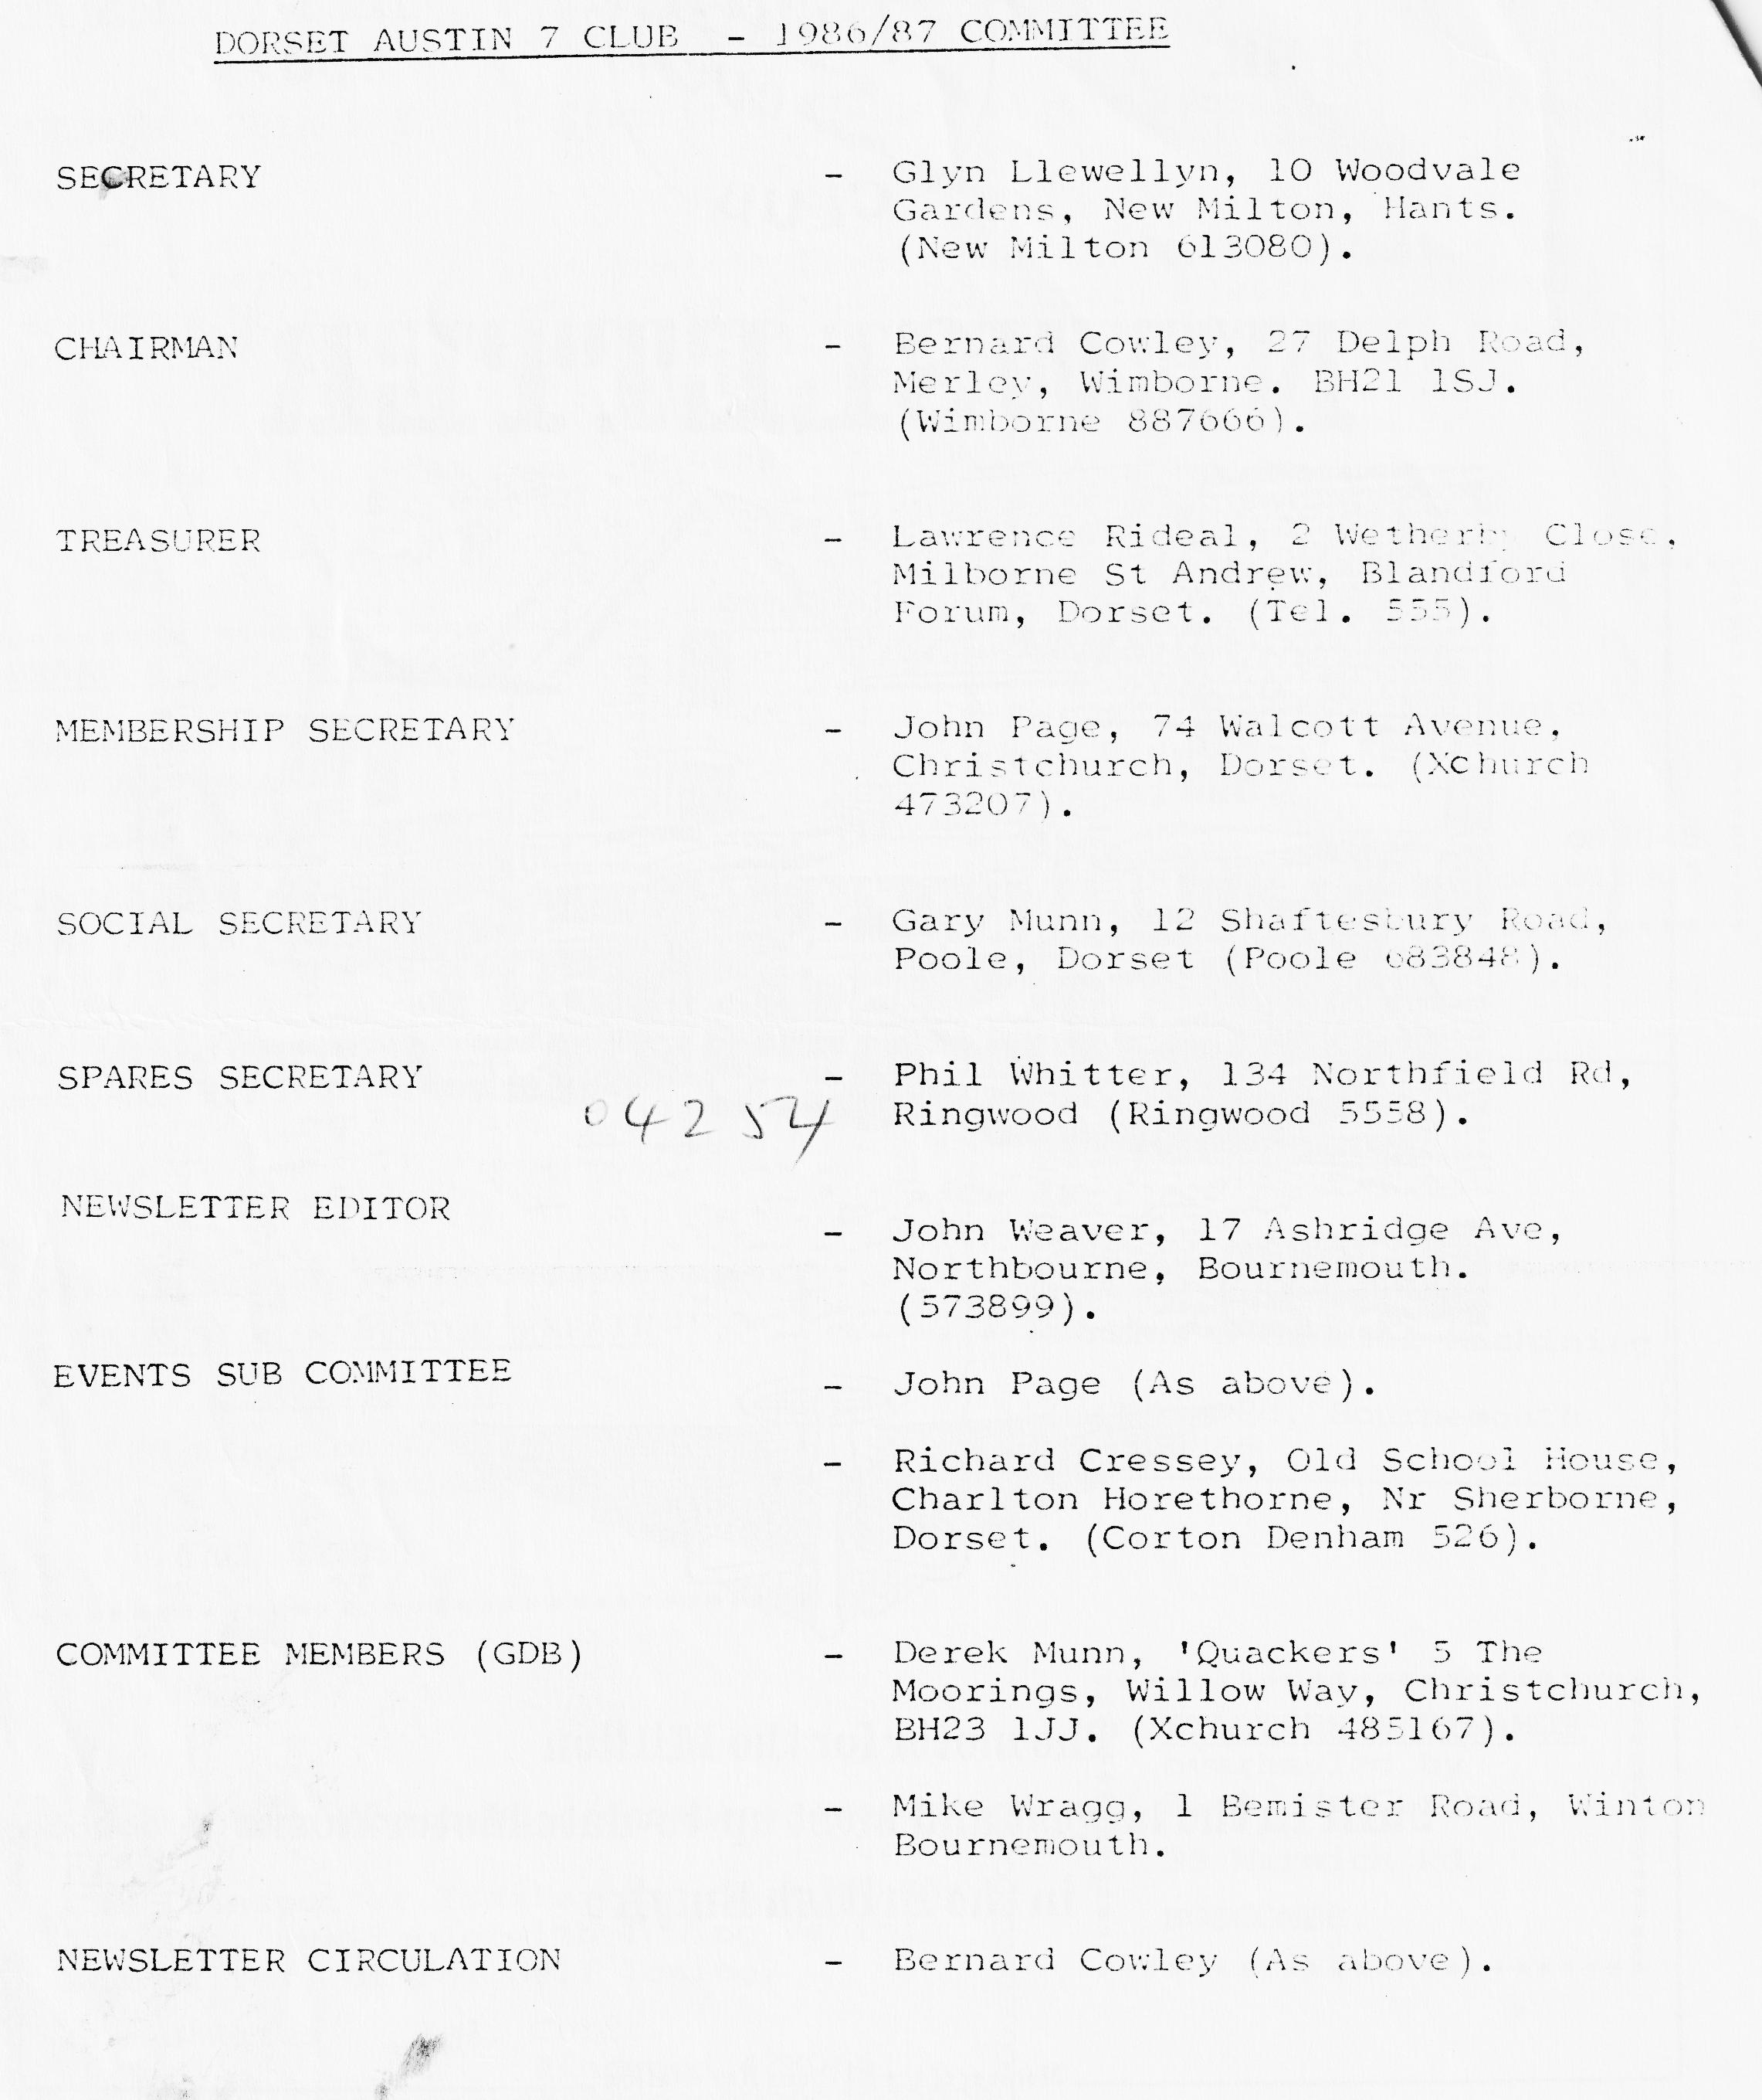

EDITORIAL APRIL 1987
Thanks to a good friend, a few copies of 'The Austin Magazine' published in 1936 have fallen temporarily into my hands. The monthly magazine was intended to interest all Austin car owners of the time. There are references to Sevens, as well as Ten Fours to Twenties. As far as Sevens were concerned the focus at that time was on the new Ruby, as might be expected. The August 1936 price list is included in this newsletter.
Most cars on the road then were owned by the quite well-heeled, despite the advent of baby cars. On reading the magazines I have a strong impression that they are aimed at an elite, but one with much less practical mechanical knowledge than most of us have today.
Some ether things seem worth reproducing. One of those included this month concerns the opening cf the Austin dealers 'Bournemouth Imperial Motors Ltd.' by no less a person than Lord Austin, followed by a rally on the East Cliff.
Thanks also to a certain part-time motor book dealer for the loan of a collection of 1929 motoring cartoons. Where were you then? I was learning to walk!
Final thanks to this month's contributors and to those who I hope will still pass something interesting my way.
John Weaver
+++++
You may recognize the cars on this month's cover. There's a pint cf your favourite brew for the first to tell me where it was taken.
+++++
MAY NEWSLETTER
Your contributions are needed - by 3rd May please.
+++++
SECRETARIAL
Hi Gang. Club night in March was a very intimate affair with members being crammed into the small room at the Inn on the Furlong. Apart from the crowded conditions a very pleasant evening was spent looking a each other's restoration photographs and pictures taken at various rallies. I managed to leave mine on the dining room table so none of my cars were represented.
I found the following letter in the Daily Mail recently under the heading 'This Car Was Light Years Ago'. "Recently it was stated in the Mail that car designers are light years ahead in introducing aluminium structure vehicle technology. In actual fact they are over 50 years behind the times. In 1928 Austin cars were manufacturing the Austin 7 tourer with an aluminium body and with an engine based on an aluminium crank case. Fifty miles per gallon was no problem. The whole car was SO light that one day I was stopped by a fire hose across the road and it was possible to lift the car over it."
Have any of you noticed the latest non-Austin 7 to appear on our runs? Jo from New Milton has recently acquired a 1978 Morgan 4 4 in bright red, it is in first class condition, and is a very pretty car (for a non-Austin).
A rally I heard of recently but seem to have lost the info. on is being held at Brooklands in Surrey on Sunday 4th October by the 750MC. As well as the rally one can visit the museum and view the parts: of the racetrack remaining.
Gary Mann and myself will be attending, the Austin Seven Clubs' Association meeting on April 12th. Will any members with trophies from the Spye Park Rally (Bristol A7 Club). please let one of us have them so that they can be returned.
Finally, if you have more than one Austin 7 insured with Direct Insurance, when they send your renewal forms check that they have only charged one brokerage charge of £5. I have three and they had put on each. When 'phoned I was told it was an error by the computer!
Glyn
+++++
OTHER EVENTS
On 10th May the Bournemouth and Poole Preservation Club Annual Vintage and Classic Car Run is again being run in conjunction with the 'Bournemouth 30s' Festival. The run starts at Bournemouth Station with a break at Lymington, lunch break at Ringwood and final assembly at the Pier Approach, Bournemouth, where cars and occupants will be judged as a 'period piece', i.e. relevant costume will be necessary for this.
Further details can be obtained from Rod Whild, 5 Victoria Crescent, Parkstone, Poole,-Dorset BH12 2JQ. We joined in last year and thoroughly enjoyed the day(Ed.).
On 3rd and 4th May the Woodford County Fayre takes place. Some of us have supported this in the past, details of Classic Car entries from S. Kerley, Wishford Road, Middle Woodford, Salisbury, Wilts. SF4 6NG as soon as possible. Tel: Middle Woodford 320
The DA7C is invited by the 1st Milton Scout Group to join in a Car Treasure Hurt on Sunday 17th May. Meet at the Scout Headquarters, Lymington Road, New Milton at 3 pm. There will be a stop for a picnic tea (bring your own). An entry fee of £1 is requested for Scout funds. For further information ring Pat Llewellyn. - New Milton 613080
The DA7C Easter Guernsey Run departs from Portsmouth on 15th April 10 am. If anyone has a direct line to the Clerk of the Weather (Marine Division) see what you can do for us. Report in the May Newsletter.
++
CHARLTON HORETHORNE FEAST DAY - 27th June 1987
As part of the village's annual Feast Day (fete) celebrations, we are organising a small display of cars on the forecourt of the local garage. We would particularly welcome any members of the Club who would like to bring their Austin 7 along. The fete opens at 2 pm and will finish at approximately 5 pm. The fete attractions will include a variety of stalls, car boot sale, the Sherborne Town Band and craft display. Additionally, the Church, local Cabinet Maker's workshop and Village pottery will be open.
In the evening there will be a Barn Dance (with an excellent local band and caller) and Barbecue at the Village Hall - tickets £2 - or alternatively a disco at the local pub. Camping facilities can be arranged.
If you are interested in joining us on the day, or would like more information, please ring either Richard or Margaret Cressey on Corton Denham (096 222) 526.
THE MARCH RUN TO THE PURBECKS VISITING TYNEHAM ‘GHOST' VILLAGE
After all the threats of snow during the preceding week, Sunday morning dawned bright and sunny. I fed the birds, sniffed the air, and backed up by the weatherman on the radio, decided it was going to be a reasonably dry day.
Assembled in Wimborne Square were seven Austins and Jo in her motorised plank (her description, not mine). At 11.05 am we set off and somehow managed to lose two of the Austins before leaving Wimborne. Heading out on the Dorchester rood towards Bere Regis, our leader turned left and drove across Worgret Heath-. A few clouds were scudding across the sky - but nothing to worry about.
The lanes became narrower and we arrived at the 'Weld Arms' at East Lulworth. The Barnes family from Shaftesbury, in a modern, joined us in the car park at the rear of the Inn. John decided to park his 'Gabrielle J' at the front, just in case our lost friends turned up looking for us.
There was a nice log fire, a good choice of food and the service was fast and efficient. On looking out of the window it was decided the weather forecast was wrong, the heavens opened and there was some real 'West Country stuff' falling from the skies for the remainder of the trip.
Leaving the 'Weld Arms' the gallant little Austins charged up Whiteway Hill pausing briefly for us to peer through the gloom from the View Point. Driving along the ridge it was more like flying through cloud, with glimpses of the beautiful countryside below.
On descending to Tyneham Village some of our party donned sou’wester and oilskins, the others, wet suits and flippers, before venturing out to look at the ruined cottages and the restored school and church, now museums. The old photographs of the villagers who were turned out of their homes in 1943 in order that the Army firing ranges could be extended tell a very sad story. Could this happen in 1987, or would there be petitions, marches and protests?
It was unanimously decided that the planned walk to Worbarrow Bay would be a miss.
Gary's precarious descent from the car park was something to behold. He nose-dived his Austin down a steep muddy bank. Our Ruby (Victoria) was trembling at the sight, so Gordon chose a more dignified exit and she calmed down.
Many thanks to John and Gay for organising a most interesting run. Perhaps we could take the weather by surprise one day in the future and do it again.
Lena Tope
IMPORTANT When on a Club Run it is essential to keep an eye open for the car behind. If it stops or does not appear you must stop. If we all do this no one will ever become lost because everyone will stop.
JO’S MORGAN
I think most of you probably know by now that I have purchased another car (sorry it's not an Austin Seven,) It is a 1978 aluminium bodied Morgan 4/4, with only 15,000 miles on the clock, from new. I noticed it in Packer-Duncan's advert in 'Classic Car'. He is the main Morgan dealer in Stourbridge, near Birmingham. Bob and I went to look at it on January 2nd and I fell in love with it straight away, even though there were a dozen or so other Morgans to choose from.
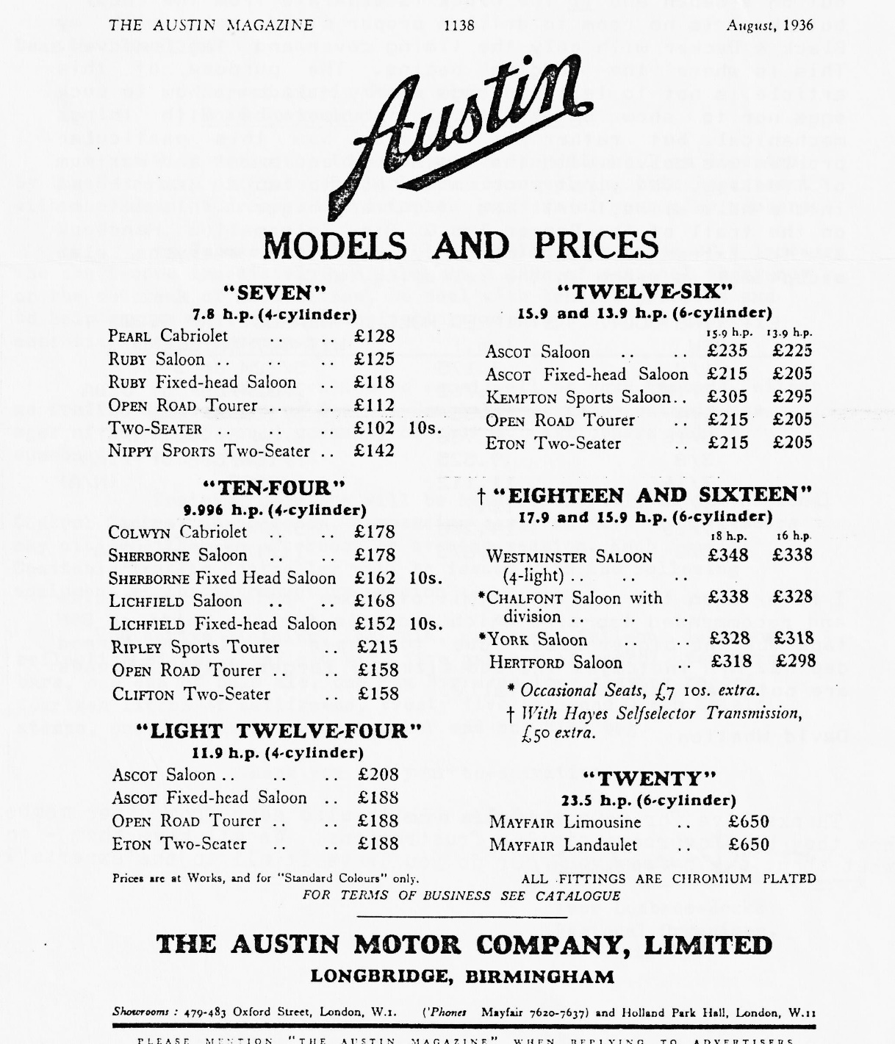
We went up to collect it on January 12th, which you may remember was the coldest Monday of the year, the day before we had all the snow. It was so cold that Bob's M.G.B. kept freezing up on the inside all the way there: I was very concerned when we reached Cirencester and it started to snow heavily, but luckily it cleared before we made our return journey. I didn't even notice the cold on the way home. I was too busy concentrating on driving my new toy:
I was going to bring the Morgan on the January run, but unfortunately it was practically snowed into the garage that week (thanks Glyn for keeping the secret to yourself until the February run - I know it was not easy;) Anyway, now you all know a bit more about my Morgan. I have to admit that it’s the car I've always wanted., and I hope to keep it for some time, but I promise that my next car will definitely be an Austin Seven: Let's hope that we have a. good Summer this year so I can enjoy lots of topless motoring (Hands up, all those who didn't think I was talking about the car!) See you on the next run.
Jo
BODGER’S CORNER — ,or tips that may be useful
When you are putting in as much oil as petrol the time has come for action. My particular problem was the square—headed locating screw for the front cam—shaft bearing, one of the most inaccessible but tantalisingly visible sources of trouble. According to the A7 Companion, it appears that the failure is caused by a combination of two main design faults — a peg that is too small but offers up a great leverage on its upper thread and a hole that goes right through to the shaft. The kick of the bearing on the bottom of the peg soon churns up the thread at the top of the screw and the bearing oil pressure is quite high (for an A7 that is) at the point of the hole. The result is similar to an oil well in full production.
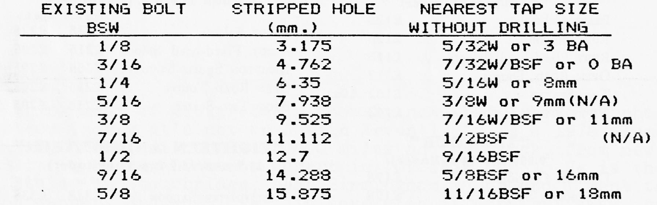
The Companion's under— stated advice is simply to re—tap the hole in the case and bearing and run a larger bolt all the way down. Now I can see that is simple if the engine is out on a bench and if the block is separate from the case, but there is no room to drill a proper sized hole with my Black & Decker with only the timing cover and fan removed. This is where the bodging begins. The purpose of this article is not to tell old lags (sorry — lads —) how to suck eggs nor to show up my total incompetence with things mechanical, but rather to describe how this particular problem was solved with the minimum of equipment and maximum of fiddling. The first problem was how to tap a new thread into a hole without drilling it out any bigger. This set me on the trail of the Dormer Tap & Die Information Handbook and the extracted info, probably known to everyone else except me, is shown in the following table:

I have taken the arbitrary limit of 0.5 mm between hole—size and recommended tap—size which accounts for the shift to BSF taps for the bigger sizes due to their shallower thread depths. N/A indicates the odd sizes of larger metric threads are not available commercially.
David Whetton

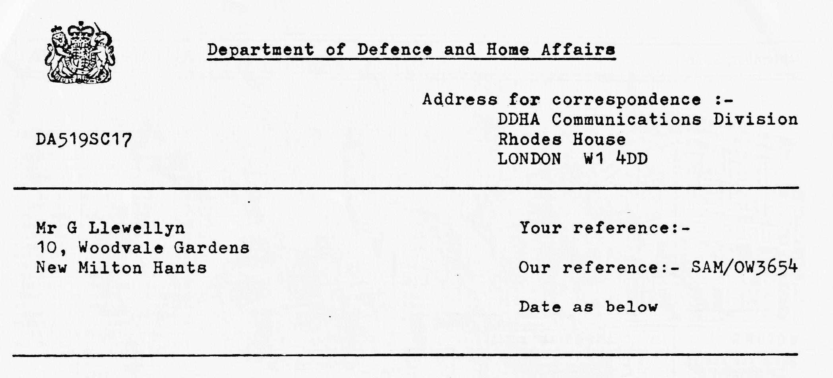
Dear Mr. Llewellyn
Dorset Austin Seven Club
Road Communications - South West
With reference to previous correspondence I am directed by the Secretary of State-to thank you for supplying this Department with the names, addresses and telephone numbers of your club members.
As I have explained, the formation of a corps of volunteers who can become immediately available at a time of national emergency, or the outbreak of hostilities, to deal with traffic problems and to help ensure that road communications are kept open is deemed essential by the Government.
It is our intention to enroll all of your members, either as Traffic Controllers or Special Constables. Those outside the ages of 18 and 65 would normally be exempt. All others will be summoned to begin training.
Training sessions will be held fortnightly at the Regional Control Centre, Southampton, commencing early in May. Your members may attend either an afternoon or evening session. Each Special Constable/Traffic Controller will be issued with the following equipment at the introductory session. Protective clothing, insignia, gas mask, fall-out detector, reflective signs, first aid kit, five gallons of petrol, ten Mars bars, one can of pale ale, one Max Bygraves long playing record, fourteen litres of antifreeze, twenty five thousand Green Shield stamps, one C. Payne luncheon voucher and one sick bag.
Thank you for your co-operation.
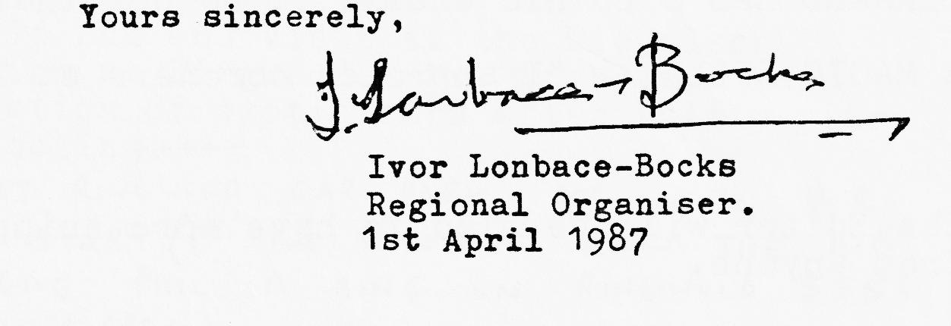

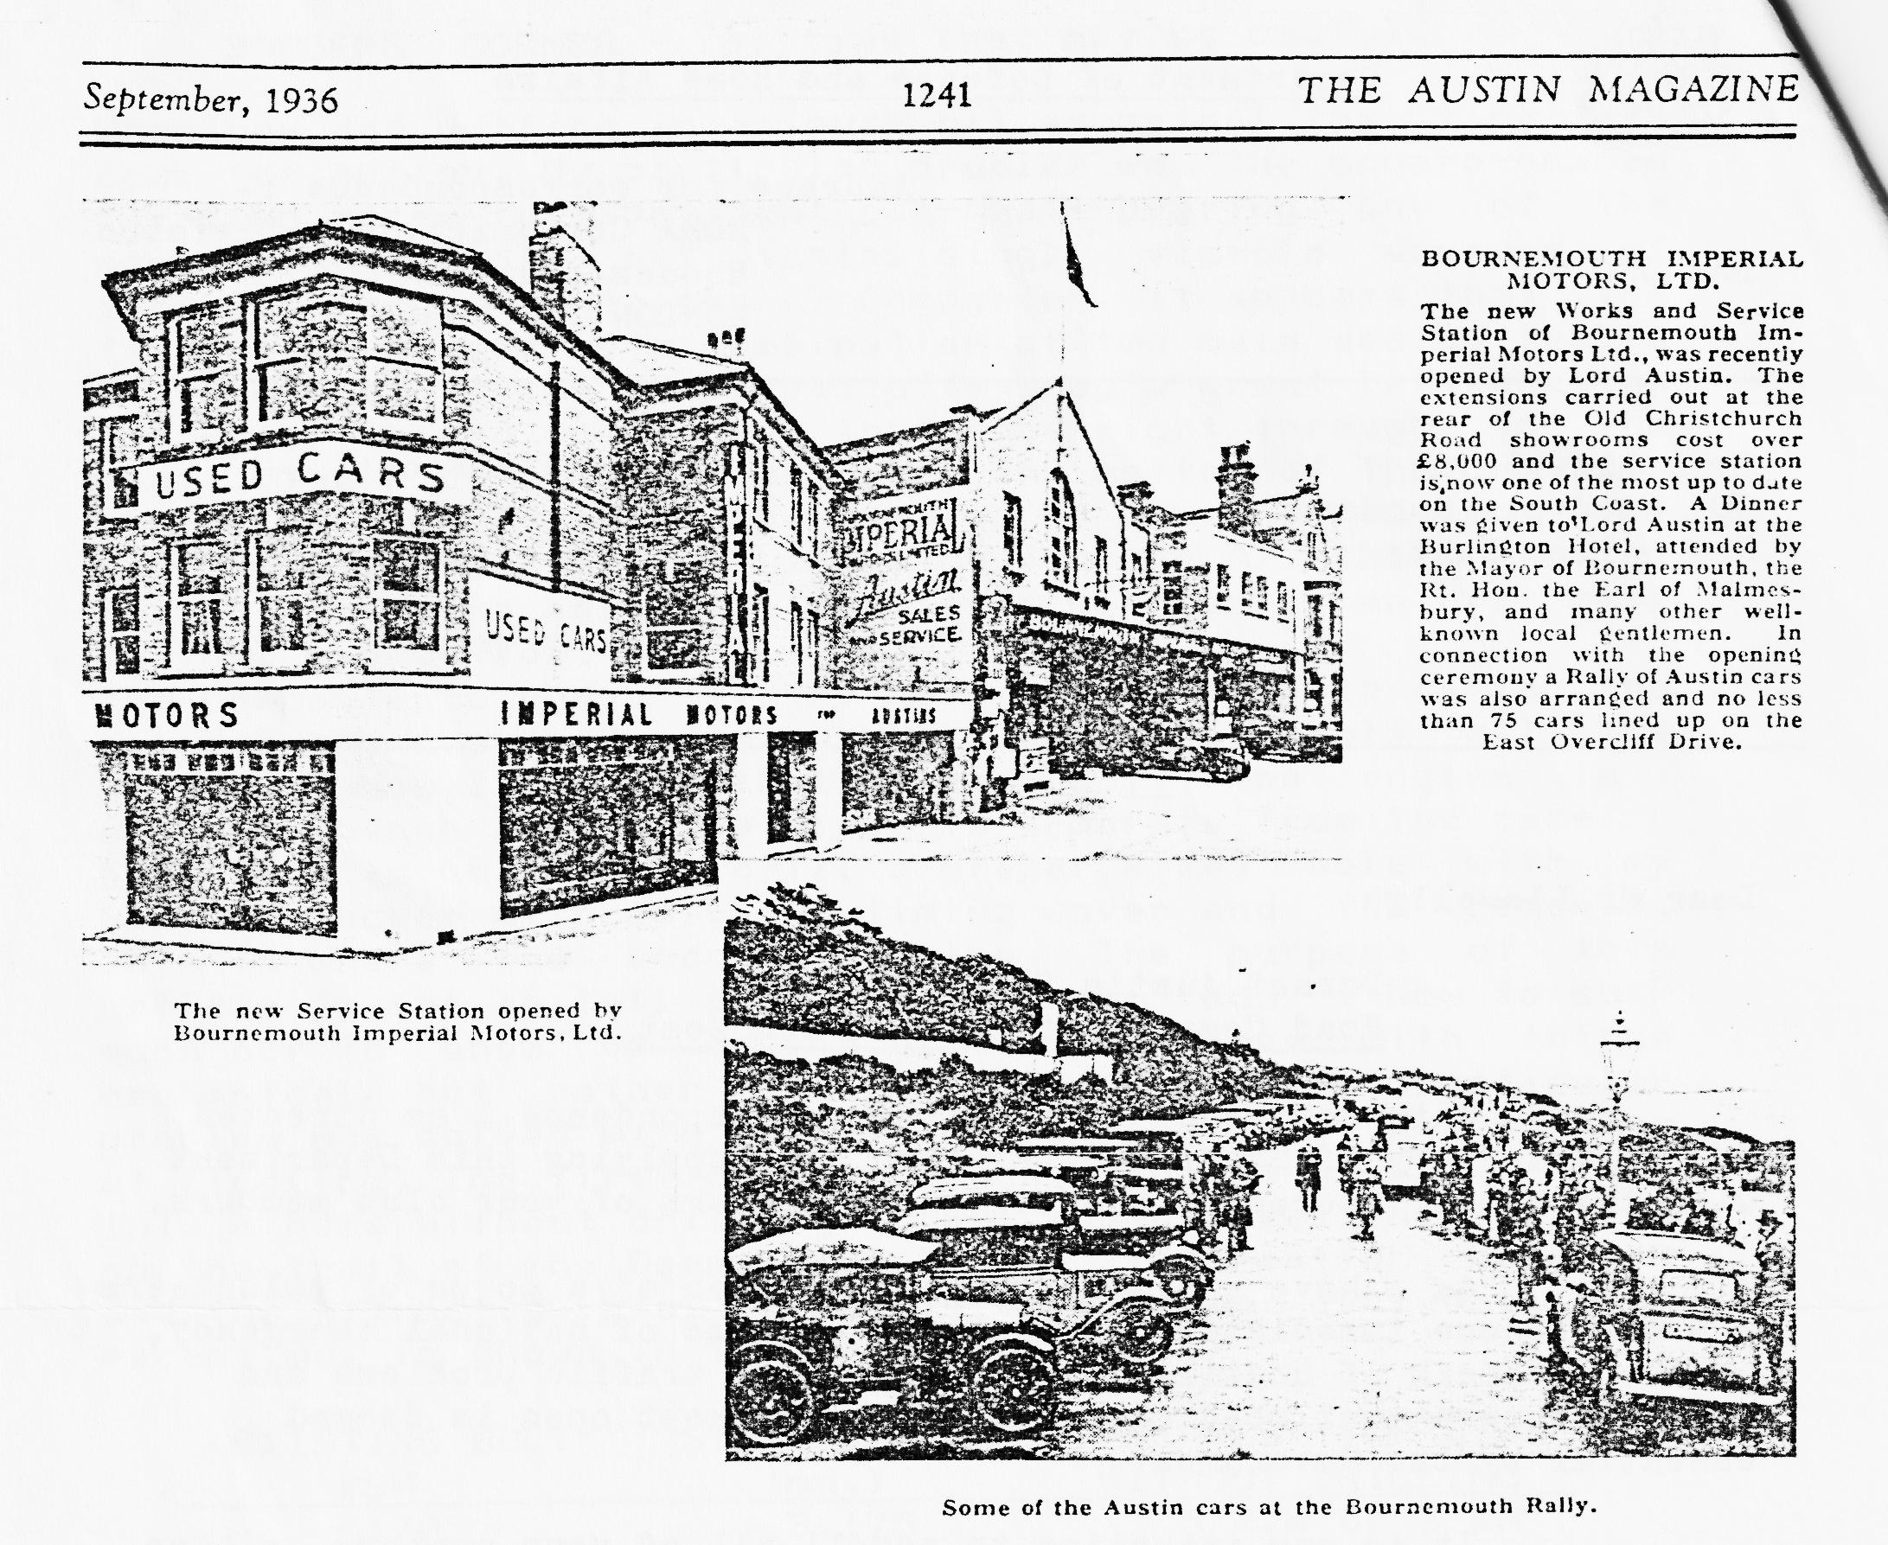
BELIEVE IT OR NOT .. Lawrence’s car has passed another M.O.T. test:
RUMOUR HAS IT .. that Nick Place has swapped the Austin 10 for a Nippy. See you on the next run Nick?
GLYN'S OPAL .. is no longer yucky in colour and is now a sparkling maroon. (He says.)
IN NEED OF FRESH AIR .. Brian Hooper has rejected that exclusive Ruby in favour of a 1932 two-seater tourer.
SOMEONE PRANGED .. Derek's new Opel. Well, if you will have a big D reg. as a standby!
GRATEFUL THANKS .. to Phil for maintaining such a wide range of spares for the club - and for humping them to meetings.
BERNARD HAS SOLD HIS CHUMMY .. no not that one - the 'bits' Chummy.
A MAGIC SPELL .. "I approach coroners at 100 mph"
The Editor will be glad to have more snippets for next month's Newsletter from anyone.

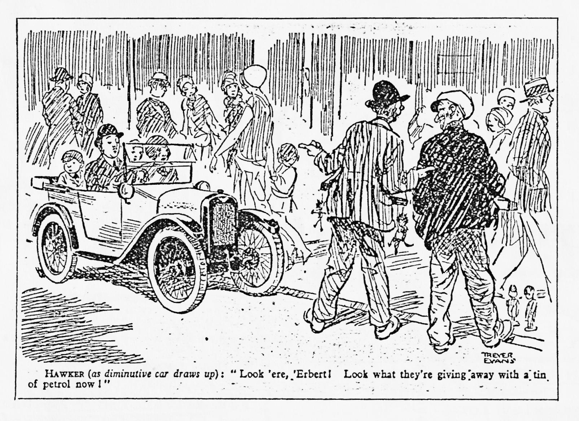
SWEATSHIRTS
We have in stock the following sweatshirts at £7 each:
Denim Blue - Extra Large & Small Black - Extra Large
Bottle Green - Large Grey - Extra Large
Maroon - Medium & Extra Lge. Beige - Extra Large & Large
Navy - Extra. Large & Med.
We can order other colours and sizes. Colours available are: White, Light Blue, Royal Slue, Navy Blue, Denim Blue, Grey, Bottle Green Maroon, Yellow, Red, Black and Pink.
As Summer is coming, we can order T-Shirts in the same colours. See me at Club night or give me a ring on New Milton 512080. Pat Llewellyn
+++++
EVENTS
THURSDAY 16th APRIL - Club Night 8.00 pm at the Elm Tree, Hightown, Ringwood. 'Noggin and Natter'.
THURSDAY 16th - MONDAY 20th APRIL - Easter Club Run to Guernsey.
THURSDAY 22nd-APRIL - Committee Meeting at the Tyrrells Ford, Avon, Ringwood at 8.20 pm.
SUNDAY 25th APRIL - Sherfield Run and Visit to the Nicholson Collection at Ringwood. Mr. Nicholson has a collection of exotic cars after thirty years of collecting.
THURSDAY 21st MAY - Club Night. The first evening run of the year. Meet at the Elm Tree at 8.00 pm.
