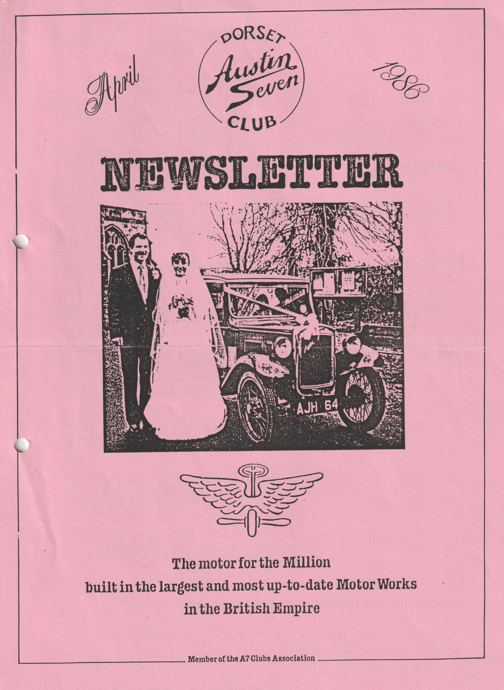

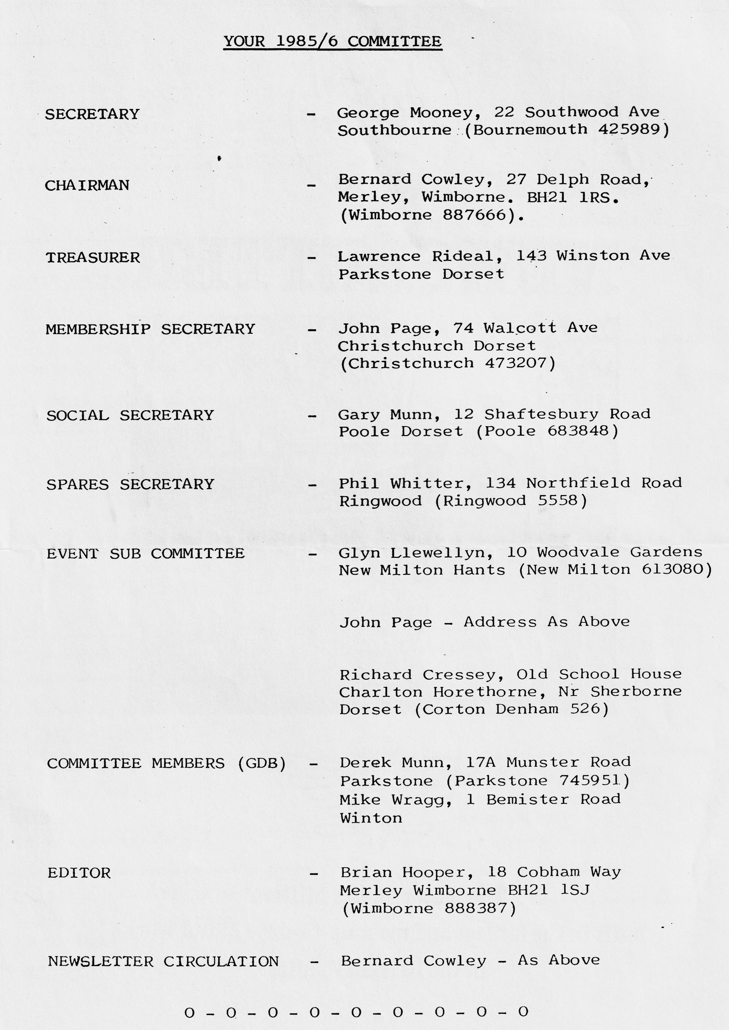

COVER PHOTOGRAPH
This month's cover photograph was supplied by club member Mervyn Frampton, who tells me it was taken on the occasion of his daughter Louise's wedding to Mark Skerritt on 2nd March 1985. It shows Mervyn's Austin 7 on the second day that it was on the road after restoration.
EDITORIAL APRIL 1986
Here we are, April already and this is my sixth Newsletter, it doesn't seem like six months ago that my arm was twisted to take on the job.
At the last club night, Noggin and Natter, doing my fair share of both, I overheard two of our club ladies talking about their interest in the club, which reminded me of my first Newsletter in which I had stated that I would like to feature in the Newsletter articles and comments from the ladies. How about it ladies, let's hear from you, is there an event that you would like arranged, or a subject in which your views could be of interest to others?
We lost what was becoming one of our favourite garden ornaments a couple of weeks ago - Bernard's A7 Chummy converted Tractor/Plough, which we had stored in the garden for Bernard, pending his house move. I was becoming quite attached to it, each week re-fastening down the protective plastic sheeting, for hardly a week went by without gale force winds blowing out the sheeting rather like a spinnaker. To get it to Bernard’s, I drove his car towing Bernard at the controls of the chummy. Not daring to venture to the main road, we towed it to a point where we were able to push it between some bollards (designed to stop a throughway for cars), pushed it a couple of hundred yards up the main road, and then re-connect for final towing to Bernard’s house.
I'm not sure that Jackie, having never before seen the 'vehicle', was delighted or shocked - she just appeared wide-eyed and speechless, obviously hiding her feelings! Of course, Bernard's timing on taking the 'Chummy' home was perfect, in as much that the previous week he had laboured all week to refit Jackie's kitchen!
This month you will see that club night is a talk and film by the RNLI, which should be an interesting evening, and for which your support will be appreciated. As all of the raffle proceeds will go to the RNLI, by buying a few extra tickets you will be supporting a very worthwhile organisation and if you have any little contributions to the raffle prizes this too might generate a few more ticket sales.
I mentioned the club ladies earlier, just a thought, but perhaps one of you could donate a home-made cake or other home-made goodies?
Regards,
BRIAN HOOPER
-0-0-0-0-0-0-0-0-
MAY NEWSLETTER
Articles, comments etc. to me by Wednesday 30th April would be appreciated. Sorry it's so early, but I am on holiday 2nd - 11th May and mailing of the Newsletter is scheduled for Friday 9th May, to proceed Club Night, which itself is early in May as the third Thursday is the 15th.
RUN REPORT
The following run report of the Powerstock run arrived just too late for inclusion in the March Newsletter, but many thanks Glyn for the contribution.
THE BRASS MONKEY RUN
‘Twas a freezing cold morning as I opened one eye and peered out of the bedroom window. We must be bloomin’ crackers to go off on a 100-mile round trip in a 52 year old car without a heater Pat moaned. I must say at that moment I felt the same, but one has to be brave. So, with as many clothes on as we could comfortably sit in, we set off at the crack of dawn for Wimborne Square. The heat of the engine soon percolated through into the Ruby, and almost melted the ice on the inside of the screen by the time we had got to Wimborne.
George and Joy were already there in the Pink Peril and soon we were joined by John & Cynthia Page in the Mulliner, Dusty and Jane and the boys and Gary in Boxes, Phil and Hilary and family in their "All Agro". I was ordered by Herr von Page to lead the way to Dorchester where we were to meet Richard and Margaret Cressey. All went well for about a mile, after which I took a wrong turn, I quickly turned around, but ended up at the back of the convoy, where we stayed until we reached Dorchester.
We met up with Richard and Margaret Cressey with Rosy & Emily, Cyril and Richard's dad in a Ruby and Bristol member Gerald Campion-Smith in his Box and were soon rolling along snow covered lanes following Richard & Margaret's Pearl Cabriolet. We had a short delay whilst advancing Cyril's timing (he was having trouble keeping up on the hills) but before long we were turning into the Three Horseshoes at Powerstock, where we all enjoyed excellent food and Palmers beer in front of a roaring fire.
After lunch Richard & Margaret led the convoy back to Dorchester, where we visited the Dinosaur Museum. There were a lot of electronic gadgets and buttons which the kids (and the adults) enjoyed playing with, and life size models of Dinosaurs as well as many fossils etc.
Pat and I had to leave early as we had to get home before Trevor went back after his leave. We really enjoyed the day out and have just about thawed out.
Glyn
WANTED
BRITISH MOTOR BIKE e.g. TRIUMPH, NORTON ARIEL etc. 1950/60s. Phone Paul (0202) 769335.
NOTES ON EVENTS
In the events calendar there is reference to the Yellow Bus Rally & Depot Open Day on Sunday 6th July. I don't know how booked up this event is from an exhibitor point of view, but should you be interested, I suggest you contact the following for an entry form: Mr V. Jeffrey, Bournemouth Passenger Transport Association, 148 Corhampton Rd, Boscombe East, Bournemouth BH6 5PD.
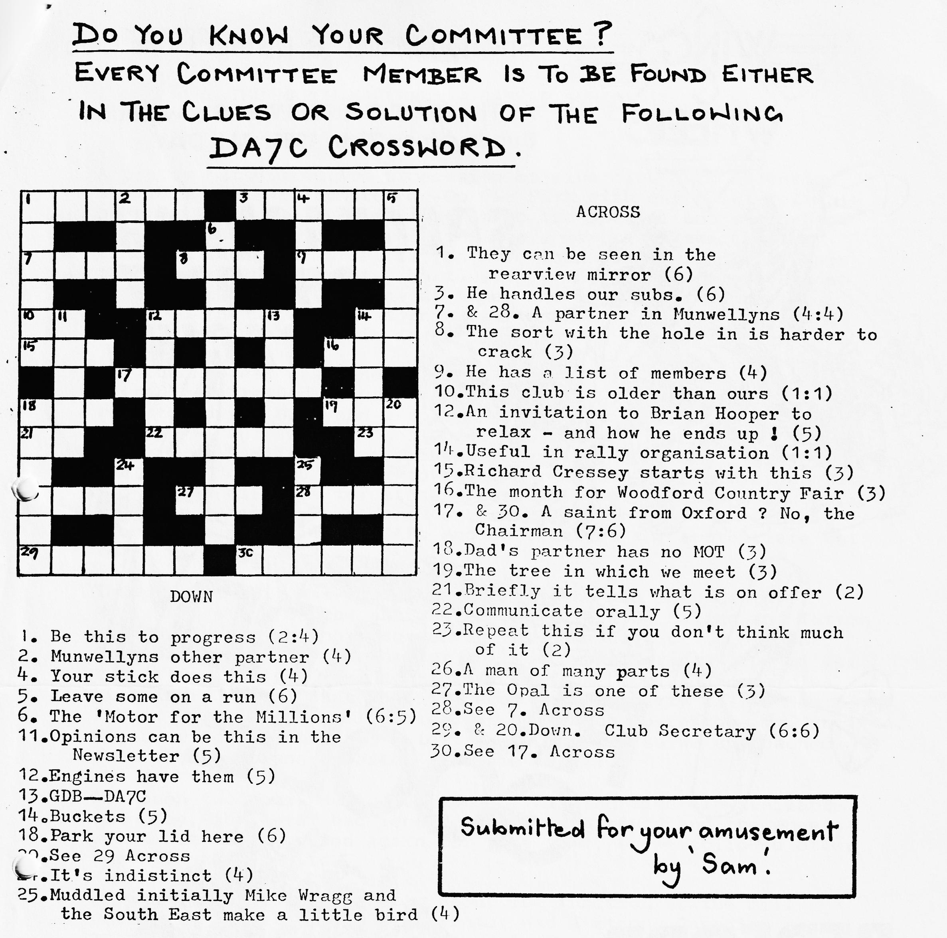
Similarly, for the Christchurch Round Table Donkey Derby on Sunday 24th August, you should contact John Humphreys at 'Mayfield', 25 Carberry Ave, Southbourne, Bournemouth. Telephone: Office 423281, Home 429770.
Editor

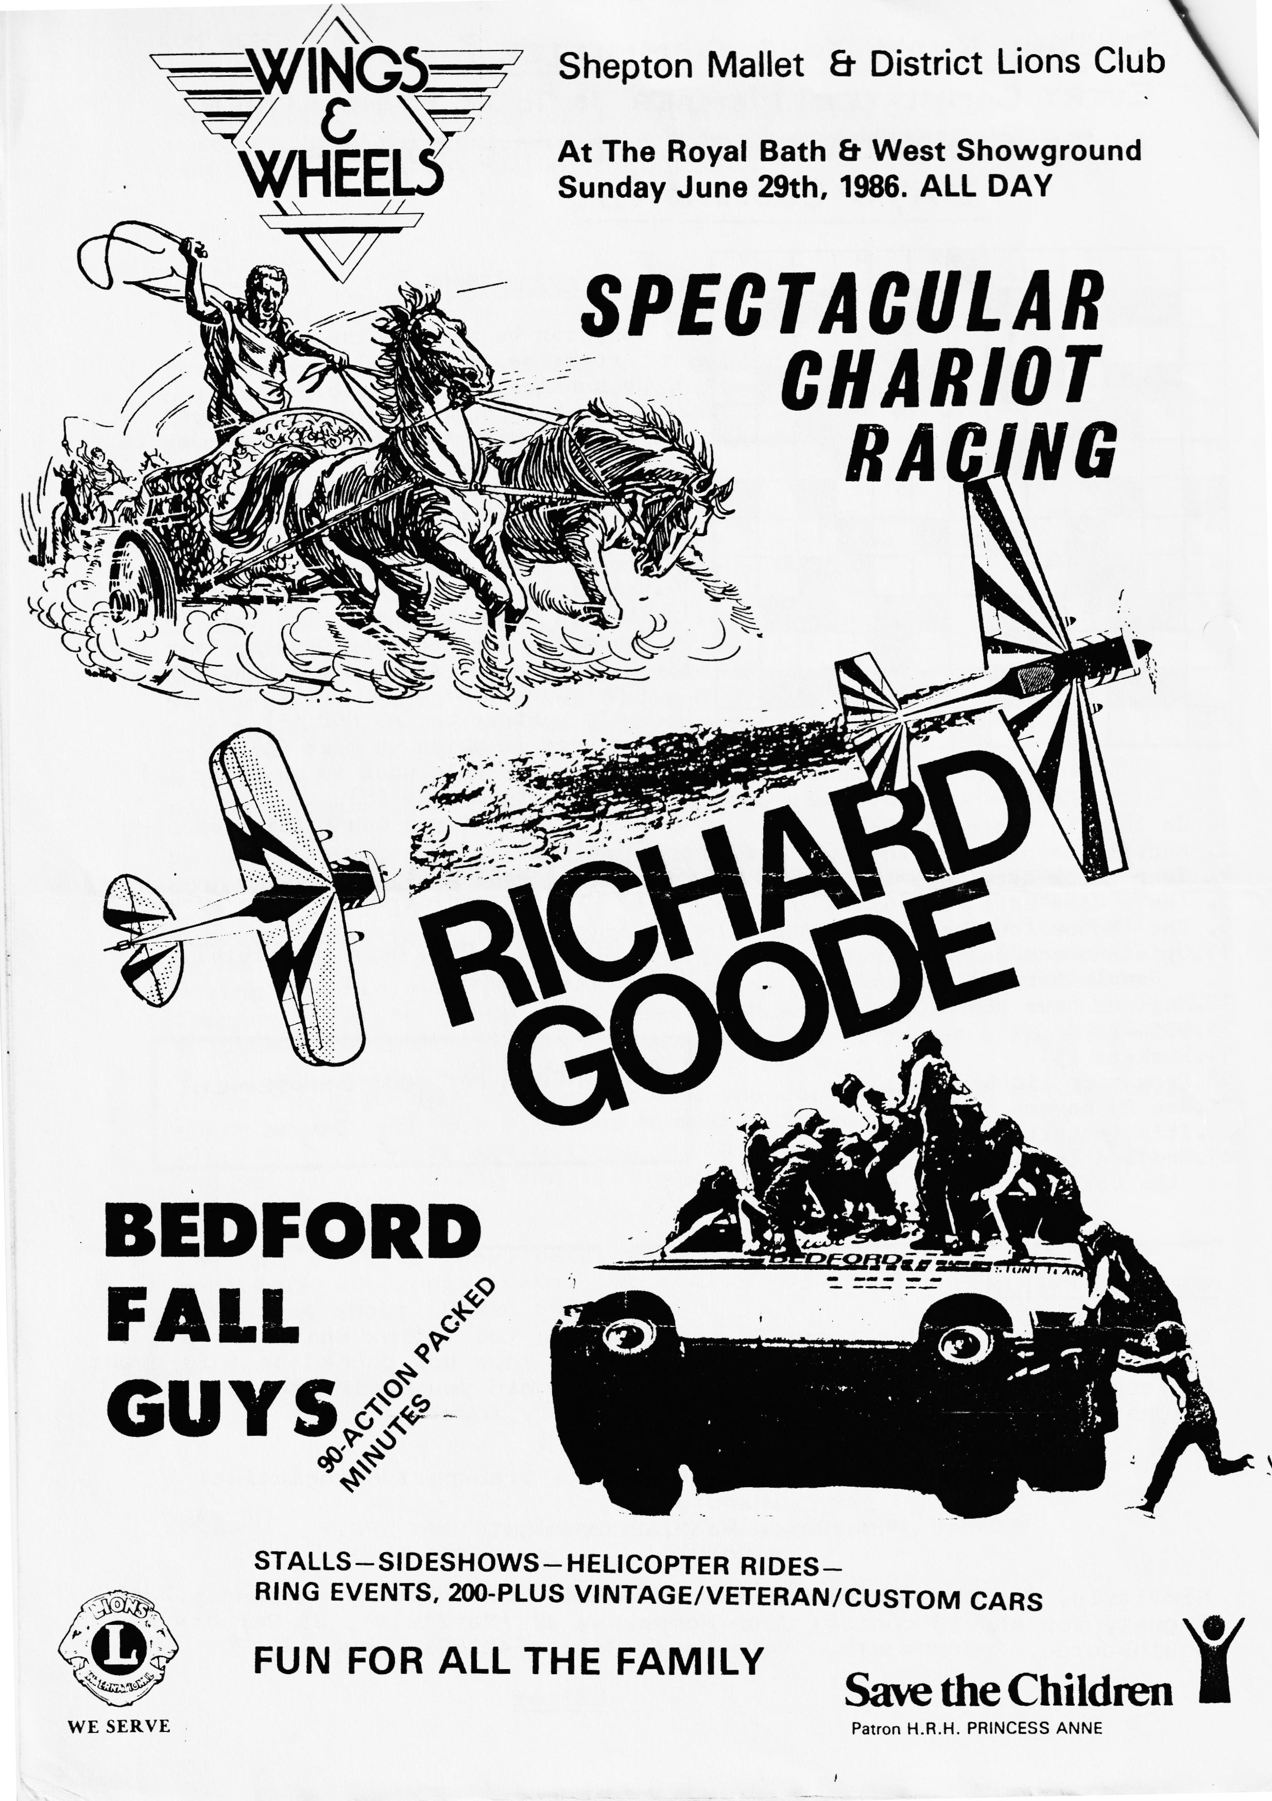

RUN REPORT
THE MARCH HARE RUN - EASTER SUNDAY
A pretty but diminutive procession of five club cars assembled and left the Christchurch Co-Op Car Park with our usual reliable punctuality. Led by Glyn and Pat in the Special and shepherded by Bernard and his family in the rear, we braved the blustery wind and launched ourselves (on more than one occasion!!!) upon the very wet New Forest. Fortunately, the weather improved, we actually glimpsed sunshine at times and we had, of course, advanced the clocks that morning. I wonder if anyone arrived at 11.45 a.m.? We were, in fact, joined along the way by more members. Our lunch break was taken at the Bold Forrester at Locksheath and suitably refreshed we progressed to Ealing Tide Mill. Together we entered the Mill and prepared to pay admission. "Are you a party?" we were asked. "Well, have you come in a coach?"
"No, in an Austin 7" our spokesman replied. "What all of you", she said, "are you trying to break a record?" She kindly enquired if we were eligible for student rates - we produced one student; or child rates - we produced one child. With that, the Cashier pronounced us all to be OAPs and we received the appropriate cut rate.
The present Mill was constructed about the mid-18th Century. Mills had stood on the ancient causeway linking Ealing and Totton previously, one being recorded in the Domesday Survey of 1086. Originally owned by Winchester College, which granted the miller lucrative rights to collect toll fees from people and vehicles crossing the mill causeway, it became the property of the New Forest District Council, which has done much to restore it, in 1974. The practice of charging a toll has continued so we approached from the south and departed the same way!!!
Although two four-hourly sessions of milling time are available each day, the water had receded when we arrived and the wheels would not be in motion again for some time, so we followed other educational pursuits.
A video provided information about the function of the mill machinery and although the narrator had a strong Canadian accent, we accepted this on learning why. A group of Canadian students had successfully used this mill to complete their entry in a national award scheme involving working mills. Mill and visitors have benefitted from this as a copy of the video tape produced was presented to the mill owners.
A set of unusual scales was used to weigh various members of the party, but these were found to be faulty. Everyone weighed more than they knew they did.
In the loft, crammed together on a tiny platform, the ancient art of whistling along two fingers was exploited without success.
Teeth, fingers and tongues became confused but what could you expect from a load of OAP's. Bread, biscuits and buns were purchased but most of the souvenirs had somehow disappeared by the time we reached home.
We followed the 'Special' for a further enjoyable tour towards home and then Glyn and Pat generously invited the survivors to their home for a cuppa, where we tramped all over their new carpet; or had it been laid in our honour?
A good run. Perhaps a little mad but well worthwhile.
Gabrielle J. (Weaver)
Secretarial April 1986
Hello. No, it's not George, it's me Brian doing my well-known impression of George. It would seem that George left the country in a hurry and has gone to paint one of the towns red in Germany. Better than doing it in Southbourne eh George:
As I wasn't able to get any of George's secretarial material before he departed and assuming he comes back in time, we can look forward to a bumper edition of the secretarial in May.
Brian
'SAM', who provided the crossword in this edition requested that we also include the solution, so here it is deliberately printed upside down to make it a bit more difficult for those who want to cheat.
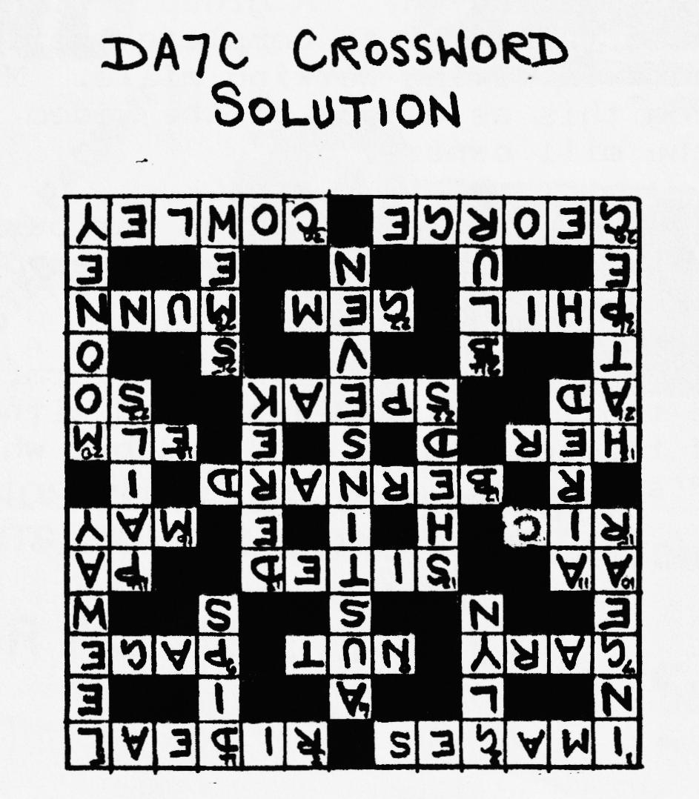

EVENTS
THURSDAY 17TH APRIL Club Night at the Elm Tree, Hightown Ringwood. 8.00 p.m. Talk and Film by the R.N.L.I.
SUNDAY 20TH APRIL Club Run to the Hawks Conservancy, Weyhill, Nr Andover. Meet in Ringwood Cattle Market Car Park at 10.00 a.m. for a 10.15 a.m. start.
THURSDAY 24TH APRIL Committee Meeting at the Tyrrells Ford, Avon, Nr Ringwood, 8.30 p.m.
THURSDAY 15TH MAY Club Night - Evening Run commencing at the Elm Tree in Ringwood (start time will be advised next month).
SUNDAY 18TH MAY Club Run to Bath. Meet in Wimborne Square at 9.45 a.m. for a 10.00 a.m. start.
THURSDAY 22ND MAY Committee Meeting.
SUNDAY 1ST JUNE Solent A7 Club Paultons Park Rally.
SAT/SUNDAY 7/8th JUNE Andover Vintage Club Rally.
SUNDAY 15TH JUNE W.V.P.C. Motorcade 86. Braemore House.
THURSDAY 19TH JUNE Club Night.
SUNDAY 22ND JUNE Club Run - Burley Wagonette Ride and Wine Tasting. Meet Wimborne Square 10.45 a.m. for 11.00 a.m. start. N.B. This event has to be booked, to reserve please let Glyn Llewelyn know by May Club Night.
THURSDAY 26TH JUNE Committee Meeting
SATURDAY 28TH JUNE Tentative Date - Club Barbecue
SUNDAY 29TH JUNE Wings & Wheels - see advertisement this Newsletter - contact Bernard Cowley if you are entering.
SUNDAY 6TH JULY National A7 Rally at Beaulieu.
SUNDAY 6TH JULY Yellow Bus Rally & Open Day.
JULY 17TH Club Night
JULY 18TH - 20TH Spye Park Rally
AUGUST 24TH Christchurch Round Table Donkey Derby - includes display Vintage/Classic Vehicles

