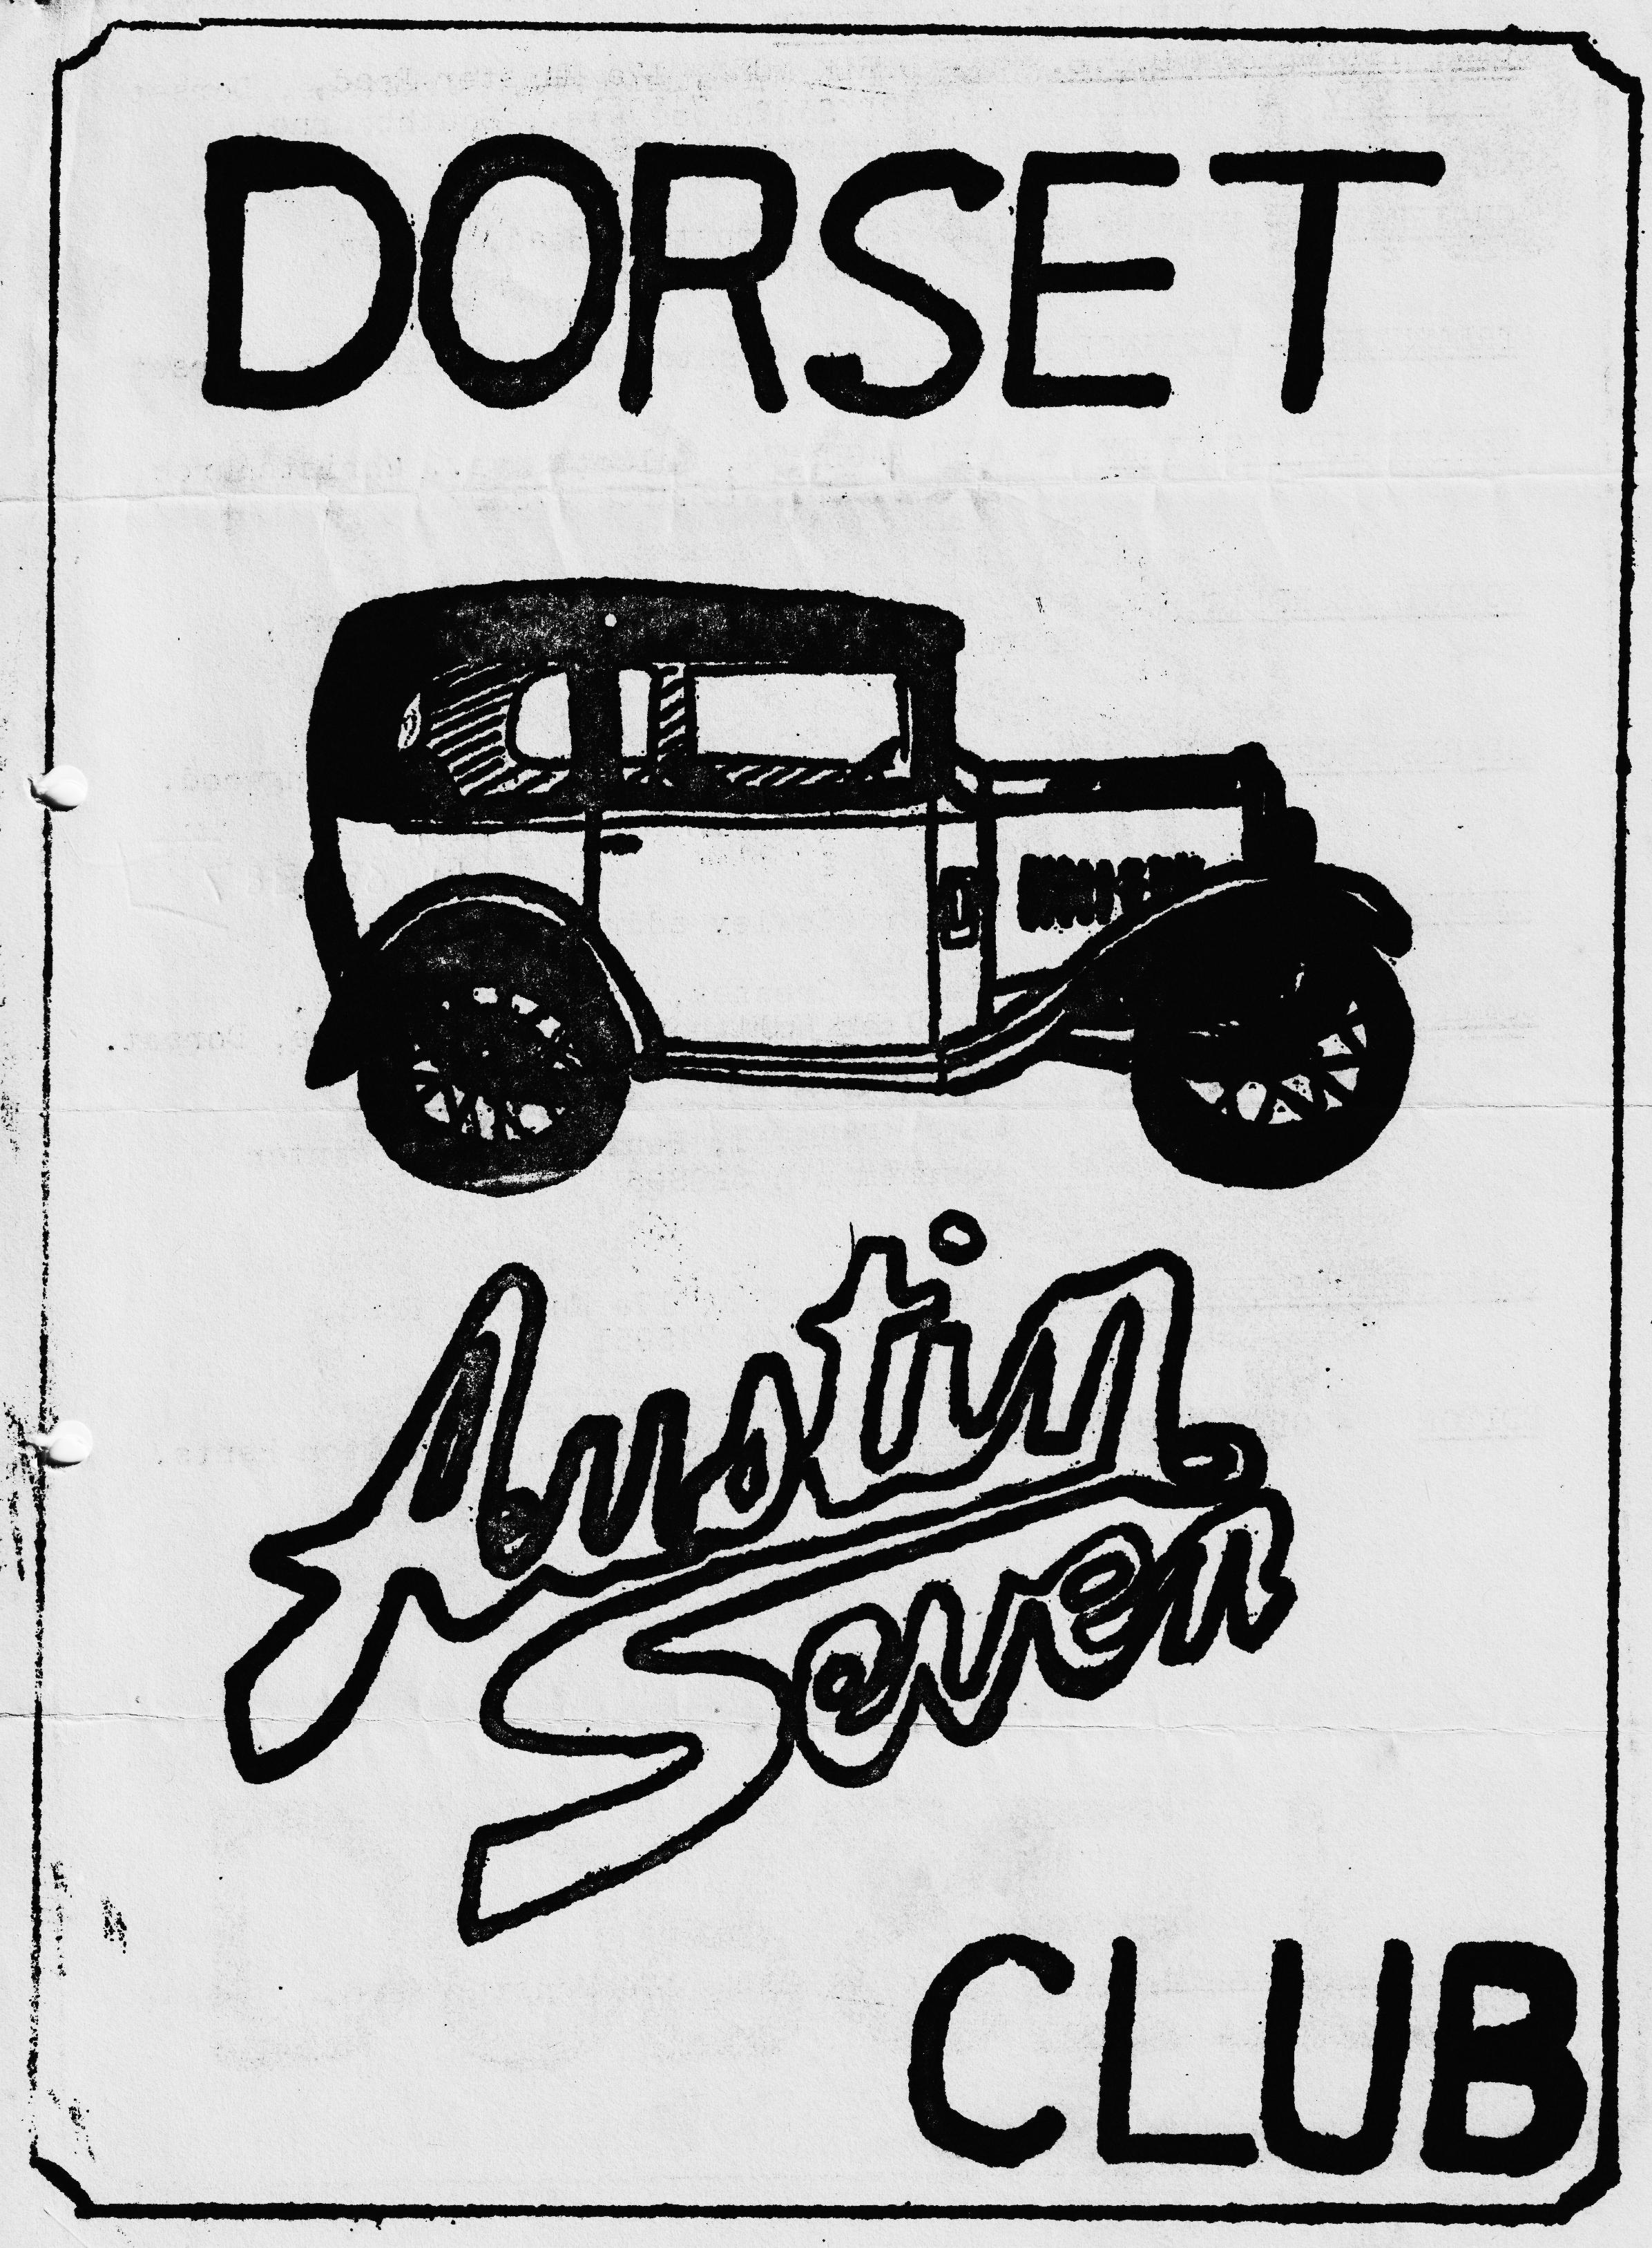

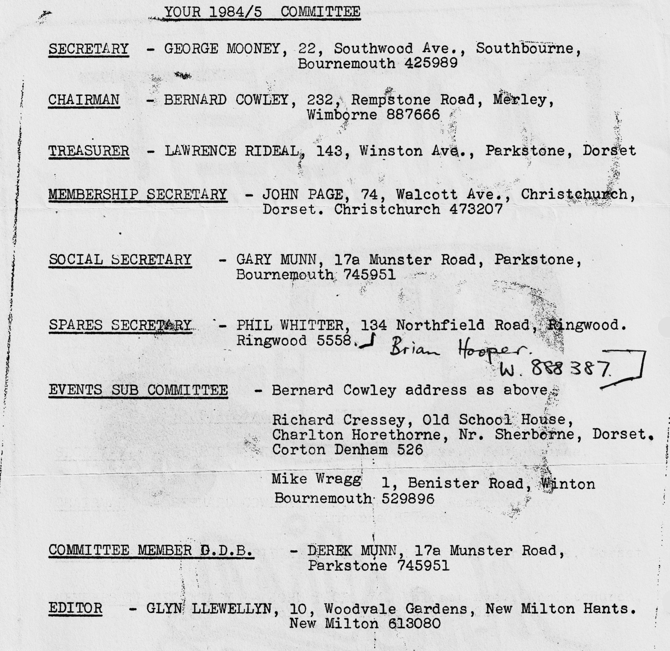

DORSET AUSTIN 7 CLUB NEWSLETTER APRIL 1985
CLUB NIGHT
THURSDAY 18th APRIL. AN ILLUSTRATED TALK BY A MEMBER OF THE SWANAGE RAILWAY AT 'THE DORMERS' WIMBORNE 8. p.m.
EDITORIAL•
Hi Gang,
It was great to see two fresh Austins on our last run to the Army Flying Museum at Middle Wallop - Brian Hooper in his Ruby (who kindly volunteered to do the article) which has been beautifully resprayed in its original Polychromatic Green, and Ted Coats super chrome rad Chummy, both cars looked superb. I noticed that neither one attempted the rather deep ford which Bernard had found for us, still we havn't indoctrinated them yet have we? Another welcome addition, who did go through the ford, incidentally was Mary and Fiona Clenaghan in their Tickford. George and Joy were also there in the Pink Peril.
We had a most interesting and entertaining club night last month. Tom 'The Pom' Newsome came along and showed us films of his drive to Australia in a Ruby. This was the first showing in this country and we invited members of the Solent Club along. Everyone enjoyed the evening which went on until 11.45 p.m.
I had a picture sent to me this morning by family member Rosie Cressey. It was of a Yellow Austin 7 going through the ford on the Middle Wallop run with water running out of the doors. The car is yellow because the blue crayon ran out. Rosie is four, and .a super drawer. Unfortunately, the picture arrived too late for the Picky Page, which was a shame as I have no others to put in. By the way if you need any spares on Club Night, give Phil Whitter a ring on Ringwood 5558 as he will only bring orders this month.
See you Club Night,
Glyn.
EVENTS CALENDAR
SUNDAY 21st APRIL Club run to Wells meet at Wimborne for a 10 A.M. START. We must leave on time to meet our organisers Richard and Margaret Cressey at the roundabout just before Wincanton at 11 a.m. So don't be late. The pub is The Crossways Inn at North Wootton
THURSDAY 25th April Committee meeting at Tyrrells Ford, Avon.
SATURDAY 27th April Beaulieu Friends evening. Surprise Evening.
•THURSDAY 16th MAY Club Night.
•SATURDAY, SUNDAY, MONDAY 25th, 26th & 27th MAY Dorset Camping weekend. Corfe Castle area. Site not yet arranged details next month.
SUNDAY 2nd JUNE Wollaton Park AutoKarna P.W.A.7.c.
SUNDAY 8th JUNE South Wales, Golden Grove Rally at Llanarthne. Some of us will be camping and there is a run on the Saturday also a Barbeque/Folk Dance Saturday evening . See Glyn for details.
SUNDAY 8th JUNE 6.30 p.m. till late. An invitation from Sandford School (near Wareham) P.T.A. to their Caribbean Evening. Attractions include, Steel Band, Bar, Pig roast, Country fair. Free Admission to anyone in an Austin 7.
Visit to the Army Flying Museum at Middle Wallop
Dear Ed,
Sunday 31st March, a day to remember, for having toiled for 17 months, it was Barbara's and my first chance to go on a club run. •
Apart from losing an hours sleep on Saturday due to the start of BST, I doubt that I slept more than three hours, my mind being on every bit of Esmerelda -(our Ruby's name) our only previous runs being around Poole and to Ringwood, the previous weekend.
I was out in the garage at the crack of dawn for final checks - was the exhaust tightened on, should I put more grease in those wretched King Pins, what spanners should I take, had I sealed the carburetter leak satisfactorily etc., etc.,
We had decided to leave Wimborne at 10.15 a.m. (half an hour to Ringwood sounded reasonable). The sun was shining and to help my confidence, Michael our youngest son had decided to come "in case Dad needs a push".
Towards Ferndown, and a few people on the roadside started smiling (paranoia sets in - perhaps they weren't smiling but just laughing out loud). "Do a royal wave" says Barbara - "Don't be bloody stupid" being my reply, "I can't let go of the steering wheel "
A van overtakes us - "Get into the slip stream" says Michael, thinks "Good idea"; we are now doing 45 mph but now they are waving to us from the rear windows of the van which perhaps appropriately was lettered 'Gerry Cottles Circus!'
Ringwood Car Park at last (or were we last?), not a sign of an Austin Seven yet, only 10.40 a.m. Panic sets in, were we in the right car park? At last in comes another Austin but before we could exchange greetings with-the lady driver, it all started to happen, another and another and another and so on, suddenly we were surrounded with. at least ten Austins. There were pink ones, green ones, blue ones, brown ones, cream ones - I became somewhat confused but with subsequent prompting I believe the line-up consisted of:-
Glyn and Pat in a super Opal, Bernard, Jackie and family in their fabulous Chummy, Paul and Emma in their Box Saloon, Lawrence and (oh dear who was he with?) in his Box Saloon, George and Joy in their eye-catching Box, John and Cynthia and the boys in their Mulliner version, Phil and Hilary in their Ruby, Ted and Penny in their newly restored Chummy ( I believe it was their first time out also) Mary and Fiona in the Tickford (lovely to see you both although we didn't have time to speak). Was that all? well not quite - a ton-up kid on a motor bike - relief, it was Vic Steele, closely followed by Mike Wragg in a Sprite and last, but of course, not least, straight from an all-night wedding party Dusty, Jane and Co in a two-tone A 30.
Now time for the car in front, to “stop at every corner until the car behind you is in sight", seems simple so off we go. Of course, the night before I had studied the maps so I knew precisely where we were going. However, after half a mile, I was totally lost and my only hope - keep Phil and Hilary in sight!
Through the forest, mind the horses, watch out for that horse and trap, all going well but who the hell let those two pigs out, .I missed them – just. I .certainly wasn't going to try my first emergency stop, I think I left that to Lawrence who was behind me!
At last, the lunch stop at the Mill at Dunbridge where we were also joined by Richard and Margaret in their Pearl and, I believe, Richard's dad and Cyril. Nice company, nice drinkies, but our sheer volume of trade brought the Mill, to a grinding halt on service and their locals will probably never return there again.
"Onward." cries our leader and off we headed, to Middle Wallop, oblivious to the hazards ahead. Bernard had. planned the route carefully and suddenly a right-hand turn took us into a ford (no not Henry's version, but a big wet one which turned out-to be a two foot deep raging torrent of river). One or two of us declined (well ,both Ted and I weren't sure whether ours were waterproof) unlike Bernard's Chummy to which he had secretly fitted buoyancy during the winter months. It should not go without mention, although not witnessed by myself, that Vic entered into the spirit of this and took the plunge! After re-grouping, the next few miles went without incident apart from several vehicles without brakes and one or two drivers finding than their distributors really were not waterproof. Phil found that it had been a good investment to fit his-Ruby with a Bilge Pump - (anyone requiring this should contact the Spares Secretary!). Suddenly on a right-hand junction I am lost and no-one is behind me, so following the instruction I came to a stop. In front of us several others also stopped and to our amusement Phil decides to test the wind speed and releases several paper bags across the plains and then proceeds to chase them but the barbed wire fence became too much for him.
After about 30 minutes, we are all together again but we now have a Police car leading the party - the local bobby obviously decided to lead us through this next hazardous section.
Middle Wallop, the home of the Army Airforce Museum - we had arrived and well worthwhile, we found it most interesting and extremely good value for money bearing in mind that we obtained a reduced admission price of 50p each .(a concession for an organised party, although I'm not sure that their assessment of our party was correct).
Time to leave, small groups all heading towards home. To sum up, as stated, our first trip with the club, our first trip in Esmerelda, but guaranteed not to be the last. Thanks to the organisers and to the club members for a super day out. Looking forward to the next .trip.
Brian C. Hooper
AN EXTRACT FROM THE VAUXHALL MOTORS BOOKLET "FOR B.F.s - TIPS ON TOPPING UP”
It used to be said - it probably still is - that any fool can pour water into a radiator. There must-be some truth in the statement, or the Army would have made it a workshop job years ago. But-even in the simplest of tasks one learns a wrinkle or two from experience'. You know, of course, that you're supposed to use soft water when it's available. YOU know, too, that if you have to use a bucket of ditch-water in an emergency, it is best to remove the dead leaves, old boots and other "foreign bodies" before you pour it in. But that doesn't exhaust the subject by a long way.
Suppose; through a defective joint or something like that, the radiator runs nearly dry. Things begin to smell a bit hot. The engine seems to stiffen up. After a time it begins to knock loudly and perhaps you wake up and start to realise that something isn’t quite as it should be. "AY” you say, "short of . water", and you pull up, undo the cap) and peer inside.
Well, you learn something right away. First that steam is hot, and second that it isn't wise to push your face into a, column of it unless you really want to look like a lobster. That, one might say, is Lesson No.1. Lesson No,2 follows almost immediately. You procure a bucket of water and, keeping your face out of the way this time, you proceed to pour it in. All at once there is a sizzling sound - another jet of steam and a loud and expensive sounding crack.
You look blank - no, let's say your expression changes - and you wonder what you've done. We'll tell you. You've carried out an experiment in rapid expansion and contraction. You've cracked the
cylinder head and that makes two heads that are useless to the army. Maybe you haven't done it yet. In which case, don't. Never pour cold water into an overheated engine. What :happens to your face is your own concern, but it’s no end of a pity to spoil a good cylinder head.
SECRETARIAL
Hello - April showers, March winds and daffodils, it must be the start of the rally season.
I would like to offer a vote of thanks to all those people who came along to the last meeting to listen to Tom Newsome and see his films. There was so much to say and show that it took a considerable amount of time. The films that were shown had not been edited so I hope you can forgive extended views of the sea and disappearing roads. We are indebted to the manager of Dormers for allowing us to stay much later than usual, the last of us left at around 12.45. Due to the extended showing Phil Whitter finished up bringing spares to no avail, he never got a chance to show them.
Sunday next is the Daffodil run so it is early up and off to Maidstone.
I would like to remind you that Solent Club; Paulton’s Rally takes place on 30th June. They are looking forward to considerable support from DORSET club and are most anxious to attract Autojumble stalls. Please therefore contact me if you would like to enter the rally or have an Autojumble stall at £6 per stall. Please make an effort to join in.
The club run to Middle Wallop was fantastic with I believe 10 7's, 2 moderns and Vic on the motorbike. The star turn has to be Vic trying to ride through a river, (it was supposed to be a Ford) and stalled in the middle, no doubt there is a report elsewhere.
Just one small point to finish on, Tom's car travelled 23,000 land miles from Melbourne Derby to Melbourne Australia with no bottom end trouble at all and, guess what, it's a 3-bearing engine! There’s quality for you.
That’s it then, not much from me this month, just as well I expect.
See you club night, George
SERVICES
MUNWELLYN'S FOR ALL AUSTIN 7 MECHANICAL AND ELECTRICAL REPAIRS AND RESTORATIONS. PHONE GARY ON POOLE 683848 OR GLYN ON NEW MILTON 613080.
BRAKE AND CLUTCH LININGS PHONE BERNARD COWLEY. WIMBORNE 887666 FOR 24 HOUR SERVICE. 8 SHOES £16 CLUTCH LININGS £10
REGARS ENGINEERING COLUMBIA ROAD, BOURNEMOUTH FOR CRANKSHAFT REGRINDING AND CON ROD REMETALING. BLOCKS REBORED AND GENERAL MACHINING.
SHOT BLAST AND STOVE ENAMELLING SPRAY FINISHERS, NUFFIELD INDUSTRIAL ESTATE, POOLE £35 FOR 5 A7 WHEELS (CASH) MENTION THE CLUB.
UPHOLSTERY AND TRIMMING COLIN MORRIS, BOURNEMOUTH 524671
RADIATORS REPAIRS OR YOUR RADIATOR REBORED. HANTS AND DORSET RADIATORS 77, STANLEY ROAD, BOURNEMOUTH 301277
RESPRAYS GEORGE MOONEY, BOURNEMOUTH 425989
STARTERS & DYNAMOS OVERHAULED P.A. MACCARTY 35, WARWICK ROAD, BOSCOMBE MENTION BERNARD COWLEY OR CLUB
WANTED
CRANKCASE FOR THREE-BEARING ENGINE. MUST BE IN GOOD CONDITION, FOR REBUILD OF SPARE ENGINE, ALSO DISTRIBUTOR (COMPLETE) OR CAP ONLY. TELEPHONE BRIAN HOOPER WIMBORNE 888387

