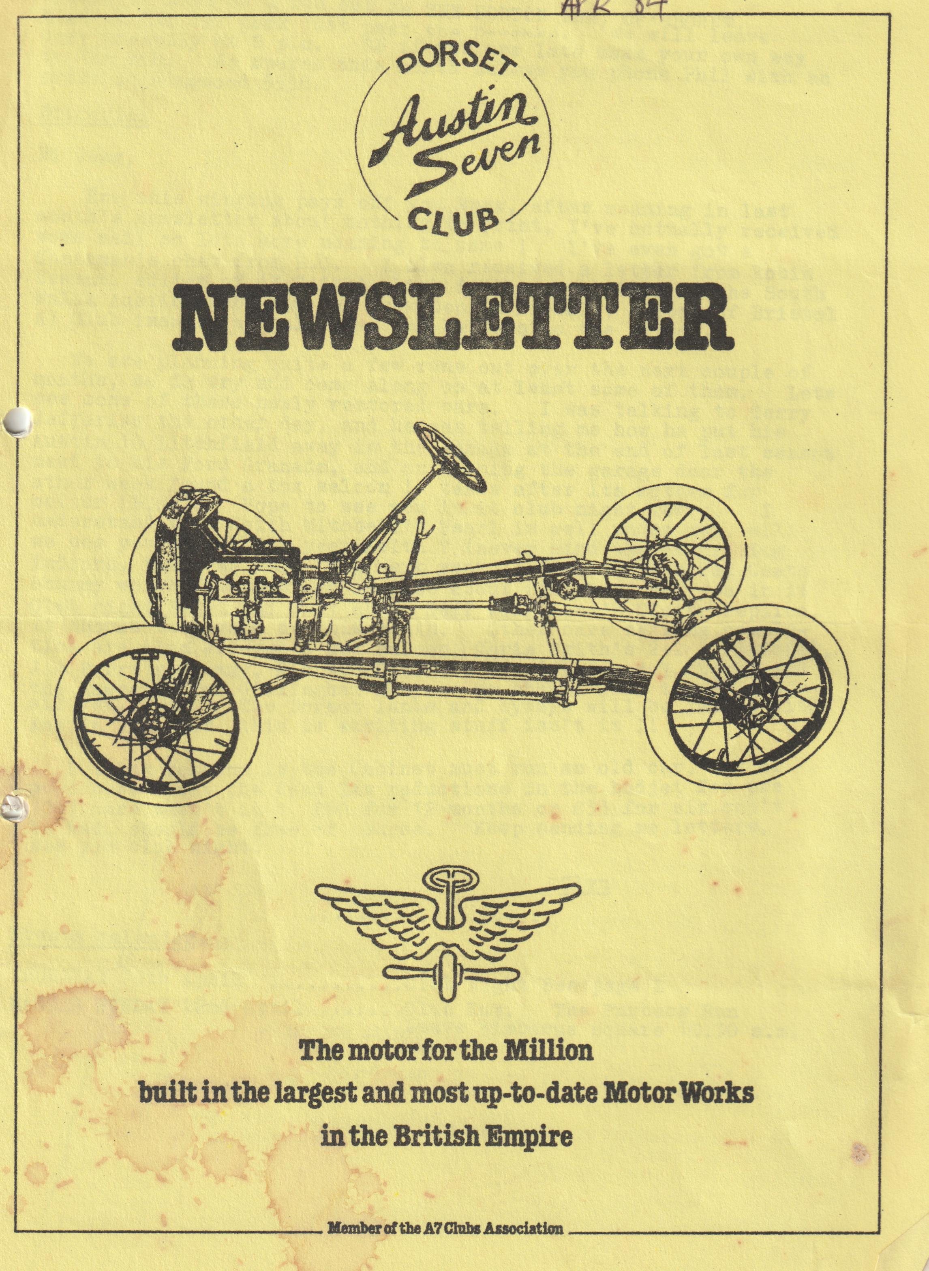
+

DORSET AUSTIN 7 CLUB NEWSLETTER APRIL 1984
CLUB NIGHT THURSDAY 19th APRIL. SPRING IS HERE so a run out to THE HORTON INN, CRANBORNE.
Meet at the car park just past the Dormers. We will leave very promptly at 8 p.m. So, if you are late make your own way to the Pub. No spares this month unless you phone Phil with an order at Ringwood 5558.
Editorial
Hi Gang,
‘Ere this winging pays off you know, after moaning in last month's newsletter about nothing to print, I've actually received some mail so lots more moaning to come! I've even got a Chairman's chat from B.C. I also received a letter from Robin Newman, editor of 'Y Saith' which is the newsletter of the South Wales Austin Club, and one from Dennis Nichols, editor of Bristol A7 Club issuing a challenge, see Letters to the Editor.
We are planning quite a few runs out over the next couple of months, so do try and come along on at least some of them. Let’s see some of these newly restored cars. I was talking to Terry Jefferies the other day, and he was telling me how he put his Austin 10 Litchfield away in the garage at the end of last season next to his Ford Granada, and on opening the garage door the other week found a box saloon! Takes after its mother for colour (Blue). Hope to see you in it club night Terry. I understand that Keith Mitchell's Pearl is well under way, will we see you in it this year Keith? (never mind the decorating indoors, that can wait till next year!) Then there's Ted Coats chummy which I understand is just about finished, see you in it Club night Ted? and what about Geoff Kingsland's Ulster replica?
It should be a good do this month. Other cars nearing completion are Alan Wiseman's Box Saloon, Chris Smith's 2+2 A7 special, Jim Burry’s Chummy, Richard Cowell's Box (finished I think) and the Lawsons from Gillingham Ruby. We should like to see you all very soon. The Dorset lanes and byways will be jammed with Austin 7's, Wow this is exciting stuff isn't it?
I think someone in the Cabinet must run an old car - bit of good news about the Road Tax reductions in the budget for pre-1947 cars wasn't it? £60 for 12 months or £33 for six can't be bad, should be free of course. Keep Sending me letters, see you club night.
Glyn
Events calendar
THURSDAY 19th April. Club Night See page 1
EASTER SUNDAY 22nd April Club Run. The Purbeck Run Leave Wimborne square 10.30 a.m.
Tuesday 24th April Commemorative Rally at Hickey Grange, the home of Sir Herbert Austin. Contact George Mooney for details B’mth 425989
Sunday May 6th Club run MAY DAY RUN. As the D.A.7.C. have been doing a survey of Anglo Saxon hill forts, Bernard thought about organising another exiting run to one!!! We start at Wimborne Square at 10.15 a.m. — a nice pub has been found at Evershot (for those who can't make the start) and finishes at Maiden Castle in Dorchester.
Monday May 7th Autojumble at Verwood B.C. for details Wimborne 887666
May 26th 27th 28th D.A.7.C. Camping Weekend in the Savernake Forest. Ring John Page for details Christchurch 473207
June 10th South Wales A7 Club rally at Golden Grove Llandeilo 94 miles from the end of the M4. NEW VENUE was Caldicot Castle.
August 4th/5th Bristol A7 Clubs Rally at Spye Park (New Venue) was Berkley Castle.
August 6th/13th Dorset/Midland holiday in North Wales more details later.
Secretarial
Another month passes by and I am no better equipped than usual to do this small chore. However here we go after about an hour of sorting through papers to see what must be said.
I note with interest in a letter from a PWA7C member Peter Gledhill in Austria that the Viennese drove on the left in the 20's and 30's. It was Hitler who persuaded them to drive on the right. No contest!
Dorset got a mention in the PWA7C newsletter for discovering about the LUCAS archivist.
I received a letter today from the intrepid Tom Newsome's mother. He has made headlines in the Brisbane Daily Sun for getting lost in a huge rain forest near Mount Cordeaux. Tom is reported as saying he wasn’t really lost, he would have got out eventually. What a character!
In a Department of Transport memorandum dated March 84 there is a great deal of concern related to repairs of load bearing areas and repairs to them on cars. MOT testing stations have been told that ONLY WELDING is an acceptable repair, brazing is not. Don’t try to kid them they say in the memo that body filler, aluminium etc., can be detected by sound when tapped or by the use of a MAGNET.
Your Secretary has entry forms for the WOODFORD COUNTRY FAIR. Two cars including ours are going so far.
Many or maybe all of you now know about the new tax rate for pre-1947. What a surprise £60 per year or £33 for half year regardless of engine capacity. Now there is good news!
A special commemorative rally takes place on 24th April at Lickey Grange, the home of Sir Herbert Austin and a TV documentary will be made on Stanley Edge. Please contact me for details. Entries must be in by 17th April. All Austin 7's are eligible but particularly Black rads.
Almost there!!
Severn Sevens rally at Attingham Park this year looks a terrific 1-day event. Camping, Barbecue with Trad Jazz Band on Saturday evening, Hot Air Balloons, Morris Dancing, Autojumble, Shrewsbury Light Orchestra and over 100 prewar cars with Concourse etc. It was good last year. Venue Attingham Park, Shrewsbury Sat/Sun 16-17th June.
Well folks that’s it for now. We are back in the PINK so to say. Box passed its MOT and back on the road.
Finally, we would just like to clarify the comment made about no moderns on club runs in the summer. We are an old car club, and we do prefer to have period cars on our runs, but of course if you want to join in and find it impossible to come unless it is in a modern then we will be pleased to see you, You could of course alternatively arrange to meet us at the lunch stop.
Anyway, we look forward to seeing you on the runs, all the best, see you club night.
George
Letters to the Editor
9, Glendower St.,
Monmouth, Gwent,
NP5 3DG 14.3.84
Dear Glyn,
First of all, I want to make it quite clear that I am writing as Editor of Ty Saith, the newsletter of the SWA7C, and not as the Association Secretary.
But under which ever hat I may be travelling, I would like to thank you and the Dorset Club for your invariably entertaining newsletter, and for sending it to me so regularly. I do, however, want to give one loud cheer for something which appeared in the March 1984 copy, which reached me today.
On page 3, in the course of the Avon Valley Amble report, Paul Mainzer, to my delight, refers to the 'warm, welcoming, good beer' at the Wheatsheaf. As a very moderate drinker, but perhaps for that reason, all the more fussy about what I do drink, I do abominate lagers and other such which drive one to the dentist because they make one's teeth ache with their frozen chill. A real ale, kept in a cellar at about 50 degrees (F) in winter provides as good a drink as any. In India, where I have spent seven years, when the temperature is about 115, the proper drink is hot tea! In this country, a drink above air temperature is the right sort of thing when it is freezing outside - not something scorching.
I speak with feeling. In December last, I took a friend down in my very open Chummy, to a choral concert in Newport in which we were both singing. We came out into a frozen fog, and halfway home, we turned off into the town of Usk for a pint of Felinfoel and a warm by the pub fire. I don't think I have ever appreciated a drink as much as that on a cold night. We came out to find the windscreen completely iced over but encouraged by the beer and the fire, we drove the 13 miles home, with the top half of the windscreen out, at about 40 m.p.h. in great delight. You can't beat good warm British Beer. (A man after my own heart. Must be a Whitbread Man Ed)
Yours, until we can meet for a good warm pint,
Robin Newman.
P.S. Our Rally this year is being held at Golden Grove, Llandeilo. 91 miles from the end of the M4 going westwards. Details, I hope in our next newsletter.
Bristol Austin Seven Club D. Nichols,
11, The Close, Kington St. Michael, Chippenham, Wilts
Dear Glyn,
I was interested to see in your Secretarial Jan. Newsletter reference to a book called ‘The motor cars we have owned’ writer of the by S.L. Spicer. Mr. Simon Spicer, the writer of the book is owner of Spye Park, the venue Bristol of the Austin 7 annual rally. Mr. Spicer is a very keen and knowledgeable motoring enthusiast, and if your secretary would like the author’s signature in the book, I'm sure Mr. Spicer will be only too pleased to do so.
When all of you Dorset folk come to our Rally on Aug. 4/5th how about the Dorset Morris Men challenging the Bristol lot to a Morris Dancing contest? Don't forget John Stone lives in our area now so book him quick.
All the best
Dennis Nichols Editor BA7C Newsletter
Well Dorset men, let’s show 'em how with perhaps the Rabbie's Reel!! Ed.
32a Chandos Road, Redland, Bristol 6
Dear Sir,
USED AUSTIN 7 PARTS
During the last few years I have had cause to accumulate some very large quantities of used Austin 7 parts in the course of my business. The sources range from large private hoards to most of the remaining items of Clares (South London) via Coastings, and the 750 Motor Club used spares.
Pressure of business has precluded accurate sorting and listing. However, it is possible that this source of parts could be valuable to you, particularly as there are many items that appear to be available now only in new replica form.
As a matter of policy, I do not attend auto jumbles and do not advertise, but if anyone wishes to write with their accurate requirements, including a stamp addressed envelope, an immediate check will be made to see if the items required are available, and details sent by return of post.
In the main the parts are of a mechanical nature, particularly engines of all years and their parts, gearboxes and spares, axles, steering gear, and so forth. Goods can be dispatched anywhere, and our terms are payment with order. All items are sent with a money back guarantee if not satisfactory a full refund (less postage costs) will be made on their return in good condition.
In view of the pressure of our main business activities, we request written enquiries only, and no callers other than to collect items already ordered.
Yours faithfully,
F. H. Crosse.
Chairman’s Chat
I thought it was about time I wrote a little bit for the newsletter. I am very pleased at the super support we get from the events that we arrange and I hope you, the members, are satisfied with the way the club is run (let’s have some letters if not!) We are about to enter another season of rallying and runs and I hope to see more Sevens than ever on the roads this year. Don’t forget to ask any member of the committee if you have a problem with your Seven. If he cannot help, no doubt he can put you in touch with someone who can. We now have a complete stock of spares thanks to the superb job Phil is doing so don't hesitate to contact him if you require anything. What good news about the motor tax for older cars.
It’s about time some thought was given to the old car enthusiast. It’s now 8 years since a small group of us started the club and I feel we have certainly established ourselves on the 7 club scene. We have now won the Inter Club challenge at the Bristol A.7.C. Rally 3 times consecutively - so this year at their new venue at Spye Park near Chippenham we must try to make it a 4th time. Well, we have a varied and interesting season of runs and rallies ahead so let’s see all those 7's on the road.
Bernard
Excerpt from "Seeing Britain From an Austin"
The 'Freedom of the Open Road’ By Edward J. Burrow F.R.G.S.
The Freedom of the Open Road - what a glorious prospect is bound up in that simple phrase and all that it means to the lover of adventure - the freedom that means release from the cares and worries of ordinary life; the broadening of the horizon until the distant purple hills become near neighbours and the white ribbon of the winding road is the pathway to green forest glades, past brimming rivers and through the crowded marketplaces of quaint old towns, where the crumbling towers of Mediaeval, castles and cathedrals look down in drowsy contempt at motors drawn up in their long shadows.
This freedom too, with an Austin for company, means an added zest to life in the sense of unaccustomed power - the power which uncannily swings its load of mechanism and human beings blithely up a steep hill without any apparent effort and yet is docile enough to crawl along at walking pace in traffic where caution is needed. In some mysterious way the power of the sturdy Austin engine links up with the power of the human driver; and nothing is more bracing to the nerves or psychologically inspiring than this sense of being able to annihilate distance and flout the laws of gravity with an ease that is little short of a miracle (would be a miracle in some Dorset cars) Ed.
A Wider Circle of Acquaintances
The Austin owner, who has taken up motoring for the first time, finds, too, that his circle of acquaintances and his visiting list widen enormously. In the days of Shanks' pony, it was impossible to pay visits for more than a mile or so; the bicycle expanded the radius eight or ten miles; but the Austin brings the whole of the country within easy reach of one's door, and laughs at the hills and valleys that lie between us and our once distant friends. A 25-mile run after tea, a round of golf, or a little tennis, or a quiet talk and home again before dark, is an easy venture in the long summer evenings of our English method of cheating the clock - the greatest boon that motorists, who are engaged in making a living during the day, have ever enjoyed.
The Austin as a Domestic Aid
Then how many thousands of the fair sex bless their car as they make their daily round of shopping at the nearest convenient market town in their neat little Austin 7, or in the more elegant and roomy 12. As I take my rides abroad I am more and more impressed with the immense difference the small car has made to the busy housewife by bringing her shopping right up to her doorstep; and this is all to the good, for no good domestic manager wishes to shop by telephone if she can avoid it. With the trusty little car, she can go to market and personally select her purchases with so little expenditure of time that she will have a good half of the day quite free for the many social engagements of a modern woman's life. So here is a remarkable sidelight of a far-reaching effect on British home life by the use of the convenient Austin.
The Picnic by the Roadside
I am inclined to believe that one of the greatest joys of the average small-car owner to-day is to take wife and family, food, and thermos flasks full of hot tea and coffee, and sally forth for a day's picnic (wot no beer?) Ed.
The Malvern Hills, or the Punch Bowl at Haslemere and dozens of other similar places are evidence of this natural and healthy desire to get out into the sunshine, amongst the gorse and heather or in a shady corner of a wood, and, for the nonce, to revert to the nature-loving habits of our ancestors (Oh Yes?) Ed. Not everyone can afford the time or expense of a tour; but the man or woman with no car misses a great deal of enjoyment, and little realizes how jolly and happy a thing is this week-end run to a convenient spot where the children can romp in the long grass, and father and mother forget for a while the little worries and trials of ordinary life, amidst the hum of bees and the sighing of the breeze.

