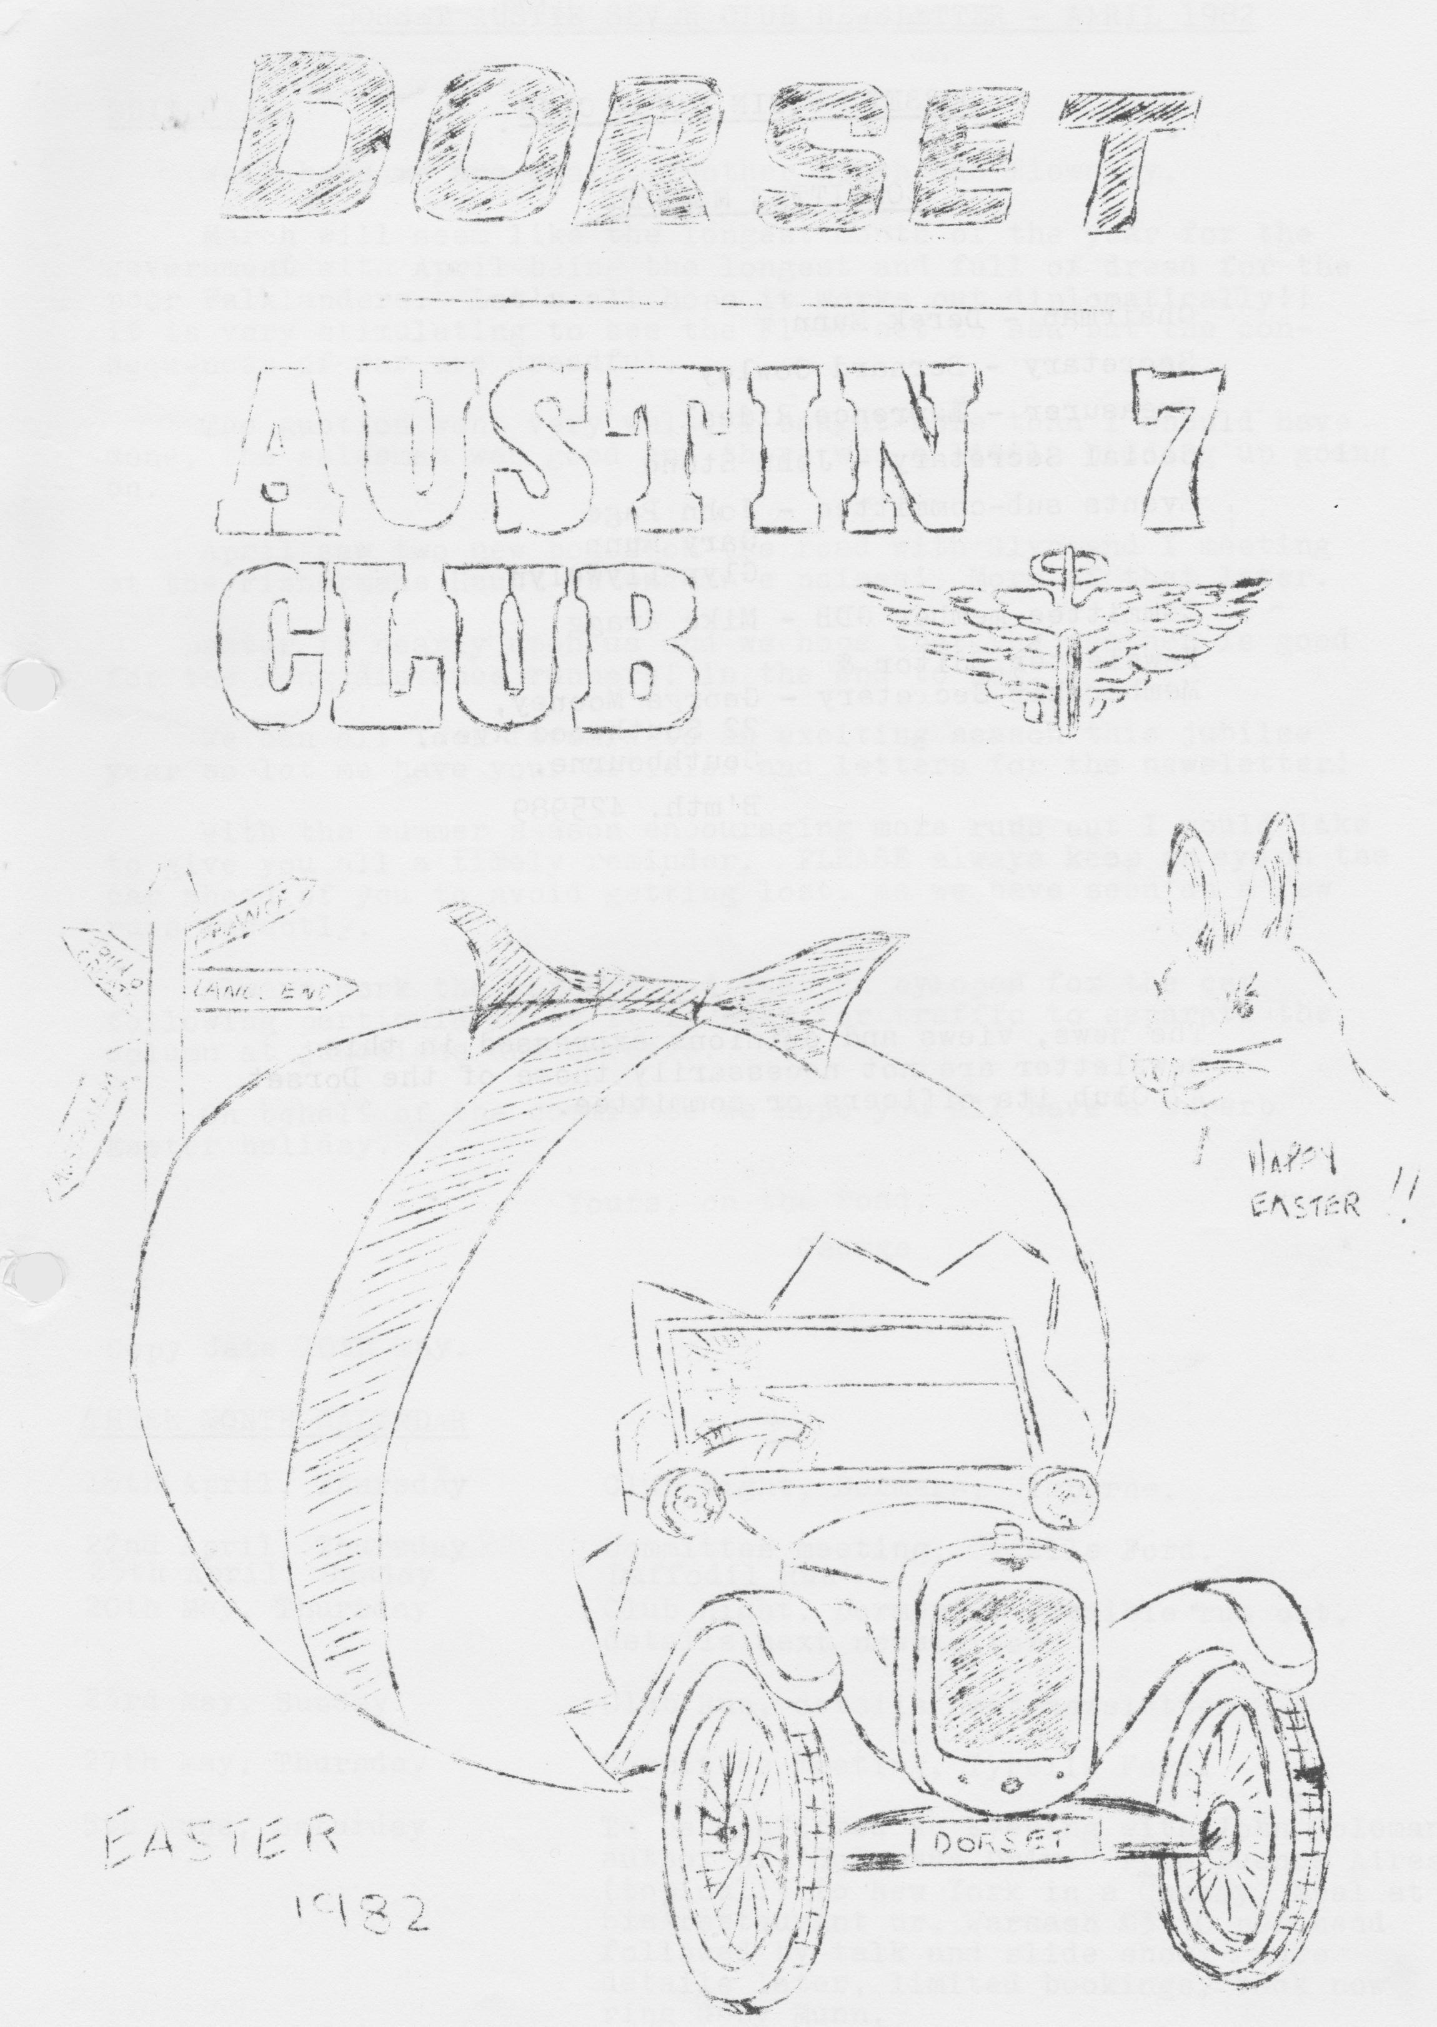

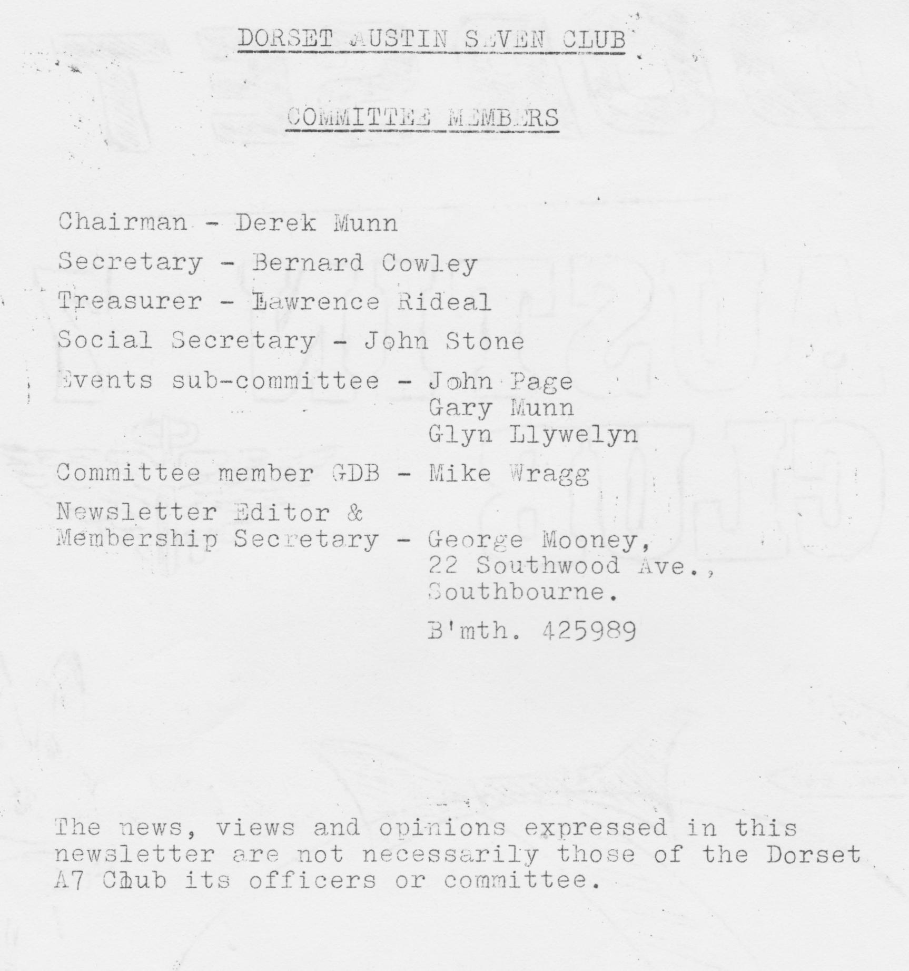

DORSET AUSTIN SEVEN CLUB NEWSLETTER APRIL 1982

EDITORIAL
Well here we are again. Another month, has flown by. March will seem like the longest month of the year for the government with April being the longest and full of dread for the poor Falklanders. Let's all hope it works out diplomatically!! It is very stimulating to see the Fleet set to sea but the consequences of war are dreadful.
The Auction went very well, I bought more than I should have done, the salesman was good and there was a little bidding up going on.
April saw two new boxes on the road with Glyn and I meeting at the Fisherman’s Haunt to exchange noises! More of that later.
Easter is nearly upon us and we hope that the weather is good for the long-distance runners in the End to End.
We can all look forward to an exciting season this jubilee year so let me have your articles and letters for the newsletter!
With the summer season encouraging more runs out I would like to give you all a timely reminder. PLEASE always keep an eye on the car ahead of you to avoid getting lost, as we have seen on a few runs recently.
Always mark the corners and keep an eye open for the car following particularly as it is easy for traffic to separate the column at junctions and corners.
On behalf of the committee we hope you all have a superb Easter holiday.
Yours, on the road,
George

Copy date 10th

THREE MONTH CALENDAR
15th April, Thursday Club Night, Dormers, Wimborne.
22nd April, Thursday Committee meeting, Tyrells Ford.
25th April, Sunday Daffodil Run
20th May, Thursday Club night, Dormers. Possible run out, details next newsletter.
23rd May, Sunday Club Run, details next newsletter.
27th May, Thursday Committee meeting, Tyrells Ford.
5th June, Saturday To be confirmed an Evening with John Coleman author of "Colemans Drive" from Buenos Aires (topical!) to New York in a Chummy. Meal at his restaurant nr. Warsash £3.50 per head followed by talk and slide show. More details later, limited bookings, book now ring Gary Munn.

Other Notable Dates
25th April - A7 Trial, Brooklands.
1st -3rd May - Stone Henge Run, BA7C
1st - 3rd May - Joint run S.-Wales/Solent
9th May Snetterton A7 Racing - 750 club.
23rd May - Lydden Hill A7 Racing - 750 club.
29th - 31st May - Scrumpy Run, BA7C
6th June - Woolaton Park Rally, Nottingham.
13th June - Motorcade WVPC
12th/13th June - Caldicot Castle Rally
19th/20th June - Berkeley Castle Rally
3rd July - pre-Beaulieu Barbecue
4th July - National Rally, Beaulieu
10th July - Silverstone VSCC Racing
11th July - Shelsley Walsh MAC Hill Climb
28th - 30th August - Longbridge Diamond Jubilee Rally

SALES AND WANTS
WANTED - Please help. A pair of headlamps good or restorable, chrome type for 1937 Ruby.
Also required a bonnet top for same car. Please contact: Mike Lawson, Gillingham 3496

TO LET IN CORNWALL - 2-bed bungalow near Truro. Reduced rates for DA7C members. Contact Roger or Rosemary Ballard, Salisbury 23570

MEMBERSHIP NEWS
Our congratulations to Lynda and Chris Smith on the birth of a daughter, in March.
No new members this month.

CLUB RUN TO STOURHEAD
We told you it was to be a special treat! Nine cars and two moderns turned up, including Henrietta in Blushing Pink and Chocbox with Glyn and Pat.
The run sported four Boxes, one Chummy, two Rubies, one 10hp and good to see the Rosenthal Armstrong Siddeley on the road again and two moderns.
Most of us assembled at 10.30 at Wimborne to go on to Henstridge traffic lights to tie up with Richard and Margaret.
My Blushing Pink motor was off colour, (do you like it?) and the nearer to Henstridge we got the worse it got. Eventually Joy and I had to leave the convoy, and go direct to the Unicorn at Bamford
(nr. Wincanton) where the box was 'reseant in pace'.
We spread ourselves in other cars after lunch and went on to see King Alfred’s tower and a superb witches’ cottage in Stourton Woods.
We all managed to get a cup of tea at Stourhead Gardens cafe before returning to the Unicorn to pick up Henrietta who was making dreadful noises!!
NB Glyn won the contest race - his car was still going - ours went Kaput: To add insult to injury he kept giving me Munwellyns cards hint hint!
Mike and Elizabeth Wragg were kind enough to tow us home the 50 or so miles back to Bournemouth.
The weather was very kind and a good time was had by all. I found out on the way back that my brakes work well! The trouble has been traced to a timing wheel which has shed 6 teeth, so it will be a few days before we are back together again. I hope this is the only time a club member needs towing this season, have a good summer.
Cameras are likely to' be banned on future club runs, Glyn will know what I mean.
George and Joy

HINTS
When you assemble your oil pump don't forget: Radiused shoulders to the top, no gasket under the cover plate.

SPARES REPORT
I am pleased to report that at 19th February our stock value at present prices stand at £260 against an original outlay by the club of £112. Members are charged current list prices for spares and the profit comes from discounts which we have negotiated together with 10% to the club from any personal spares I sell. Added to this profit there are the spares made and/or donated and the sale of donated magazines such as A7CA.
In order to improve stocks, I have had a further injection of £50 from the club funds taking us over the £300 mark and the following are additions to existing stock.
Complete LWB exhaust system
silencers
Exhaust clamps + straps
+60 rings (+40 to follow)
T-type pump diaphragms
Starter brushes.
Rad. hoses
Radius arm socket bolt + spring
Spring pins + bushes
Heavy duty clutch springs
head stud sets with nuts + washers
Side water stud sets
High tensile little end/flywheel bolts + washers
Nyloc big end nuts
Remember the more you support the scheme the more we can keep in stock.

The following articles borrowed, with thanks, from the PWA7C newsletter:

'`Welding for Beginners " Part 1
I bought my 1933 box saloon in kit form although a. new floor pan and roof transom had been welded in and the body repaired generally. The wings mainly were in poor condition, especially the rear ones. I parted with £18 to a chap who brazed a strip on the inside of the wings, where the slotted holes are drilled, and who kept me waiting four months for this but who failed to weld the two tears in one wing.
I then took it to another chap who kept the wing for another four weeks but who welded the tears in it, for £12. - Then I offered up the wing to the car, I found that it had been incorrectly welded and didn’t fit. I subsequently cut this to make it fit and then took it to another chap who correctly welded it this time, kept it-two months and charged me a further £10. Total outlay was therefore £40 plus seven lost months!
It was at this time I decided to purchase a welder.
At this stage I must state I have no connection with the motor trade nor with the firm who supplied the welding machine. I have had to learn things the hard way by trial and error plus picking the brains of more skilled amateurs than myself.
After due deliberation I bought an electric welder from Middleton Mail Order; a s.i.p. top weld 30-140 amp model with the carbon arc brazing torch kit etc. for approximately £59. I hadn't used an arc welder but had seen one used many times. I had brazed at school, like a lot of other people, but nothing else.
I got hold of a lot of pieces of old steel and tried welding bits together, and a couple of things became apparent. There are two basic methods of striking the arc: (a.) the touch and withdraw method, and (b) the striking a match technique. I have tried both and cannot say if one is really any better than the other.
I have found that if a piece of old steel is bolted to the earthing clamp one can strike the arc on this, which helps when actually welding the job, i.e. a hot, glowing electrode is much easier to make a "run".
False run on and run off plates are nice to use but are usually impracticable on wings etc. If the welding rods are cut in two to minimize the wavering of the rod tip due to nerves or inexperienced hands, this is found to help. It is possible to weld "Seven" wings and I find that 14-gauge rods are better than 16 or 17g, as the latter seem to be all flux and no filler metal.
Holes can be filled in up to about ¼ " diameter, using rods, at about 60 to 65 amps and without using any backing plate, but I fill them using a 'blob' soldering type technique, i.e. striking the arc and then pulling it away before the heat becomes too great and melts away the parent metal, then repeating this technique until the hole is filled. It is true a fair amount of 'slag' is trapped but as one has to use a proprietary filler, for example P.38, one usually just wants a backing onto which one may apply the filler. Another way is to cut off the head of a nail and place this through the hole and then weld the nail stub to the wing from both sides, later filing flush. Yet another method is to insert a piece of plate inside the wing and if possible provide a heat sink in the form of another behind the first piece. A weld is then made to the first piece of plate in the usual manner and because of the heat sink there is less chance of blowing a hole in it.
I keep numerous clamps and odd bits of steel in the form of RSJ's and channels, and a mini disc to prop up articles whilst I am welding them. I usually clamp a piece of 12" x 4" channel to the jaws of my workmate bench as this stops me burning the wooden jaws.
The carbon arc brazing torch works well although I have modified the Allen screws by brazing a washer to them, thereby forming a crude butterfly set bolt, which holds the carbon rods in the torch. I used the torch to bend a piece of 1" x 1/8" flat along its strong axis to form a pair of rear number plate brackets, and was most pleased with the result.
For this welding kit the carbon arc torch now incorporates a spot welder attachment, but I haven’t had any reports on its performance as I have the older tool.
In conclusion I feel fact the welding kit was a most worthwhile purchase, I have repaired my brother's 1935 Opal front and rear wings, the children's bikes, etc. etc. Furthermore, one never seems to see advertisements in say "Exchange & Mart” which probably means that they are easily sold by word of mouth.
A 4" Black & Decker angle grinder is a useful compliment to this welder and was obtained through the same suppliers. As in all cases, practice makes perfect, and whilst the welder will blast through a certain amount of rust and paint, the arc is difficult to strike and maintain and if using the brazing rods will result in a dry join.
I hope that the above proves useful to others, I honestly feel that we must have many experienced members some with considerable experience with both welding, body repairing, spraying and upholstering, and exhort them also to write a few lines for publication in the newsletter for the benefit of others.
Ian C. Benfield

Welding for Beginners Part 2
Perhaps I could add my experiences to those of Mr. Benfield. I am also basically self-taught. My own experiences with an arc welder (borrowed) are as follows:
Minimum thickness for a successful joint about 2.0 mm (0.080") Anything less than this and instant holes are all I manage to join together! as you can gather I found it pretty useless for bodywork. I then bought a carbon arc brazing torch attachment, which did enable thin sheets to be brazed together, although the 'flame' was rather large and the joints not particularly neat. The brazing attachment was also used for heating and bending bits and even soft-soldering once when the blowlamp was u/s - a really useful accessory.
Using the arc welder, I have built an engine hoist, a dinghy trailer and mended other items but the metal must be reasonably thick. Anyone considering buying an arc welder I suggest get one with an adjustable output end at least 90 amps for thicker work - 3/16ths. and 1/4” inch.
When I bought 'Little Ethel' my 'new' RN saloon, it was very, very rusty and as I had to return the borrowed. arc welder by this time anyway I considered the best way to go about welding and repairing i.e. new-floor and every corner and the wings.
After much deliberation and with a fellow enthusiast we purchased a BOC portapack oxy/acetylene welding and cutting set. This has miniature gas bottles and is in all about the size of a ladies shopping trolley. It came complete with safety rules and welding techniques and tips and it is a far better tool than an arc welder for bodywork.
I started out brazing all the joints but as confidence and technique improved found that I was welding most of the time, even vertically and upside down! I only brazed when heat distortion was likely to be a problem. The cutting attachment has been used on items such as chassis frame of a Morris Minor when it was broken up for parts; this also is first class. The gas lasts a surprisingly long time and refills are around £14 a time for both bottles - which have to be changed at the British Oxygen Co.’s depots - a slight snag, as the nearest may be quite some way away from you. However, you do have the same gear as a garage is likely to have so there isn't much you can't do in the way of bodywork welding.
I would recommend anyone contemplating a welding set to spread the cost with others - say about three - and buy an oxy/acetylene portapack set, since it is unlikely to be required by everyone at the same time and I guess the cost spread say, three ways would be less than one person outright purchasing an arc set-up.
I believe any responsible person can obtain these small bottles from BOC. When we had ours, about five years ago, the cost was around £135, complete with sapphire torch, regulators, nozzles, rods and cutting attachment.
An angle grinder would be a great additional help, but I make do with a sanding disc attachment and. electric drill.
S. Carpenter

CHAIRMANS CHAT
Having had a few gins last Saturday night, I was having a quick forty winks in Gary's chummy on the way to Wimborne Square, the start of Sundays run to Stourhead. When we arrived, I received a quick elbow from Gary and in my half-asleep state I lurched out of the car to be confronted by a pink Austin Seven, yes Officer: PINK!! Now, having been off the fags for a month and one day I thought I'd got the withdrawal symptoms back. It was only when Phil came up and said didn't it look nice that I stopped shaking. Next, up came George to show me the engine; the shiniest cut-down Ford Cosworth I have ever seen! This car is worth having a look at! I did think at the time that nobody would be able to keep up with it on the run. Suffice it to say that Glyn's beautifully restored brown Box trundled sedately along all day with no trouble at all. Lots of luck to Phil, Keith and Mark on the End to End run. By the time this newsletter is printed it will all be over bar the equivalent of saddle sores. We all hope the sponsorship goes well Phil.
Well, have a nice Easter everybody, mind how you go on the road, especially those on the French trip. The 'frogs' still ride on the wrong side, it must be something to do with the garlic.
Derek.

Well, folks, that’s it for now, sorry it isn't more exciting but no input this month from the membership!
Write to me, I enjoy reading your articles.
Have a lovely Easter, see you around in the Pink.
Cheers, George.

