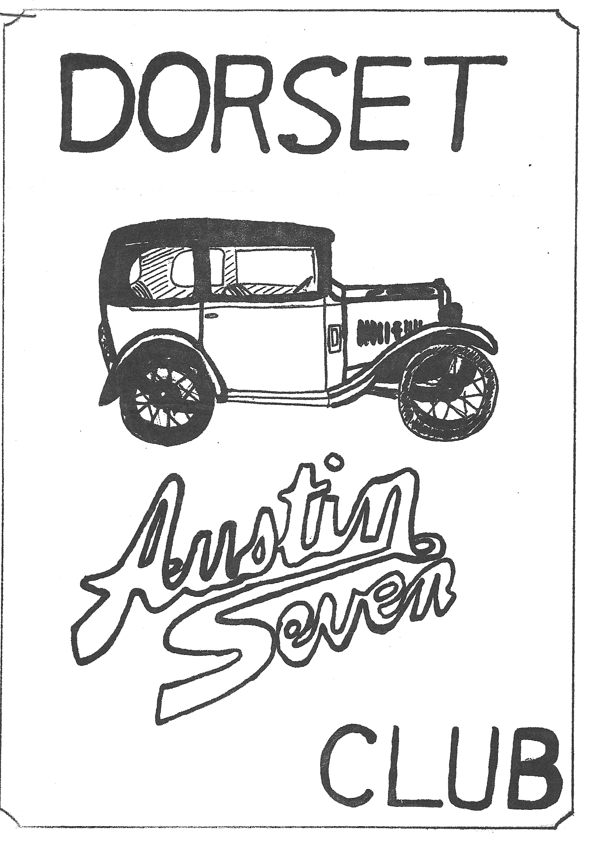
DORSET AUSTIN SEVEN CLUB NEWSLETTER APRIL 1981

APRIL MEETING
THURSDAY 16th APRIL 8.30 p.m. AT 'THE NAGS HEAD' RINGWOOD. FILM AND SLIDE SHOW. BRING YOUR FILMS, SLIDES, AND PHOTOS OF RALLIES AND EVENTS.

MAY MEETING
THURSDAY 21st MAY AT ‘THE NAGS HEAD’ FOR A RUN TO THE "HIGH CORNER" AT LYNWOOD.

NEXT COMMITTEE MEETING THURSDAY 7th MAY AT PHIL & HILLARY WHITTER'S HOUSE, 134, NORTHFIELD ROAD, POULNER, RINGWOOD at 8 p.m.

EDITORIAL
HI GANG.
We had a good pre-France natter at the 'Nags Head' on Sunday, where we made last minute plans, and made notes of things take and do before the big day. This was followed by a run through the New Forest, organised by Gary Munn.
I recently heard about a Chummy sold for £300 in Corfe Castle. I understand it was 90% complete, so they are still about; funny though, I never hear of them before they are sold!
Did you see we got a mention in collectors Car this month? It was on the club news page and concerned our VIP. member. By the way those wishing to attend the wedding, must let any committee member know in plenty of time.
ED
.
NEW MEMBER
Welcome to Mr. Ted Carr-Jones of 18 Fernside Road, Winton.

DORSET AUSTIN SEVEN CLUB SWANAGE RUN SUNDAY 15th MARCH, 1981
Sunday 15th March dawned cloudy and by half past ten a little drizzle drifted about as a total of 31 people (including babes in arms), 9 'Sevens', an MGA and a 'modern' gathered in Wimborne
Square at the start of the run into the Purbecks.
Setting off in convoy there were all sorts of Austin Sevens, ranging from Bernard's 1925 'Chummy' to my 1938 'Big Seven', taking part in its first DA7C event. Among those present were Bernard,
Phil, Richard Cressey plus wife Margaret and baby Rosy in their 1931 RN saloon, all the way from Chippenham, David Simons and family in his 1930 Box Saloon, Peter and Mrs Holmes in their very nice MGA, Mike Lawson and Ann in the modern, also Glyn and John Page and others in a wide range of Sevens including Ruby saloons.
Passing through Corfe Mullen we started to climb, then descended in style to Lytchett, and off through Wareham. It had been decided to take the 'Creech' road out of Stoborough but Bernard's Chummy had other ideas and disappeared at a high rate of knots towards Swanage! Frantic signs had no effect and the other cars, after waiting at the junction for a while, set off for East Creech, confidently expecting to meet Bernard later, coming in the opposite direction!
We all pulled up, still in convoy, in the village, where upon Bernard and Chummy appeared from behind us! While we were stopped a man who had been chopping wood in his garden took a long look at our line of cars and announced that he had a 'Ruby' in his shed, awaiting restoration. Always eager to co-opt new members, officials of the Club were seen disappearing to view this machine, and the result was that we have, hopefully, one new prospective member.
Through the Purbecks and into Church Knowle, where we took over the New Inn during lunchtime, whereafter the sun came out as we travelled back to Corfe Castle, then up that long, long hill into
Kingston. Bernard's Chummy and the ordinary Sevens (SAUCE!: Ed.)
ascended well, with the Big Seven taking things easy with its extra horsepower carefully restrained through 'running in' orders (in any case it's got two more doors to carry around), and the convoy reached the top amid glorious sunshine.
Down again into Swanage, where we stopped to look at the Railway restorations in the Station yard, then on to Durlston Head for an exploration on foot of the famous stone 'Globe' at Tilly Whim, and
a walk along the clifftops. Back into Swanage for a little refreshment, and the Big Seven and friends cruised home. A very pleasant run, enjoyed by all who went.

Kim Henson
1923 AUSTIN SEVEN CHUMMY
The 'SEVEN' saved Austin from a collapse which had been threatened by the failure of the 'Twenty'. It was the first real people's car to be built in Britain, and it was an immediate success.
Despite being very slow and having poor brakes and a jerky clutch, it had several endearing virtues other than its low price - it was very, easy to drive, and its simple two-bearing side-valve engine was virtually unbreakable.
The Museum's Seven was one of the first to roll off the Longbridge production lines, and I found it interesting to compare it with the 1932 saloon I once owned and also various later models I have
driven.
People either love or hate Austin Sevens, and although YA 7103 is a very pretty and immaculately maintained example, I hardly imagine many people driving the old baby for the first time would go away in raptures.
For a start, it is on beaded edge tyres, and very narrow ones at that, which give it rather wobbly cornering, It also has the early three-speed gearbox, which as well as being hard to learn because of the reversed gate is also saddled with an enormous gap between the second and top ratios: you either scream along in second, or change up and splutter along at hardly any speed at all.
And the clutch is dreadful.
Taken from the supplement of Motor March 18th 1978

FOREST RUN 5th APRIL
After a super lunch at the Nags Head, six Austin 7's and one Austin 10 left Ringwood, led by our organiser for the day, Gary Munn.
Those taking part were John & Cynthia Page in their Mulliner box, Jim & Mary Clenaghan in a Tickford, Phil &. Hilary Whitter in their Ruby, Martin Gover in his Ruby, Ken Ford in an Austin 10, myself and Pat in the Ruby, and Gary, Derek and Jane Munn in a box.
We wended our way via country lanes to Fordingbridge where, to the delight of the locals, we drove in convoy through the town. On then through Gods Hill, after which I became lost until, after passing through a ford (dry, unfortunately) we arrived eventually at the Rufus Stone, where we all piled out for a natter, and a stroll over to see the monument. On then via Lyndhurst and Brockenhurst, down the Ornamental drive to Rhinefield House, where it was suggested we should stop for tea. On arriving there however, we discovered that we would have to pay 75p. each to get into the house before we could have tea. So, after a short discussion we decided not to bother with tea, and continued on down the ornamental drive to the A31, where we split up and made our way home . Thanks Gary for a very pleasant afternoon.
Glyn

TECHNICAL TOPICS
HOW TO ADJUST THE AUSTIN SEVEN STEERING BOX
The Problem; Methods of adjusting the "7" steering box on the bench are sufficiently well known to require no repetition. However, much less has been written on adjustment in situ. The two usual adjustments, i.e., column end-float and worm & wheel engagement, are straightforward and need no comment either. The coloured person in the woodpile is side-float, controlled by shims beneath the steel button in the nearside of the box. I was recently presented with this problem on my '33
Tourer. I couldn’t face removing the box - the following is the alternative method adopted.

The Method: First, remove the drag-link from the steering box drop arm. This is easy. Now extract the split pin from the footbrake clevis pin. You should now be able to push the brake operating rod aside, once the clevis pin.is removed. If some goon has assembled the footbrake with the clevis
pin head towards the chassis, you will have to remove the foot-brake from its pivot before you can do this. I suppose it doesn't matter, really, since the next move is to remove the footbrake anyway. This is a good time for you to go and have a cup of tea, or, (if you are working outside,) cocoa.
On your way back to the car, make sure you are clutching a nice long drift. I use a 5/16" diameter brass rod about. 14" long. This would have been expensive had I not pinched it from a defunct
lavatory cistern! This fine tool, used in conjunction with the Austineer's Friend (2½ lb variety), will enable you to undo the locking tabs on the steering box side-plate nuts. Do not waste your time undoing the locking tab on the wheel to worm adjustment nut. Now get some idea of the amount of side-float present - a rough guess will do. Next, procure a drip-tray, old newspaper or a small wellington boot. Place this beneath the steering box so that, when you undo the side-plate nuts, the oil (what oil?) runs into the receptacle.
A ring spanner deals with even the remotest sideplate nut. DO NOT SHEAR THE STUDS FOR GOD'S SAKE OR YOU'LL HAVE TO TAKE THE BOX OFF.
Remove the sideplate/steering-arm assembly and put it in a safe place where it won't get grit in it. You are now in a position to try to remove side-float. The next few minutes will decide whether you go for a glass of beer now or in about half an hour. When reducing side-float, the object of the exercise is to (1) to move the steering arm (held in the sideplate) nearer the steel button - or (2) vice-versa.
(1) When you remove the sideplate I hope you will find a nice thick generous Austin gasket between it and the box. If you didn't go ahead to section (2). If you did, discard the gasket, having examined it. It will probably be about ten-thou. thick. Replace the steering box sideplate without the gasket and cautiously tighten the side-plate nuts. Then, turn the steering wheel. If you feel resistance, the side-float in the box was obviously less than the thickness of the gasket. If not, go ahead to section (2). If you did feel resistance to your attempt to turn the wheel, remove the sideplate, and replace it with, in addition, a gasket made of notepaper - my notepaper is about 3 thou. thick, but then, I'm
mean. This should just create enough side-float to enable the box to operate smoothly. If not, use more or thicker gaskets.
You may now effect the other two adjustments (column endfloat at and wheel-to-worm adjustment) in the normal manner. Then go for that glass of beer.

BRAKE TESTING FOR ADVANCED AUSTINEERS
I was talking to an old-timer (over forty) over a glass of the strong stuff at the local pothouse, when the conversation drifted to that forbidden topic - the Ministry of Transport compulsory vehicle test, brakes, in particular, and I was amazed to learn of what was called "the brick-dropping method" which, though possibly known to most old timers is new to me, and I therefore pass the method on for your interest.
A rare piece of testing equipment is called for - a standard British house-brick. The procedure for carrying out the test is as follows: -
Lay the brick on its side, with the "frog" (indentation) facing forwards, on the floor of the car in front of the passenger seat i.e. the brick is now lengthways across the car. Drive along a selected stretch of road suitable for carrying out braking tests carry out an emergency stop at 20 miles per hour. (For some cars a following wind might be required, but don't have a prevailing wind as it'll assist your brakes! If your brakes are in anything like good condition, the brick will fall over. This
is what is supposed to happen and it indicates that your braking power exceeds 0.75g and is acceptable. However, if the brick doesn't fall over, and having checked that there was nothing in its way to so prevent it, the possible fitment of about a dozen cable tensioners on the brake cables may be called for (to grind along the floor, if nothing else, to assist the brakes!)
No, seriously, don't turn to the Sports page yet, please read on. Assuming that all was well with the footbrake, we now have to test the handbrake. This time the brick has to stand on its end, with the "frog" facing forwards. Carry out your test at ten miles per hour. The brick, having fallen over, indicates that your handbrake is better than 0.37g,, will just hold your car on a 1 in 3 hill and will also just be sufficient to get you through the test.
You may now replace the brick in the wall, or wherever else you pinched it from, that is, of course, unless it failed to fall over in either of the tests, when there is a strong possibility that it may come in handy to tie a rope to and chuck out of the window when you want to stop, and chock the wheels when you park.
The following table is reproduced for the more technically minded:
Attitude of brick: Position of "frog" 'g' force required to topple brick:
On its side. facing forwards 0.75 (approx.)
On its side. facing rearwards 0.05 (approx.)
On its end. facing forwards 0.37 (approx.)
On its end. facing rearwards 0.25 (approx.)
'g' force required to pass M.O.T. test is (I think) 0.50 on hand and 0.25 on foot.

The two preceding articles were pinched with thanks from The PreWar Austin 7 Club.

FOR SALE
A7 OPAL CHASSIS UP RESTORATION NEEDS MINOR FINISHING £1,500 NIGEL RICARDO, DORCHESTER 3827

1925 PRAM HOOD CHUMMY, GOOD RUNNING ORDER NICE LOOKER £3,750 BERNARD COWLEY, WIMBORNE 887666

WANTED URGENTLY
COPY FOR NEWSLETTER - ARTICLES, POEMS, ADVERTISEMENTS TO REACH THE EDITOR BY MAY 14th FOR THE NEXT ISSUE.

WANTED
FOR 1937 PEARL CABRIOLET - 2 FRONT SEATS - ANY INSTRUMENTS AND AN INSTRUMENT PANEL. Tel: John Bramwell, New Milton 612544

EVENTS REMINDER
Sunday 26th April - Daffodil Run, Bean Car Club. Those wishing to join the run at Stockbridge meet at Ringwood Cattle Market Car Park at 10 a.m. or see us at the 'Alise Lisle' Pub at 1 p.m.

Sunday May 3rd - Dorset A7 Club visit to Brownsea Island. Meet at View Point, top of Constitution Hill, Parkstone 10.30 a.m. Modern cars accepted on this run. Bring a Picnic lunch.

Friday 15th May )Dorset A7 Club Camping Weekend at Charmouth
Saturday 16th May )Dorset leaving lay-by just over bridge on
Sunday 17th May )Dorchester Road outside Wimborne at 6 p.m. on Friday 15th May. Details John Page x/c 473207

